Supplementary Material

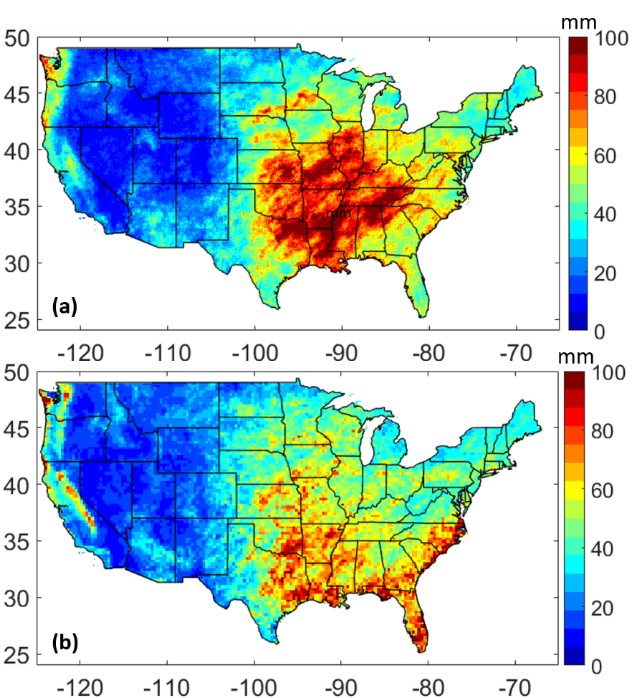
SM1: 99th percentile precipitation maps (mm) over CONUS for a) IMERG Early and b) GEOS-Forecast for study period (July 2018-Feb 2020).

Both IMERG Early and GEOS-Forecast show high precipitation values in Midwest and Southeast. Analogous to average daily precipitation values (Figure 2), GEOS-Forecast exhibits higher 99th percentile values in the West (e.g. California) relative to IMERG Early.
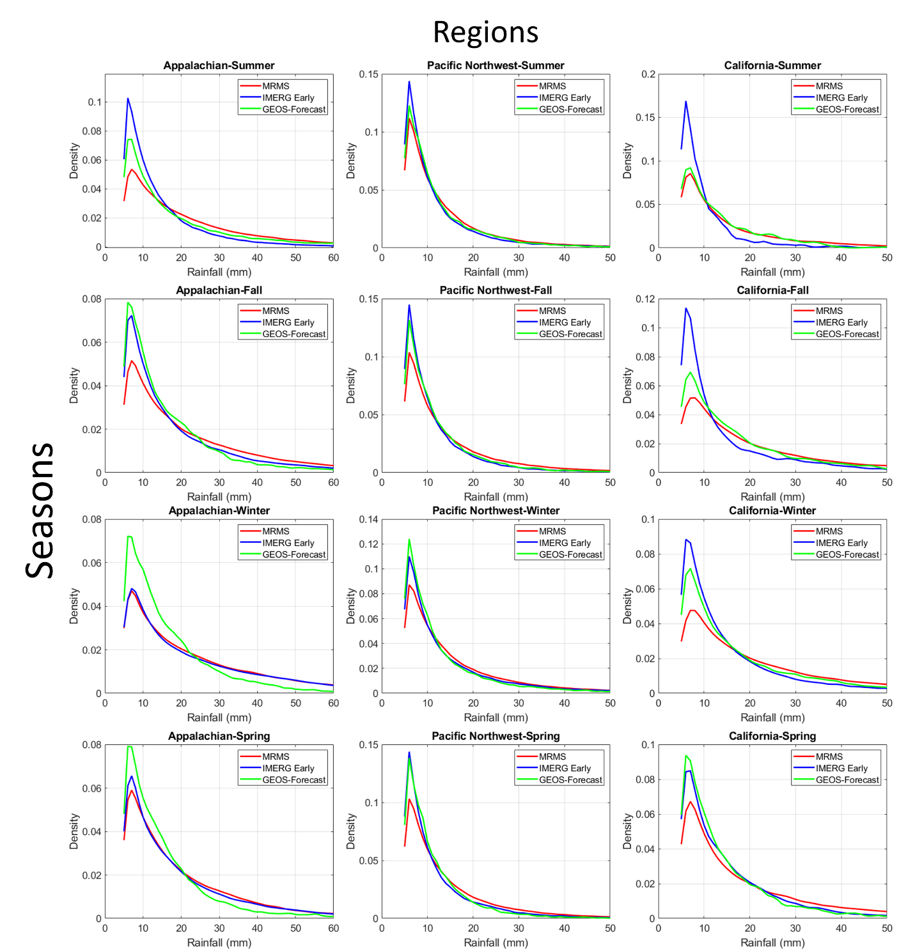
SM2: Seasonal PDFs for Appalachian (left panels), Pacific Northwest (middle panels) and California region (right panels) respectively. Red lines are for MRMS, blue lines show IMERG Early PDFs and green lines are for GEOS-Forecast.

SM2 indicates that PDFs of both satellite and model-based estimates vary with respect to seasons and regions relative to MRMS. In case of IMERG Early, the best agreement with MRMS is found in winter for Appalachian, whereas for GEOS-Forecast in summer for California region. The PDFs for IMERG Early and GEOS-Forecast almost overlap for all four seasons in Pacific Northwest.

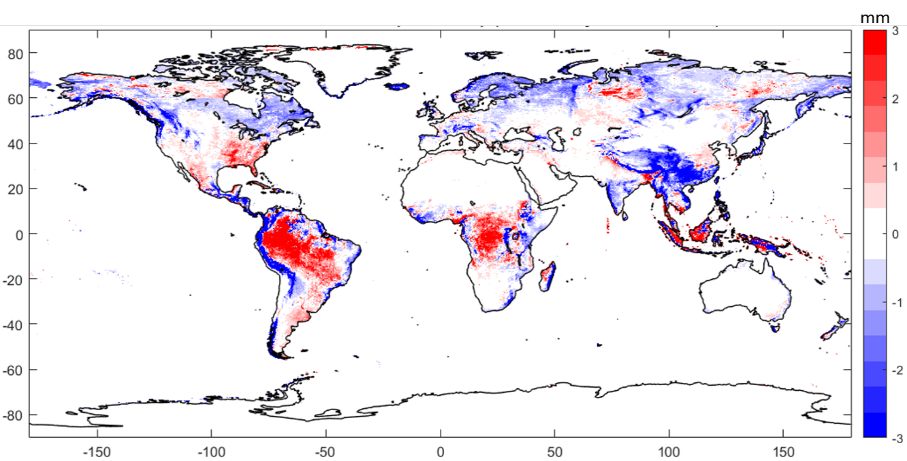
SM3: 50th Percentile difference between IMERG Early and GEOS-Forecast precipitation map (mm/day) for the study period. Red color indicates IMERG Early greater than GEOS-Forecast and blue color correspond to greater GEOS-Forecast 50th percentile precipitation accumulation.

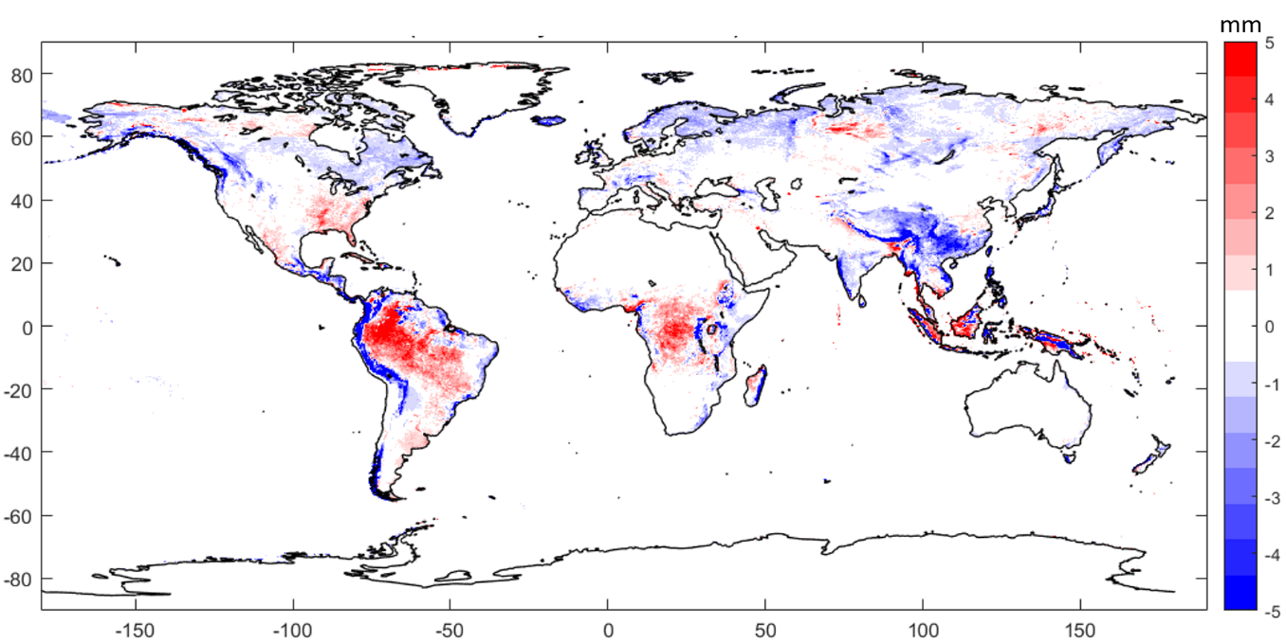
SM4: 75th Percentile difference between IMERG Early and GEOS-Forecast precipitation map (mm/day) for the study period. Red color indicates IMERG Early greater than GEOS-Forecast and blue color correspond to greater GEOS-Forecast 75th percentile precipitation accumulation.

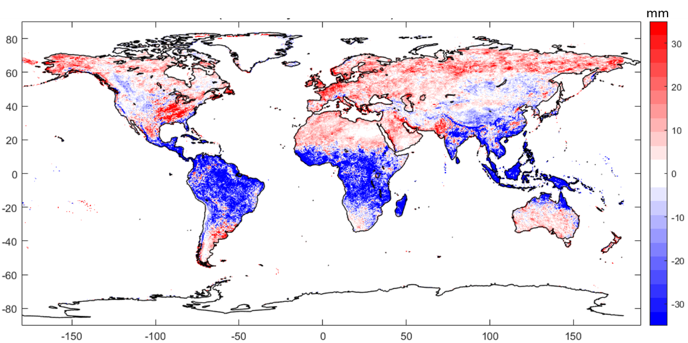
SM5: 99th Percentile difference between IMERG Early and GEOS-Forecast precipitation map (mm/day) for the study period. Red color indicates IMERG Early greater than GEOS-Forecast and blue color correspond to greater GEOS-Forecast 99th percentile precipitation accumulation.

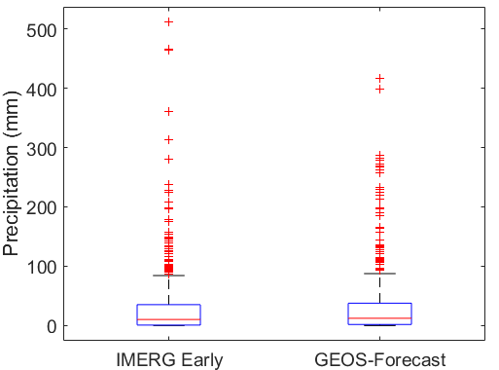
SM6: Box-Whiskers plot for IMERG Early and GEOS-Forecast for recent twitter reports-based landslide points.

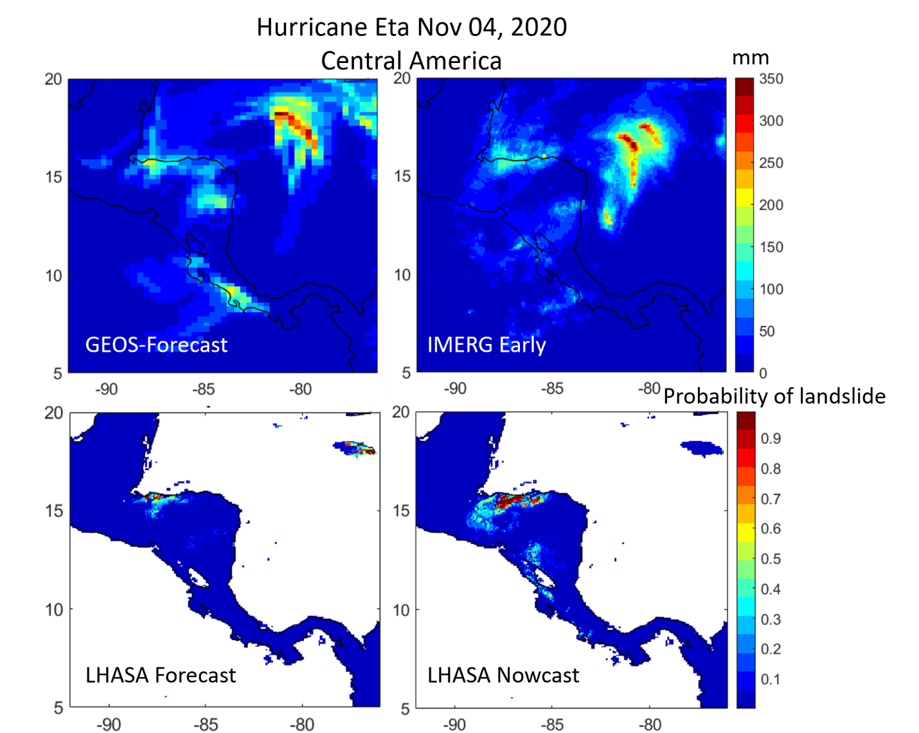
SM 7: Top panels show daily accumulated precipitation (mm) for GEOS-Forecast (left) and IMERG Early (right) for Hurricane Eta on Nov 4, 2020 over Central America. Bottom panels show probability of landslide in the LHASA forecast output (left) and LHASA Nowcast (right) respectively.

SM7 (bottom panels) suggests that the spatial location of the forecasts may be similar to the nowcasts, but that if the forecast is used “as is” the magnitude probability values are diverge.

