Supplementary Figures.
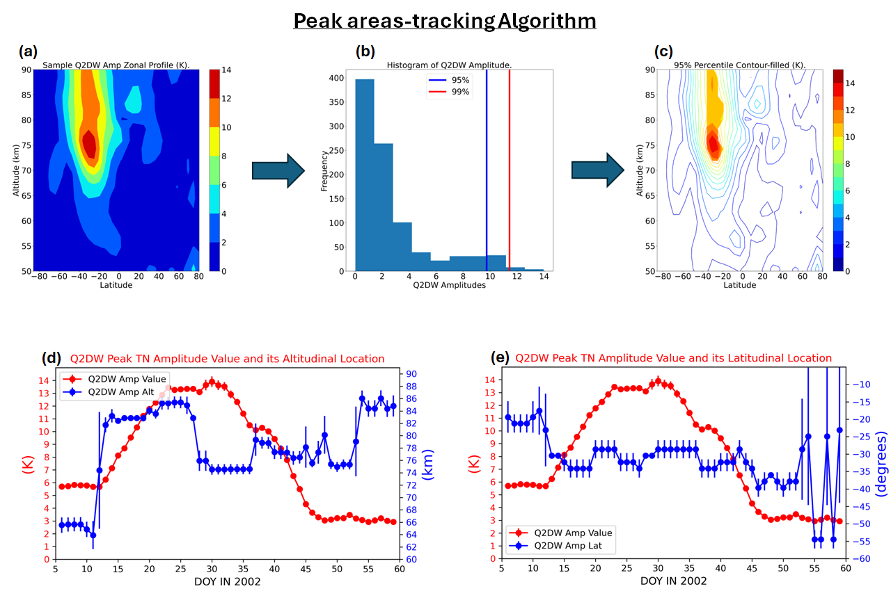
Figure S1: (a) Sample Q2DW amplitude zonal profile. (b) Histogram of the Q2DW amplitude values in (a) as well as lines marking 95th-percentile and 99th-percentile of the values. (c) Sample Q2DW amplitude zonal profile whose contour-filled regions are areas with values belonging to the 95th-percentile. (d) Time-series of the peak Q2DW amplitude and its altitudinal location. (e) Time-series of the peak Q2DW amplitude value and its latitudinal location.

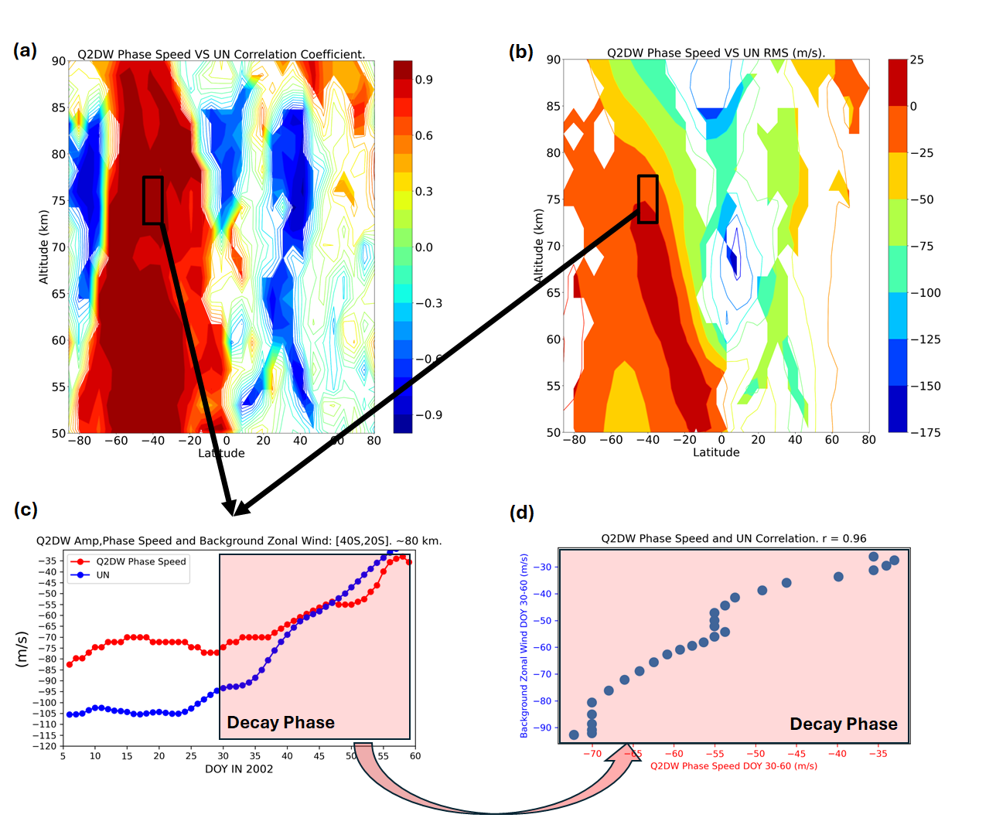
Figure S2. (a) Correlation between decaying Q2DW phase-speed and decay-phase SMEJ wind values for Q2DW event in model year 2002. (b) RMS between decaying Q2DW phase-speed and decay-phase SMEJ wind values for Q2DW event in model year 2002. (c) Sample time-series found inside boxes in (a) and (b). (d) Scatter plot of two time-series in (c).

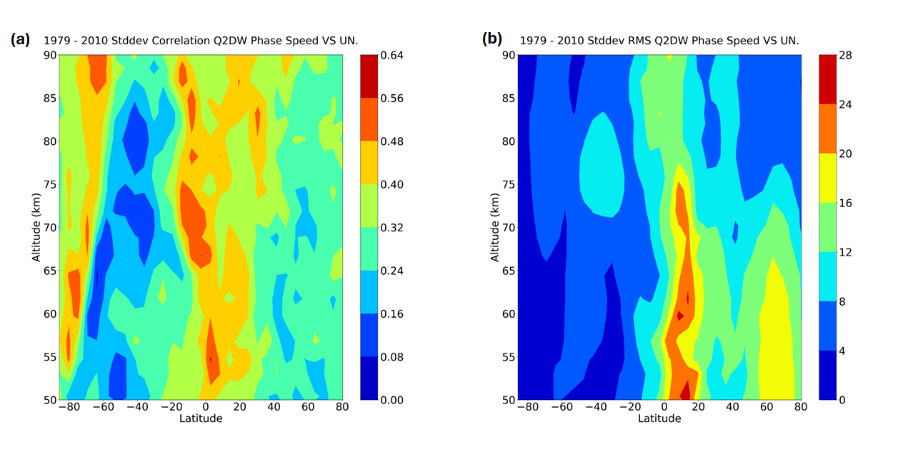
Figure S3: (a) 31-year standard deviation of the yearly correlation zonal-profile between decaying Q2DW phase-speed and decay-phase SMEJ wind values. (b) 31-year standard deviation of the yearly RMS zonal-profile between decaying Q2DW phase-speed and decay-phase SMEJ wind values.

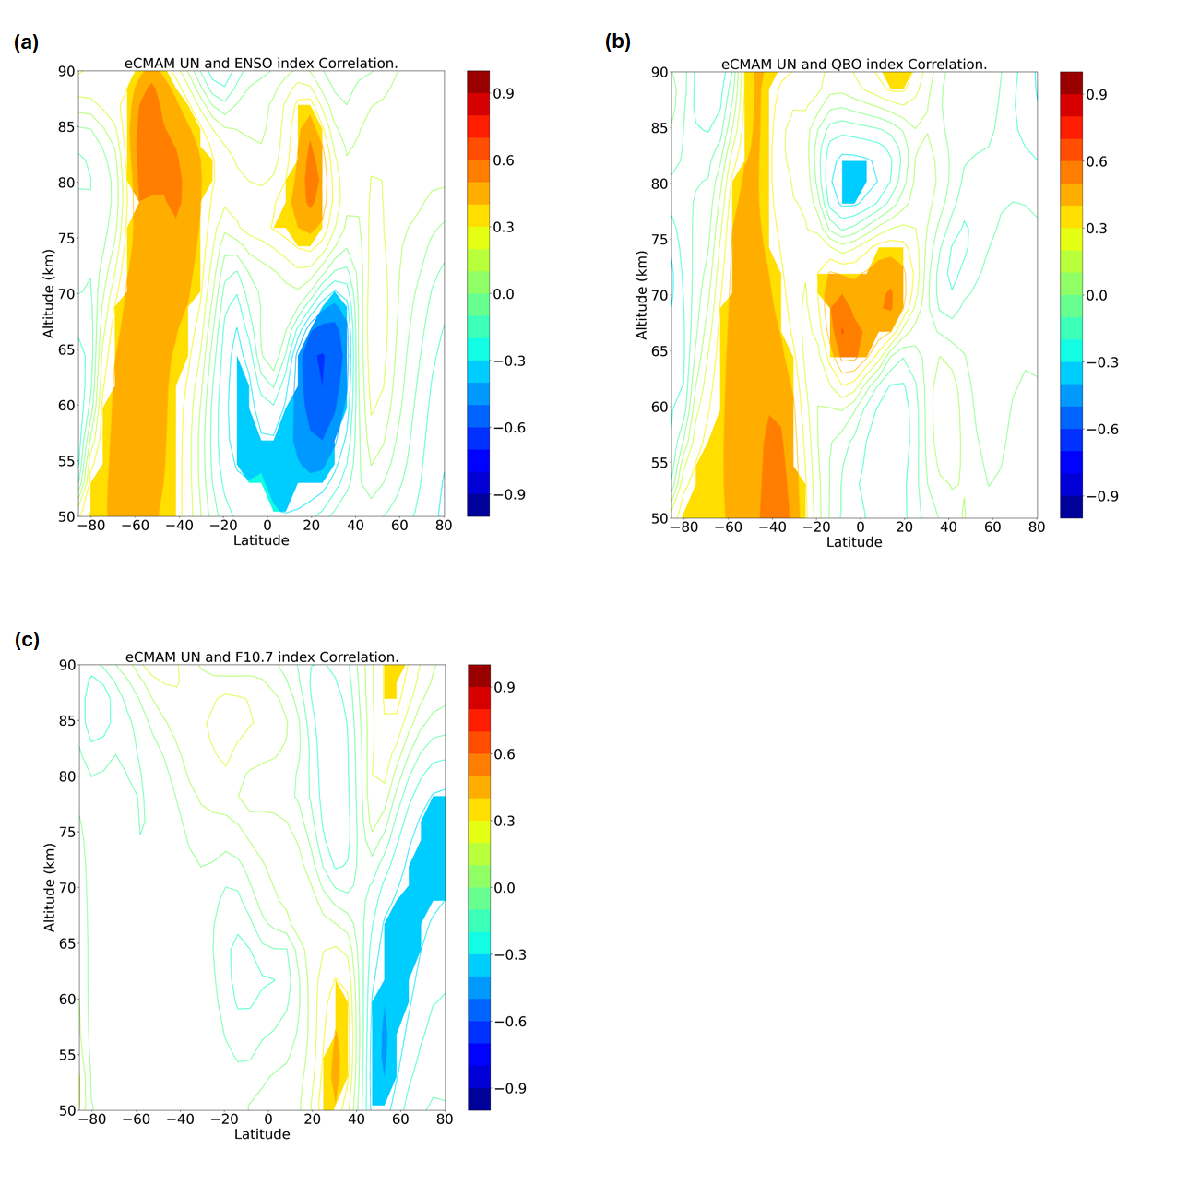
Figure S4: Correlation between eCMAM decay-phase SMEJ average wind values and (a) ENSO index, (b) QBO index and (c) F10.7 index.

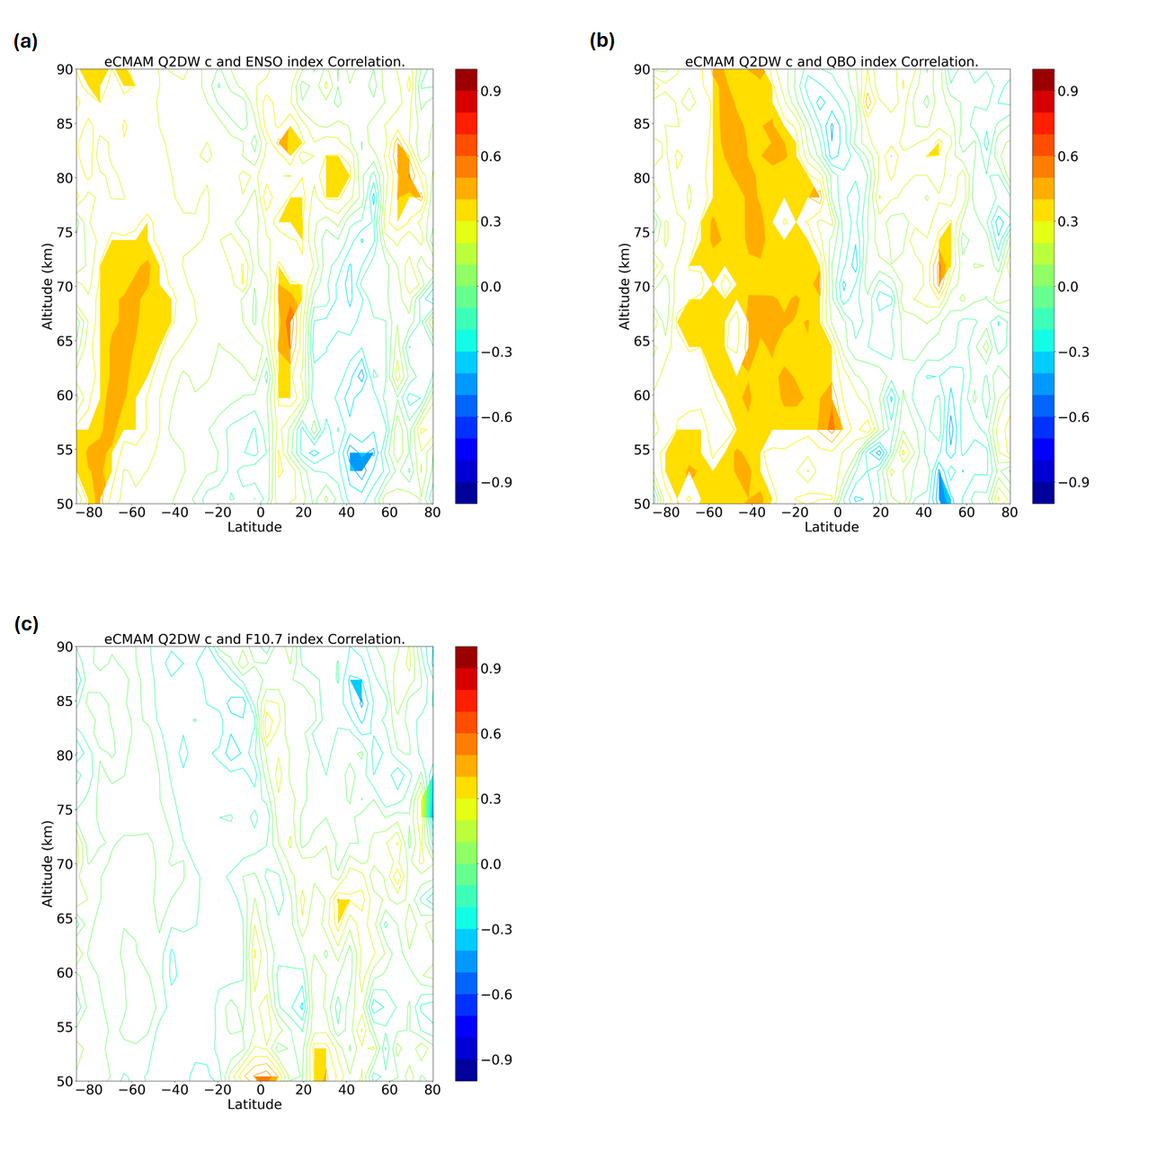
Figure S5: Correlation between eCMAM decaying-Q2DW average phase-speed and (a) ENSO index, (b) QBO index and (c) F10.7 index.

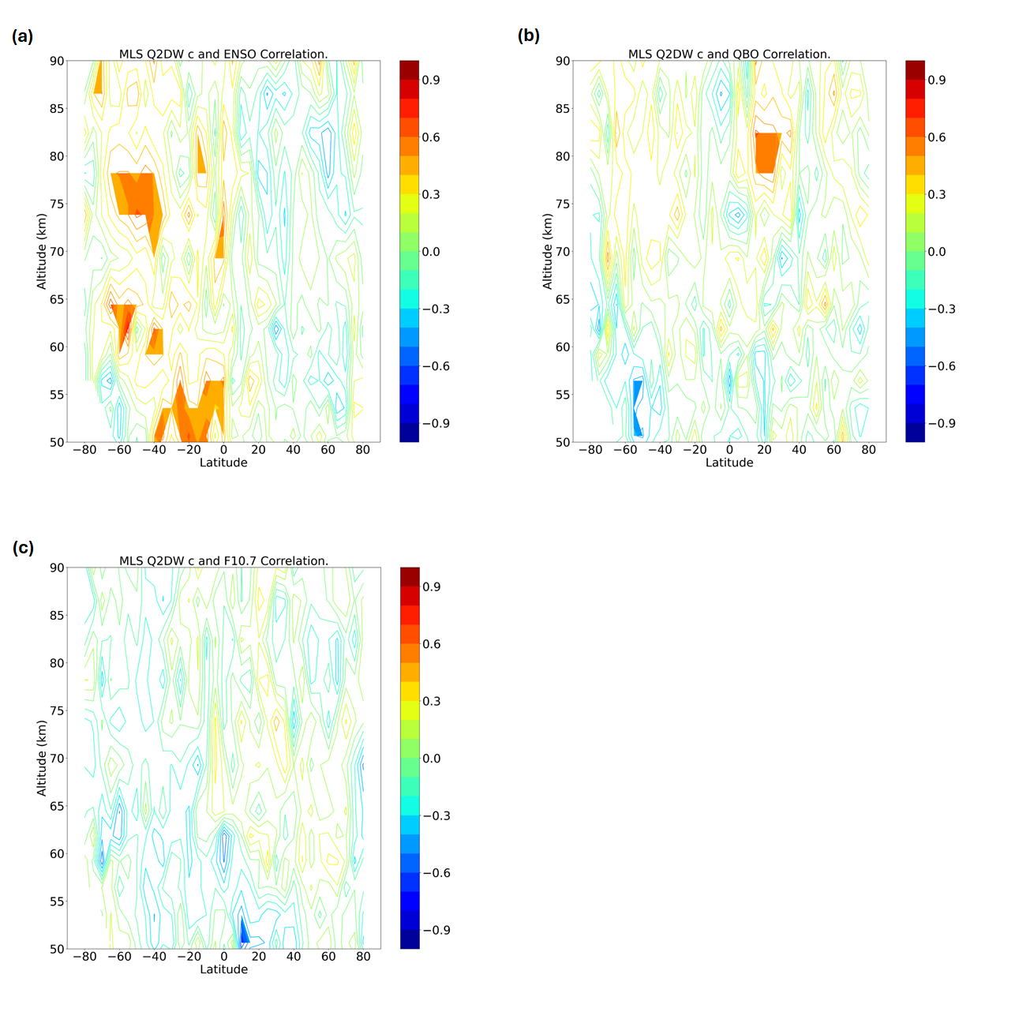
Figure S6: Correlation between MLS decaying-Q2DW average phase-speed and (a) ENSO index, (b) QBO index and (c) F10.7 index.

