-

PRODUCTION OF MURRAY VALLEY ENCEPHALITIS VIRUS-Like PARTICLES FOR VACCINE STUDIES
by
Janine Wince Thomas
B.A. (Hood College) 2006
MOCK GRANT PROPOSAL
Submitted in partial satisfaction of the requirements
for the degree of
MASTER OF SCIENCE
in
BIOMEDICAL SCIENCE
in the
GRADUATE SCHOOL
of
HOOD COLLEGE
May 2019
Accepted:

________________________________ ________________________________
Oney Smith, Ph.D. Ann Boyd, Ph.D.
Committee Member Director, Biomedical Science Program

________________________________
Craig Laufer, Ph.D.
Committee Member

________________________________ ________________________________
Ann Boyd, Ph.D. April Boulton, Ph.D.
Project Adviser Dean of the Graduate School

STATEMENT OF USE AND COPYRIGHT WAIVER

I do authorize Hood College to lend this mock grant proposal, or reproductions of it, in total or in part, at the request of other institutions or individuals for the purpose of scholarly research.

ACKNOWLEDGEMENTS

I would like to thank the members of my committee for their support in my studies at Hood College. I am grateful to Dr. Boyd for her support agreeing to advise me on this capstone project. Additionally, I’d like to thank Dr. Smith and Dr. Laufer for the support they offered me as part of my committee.

Mock Grant Application  Modeled after Department of Health and Human Services  Public Health Services  (based on Form PHS 398) |  |  |  |  |  |  |  |  |  |  |  | LEAVE BLANK—FOR OFFICIAL USE ONLY.
 |  |  |  |  |  |  |  |  |  |  |  | Type |  |  |  |  | Activity |  |  |  |  | Version – HCBMS.011712
 |  |  |  |  |  |  |  |  |  |  |  | Review Group |  |  |  |  |  |  |  |  |  | Formerly
 |  |  |  |  |  |  |  |  |  |  |  | Council/Board (Month, Year) |  |  |  |  |  |  |  |  |  | Date Received
1. TITLE OF PROJECT (Do not exceed 81 characters, including spaces and punctuation.)
Production of Murray Valley Encephalitis Virus-Like Particles for Preliminary Vaccine Studies
2. RESPONSE TO SPECIFIC REQUEST FOR APPLICATIONS OR PROGRAM ANNOUNCEMENT OR SOLICITATION NO YES
(If “Yes,” state number and title)
Number: |  |  |  |  | Title:
3. PROGRAM DIRECTOR/PRINCIPAL INVESTIGATOR |  |  |  |  |  |  |  |  |  |  |  | New Investigator No Yes
3a. NAME (Last, first, middle) |  |  |  |  |  |  |  |  |  |  |  | 3b. DEGREE(S) |  |  |  |  |  |  |  |  | 3h. eRA Commons User Name
Thomas, Janine, A |  |  |  |  |  |  |  |  |  |  |  |  |  |  | B.A. |  |  |  |  |  | N/A
3c. POSITION TITLE  Graduate Student |  |  |  |  |  |  |  |  |  |  |  | 3d. MAILING ADDRESS (Street, city, state, zip code)  401 Rosemont Ave.  Frederick, MD 21201
3e. DEPARTMENT, SERVICE, LABORATORY, OR EQUIVALENT
Department of Biology
3f. MAJOR SUBDIVISION
Biomedical Science Program
3g. TELEPHONE AND FAX (Area code, number and extension) |  |  |  |  |  |  |  |  |  |  |  | E-MAIL ADDRESS:
TEL: | N/A |  |  |  |  | FAX: |  | N/A |  |  |  | jwincethomas@gmail.com
4. HUMAN SUBJECTS RESEARCH |  |  |  |  |  |  |  |  | 4a. Research Exempt
No Yes |  |  |  |  |  |  |  |  | N/A
4b. Federal-Wide Assurance No. |  |  |  |  |  |  |  |  | 4c. Clinical Trial |  |  |  |  |  |  |  |  | 4d. NIH-defined Phase III Clinical Trial
N/A |  |  |  |  |  |  |  |  | No Yes |  |  |  |  |  |  |  |  | No Yes
5. VERTEBRATE ANIMALS No Yes |  |  |  |  |  |  |  |  |  |  |  | 5a. Animal Welfare Assurance No. |  |  |  |  |  |  |  |  |  | N/A
6. DATES OF PROPOSED PERIOD OF  SUPPORT (month, day, year—MM/DD/YY) |  |  |  |  |  |  |  |  |  |  | 7. COSTS REQUESTED FOR INITIAL  BUDGET PERIOD |  |  |  |  |  |  |  |  | 8. COSTS REQUESTED FOR PROPOSED  PERIOD OF SUPPORT
From |  |  |  | Through |  |  |  |  |  |  | 7a. Direct Costs ($) | 7b. Total Costs ($) |  |  |  |  |  |  |  | 8a. Direct Costs ($) |  |  |  | 8b. Total Costs ($)
05/01/2019 |  |  |  | 05/01/2022
9. APPLICANT ORGANIZATION |  |  |  |  |  |  |  |  |  |  |  | 10. TYPE OF ORGANIZATION
Name |  |  | Janine Thomas |  |  |  |  |  |  |  |  | Public: → Federal State Local
Address |  |  | Department of Biology  Hood College  401 Rosemont Ave  Frederick, MD 21701 |  |  |  |  |  |  |  |  | Private: → Private Nonprofit
For-profit: → General Small Business
Woman-owned Socially and Economically Disadvantaged
 |  |  |  |  |  |  |  |  |  |  |  | 11. ENTITY IDENTIFICATION NUMBER
 |  |  |  |  |  |  |  |  |  |  |  | DUNS NO. |  |  |  | N/A |  |  |  |  | Cong. District |  |  |  |  | N/A
12. ADMINISTRATIVE OFFICIAL TO BE NOTIFIED IF AWARD IS MADE |  |  |  |  |  |  |  |  |  |  |  | 13. OFFICIAL SIGNING FOR APPLICANT ORGANIZATION
Name |  |  | Janine Thomas |  |  |  |  |  |  |  |  | Name |  | Janine Thomas
Title |  |  | Graduate Student |  |  |  |  |  |  |  |  | Title |  | Graduate Student
Address |  |  | Hood College  401 Rosemont Ave  Frederick, MD 21701 |  |  |  |  |  |  |  |  | Address |  | Hood College  401 Rosemont Ave  Frederick, MD 21701
Tel: | N/A |  |  |  |  |  | FAX: |  |  | N/A |  | Tel: | N/A |  |  |  |  |  |  |  |  |  | FAX: |  | N/A
E-Mail: |  |  | jwincethomas@gmail.com |  |  |  |  |  |  |  |  | E-Mail: |  | jwincethomas@gamil.com
14. APPLICANT ORGANIZATION CERTIFICATION AND ACCEPTANCE: I certify that the statements herein are true, complete and accurate to the best of my knowledge, and accept the obligation to comply with Public Health Services terms and conditions if a grant is awarded as a result of this application. I am aware that any false, fictitious, or fraudulent statements or claims may subject me to criminal, civil, or administrative penalties. |  |  |  |  |  |  |  |  |  |  |  | SIGNATURE OF OFFICIAL NAMED IN 13.  (In ink. “Per” signature not acceptable.)  Janine Thomas |  |  |  |  |  |  |  |  |  |  |  |  |  |  | DATE
Face Page

PROJECT SUMMARY (See instructions):

The aim of this research is to produce virus-like particles (VLPs) for Murray Valley Encephalitis Virus (MVEV) Genotype 1 and Genotype 2. This research will incorporate strategies previously shown to increase production yield and to increase neutralizing antibody titers. The incorporated envelope protein will include a modification substituting phenylalanine at position 108 with alanine to increase the production yield of VLPs (Urakami et al. 2017). The co-expression of the capsid, pre-membrane, and envelope (CprME) proteins along with non-structural protease proteins (NS2B/NS3) in Expi293F™ cells will be used to produce self-assembling VLPs which lack viral RNA. The self-assembly of VLPs is expected to enable the development of native, properly configured VLPs necessary for inducing a high neutralizing antibody response (Boigard et al. 2017).

RELEVANCE (See instructions):
Infection with Murray Valley Encephalitis Virus (MVEV) usually results in subclinical presentation, however, it is estimated that 0.01 % – 0.67 % of occurrences result in severe meningitis or encephalitis. There is currently no prophylactic treatment available for the prevention of MVEV.

PROJECT/PERFORMANCE SITE(S) (if additional space is needed, use Project/Performance Site Format Page)
Project/Performance Site Primary Location
Organizational Name: |  |  |  | Department of Biology, Hood College
DUNS:
Street 1: |  | 401 Rosemont Ave |  |  |  |  |  |  | Street 2:
City: | Frederick |  |  |  |  |  |  | County: | Frederick |  |  | State: | MD
Province: |  |  |  |  | Country: |  | United States |  |  |  | Zip/Postal Code: |  | 21702
Project/Performance Site Congressional Districts: |  |  |  |  |  | 6th Congressional District
Additional Project/Performance Site Location
Organizational Name:
DUNS:
Street 1: |  |  |  |  |  |  |  |  | Street 2:
City: |  |  |  |  |  |  |  | County: |  |  |  | State:
Province: |  |  |  |  | Country: |  |  |  |  |  | Zip/Postal Code:
Project/Performance Site Congressional Districts:
Page 2

BIOGRAPHICAL SKETCH
Provide the following information for the key personnel and other significant contributors in the order listed on Form Page 2.
Follow this format for each person. DO NOT EXCEED FOUR PAGES.
NAME  Janine Thomas |  | POSITION TITLE  Graduate Student
eRA COMMONS USER NAME (credential, e.g., agency login)

EDUCATION/TRAINING (Begin with baccalaureate or other initial professional education, such as nursing, and include postdoctoral training.)
INSTITUTION AND LOCATION | DEGREE  (if applicable) |  | YEAR(s) | FIELD OF STUDY
Hood College, Frederick, MD | B.A. |  | 2006 | Biology
Hood College, Frederick, MD | M.S. |  | 2019 | Biomedical Science
 |  |  | (anticipated)

- Positions and Honors

2015 – Present: Graduate Student

2007 – Present: Quality Control Analyst, Leidos Biomedical, Inc.

- Selected peer-reviewed publications (in chronological order)

N/A

- Research Support

N/A

Program Director/Principal Investigator (Wince Thomas, Janine)

RESOURCES
FACILITIES: Specify the facilities to be used for the conduct of the proposed research. Indicate the project/performance sites and describe capacities, pertinent capabilities, relative proximity, and extent of availability to the project. If research involving Select Agent(s) will occur at any performance site(s), the biocontainment resources available at each site should be described. Under “Other,” identify support services such as machine shop, electronics shop, and specify the extent to which they will be available to the project. Use continuation pages if necessary.
Laboratory:
Hood College facilities will be utilized to perform this project. All necessary equipment and laboratory space needed to perform this project will be available for use including, but not limited to, pipettes, centrifuges, biological safety cabinets, refrigerators, and freezers.
Clinical:
N/A
Animal:
Charles River will be contracted for immunization and blood serum harvesting of BALB/c mice.
Computer:
Hood College is fully equipped with computational equipment for the analysis of data and execution of this project.
Office:
Common materials will be available within Hood College for use during the execution of this project.

Other:
N/A

MAJOR EQUIPMENT: List the most important equipment items already available for this project, noting the location and pertinent capabilities of each.

The following major equipment is available on site:  • Vortex  • Centrifuge  • Thermomixer  • Transilluminator  • Incubator  • Genetic Analyzer  • CCD Imager  • Waterbath  • Spectrophotometer  • Gel running tank | The following consumables will be purchased  with grant funding:  • Taq Polymerase  • Agarose gel  • Plasmid Vector  • Chemically competent E. coli  • LB plates  • HQ Mini Plasmid Purification Kit  • LB Agar  • Isopropanol  • Sequencing Kit  • Expi293F cells

SPECIFIC AIMS

There are two primary objectives of this research; the first is production and characterization of virus-like particles (VLPs) for Murray Valley Encephalitis virus (MVEV). The VLP platform is ideal for this research due to its high level of immunogenic response and its inability to replicate and cause infection in the host. The second objective is preliminary vaccine studies using the developed VLPs. The specific aims for accomplishing these objectives follow.
Aim 1: The first aim of this study is to develop a VLP containing the pre-membrane (prM) and Envelope (E) proteins from MVEV Genotype 1 (G1) and a VLP containing prM and E from MVEV Genotype 2 (G2).
Synthesized sequences for the capsid, pre-membrane and envelope (CprME) and nonstructural proteins (NS2B/NS3) will be amplified by insertion into an Escherichia coli (E. coli) plasmid vector. Following sequence confirmation, the plasmid sequences will be transfected into Expi293F™ cells. The VLPs produced will be purified for further characterization.
Aim 2: The second aim of this study is the characterization and identity confirmation of the MVEV G1 and G2 VLPs produced.
The concentration, purity and approximate molecular weight of the VLPs will be determined. Transmission electron microscopy (TEM) will be used to compare the VLPs produced with the envelope structure of the native wild-type virus.
Aim 3: The third aim of this study is to measure the immunogenicity and efficacy of the VLPs using a BALB/c mouse model.
Immunoglobulin G (IgG) concentrations will be quantitated to assess the immunogenic response of VLP inoculation. Neutralizing antibody titers will be assessed to establish the level of protection against MVEV. Viral challenge will be used to assess protection against Murray Valley Encephalitis infection.
BACKGROUND AND SIGNIFICANCE

MVEV was first isolated from the Murray Valley in the Victoria region of Australia in 1951 following an outbreak of the disease. Prior to this isolation and identification MVEV is suspected to have been responsible for at least four other epidemics in Eastern Australia (Anderson 1954). The highest risk of MVEV infection occurs in the Northwest Territory from February to July (Floridis et al. 2018). In 2011, Australia experienced their first MVEV outbreak in almost 40 years corresponding with an abnormally high rainfall in the wet season (Selvey et al. 2014).
Most MVEV infections in humans result in subclinical to mild disease presentation (Australian Government Department of Health 2013). Adult infections present as meningitis or encephalitis in 1:150 – 1:1000 cases (Lindsay et al. 2002). Children are at greater risk (1:20) of developing meningitis or encephalitis (Mackenzie et al. 1993). Early symptomology indicating encephalitis onset includes drowsiness, confusion, seizures, weakness, tremors, ataxia, and cranial nerve palsy (Cordova et al. 2000). With symptomatic MVEV infection the mortality rate is 15-30%. Survivors of symptomatic MVEV have permanent long term neurological sequelae in 30-50% of cases, while only 40% suffer no permanent effects.
MVEV, which is maintained in reservoirs of egrets and herons, is transmitted to humans via the mosquito species Culex annulirostris (Australian Government Department of Health 2013). Increased MVEV activity is exhibited during periods of heavier rain in association with increased numbers of C. annulirostris (Selvey et al. 2014). Rising economic activity and development in MVEV endemic areas, as well as climate change are expected to continue to increase the risk of MVEV epidemics (Ho et al. 2016).
There is currently no prophylactic vaccine available for the prevention of MVEV (Australian Government Department of Health 2013). The majority of vaccines currently available are based on live-attenuated or inactivated viruses (Ulmer et al. 2006). Live, attenuated vaccines are manufactured through the serial passaging of a virus in cell culture to select a virus with reduced to no virulence; yet retaining immunogenicity (Ulmer et al. 2006). Live-attenuated vaccines risk pathogenic potential being missed in selective screening and potenial ability to revert to virulence thus presenting an infection risk to the patient (Ulmer et al. 2006).
Inactivated vaccines are typically virus which has been killed using chemical or heat treatment which renders them harmless (Ulmer et al. 2006). Inactivated vaccines, avoid the infection risk to the patient so long as all vuirus has been inactivated. Inactivated vaccines often produce lower immunogenic responses (Ulmer et al. 2006).
Additional vaccine development strategies include subunit vaccines composed of recombinant or purified proteins, and VLPs (Fuenmayor et al. 2017). Recombinant subunit vaccines are nanoparticle structures comprised of viral structural proteins but lacking the genetic material necesaary for replication (Chroboczek et al. 2014). The largest drawback to subunit vaccines composed of recombinant or purified proteins is low immunostimulatory response (Karch and Burkhard 2016).
VLPs consist of polyprotein structures which lack the genetic material necessary for replication and infection (Naskalska and Pyrć 2015). VLP interaction with the host immune system results in “high” virus specific immunogenic responses (Naskalska and Pyrć 2015). VLPs can be produced in different systems including yeast, bacteria, or mammalian cells (Fuenmayor et al. 2017). The advantage to producing a VLP in a mammalian cell line is the potential for post-translational modifications conistent with wild-type virus (Fuenmayor et al. 2017). The host cell line is transiently transfected with a gene to allow for rapid production of VLPs (Fuenmayor et al. 2017).
The Food and Drug Administration (FDA) has approved the use of VLP-based vaccines for Hepatitis B Virus (HBV) and Human Papillomavirus (HPV). The recombinant Hepatits B vaccine, which was first licensed in the United States in 1986 has an efficacy rate of 80-100% after three doses (Centers for Disease Control and Prevention 2018). A VLP-based Human Papillomavirus (HPV) vaccine, which became available in 2006, has been shown to induce high levels of protective antibodies (World Health Organization 2019a). In addition to the approved Hepatitis B and HPV vaccines, several pre-clinical and clincal trials for VLP based vaccines are on going, including those for Influenzavirus A, Human Immunodeficieny Virus, Human parvovirus, and Norovirus (Fuenmayor et al. 2017).
MVEV is a typical flavivirus in which the positive-sense RNA genome is contained within a capsid and outer lipid-envelope. The replication cycle of MVEV begins when the virus enters the host cell through receptor mediated endocytosis (Pulkkinen et al. 2018). Low pH in the endosome leads to the fusion of the viral and endosomal membranes which leads the virion to uncoat (Pulkkinen et al. 2018). As the viral RNA is positive stranded, it is directly translatedinto viral proteins by ribosomes in the rough endoplasmic reticulum (ER) (Pulkkinen et al. 2018). The immature viral particles are transported through the trans-Golgi network where they are cleaved by the host cell furin protease to become mature infectious particles (Pulkkinen et al. 2018). Following maturation, the viral particles are released from the cell through exocytosis (Figure 1) (Pulkkinen et al. 2018).
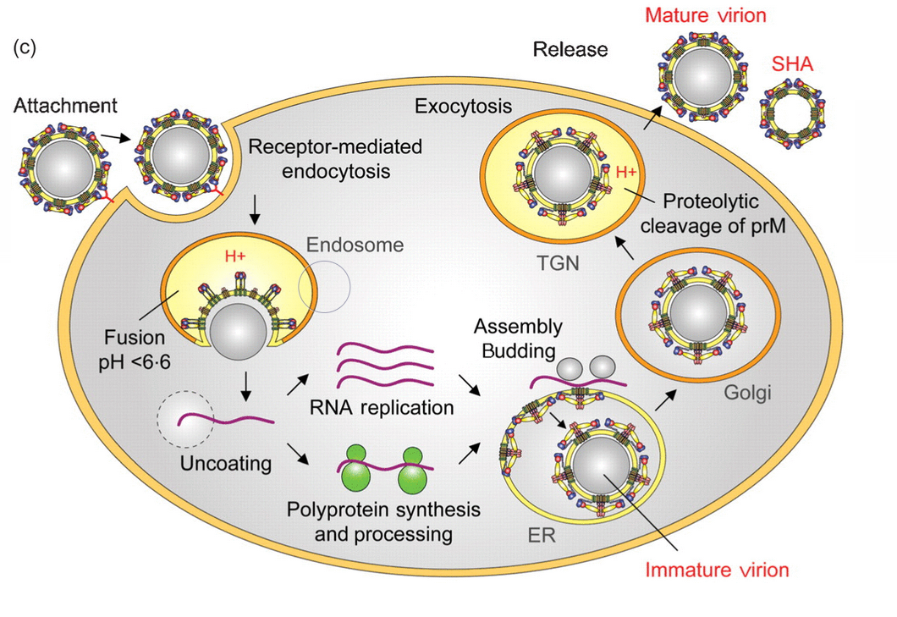
Figure 1. The replication cycle of a flavivirus inside the host cell (from Stiasny and Heinz 2006).

The MVEV genome consists of structural proteins C, prM, and E, as well as non-structural proteins NS1, NS2A, NS2B, NS3, NS4A, NS4B, and NS5 (Rice et al. 1985) as shown in Figure 2 below.

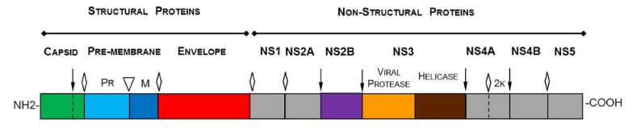
Figure 2. This figure depicts the open reading frame for Zika virus including structural proteins (C, prM, and E), as well as the nonstructural proteins (from Boigard et al. 2017).

During viral maturation prM is cleaved by the host cell protease to produce M and pr proteins with the pr fragment being released from the cell during exocytosis (Boigard et al. 2017). The enveloped virion is studded with 180 copies of the E and M proteins (Boigard et al. 2017) (Figure 3). The E protein is the primary antigen inducing protective immunity (Crill and Chang 2004). Succesful markers of vaccine efficacy (protection) should include the production of broadly neutralizing antibodies towards the E protein (McArthur 2017). Protective immunity towards Dengue have been observed in studies of monocolonal antibodies (mAbs) targeting the E protein (Robinson et al. 2015).

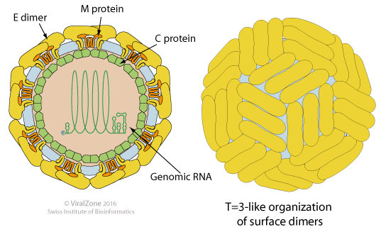
Figure 3. The surface proteins of flaviviruses form icosahedral-like symmetry (from Swiss Insititute of Bioinformatics 2016).

PRELIMINARY REPORT / PROGRESS REPORT

Murray Valley Encephalitis Virus is a member of the flavivirus genus of the Flaviviridae family. Notable members of the flavivirus genus include Zika virus, Dengue virus, West Nile virus, and Japanese encephalitis virus. Flaviviruses possess a lipid-enveloped, single-stranded positive-sense RNA genome exhibiting a single open reading frame (ORF) as seen in Figure 2 (Kroeger and McMinn 2002). The ORF is translated into a single polyprotein which is cleaved by cellular and virus-encoded proteases into structural proteins C, prM, and E, as well as seven non-structural proteins (Boigard et al. 2017).
Flaviviruses enter the host cell through clathrin-mediated endocytosis, which begins when the E glycoprotein binds to a cellular receptor (Smit et al. 2011). Following uptake, the virus is delivered to early endosomes, which mature into late endosomes (Smit et al. 2011). The low pH of the endosome triggers conformation changes in the E glycoprotein leading to the fusion of the viral and endosomal membrane and release of the capsid into the cytosol (Smit et al. 2011) (Figure 6).
Virus-like particles are composed of structural proteins which are able to self-assemble when recombinantly expressed (Fuenmayor et al. 2017). Several expression systems exist for the production of VLPs including E. coli, yeast, insect cells, mammalian cells, and plants (Fuenmayor et al. 2017). The use of mammalian cells as an expression system has the advantage of producing a protein more similar to the native virus by allowing post-translation modifications and natural assembly of proteins (Fuenmayor et al. 2017). Mammalian cells have previously been used successfully in flavivirus VLP development for Zika virus and Dengue virus (Boigard et al. 2017; Urakami et al. 2017).
Dengue virus, which was first recognized as a public health threat in the 1950s, is a member of the flavivrius family (2019b). Prevention of Dengue virus infection is a top priority of the World Health Organization (World Health Organization 2019b). The Dengue virus complex consists of four distinct serotypes for which VLPs have previously been produced through recombinnant transfection of yeast cells (Liu et al. 2014). Synthesis of VLPS for amplified prM and E proteins used a plasmid vector expression in yeast cells and mechanical disruption to harvest the VLPs (Liu et al. 2014). Immunogenicity studies were carried out in mice which were immmunized with either a single monovalent serotype or a combined tetravalent immunization combination of all four serotypes (Liu et al. 2014). It was observed that higher Dengue-specific IgGs were present in mice receiving the combined tetravalent immunization than individual monovalent immunizations (Figure 5) (Liu et al. 2014).
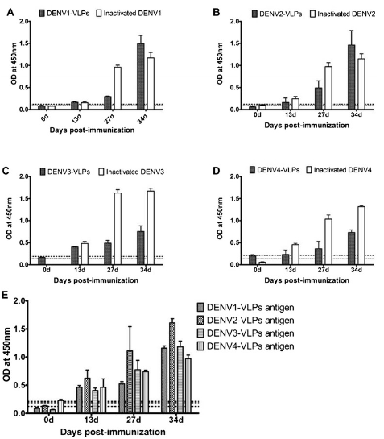
Figure 5. Sera from BALB/c mice immunized with either monovalent VLPs, tetravalent VLPs or inactivated Dengue virus were analyzed for antigen specific IgG response. A) Sera binding of mice immunized with Dengue serotype 1 VLP or inactivated Dengue serotype 1 to the respective antigen. B) Sera binding of mice immunized with Dengue serotype 2 VLP or inactivated Dengue serotype 2 to the respective antigen. C) Sera binding of mice immunized with Dengue serotype 3 VLP or inactivated Dengue serotype 3 to the respective antigen. D) Sera binding of mice immunized with Dengue serotype 4 VLP or inactivated Dengue serotype 4 to the respective antigen. E) Sera binding of mice immunized with tetravalent VLPs to Dengue specific antigens (from Liu et al. 2014).

In 2014, Zika virus (Group IV flavivirus) emerged as a major public health issue in Brazil (Lin et al. 2018). This ongoing health crisis predicated developmental work on a Zika vaccine using a novel VLP based platform. Utilizing co-expresion of CprME along with the NS2B/NS3 protease complex to aid in self-assembly, VLPs lacking viral RNA were produced in 2017 (Boigard et al. 2017). Immunogenicity studies of the VLPs in a mouse model produced high titers of IgG antibodies and high levels of neutralizing antibodies (Figure 6) (Boigard et al. 2017). This display of native properly configured surface proteins is considered key to stimulating a diverse neutralizing response as it presents a better antigenic array to the immune system (Boigard et al. 2017).
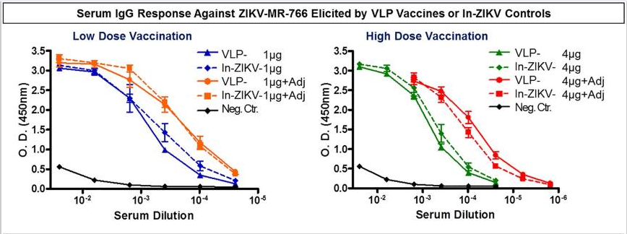
Figure 6. Sera from BALB/c mice immunized with varying doses of Zika VLP and inactivated Zika with and without adjuvant. Strong antibody response against Zika infection was observed in mice immunized with either Zika VLP or inactivated Zika in comparison to the negative control (from Boigard et al. 2017).

Additionally, Dengue virus VLP research shows that mutation of the phenylalanine at position 108 (F108) of the envelope to alanine increases production of VLPs (Urukami et al. 2017). F108, a highly conserved amino acid in flaviviruses, is located in the fusion loop structure of the envelope (Urakami et al. 2017). The E protein undergoes conformational changes which exposes the hydrophobic fusion loop to the host cell during infection (Figure 7) (Urakami et al. 2017). The substitution of alanine at position 108 is hypothesized to prevent VLPs from fusing to the production cell line during the production process, thereby, increasing yield (Urakami et al. 2017). Modified Dengue VLP yield was 16-fold higher for serotype 1, 15-fold higher for serotype 2, and 14-fold higher for serotype 4 compared to the wild type (Urakami et al. 2017).
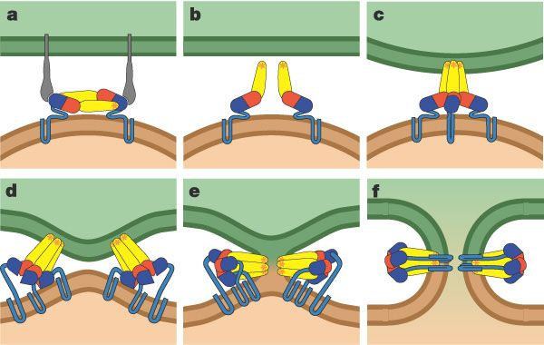
Figure 7. a) The E protein binds to receptors on the host cell. b) Domain II of the E protein hinges outward exposing the fusion loop. c) The fusion loop inserts into the host cell, promoting trimer formation. d) Domain III shifts and rotates to create trimer contacts. e) Creation of additional trimer contacts leads to hemifusion. f) A lipidic fusion pore is created (from Modis et al. 2004).

This research project will incorporate a combination of the strategies used in Zika VLP and Dengue VLP production to produce bivalent MVEV Genotype 1 and Genotype 2 VLPs. The CprME and NS2B/NS3 proteins for MVEV will be coexpressed in Expi293F™ cells to allow for self-assembly. Additionally, alanine will be substituted for phenylalanine at position 108 in the envelope. The hypothesis is that a high yield of VLPs will produce neutralizing activity.
Previously, MVEV sub-viral particle development work was done for Genotype 1 (Kroeger and McMinn 2002). At the time of development only one strain of MVEV had been identified and sequenced. Immunization with MVEV VLPs was shown to induce high humoral immune response, but low protective neutralizing activity in vitro (Figure 4) (Kroeger and McMinn 2002).
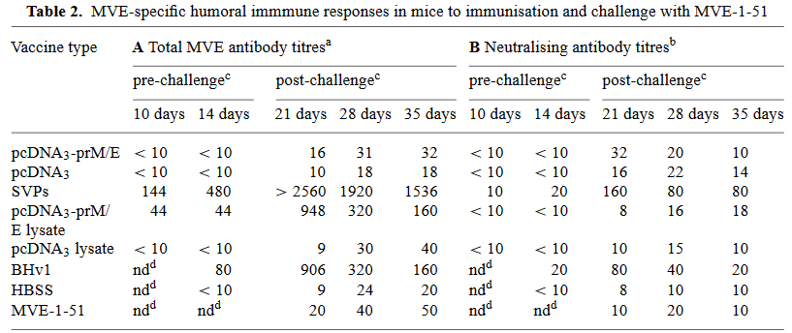
Figure 4. A) Total antibody titers of immunized BALB/c mice pre- and post challenge with MVEV infection. B) Neutralizing antibody titers of immunized BALB/c mice pre- and post- challenge with MVEV infection (from Kroeger and McMinn 2002).

Kroeger and McMinn hypothesized that presentation of mature E proteins in the correct conformation would be necessary for neutralizing antibody induction (Kroeger and McMinn 2002). Native flavivirus E proteins form antiparallel homodimers on the viral membrane (Zhang et al. 2017). Each E protein consists three separate domains (EDI, EDII, and EDIII) anchored to the mebrane through a transmembrane seqment (Zhang et al. 2017).
Subsequent to Kroeger and McMinn’s MVEV VLP work with genotype 1 in 2002, genotypes 2-4 were identified and sequenced (Williams et al. 2014). Genotype 2 was isolated from humansand has a more limited geographic range than genotype 1 (Russell et al. 2018). Genotype 3 was isolated from a single human infection in 1956 (Williams et al. 2015). Genotype 4 was isolated from a mosquito in 1966 (Williams et al. 2015). While genotype 2 is considered a less virulent strain in circulation, genotypes 3 and 4 are considered non-circulating due to their singular isolated recoveries (Russell et al. 2018).

RESEACH DESIGN / METHODS

Aim 1: Production of MVEV VLPs (Months 00-15)
VLPs expressing the E protein from MVEV G1 and G2 will be produced. The MVEV CprME and NS2B/NS3 sequences will be amplified by ploymerase chain reaction (PCR) prior to E. coli transformation. The purified DNA from the transformation coding for CprME and NS2B/NS3 will be transfected into Expi293F™ cells. The E protein will be cleaved from the C and prM by the NS2B/NS3 protease within the Expi293F™ cells during assembly. Sucrose gradient centrifugation will be used to purify the E VLPs.
Sequence Amplification Methods
Sequences for CprME will be manufactured for MVEV G1 (NCBI Reference Sequence NC_000943.1) and MVEV G2 (GenBank KF751871.1). The CprME sequences will be flanked at the 5’ end with an XbaI restriction sequence (TCTAGA) and at the 3’ end with an EcoRV restriction sequence (GATATC) for insertion into the pcDNA 3.4 TOPO® plasmid vector (Figure 8). The CprME sequences will be modified at position 108 of the envelope to convert the phenylalanine to an alanine as has been previously documented to increase VLP production (Urakami et al. 2017).

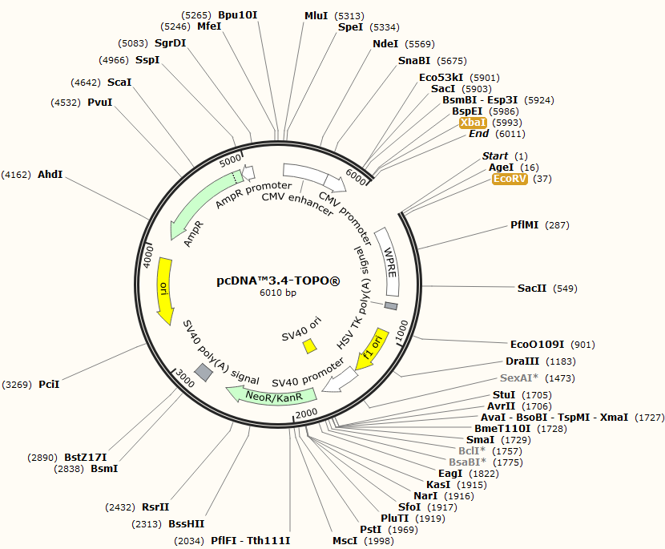
Figure 8. The CprME sequence will be subcloned into the plasmid using the XbaI/EcoRV restriction sites (from SnapGene 2019).

Sequences for NS2B/NS3 will be manufactured for MVEV G1 and MVEV G2. The NS2B/NS3 sequences will be flanked at the 5’ end with an BspEI restriction sequence (TCCGGA) and at the 3’ end with an AgeI restriction sequence (ACCGGT) for insertion into a modified pcDNA 3.4 TOPO® plasmid vector (Figure 9). The plasmid will be modified to replace the neomycin resistance casette with a bleomycin resistance casette (GeneArt, USA).
Primer sequences for CMV forward primer (CGCAAATGGGCGGTAGGCGTG) will flank the 5’ end and pcDNA3.4 reverse primer (CAACATAGTTAAGAATAC) will flank the 3’ ends of all sequences. All sequences will be manufactured by GeneArt (Invitrogen, United States).

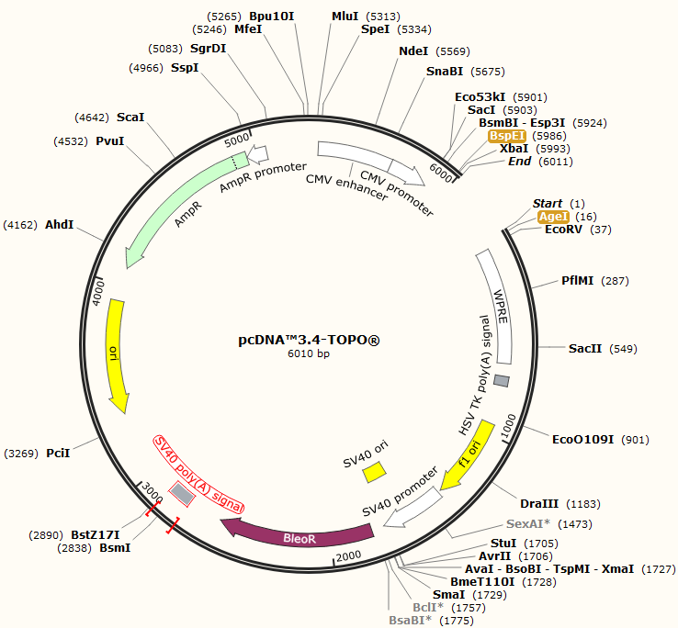
Figure 9. The NS2B/NS3 sequence will be subcloned into the modified plasmid using the BspEI/AgeI restrictions sites (from SnapGene 2019).

Individual PCR reactions will be performed for G1-CprME, G2-CprME, G1-NS2B/NS3, and G2-NS2B/NS3. Master mix for each PCR reaction will include nuclease-free water, 10XPCR buffer, MgCl2, dNTP, and Platinum™ Taq DNA Polymerase (Invitrogen, United States). Final PCR reactions will be prepped using PCR master mix, forward primer, reverse primer, and template DNA. A negative control will be prepped using PCR master mix, forward primer, reverse primer, and water.
The profile for PCR amplification will include initial denaturation at 94ºC for 2 minutes, denaturation at 94ºC for 30 seconds, annealing at 55ºC for 30 seconds, and extension at 72ºC for 210 seconds. Amplification will be extended for 30 cycles. PCR reactions will be held at -20ºC after amplification prior to band size confirmation and gel electrophoresis.
Size Confirmation
The sizes for amplified PCR products will be confirmed using the E-gel® agarose gel electrophoresis system (Invitrogen, United States). Samples will be electrophoresed alongside a DNA ladder loaded onto a 1% agarose E-gel® EX precast gel (Invitrogen, United States). Electrophoresis and imaging will be conducted according to the protocol established by the manufacturer.
E. coli Transformation
Plasmid vector pcDNA3.4 TOPO® (Invitrogen, United States) will be used to subclone the CprME and NS2B/NS3 sequences. TOPO® vector solution will be prepared using amplified PCR product, salt solution, sterile water, and TOPO® vector. Solution will be incubated at room temperature for 10 minutes, before being placed on ice to stop the reaction.
Chemically competent One Shot® TOP10 E. coli will be transformed with the TOPO® vector reaction. One Shot® TOP10 E. coli will be thawed on ice prior to transformation. TOPO® vector reaction will be pipetted directly into One Shot® TOP10 E. coli chemically competent cells and incubated on ice. Cells will be heat shocked before immediately being placed on ice. SOC medium will be added to the cells and placed in a shaking incubator. Transformed cells will be plated on LB agar and incubated for 18 hours.
For each CprME and NS2B/NS3 culture plate 10 colonies will be picked for sequence confirmation of orientation. Colonies will be cultured for 18 hours in LB medium containing 100 µg/mL ampicillin. Isolates will be purified using the PureLink® HQ Mini Plasmid Purification Kit (Invitrogen, United States). LB cultures will be harvested by centrifugation and the pellet will be resuspended in resuspension buffer. Lysis buffer will be added to resuspension and incubated at room temperature. Precipitate will be added to lysis suspension and mixed by inversion and centrifuged. Supernatant from lysis suspension will be pipetted onto equilibrated column. Column will be washed twice with wash buffer after lysis suspension has drained through. Elution tube will be placed under column and elution buffer will be added to the column to elute DNA. Isopropanol will be added to the elution tubed and mixed. Eluted DNA suspension will be centrifuged to pellet the DNA. Supernatant will be removed from the pelleted DNA. DNA pellet will be resuspended in ethanol. Resuspended DNA will be centrifuged, and the supernatant discarded. DNA pellet will be air dried followed by resuspension in TE Buffer.
Sequence Confirmation
Purified DNA will be sequenced using the BigDye™ Terminator v3.1 Cycle Sequencing Kit (Applied Biosystems, United States). Forward and reverse reactions will be prepared in a 96-well plate. Forward reaction will be prepared with BigDye™ Terminator 3.1 Ready Reaction Mix, deionized water, purified DNA sequence, and CMV forward primer. Reverse reaction will be prepared with BigDye™ Terminator 3.1 Ready Reaction Mix, deionized water, purified DNA sequence, and pcDNA™ 3.4 reverse primer. PCR amplification of the plate will occur in a thermocycler. The profile for PCR amplification will include initial denaturation at 96ºC for 1 minute, denaturation at 96ºC for 10 seconds, annealing at 50ºC for 5 seconds, and extension at 60ºC for 4 minutes for 30 cycles. DNA sequencing reaction will be purified by adding BigDye XTerminator™ bead solution and SAM solution to each reaction well. Plate will be vortexed for 20 minutes and centrifuged for 2 minutes. DNA will be sequenced on Applied Biosystems 3500 Genetic Analyzer.
The construct showing correct sequence orientation will be streaked on LB agar containing 100 µg/mL ampicillin. A single colony for each plasmid will be inoculated into LB medium containing 100 µg/mL ampicillin. Cultures will be grown at in a shaking incubator at 37ºC until the culture reaches stationary phase. Each culture will be mixed with sterile glycerol. Glycerol plasmid stocks will be maintained at -80ºC.
Host Cell Transfection
Purified plasmid DNA will be transfected into Expi293F™ cells using the Expi293™ Expression System Kit (Gibco, United States). Expi293F™ cells will be subcultured and expanded to reach a density of 3-5 x 10⁶ viable cells/mL. Cells will be split 1 day prior to transfection for a density of 2.5-3 x 10⁶ viable cells/mL and grown overnight. Cell density of 4.5-5.5 x 10⁶ viable cells/mL and viability of 95-99% will be confirmed prior to transfection. Cells will be diluted to 3 x 10⁶ viable cells/mL with 37ºC Expi293™ Expression Medium. Plasmid DNA will be diluted to 1.0 µg/mL with Opti-MEM™ I Reduced Serum Medium and mixed by inversion. ExpiFectamine™ 293 reagent will be diluted with Opti-MEM™ I Reduced Serum Medium and incubated at room temperature for 5 minutes. Diluted ExpiFectamine™ 293 will be added to diluted DNA and mixed by inversion. ExpiFectamine™ 293/plasmid DNA complex will be incubated at room temperature before being slowly added to dilute Expi293F™ cells. Cells will be incubated 37ºC at 8% CO₂ on an orbital shaker. At 18-22 hours post incubation ExpiFectamine™ 293 Transfection Enhancer 1 and ExpiFectamine™ 293 Transfection Enhancer 2 will be added to cells and gently swirled to mix.
Clarification and Purification
Cells will be harvested at 4 days post transfection. Clarification of harvested cells will occur by centrifugation. The supernatant will be filtered through a 0.22um cellulose acetate filter. Further purification of supernatant will be done be sucrose gradient centrifugation of 20% to 70% sucrose concentration in 10% increments.
Envelope Protein Confirmation
Dot blot will be used to confirm presence of E protein following purification. Purified samples will be pipetted on to a nitrocellulose membrane and the membrane will be dried. Membrane will be blocked with 5% Bovine Serum Albumin (BSA) in Tris Buffered Saline with Tween 20 (TBS-T) and incubated with 4G2 mAb (MilliporeSigma, United States). Membrane will be washed with TBS-T. Membrane will be incubated with goat-anti mouse secondary antibody (Invitrogen, United States). Membrane will be washed with TBS-T. Membrane will be incubated with enhanced chemiluminescence serum and visualized using a charge-coupled device (CCD) Imager.
Aim 2: Characterization of MVEV VLPs (Months 15-18)
Determination of Concentration
Protein concentration will be determined using the Pierce™ bicinchoninic acid (BCA) Protein Assay Kit (Thermo Scientific, United States). BCA working reagent will be added to test tubes of BSA standard (25-2000 µg/mL) and VLPs. Test tubes will be incubated in a 37ºC water bath and cooled to room temperature. Standards and VLP samples will transferred to cuvettes and absorbance measured by spectrophotometer at 562nm. VLP protein concentration will be extrapolated from the standard curve.
Purity Confirmation
SDS-PAGE will be used to confirm purity of VLPs. VLP samples will be prepared in test tubes with sample buffer, reducing agent and deionized water. Test tubes will be heated at 70ºC for 10 minutes. Gels will be prepped by rinsing three times with running buffer. Prepared gels will be placed in the gel running tank and wells will be filled with 3-morpholinopropane-1-sulfonic acid (MOPS) running buffer. Gel electrophoresis will conducted for 50 minutes at 200 V constant.
TEM Visualization
VLPs will be prepared for TEM by negative staining. VLP samples will spread on an ultrathin carbon film. VLPs will be stained with 2% phosphotungstic acid (PTA). A comparison will be made between the morphology and size of native MVEV envelope structure and that of the VLPs.
Aim 3: Measurement of Neutralizing Antibody and IgG Responses (Months 19-26)
Immunogenicity of VLPs will be evaluated using a BALB/c mouse model. Groups of 8-week-old BALB/c mice will be immunized intramuscularly on day 0 and day 21. A control group will be inoculated with PBS. Blood serum will be collected from mice 2 weeks after the second immunization.
IgG Concentration
Enzyme-linked immunosorbent assay (ELISA) will be used to quantitate IgG concentrations in mouse serum. Microtiter plates will be coated with 1 µg/mL MVEV virus strain VR-77. Plates will be blocked with BSA/milk solution. Serum samples will be added to plates and incubated at 37ºC for 90 minutes. PBS will be used as a negative control.
Plates will be washed with 0.1% Tween-TBS. HRP-labeled anti-mouse IgG mAb (Invitrogen, United States) will be used as a detection antibody. Plate will be incubated at room temperature for 60 minutes. Plates will be washed to remove excess detection antibody with 0.1% Tween-TBS. Tetramethylbenzidine (TMB) substrate will be added to plate and oxidized by the bound HRP for color visualization. TMB stop solution will be added to stop the oxidation reaction. Samples will be read at 450nm by plate reader.
Neutralizing Antibody Titer
Vero cells will be grown in monolayer in 24 well plates for plaque reduction neutralization test (PRNT₅₀) analysis. MVEV strains VR-77 (ATCC, United States) and OR156 will be inoculated into the cells. MVEV G1 VLP serum, MVEV G2 VLP serum, and MVEV G1-G2 VLP in dilutions of 1:20 and 1:40 will be added to cells according to Figure 10. VR-77 and OR156 without serum will be used as positive controls. Serum-virus inoculum will be incubated on cells for 90 minutes at room temperature. First overlay medium will be added and solidified for 15 minutes. Plates will be incubated at 35ºC in 5% CO₂ for 7 days. A second overlay containing 4% Neutral Red will be added to the cells to allow for staining. Plates will be incubated at 35ºC in 5% CO₂ overnight. Plaques will be counted to determine PRNT₅₀.
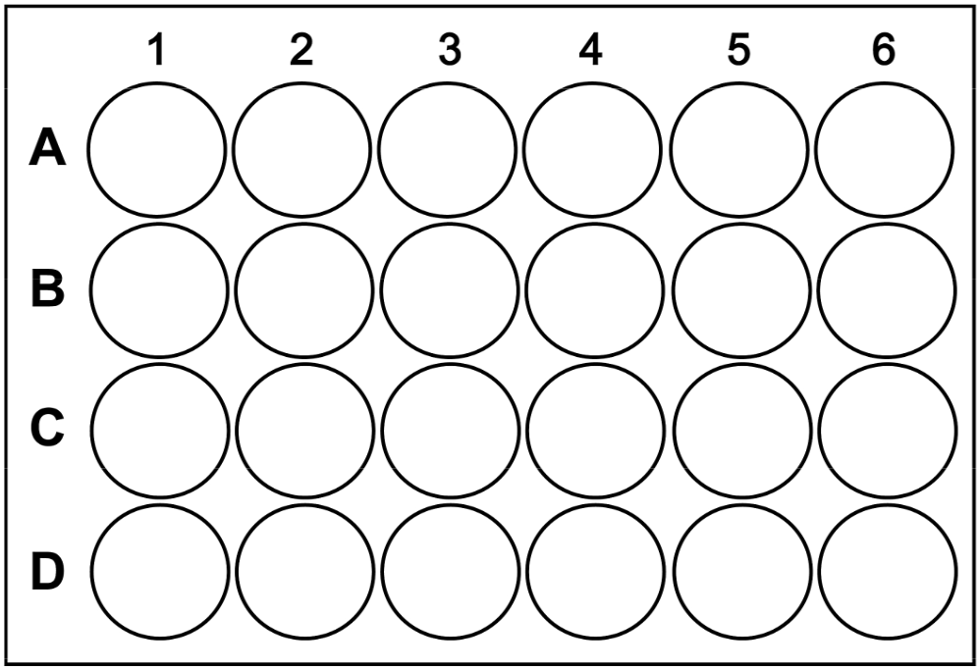 Figure 10. Plate layout for PRNT₅₀ analysis of neutralizing titers. Positive control (PC) is MVEV strain VRC-77 or OR156 without serum. Negative control (NC) is PBS. MVEV VLPs will plated in 1:20 or 1:40 dilutions.
MVEV G1-G2 1:40

MVEV G1-G2 1:40

MVEV G1-G2 1:40

MVEV G1-G2 1:20

MVEV G1-G2 1:20

MVEV G1-G2 1:20

MVEV G1 1:20

MVEV G2 1:20

MVEV G2 1:40

MVEV G2 1:40

MVEV G2 1:40

MVEV G2 1:20

MVEV G2 1:20

MVEV G1 1:40

MVEV G1 1:40

MVEV G1 1:40

MVEV G1 1:20

MVEV G1 1:20
NC
NC
NC
PC
PC
PC

Viral Challenge
Protective immunity will be assessed using viral challenge in BALB/c mice inoculated with either MVEV VLP or PBS. Groups of 8-week-old BALB/c mice will be immunized intramuscularly on day 0 and day 21. Immunized mice will be challenged against VR-77 and OR156 on day 35. Each group will be assessed for morbidity and mortality daily.

Expected Results
The expected outcome of the preliminary immunization studies is that the MVEV VLPs will elicit both high serum IgG titers, high neutralizing titers, and protective immunity in vivo. This outcome is indicative of an immune response necessary for protection against MVEV infection.
Previous MVEV VLP studies have found that high IgG concentrations might not be indicative of high neutralizing antibody titers. The inclusion of an adjuvant in vaccine formulations has previously been shown to overcome this drawback. In the event that neutralizing titers in this study are suboptimal, further assessment will be undertaken to assess whether inclusion of an adjuvant is able to boost the immunogenic response.

REFERENCES

Anderson S. 1954. Murray Valley encephalitis and Australian X disease. J Hyg (Lond). 52(4):447–468.
Australian Government Department of Health. 2013 Dec 3. Murray Valley Encephalitis Virus - National Guidelines for Public Health Units. [internet] [accessed 2019 Feb 20]. Available from: http://www.health.gov.au/internet/main/publishing.nsf/content/cdna-song-mvev.htm#summar
Boigard H, Alimova A, Martin GR, Katz A, Gottlieb P, Galarza JM. 2017. Zika virus-like particle (VLP) based vaccine. PLoS Negl Trop Dis. 11(5). doi:10.1371/journal.pntd.0005608. [accessed 2018 Sep 8]. https://www.ncbi.nlm.nih.gov/pmc/articles/PMC5436897/.
Centers for Disease Control and Prevention. 2018 Jul 27. Epidemiology of Vaccine Preventable Diseases - Hepatitis B. [Internet]. [accessed 2019 Feb 20]. Available from: https://www.cdc.gov/vaccines/pubs/pinkbook/hepb.html
Chroboczek J, Szurgot I, Szolajska E. 2014. Virus-like particles as vaccine. Acta Biochim Pol. 61(3/2014):531–539.
Cordova SP, Smith DW, Broom AK, Lindsay MD, Dowse GK, Beers MY. 2000. Murray Valley encephalitis in Western Australia in 2000, with evidence of southerly spread. Commun Dis Intell. 24(12):368–372.
Crill WD, Chang G-JJ. 2004. Localization and Characterization of Flavivirus Envelope Glycoprotein Cross-Reactive Epitopes. J Virol. 78(24):13975–13986. doi:10.1128/JVI.78.24.13975-13986.2004.
Floridis J, McGuinness SL, Kurucz N, Burrow JN, Baird R, Francis JR. 2018. Murray Valley Encephalitis Virus: An Ongoing Cause of Encephalitis in Australia’s North. Trop Med Infect Dis. 3(49). doi:10.3390/tropicalmed3020049.
Fuenmayor J, Gòdia F, Cervera L. 2017. Production of virus-like particles for vaccines. N Biotechnol. 39(Pt B). doi: 10.1016/j.nbt.2017.07.010.
Ho SH, Speldewinde P, Cook A. 2016. A Bayesian Belief Network for Murray Valley encephalitis virus risk assessment in Western Australia. Int J Health Geogr. 15(6). doi:https://doi.org/10.1186/s12942-016-0036-x.
Karch CP, Burkhard P. 2016. Vaccine Technologies: From Whole Organisms to Rationally Designed Protein Assemblies. Biochem Pharmacol. 120:1–14. doi:10.1016/j.bcp.2016.05.001.
Kroeger MA, McMinn PC. 2002. Murray Valley encephalitis virus recombinant subviral particles protect mice from lethal challenge with virulent wild-type virus. Arch Virol. 147(6):1155–1172. doi:10.1007/s00705-002-0809-3.
Lin H-H, Yip B-S, Huang L-M, Wu S-C. 2018. Zika virus structural biology and progress in vaccine development. Biotechnology Advances. 36(1):47–53. doi:10.1016/j.biotechadv.2017.09.004.
Lindsay MDA, Condon RJ, Broom AK, Plant AJ, Mackenzie JS, Wright AE. 2002. Epizootic activity of Murray Valley encephalitis virus in an aboriginal community in the southeast Kimberley region of Western Australia: results of cross-sectional and longitudinal serologic studies. The American Journal of Tropical Medicine and Hygiene. 67(3):319–323. doi:10.4269/ajtmh.2002.67.319.
Liu Y, Junmei Z, Yu Z, Fang D, Fu C, Xun Z, He Z, Yan H, Lifang J. 2014. Tetravalent recombinant dengue virus-like particles as potential vaccine candidates: immunological properties. BMC Microbiol. 14(233). doi:10.1186/s12866-014-0233-3.
Mackenzie J, Smith D, Broom A, R Bucens M. 1993. Australian encephalitis in Western Australia, 1978-1991. The Medical journal of Australia. 158:591–5.
McArthur M. 2017. Zika Virus: Recent Advances towards the Development of Vaccines and Therapeutics. Viruses. 9(6):143. doi:10.3390/v9060143.
Modis Y, Ogata S, Clements D, Harrison SC. 2004. Structure of the dengue virus envelope protein after membrane fusion. Nature. 427(6972):313–319. doi:10.1038/nature02165.
Naskalska A, Pyrć K. 2015. Virus Like Particles as Immunogens and Universal Nanocarriers. Polish Journal of Microbiology. 64(1):3–13.
Pulkkinen LIA, Butcher SJ, Anastasina M. 2018. Tick-Borne Encephalitis Virus: A Structural View. Viruses. 10(7). doi:10.3390/v10070350. [accessed 2019 Mar 24]. https://www.ncbi.nlm.nih.gov/pmc/articles/PMC6071267/.
Rice CM, Lenches EM, Eddy SR, Shin SJ, Sheets RL, Strauss JH. 1985. Nucleotide sequence of yellow fever virus: implications for flavivirus gene expression and evolution. Science. 229(4715):726–733.
Robinson LN, Tharakaraman K, Rowley KJ, Costa VV, Chan KR, Wong YH, Ong LC, Tan HC, Koch T, Cain D, et al. 2015. Structure-Guided Design of an Anti-dengue Antibody Directed to a Non-immunodominant Epitope. Cell. 162(3):493–504. doi:10.1016/j.cell.2015.06.057.
Russell JS, Caly L, Kostecki R, McGuinness SL, Carter G, Bulach D, Seemann T, Stinear TP, Baird R, Catton M, et al. 2018. The First Isolation and Whole Genome Sequencing of Murray Valley Encephalitis Virus from Cerebrospinal Fluid of a Patient with Encephalitis. Viruses. 10(6): 319. doi:10.3390/v10060319.
Selvey LA, Dailey L, Lindsay M, Armstrong P, Tobin S, Koehler AP, Markey PG, Smith DW. 2014. The changing epidemiology of Murray Valley encephalitis in Australia: the 2011 outbreak and a review of the literature. PLoS Negl Trop Dis. 8(1):e2656. doi:10.1371/journal.pntd.0002656.
Smit JM, Moesker B, Rodenhuis-Zybert I, Wilschut J. 2011. Flavivirus Cell Entry and Membrane Fusion. Viruses. 3(2):160–171. doi:10.3390/v3020160.
Snapgene. 2019. Plasmid Maps and Sequences. [Internet]. [accessed 2019 Feb 20]. Available from: https://www.snapgene.com/resources/plasmid-files/?set=ta_and_gc_cloning_vectors&plasmid=pcDNA3.4-TOPO_(linearized).
Swiss Institute of Bioinformatics. 2016. ViralZone Flavivirus. [Internet]. [accessed 2019 Mar 18]. Available from: https://viralzone.expasy.org/24?outline=all_by_species.
Stiasny K, Heinz FX. 2006. Flavivirus membrane fusion. Journal of General Virology. 87(10):2755–2766. doi:10.1099/vir.0.82210-0.
Ulmer JB, Valley U, Rappuoli R. 2006. Vaccine manufacturing: challenges and solutions. Nature Biotechnology. 24:1377.
Urakami A, Ngwe Tun MM, Moi ML, Sakurai A, Ishikawa M, Kuno S, Ueno R, Morita K, Akahata W. 2017. An Envelope-Modified Tetravalent Dengue Virus-Like-Particle Vaccine Has Implications for Flavivirus Vaccine Design. Pfeiffer JK, editor. Journal of Virology. 91(23). doi:10.1128/JVI.01181-17. [accessed 2018 Sep 8]. http://jvi.asm.org/lookup/doi/10.1128/JVI.01181-17.
Williams D, Diviney S, Corscadden K, Chua B, Mackenzie J. 2014. Complete genome sequences of the prototype isolates of genotypes 2, 3, and 4 of murray valley encephalitis virus. Genome Announcements. 2(3):e00581-14. doi:10.1128/genomeA.00581-14.
Williams DT, Diviney SM, Niazi A-R, Durr PA, Chua BH, Herring B, Pyke A, Doggett SL, Johansen CA, Mackenzie JS. 2015. The Molecular Epidemiology and Evolution of Murray Valley Encephalitis Virus: Recent Emergence of Distinct Sub-lineages of the Dominant Genotype 1. PLoS Negl Trop Dis. 9(11). doi:10.1371/journal.pntd.0004240. [accessed 2018 Nov 6]. https://www.ncbi.nlm.nih.gov/pmc/articles/PMC4657991/.
World Health Organization. 2019a. Human Papillomavirus. [internet] [accessed 2019 Feb 20]. Available from: http://www.who.int/biologicals/vaccines/human_papillomavirus_HPV/en/.
World Health Organization. 2019b. | Dengue Control. [internet] [accessed 2019 Mar 11]. Available from: https://www.who.int/denguecontrol/disease/en/.
Zhang X, Jia R, Shen H, Wang M, Yin Z, Cheng A. 2017. Structures and Functions of the Envelope Glycoprotein in Flavivirus Infections. Viruses. 9(11). doi:10.3390/v9110338. [accessed 2019 Mar 11]. https://www.ncbi.nlm.nih.gov/pmc/articles/PMC5707545/.

