Darrell Rushton
Associate Professor of Theatre
SAFD Certified Teacher of Stage Combat
SAFD Certified Theatrical Firearms Safety Instructor
Report on Sabbatical Leave
Spring, 2018

In the spring of 2018, I began the semester with only one sabbatical project in place, although it was a large one. West Virginia University had invited me to be a Faculty Guest Artist in Residence for their Spring Studio, teaching both graduate acting majors and undergraduate seniors. In addition, I was to act as the resident fight director for their April production of The Three Musketeers; with my colleague Jessica Morgan-Bishop acting as my Assistant Fight Director and Teaching Assistant. Soon after accepting, the Cumberland Theatre approached me to direct their season’s opening production of Sam Shepherd’s Fool for Love. And shortly after that, Dean Michael Hood, longtime friend, and Dean of the School of Arts at Indiana University of Pennsylvania asked me to fight direct his production of Twelfth Night. So, in short, my time off to relax and work on one project rapidly became a semester more full of projects than had I been teaching. In this report, I will only address the Sabbatical Project, as I will be applying all of the other activities to my next renewal as Professional Development.
From my proposal:
“The goal would be to train West Virginia University’s masters of Fine Arts (MFA) students in a studio classroom, where they could get certified by me in multiple weapons, as well as during the production, and the entire semester would culminate in a giant stage combat show and adjudication. The only possible way for me to achieve both would be to apply for a sabbatical in the spring of 2018, far enough off to plan, research, plan, work out logistics with two universities, and prepare for a creative project of this magnitude.”
Towards this end, I completed the following during my sabbatical:

The Three Musketeers:
- Extensively researched the style, period, history of the actual King’s Musketeers of 17th Century France.
  - (See attached Works Consulted)
- Extensively read and researched the literary The Three Musketeers, and related books and novels.
  - (See attached Works Consulted)
- Watched multiple movie and television adaptations of The Three Musketeers.
  - (See attached Works Consulted)
- Attended and contributed to all relevant production meetings, technical rehearsals, and rehearsals.
- Staged twelve different theatrical fights for West Virginia University’s production of The Three Musketeers.
- Led three rapier masterclasses for the entire cast of The Three Musketeers.
- Collaborated with Cornel Gabara (director) to cast the show and rehearsed, and collaborated with him extensively.

WVU Studio:
- Taught Unarmed Stage Combat and Rapier and Dagger to 18 students as Guest Artist in Residence from January through April.
- Coached all students in preparation for the Society of American Fight Directors Skills Proficiency Exam.
- Arranged travel and contracted with outside adjudicator Michael G. Chin, SAFD Fight Master.
- All students passed the Unarmed section. All students but three passed the Rapier and Dagger.

Appendix 1
Works Consulted

Angelo, Sydney, The Martial Arts of Renaissance Europe, Yale University Press, New Haven, 2000.

Bardic, Vladimir, Imperial Arms of the Thirty Years War (1) Infantry and Artillery, Osprey Publishing,
New York, 2009.

Bardic, Vladimir, Imperial Arms of the Thirty Years War (2) Calvary, Osprey Publishing,
New York, 2010.

Castle, Egerton, Schools and Masters of Fencing from the Middle Ages to the Eighteenth Century,
Dover Publications, New York, 2003.

Chartrand, Rene’, French Musketeer, 1622-1775, Osprey Publishing, New York, 2013.

Durdik, Jan, Firearms, a Collector’s Guide, Hamlyn, London, UK, 1981.

Grant, R. G., Battle: A Visual Journey through 500 Years of Conflict, DK Publishing Inc., New York, 2005
Pages142-154.

Grant, R. G., Warrior: A Visual History of the Fighting Man, DK Publishing Inc., New York, 2007
Pages 130-138.

Harding, David, Ed. Weapons: An International Encyclopedia from 5000 BC to 2000AD, The Diagram
Group, St Martin’s Press, New York, 1990.

Hobbs, William, Fight Direction for Stage and Screen, Heinemann, Reed Publishing, Hanover, NH, 1995.

Hutton, Alfred, Old Sword-Play, Techniques of the Great Masters, Dover Publications, Inc., New York,
2001.

Maund, Kari & Nanson, Phil, The Four Musketeers: The True Story of D’Artagnan, Porthos, Aramis &
Athos, Tempus Publishing Limited, Stroud, Gloucestershire, 2005.

Reiss, Tom, The Black Count, Glory, Revolution, Betrayal and the Real Count of Monte Cristo, Crown
Publishers, New York, 2012.

Roberts, Keith, Pike and Shot Tactics, 1590-1660, Osprey Publishing, New York, 2010.

Roberts, Keith, Matchlock Musketeer, 1588-1699, Osprey Publishing, New York, 2002.

The Three Musketeers, Director Stephen Hereck, Performances Charlie Sheen, Keifer Sutherland,
Chris O’Connell, Oliver Platt, Tim Curry, Rebecca DeMornay, 1993.

The Three Musketeers, Director Richard Lester, Performances Michael York, Oliver Reed, Christopher
Lee, 1973

The Four Musketeers, Director Richard Lester, Performances Michael York, Oliver Reed, Christopher
Lee, 1973

Appendix 2
Documentation:

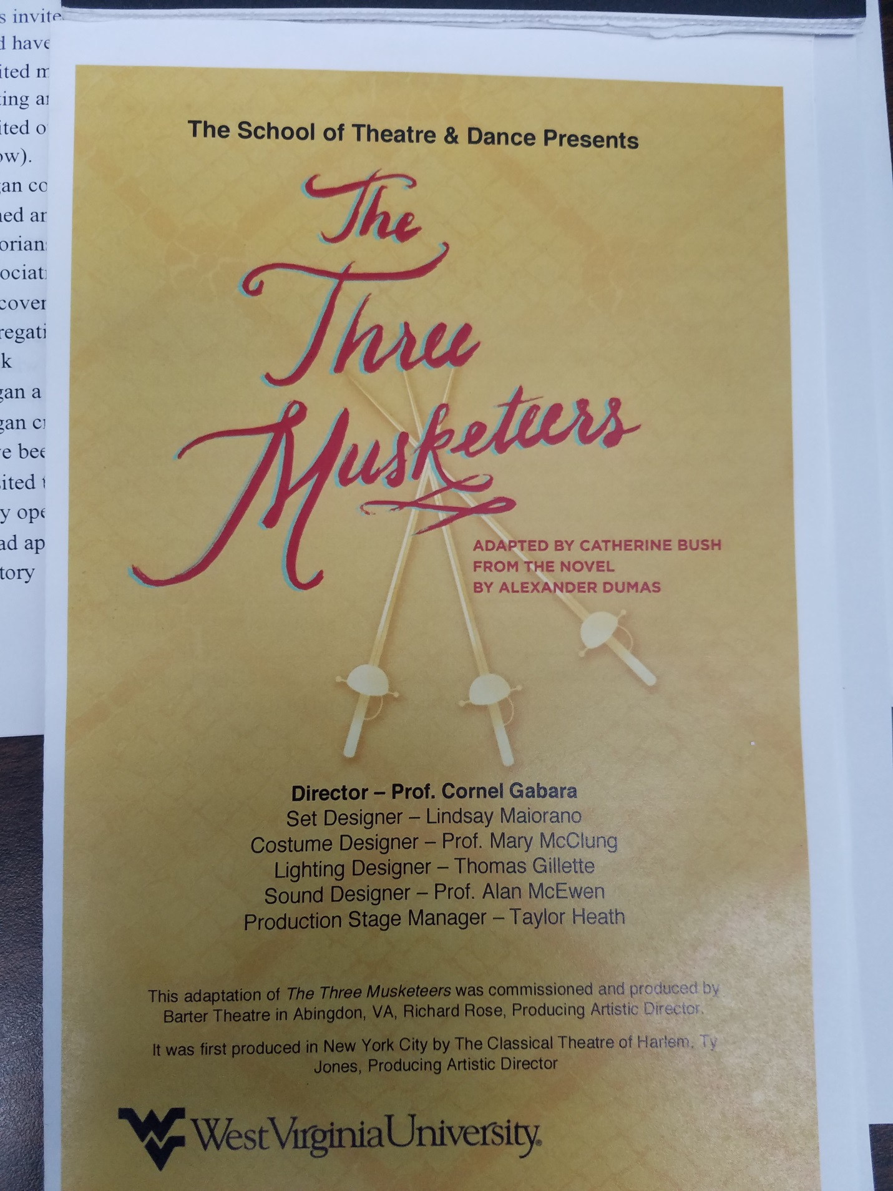
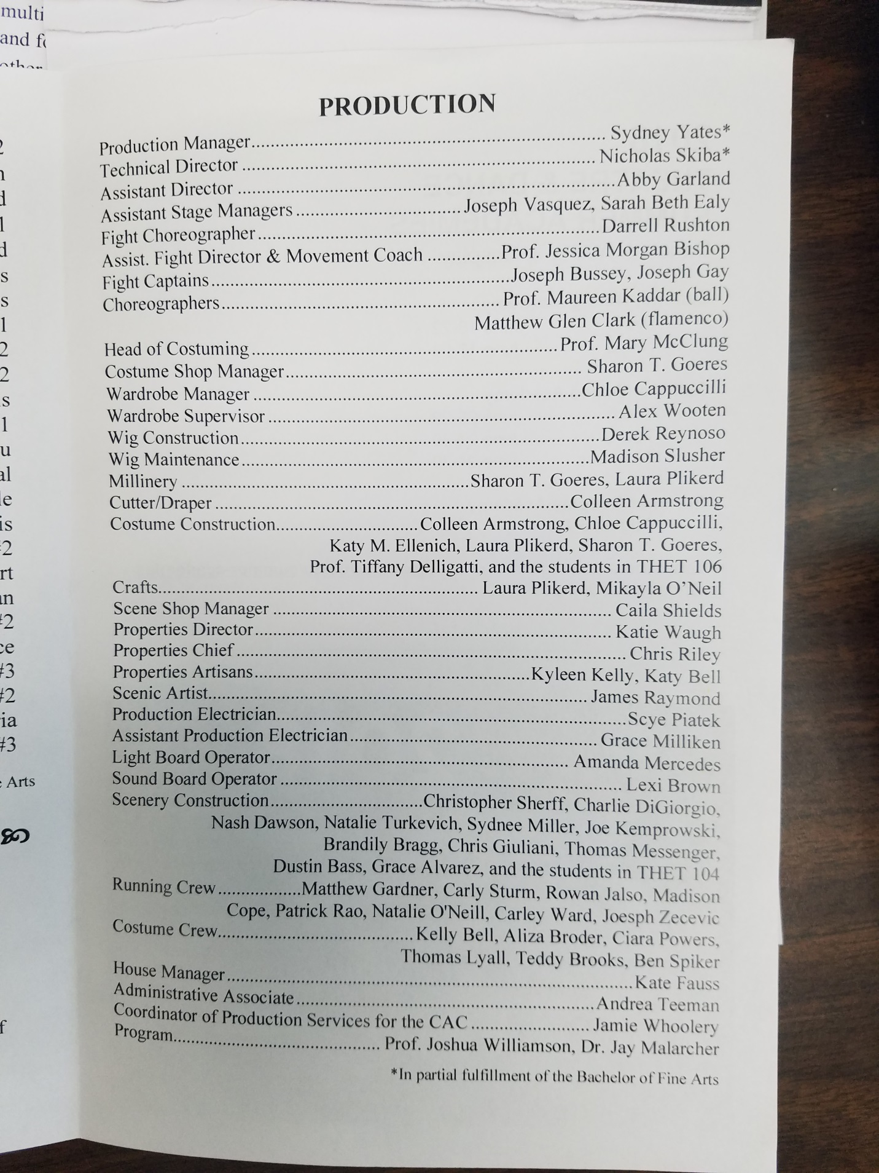

(Agreement between WVU and Darrell Rushton, Guest Artist)
Proposal for Darrell Rushton fight choreography for production of Three Musketeers and armed combat teaching in Studio Acting Program.

Production: $1,500 fee

- Meet on the three Mondays leading up to first rehearsal with cast, with the goal of beginning orienting them to weapons and working them in basic principles of the fighting and the style.
  - 1/22, 1/29, 2/5 – 6:30 to 8:30
- Participate in three rehearsals in first week in arrangement with the director (two of those three days will correspond with teaching days to minimize your travel time.)
  - 2/12 – 2/16
- Not required to rehearse 2/19 through 2/28 while you direct Fool for Love.
- Return to rehearsal 3/2
- Rehearse three days a week for the next 4 weeks (not counting spring break)
  - 3/5 to 4/10
  - No rehearsals through spring break 3/10 - 3/19.
- Show opens 4/13

Teaching: $3,000 fee

- Meet on Monday afternoons for 2 hours 1:00 to 3:00 with Grads and Seniors Combined for seven weeks (Certification in one weapon) 18 students total
  - 1/8 – 2/19
- Meet on Monday afternoons for 2 hours with Grads only (certification in second weapon) 8 students total
- Pick up an extra day here and there to make sure students accrue sufficient hours of training.

Jerry McGonigle, Head of MFA Acting Program, WVU
Jerry.McGonigle@mail.wvu.edu
(304) 293-6969
311A Creative Arts Center

