Supplementary Tables and Figures
Table S1. Improvement of lighting conditions in the 340 L-bioreactor and Nannochloropsis culture analysis during the second scale-up experiment.
 | No culture | Day 0 culture | Day 5 culture
Light intensity (μE m⁻² s⁻¹)
Near point | 680 | 320-350 | 320-350
Mid point | 450 | 80-100 | 40-55
Far point | N/D | 12-35 | 8-12
Temperature (ºC) | N/D | 22 | 25
pH | N/A | 9.0 | 10.0
Optical density at 750 nm (OD₇₅₀) | N/A | 0.69 | 1.84
Cell density  (x10⁶ cells/ml) | N/A | 26.6 | 47.2
N/D, not done.
N/A, not applicable.

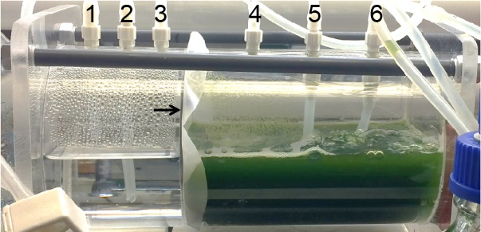
Figure S1. A close-up view of a horizontal culture chamber. The algae side (the right side) and the fluid side (the left side) of the culture chamber was separated by 1 μm polycarbonate membrane (black arrow). Different lines (1, media out; 2, water sampling; 3, air out; 4, air out; 5, air in; 6, media in and algae sampling) were set up with appropriate bottles. Lines 3 and 4 were connected to an air-venting bottle to prevent contaminations of the fluid side by the algae side.

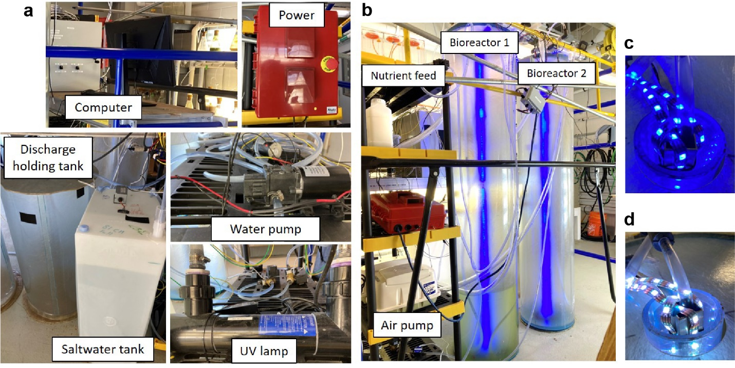
Figure S2. The 340 L-bioreactor system. Components in font view (a) and rear view (b) of the system are shown. LED lights housed in the center of the bioreactor are programed in blue channel (c) or white channel (d) to illuminate the bioreactors.

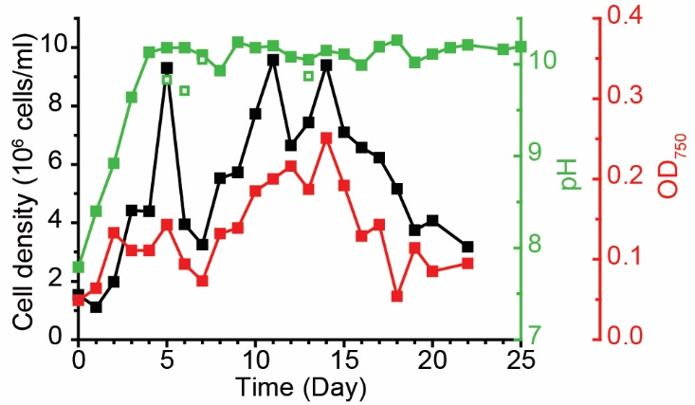
Figure S3. Growth indices of the Nannochlorpsis oceanica IMET1 in the second horizonal culture chamber experiment. The culture was grown in f/2 and 34 ppt salinity. Indices included cell density (10⁶ cells ml⁻², black), optical density (OD₇₅₀, red), pH on the algae side (open green square), and pH on the clear side (solid green square).

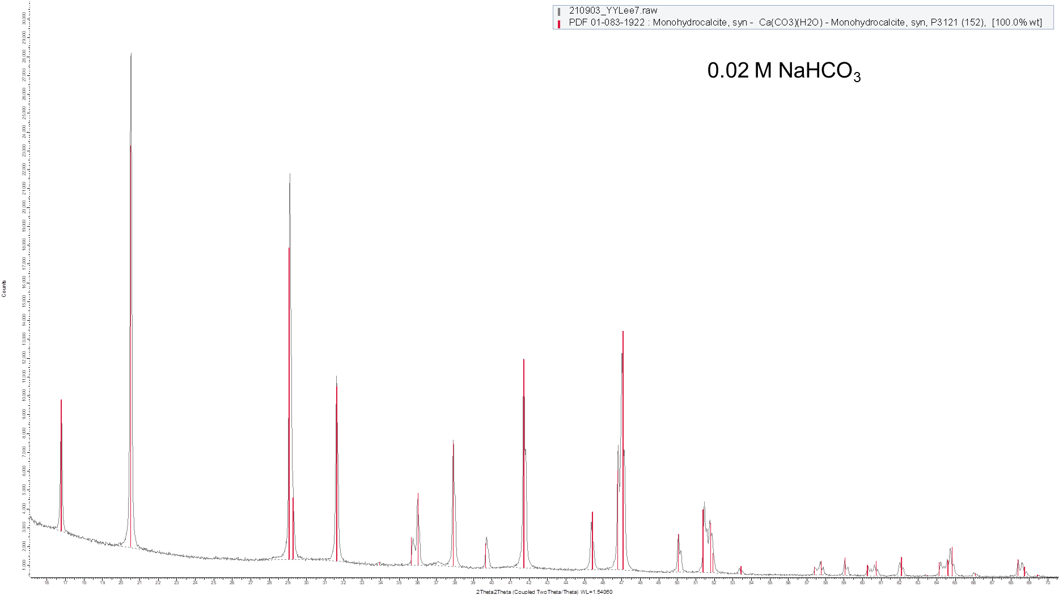
a
b
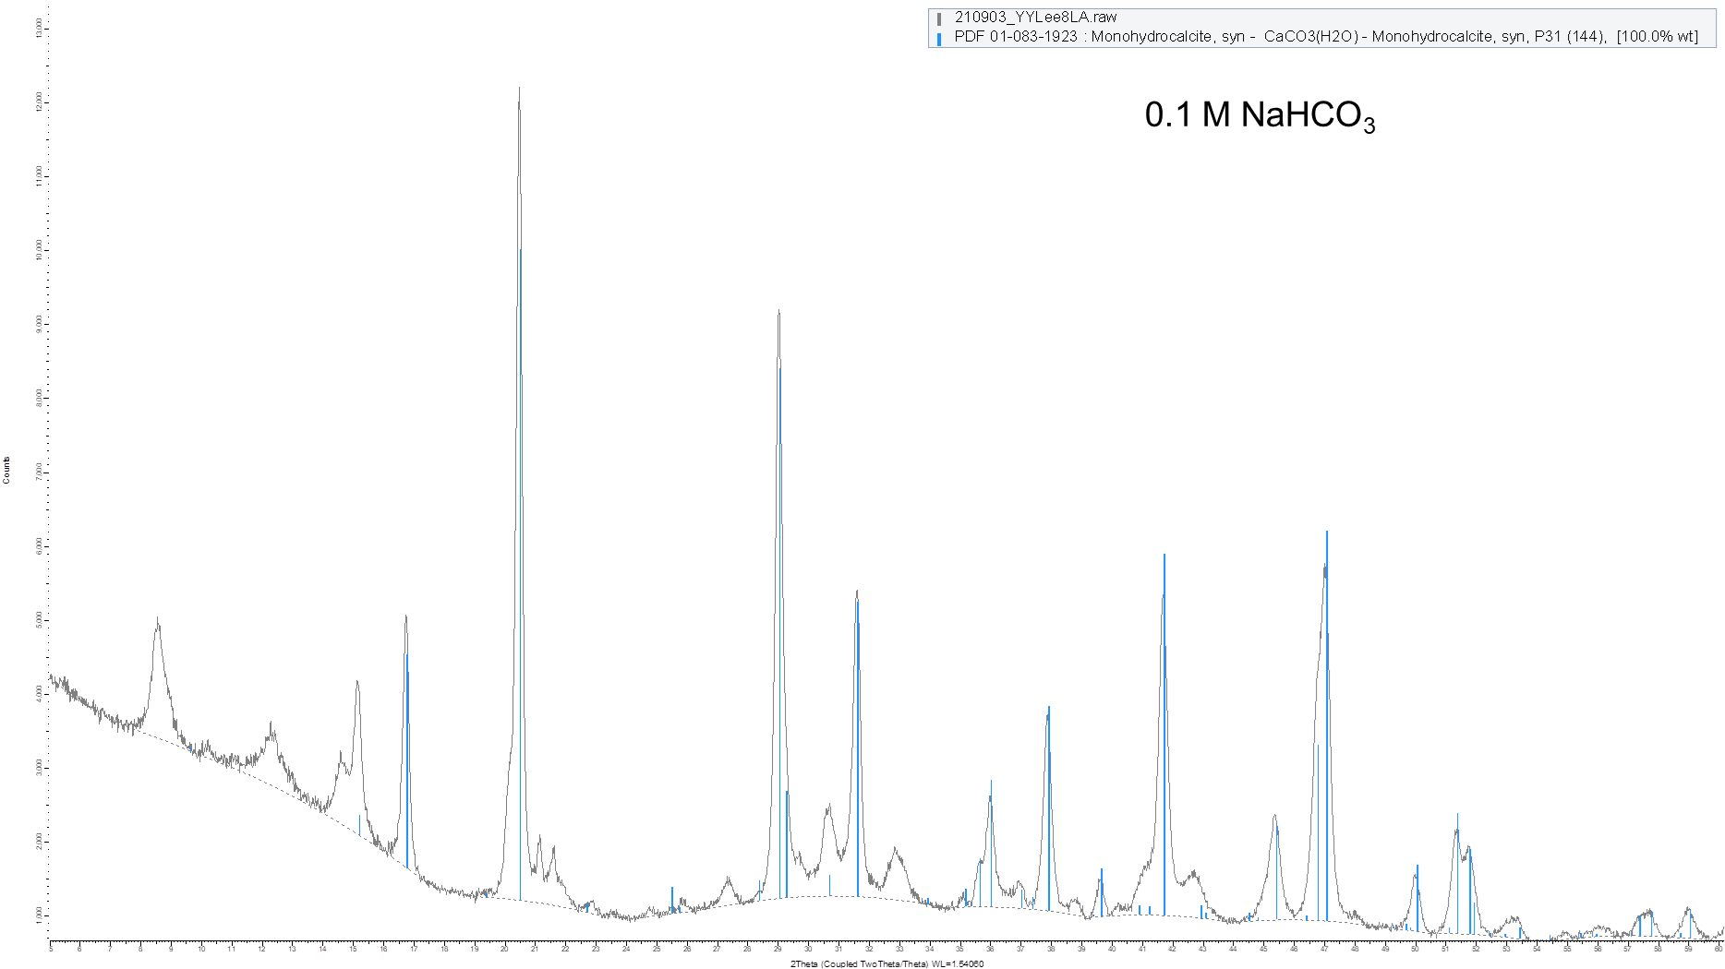
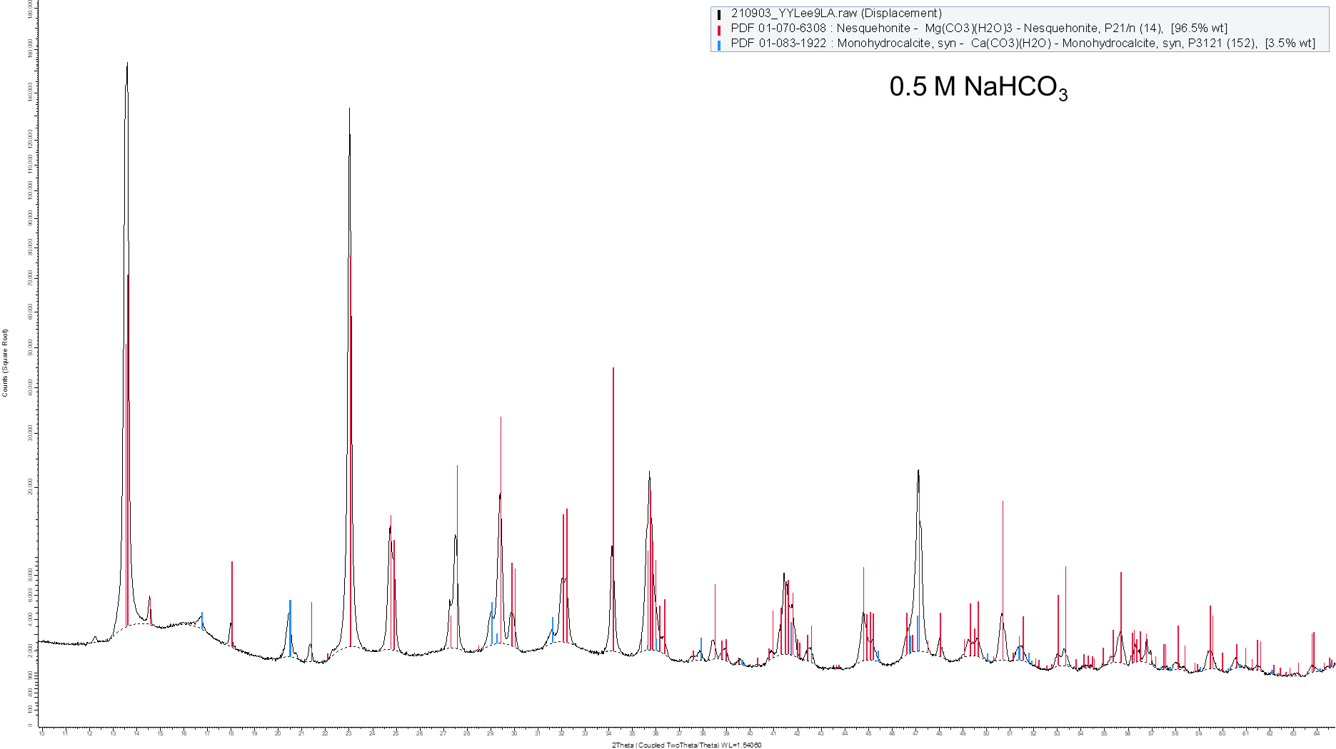
c
d
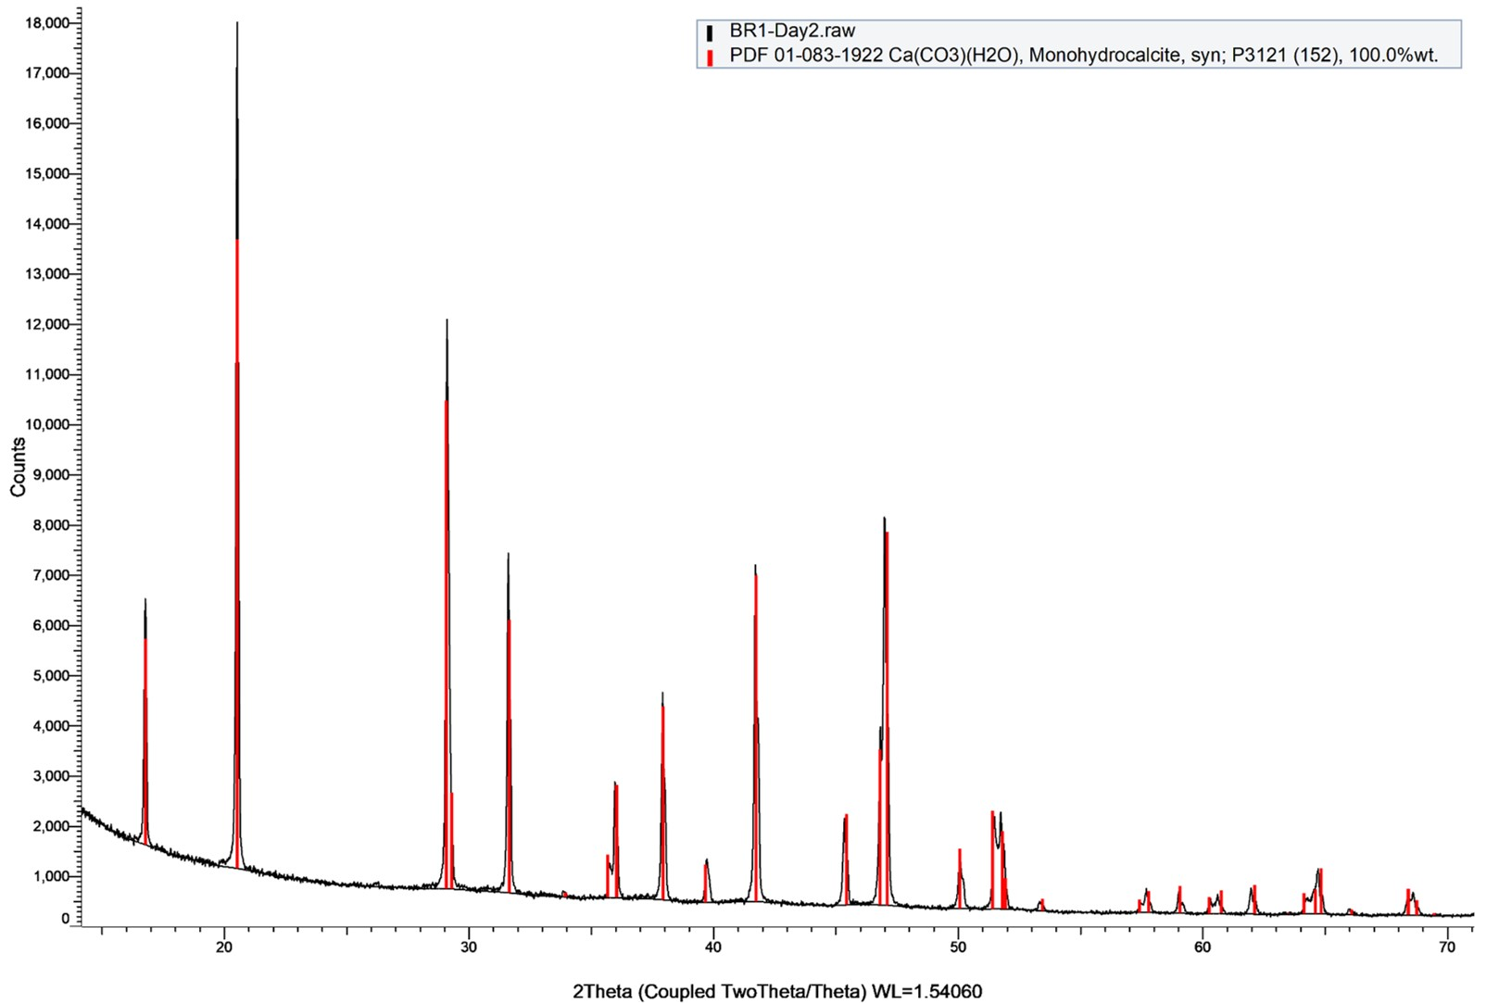
Figure S4. X-ray diffraction (XRD) analysis of the precipitates harvested from cultures supplemented with 0.02M (a), 0.1M (b) and 0.5M (c) sodium bicarbonate, respectively, and from the 340 L-bioreactor (d). The XRD spectrum of the crystalline (black) overlapped with the spectrum of monohydrocalcite or nesquehonite (red and blue).

Figure S5. Phylogenetic tree of partial 16S rRNA gene sequences associated with N. oceanica IMET1 microalgal cultures from the second bioreactor experiment. Sequences from this study are in bold. Nucleotide alignment was conducted with MUSCLE and curation with a built-in Gblocks utility. The tree was constructed using the maximum likelihood method and boot strap confidence values (expressed as percentages of 1000 replications) are shown at branch nodes. Branches with bootstrap values less than 50% were eliminated. TreeDyn and Adobe Illustrator were used for tree construction. A phylogenetic tree was created with Méthodes et algorithmes pour la bio informatique (MAB) [1, 2], alignment with MUSCLE [3], a curation by Gblocks which eliminates poorly aligned positions and divergent regions [4], PhyML for phylogeny [5, 6], and TreeDyn for tree rendering [7]. For confidence analysis, data was resampled using 1,000 bootstrap replicates.

Reference:
[1] A. Dereeper, S. Audic, J.-M. Claverie, G. Blanc, BLAST-EXPLORER helps you building datasets for phylogenetic analysis, BMC Evolutionary Biology 10(1) (2010) 8.
[2] A. Dereeper, V. Guignon, G. Blanc, S. Audic, S. Buffet, F. Chevenet, J.F. Dufayard, S. Guindon, V. Lefort, M. Lescot, J.M. Claverie, O. Gascuel, Phylogeny.fr: robust phylogenetic analysis for the non-specialist, Nucleic Acids Res 36(Web Server issue) (2008) W465-9.
[3] R.C. Edgar, MUSCLE: multiple sequence alignment with high accuracy and high throughput, Nucleic Acids Res 32(5) (2004) 1792-7.
[4] J. Castresana, Selection of Conserved Blocks from Multiple Alignments for Their Use in Phylogenetic Analysis, Molecular Biology and Evolution 17(4) (2000) 540-552.
[5] M. Anisimova, O. Gascuel, Approximate likelihood-ratio test for branches: A fast, accurate, and powerful alternative, Syst Biol 55(4) (2006) 539-52.
[6] S. Guindon, O. Gascuel, A simple, fast, and accurate algorithm to estimate large phylogenies by maximum likelihood, Syst Biol 52(5) (2003) 696-704.
[7] F. Chevenet, C. Brun, A.-L. Bañuls, B. Jacq, R. Christen, TreeDyn: towards dynamic graphics and annotations for analyses of trees, BMC Bioinformatics 7(1) (2006) 439.

