Crownsville Hospital Memorial Park:
Honoring the Past, Healing the Present, Imagining the Future

Sandra Neva Howard

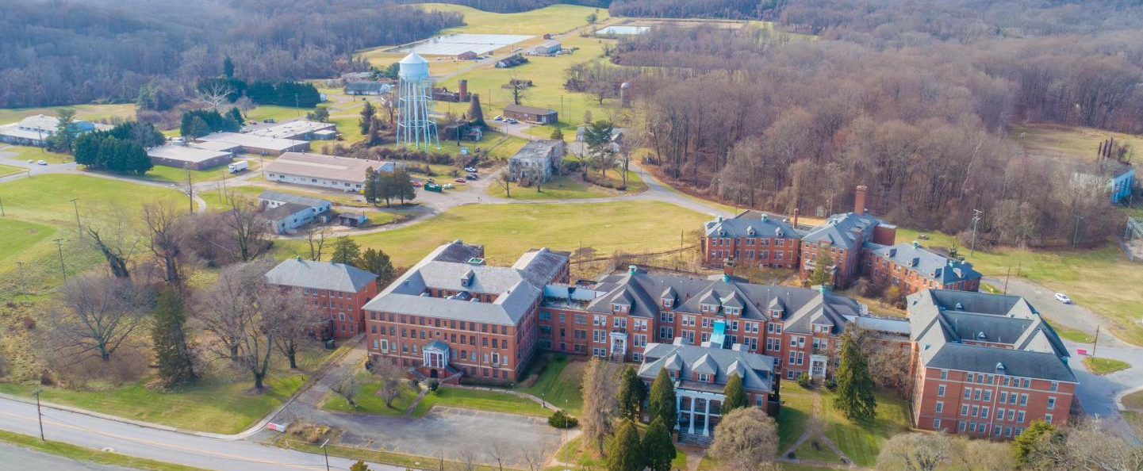
Photo Source: https://www.aacounty.org/CrownsvillePark

This report was created to satisfy the requirements for the Master of Arts in Cultural Sustainability degree at Goucher College. It was defended June 16, 2025 and submitted to Goucher July 2, 2025.

Capstone Committee:
Amy Millin, M.A., M.S.W., Advisor
Robert Forloney, M.A., Reader
Melanie Lytle, M.A.H.P., Reader

I thank whatever gods may be
For my unconquerable soul.

And

The Voices of Crownsville, including, Faye Belt, Janice Hayes-Williams, Antonia Hylton, Janssen Evelyn, Chanel Compton Johnson, Asha Smith, and Elinore Thompson.

Other Voices, including Lula Beatty, Jeremy Ellis and Michelle Anderson.

The Goucher MACS Faculty, including my Capstone Committee – Amy Millin, Robert Forloney, Melanie Lytle -- and Amy Skillman.

My Goucher Tribe, Stacie Cutback, Marianna Brown, and Cory France (whose expertise and generosity helped me solve many tech problems).

The extended Howard Family for their unflagging support – Bill, Darryl, Julie, and their families. A special thank you to Jessica Howard for her thoughtful comments.

Mom and Dad, your stories continue to inspire me. I go back to them and remember. Sankofa!

Neva, a Griot

Table of Contents
Overview 4
Methodology and Research Techniques 6
Themes 12
Systemic and Institutional Racism: An Overview 14
History and Public Memory 21
A Brief History of Crownsville Hospital, 1911 to 2004 23
Previous Development Plans 27
Background and Current Status of Crownsville 37
Crownsville Community Ethnography 39
People 42
Master Plan Development 44
Case Study: Dorothea Dix Park 55
Possible Future of Crownsville Hospital Memorial Park 65
Antonia’s Story 72
Old Places Matter: An Old Place Becomes a Community Asset 75
What Remains: Voices from the Hiawatha Asylum for Insane Indians 83
Africatown, Alabama: A Site of Memory and Justice 91
Challenges 105
The Full American Story 107
Equity and Social Justice in Crownsville 110
Justice Delayed: Tulsa, Oklahoma 117
Conclusion 119
CODA: Reflection 127
Bibliography 131

Crownsville Hospital Memorial Park:
Honoring the Past, Healing the Present, Imagining the Future

Overview

Description of Inquiry

This capstone thesis focuses on the efforts of Maryland’s Anne Arundel County to transform the former Hospital for the Negro Insane of Maryland, a former psychiatric hospital with a history of racial segregation and maltreatment of patients, into the Crownsville Hospital Memorial Park, a place of healing, education, and reparative justice, while honoring the lives of the people who lived and worked there. The County now owns the 565-acre site of the abandoned psychiatric hospital and its grounds. The County government undertook a civic planning process to develop a master plan for the site. This transition project is expected to be a multi-generational undertaking. Following several rounds of workshops, town halls and opportunities for the citizenry to comment, the County Executive released the Final Master Plan for Crownsville Hospital Memorial Plan on February 12, 2025.
I live in Anne Arundel County. I am witnessing and participating in the process of planning for the transformation of this site. Through qualitative research using scholarly literature and other sources, as well as ethnographic techniques, including participant observation and interviews, I will document this community’s place-making process, compare it with the work of other communities with historically controversial properties, and describe a path toward reconciliation that can be a model for other communities addressing similar challenges.

Rationale

This project advances my personal goals: continued scholarship in African American heritage studies; community awareness and participation; and encouraging efforts to achieve reparative spatial and social justice. I have lived in Maryland’s Anne Arundel County for more than thirty years; yet I feel that I have not fully embraced it as “home”. With this capstone project, I will come closer to doing so, by understanding a facet of its history and observing and participating in its movement forward toward social justice.
Participating in and documenting this project also draws on my skills as a strategic planner and policy analyst, applying them now in documenting placemaking and heritage preservation. Furthermore, in both my personal and academic life, I have explored and written about the concept of “home” – especially what it means to people like myself who have lived in various places throughout the United States, in other countries, or are descendants of migrating and immigrating peoples. I have lived in the Washington, D.C. area for over 40 years. Now, in my retirement, I am turning my attention away from the excitement and turmoil of the nation’s capital and toward Maryland’s capital and the African American heritage being sustained here. I participated in this process by serving on an ad-hoc subcommittee of the Crownsville Advisory Committee that developed an equity statement for the Master Plan.
My capstone thesis will make a significant contribution to the body of research and practice of cultural sustainability, as it explores the efforts of a community to transform a site with a legacy tainted by racism and abuse into a place of healing, education, and reparative justice. There are many such sites of contested histories in the United States, as well as places in other countries. Although their histories, cultures, and situations differ, communities can learn from each other’s efforts and develop their own paths toward reconciliation or transformation. Included in this paper are case studies of sites that either have sought or are seeking to make similar transitions. In addition to the case studies, there are examples of other spaces with difficult heritage in the text.
Civic planning projects deploy people from various professions – landscape architects, preservationists, historians, civil engineers, government planners, to name a few. Community members with various backgrounds and interests also observe and participate in civic projects. Although often unpaid, they can play important roles in the development projects, supporting them, or stopping them cold. There are always communities that have a geographical connection, a connection based on history or heritage, or a special interest in an aspect of a particular site. These parties will look for research materials, such as my paper on Crownsville, seeking to learn what other communities have done and not done with contested properties. My paper will be available for their review in a publicly accessible database.

Methodology and Research Techniques

My paper brings together issues of historic preservation, community development, cultural policy, public and personal memories, and social justice. Through research using scholarly literature and other sources, as well as ethnographic techniques, such as participant observation and interviews, I have documented Anne Arundel County’s placemaking, compared it with the work of other communities with controversial properties, and described a path toward reconciliation that can be a model for other communities addressing similar challenges.
This paper addresses the foundational question: How do we encourage cultural health and equity in a diverse and unequal world? (MACS 2018, 2) In response to this interrogative, I will examine the following issues:
- The community of Crownsville is just south of Annapolis, about 15 miles from my home. However, it differs from my part of the county in many ways. Ethnographic research is necessary to understand the demographics of the area now and in the past. Who lives in Crownsville now? How are the current residents of the Crownsville area connected to the site? How do they perceive they will be affected by the proposed memorial park? Who will benefit from the proposed development? Where are the descendants of those who lived or worked for the hospital? What stakes of history and culture do they maintain in the site? How were they affected by the hospital and its closure? How will their voices be centered in the county project?

- How can the “full American story” of Crownsville Hospital be told, its cultural relevance be sustained, and a path forward to reconciliation and healing be developed? What explicit and implicit policies govern this transformation?

- How have other communities honored memory at sites where there has been atrocities or other contested histories? Related efforts include other hospital conversions, and expansion of tourism in a town born from the illegal slave trade. Could these cases be drawn upon to inform the Crownsville effort? Could the Crownsville memorial serve as an exemplar for other communities with sites of trauma?

This exploration was accomplished through multiple methods, including background research, participant observation, interviews, case studies, and analysis.

Initiating the Capstone Project

To refine my project, develop a methodology for my research, and determine how it would fit in the body of writings on cultural sustainability, I consulted Michael Mason and Rory Turner’s 2020 paper, “Cultural Sustainability: A Framework for Relationships, Understanding and Action.” Mason and Turner present a definition for “cultural sustainability” and put forth a framework for its practice. Among the founders of the discipline, the authors’ intended audience is practitioners and students of folklore and related fields. They write, “Ideas from public folklore, applied ethnomusicology, reciprocal research, social justice folklore, performance theory, cultural policy, and sustainable development have all nourished the discourse around cultural sustainability” (Mason and Turner, 2020, 88). The discipline builds on their imprint -- long-term fieldwork, deep social relationships, knowledge generation and exchange, recognition of cultural diversity, exploration of material and non-material wellbeing, and the promotion of equity. In carrying out my fieldwork over a period of approximately eleven months, June 2024 – May 2025, I developed relationships that fostered my respect for the people I interacted with at town halls, interviewed, and served with on an ad hoc subcommittee on equity.

Preliminary Research

Background research was necessary to fully understand the past and current relationships between the former hospital and the Crownsville community. The history of Crownsville Hospital is well documented from its founding in 1911 to its closure in 2004. The most convenient way to begin information gathering was to start with the library guide maintained by Bowie State University. An online resource, it enables access to primary and secondary sources -- documents, articles, and images -- concerning the hospital’s establishment, operations, treatment of patients, and its closure. Current to 2014, it also links to State and County planning efforts after the hospital closed. Given the University’s connection to the hospital, this library guide is of historical value and cultural importance.
Information on the transfer of the Crownsville site from the State of Maryland to Anne Arundel County in 2022 and subsequent actions by the County are available on the Anne Arundel County website, which I consulted often. This is the site established and maintained by the County to support the Crownsville Advisory Committee and to document the County’s efforts to develop a master plan for the plot of land and buildings on the site. It provides both historic and current information, primarily official documents issued by the County, documents related to the master plan, past public presentations, and upcoming meetings. In my opinion, the process of developing the master plan was a very open one, given that official documents are on a public-facing website.
Although my project does not focus on the early history of the hospital, such information can be found in the Maryland State Archives. In addition, there are contemporaneous accounts in the popular media, including the Baltimore Sun, the Afro, and the Capital Gazette (previously called “Evening Capital and Maryland Gazette”). Antonia Hylton’s recent book, Madness: Race and Insanity in a Jim Crow Asylum draws upon archival resources, as well as accounts from former patients, staff, and their family members to tell the story of the hospital’s history. This book, published in 2024, has been a key resource for me. In researching her book, Hylton, a journalist, spent time in Crownsville and formed deep social relationships within the community. She still comes back. I went to an event for her on March 2025 and had an exchange with her. That conversation is discussed later in my paper.

Ethnography and Cultural Assets

To understand the community surrounding the site – past and present -- including demographics of the population, such as socio-economic status, race, ethnicity, age, and other statistical data, I gleaned information from the census and other sources. Both history and local color can be obtained from the Anne Arundel County Historical Society, the Anne Arundel County website, the City of Annapolis website, and county and state newspapers. I used these sources, as well as stakeholder interviews to produce an ethnography of the Crownsville community, including a description of its cultural assets.

Fieldwork

The sources above provided a sketch of the community. To gain a fuller picture, I spent time in Crownsville, interacting in various ways with people interested in the Crownsville Hospital Memorial Park project. I attended community meetings convened by the County’s Crownsville Advisory Committee, including a workshop in which the draft master plan was presented and subjected to community comments. I attended in person when that was an option; otherwise, by Zoom. I also joined the Advisory Committee’s Ad Hoc Subcommittee on Equity. Field notes from these meetings were helpful in describing the process for developing the master plan.

Interviews

I received a determination from Goucher’s Institutional Review Board that my proposed project was exempt from IRB review as my proposed project would not produce generalizable knowledge. Furthermore, the people I planned to talk to are all adults and not known to be vulnerable. They would be subject to no more than minimal risk.
I conducted eight semi-structured interviews with stakeholders about the proposed memorial park, intergenerational trauma, and heritage preservation. Over zoom, I interviewed:
- Michelle Anderson, Rural Director, Springboard for the Arts, Fergus Falls, Minnesota
- Lula Beatty, Psychologist, Former Director of the Special Populations Office at the National Institute on Drug Abuse
- Faye Belt, Licensed Practical Nurse, Faye’s Angel Network, and Former Crownsville Hospital employee and resident (non-patient)
- Jeremy Ellis, Clotilda descendant and Immediate Past President of the Clotilda Descendants Association
- Janssen Evelyn, Deputy Chief Administrative Officer, Anne Arundel County
- Asha Smith, Director, Office of Equity and Human Rights, Anne Arundel County
- Chanel Compton Johnson, Executive Director, Maryland Commission on African American History and Culture, member of the Crownsville Advisory Committee
- Elinore Thompson, Genealogist, Historian, Author, and Cemetery and Church Preservationist, Commissioner, Maryland Commission on African American History and Culture, member of the Crownsville Advisory Committee

In addition, I also had informal conversations with Janice Hayes-Williams about the Crownsville patient cemetery and with Antonia Hylton, the author of Madness, about Crownsville Hospital Memorial Park.
My questions to the interviewees were based on my knowledge of their roles and perspectives. With the consent of the interviewees, the sessions were conducted over Zoom, audio recorded in all cases, and video recorded (with two exceptions). Summaries of the meetings were produced by both Zoom and Otter AI. tools. While the A.I. summaries were useful for checking details like names and dates, I wrote my own summaries, largely based on my own handwritten notes and my recall. In addition, I wrote personal reflections on the interview. You will find some of these reflections in the summaries included herein.
As noted on the release form I developed and sent to participants, interview summaries will be part of the capstone documentation that will be archived in Maryland’s Shared Open Access Repository for Scholarship. Notes, recordings, and related materials will remain in my possession and stored in my personal archive. Digital recordings will be password-protected.

Case Studies and Examples

In addition to research on the Crownsville Project, I examined published papers on projects documenting the work of other communities that seek to reconcile the heritage of sites linked to controversial histories or events. These sites include other psychiatric hospital conversions and movements to preserve a Native American burial ground. Analysis of selected cases facilitated identification of possible outcomes that may apply to the Crownsville Memorial Park project or projects undertaken by other communities. Through research, ethnographic construction, participant observation, interviews, and analysis of case studies, I present paths that communities used to transform historic properties from sites of atrocities to places of healing. The ongoing work in Crownsville and other places could serve as models for other communities.

Themes

Throughout this paper, recurrent themes appear in literature reviews, interviews, case studies and my observations and reflections. Quests to achieve spatial justice – a term used to link social justice and injustice with physical space -- travel throughout this narrative. In Crownsville MD, Africatown AL, Canton SD, and Raleigh NC, and Tulsa OK, communities are trying to reconcile competing and complementary forces of memory, justice, and economic sustainability. Communities differ in their approaches to achieve these ends. In all cases, reconciliation is an ongoing process.
Another theme that recurs throughout this paper is the desire to honor in the placemaking process the voices of the living and the dead associated with spaces with difficult histories. In the cases I examined, there were living individuals who either had been affected by the place under consideration or were descendants of such people. These affected community members often led efforts to preserve the work and stories of people who lived, worked, and suffered in these spaces. They wish to change the narrative, from that of a people viewed as downtrodden, to one that honors the courage and sacrifice of those who persevered in the face of discrimination and abuse. The full American story of a place cannot be told without their voices and acknowledgement of their contributions. However, they are not the only stakeholders involved in these reconciliation efforts – current residents of these spaces, political leaders, the business communities, historians, and cultural workers – all have interests, both complementary and competing. These play out in different ways in the process of placemaking.
The people whose voices are heard during my interviews and those identified in case studies often have complicated feelings about a place that has been home to them or to their ancestors. As is the case with Crownsville Hospital, some community members lived and worked there remain acutely aware of the maltreatment that occurred there, yet their recollections are also tinged with pride and nostalgia about their time in that place, a home for them and for the patients. As may appear evident to readers, the concept of home and ancestry underlies my own quest to understand and participate in placemaking. I have lived in a lot of places but have yet to fully embrace the State of Maryland as home. My journey along the path of this project may lead me there.
The overarching theme of this paper is systemic and institutional racism, and the resulting consequences, historical and intergenerational trauma. An in-depth analysis of these forms of discrimination and subjugation are beyond the scope of my project. Actions perpetrated by these forces have been carried out in the past and are also carried out in the present. The trauma continues. I address the foundational question, “How do we encourage cultural health and equity in a diverse and unequal world?” The process of reconciliation must look forward to ensure that there will be an end to racism and its sequelae.
***

Systemic and Institutional Racism: An Overview

The central theme underlying this thesis is mitigation of the trauma caused by discrimination, particularly racism. In Crownsville and some of the other examples in this paper, people were subjected to multiple forms of discrimination, including sexism, and homophobia. It is not possible in this thesis to conduct a full exploration of racism in its various forms, or other types of discrimination, such as those faced by vulnerable people who have been designated mentally ill or disabled. Although racial discrimination is part of my lived experience -- being a person of mostly African descent in America -- my positionality is not that of an expert of academic caliber on this subject. For that perspective, I turned to others.

Definitions and Applicability

The terms “systemic racism” and “institutional racism” are often used interchangeably in popular literature and in common parlance. However, distinctions between the two concepts are worthy of note. The United Nations Human Rights Office of the High Commissioner makes available a paper from an “Out of Africa Monologue Series” in which was defined the terms “systemic racism” and “institutional racism”. This paper defines systemic racism as “an infrastructure of rulings, ordinances, or statutes promulgated by a sovereign government or authoritative entity, whereas such ordinances and statutes entitles one ethnic group in a society certain rights and privileges, while denying other groups in that society these same rights and privileges because of long-established cultural prejudice, religious prejudices, fears, myths, and Xenophobias held by the entitled group”( United Nations n.d.,1). In the United States, racism was upheld toward Americans of African descent by slavery, Jim Crow laws, de jure segregation, denial of voting rights and other civil rights. These mechanisms of oppression eventually were overturned here, although U.S. courts continue to hear cases related to the vestiges of systemic racism.
Institutional racism is still very much at work in this country. Page 2 of the “Out of Africa” paper, defines institutional racism as “racial attitudes found in an ethnic group’s traditions, beliefs, opinions, and myths that are firmly ingrained in the very fiber of the ethnic group’s cultural paradigm, where such traditions, beliefs, opinions, and myths have been practiced and sustained for so long, that they are accepted as common facts, understood to be normal behavioral practices whereas, such practices in effect marginalize, and demonize the human worth of another ethnic group” (United Nations, 2). Though institutional racism is found in institutions throughout the U.S., its presence in the medical system, particularly the history and practice of psychiatry, and the operation of the penal system are particularly relevant to my thesis.
For the purposes of this paper, it is important to understand the force and effects of systemic and institutional racism in perpetuating trauma across generations. This is the context for understanding how our society operates, and that interventions to combat racism must be made at levels that aim high, go deep, and are applied broadly. However, a deep dive into these issues is beyond the scope of this paper, as are the narrower concepts, “casual racism” and “individual racism”.

Historical and Intergenerational Trauma

The impacts of systemic and institutional racism are prevalent throughout American history and reverberate across generations. In January 2025, I heard a presentation on historical trauma given by Dr. Lula Beatty at a public hearing of the Maryland Lynching Truth and Reconciliation Commission (Commission). This was a hearing on historical events in Prince George’s County in which Black people had been lynched. Such hearings have been held in counties throughout the State to “research cases of racially motivated lynchings and hold public meetings and regional hearings where a lynching of an African American by a white mob has been documented” (Maryland Lynching Truth and Reconciliation Commission, n.d.). The Commission seeks to promote reconciliation. At this meeting, psychologist Beatty spoke in the absence of Dr. Gail Christopher, who had not been able to attend the meeting. (Her full presentation can be found at: https://www.youtube.com/watch?v=-ShUTvj0FA4 beginning at 3:22.00.) Some highlights of her talk, which included Christopher’s slides, with quotes from others in the field, are below:
- “’Historical Trauma’” refers to the legacy of psychological, physical, and social impacts stemming from a past collective trauma experienced by historically marginalized and oppressed communities over succeeding generations. (From O’Neill et al., 2018)
- “Race-based trauma is the psychological distress following exposure to a traumatic or stressful event based on one’s phenotype that is emotionally painful and uncontrollable. (From Carter, 2007)
- “This suffering is labeled as intergenerational trauma, historical trauma, and transgenerational trauma. . . defined as trauma transferred between generations as a result of exposure to adverse experiences affecting offspring through physiological and psychosocial transmission.” (From BraveHeart, 2003)

Beatty herself prefers to use the term “historical trauma” because she says that it identifies the root cause, not just the behaviors of those affected. She believes that there are two ways of healing from such trauma. 1) Upstream: fixing the system -- changing policies, laws, etc. to ameliorate and prevent historical trauma; and 2) Downstream: “fixing” individuals, families, communities through counseling, therapy, etc. She advocates for both approaches.
Some communities have sought reconciliation through applying a framework based on Dr. Christopher’s work with the W.K. Kellogg Foundation: “Truth, Racial Healing a Transformation” (TRHT)TM (Christopher, 2017). Christopher is a change agent who facilitates racial healing workshops. The Truth, Racial Healing, and Transformation described by Christopher in an article in National Civic Review is a “national truth and reconciliation process for the United States of America, its territories, and the sovereign nations of indigenous people within its borders. The TRHT, while informed by the well-recognized truth and reconciliation commission (TRC) model, is a unique process designed to reflect, embrace, and address the unprecedented diversity and unparalleled racialized history of the United States”(Christopher 2017, 12). TRTHTM is from an international model employed by South Africa and Canada, among others. TRTHTM emphasizes transformation rather than reconciliation. The author explains, “The goal of the TRHT is to change the way the people in America think about issues of racism by exposing and addressing the fallacy of the dominant belief and subsequent societal systems of racial hierarchy” (Christopher 2017, 14). In short, change the narrative that perpetuates beliefs about inferiorities based on race. Narrative change along with racial healing and relationship building are the two components of TRTHTM most relevant to my exploration of transformation of the Crownsville Hospital site.

Considering Sites of Historical Trauma

In my background research, I found two examples of papers on the subject of sites of historical trauma produced within the Goucher community. In 2014, Goucher College M.A. in Cultural Sustainability candidate Michele Anderson submitted her capstone, “Imaginative Fields: A Companion to Action” (Anderson 2014). Anderson wrote a case study of the Fergus Falls State Hospital in rural Minnesota. The facility at issue is a century-old, abandoned mental institution that closed in 2006 and was slated for destruction. Her paper explores the role of community participation in determining the fate of this property. In this case, artists, preservationists, mental health advocates, and activists worked together on an initiative called “Imagine Fergus Falls.” Funded by the National Endowment for the Arts “Our Town” program. Anderson uses a public narrative framework and cultural sustainability leadership theory to illuminate processes and potentials in this case study of a community exercising its cultural rights.
A few years earlier and further afield, Melanie Lytle wrote her Historic Preservation Master’s thesis, “A Fundamental Transformation: The Management of South Africa’s Heritage for Nation Building in the Post-Apartheid Era” (Lytle, 2011). Lytle’s thesis considers examples of South Africa’s heritage sector transformation. It offers a view of the use of heritage resources in rebuilding the nation after the end of apartheid against the backdrop of the country’s painful history. The author analyzed three sites: “Constitution Hill in Johannesburg, a notorious twentieth century former prison incorporated into the new Constitutional Court complex; Prestwich Place in Cape Town, a pre-1830s informal burial ground, the management of which has spurred contentious debates; and the Voortrekker Monument in Pretoria, an ostentatious symbol of the former regime built in 1949 that is struggling to maintain its relevance.”(Lytle, 2011, Abstract). In her conclusion, she puts forth recommendations for other sites in South Africa and other countries that are dealing with sites of atrocities and other places carrying painful heritage.
Reconciliation of sites of trauma and shame is a global issue; however, the United States has its unique history, as well as political and social dynamics. One paper specific to the U.S. is Barbara Little’s 2019 paper, “Violence, Silence and the Four Truths: Towards Healing in U.S.-American Historical Memory” (Little, 2019). This paper is the introduction to a volume entitled “Heritages Haunting the American Narrative”. The volume brings together writings about the changing nature of American historical memory. Included are essays about places and communities that “share, represent, contest, and claim memories of the past,” where the making and sustaining of memory is contested (Little 2019, 631). The unifying theme of the collection is the extent that political, social, and economic power determines whose history is told and whose history is silenced. Little describes these writings as “part of an important ongoing conversation among heritage workers concerning our role in negotiating these narratives, representing, or amplifying voices, and opening up access to the power embodied there. We seek to shed some light onto communities taking back control, asserting their own stakes in our iconic American stories, and demanding recognition and a seat at the table” (Little 2019, 631).
The four truths that Little introduces can be used as a paradigm to examine heritage work in the examples discussed in my paper. As the author notes, South Africa’s Truth and Reconciliation Commission identified this typology to better explain the complexity of truths they had to consider in their deliberations on reconciliation after Apartheid (Truth and Reconciliation 1998, 110-117). This typology is described below.
The first type of truth is factual or forensic truth. This category includes the provable facts of an event. For example, in Crownsville there are the remains of the psychiatric hospital. This is undeniable. Furthermore, there is evidence in the public records of what happened there, to whom it happened and for what purposes it happened. Still, these facts can be subject to interpretation. That is likely the case in the matter of the intent of those actions in Crownsville.
Secondly, there is the personal or narrative truth. This is the truth that we tell ourselves based on our personal experience. Later in my paper, a former staff member, Faye Belt, relates her personal truth about her time living and working at Crownsville Hospital. I found that even a personal truth told by one person can be multi-faceted.
When there exist personal truths of many different people, social truths take root. These narratives can complement or compete with each other, particularly when multiple different communities are narrators. There are a number of social truths -- folklore and myths even --surrounding the founding of Africatown, the subject of one of my case studies. I interviewed Jeremy Ellis, one of the descendants of the survivors of the Clotilda shipwreck that illegally brought enslaved people from Africa to Alabama. He told me that the narratives that had been passed down to him through oral traditions should not be called “stories”. He calls them “truths” (Ellis, 2025).
Finally, there are public or healing truths. Little explains that this type of truth emerges from the reconciliation process. Her intent in shepherding this volume is to integrate these concepts and advocate for working towards a reconciliatory process and healing truth. This is the path that Anne Arundel County is on in creating Crownsville Hospital Memorial Park.
***

History and Public Memory

History and Heritage Preservation
In his exploration of attachment between people and places, Thomas M. Mayes explains why old places matter (Mayes 2018). He offers 14 reasons, some overlapping, why people in general like old places, and why some old places matter. Mayes writes about old places in general, not specifically those of importance to specific racial or ethnic groups. However, many of his ideas support the argument that heritage sites are beneficial to the identity and well-being of people. Of particular relevance to racial heritage are the following attributes of old places identified by Mayes.
Old places can create a sense of continuity, particularly between generations. Old places, including those that recall pain, help us remember. Old places contribute to individual and collective identity, including national identity. Old places help us understand history. Old places can create a sense of the sacred. By redeployment of original materials, old places can contribute to sustainability. Old places sustain a connection to ancestors. Old places tell us about their past and about ourselves. Old places can foster a sense of community. Through preservation, old places can support the economy by producing jobs, improving property values, creating heritage tourism, and revitalizing urban areas. (Mayes 2018)
Ned Kaufman points out that historical sites, cultural sites, and sites of social value bring socially valuable stories to mind -- stories of history, tradition, and shared memory. He calls these “storyscapes”. He elaborates, “Stories live in people’s minds. But they also live in places: indeed specific places are often essential to their survival” (Kaufman 2009, 3). The stories may be latent, such as burial grounds recently rediscovered. In addition to anchoring individual life stories and fostering neighborhood identity, storyscapes preserve social capital (vs. financial capital). Social capital connects individuals with social networks and norms of reciprocity and trustworthiness that arise from them. These arise from clubs, churches, etc. Storyscapes also nurture cultural capital – by Kaufman’s definition, a relative of social capital, but not the same thing. Social capital includes traditions, lifeways, beliefs, and modes of thought and of expression. Intangible aspects of culture, such as cuisines, games, and singing styles, etc. are nurtured in storyscapes. These stories are also of value to the general public, as they can fill out or change their view of communities and events. They can also lead to policy changes. He calls them “lighthouses of historical awareness” (Kaufman 2009, 48). In particular, he cites the African Burial Grounds in Manhattan, the oldest and largest known excavated burial ground in North America for free and enslaved Africans. The treatment of this sacred space sheds light on the role slavery played in building New York. It also led to public policy changes in the way that New York City landmarks are handled. In Crownsville, the site of the former psychiatric hospital matters for many reasons, including it is a representation of man’s inhumanity to man, it is a testament to fictions about of race, a chronicle of the history of science and medicine and their application, and the story of people who persevered despite institutional racism and abuse.
***

A Brief History of Crownsville Hospital, 1911 to 2004

Perceptions of African Americans during the era of human enslavement and its aftermath directly led to the creation of psychiatric facilities specifically created to house Black people who were deemed unfit to live among White people. The public memory of these institutions has largely faded, but is brought to the forefront when properties built for these purposes are proposed for reuse or destruction. Such is the case of Crownsville Hospital.

Background
Originally named the Maryland Hospital for the Negro Insane, this facility operated from 1911 to 2004, albeit racially integrated in the 1960s. There is much documentation of the history and operation of the hospital, some of it contemporaneous with its operation – newspaper reports in the Baltimore Sun, the Afro, and local newspapers, including the Evening Capital, now known as the Capital Gazette. There is even a feature-length documentary released in 2018, “Crownsville Hospital: From Lunacy to Legacy“ (Stevens, 2018). It is available to stream on multiple platforms.
A detailed history of this hospital, as well as other psychiatric facilities in Maryland and other states is beyond the scope of this paper. However, it is necessary to review the past to understand the present and imagine the future of this space.
The physical remains of the hospital and grounds comprise more than 500 acres in Crownsville. Its buildings have deteriorated and its grounds are overrun by environmental processes. After failed attempts to develop the site, the state of Maryland deeded the property to Anne Arundel County in 2022. The county undertook a civic planning process that brings together community development, historic preservation, heritage acknowledgement, and social justice issues. The sources described below informed my understanding of the past, present, and possible future of the Crownsville site.
Since the evolving story of the Crownsville Hospital involves state and county actions and records, I relied on the website for Anne Arundel County Government (Anne Arundel County), specifically the Crownsville Park page. This is a site established and maintained by the County in support of the Crownsville Advisory Committee and its efforts to develop a master plan for the land and buildings acquired from the State of Maryland. The County webpage provides both historical and current information. It contains links to the following: executive order establishing the Advisory Committee; master plan schedule; past public presentations, such as workshops and town halls; meeting documents; maps; description of the property; memorandum of understanding with Bowie State University; ongoing activities; and future events. It also links to an open public survey collecting information for the Crownsville Hospital Oral History. The site is kept current, but only picks up the story of the property when it was purchased by Anne Arundel in 2022. This site is invaluable for gaining an understanding of the current status of the county’s efforts. The finalized Master Plan report, completed in February 2025 is now located on this site.
Historical documentation for years prior to 2022 can be found in the Maryland State Archives (limited access), by accessing the Bowie State library guide, which was discussed earlier in this paper.
When reviewing the history of Crownsville Hospital or any other facility that sought to provide mental health services in the late 19th century and early to mid-20th century, one should keep in mind the history of psychiatry and the state of the science of diagnosis and treatment of disorders thought to have originated in the brain. Such history is documented but is beyond the scope of this paper.
My interest in the Crownsville Hospital lies not in the details of the treatment of the patients, for which I feared I had no tolerance. Yet, I was able to sit through the documentary, “Crownsville Hospital, From Lunacy to Legacy.” In my opinion, the film was well-researched. It provides a history of the administration of the hospital, the living quarters of the patients, and their day-to-day existence. However, this film focuses more on the “Lunacy” than on the “Legacy”. Through interviews with former patients and staff, the treatment and the abuse of patients are detailed. The psychiatrists and other care providers are frank about the primitive nature of the treatments that were available to patients, many of whom were sequestered at Crownsville for reasons not thought of today as psychiatric illnesses. Rather, they were put out of their communities for legalistic or punitive reasons, and drugged and “warehoused”, as one interviewee described it. Doug Struck, a reporter for The Evening Capital, as the Annapolis-based local newspaper was formerly called, went undercover at the hospital in 1975. Under the pretense that he was suicidal, he recalled in his interview. His impression was that people were not treated or cared for. “It was a locked prison” (Stevens 2018, 1:11:32). Using chemical restraints and shackles, patients were drugged and forgotten. He said he saw no one receive therapy.
A recently published source capturing the history, horror, humanity, and hope of Crownsville Hospital is Madness: Race and Insanity in a Jim Crow Asylum (Hylton, 2024). Journalist Antonia Hylton traces the story of Crownsville Hospital from its inception in 1911 as the Maryland Hospital for the Negro Insane, through its phase as an integrated psychiatric facility known as the Crownsville State Hospital, and its closure in 2004. She gives voice to the stories of patients, families, and employees through this 93-year period. To do so, she conducted interviews and combed through state archives and published articles. It took her ten years to complete her research. Meticulously researched, it presents a compelling story of the people whose lives were affected by this facility, as well as the legacy of slavery and the relationship between systemic racism, the mental healthcare system, and the penal system (official and unofficial). Hylton takes a reflexive stance by including her own family’s history of mental trauma, which inspired her to write this story of systemic oppression in the guise of health care. For people looking to understand the current status of the Crownsville site and debates concerning its fate, this book will explain why things are the way they are. I met the author in March of 2025 at a book event at the University of Maryland. She maintains her connection to the Crownsville Memorial Park and the people who have been its champions.

Closure
Crownsville Hospital closed in 2004, the remaining patients dispersed to facilities in Baltimore and Sykesville. Some staff lamented the closure. Other people began imagining or planning for the future of the site. The “Crownsville Hospital” film, released in 2018, concludes with a vision of the future of the hospital site. However, the plan for a community service center at the property did not come to pass, nor did a later idea to build a stadium there for a minor league baseball team. Other ideas were considered, including some that came from graduate students at the University of Maryland. Although they may have been published only in archives for theses written by Maryland’s graduate students, I found their ideas to be relevant to the current civic planning in Crownsville.
***

Previous Development Plans

After the closing of the Crownsville Hospital in 2004, there were several efforts to repurpose the site, but they were not realized. These included the following (Tai, 2019).
- In 2005, a Maryland State Horse Park, an equestrian facility and museum, was proposed.

- In 2009, the Maryland Department of Health considered eleven bids for developing the site, settling on a developer that proposed a retirement community but dropped out of the project in 2010 because of financial difficulties.

- In 2017, the owner of the Chesapeake Bayhawks lacrosse team proposed construction of a 10,000-seat stadium, 6,000-seat amphitheater, 20 full length youth sports fields, and 2,4000 parking spaces.

Daniela Tai’s Thesis

Tai’s Vision

According to Tai, these plans failed for various reasons – concerns about the condition of buildings, including the presence of asbestos and lead-based paint were among them. (These conditions are still present today.) Daniela Tai recapped these development efforts in her 2019 Master’s thesis, “Seeking Asylum: Race, Memory, and the American Landscape” (Tai, 2019). In pursuit of dual degrees in architecture and historic preservation at the University of Maryland, her thesis explored the use of preservation, storytelling, and sustainable practices to respond to the challenge of reclaiming spaces linked to difficult histories. The focus of her work was Crownsville State Hospital. Of these aborted plans, she observed, “All of the aforementioned projects failed to address the heritage of the site beyond the physical fabric of the site” (Tai, 2019, 43).
I wanted to look carefully at her thesis because she used an approach similar to mine. Tai familiarized herself with the history of African Americans in the United States and in Maryland in particular. Framed around this history is the systemic and institutional racism of slavery, Jim Crow laws, segregation, as well as the theories of science and medicine regarding race and mental health prevalent in the centuries leading up to the 21st. In addition, she developed case studies of spaces with difficult histories that have been reimagined and transitioned and compared them to Crownsville. One is particularly relevant to my work – her case study of Walter Reed National Military Medical Center in Washington, D.C., which closed in 2011, and its continuing transition to “The Parks at Walter Reed.”
Tai describes the Walter Reed redevelopment plan as part of a larger D.C.-wide initiative to target underserved and underinvested areas through neighborhood revitalization and job creation. “After a lengthy community engagement process, a vision for the future use of the site was framed around the community goals of: neighborhood integration, mixed use programming, job and revenue creation, and site activation. After a century of being walled-off from the neighboring communities, the campus was reintegrated into the city fabric through the placement of strategic open spaces and extended circulation corridors” (Tai 2019, 62).
Although the Walter Reed property does not have the same kind of history of structural racism as does Crownsville Hospital, Walter Reed Hospital is associated with deaths and trauma related to war and combat. It even had a widely publicized scandal related to poor care, substandard housing, and mismanagement. Furthermore, suburban Crownsville is not Northwest Washington, D.C. Different spaces, different places. What they have in common is that both properties are economically valuable, and that planners implemented an intensive community engagement. For Crownsville, the cultural heritage should be seen as an asset of value.
“Time and again in the proposals that have been floated for Crownsville’s future development, the economic value of the land has taken precedence over its cultural and heritage value” (Tai, 43).

Tai thought, as do I, that the redemption of Crownsville Hospital could be a model for other communities dealing with spaces with difficult histories. The challenge, as she saw it in Crownsville, is that “The racial and systemic trauma experienced at the formerly racially segregated mental health facility permeated the campus grounds; not only does the community need to heal, the land does too” (Tai 2019, 1). This healing of the land is an important consideration that should be observed in planning efforts in Crownsville and other communities.
Tai’s research and case studies helped form her vision of the Crownsville site. She was concerned about the relationship between time and the built environment, as well as the legacy of the people associated with the site. She states, “Preservation of Crownsville’s built environment is integral to remembering the legacy of the people and practices associated with the historic campus” (Tai 2019, 71). In other words, some physical reminders of the hospital should remain at the site to help preserve memories over time.
Tai was also concerned about prioritizing the preservation of buildings over the memorialization of people. She cited the potential of “fetishizing the narrative of loss and trauma. A misaligned attempt at a design intervention could bring the hospital full circle in attracting morbidly curious visitors seeking a voyeuristic experience, similar to the crowds that peered through the gates of Kirkbride hospitals in the nineteenth century” (Tai 2019, 72). Crownsville has already had some of this kind of treatment. In 2007, “Crazy Eights,” a horror movie filmed in Crownsville, was released. As I understand it, the physicality of the site was included in the film, but the actual history of Crownsville Hospital is not the basis of the film.
When viewed through the lens of cultural sustainability, the following excerpts from her thesis are most relevant. (Note: Her thesis was written before the property was taken over by Anne Arundel County.)
- In her design proposal, she proposed that State agencies move into the buildings and that subsidized leases for community service providers and nonprofits be continued. Her vision was that the Maryland Historical Trust, the state institution responsible for the policies regarding the protection, identification, and recognition of Maryland’s historic properties, would occupy space at the site. “This symbolic move not only serves to acknowledge the State’s role in the history of the campus, it positions Maryland to be progressive stewards of how this history is framed and saved for future generations” (Tai 2019, 83).

- Tai believed that the land also must be healed. She suggested that the rest of the land be reserved for the creation of Crownsville State Heritage Park, which would transform the grounds into an open-air classroom centered on African American cultural heritage and sustainable practices. She also recommended nature trails with heritage markers to honor the first twelve patients transferred to Crownsville in 1911; heritage gardens to feature plants relevant to African American heritage and support educational activities; and a Memorial Hall that would tell the “full story” of Crownsville hospital.

- She, too, was concerned about linking the hospital site to the patient cemetery and proposed a pedestrian bridge between the two. She writes, “Whether the identities of patients were stripped away in the form of numeral demarcations on their grave markers, or with a literal black strip across their face in newspaper publications, it is important to remember that these patients are also people and each of them have a story worth preserving. . . . Memorial Hall will serve as a venue for tying these resonant themes together while inviting visitors to see the person beyond the diagnosis. . . . The building itself serves as literal threshold into the sacred cemetery ground”(Tai 2019, 92).

- Finally, a “Sunset Memorial” is in the shape of Sankofa, a symbol of the Akan people of Ghana, that means “Go Back and Find What Has Been Forgotten.”

Tai’s approach to making this space a place is based on her understanding not only of the systemic and institutional abuses that occurred in Crownsville, but also of her demonstrated respect for the individuals who lived and worked there and their heritage and stories. She stresses community engagement in the transformation of sites with difficult histories. I share her hope for the future of Crownsville Memorial Park: “By addressing the tangible, intangible and environmental elements of the past, Crownsville will serve as a model of preservation for the future” (Tai 2019, 103).
***

Matthew Reise’s Thesis

Daniela Tai’s paper was not the only Crownsville-related project produced by a University of Maryland graduate student. At the very tail end of my research quest, I learned of another, “From Harm to Hope: Reimagining an Abandoned Asylum as a Space of Reflection, Rejuvenation, and Rejoice.” It was written by Matthew Reise in fulfillment of the requirements for the Master of Landscape Architecture from the University of Maryland in 2023. Instead, I was able to access the paper in another digital archive, “DRUM: Digital Repository at the University of Maryland.”
The two papers are separated by four years. During that time, the scenario in Crownsville changed. The hospital site became County property in 2022, and the County Executive launched a major initiative for the site. Reise has the advantage of having Tai’s paper and lists it in his bibliography. Both authors were seeking advanced degrees in related, but different disciplines – Tai in architecture and historic preservation; Reise in landscape architecture. They accessed and included a common set of facts related to African American history and the story of the Crownsville State Hospital. They used similar methodologies for their research and analysis, including the use of case studies. Tai, however, placed a stronger emphasis on ownership and sharing of heritage and story. Reise recognized these aspects, but his focus seemed to be on using the natural landscape to promote spatial justice. Both approaches could have been or could still be implemented in Anne Arundel County’s project.
Reise tells us how he chose Crownsville as the subject of his Master’s work. He wrote, “The single thing that turned this project from a little idea into a full-blown thesis was one site visit. The sprawling 532-acre campus is, simply put, breathtaking” (Reise 2023, 31). The potential of the site was immediately evident.
Reise wrote three types of case studies: asylum studies, memorial studies, and village studies. One of his memorial studies is of Historic Fort Snelling at Bdote. This is a civil-war era military base in Minnesota at the intersection of the Minnesota and Mississippi rivers. A sacred space for the Dakota people, nearly 1700 Dakota people were held here in a concentration camp. Their leadership was killed and their culture attacked (Reise 2023, 27).
According to Reise, a local landscape architecture firm, TEN x TEN Studio, worked closely with indigenous communities to craft a dignified memorial space to occupy this holiest space. “By listening, hearing the community’s values, and investing time into this place, they gained a profound respect for the nature that is held here. They have crafted a design which encourages people to move through the landscape, appreciate its innate ecology, reflect on actions of the past, and help build a relationship with the land” (Reise 2023, 27). Reise considers the design introspective and reflective, prompting him to point out that there is no consensus on the design of memorials. “Historic injustice is processed differently by each individual – we all heal differently. Therefore, it might be best to consider a multi-dimensional approach to the healing landscape at Crownsville” (Reise 2023, 28).

Reise’s Vision

Reise describes a two-part vision of the future Crownsville site. The first step is for the history of the Crownsville Hospital to be recognized and the stories of those who were harmed to be told. A museum on the grounds would enable reflection on the past, celebration of the resilience of the Black and disabled communities, and inspire hope for the future. (Reise includes those with mental and physical disabilities among those treated unjustly at the hospital.) The museum would house artifacts, personal accounts, and historical data. A center for Black Heritage and Culture would also be created on the grounds for art, education, justice, and regional connection. The second part of his vision calls for space for vulnerable people, particularly those recovering from substance abuse disorders. He hopes that other “vulnerable” populations, including immigrants and those reentering the community following incarceration, could also find shelter in housing and services. He believes that people in transitional periods would benefit from the natural amenities of the site, as the woodland setting will promote recreation and reflection, decreasing stress.
One of Reise’s goals was to concentrate similar facilities. In his view, the current Crownsville site “is dotted with disjointed nonprofits, random semi-maintained sports fields, and has no coherent thread of usage. This incoherence creates a sense that the space is unimportant, and that people occupying the space are, through extension, less important. By concentrating spaces which serve similar purposes, the property becomes easily legible, accessible, and its purpose becomes clearer”(Reise 2023, 40). I did not hear a concern about a coherent thread of usage articulated at the town halls I attended in 2024-2025. However, participants supported services for a common set of individuals, including people in need of transitional housing and veterans.
Reise’s plan would create energy and vitality by attracting a variety of people – not just those seeking services or solace. Sports fields, community gardens, walking paths, restaurants, businesses, performances, and other spaces and functions can attract people in various situations. These ideas were echoed in later Crownsville town halls.
Reise notes that despite its proximity to larger population centers, including Annapolis, Crownsville is not easily reached, except by automobile. There are no forms of public transportation along Generals Highway, the main road in and out of Crownsville from I-97, and nothing close to the hospital site. He suggests a shuttle service between Annapolis and Crownsville as a start. Residents of Crownsville are car-dependent and expressed serious concerns about traffic volume.
Despite calling for greater access to what would have become the site of a grand memorial dedicated to educating the public about Crownsville Hospital, Reise states that his vision does not amount to constructing a tourist destination. Providing opportunities for recreation and reflection to the local community and to vulnerable populations is his primary intention.
Other suggested amenities that promote the hospital ground’s natural assets include an Eco-Retreat that can be used as an outdoor learning center, a Heritage Park, and Heritage Gardens. Reise proposes to “reclaim Black agricultural heritage” and preserve the landscape by creating a reference to the land’s historic usage (Reise 2023, 63). I have concerns about this idea, though the author may not have been able to fully articulate his proposal within the limits of a thesis. The usage he suggests has both proud and painful associations. While it is true that Crownsville and Maryland were generally rural and agricultural for centuries, Crownsville Hospital was built by the forced and unpaid labor of Black Americans. Crownsville Hospital maintained its self-sufficiency by exploiting its captive patient population through agricultural work, among other forms of labor. This should not be and cannot be forgotten. But neither should it be glorified. In the present, there is community support for productive use of the land. In several instances, area residents who spoke at recent public meetings recommended community gardens on the site. This is a tough issue to balance. I’m not sure who would be growing that willow and weaving those baskets that Reise cites as examples of Black agricultural heritage. His vision even suggests that a barn “would function as the epicenter of activity in the heritage garden” (Reise 2023, 64). This might be referential to plantation re-creation, which is not what the author intends. There are some aspects of culture, while historically true, are just not appropriate in the times in which we now live.
Nevertheless, Reise did offer something spectacular. There is a hill to climb to get to a monument that he would have had installed. It’s really a mound. This peak of the proposed monument rests on a tall hill, and at the summit, guests have a view over much of the Crownsville property. At the lowest elevation, would be Willow Landing – a space of reflection. See the image from his thesis below.
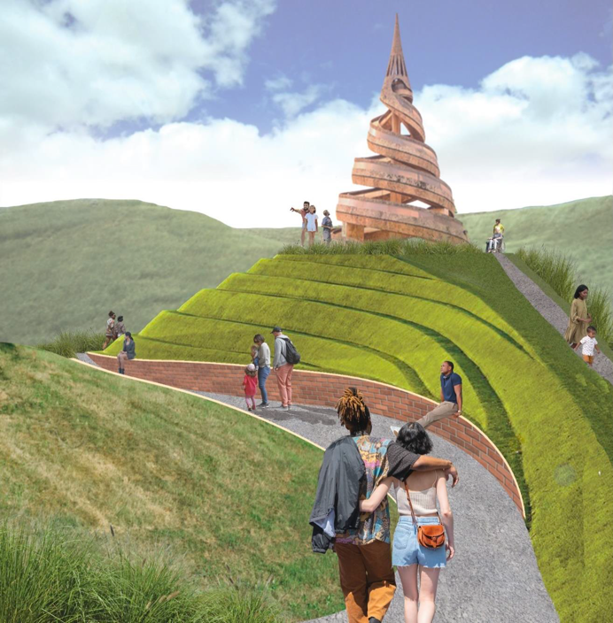

Photo Credit: Reise 2023, page 59, captioned: “Figure 42-View of the Memorial space, gathering area, and the Monument directly after leaving the museum. The location of the memorial space is represented in the top-left. It is in the property's northeast (author's work).”

In the architect’s words:
“The architectural style of both the mound and the central sculpture are intended to mimic traditional African and African-American forms pervasive through art and architecture. While mimicking the work of Charles Jencks, the terraced mound also is reminiscent of the terraced architectural structure of the National Museum of African American History and Culture in Washington DC. The museum itself took inspiration from traditional Nigerian sculpture. The central double-helix spiral sculpture which reaches to the heavens – and the intertwined spiral pathway design – also mimic a traditional African form. Found in different art media across west and central Africa, it was initially inspired by the Reunification Monument in Cameroon.” (Reise 2023, 60)

These features would not have been practical or accessible. They are a curious juxtaposition of the African American heritage and Afro-futurism -- a distraction from the central story, possibly -- a tourist attraction, definitely. The Crownsville team did not include such a feature in their plan. But it would have been spectacular.
I recognize that ideas presented in a thesis are usually not developed in concert with public processes that must occur in real-world implementation. These include funding, environmental remediation, and impact on neighboring communities, among other concerns that must be identified and managed in a civic project. Nevertheless, these two students saw the history and heritage of a space and dreamed of making it a place that honors and redeems—one that becomes a site of reconciliation and justice. Many in Anne Arundel County share that dream.
***

Background and Current Status of Crownsville

Crownsville is a census-designated place in Anne Arundel County, Maryland. It comprises a total area of 5.1 square miles, all land. However, waterfront communities such as Arden On The Severn and Herald Harbor have Crownsville addresses. Crownsville is approximately 7 miles from Annapolis, the state capital; 23 miles from Baltimore; 15 miles from the Bay Bridge, and about 15 miles from my house in Laurel, Maryland.
Data USA, a website that aims to make government data easier to sift through, provides geographic, demographic, and ethnographic information on communities across the country. Unless otherwise noted, this is the source of the statistics below. Much of this information comes from the U.S. Census Data (Data USA: Crownsville, MD, n.d.).
For Crownsville in 2023, this source reports that this census area had a population of approximately 1,700 people, with a median age of 54.5 and a median household income of $146,486. The Crownsville area is primarily White, and relatively wealthy.
The five largest racial and ethnic groups in Crownsville, MD are:
- White (Non-Hispanic) (91.1%),
- Two+ (Hispanic) (5.7%),
- Black or African American (Non-Hispanic) (0.705%),
- Two+ (Non-Hispanic) (2.35%), and
- White (Hispanic) (0.175%).
None of the households in Crownsville, MD reported speaking a non-English language at home as their primary shared language. 100% of the residents in Crownsville are U.S. citizens. In addition to being less diverse, based on my observations while in Crownsville, it is more politically conservative than Annapolis and parts of the County closer to Baltimore and Washington, D.C., including Maryland City (another name for the area I live in).
In 2023, the median property value in Crownsville was $885,600 and the homeownership rate was 100%. 67.2% of homeowners have mortgages. There are approximately 500 households.
People in Crownsville tend to work close to home and travel to work in cars. Most people in Crownsville drove alone to work and the average commute time was 21.6 minutes. The average car ownership was three cars per household. In public meetings I attended, including those pertaining to the Memorial Park project, residents expressed concerns about traffic in and around the community, both as a current phenomenon and in anticipation of new construction and a tourist attraction.
The economy of Crownsville currently employs about 652 people. The largest industries are retail trade, arts, entertainment, recreation, and construction. However, Crownsville is just outside of Annapolis and within the Baltimore-Washington, D.C. corridor, which have large, robust economies that draw workers from and to the Crownsville area. However, the data above for commuting and travel indicates that many Crownsville residents do not work very far from home.
Only 8.5% of the population for whom poverty status is determined live below the poverty line. That works out to 143 people. This is lower than the national average of 12.4%. 98.5% of the population has health coverage. 45% are on employee plans, 8.7% are on Medicaid, 17.3% on Medicare, 16.6% on non-group plans, and 10.5% on military or Veterans Affairs plans. Military veterans, particularly those who served in the Vietnam area, are represented in the area. The U.S. Naval Academy is in Annapolis, and Fort Meade is also nearby.

Crownsville Community Ethnography

Cultural Assets

This part of the Crownsville ethnography is a description of the cultural assets of the area, by which I mean the tangible and intangible features of a community that comprise its identity, character, and customs. Features salient to my study include the physical environment and structures; cultural heritage sites and organizations; art and music and their related organizations. Oral histories, memories, and stories, as well as those who bear them are also cultural assets.
Tom Borrup, a planner, educator, and nonprofit arts leader, wrote a book to help people understand such assets, The Creative Community Builder’s Handbook: How to Transform Communities Using Local Assets, Art and Culture (Borrup, 2006). The subtitle of Borrup’s book speaks to transformation of communities using local cultural assets. Although the Crownsville Hospital project does not seek to transform the Crownsville community as a whole, the Memorial Park can be a driver of economic development, affecting the surrounding areas, particularly Annapolis. Furthermore, its civic engagement process identified the community’s strong desire for the Memorial Park to focus on the arts and humanities, as well as history and heritage. The development and placement of arts and humanities projects within the Memorial Park will generate additional cultural assets that can benefit residents and visitors.

History, Preservation, and Culture

Key cultural assets in Crownsville include the Maryland Historical Trust. This agency’s resources include information recorded in the Maryland Inventory of Historic Properties and the National Register of Historic Places. The Trust also houses collections of oral histories related to African American Communities in nearby counties, which may be relevant to Crownsville and the Annapolis area. Although a Historical Trust entity is not usually considered a cultural asset, its proximity to the Hospital Site – about a half mile away – contributes to the historical landscape. Daniela Tai suggested that this State agency be moved to the Hospital site (Tai 2019, 83).

Natural Environment

Anne Arundel County has abundant water resources, though Crownsville itself is land locked. Nevertheless, there are significant natural resources. In particular, the Bacon Ridge Natural Area is a beloved community resource. The Scenic Rivers Land Trust describes the Bacon Ridge Natural Area as a “true natural gem”(Scenic Rivers, n.d.). The area includes over 900 acres containing marshes, mature forests, and at the center, a creek -- Bacon Ridge Branch. Bacon Ridge Natural Area is owned by Anne Arundel County and managed by the County’s Department of Recreation and Parks. Since 2010, 630 acres are protected by a conservation easement held by Scenic Rivers and the Maryland Environmental Trust to preserve the natural features of the land (Scenic Rivers, n.d.). The terms of the easement allow for the land to be open to the public as a park for passive recreation, primarily hiking and nature study. An annual “Walk for the Woods” is held in the spring. The Bacon Ridge Natural Area Stewardship Committee makes recommendations to the County on how the parkland is managed.
According to the Scenic Rivers site, the Bacon Ridge Natural Area is both ecologically and historically significant. “Local folklore claims that the creek that runs through the heart of the natural area is named Bacon Ridge Branch because there was a hog farm in the center of the natural area over a century ago” (Scenic Rivers, n.d.). At that time most of Anne Arundel County was farmland.
Portions of the Bacon Ridge Natural Area were once part of the Crownsville Hospital property and still neighbors the site. The hospital cemetery is on the grounds of the natural area with over 1,800 patient graves. The cemetery has a supporting “Friends” group that holds a “Say My Name” ceremony every year. At the town halls I attended, speakers, including the County Executive, expressed their concern and support for Bacon Ridge and the natural environment. Janssen Evelyn, the County’s Deputy Chief Administrative Officer, told me in a recorded interview that one of the two most highly ranked priorities for the Memorial Park, as voiced by public commenters, was, “Make the site a nature park, expand it into the woodlands” (Evelyn 2025).
Bacon Ridge also references other cultural features. “Bacon Ridge includes the remains of the Charles S. Waters Mill. The mill race and many foundations are still visible. The County’s Cultural Resources Division has documented 16 discrete archaeological sites with intact evidence of prehistoric or Native American campsites, 18th, 19th, and 20th century structural foundations, and artifact scatters within Bacon Ridge” (Scenic Rivers, n.d.).

Fairgrounds and Renaissance Festival
Within Crownsville, there are two large public gathering spots. The Anne Arundel County Fairgrounds hosts a mix of events of the types one might expect to see at a county fair in the U.S. – music festivals, rodeos, tractor pulls, monster truck tours, gun and knife shows, as well as cultural celebrations such as the Irish Festival, Juneteenth Festival, and the Halal Food Festival. The most well-known and highly attended event in Crownsville is the Renaissance Festival. When it opens again in August 2025, it will be the 49th Maryland Renaissance Festival. It runs for nine weekends – through October. As noted on the website, it replicates an English Tudor village, taking up 27 acres. It hosts craft shops and food outlets. Over 1,000 workers and entertainers will be at the venue. There are eight major theaters, four smaller stages in taverns, a children's area, and a jousting tiltyard with seating for 3,000. (Maryland Renaissance Festival, n.d.) The traffic during festival time is noteworthy. The community puts up with it during this limited time, but the crowds must be planned for if another attraction is to be close by.

People
People are the most valuable cultural resource in a community. This includes their singular efforts, as well as efforts they undertake as part of organizations. In Crownsville, the public engagement for the Crownsville Hospital Memorial Park included participation in town halls, advisory committees, and other collective activities. Representatives of organizations, such as Crownsville Caretakers United, Friends of the Crownsville Patient Cemetery, and the American Descendants of Slavery, are playing roles in shaping the Crownsville project. In addition to providing guidance on culture and heritage, they can also be political forces.
On March 31, 2025, I interviewed Chanel Compton Johnson, the Executive Director of the Maryland Commission on African American History and Culture over Zoom. She serves on the Crownsville Hospital Memorial Park Advisory Committee, including the Subcommittee on History and Culture. In her capacity at the Commission, she directs the Banneker-Douglass-Tubman Museum. She gave me useful advice on capturing “the beauty” of the Crownsville Hospital story. Chanel advised me to focus on the roles of various community members, government officials, and historians. She described multiple layers of community involvement. She also urged me to talk to “power people” such as Historian Janice Hayes-Williams, Vince Moulden, the Director of the County’s Office of Community Engagement and Constituent Service, and the County Executive, himself. “Shoot High” she advised me. “Policy is one thing, but how it is interpreted is another” (Compton Johnson 2025).
My Reflection: Throughout the interview, Chanel spoke of various people who have been building the foundation for this community project. She spoke in a powerful and prideful voice about the “love and labor” of Black women who have been working in Crownsville/Annapolis for decades and their role in building public awareness. This particularly includes Janice Hayes-Williams. Chanel asked me to consider how Janice navigated the power dynamics in Anne Arundel County to push the Memorial Park project forward. She said that this is “righteous” work that takes a lot of energy. This level of involvement and commitment of people moving the Crownsville Memorial Park project makes them the most valuable cultural resource. The efforts and the voices of the various stakeholders is shaping this project.
***

Master Plan Development

As discussed previously, there were several attempts by State and County leadership to develop the site of the former Crownsville Hospital after it closed in 2004. In 2018, Steuart Pittman, Jr. was elected County Executive. According to his biography on the County webpage, he is a native of Davidsonville, an unincorporated community in Anne Arundel County, where he was raised on a family farm. A graduate of the University of Chicago, he worked as a community organizer in Chicago and Des Moines. In that role, he built neighborhood organizations, confronted environmental hazards, and attracted private investment to blighted communities. When Pittman came back to Anne Arundel County, he worked on low-income housing. He also started his own business as a farmer and horse trainer. He is famous in the horse industry for creating the Retired Racehorse Project, an award-winning national nonprofit that is responsible for transitioning thousands of racehorses into second careers (Anne Arundel County Government n.d.)
Pittman, a Democrat, claims to be both conservative and progressive. The website further informs that the Executive has pledged to make Anne Arundel County “The Best Place - For All,” by “Putting Communities First.” “His strategy is to engage communities from every sector and to practice transparency and data-driven policymaking” (aacounty.org, n.d.). He was reelected in 2022. Term-limited, he will be stepping down in 2026. I have seen no announcement of his future plans.
Based on his public profile, I can see why he was drawn to the Crownsville property and made it a priority for County development. His December 5, 2022 inauguration took place at the Crownsville Hospital site. At that time, he said, "Today, in this place, we launch Crownsville Hospital Memorial Park, and its campus for the community-based nonprofit organizations that so effectively deliver behavioral health services, food assistance, job training, and anything and everything that promotes the social determinants of good health." This excerpt from his speech appears prominently on the Crownsville Hospital Memorial Park website. (aacounty.org, n.d.) Pittman regards Crownsville as the geographical center of Anne Arundel County and the hospital site, the heart of the geographical center. “Heal the heart,” he said on a podcast on the future of Crownsville Memorial Park. (Pittman and Friends n.d.)
The County bought the Crownsville site from the State of Maryland for a nominal sum of $1 (Kinnally 2022). What the County owns:
- Full Parcel: Approximately 500 acres containing 76 structures
- Maryland Environmental Trust Easement: Approximately 160 acres
- Maryland Historic Trust Easement: Approximately 20 acres surrounding the core historic building complex comprised of 10 structures, all property development will be reviewed but limits on what we can do for these structures
- Water Utilities: Water treatment facility, drilled wells, two 250,000 gallon elevated water storage tanks, and a distribution network
- Wastewater Utilities: Wastewater treatment facility and collection network
Current major tenants include the County Food Bank, Gaudenzia, and Hope House. The County also owns Crownsville Hospital Patient Cemetery, but the cemetery is not part of the master planning. It is acknowledged and considered in the plan’s movement of people around the Memorial Park.
In 2022, the Maryland General Assembly provided $30 million to Anne Arundel County for planning and initial remediation and renovation work on the site. A landscape architecture firm, Design Collective, was hired to develop the master plan.
Pittman issued Executive Order Number 61, creating the Crownsville Advisory Committee for Crownsville Hospital Memorial Park, effective September 5, 2023. In addition to advising the County Executive and Departments on the planning process, including community involvement, the Committee was also tasked with recommending uses of the Memorial Park, “taking into account the cultural history of the site, the health and wellness of County residents, the need of residents for recreation and parks, and necessary infrastructure to support those uses” (Anne Arundel County Government). An executive order is a strong policy tool to craft initiatives, such as this. Consideration of the cultural history of the site is mandated by this document. The order also specifies the number of voting members at 15, as well as the expertise and interests to be represented. The membership must include the following:
a. State and local elected officials who represent constituents in the immediate area
surrounding the Crownsville Hospital Memorial Park;
b. The Office of the Governor of Maryland;
c. A Commissioner of the Maryland Commission on Civil Rights representing Anne
Arundel County;
d. Communities adjacent to the Crownsville Hospital Memorial Park;
e. One person with expertise in cultural history;
f. One person with expertise in health and wellness;
g. One person with expertise in recreation and parks;
h. One person with expertise in infrastructure;
i. The County Budget Officer, or their designee; and
j. The County Director of the Office of Equity and Human Rights, or their designee.

Of these representatives, those most important to my Crownsville project are cultural history; health and wellness; and equity and human rights. I was able to interview individuals representing these areas. Summaries of these interviews are included in or appended to this thesis.
The Advisory Committee first met on September 28, 2023 and held eleven meetings through April 17, 2025. At the end of its 2025 session, the Maryland General Assembly enacted a law authorizing the Committee in State law. Statute is an even more powerful tool than executive orders, since the orders can be overturned by future administrations, and laws require enactment by the legislative body. (The Advisory Committee will continue to meet. The next meeting is scheduled for July 10, 2025.)
Design Collective, a multidisciplinary design firm, conducted deep research into the history, drawing upon resources of the Maryland Historic Trust, among other sources. They also interviewed many members of the affected communities to learn their stories about their experiences at the hospital and thoughts about the adjacent patient cemetery. I neither saw nor heard that Design Collective considered the two theses I found. Nevertheless, the company heeded the warning of one of the authors. Tai’s said that previous development efforts failed because the economic value of this property had “taken precedence over its cultural and heritage value” (Tai 2019, 78).

Community Voices

In addition to the Advisory Committee and subcommittee meetings, the County also sponsored three workshops and two town halls. The agendas and video recordings of these meetings are on the County’s websites. I began working on my project in the summer of 2024. I attended as many meetings as I could in person or virtually, beginning with the June 27, 2024 Advisory Committee meeting. Here I learned how deeply engaged the County staff and the Advisory Committee were with the community, with both the current residents of Crownsville, as well as the “affected communities.” The affected communities are those who have deep ties to Crownsville and/or the hospital, but who may or may not still live or work in Crownsville. Those from affected communities that I interacted with were Black, but there could be others from other races.
There were multiple ways of receiving community feedback – vocally at public meetings; such as town halls and workshops; written comments on sticky notes or postcards at meetings; and via the County website, which remained an option throughout the development process. The town halls were well attended, current Crownsville area residents were the majority, and they are predominantly White. The atmosphere of these meetings was generally neighborly and even friendly. Various interests were vocalized and perhaps even conflicted, but I observed no confrontations. At an October 30, 2024 meeting, Executive Pittman said that there were 200 comments sent to the online web address in response to the first draft of the master plan. Following is a smattering of comments I heard most frequently at the meetings I went to.
- Strong concerns about traffic in and out of the Memorial Park; in the residential areas of the community; and on the main roads, including Routes 50, 97, and General’s Highway.
- Addressing the ability of police and emergency vehicles to respond, given the increased traffic, was among the concerns.
  - Support for recreational resources, including pickleball courts, tracks, equestrian activities, walking and hiking and biking paths. Some could be therapeutic as well.
  - Gardens and water features had support.
  - The issue of affordable housing frequently came up, as did transitional housing.
  - Targeted remedies to remediate harms committed against American descendants of slavery were frequently advocated for. This concern will be discussed in the upcoming section on equity.
  - Concern for funding was frequently raised, e.g., the cost of maintaining old buildings and the self-sustainability of the Memorial Park.
  - Questions came up about the nomination for placement of the site on the National Register of Historic Places.
  - Commenters expressed concerns about future development and commercialism nearby.
  - Among the concerns for the landscape and natural environment was the site’s relevance to the Bacon Ridge Natural Area.
  - Desires for art/artwork were expressed.
  - People asked about the role of Bowie State University in the Park.

To maximize community outreach, the County wanted to receive feedback from former employees, patients of the hospital, and those affected by the hospital's presence, as well as their descendants. This includes people like Faye Belt, who was a key figure in Antonia Hylton’s book and is one of my interview narrators. People in affected communities have ties of heritage and continuing interests in the hospital site. A workshop targeted to this audience was held on May 16, 2024, to ensure that they had the opportunity to share their vision for the Memorial Park. The video is available on You Tube. It seemed well attended, with Black and White representation. After an update from County staff on the status of the Memorial Park, people who identified as affected community members made short presentations.
- Faye Belt spoke first. She leads Crownsville Caretakers United. She spoke from the point of view of the workers, including her mother, who treated the patients with respect and kindness in the years after the staff was integrated. She wants to see their stories included in the Memorial Park. Several other speakers voiced support for Faye and her organization.
- Many speakers referred to Antonia Hylton’s book as a source for the history of Crownsville and other such institutions, as well as her telling of the importance of mental wellness to the Black community. One participant stated that “The World is Watching” because of that book.
- Several representatives from the Maryland Chapter of the American Descendants of Slavery (ADOS) Advocacy Foundation spoke, including Stephanie Franklin, who later would serve on the Equity Subcommittee. Stephanie said that the voices of environmental groups, bicycle enthusiasts, and others could drown out those who were directly affected by the asylum. ADOS wants Black representation in shaping the future of this former hospital site. They spoke of a reparative justice framework for centering the voices of Crownsville Caretakers United.
- Others, including a former Annapolis police officer and two former Crownsville Hospital employees, spoke of the need for wellness organizations to be present at the site. (Some of the existing tenants fit that description, including Joy Howard’s In Bloom.)
- The education and mental health needs of young people were also advocated for.
- Two speakers expressed concerns about the patient cemetery. Faye Belt cautioned against believing that 1700 bodies are buried in the cemetery because the construction of Route 97 unsettled the grave sites. For that reason, it isn’t clear where all the bodies are. Another woman, who had worked at the hospital, as did her mother, pointed out that not everyone who died there was buried. Some became cadavers that were used for other purposes, presumably including by other hospitals and by medical schools.
- Black representation at the table of decision-makers was a recurring theme. Specifically, people wanted to know how selection of organizations and businesses vying for space at the memorial park would be made. The process for selection must be fair and intentional, it was stated.

This issue of equity within the Memorial Park was also a concern of the Health and Wellness Subcommittee. At the June 27, 2024 meeting of the Advisory Committee, County staff announced that an ad hoc committee would be established to explore ways that equity can be factored into decision-making in the development and implementation of the memorial park. I volunteered to serve on this committee. Under the leadership of the County’s Director of the Office of Equity and Human Rights, Asha Smith, we developed an Equity Statement that became embedded in the final Master Plan. The Equity Statement will be discussed later in the paper.
***

COMMUNITY VOICE: FAYE BELT

I interviewed several people who played critical roles in the development of the Master Plan. One of the first people I wanted to talk to was Faye Belt. She grew up and worked at Crownsville Hospital for more than thirty years. I interviewed her on April 5, 2025. Here is my summation of Faye’s story.
April 5, 2025
Gertrude Faye Allen Belt and I began our conversation with a prayer for guidance and unity. This was my first clue that Faye considers the hospital site and cemetery as sacred places and that she is in touch with the spirits of some spaces. Faye grew up on the grounds of the hospital. It was at that time a contained and self-sufficient institution in a community that was essentially farmland – owned and tended to by both Black and White farmers. She says that the site, now 500 acres, was even larger at one time – 1500 acres. The creation of Highway 97 took away some of the hospital grounds. In fact, it went straight through her father’s farm. She also mentioned that it also took away land from the burial grounds, and some remains may be under the highway. What happened to the other 1,000 acres? They were taken over by developers of neighborhoods and by farming.
She spoke with reverence about her childhood on the campus, where she and her brother and a cousin were known as “Mrs. Belt’s children.” They who were expected to behave themselves and take on chores and participate in events and ceremonies, such as Family Day and Thanksgiving. She was a singer in a gospel choir. She interacted with the patients and the staff even as a child. “Never had a fear,” she said.
She extolled the beauty of the grounds at that time, remembering the surrounding natural environment, including forests and streams. She described the grounds as “immaculate”. She recalled having “so much fun” camping at an area that she had not realized at the time that the building was housing for slaves.
She owed her pleasant memories to her mother, who was a nurse at Crownsville. She described her as “giving love” to the patients. Working in the 1960s in a formerly segregated institution, her mother spoke up against racism. Faye, herself, took her first job there – in the recreation department. Later, she became a nurse and did several tours of duty at Crownsville, though she also worked at other psychiatric facilities.
Faye does have memories that are less sanguine. She particularly remembers working at the “original building” as loathsome. She recalls the smell of urine. She much preferred working in the building for adolescents. Her mother, now in her 90s, remembers abuse suffered by patients, some of which, like lobotomies and electric shock, reflect the state of psychiatric medicine of that time period. Yet, she said that the staff built a sacred place for the patients.
Although Faye lives in Columbia Beach, MD now, she maintains close ties to the Crownsville area. Her mother and a cousin still live there on the family’s long-held property. Having once been surreptitiously moved into the higher taxing zip code of Annapolis, her ownership is now threatened by encroachment of the Memorial Park. Faye continues to fight for her land, even against a memorial park that she supports.
Faye says she participated in five Crownsville oral history projects, presumably at least one related to the Memorial Park. She was a key figure in Antonia Hylton’s book, narrating her story and setting up interviews for the author. In one Zoom session, she arranged for 35 people to tell Antonia their stories. She is cognizant of the emotional impact of telling stories. She said that she herself is writing a book. Her mother has said, “God is using my daughter to tell the story.” She has been invited to make a presentation at the American Society of Landscape Architects at their October 12 meeting in New Orleans.
Faye attended nearly all the town halls for the county project. She has hope for the Memorial Park and feels that the community narratives must be part of it. “Until you talk to us, you can’t do anything.” She hopes that the natural environment will be featured, that there will be recreational facilities, such as baseball and soccer fields; that there will be a historical timeline; a museum that tells Dr. Phillip’s story; a place of healing; housing for the elderly and people with PTSD. She stressed the importance of having a teaching space for young people – art, meditation, healing, gardening, etc. She is starting a nonprofit to raise funds for the museum.
Faye’s richly documented stories of her life and Crownsville hospital are a treasure, as are those of Elinor Thompson, whose story follows. They know how important it is to capture and share these stories. I hope that their narratives and artifacts are well protected and will live on long after these amazing women have concluded their work.
***

Community Voice: Elinor Thompson

Elinor Thompson also has a decades long relationship with Crownsville Hospital. She is serving on the Cultural History Subcommittee of the Crownsville Memorial Park Advisory Committee. I interviewed her on March 26, 2025. Following is my summation of the interview.
On March 26, I conducted an interview with Elinor Thompson. Elinor is a genealogist, historian, author, and cemetery and church preservationist. She works with various non-profit organizations, including her own, the Broadneck African American Heritage Project.
Dr. Thompson serves on the Maryland Commission on African American History and Culture, from which she will be retiring in July of this year.
Elinor served on the Cultural History Subcommittee of the Arundel County Crownsville Hospital Memorial Park that advised the county on developing the Master Plan. She said that she has a 40-year-long interest in the Crownsville Hospital and adjacent cemetery. It began when she, Mr. Phelps, his niece Janice Hayes-Williams, and former County Executive Leopold began documenting the burials at the Crownsville Hospital cemetery. However, she had been familiar with the hospital since her childhood in Maryland’s Eastern Shore. She said that her family history includes relatives who worked in mental institutions.
Throughout the interview, she noted that although the Crownsville Hospital was located in western Anne Arundel County, it was well known throughout the state. She mentioned several times that she wished that the outreach for oral histories and town halls had been more expansive, bringing in the concerns and memories of people who lived or had lived in other parts of the state. She also said that these outreach efforts did not reflect the racial/ethnic diversity of the population affected by the hospital. “Everyone has a story to tell.” she said. However, she herself did not submit an oral history for the project.
Regarding the planning process, she would have liked to have seen the planning effort include liaisons from each Maryland county. She stated that stipends for volunteers doing this work would be a good idea.
She looked forward to the inclusion in the Memorial Park of entities that would foster opportunities to create generational wealth and sustainability. She was particularly supportive of getting young people involved in appreciation and preservation of their heritage.
She thought that there would be an increase in tourism related to African American cultural heritage. Her three priorities for the Memorial Park are: protection for stories; creation of generational wealth (i.e., wealth that can be passed down to subsequent generations), and generational sustainability.
Elinor will continue to support Crownsville-related activities even after her term on the Maryland Commission on African American History and Culture ends.
***
Other communities are undergoing similar processes to transition sites of historical trauma. One in particular is comparable to Crownsville in its goals and its practice of public engagement, although the backdrop of the site is very different than Anne Arundel County and the project is at a different stage of development. That community, too, is seeking cultural health and equity in a diverse and unequal world. That project is Dix Park in Raleigh, North Carolina.
***

Case Study: Dorothea Dix Park
“Enormous sculpture weaving through Dix Park draws massive crowds.”
“The enormous piece of secular art sits gracefully amid the campus' historical buildings, providing contrast between the new and old” ( Leah, 2024).

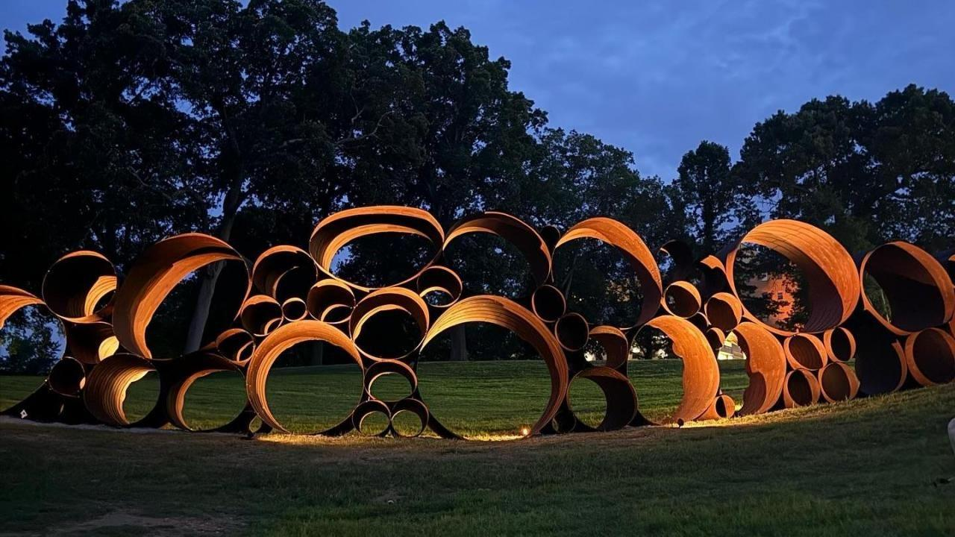Image courtesy of Marjorie Hodges.

In Raleigh, North Carolina there is an expansive urban park. At 308 acres, Dix Park, as it is usually called, is Raleigh’s largest urban park. Open seven days a week, its amenities include a dog park, the largest adventure playground in the Southeast, and works of art throughout the grounds. It hosts events such as indoor/outdoor yoga, an annual Inter-tribal Pow Wow, and a vendor market. It is named for Dorothea Lynde Dix, an early 19th century activist who championed better treatment for the mentally ill. She helped recruit and train nurses for the Union Army during the Civil War and is credited with transforming the field of nursing.
There are many buildings and spaces named for Dorothea Dix in the United States. Dix worked in several states and traveled to Europe to learn about care for the mentally ill there, bringing back new ideas to implement in America. The park in Raleigh honors her work in North Carolina. In 1848, she visited the state and tried to work with the legislature to improve care for the mentally ill, especially for women, though not for Black people. Kylie Smith, in her paper “Psychiatry in the Wake: Racism and the Asylumed South,” notes that Dix did not care particularly for the African American patient (Smith, 2021). In 1856, North Carolina constructed a mental hospital. At her request, it was named Dix Hill in honor of her grandfather. It was renamed in honor of Dorothea 100 years or so later (McKown 2006).
Like the proposed Memorial Park in Crownsville, the Dix Hospital occupied a larger plot of land than it does now and had been farmland. The Dix Hospital grounds at one time included 2,354 acres that were used for the hospital's farms, orchards, livestock, maintenance buildings, employee housing, and park grounds. In 1984, the State transferred 385 acres to North Carolina State University's "Centennial Campus", and in 1985, it transferred an additional 450 acres to North Carolina State. The state’s farmers market also now occupies some of this land.
The process of closing Dorothea Dix Hospital began in 2000. Efforts and discussions to close the hospital increased from 2008 to 2010. During this time, the State continued to transfer some of the land for other purposes. The closure was complete in 2012, when the last patients were relocated. In 2015, the State approved the sale of 300-plus acres to the city of Raleigh for the development of Dorothea Dix Park. (dixpark.org, n.d.) Unlike Crownsville, Dix Park is just outside the city center. Dix Park is within walking distance of downtown Raleigh, Historic Boylan Heights, and Pullen Park. Nearby is the State Farmers Market and North Carolina State University's Centennial Campus. It is connected to the Capital Area Greenway System by the Rocky Branch Trail. Crownsville, on the other hand, is situated in a suburban/rural environment and is not easily accessible, except by car, to the closest city, Annapolis. Differences in location to institutions, different housing scenarios, and different connections to roads and transportation make for very different development options for these two communities.
Dix Park has at least two things in common with the proposed Crownsville Hospital Memorial Park. Neither is complete, and both properties have complicated histories involving systemic and institutional racism. Both are trying to address these histories through community involvement in planning and development of these sites, as well as incorporating the truths and stories of the people who lived and worked in and around these properties. These are multi-generational projects. As noted on the Dix Park website, “The history of the Dix Park site is layered, complex and important in shaping the future of this public space for generations to come” (dixpark.org, n.d.). Reconciliation is a process. It is much more than an apology, although an apology or an acknowledgement may be part of the process. In a post on the United Methodist Church website, Reverend Brian A. Tillman put it this way: Reconciliation must address the root cause of injustice and lay a foundation that leads to community. “It is a process by which the participants with injustice and the endurers of injustice come together to do the work of bringing about restoration of the relationship with God and one another” (Tillman, n.d.).

History of the Site

Dix Park is connected to American histories of colonization, racism, and the evolution of perceptions and treatment of mental illnesses. Before the Americas were colonized by Europeans, North Carolina was populated by Indigenous people. The land sustained them. The Europeans and their descendants took over the land and displaced the people. For 150 years, this land was part of the Spring Hill Plantation, worked by enslaved African Americans. For 160 years, the State operated its first mental hospital in this space. (dixpark.org, n.d.) These three facts complicate the history of this parkland. Furthermore, Dorothea Dix herself, though rightly honored for her work to improve treatment for the mentally ill, brings additional complexity. According to an article in Psychiatry Online, Dix’s findings and her presence in state capitols led to reforms and new construction of facilities. Aaron Levin notes, “She was particularly welcomed in the antebellum South. Southerners saw her as one reform-minded Northerner who did not insist on lecturing them about slavery. And slavery was probably Dix’s most notable intellectual blind spot. By all accounts, her sympathy for the downtrodden did not extend as far as considering African-American slaves as fully human beings” (Levin 2019, n.d.). Yet, the history of the hospital states that Native American patients were treated at the hospital, though in segregated wings, and that some of these patients are buried in the patient cemetery.
For the past ten years, the North Carolina Department of Health and Human Services has been headquartered in Dix Park. The reconstructed space will bring another healing dimension to this space. The reimagining seeks to bring people from diverse communities together, both to enjoy this natural setting, and to learn about and reconcile past systemic and institutional injustices. Doreatha Dix Park has already become a member of the International Coalition of Sites of Conscience, a global network of historic sites and initiatives that seek to turn memory into actions that will lead to a better future. This could be a recognition that Crownsville could pursue for the Memorial Park.

The “Dorothea Dix Park Master Plan”

As did Anne Arundel County, the City of Raleigh embarked on a major master planning effort that focused heavily on community engagement to create a vision for Dix Park. In 2017, the City, in partnership with Dix Park Conservancy, contracted with a landscape architecture team and consultants to build out the plan. Their process engaged over 65,000 area residents in a discussion of the future of the park. The Raleigh City Council adopted the Dorothea Dix Park Master Plan in 2019, directing staff to develop a Phase 1 implementation plan. They are in Phase 1 now. The Dix Park Leadership Committee provides guidance to City staff, the Conservancy, and other partners on the implementation of the Dorothea Dix Park Master Plan. The Leadership Committee is supported by City staff and makes recommendations to the Raleigh City Council, which has final approval on the implementation of the Master Plan. The committee meets monthly and is composed of 12 members appointed by the Raleigh City Council.
There is also a Dix Park Community Committee, impaneled to represent the diversity of the community and bring a broad range of experiences and expertise to the project. It provides guidance and recommendations to the Dix Park Leadership Committee on matters related to park development, programming, and engagement. The management of the Community Committee is led by City staff with the support of the Dix Park Conservancy.
Agendas and minutes for these two committees are said to be available on the City’s website. However, I could not locate them. A better source of information on the master plan and its implementation is the plan itself at: https://dorotheadixpark.org/master-plan. Many videos related to the work of these committees can also be found on You Tube.
The master plan marks the beginning of a much more detailed public process. It provides a conceptual framework for developing the park in phases. The public process will include details such as plans for parking, building reuse, funding, and partnerships. Implementation plans will be subject to City Council approval.
The proposed projects within this first phase embody the three Master Plan principles of: Open Up and Connect, Build from What is There, and Offer Something for Everyone. These projects are intended to “connect the park to the greater community, repair and enhance the unique landscapes and structures that exist today, and create a variety of spaces to offer multiple experiences for all park users”(Raleigh Parks 2019, n.p.). Even with the COVID pandemic as an obstacle, they were able to complete four of the planned projects. Now they have developed a 10-year implementation plan to carry on the work.

Cultural Interpretation Plan
In addition to the landscape and infrastructure improvements, Dix Park has developed a cultural interpretation plan, a document that will guide storytelling in the park, enabling visitors to connect with the history of the site, as well as to the past, present, and possible future. The “Cultural Interpretation Plan” (Cloud Gehshan Design and Brocade Studio 2024) centers community histories and voices. It also reflects national history and current concerns. Planning began in December 2022 and was completed in June 2024. It was supported by the National Endowment for the Humanities, the State of North Carolina, and the Dix Park Conservancy. The City of Raleigh and the Dix Park Conservancy gathered historical records and community perspectives. Community members assembled archival records, oral histories, and scholarship that would become the basis for cultural interpretation. A contractor was hired to lead the community engagement and planning process.
Through conversations with community members, park staff, and stakeholders, five overarching goals for cultural interpretation emerged:
- Bring relevance and meaning to the site by making connections to issues Raleighites face today;
- Increase appreciation and understanding of the natural resources of the park and how to protect them;
- Tell the unfolding history of the site, with special care for stories that have been buried or forgotten here;
- Cultivate curiosity, dialogue, and empathy; and
- Challenge visitors to think in new ways about history.

The Cultural Interpretive Plan builds upon the foundational research and community engagement upon which the Master Plan was built. It was also built upon the work of a Legacy Committee and a Community Committee. These committees pushed for a reckoning with the site’s history, “highlighting the need to incorporate fuller accounts of what happened and center the perspectives of those with connections to this history. This includes, for instance, the perspectives and commitments of people who were treated at Dix Hospital and people whose ancestors were enslaved at Spring Hill plantation. Insights from the wider Raleigh community, gathered in workshops and online, also guided planning. Community storytellers, historians and elders advised the team throughout the process” (Cloud Gehshan Design and Brocade Studio 2024, 15). This is analogous to the outreach to affected communities that Anne Arundel County took while developing the master plan for Crownsville Memorial Park. Raleigh identified these communities as people with historical or ancestral connections to the site, including: Native American North Carolinians who host an annual Pow Wow at Dix Park; descendants of people who were enslaved at Spring Hill plantation; and members of the mental health community, including former patients and their families, mental health practitioners, and hospital staff whose families lived and worked at the site for generations.
The idea of the plan is to use memory and history to inspire positive action. The Interpretive Planners found that community members want spaces that can hold powerful memories, promote healing, and provoke real dialogue. The community wants engaging memorials, community-driven works of art, gathering spaces, and walks in nature. The plan calls for paths and landmarks that can take various forms but should be placed deliberately and of a scale to be experienced by visitors from a distance and up close.
The Dix Park Sites of Conscience Work Group described steps toward reconciliation, which can be a long and painful process, but is the object of their dreams. “The complicated, unspoken, and often uncomfortable histories of slavery, abuse, segregation, and removal that have occurred in this space must be documented. The issues of race, disability, mental health, discrimination, and communal healing inherent in our space are inseparable from our desires for what this park could become” (Cloud Gehshan Design and Brocade Studio 2024, 19).
Below is the “Matrix Storyline” of the Cultural Interpretive Plan. The Matrix is organized into four major sections: Ecological History, Native American Community History, African American Community History, and Hospital Community History. Each section contains several major storylines. The table below lists the storylines that flow through the plan (Cloud Gehshan Design and Brocade Studio 2024, 148-149). 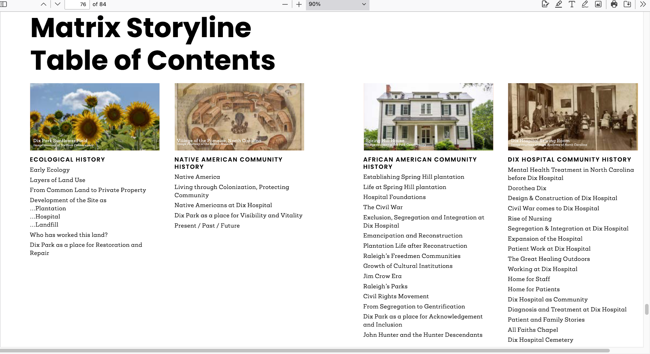

Sustaining Mission and Theme

Similar to Crownsville’s Master Plan, Raleigh’s Legacy Committee’s 2018 report outlines several ways to honor the site’s legacy during redevelopment and securing tenant partnerships (Dix Legacy Committee 2018, 28). They both would retain or renovate some of the existing space for nonprofits that serve or advocate for people struggling with mental illness, endorse creating employment and training opportunities for specific populations e.g., youth, and include plans for use the space for conversations and convenings on topics that fit the mission and theme of the park.

Complex Stories

The Dix Park Interpretive Plan recognizes that the site holds big and small stories – community histories, as well as personal anecdotes. It offers strategies for inclusive interpretation and specific storytelling media (Cloud Gehshan Design and Brocade Studio 2024, 57-65).
- Make room for a range of perspectives on the same place, event, or time period, while also grounding these perspectives in historical evidence.
- Wherever possible, encourage people to speak for themselves, from their own perspective, rather than having others speak on their behalf.
- Acknowledgement of past harm is an important part of community history-telling. If the City is speaking, take a matter-of-fact approach to presenting histories of harm. Warn visitors when exhibits contain sensitive topics or depictions of harm at installation and exhibition entrances.
- Community history-telling is more than the acknowledgement of harm and suffering. Tell the longer stories of community life.
- Center those histories and communities that have historically received the least investment, inquiry, and protection in public contexts.
- Foreground the humanity of all people as complex beings, not just as heroes or villains.
- Include members of affected communities in planning and review of messaging and design elements.

These may be helpful to other communities working with properties with complex histories. Crownsville Hospital has a history comparable in complexity. In developing their Master Plan, the County has already drawn upon principles embodied in these guidelines. As they move forward into implementation, these guidelines can move the community toward reconciliation.
***

Possible Future of Crownsville Hospital Memorial Park
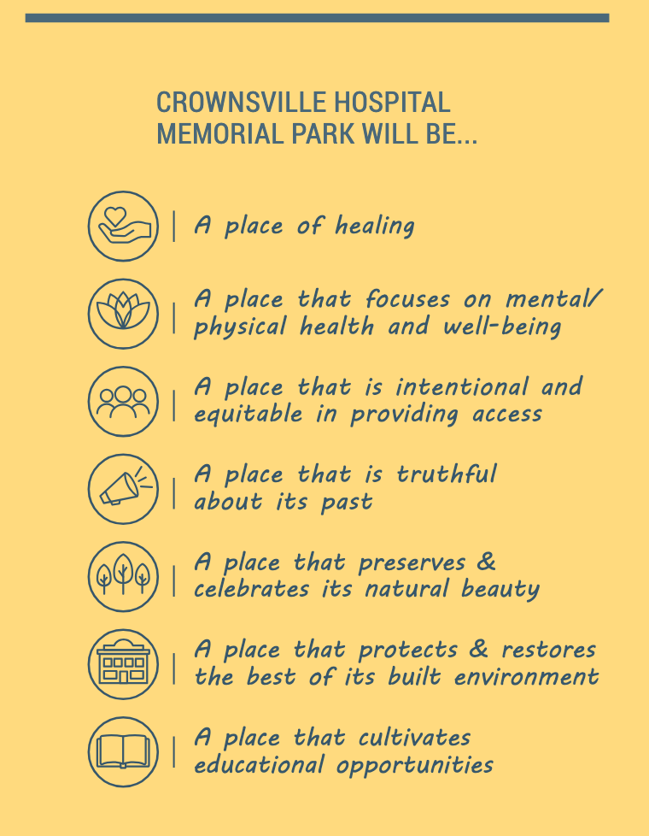
From Final Master Plan pg. 106

Master Plan Reveal

On February 12, 2025, County Executive Pittman held a press conference to announce the “Final Master Plan Report” for the Crownsville Hospital Memorial Park was published. The 220-page “Final Master Plan Report (Design Collective 2025)” is available on the County website. It is described as an expansion of the draft, which went through months of public vetting. The final includes additional environmental, design, and implementation components. Also added and displayed in a prominent position in the report is the Equity Statement written by the ad hoc subcommittee, of which I was a member. Other modifications include an Environmental Statement outlining sustainability efforts and a traffic analysis, traffic being a major community concern. It offers plans for vehicular, pedestrian, and bicycle circulation, along with the Maryland Environment Trust Conservation Easement to protect natural resources. A summary of community feedback, an implementation matrix for phased development, and a cost analysis to assess financial feasibility are also included. “The final master plan serves as a blueprint for future development, ensuring that projects align with community values and historical integrity. It provides detailed recommendations for land use, building programming, open space, traffic management, and public art installations, all designed to create a balanced and sustainable vision for Crownsville” (Anne Arundel County 2025).
Community members often raised matters related to building preservation and renovation, water, sewer, and electrical infrastructure, and these were addressed in the report. Recommendations from the Subcommittees on Health and Wellness and on Cultural History and are also addressed in the final report.
For orientation of my readers, below is a map from the “Final Report on the Master Plan”. Following that are some of the highlights that address interests and concerns that many stakeholders expressed at town halls and workshops.

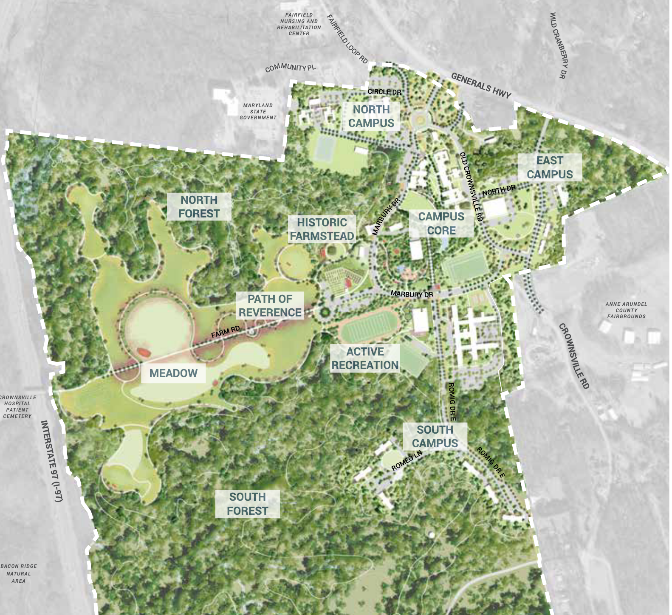
From Page 118 of “The Final Master Plan Report”
Highlights from “The Final Master Plan Report”
- Museum Interpretive Plan
As desired by the community, a museum expressing the many dimensions of the history of Crownsville Hospital is a major feature of the Memorial Park plan. The Plan recommended that the museum and an interpretive plan be developed through a museum master planning process in the future. Indoor and outdoor exhibits and experiences, including interactive exhibits were included features. As called for by affected community members, education and training opportunities for young people would be available in the museum.
- Art and Sculpture Plan
Art marks a space; it can make it a place. Art can define, especially a large piece like a sculpture or monument. Art can tell a story in a way that written prose or oral history does not. It engages the mind through the senses of vision and touch, and sometimes sound. It can be dynamic. It can spark conversation. It educates. It can promote a sense of well-being. This is true for the creators of works of art, as well as their audience. Here, art is planned to be used strategically to attract and engage visitors. At Crownsville Hospital Memorial Park art can be used to attract people to the site to explore, learn, heal, reflect, and be inspired. Community feedback often mentioned inclusion of Crownsville patient-created artwork and narratives in the landscape to honor their time spent there and to lift their voices. The landscape plan provides opportunities for Black artists and young people to shape the narrative of the Memorial Park.
- Active Recreation
Members of community around the Memorial Park expressed strong support for active recreation areas in the Memorial Park itself. There currently exists some recreational spaces in use by the community. The final plan calls for upgraded ballfields, a new track and multi-use field, and amenities such as a pump track and dedicated tennis/pickleball courts, all aimed at promoting healthy living and improving accessibility to Crownsville Road. In addition, the Campanella Building can host various indoor recreational activities, while the synthetic turf field will accommodate community sports likes soccer and lacrosse. The plan calls for amphitheater-style seating for spectators. The plan also includes a nature-based playground for children of all abilities, and park pavilions for celebrations and events.
In the North Forest, health and wellness trails conducive to forest bathing are proposed. This practice is believed to foster a healthful connection to the natural world. In the South Forest, hiker/biker trails will also provide opportunities for adventure and connection to the environment.
- Housing and Community Support
Among the types of support proposed for the Meyer Building are a Veterans and Family Clinic, which will address a community need for such services that was often noted in community discussions. There are military installations not far from Crownsville, including the United States Naval Academy and Fort Meade. There is now a tenant on site that provides some services to veterans.
Although the neighboring community expressed concerns about (affordable) housing development in Crownsville, there was support for some types of housing for specific populations, notably transitional housing for people who will be transitioning out of mental health facilities or in need of temporary shelter, for example. The planners found that space for a housing program, with two different room types, including one-bed and two-bed rooms, would fit well within existing, original patient rooms, with minimal interior wall changes. The plan states that apartment-style housing is also feasible but would require modifications to the interior walls. Whether as beds or apartments, this housing is envisioned for mental health and/or similar services. A current tenant provides substance abuse and mental health treatment for women and their children and may be interested in operating transitional housing in this space.
- Community Garden Center and Outdoor Education Hub
The Historic Farmstead will become a community garden center and outdoor education hub. This repurposed area will provide agricultural, educational, and therapeutic opportunities, featuring community gardens, an orchard, and a pollinator garden aimed at supporting local ecosystems. Below is an image of what the Garden Center and Communication Hub could look like.
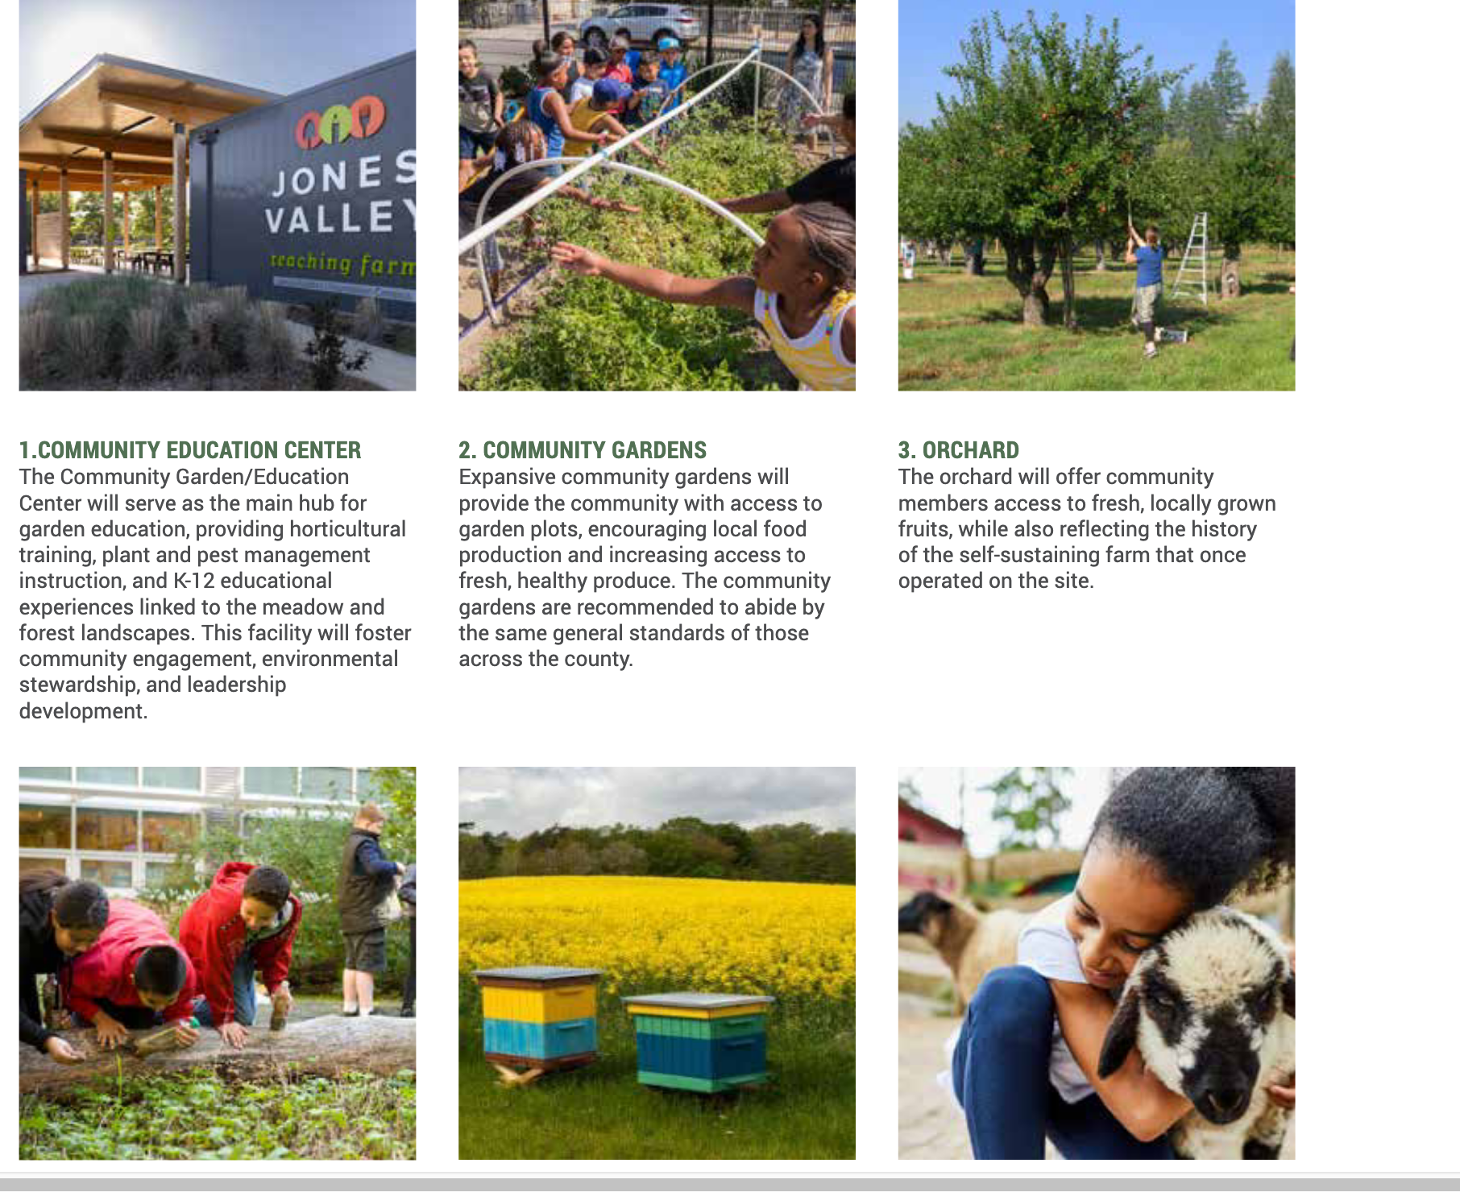
From page 168 of “The Final Report on the Master Plan”
- Path of Reverence
The Crownsville Hospital Patient Cemetery, though not a part of the Master Plan development process, figures prominently in the overall panorama of the site. Many of the events in the public review process were attended by the Friends of the Crownsville Hospital Patient Cemetery and the group was represented on the Advisory Committee.
Concerns for the cemetery’s continued existence and restoration were spoken of at these fora. Separate actions to create a monument honoring the cemetery are underway. This is sacred space for many in the affected community and beyond. The planned footpath between the Memorial Park and the cemetery is called, “The Path of Reverence.” It is intended to be a route for reflection and remembrance, honoring those patients who rest there, as well as those who provided care for them while they lived at the hospital. According to the founder of the Friends of the Crownsville Hospital Patient Cemetery, Janice Hayes-Williams, there are 1700 souls accounted for in the current configuration of the cemetery, all but one of African descent. The Path of Reverence is a key component for achieving historical truth and reconciliation.
***

STEPS TO THE FUTURE

The creation of the Crownsville Hospital Memorial Park is a multi-generational effort. To bring the project to fruition, the Report on the Master Plan includes a table of necessary short-term actions (0-5 years) and long-term actions (5+ years).
The Report includes a cost analysis. Construction for the project is estimated to cost more than $67 million, not including landscaping, or engineering and public fees. The cost will be reevaluated following more studies and could further change when construction begins (Lockman 2025). As previously noted, the State of Maryland funded the beginning phases of the project for $30 million. Given Maryland’s current budget situation (Shepherd 2025), it seems unlikely that the State would be able to provide a similar dose of funding. Furthermore, the $4 million earmark Maryland’s Congressional Delegation brought home for the project might not be duplicated in the near future either. Executive Pittman has stated that some of the upcoming funding for certain parts of the park may be funded out of the County Parks and Recreation Budget. Pittman frequently spoke of the Memorial Park as something that would have to be self-sustaining. He noted that there has already been philanthropic interest in the park, and he expects more interest. In public discussions, the prospect of commercial developers was not much talked about, except negatively, but there is likely to be interest there as well.
The reveal was covered by the local Maryland press. They focused on the difficult history of the Crownsville Hospital, the goal of transformation, the public engagement process to develop the plan, the details of the future use of the grounds, and the projected expense. In April, The New York Times published an article, “Can a Decaying Hospital With a Grim History Be Brought Back to Life?” (Nazaryan 2025). The author, informed by Hylton’s book, as well as his visits to the site, recounted the history of the hospital, as well as the Master Planning process. He also discussed the probability of development of the site. He wrote, “For the county’s plans to become reality, the project needs an enormous amount of funding as well as a developer who is willing to take on the risks of a project with multiple stakeholder interests and decrepit buildings and structures”(Nazaryan 2025). But Nazaryan also noted the importance of this project is to the history of Black Americans and the sensitivities involved in the site’s transformation. “Such redevelopments, when done correctly, can help acknowledge painful elements of the nation’s history and rebuild communities while also competing for the hundreds of millions of dollars that historical tourism can contribute to local businesses and governments” (Nazaryan 2025).
I did not hear much about the value of the expected increase in tourism during the community meetings I attended. However, visitors to the site, including those who previously would know little of its history, were clearly expected, since the layout of automobile and foot traffic anticipated these visitors.
The media coverage pointed out the practical realities of implementing the Master Plan, but also spoke to the positive effects that bringing the project to fruition would mean to the Crownsville area. An article in the New York Times is indicative of the national importance of efforts such as this one. Even before this article came out, I wondered what Antonia Hylton would think of the County’s Master Plan. I got to find out in March 2025.
***

Antonia’s Story

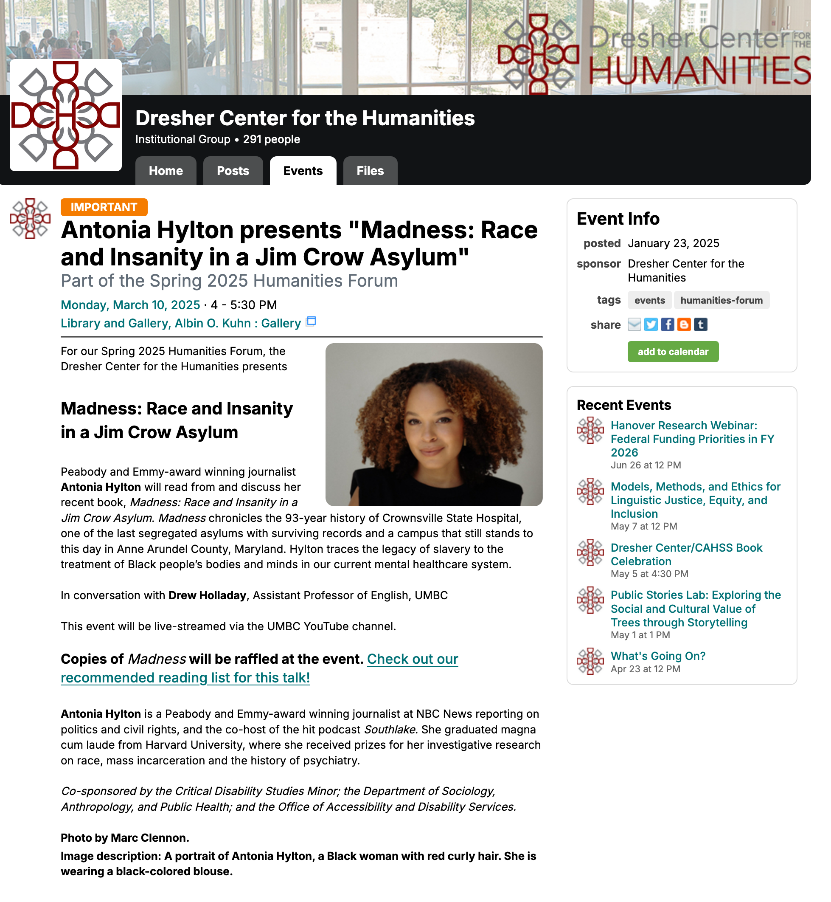

By happenstance or divine intervention, Antonia Hylton’s book, Madness: Race and Insanity in a Jim Crow Asylum, was published at the beginning of 2024. Hylton was a high-profile NBC reporter at the time, having won a Peabody award and an Emmy. Based largely on the history of Crownsville Hospital, the book received a page-long review by Linda Villarosa in The New York Times (Villarosa 2024) that attested to its veracity and value as an accounting of institutional racism in the psychiatric system of care. For me, this was divine intervention. Hylton spent 10 years researching this book, including time spent in the Crownsville community building relationships with people she would interview and visiting the site. I knew I could be informed by it for my thesis, particularly with regard to the history of Crownsville and the history of psychiatric medicine in the United States. Her book enabled me to spend less than a year doing research on the history of Crownsville. Perhaps by happenstance, the book came out while the Crownsville Hospital Memorial Park Master Plan was under development and public meetings were underway. This focused national attention on Anne Arundel County’s plan for the hospital site. In the words of a Crownsville community member, whose name I did not catch, “The world is watching because of her book.”
I was excited to learn that during the writing phase of my project, Antonia Hylton would be at an event at the University of Maryland. She was the guest speaker at their Spring 2025 Humanities Forum. On March 10, 2025 I attended this event in person.
In Hylton’s conversation with Drew Holladay, a professor of English at the University of Maryland, the author recapped the book, stressing that her book was about a system of oppression and that myths and stories still impact institutions today. The power of lies, such as those declaring the inferiority of Black people and that their “insanity” was the result of their freedom from bondage, still haunt various systems and institutions. She stated that these lies are hard to undo without intentionality. “People want change,” she said.
I asked her what she thought about the Crownsville Memorial Park Master Plan. She said that it is a great investment in telling the story and that she was glad it is being told. She was glad that affected community members showed up at public meetings to state what they wanted and to press for accountability. She felt that more than acknowledgement was appropriate. She wanted Black people to be welcome at the Memorial Park. “It’s a great start,” she said.
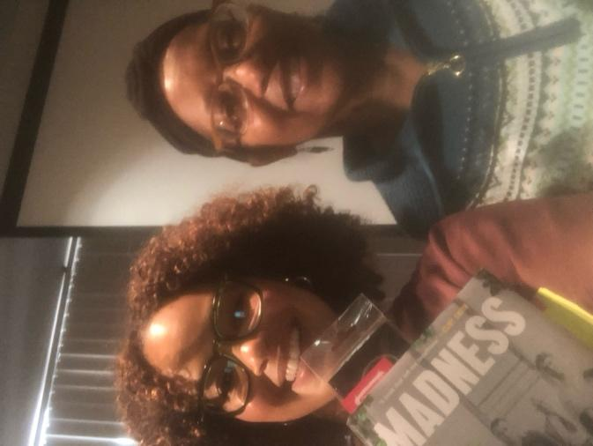
During a side conversation, I asked what was next for her. She replied that she is consulting on the Crownsville project, though she didn’t say with whom. She said that she is working on training people for the new oral history project on Crownsville Hospital, presumably the one funded through the Congressional earmark. She hinted that there are, perhaps, “other media projects” in the future. I can only hope that it is a stellar documentary on Crownsville Hospital and the transition to a memorial park, or Janice Hayes-Williams’s quest to identify the names of those buried in the Crownsville Hospital Patient Cemetery. Even an adaptation, well done, starring my favorite actors, would be a good vehicle to get the story out.
1Antonia Hylton (l) and Sandra Howard (r) in Baltimore, MD March 10, 2025
The Crownsville Master Plan presents an ambitious vision for transforming a space with a contested history into a place of healing, where reconciliation is possible. The transformation may never be fully complete. Even the short-term actions in the Master Plan are estimated to take place over a five-year period. It is not certain that even these can be completed, as all actions are dependent on continued funding and support from the public and elected officials. What if the history of Crownsville Hospital were less complicated? Could this old place still be an asset to the community?
***

Old Places Matter: An Old Place Becomes a Community Asset

Fergus Falls Case Study
The following case study focuses on placemaking in a community geographically, demographically, culturally, and historically different than Crownsville, Maryland. The similarity of note is that the focal point of community transition efforts is a psychiatric hospital that is no longer in use. Fergus Falls State Hospital/Regional Treatment Center surely bears the weight of the legacy of early 20th-century psychiatric practices, as well as the folklore commonly attributed to psychiatric facilities. However, the community puts forth a kind of reverence for the place, gets involved in efforts to save it from demolition, and most recently began to enjoy it as a venue for the arts.

Fergus Falls, a Rural Midwestern Community

Fergus Falls is a city in west-central Minnesota. It is the county seat of Otter Tail County. As of the 2020 census, its population was 14,119. Just over 90% of the residents identified themselves as White/Non Hispanic. 1.7% are Black or African American/Non Hispanic. Hispanic ethnicity of any race made up 2.5%. Fewer than 1% are Native American, Asian, Pacific Islander, or some other. Other/Mixed is 3.7 percent. (United States Census Bureau, n.d.)
The website, Visit Fergus Falls, tells us that the city has amenities such as the George B. Wright Park Veteran Memorial Park, a scenic River Walk Park, lakes -- including Lake Alice, Pebble Lake Golf Course woodlands, stores, the county museum, and other features for the use of the community and tourists. Resources dedicated to the arts include a community theatre program and a Center for the Arts. (visitfergusfalls.com, n.d.)
Fergus Falls is a micropolitan with a diversified economy that includes healthcare, manufacturing, agriculture, information technology, and utilities. The largest employer is Lake Region Healthcare, an integrated health system, employing 835 people. Other major employers include the public school system, the county government, and the power company. (City of Fergus Falls 2023)
Arts and culture seem to have a strong presence in the city. Arts venues include A Center for the Arts and the Kaddatz Galleries -- a nonprofit art gallery founded in 2001 when Artspace bought The Kaddatz Hotel in partnership with the Hotel Kaddatz Preservation Association. The Hotel Building hosts artist live/work spaces. Otter County is one of the nine counties served by the Lake Region Arts Council. Its main office is in Fergus Falls. Springboard for the Arts, another nonprofit art organization, has its only satellite office in Fergus Falls.
In addition to those arts organizations and facilities, Fergus Falls has another cultural resource, the site of the former Fergus Falls State Hospital. Now identified as the Fergus Falls Regional Treatment Center, this unoccupied building and grounds of this site comprise 120 acres.

Fergus Falls State Hospital

The Fergus Falls State Hospital opened on July 29, 1890, becoming the first state institution in northern Minnesota for those deemed to be insane. The hospital was built in the “Kirkbride Plan” style, a system of design for mental asylums in the mid-19th century advocated by American psychiatrist Thomas Story Kirkbride. The structures of these hospitals, including Crownsville Hospital, were based on Kirkbride’s theories regarding the healing of the mentally ill, in which environment and exposure to natural light and air circulation were crucial. Hospitals built according to the Kirkbride Plan would adopt various architectural styles, but had in common the "bat wing" style floor plan, housing numerous wings that sprawl outward from the center. Patients’ treatment included exercise, farming, entertainment, reading and sewing. This provided occupational therapy for the patients and goods for the hospital. (Cartwright, n.d.)
Decades after its opening, the hospital “dominated the cultural and economic landscape of the area” (Visit Fergus Falls.com, n.d.). The fate of the hospital and the town became intertwined. As the hospital grew, the town grew. The population of Fergus Falls more than doubled between 1890 and 1930. The hospital became overcrowded. As many of the patients were poor and had no resources, they stayed there for the rest of their lives. After World War II, the advent of drug therapy in outpatient settings, Minnesota scaled back its hospital system, as did other states. In 1971, it became Minnesota’s first multi-purpose regional center, which meant accepting patients with developmental disabilities and chemical dependencies. The hospital then became known as the Fergus Falls Regional Treatment Center.
After years of moving patients into smaller, community-based facilities, this Regional Treatment Center closed in 2005. The state sold the land to the city of Fergus Falls in 2007. The main building was placed on the National Register of Historic Places in 1986. Although it was one of the few remaining examples of buildings in the Kirkbride style, the City was concerned that it was too large for their town to redevelop or maintain it and considered demolishing it. After years of debate, the city entered into an agreement with a private firm to explore plans to redevelop the site (Gunderson, 2018). However, efforts to develop the site with commercial potential have not come to fruition.

Redevelopment Potential

Greater Fergus Falls, an organization whose mission is to attract, support, and retain businesses and entrepreneurs in Fergus Falls, lists the Regional Treatment Center (RTC) as a property available for development. It states, “the property is structurally sound and offers a multitude of repurposing opportunities, including housing” (Greater Fergus Falls). Further, it states that a master plan study is in progress. The master plan was completed in 2021 and released to the public. The major finding of the plan was that the property was structurally sound, and that housing is a viable reuse for the city. It was sent to the City Council for review, but no further action has been reported (Greater Fergus Falls).
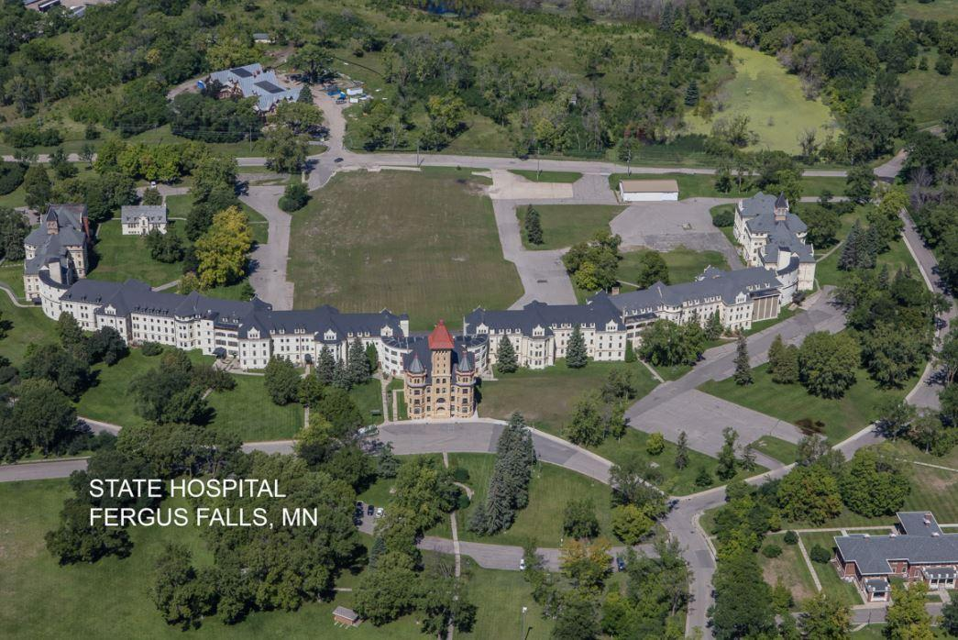
Photo Credit: greaterfergusfalls.com n.d.
There is some indication that economic development in general in Fergus Falls has stalled. Greater Fergus Falls and the Foundry, an economic development agency in Fergus Falls, is becoming inactive for the foreseeable future. As reported by Fergus Now on March 6, 2025, the Greater Fergus Falls and the Foundry posted on Facebook that the decision to suspend activities came after the City Council began to take alternate paths for economic development, “Since October, we have engaged in discussions with City Council about a collaborative future for our community. In light of these discussions, we have delayed hiring a director to ensure alignment with the emerging vision. Recently, it has become evident that the City Council has no current consensus for economic development and is actively pursuing alternate paths. The leaders serving on the board of Greater Fergus Falls live in and care deeply about our community, but without a (literal or figurative) seat at the table for any of the discussions, we believe our passion and talent can be used to help alternate organizations and causes in our community.” (Sidian, 2025 n.p.) The article further reports that the Greater Fergus Falls says its leaders are making plans to vacate their downtown office space and will collaborate with City staff to ensure a swift transition for business, land, and growth inquiries. Whether there will be further development of the site remains unclear.

Use as Artist Space

Still, the site and its links to the history of the practice of psychiatric medicine loom large on Fergus Falls’ landscape. The civic organization, “Visit Fergus Falls” touts the former Fergus Falls Regional Treatment Center complex hospital as a “unique landmark” and includes the site on their page of “things to do”. However, they advise visitors, “Tours of the inside of the facility are not available. However, the grounds are public property, and we invite visitors to walk around the beautiful campus. The local museum occasionally provides outdoor walking tours during the summer.” (Visit Fergus Falls)
In 2014, the Minnesota non-profit arts organization Springboard for the Arts received a $100,000 grant to establish a community development and artists residency program, Hinge Arts at the Kirkbride. Selected artists reside in apartments that were formerly a nurses' dormitory, creating a variety of art projects that often reflect on the history of the building and comment on the past and present of mental health treatment. Springboard hosted an annual Kirkbride Arts & History Weekend from 2013 to 2017, featuring tours, music, and speakers focusing on mental health and historic preservation.
On March 26, 2025, I interviewed Michele Anderson, the rural director of Springboard’s Fergus Falls Office. Michele is a graduate of the Goucher M.A. in Cultural Sustainability Program. Fergus Falls is her home region. I requested an interview with her because her capstone was based on her leadership of the Springboard’s efforts to transition the site of a former psychiatric hospital into a community resource by community visioning activities, sponsorship of arts events, support for artists, and other placemaking techniques. Michele completed her capstone in 2014. I wanted to know what had happened to the site in recent years.
Michele gave me an update on the Fergus Falls State Hospital Building project. The building is referred to as the Kirkbride Building. Her organization, Springboard for the Arts, continued working on placemaking. They got a grant from Arts for Artists for the Hinge Arts residency program, though not at the funding level requested. They were able to provide two apartments for artists in residence. They brought in over 100 artists prior to the onset of the COVID pandemic. They continued to engage the community in storytelling. There was a theatre production. In 2016, a new mayor took an interest in the project. There were some improvements to infrastructure. The site got street names and electricity. And the site was renamed “Kirkbride Park”. As a park, it hosted performing arts festivals, cross-country skiing, and other activities. However, in 2017, a proposed developer for the site stepped away from the project and still has not been replaced. The pandemic shifted the focus to outdoor activities at the site, which continues to this day. (Anderson 2025)
In 2025, Michele and her organization are no longer involved in the Kirkbride Park project. People still can’t tour the buildings. In reflection, she thought that the use of the grounds as a venue for the arts was beneficial to Fergus Falls. There has been an increase in inquiries about the place fielded by the history museum, which is an indication of interest in cultural tourism and heritage studies. She thought that festivals at the site draw more people now. Overall, she said that the leadership of the community now considers the site an asset, rather than a liability. (Anderson 2025)
In this case study, Fergus Falls was able to put the grounds of the former asylum to good use by the community, in spite of not being able to renovate the hospital building and further develop the site. If there are stories of individuals who lived and were treated there, they are not part of the visitor’s experience in the way that Crownsville Memorial Park plans to make them. In some instances in which a community seeks to transition a former psychiatric facility, the history and memories can be lost forever, or are on the verge of being lost forever and require immediate action.
***

At present, Crownsville has an opportunity to construct a place that will embody the concept of reparative justice. To use the existing landscape to create a place of healing and reconciliation, and perhaps right some of the injustice that was perpetrated against a people. There are many sites where this reconciliation could have happened. This is never an easy process. Sometimes, the events conspire to make this difficult or impossible, as the following case study illustrates.

What Remains: Voices from the Hiawatha Asylum for Insane Indians

Case Study: The Hiawatha Asylum for Insane Indians in South Dakota,
a.k.a Canton Indian Insane Asylum

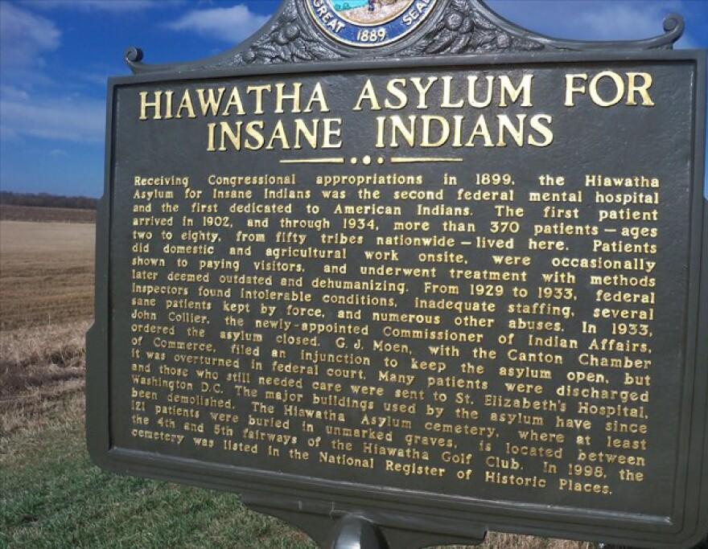
Photo Credit: South Dakota Public Broadcasting, September 21, 2018
African Americans were not the only racial or ethnic group that was confined to segregated spaces that purported to treat them for mental illnesses. This also happened to America’s Indigenous peoples. In 1903, the first federal mental hospital exclusively for Native Americans was established in Canton, South Dakota. This was even earlier than the 1911 Crownsville Hospital opening. The situations faced by Native Americans and African Americans are not identical. They should not be directly compared. However, the cruelties and mistreatment of both populations in institutions purporting to be in the interest of their mental health echo each other. In both cases, the descendants are honoring and preserving the memories of the people who were confined in these spaces.

Canton, South Dakota

Canton is a city in southeastern South Dakota and the county seat of Lincoln County. Canton is located 20 minutes south of Sioux Falls in southeastern South Dakota. This city could be considered a suburban area, with a high degree of home ownership. The city lies in the rolling hills of the Sioux Valley, providing an abundance of recreational activities with the Big Sioux River bordering the eastern side, Newton Hills State Park to the south, and Lake Alvin to the north. It is supported by rural agriculture, as was true in the past (Yellow Bird 2017).
According to Data USA, in 2023, there were 3,060 people, 1,248 households, and 789 families residing in the city of Canton. The racial makeup of the city was 95.8% White, 0.3% African American, 1.3% Native American, 0.8% Asian, 0.2% from other races, and 1.6% from two or more races. Hispanic or Latino of any race were 1.7% of the population. There are few representatives of America’s Indigenous people in Canton. (Data USA “Canton”n.d.) Of course, this was not always the case. Historically, the area was inhabited by various Sioux tribes, including the Santee and Yankton, as well as other tribes like the Arikara, Cheyenne, Omaha, and Poncas, according to FamilySearch. (Family Search. n.d.)
Among the many atrocities committed against the Native American population was the incarceration of people in a facility with the mission of “curing” their “mental illnesses.” (Bhatara 1999). The South Dakota institution was called by many names: The Hiawatha Asylum for Insane Indians, The Hiawatha Insane Asylum for Indians, and The Canton Indian Insane Asylum are appellations in the literature cited in this paper. One will have to assume that those at risk of being remanded there had other terms to describe this space.

The Hiawatha Asylum for Insane Indians

Among the recreational activities available in this suburban landscape is golfing. The Hiawatha Golf Course holds the story of the first and only asylum created specifically to hold Indigenous Americans deemed “insane,” (or terms to that effect). This space retains special importance in the history of mental health services for Indigenous Americans. It is linked to stories not often heard about the treatment of the Indigenous Americans in the service of “mental health”. In reality, the reasons for their commitment often had nothing to do with mental illnesses, as they were defined in the early 20th century.
In the late 19th century, South Dakota was a new U.S. state, as well as the homeland of many Indigenous peoples. Ostensibly, in an effort to create an economy in the frontier state, two members of the South Dakota Congressional delegation proposed to create a psychiatric institution for Native Americans. The federal government funded the Hiawatha Insane Asylum for Indians in Canton. It is said to be the first and only federally funded psychiatric institution for American Indians in America. I found no evidence that this was done at the request of the Native population, rather, it was done in the pecuniary interests of the congressmen. From 1903 to 1933, more than 350 Native Americans were forcibly committed to the Asylum, often for reasons that had nothing to do with having a “mental illness.” This institution had a “short, but brutal, existence” in which more than 350 Native people had been held, and at least 121 people had died in the facility (Brice, 2020, 1).

“Alvin Abner Big Man’s” Story

Many of the stories of people who were sent there are lost to time or remain in archives, like the National Archives Record Administration (NARA). David Walker, a Cherokee psychologist and researcher who at one time worked for the Indian Health Service, combed through records at the NARA location in Fort Worth, Texas. He found details of one man’s experience with the Canton facility. This story is that of a Lakota man from the Rosebud Indian Reservation in South Dakota. In 1913, he had been accused of stealing horses and was arrested despite his pleas of innocence. He was diagnosed as having “horse-stealing mania”. Because Native people were under the jurisdiction of the federal government, he was first sent to St. Elizabeth’s Hospital in Washington D.C., which was the only federal psychiatric facility at that time. Three years later, he was transferred to the Hiawatha Asylum, where his trauma began anew.
Walker wrote a blog about the captive patient, assigning him the pseudonym of “Alvin Abner Big Man” (Walker 2015). Focusing on the improbability of the diagnosis of “horse-stealing mania,” he called it an embarrassment to the profession of psychiatry. After being transferred from St. Elizabeth’s Hospital, Alvin spent the next two years in the Hiawatha Asylum for Insane Indians, pleading through his attorney and other means to be released. There, he had been diagnosed with “Constitutional Inferiority,” another dubious diagnosis, by Dr. Harry Hummer, the lead psychiatrist. Supported by his archival research, Walker suggests that in those two years of his confinement, “Alvin turned into an in-house activist, fighting against Dr. Hummer, about the treatment of his fellow inmates. I’d say he became rather a thorn in the Doctor’s side. He even attempted to smuggle a note out of the building to the Indian Commissioners” (Walker, 2015). Walker actually found his note. The note was intercepted by Dr. Hummer, but Alvin was released from Hiawatha shortly afterward. Walker ends his analysis of Alvin’s medical archive here. However, one wonders about the stories that remain undiscovered.
In 1933, amid reports of abuse of patients, including people shackled to beds and pipes, some of which were witnessed by White investigators, the Hiawatha Asylum for Insane Indians was closed. Some “sane” Indians were released. Others were sent to St. Elizabeth’s in Washington, D.C. (Walker 2015).

What Remains? The Cemetery at the Golf Course

Nothing is left of the structure of the asylum. There is, however, a cemetery. Land was set aside for a cemetery, but the Indian Office decided that stone markers for graves would be an unwarranted expense. Today, the cemetery, with at least 121 burials, is located north of the junction of U.S. Route 18 and the former Chicago, Milwaukee, St. Paul and Pacific railroad tracks. The National Park Service added the cemetery to the National Register of Historic Places in 1998. A description of the cemetery, including names of those known to be buried, are on the NRHP document. However, there is no visual historical marker for the cemetery grounds (National Park Service n.d.).
Dr. Walker was urged by a Native elder to do what he could to expose the intergenerational effects of the oppression of American Indians and Alaska Natives. In this blog post, he raises the specter of the graveyard on the site of the aforementioned Canton golf course. He implores the readers, “Let’s refrain from looking closer at the graves at the golf course and the filthy coal-fired furnaces that coated the floors with soot that caused chronic respiratory diseases and the deaths of so many resistors forcibly committed to the Asylum. . .” (Walker, 2015).
Stories are buried here, as well as the people. But the stories can come back to us if care is taken to reconstruct and disseminate them. Pemina Yellow Bird is an enrolled member of Three Affiliated Tribes who has represented her people in matters related to the repatriation and reburial of ancestral remains and burial property, as well as protection and preservation of irreplaceable sacred and cultural places. (Yellow Bird 2017) She writes in “Wild Indians: Native Perspectives on the Hiawatha Asylum for Insane Indians” that she does this work to protect her people’s sacred, cultural, and historical sites, “to keep them from disappearing under the onslaught of industrial and recreational development” (Yellow Bird 2017, 3). Of the importance of the stories of the Indigenous Americans’ holocaust, she writes the following.
We must then tell our stories of loss, of
violation, of what happened to us, and we
must at long last grieve those things; we
must determine how the past informs us, is
part of who we are, and how it walks with
us every day of our lives as Native people.
We must tell those stories and we must
determine for ourselves, based on our own
original teachings and instructions, what
we must do to care for ourselves.
(Yellow Bird 2017, 3).
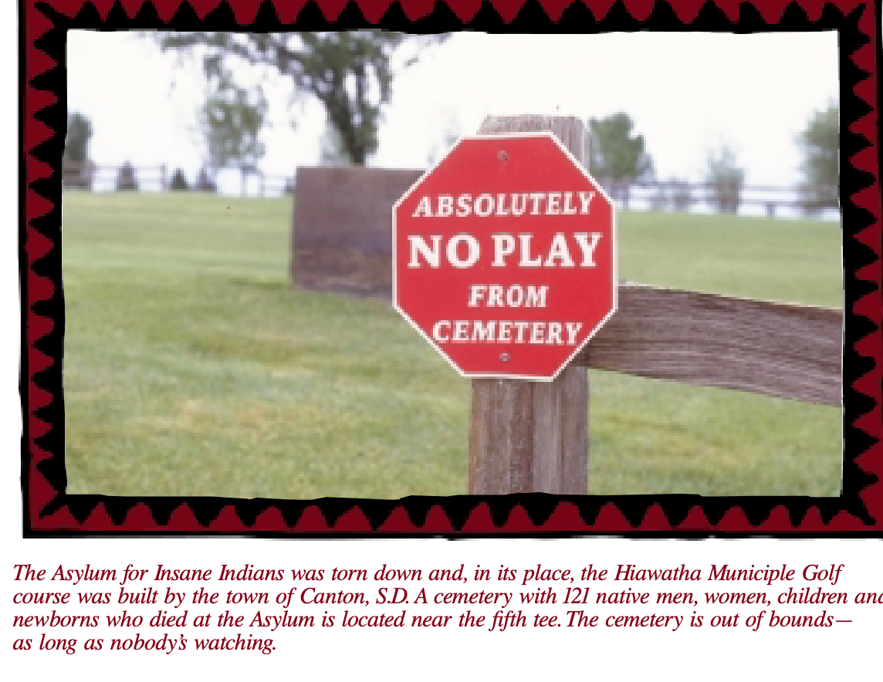
She acknowledges the efforts of two non-Native historians and one psychiatrist who have previously brought the story of the asylum to light. But she says, “time is long overdue for this story to be told from a Native perspective, because the story is only half-told without that perspective. It is also crucial, as part of the healing for Native people to tell our own stories, a thing we do well, given half a chance.” (Yellow Bird 2017, 4). She adds her voice to the efforts of Lakota journalist Harold Ironshield, who has also sought to bring dignity to the resting place of the 121 Native people buried Hiawatha site. Ironshield’s efforts led to the graves being fenced out of the golf course. A sign, the same shape and color as a traffic stop sign, admonishes “Absolutely No Play From Cemetery”. Yellow Bird doubts that this is an effective deterrent.

Ceremony

Another of Ironshield’s accomplishments is the inception of an annual memorial service he began holding for the people who are buried there. He brought people of all backgrounds together to offer traditional prayers and sacred songs, as well as preparing and offering traditional foods, according to their customs. Harold Ironshield is no longer on this earth, but his work ensures that “these ancestors know they are not forgotten, that their memories are cherished and held up, that what happened to them will no longer be hidden from view” (Yellow Bird 2017, 7).
This ceremony echoes the story of the cemetery adjacent to the Crownsville Hospital Memorial Park site. Only in the South Dakota case, there is no building, and the remains of those buried in Canton have been dishonored by the recreational use of what is to descendants and others, a sacred space. The community of Crownsville also holds a yearly ceremony at the cemetery, “Say My Name”. It is supported by the Friends of Crownsville Hospital Patient Cemetery and attended by people of many backgrounds.

The Story Retold and Contextualized

One recent telling of the story of how the federal government forcibly committed more than 350 Native Americans to the Hiawatha Asylum in Canton was relayed in a post and via podcast in 2020. Berkeley News reporter and podcaster Anne Brice discussed the story of the Hiawatha Asylum for Insane Indians in an interview with Ella Callow, who at the time was the director of the Office of Disability Access and Compliance at the University of California, Berkeley. Callow was also a board member of the Friendship House Association of American Indians in Oakland. The report was part of a two-part series about how disability has been and continues to be used to control and profit from Native populations (Brice 2020).
As is the case in Crownsville, the stories of people who have been treated unjustly and memorialized inappropriately or not at all are kept alive as new generations continue to dismantle systemic and institutional racism. As it is often said, “Remembering is a form of resistance” (Multiple sources, including International Sites of Conscience). Memories can become actions.
***

Africatown, Alabama: A Site of Memory and Justice
“Sites of Memory,” or “Sites of Conscience” are historic places that activate the power of memory to engage the public in a deeper understanding of the past, inspiring action to shape a more just future. These sites break the silence surrounding slavery, and place the tragedy into our universal memory. It is only through dialogue that we can have peace and reconciliation. We have a duty to remember the crimes committed against humanity by our ancestors, especially as we see the return of prejudice and discrimination today. (UNESCO, n.d.)

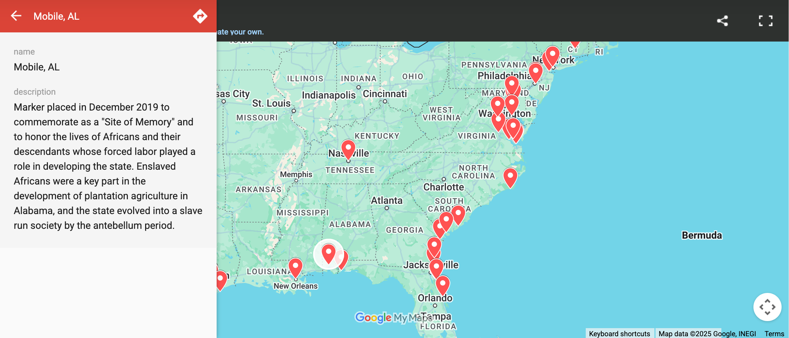
Screen Shot of https://unescositesofmemory.org/sites-of-memory/

CASE STUDY: Memory and Justice: Africatown, Alabama

Overview

Within the city limits of Mobile, Alabama lies a historically Black community called “Plateau” by some and “Africatown” by others. Founded by survivors of the wrecked slave vessel, Clotilda, Africatown was once a thriving self-sufficient community, but became depopulated and environmentally degraded. Yet, it continued to attract visitors and became recognized by the United Nations Educational, Scientific and Cultural Organization as a UNESCO Site of Memory. The location of the shipwreck had been known to those who lived there. However, with the “revelation” that the remains of the Clotilda had been “found” in 2019, the community gained an opportunity to become a major tourist destination, as well as a chance to revitalize itself. (Diouf, 2025) This case study will discuss the competing and complementary forces of memory, tourism, and justice in this Gulf Coast community, which includes descendants of enslaved Africans smuggled into the United States in 1860, as well as the descendants of the man who commissioned their kidnapping and enslavement. Recently, these contending forces came together to open the Africatown Heritage House, a step toward the community becoming a major tourist attraction and another step on the path to reconciliation.
This case study is built on the bones of a paper I wrote (Howard 2022) on Africatown in December 2022 for a cultural policy class. Although Africatown differs from Crownsville in many respects—location, intention, and scope among others—there are enough commonalities to include it among the case studies of this paper. The memories, stories, and truths of those to be memorialized in both instances were of captive populations -- people stolen from their homeland in the case of Africatown, and people committed to a psychiatric facility often under dubious conditions. In both cases, people engaged in placemaking, doing what they had to do to survive and to thrive. There are successes in both places. The staff of Crownsville Hospital did what they could to make the hospital a place of healing for the patients and the staff. Their memories are precious to them and spurs the work of those former staff who support the development of the Crownsville Hospital Memorial Park. The founders of Africatown built a place that their descendants still memorialize, whether they live in the Mobile area or not. Both projects seek justice.
Historically Black communities, such as Africatown, as well as segregated institutions, such as Crownsville Hospital, stand in the crosswinds of explicit and implicit cultural policies, such as segregated housing, zoning decisions, and disinvestment in certain neighborhoods. They are also buffeted by the conflicting desires of remembering and forgetting abominable aspects of our nation’s history. Whether to memorialize or cover over the past is a question state and local governments, as well as community members, face in the 21st century, and not just in the Southern United States.

History of Africatown

The primary source for this section is The Last Slave Ship: The True Story of How Clotilda Was Found, Her Descendants, and an Extraordinary Reckoning (Raines 2022).
In 1808, Congress outlawed explicit participation in the international slave trade by the United States. However, slavery was still legal by lack of federal law forbidding it. Yet, some states had taken legal action to outlaw human bondage in their jurisdictions. Despite this prohibition on the slave trade, in 1860 Alabama shipbuilder Timothy Meaher smuggled a schooner, the Clotilda, into the Gulf of Mexico, up the Mobile River. The ship carried 110 enslaved people captured in the West African kingdom of Dahomey (now the nation of Benin) to Mobile, Alabama. The Africans were deboarded. Then William Foster, the ship’s captain, set the ship on fire and scuttled it in the Mobile River, where it remains to this day. In 1865, following the end of the Civil War, the 13th Amendment to the Constitution abolished slavery throughout the United States. Longing to go home to Africa, but unable to find the means, some of the freedmen petitioned Meaher, their enslaver, to give them land. He refused. The Africans then found ways to earn enough money to buy acreage from Meaher. In 1870, on that land, 35 of them founded a town, Plateau, also called Africatown.
The lore of this community, founded by survivors of the last known slave ship to come to the US, began to spread as early as 1927. Anthropologist and folklorist Zora Neale Hurston conducted interviews with 86-year-old Cudjo Lewis, one of the founders of Africatown. She presented Mr. Lewis as the last living survivor of the Clotilda. Her account of his stories was written for the Journal of Negro History in 1927, but Hurston was unable to get her work published before her death in 1960. In 2019, her book, about Lewis, Barracoon, was published.
Cudjo Lewis died in 1935. His descendants, as well as those of other founders, maintain a presence in the Mobile area, though others have migrated across the country. For a time, the community maintained self-sufficiency. However, there were challenges, such as polluted well water. In order to access municipal water, Africatown was annexed into the city of Mobile in 1960. However, their incorporation also made the community subject to zoning actions that allowed industries and their pollution to flourish within Africatown.

Africatown Today

According to Renee Kemp-Rotan, Africatown once consisted of 14 distinct neighborhoods. That was before the construction of the Interstate 165 bypass, the widening of Bay Bridge Road, and the loss of land through rezoning and industrial takeover. Since 1970, the number of neighborhoods has been cut mercilessly in half. Its narrative covers an area of approximately 2,000 disconnected acres in this Gulf state, from Mobile through Chickasaw to Prichard. Its mass is far less now (Kemp-Rotan, n.d.). Its population has shrunk considerably -- from a peak of 10,000 or more to now fewer than 3,000. Although it is only a few miles from downtown Mobile, Africatown’s residents have become isolated by transportation and land-use decisions, examples of structural racism.
As of the 2020 census, the City of Mobile is now majority Black and low-income. The area is industrial. Paper, asphalt and petrochemical plants, pipelines, and coal terminals surround the town. Many of the larger employers and alleged polluters have left the area. Kimberly-Clark, maker of paper-based consumer products, for one, remains close by. Steel manufacturers operate in the surrounding areas. An asphalt manufacturer backs up onto some residents’ property. Dust from the trucks blows into the air (Zanolli, 2018).
Over the years, a number of industries, including paper mills, provided employment to the residents who stayed there until the industries left town. Then the people left. Then the supporting businesses left. The result was abandoned buildings and blight in the residential areas. These industries left behind a legacy of pollution in the air, water, and land that haunts Africatown today. Given the residents’ experiences with cancer, some believe they live in a “cancer cluster”(Zanolli, 2018), but that has not been proven scientifically. And remaining industries continue to pollute.

Why Tourism Matters

Despite the economic downturn in their community and their struggles against environmental injustice, the community has kept alive its heritage and knows its value. In 1997, the Clotilda descendant community formed the Africatown Community Mobilization Project to seek recognition of an Africatown Historic District. Other developments that have put this historic community in the spotlight include becoming a site on Mobile’s African American Heritage Trail; being listed on the National Register of Historic Places in 2012; the publication, finally in 2018, of Zora Neale Hurston’s book retelling Cudjo Lewis’s story, with its related fanfare and controversies; the release of the 2022 film, “Descendant”; and the National Geographic Documentary, “Clotilda: Last American Slave Ship.”
These events provided the basis for increased tourism in Africatown. However, one other event boosted this effort. In 2019, the Alabama Historical Society announced that the wreckage of the Clotilda had been found at the bottom of the Mobile River (Alabama Historical Commission 2019). Although referred to as a “discovery” many people had known or had suspected its location over the years it lay in the river. But its rediscovery by divers, reporters, archeologists, and other professionals is central to the area’s potential to become a major tourist destination.
Tourism can be a major economic driver for countries, states, and cities (Gmelch, 2008). For African Americans seeking out heritage and sites of memory, Africatown can be a draw. To quantify this attraction for African Americans, according to studies conducted by Mandala Research, African American travelers spend $48 billion worldwide each year and are among the fastest growing traveler groups in the U.S. — 68 percent of African American travelers would like to learn more about African American history and culture while traveling (Skift, 2016).
Africatown is the first and only 19th century settlement built by freed Africans in the United States, according to Kemp-Rotan. As such, it will appeal to a broad spectrum of visitors from throughout this country and from abroad. As Lonnie Bunch, the Secretary of the Smithsonian Institution, referencing finding the Clotilda, put it, “One of the things that’s so powerful about this is by showing that the slave trade went later than most people think, it talks about how central slavery was to America’s economic growth and also to America’s identity” (quoted in Keyes 2019, n.p.). As is the case in Crownsville, it is an opportunity to change the narrative of slavery in the United States and the contributions of Africans and their descendants to this country’s development.
Tourism is one of the world’s largest industries. It can be a positive force for economic development, furthering educational and cultural exchange. Given the history of disinvestment in Africatown by local government and businesses, Africatown could have continued to struggle, or it could prosper on the fuel of tourism and possibly spur growth beyond its boundaries.

The Current and Future Africatown

The promise of a well-visited tourist attraction featuring the Clotilda and its story looms large around Mobile. However, a site like that envisioned by its supporters needs a tourist-friendly backdrop. It needed the ship. As Kemp-Rotan emphatically titled her paper for the Architectural League of New York, “If We Save the Ship, We Can Save the Town.” (Kemp-Rotan n.d.) This effort can bring resources, empowerment, and reconciliation to a historically black community in the Deep South and improve the wellbeing of its residents.
There seems to be a consensus within the community to support this effort, however some concerns were raised about ensuring that the plan for an Africatown Historic District not be “boat-centric”, that is, not focusing solely on the Clotilda as the vehicle for the story of the town, but rather highlighting the story of the people who established the town and what they accomplished over the past century and a half. To bring about a revitalized community, there are ongoing plans that include improvements to Africatown’s housing stock. Most of that work is led by the Africatown Redevelopment Corporation, a community-based organization that was formed in 2021. Their projects include the construction of new houses and the rehabilitation of older housing within the community. The group planned to oversee 25 projects that will be scattered throughout the community. Other efforts include community events, such as the revival of an Africatown lantern walk around the community that has not occurred since 1952, when graduating high school seniors walked around the community, including the Old Plateau Cemetery. The walk is not connected to the Clotilda story. “It is so individuals will understand the connection of our community as one,” said resident Anderson Flen, founder of the Africatown Heritage Preservation Foundation (Sharp, 2022).
There are a great many stakeholders that must work together if this revitalization is to be successful. They represent a broad range of interests and are not limited to local or regional organizations. In summary, they include the following types of organizations:
- Federal, state, local government entities (US Environmental Protection Agency, US Department of Justice, US Parks Service, the Smithsonian Institution, State of Alabama, Mobile County, City of Mobile)
- Public/community groups
- Local community-based organizations (Africatown Descendant Association, Africatown Heritage Preservation Foundation, etc.)
- Environmental Justice Organizations (MEJAC, Africatown CHESS)
- Media (AL.com and others)
- National/International Organizations (National Trust for Historic Preservation, UNESCO)
- Foundations (Bloomberg Philanthropies)
- Individuals
- Heritage/Tourism industry and other businesses
Although there has been a multitude of interests involved in this multidimensional undertaking, the players seem to be working toward the same goals. Vikki Howell, who worked with the community on a design competition, addressed concerns about competition and dissent this way:
“I really want to disabuse people of the notion that there are a bunch of fighting factions in Africatown.… The only thing they may fight about is the methodology, but they all want the same thing. They want Africatown to redevelop, they want the school to be strong, they want to see more people come back, they want to see more businesses. That is universal. I really think it’s a disservice to the community to talk about these fighting factions. I don’t think that’s true at all” (Specker, 2021).
The project has drawn in major public and private investors that could generate millions of dollars for Mobile’s tourism industry. But will the long-time residents benefit from this boost? Africatown residents are persistent in getting to the table when decisions are made about “their heritage, their land, and their boat.” The Office of the Mayor of Mobile is leading collaborations between the city and community stakeholders, employing community meetings and public briefings, it was reported” (Kemp-Rotan n.d.,18-19).
Through the Africatown Preservation Heritage Foundation and the Clotilda Descendants Association, residents sought greater engagement on how the Clotilda artifacts will be interpreted and displayed in the Heritage House, the new Welcome Center, and near the cemetery where the Clotilda ancestors are buried. They also asked for a comprehensive economic development plan that outlines: a tourism cost-benefit-revenue analysis; a capital infrastructure budget; and a community benefits memorandum of agreement between the community and all tourism stakeholders (Kemp-Rotan n.d., 19-21).
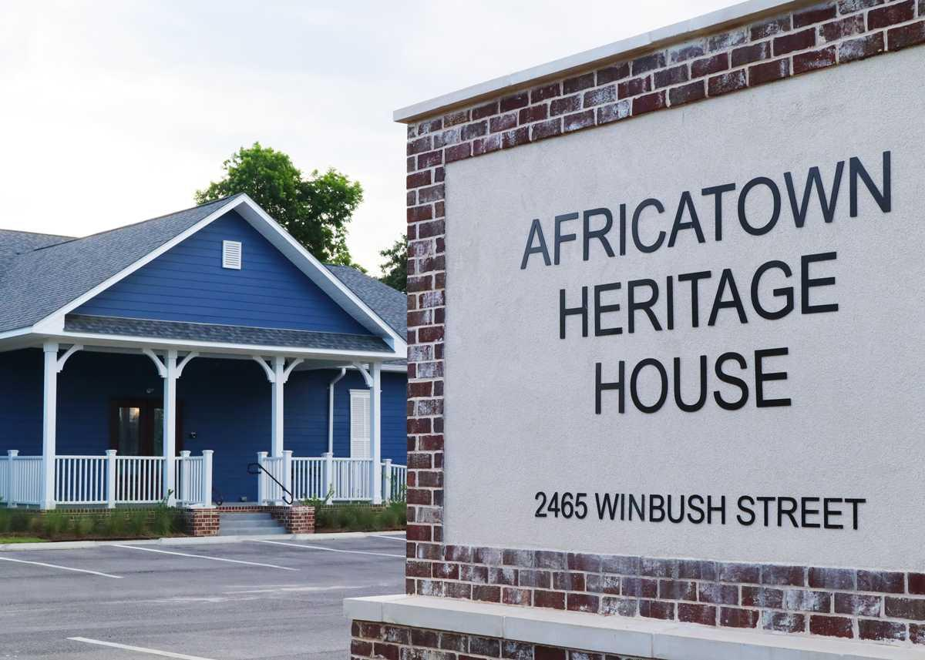
Image courtesy of The Africatown Heritage Museum, Reprinted in Country Roads, June 22, 2023

A View from a Descendant

I had not kept current about Africatown since 2022. In order to find out what has been going on since then, I interviewed Jeremy Ellis on April 9, 2025. Jeremy introduced himself as a direct descendant of Cupola and Rose Allen Cooper Lee, two of the enslaved Africans who were aboard the Clotilda. He paid tribute to the “original Descendants Association,” which his grandmother founded in 1984. He said that he was “standing on the shoulders” of the ancestors before him. The Africatown ancestors had been telling their truth since before the Clotilda had been “verified” in 2019. He does not say that the ship was “discovered” since its location was well known in the community. With regard to the narratives he had heard from the ancestors, he prefers to call them “truths, “rather than “stories”.
When I closed my paper in 2022, I was not sure the various interested stakeholders would be able to come together successfully to build the Heritage House and Museum and continue to advance the concept of Africatown as a tourist destination. However, in 2025, I learned that the Heritage House had a grand opening in July of 2023. The thrust of my questions to Jeremy was directed at how this goal had been achieved.
Jeremy outlined some components that drove the project to completion:
- Partnerships and Community Support for historic sites – The Heritage House Museum is a partnership between the Clotilda Descendants Association, Mobile County Commission, Visit Mobile, and the History Museum of Mobile. Through their efforts, the museum has become a popular tourist attraction. The National Geographic named it one of the “must-see” exhibits in 2024.
- Elected officials and civic organizations that understand the significance of these sites can be strong advocates. They can be local, state, and regional officials. In this case, the woman that Jeremy considers the “godmother” of the project is Merceria Lodegood, a County Commissioner. Though not a descendant, she is a long-time supporter of Africatown and its residents. She was able to secure $1.3 million for the opening of the Heritage House. Other prominent partners include:
  - City Mobile – funding of $250,000 (maybe he said “Visit Mobile” or “City of Mobile”)
  - Alabama Power Foundation (energy concern) – provided $75,000.
  - History Museum of Mobile – Jessica Farley now works inside of the House and oversees daily administration of the House. Their director, Meg Fowler, curated the exhibits in the House.
  - Visit Mobile – David Clark was a partner in planning the opening. This organization has done a lot of Public Relations work for the project.
  - The Clotilda Descendants Association continues to be involved in promoting Heritage House and other community events, along with Visit Mobile and the History Museum of Mobile. The descendants continue to tell their ancestor’s truths, holding an annual festival and landing event. There are boat tours and a wreath-laying ceremony at the site of the Clotilda. They stage plays to continue the oral traditions of the community.
I asked Jeremy whether the project was completed or if there is more work to be done. He said there are projects yet to be completed. There is to be a Welcome Center, a separate million-dollar project that will be led by the City of Mobile. The Welcome Center is to be across the street from the cemetery and Union Baptist Church, founded by the Clotilda Survivors in 1876. There is an ongoing effort to engage the descendants of Timothy Meaher, who commissioned the Clotilda, and still live in the Mobile area. In 2022, it did not seem to me that the two sets of descendants had achieved a meeting of the minds. However, Jeremy told me that the Meaher sisters have a presence in the community. They volunteer with organizations there. In 2023, they participated in a series of meetings to discuss the Meaher sisters’ involvement with the Clotilda descendants. Jeremy has a sense that the sisters are supportive of the development of Africatown. However, there are some asks related to artifacts that have not been made good on.
Regarding the impact of the development on the community, particularly the influx of tourists, Jeremy said that there had been a boom in tourism for Africatown and Mobile. He acknowledged that there have been concerns raised about traffic -- particularly buses, property taxes, and relocation of residents. He does not live in Africatown and cannot verify the impact on quality of life for the residents of the community. Yet, there are some trade-offs that benefit the community. There is training and certification for residents to participate in the tours for visitors. He said that those opportunities to share their ancestors’ truths were very important to the descendant community. The need for such training at historical sites was also noted by Lula Beatty when I talked to her about Crownsville. They would help ensure consistency of storytelling.
“What lessons can be shared with other communities undertaking such projects?” I asked. His reply:
- Partnerships were key to making this project a reality, as well as strong advocacy.
- Voting into office officials who understand the importance of historic places and landmarks.
- The significance of narration and history.
- Funding. Capitalism was a significant draw to partners. “If it don’t make dollars, it don’t make cents/sense” he recited. Show the economic benefit of the project.
- Make sure that the project is “descendant-driven”. “It is about the people, not the buildings.”
Although Africatown differs from Crownsville, Maryland in many respects—location, intention, and scope, among others—there are enough commonalities to include it among the case studies for this paper. In both instances, the memories/ stories/truths of those to be memorialized include captive populations -- people stolen from their homeland in the case of Africatown, and in Crownsville Hospital, people committed to a psychiatric facility sometimes under dubious conditions. In both cases, people engaged in placemaking, doing what they had to do to survive and thrive. There are successes in both places. The staff of Crownsville Hospital, particularly after the hiring of Black staff, did what they could to make the hospital a place of healing for the patients and the staff. Their memories are precious to them and spur their work to preserve them and be faithful to them. The founders of Africatown built a place that their descendants still honor, whether they live in the Mobile area or not. Both projects seek reparative justice.
***

Challenges

Consideration should be given to the potential for negative outcomes associated with expanded tourism. These may include, but are not limited to the following:
- Tourism can be a source of environmental degradation and human overcrowding. Motor vehicle traffic, particularly buses, will worsen air pollution and make it difficult for residents to get around. Crowds can be unruly and displace residents. They leave trash. However, it is possible to institute controls on the number of vehicles and or visitors allowed into the historic district at any given time. Trash disposal and recycling must be established.
- Increase in the volume of people in this old city will strain existing infrastructure, such as roads, the potable water supply, and the sanitary sewage system. Investment in these areas is necessary.
- Tourism can attract crime and other undesirable activities. Given that Black sites of memory, such as the marker for Emmett Till, have been repeatedly vandalized, keeping the area safe without an overbearing presence of law enforcement must be achieved.
- Tourism and, in this case, the new housing that comes with it, can displace long-time residents and replace traditional cultural practices with tourist shows and products unrelated to the history and people of Africatown. Residents have already raised questions of authenticity of story. The site can become “Disneyfied.”
- Can Africatown and the envisioned Africatown Cultural Mile be a sustainable resource? Can it be “green,” “clean,” and resistant to hurricanes, floods, and tornadoes? These events are expected to increase and become more intense as the climate changes. There has been little published discussion of these environmental hazards. Given their location on the Gulf of Mexico, these hazards must be considered.

Is This Justice?

The above considerations can be addressed through public engagement, thoughtful planning, and implementation facilitated by sufficient resources. However, even with the benefits of revitalization and reimagination of the Africatown community, the questions of equity and justice may still exist. That is, whether the proceeds from tourism can be equitably distributed in the community. If they are not, then those with means may obtain more means, and those living on the economic edge will continue to do so or be forced out. Justice will not have been achieved. One would hope that the residents of Africatown will not have to choose between their history and their people.

Janssen Evelyn on Crownsville vs Mobile

Given the differences in the situations between Mobile, Alabama and Crownsville, Maryland, are they at all comparable? On April 15, 2025, I interviewed Evelyn Janssen, the Deputy Chief Administrative Officer in the Office of the County Executive. An attorney, his Anne Arundel County portfolio includes land use, housing, and economic development. Regarding the Crownsville project, he was the staff assigned to the Advisory Committee’s Cultural History Subcommittee. His academic background includes African Diaspora Studies. We noted our mutual interest in the history and culture of African Americans and that it weaves through our work. He also teaches a course on community advocacy at the University of Maryland, Baltimore County.
I put this question to him: Are there lessons from Crownsville that other communities could benefit from, specifically Africatown and its goal of becoming a tourist draw. He opined that Mobile was such a different locale than Crownsville. He pointed out that nearby Annapolis is “the center of the state” as opposed to Mobile’s location in Alabama. Annapolis was slave port integral to the heritage of the area. He recalled the Sankofa principle – Go back and remember what you forgot. “Redevelop with history in mind. Make it a place of healing” (Evelyn 2025).
***

The Full American Story

Many have written about how to tell the “Full American Story” in heritage preservation --myself included (Howard 2021). In my research, I found that not everyone is sanguine about the prioritization of preservation and promotion of memorial properties, such as the one in Crownsville. In addition to town halls and workshops connected to the Memorial Park, I also attended every budget town hall for every district in Anne Arundel County in the winter of 2025. In my opinion, the meetings for the Memorial Park were well attended and focused. I will say the same for the budget meetings. Budget meetings, not unlike hearings held by the U.S. Congress for fiscal year appropriations, provide an opportunity for interest groups to lobby the County Executive to include or increase funding for their line item or program in the County budget. For most of the meetings, this included money for schools -- particularly special education teachers; public safety, including police and fire response; county libraries; improvements to the animal welfare facility; and sustained funding for the county food bank. I did not hear anyone speak about the Memorial Park in that setting. Apart from what will be in the County’s parks and recreation budget, funding for this restoration and repurposing will be proceeding on a separate track. Does this mean that the opportunity to tell the full American story about psychiatric imprisonment of African Americans it is not a priority?
Some argue that the sustainability of African American material culture is crucial to the survival of the people themselves, for them to be able to see their strength, ingenuity, and survival. Artist Joan Maynard observed that Black History needs the same protection as Black Lives (Cep 2020, 6). Black descendants also want and need to hear from and speak for previous generations. In the distant and recent past, it was seldom possible for Blacks to sustain family or historic properties or to participate in planning and demolition processes. As a result, countless heritage properties and communities were lost. In Crownsville, and in the Africatown and Dix Park cases discussed herein, meaningful representation and active participation in the processes of planning and implementation have been keys to bolstering support for these projects.
On the other hand, those active in social justice movements do not necessarily embrace this work on heritage sites. In The Sustainers (Bruce, 2019), civil and human rights scholar/activist Catherine Fleming Bruce reports that she spoke with Diane Nash, noted for her work with the Student Nonviolent Coordinating Committee (SNCC), the Freedom Riders, and the Alabama and Selma voting campaigns. Ms. Nash expressed a pragmatic attitude about the preservation of civil rights sites. Earlier, in response to efforts in Mississippi to promote civil rights tourism, Bruce states that Nash and fellow long-time activist C.T. Vivian published an open letter questioning the development of civil rights tourism and spaces, asking, ‘Who benefits?’ Bruce recounted, “From Nash’s point of view, with the exception of an elite few, the work in saving these sites does not produce a better income and a better quality of life for the masses in black communities who need jobs and opportunity. What’s more, the revenue from sites that are critical spaces born of the blood and sacrifice of black people is syphoned off to other communities. What does not uplift in a tangible way is not acceptable to Nash” (Bruce 2019, 199).
Bruce also quotes Jacqueline Smith, who questions the effort to convert the site of the assassination of Dr. Martin Luther King, Jr. into the National Civil Rights Museum. Smith believes that the funding spent on the Lorraine Motel and the National Civil Rights Museum should have been used to help the poor around the community through direct services. “Her point of view suggests that civil rights hallowed ground could and should do more to promote the political and economic agenda of civil rights struggle, not just the legacy. . . . Smith’s view is that the decision to save and transform the place where Dr. King’s life ended was actually an injustice, where poor people who need financial support were on the losing end” (Bruce 2019, 200). One may wonder whether the work of addressing past harm is isolated from addressing present harm. Can the memorials and monuments be a distraction from addressing what is currently happening in communities struggling against systemic racism?
Also for consideration: What form should reparative actions take? Bruce asks, “Do African American communities benefit when civil rights tourism, museums, re-enactments or films are created: Should they? If so, in what form should that benefit come? Would the money be better spent on social, economic uplift and political programs, as some activists say?”(Bruce 2019, 200-201). In Crownsville, the Equity Subcommittee of the Crownsville Hospital Memorial Park Advisory Committee considered these questions within the context of planning for the Memorial Park. They are addressing my foundational question, “How do we encourage cultural health and equity in a diverse and unequal world?”
***

Equity and Social Justice in Crownsville

What is Equity?

Promoting equity was the vision for the Crownsville Hospital Memorial Park from its inception. The Master Plan’s Equity Statement references Executive Order 61, an explicit policy statement that articulates the County’s vision of “an equitable and just world, where Crownsville Hospital Memorial Park honor[s] and preserve[s] the history and legacy of the Hospital, and those who were institutionalized during its operation, by creating a space where people can heal through the natural beauty of the site and access multi-needed resources and services” (Anne Arundel County 2023, 2).
To ensure that equity was a guiding principle of the Master Plan, the Crownsville Advisory Committee empaneled an ad hoc subcommittee to develop a statement and operational tools to promote this concept. Do note: the Master Plan’s Equity Statement is placed on Page 3, immediately following the Executive Summary. Accompanying it is an acknowledgement of injustice and inequity that took place at Crownsville Hospital. Acknowledgement is a first step toward social justice. The Acknowledgement is below. (Design Collective 2025, 3)
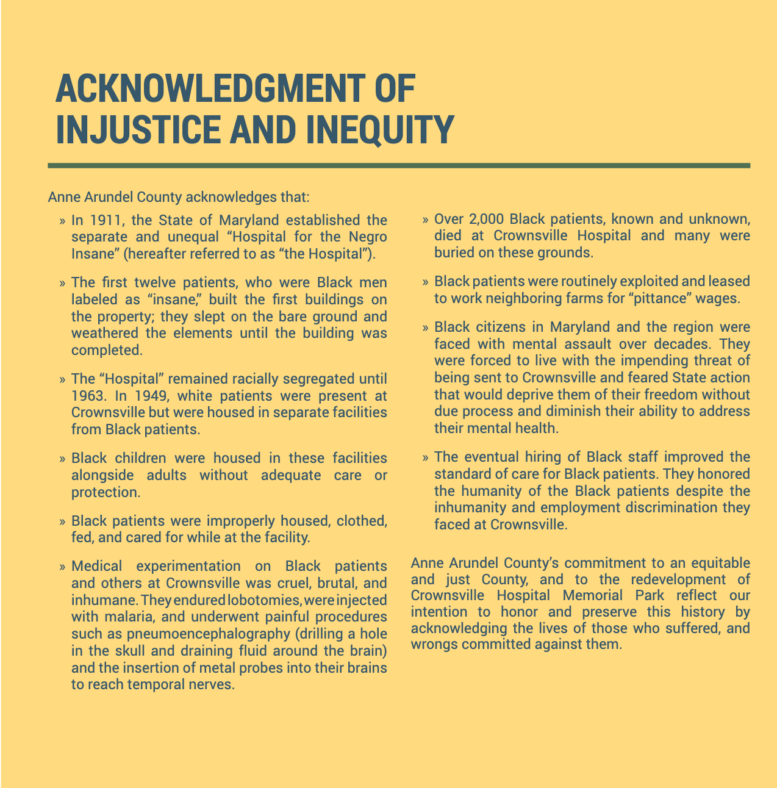
The Master Plan references a definition of equity attributed to the United Way of National Capital Area, which uses it to differentiate between equality and equity.
“Equity”, in its simplest terms as it relates to racial and social
justice, means meeting communities where they are and allocating
resources and opportunities as needed to create equal outcomes
for all community members. “Equity” further recognizes each person
has different circumstances and needs, meaning different groups of
people need different resources and opportunities allocated to them
in order to thrive.” (United Way of the National Capital Area)

But how can this definition be applied to achieve social justice for those who were affected by Crownsville Hospital? The United Way of the National Capital Area dives deeper into the concept of equity in a blog post on their website dated March 20, 2025. It states, “social justice typically focuses on fairness for historically oppressed people—especially Black, Indigenous, and People of Color (BIPOC) who have disproportionately faced institutional discrimination or systemic racism. Social justice and equity go hand in hand” (United Way of the National Capital Area, 2025). Social justice recognizes and addresses systemic barriers and provides tailored support to create fair outcomes. “Seeking equity is, by default, seeking social justice” (United Way of the National Capital Area, 2025). In the case of Crownsville Memorial Park, their pledge to equity comes with tools to implement racial reconciliation, restorative justice, and wellness. In summary, the Equity Plan iterates the County’s commitment to do the following:
- Prioritize the history of Crownsville with respect to African-Americans and persons with mental illness, to ensure that barriers to their access and full participation are addressed.

- Utilize an equity lens in making decisions regarding access, programming, services, and opportunities associated with the site to ensure that no groups are unintentionally excluded, marginalized, or harmed by governmental action at the site.

- Identify opportunities to enhance our collective understanding of racism, ableism, intolerance, inequity, and injustice, as well as the institutional structures perpetuating them to prevent the replication of harmful structures.

- Maintain dedicated spaces at the Memorial Park for an accurate narrative of the history of Crownsville Hospital and the continued need for racial equity work in the County.

- Ensure that former patients, employees, and their descendants are afforded opportunities for meaningful representation and participation on any board(s), commission(s), or entity(ies) authorized to manage the Park’s activities and affairs.

- Solicit organizations, staff, donors, board members, volunteers, partners, and service providers that reflect the diversity and breadth of the County’s communities.

- Utilize best practices to provide minority and disadvantaged business enterprises with opportunities to contract or otherwise provide vendor services for the redevelopment and continued operation of the Park.

The Equity Committee developed an “Equity Lens” for use as a tool to guide equity-informed decision-making in evaluating proposals for procurement, contracting, and personnel. (Design Collective 2025, 6)

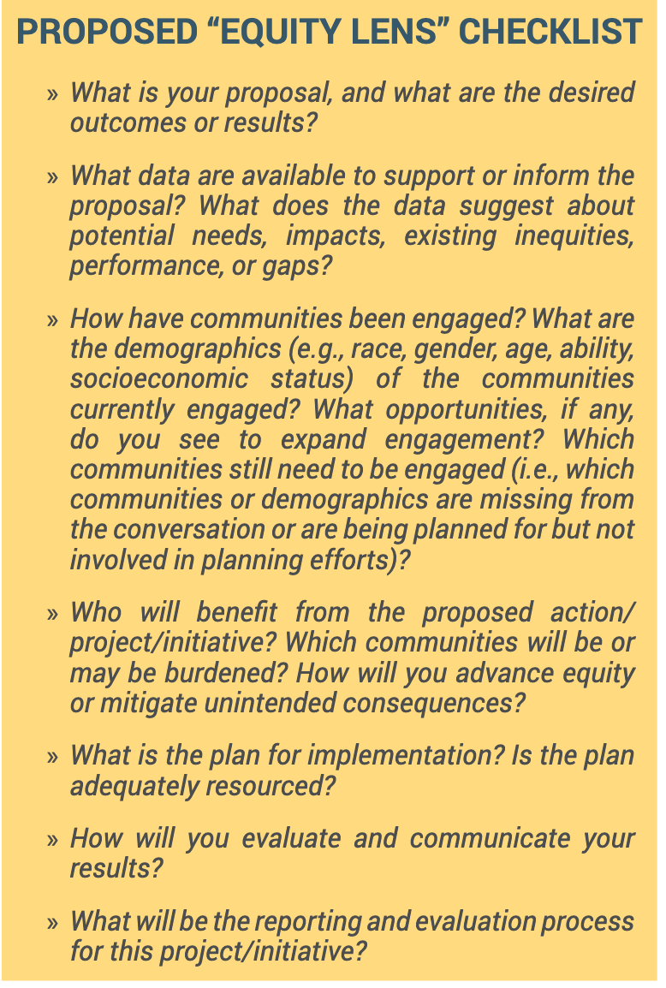
The committee also recommended engaging local communities through social media platforms and public meetings; setting measurable goals and transparently communicating results to the public; providing ongoing training for board members, staff, and volunteers on racial equity, diversity, inclusion, and cultural humility; and using data-informed insights to identify gaps in service delivery and community engagement. Furthermore, data should be disaggregated by race, gender, socioeconomic status, and other social identity markers.

Bending the Arc

“The arc of the moral universe is long, but it bends toward justice.” Can this march toward justice be sustained in Crownsville? This is a multi-generational project in which the background context and environment will continue to shift. How can the momentum driving this effort be sustained? Efforts are already underway. These include the following:
- Actions by the County, such as Executive Orders that remain in effect unless overturned; prioritization in budgets; incorporation in agency strategic plans, particularly in the forthcoming strategic plan for the Office of Equity and Human Rights;

- Legislative actions by the Anne Arundel County Council, exemplified by recent passage of a law authorizing the Crownsville Hospital Memorial Park Advisory Committee, as well as actions taken by other legislative bodies, such as the Maryland General Assembly and the U.S. Congress;

- Interest by philanthropic organizations and developers, which has already been seeded;

- The public process itself, which promotes activism on the part of stakeholders and accountability on the part of civic leaders; and

- Continued coverage by the media.

***

A View on Equity from Asha Smith

On March 27, 2025, I interviewed Asha Smith, Director of Equity and Human Rights for Anne Arundel County. Asha led the Equity Ad Hoc Subcommittee of the Crownsville Hospital Memorial Park Advisory Committee. I participated in that group’s effort to draft an Equity Statement to accompany the County’s master plan. This interview was part courtesy and part information gathering. I wanted to let Asha know that my attendance at town halls and working on the subcommittee led to my choosing Crownsville Hospital Memorial Park as the focus of my capstone, and that I would be in contact with others who worked on the subcommittee or the full committee. I was also hoping to get some information about how the focus on equity might be sustained throughout the development of the Memorial Park and instilled into its operation as a complete entity.
Asha, an attorney, came to her office, the first of its kind in the County, from the Department of Education. A generation or two younger than myself, she had never undertaken a project like Crownsville, though she was not surprised that such institutions and circumstances, at the intersection of race and mental illness, existed in the U.S. I asked her whether anything had surprised her about Crownsville. She said the vastness of the site, and its development and existence as a self-sustaining entity (farming, industries, etc.) had surprised her, as did her recognition of how many people were affected by Crownsville Hospital.
When asked how the concept of equity could be sustained through the life of the project, she suggested that the process itself had memorialized equity. Documentation of the work of the various committees through their reports and suggestions, created a public voice to shape a community narrative. These records would be available to future administrations and to the general public. She believes that it is up to the public to keep the implementation of the project accountable regarding equity. She also said the promotion surrounding the publication of Antonia Hylton’s book about Crownsville has demonstrated that the triad of race, mental illness, and incarceration is a national issue.
Asha’s office is working on a strategic plan. Although it has not yet appeared on the County website, I am anticipating that it will address the issue of sustainability of equity in the Memorial Park project and other County efforts.
***
The case studies in this thesis document the way communities in the United States have honored memory at sites where there have been atrocities or other contested histories, some of which took place decades ago. Is it ever too late to achieve justice? In Tulsa, Oklahoma, the march toward reconciliation has been ongoing for more than 100 years, pursued by several generations of survivors of a massacre, their descendants, and supporters of the effort in Tulsa and in other parts of the United States.
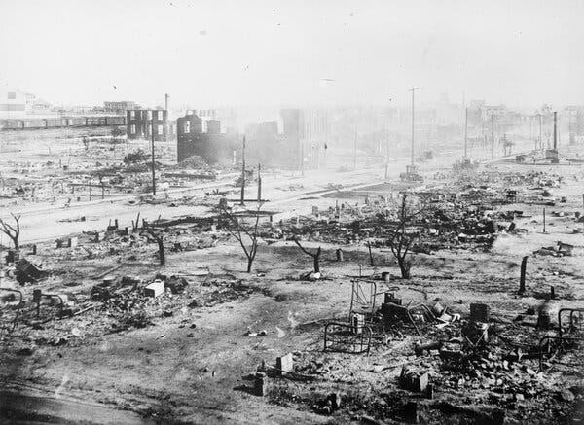
“The Greenwood district after the massacre in Tulsa, Okla, in 1921. Library of Congress” Reprinted in The New York Times, June 1, 2025.

Justice Delayed: Tulsa, Oklahoma

“Justice Delayed is Justice Denied.” This is a proverb quoted by many. Long a maxim reflecting the goal of a swift resolution in the American legal system, it is often honored in the breach. However, there are some instances in which long-denied justice can be brought to bear on long-standing consequences of unjust acts. Intergenerational trauma wrought by acts of racism and perpetuated by systemic and institutional racism might still be addressed in Tulsa, Oklahoma.
The Tulsa Massacre in brief: In 1921, as many as 300 Black people were killed and dozens of homes and businesses of Black people were destroyed in acts of racially motivated violence committed by a White mob over a two-day period. Today, there are many memorials to Black Wall Street, and the people who lived, thrived, died, and survived in the Greenwood District of North Tulsa. (Museum of Tulsa History. n.d.) However, people of Tulsa want more than memorials. Even more than spatial justice, they want reparations. After more than one hundred years, they may get them.
On June 1, 2025, the media reported that a $105 million charitable trust was to be created as reparation for the harms resulting from the 1921 Tulsa Race Massacre. As reported by the New York Times (Burch and Kerr, 2025), Tulsa Mayor Monroe Nichols announced that this charitable trust is designed to address housing, scholarships, land acquisition, and economic development for people in North Tulsa. It will be funded by money from private sources, property transfers, and possibly also by public sources. Funds will be raised over the next 12 months to initiate the “Greenwood Trust,” named after the neighborhood where the violence occurred. Greenwood had been a prosperous area nicknamed “the Black Wall Street” before it was destroyed by a mob led by White people. The Greenwood Trust is being created to provide relief from blight, poverty, and other consequences of inequality endemic to Tulsa. This was announced on Tulsa’s first “Race Observance Day”. The new plan does not include direct payments to survivors or descendants of the massacre. The city has created a “Beyond Apology Commission” to explore reparations for descendants of massacre survivors and people who live in the area today.
This effort is the first large-scale effort to ameliorate the impact of the Tulsa Massacre. Previously, there was an unsuccessful lawsuit to award cash reparations to the few remaining survivors of the atrocity. It has been 104 years since the massacre. Now, there are only 2 survivors. There are descendants of the people harmed by the events still living in North Tulsa. This new effort is intended to uplift Tulsa as a whole. “There is not one Tulsan, no matter their skin color, who wouldn’t be better off today had the massacre not happened,” Mayor Nichols said (Bryan 2025). The city was destroyed by the events in 1921, and its future altered. It might have continued to be a place of Black prosperity. The city issued an apology for its role in the massacre in 2021. To acknowledge and preserve the past, the mayor also announced the release of 45,000 previously classified city records on the race massacre. This was an action recommended by the descendant group, “Justice for Greenwood” (Bryan, 2025).
LaDonna Penny, a granddaughter of one of the survivors, Lessie Benningfield Randle, was interviewed by the New York Times reporters. She said she was ecstatic about the trust. “Restoration and reparation,” she said. “That’s what happened today” (Burch and Kerr, 2025).
***

Conclusion

Could Crownsville and other communities identified in this paper be exemplars for other communities seeking reconciliation of sites with contested histories? The simple answer is “yes”. The complex and realistic answer is “it depends”. Every site, every community, and every country is going to have its own historical, geopolitical, economic, and environmental scenario. Time is another important variable. What worked in Mobile, Alabama in the 2020s might not work in Los Angeles in the 2030s should atrocities occur there. Sometimes action is spurred or sustained by a confluence of events and forces, for example, the publication of a book documenting the history of a place and elevating voices; empathetic and effective political leadership; economic environment ripe for development, engaged affected communities, and the general sociopolitical climate.
The timing and environment may never be perfect to sustain the effort for the many years it takes to bring a project to fruition, but at least communities can get on the path toward reconciliation of disparate forces in heritage work. Based on my research, the following are some observations about successful elements of the process of transforming sites of atrocity to places of healing, education, and reparative justice.

Suggestions for Communities Undertaking Projects Involving Sites with Difficult Histories

- People are the best cultural asset. Individual actions as well as group activities can make or break a project. In Crownsville and some of the case studies, there are descendant groups and “friends” groups that protect and support the project, a museum, a cemetery, or other entity. They can fundraise, provide points of contact for certain issues, and perform other functions. They can be a presence at public meetings and yield clout. There are at least two such groups associated with Crownsville Memorial Park, including the Friends of the Crownsville Hospital Patient Cemetery and Crownsville Caretakers United. A friends group could be established for the future museum and other components of the Memorial Park. These organizations can be an action arm of a project, in addition to being a point of contact and a source of knowledge.
People need not act as a group to effect change. In Africatown, County Commissioner Merceria Lodegood may be considered a godmother of the Africatown project. Though not a descendant, she is a long-time supporter of Africatown and its residents. She was able to secure $1.3 million for the opening of Heritage House. In Crownsville, several godparents were apparent to me, including Janice Hayes-Williams and Faye Belt. Although there are men who have championed the Memorial Park, including Steuart Pittman, I found that this role often is seized by women. These women are “bad asses” in the way they work within and outside of systems of power to accomplish their goals. It is also true that there is an emotional weight to supporting heritage projects. It takes a lot of energy, and people who put in this energy should be recognized, supported, and honored.
- Individuals can play important roles in developing and promoting a heritage project, but partnerships are the key to successful implementation. In the Africatown case study, I noted the many partners in the development process. It seems to me that it took time for partnerships to ripen and partners to get comfortable and productive in their roles. I expect that there will be many more partners attached to the Crownsville project.
- Do not prioritize the preservation of buildings, infrastructure, or objects over the memorialization of people. I heard and read some versions of this admonition several times in the course of my research. The voices of descendants and affected community members should guide the process.
- Take a broad view when defining “affected communities”. Include people who are current members of the community, former community members, and people whose lives were directly affected by the site but may not have lived or worked at the site. For example, Elinor, my interviewee, wanted the Crownsville Memorial Park outreach to have included people who lived beyond the immediate circumference of the hospital and into other parts of Anne Arundel County.
- Stories are complex. Big and small, stories can be expressed in a variety of ways, including through visual arts, oral histories, and reenactments. This approach is being implemented in Dix Park through its cultural interpretation plan. Additionally, a range of perspectives should be represented. Acknowledgment of past harm is critically important, but so are stories of community life. For example, in Crownsville, the memories of those who worked at the hospital and helped patients must be presented, as well as the difficult lives of the patients. In Africatown, the success of the establishment of the town and the achievements of the community members must not be overshadowed by the story of the trafficking of humans, the wreck of the ship that carried them from Africa and Alabama, and their lives as enslaved people.
- A variety of policy tools can be deployed. For instance:
- Acknowledgment of harms by community, state, national, or institutional leaders is an important first step. Official apologies, such as the one issued by Tulsa, Oklahoma, can receive national attention and garner wider support for a site transformation.
- Policy tools, including Executive Orders, legislation, zoning decisions, and government budgets, can provide sustainability for a project, though such actions can also be overturned or withdrawn.
  - In government-sponsored projects, a cross-agency approach to prioritizing the project is essential. Agency strategic plans should articulate goals and initiate actions related to the project. Future strategic plans should include actions to sustain the goals of the heritage project across multiple government agencies and offices.
- Keep telling the story. Hiawatha Asylum is gone, but the story of the people who lived there remains. The descendants and tribal members are honoring and preserving the memories of the people who were confined to these spaces. Their stories are even now told in ceremonies, blogs, and podcasts. Doing this could create momentum for a more fitting memorial to those who suffered there. As it is often said, “Remembering is a form of resistance.” Memories can become actions.
- If the space allows for it, and the community advocates for it, the heritage aspects of the site can be joined with spaces for nonprofits that serve or advocate for people who need transitional housing, counseling, job training, and arts education. These may fit the mission and theme of these sites and promote reconciliation. Community gardens and spaces for recreation are also essential. It is a form of healing the land. Dix Park and Crownsville are proposing this remedy for the land.
- If equity is a goal, ensure that it means more than representation, though there should be representation of affected people and community stakeholders at meetings, on committees, and in story narratives. Tools to implement equity, to document effort, and to sustain it are necessary. Achievable goals must be set, and evaluation of progress toward them must be documented and publicly available.
- In some cases, targeted remedies to remediate harms committed in the past may be sought. This has been the case in Tulsa, where reparative justice was sought for survivors of the Massacre and is now being implemented on the community level. In Crownsville, a local branch of the organization, the American Descendants of Slavery, advocated for targeted actions to ensure equity in services, management, and resources in the Memorial Park.
- If the project is expected to generate proceeds, such as from tourism, a mechanism should be in place to ensure that the income can be equitably distributed in the community in however the community is defined. If it is not, then those with means may obtain more means, and those living on the economic edge will continue to do so or be forced out. Equity will not have been achieved.
- Pursue recognitions, such as by the International Coalition of Sites of Conscience, National Register of Historic Places, and/or state and local recognitions of historic significance. Privately funded organizations may also support recognition of noteworthy sites. The Toni Morrison Society supports the “Bench by the Road” project, which honors Morrison’s wish for there to be somewhere to sit and reflect on the stories of enslaved African Americans and important significant moments, individuals, and locations related to the African diaspora. (The Toni Morrison Society n.d.) Crownsville and other sites might consider these forms of recognition if they have not already done so.
- The development process should remain open to public viewing. Keep it on their radar. The Crownsville Memorial Park website has a virtual walk-through of the site, enabling viewers to see the progress since they cannot visit the site in person. When possible, related public observances, such as the Say My Name Ceremony in Crownsville and Canton, can help keep memories alive.
- Study other development plans for the same site. Idealistic or not. Implementable or not. I reviewed two master’s theses for Crownsville Hospital and found them to be thoughtful in their context. Perhaps there are papers in university archives that re-imagine other sites that are worth considering. If there is a plan for restoration of the Hiawatha Cemetery site, it could be helpful in igniting action there.
- Consider that planning and implementation processes to reimagine a heritage site, even when the heritage is not strongly contested, may encounter a series of failures or delays. Plans may have to be scaled down or abandoned, at least until the stars realign themselves in the site’s favor. This is the case in Fergus Falls. But even so, the community is able to use the landscape of the site. It is a community asset while on the market for further development.

Exemplars

In conclusion, Anne Arundel County and other communities can serve as exemplars to others trying to transform sites with contested histories. Unfortunately, many more properties fit that description in the United States and abroad. We can learn from each other and adapt strategies others have used to meet these challenges to fit their specific situations. Reconciliation is a long process, but bending the arc of the moral universe toward justice is worth it. In my opinion, this is particularly true for Black heritage sites. During the public comment period on the Crownsville Master Plan, I submitted an idea for consideration. I recommended that there be space set aside for conferences, not a full conference center per se, but a small building for policy discussions or educational retreats on matters of social justice. Accommodations for participants could be in Annapolis, and refreshments catered. I imagined a “Crownsville Memorandum” or a “Bacon Ridge Agreement” being hammered out there, in the mode of the Wye River Conference Center. Alas, my suggestion did not make it into the Master Plan.

Black Landscapes Matter

In the introduction to a collection of essays entitled Black Landscapes Matter, editor Walter Hood, a landscape architect, puts forward three reasons why Black heritage landscapes are important. He notes the following. (Hood 2020, 1-8)
- “Black landscapes matter because they are prophetic. They tell the truth of the struggles and victories of African Americans in North America. . . . These landscapes are the prophecy of America: they tell us our future.“ We can reflect on the past to ensure that we get the future we want. (Hood 2020, 1-2).
- “Black landscapes matter because they are renewable. We can uncover, exhume, validate, and celebrate these landscapes through new narratives and stories that choose to return us to origins. . . . It is up to us to help America remember through our collective speech, writings, art, music, architecture, and landscapes” (Hood 2020, 4).
- “Black landscapes are resilient and forward looking” (Hood 2020, 5).
Crownsville Hospital surely fits Hood’s paradigm for Black landscapes. The transition of the hospital site into a Memorial Park will enable those who visit the site to both go back and remember and to look forward – the embodiment of Sankofa.


CODA: Reflection

Field Trip: A Walk in the Woods – April 26, 2025, noon
On a Saturday in April that rained off and on, I took a field trip to Bacon Ridge, in observance of the Scenic Rivers annual “Walk in the Woods” event. The Walk in the Woods is sponsored by Scenic Rivers Land Trust, with additional sponsorship from local organizations and individuals. This year is the 20th anniversary of the walk. I had never been to Bacon Ridge though it is no more than 15 miles from my house.
I was alerted to the event after seeing a posting for the Walk in the Woods on Facebook and in a newsletter sent out by the County Executive’s Office. They noted that Janice Hayes-Williams would be giving a talk on the memorial to be built for the Crownsville Hospital Patient Cemetery, for patients of the hospital who died there and had not been claimed by family or others. Some of these patients had been “disappeared.” (My term.) They had been sent to Crownsville without the knowledge of family members and never heard from again. They had been buried without the dignity of name markers. I had been hoping to get an interview with Janice, an Annapolis historian and former director of the Anne Arundel County Office of Community Engagement and Constituent Services. Janice wears many hats. Another of them is leading the Friends of the Crownsville Hospital Patient Cemetery, which is adjacent to the hospital site.
I had registered for Janice’s walk. In anticipation that I would be treading on sacred ground, I donned respectful gear. I wore my bright yellow “We Can Do It” t-shirt, featuring Michelle Obama as Rosie the Riveter flexing her fabulous arm muscles and my double axe earrings – an homage to Shango, a deity of the Yoruba people of Nigeria. For practicality, I wore hiking boots in my favorite color, blue. I was ready to meet the ancestral spirits at the Crownsville Hospital Patient Cemetery.
From the perspective of entering Crownsville through Crownsville Road, the registration tables for the walk were directly behind the remains of the asylum. As I drove to the registration site, I could see that construction related to wastewater and sewage on the hospital site was underway, even on a Saturday.
I had assumed that we were going on a walk, but when I arrived, Janice was speaking to a group of about a dozen people at the top of a slight hill just a few feet away from the registration tables. I joined them. It was just starting to rain.
The feature Janice was describing was the site of the memorial to those who are buried there. Its platform is already in place. She said that she made sure it could take the weight of the monument that will arrive this June when there will be a “Say My Name Ceremony”. An annual spring observance, it will take place on June 26 from that point on. The bricks are in place with numbers that represent each departed. However, she and others have identified each person by name. In speaking of this work, Janice said she was surprised to find out that one of those buried there was a White woman, or someone we would consider White now. All the others were classified as Black (probably “Negro” or “Colored”). She said the White woman was supposed to have thrown herself in front of a train which used to run through the property. Her family apparently had not wanted to make other arrangements for her. So, she, perhaps a dark complected woman, was buried with the Negroes. There she will remain, memorialized with the others.

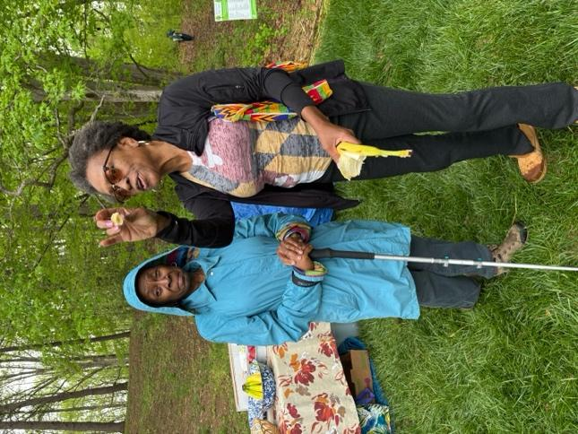

Janice Hayes Williams Speaking Her Truth at Bacon Ridge, April 26, 2025.
Photo Credit: Sandra Howard
In addition to talking about the work she has been leading to identify those buried in the patient cemetery, she told me one more amazing thing. She said that the state of Maryland had paid “reparations” to the families who had not been notified of the deaths of their relatives. I asked a follow-up question as to the form of the reparations. She said that the reparation was money, but she didn’t give details of the amount. I wanted to know more but didn’t want to press her during the walking tour.
The responsibility of protecting heritage and honor is a heavy one. Janice is a petite, lively woman. “Bad-Ass” is an honorific I have heard ascribed to her. At some point in her storytelling, she laughingly said that the “County is sick of her.” I begged to differ and said so in the group. I’m sure she has been insistent and persistent, as she is armed with knowledge and passion. However, I have heard (or read) Executive Pittman note her as the person who had educated him about why the hospital memorial park is important. Given the investment of time and county resources put toward this project, he seems to have embraced this passion in his own way.
Although there will be an installation of the memorial to the patients this year, the entire memorial park is a multi-generational endeavor. Janice said that she expects the construction project is going to take 20 years. Janice, a woman who may be at least in her sixties, said she will be there at the finish! I applauded. I don’t know if I will be there at the finish, but I intend to keep an eye on its progress.
Janice also said that she is taking oral histories for the county. They will become a collection. I met one of the women who is assisting her. Like me, she had worked in Washington DC and had had more of an attachment to it than where she lived, or “slept”, she said of her homeplace in Annapolis. Her life had been focused on D.C. I understood. Eventually, she made a deliberate effort to embrace the Annapolis area as “home”. I told her I was trying to do the same thing. She said it was a good idea to get involved in something to make that happen. We are keeping in touch on these possibilities.
There will be a dedication ceremony for the monument at the patient cemetery later this year. I plan to be there.
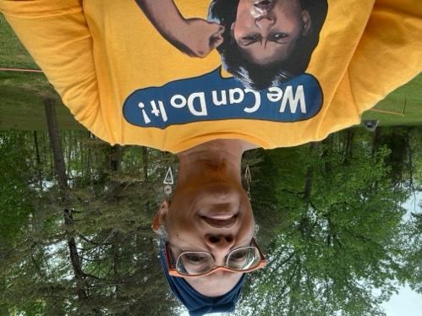 The author at Bacon Ridge, April 26, 2025. Photo Credit: Sandra Howard

Crownsville Hospital Memorial Park:
Honoring the Past, Healing the Present, Imagining the Future

Bibliography

Archives and Libraries

Bowie State University. “LibGuides: Crownsville Hospital.” Bowie, Maryland. https://bowiestate.libguides.com/c.php?g=442220&p=3014786.
Digital Repository at the University of Maryland (DRUM). College Park, Maryland. https://umd.libanswers.com/systems/606?product_id=606&m=view_posts
Maryland Shared Open Access Repository (MD-SOAR). https://mdsoar.org/home.

Books, Articles, Reports, Theses, and Websites
Alabama Historical Commission. 2019. “Finding the Clotilda.” https://ahc.alabama.gov/press/Finding_Clotilda_Press_Kit_%205.30.19_edit_11.16.21.pdf
Anderson, Michele. 2014. “Imaginative Fields: A Companion to Action.” M.A. Capstone, Goucher College. https://mdsoar.org/items/3c8f1116-f77b-45aa-9380-c5bdf0835f9e.
Anne Arundel County Government. n.d. Accessed 2024-2025. https://www.aacounty.org.
____________. 2025. “Anne Arundel County Releases Final Master Plan for Crownsville Hospital Memorial Park.” February 12, 2025. https://www.aacounty.org/county-executive/news/anne-arundel-county-releases-final-master-plan-crownsville-hospital-memorial.
____________. 2023. “Executive Order No. 61.” https://www.aacounty.org/sites/default/files/2023-09/SP-61.PDF
Atlas, Caron. 2001. “Cultural Policy: What Is It? Who Makes It? Why Does It Matter?” In Culture Counts: Strategies for a More Vibrant Cultural Life for New York City. 65-68. New York: New York Foundation for the Arts.
Avrami, Erica, ed. 2020. Preservation and Social Inclusion. New York: Columbia Books on Architecture and the City. https://www.arch.columbia.edu/books/catalog/503-preservation-and-social-inclusion
Bedoya, Robert. 2014. “Spatial Justice: Rasquachification, Race and the City.” CreativeTime Reports.
Bhatara, Vinod S., Sanjay Gupta, and Martin Brokenleg. 1999. “The Hiawatha Asylum for Insane Indians: The First Federal Mental Hospital for an Ethnic Group.” American Journal of Psychiatry. 156:5, May 1999. https://psychiatryonline.org/doi/full/10.1176/ajp.156.5.767#F1
Borrup, Tom, 2006. The Creative Community Builder’s Handbook: How to Transform Communities Using Local Assets, Art and Culture. St. Paul: Fieldstone Alliance Publishing Center.
Brice, Anne. 2020. “How the U.S. government created an ‘insane asylum’ to imprison Native Americans.” UCBerkeley News. https://news.berkeley.edu/2020/11/19/using-disability-to-imprison-native-americans/.
Brow, James. 1990. “Notes on Community, Hegemony, and the Uses of the Past.” Anthropological Quarterly. 63(1):1-6.
Bruce, Catherine Fleming. 2019. The Sustainers: Being, Building and Doing Good Through Activism in the Sacred Spaces of Civil Rights, Human Rights and Social Movements. TNOVSA LLC.
Bryan, Max. “$105 Million Trust to Be Built for 1921 Tulsa Race Massacre Reparations, City Says.” Public Radio Tulsa, June 2, 2025.
https://www.publicradiotulsa.org/local-regional/2025-06-01/105-million-trust-to-be-built-for-1921-tulsa-race-massacre-reparations-city-says.
Burch, Audra D. S., Breena Kerr “$105 Million Reparations Package for Tulsa Race Massacre Unveiled by Mayor.” The New York Times, June 1, 2025. https://www.nytimes.com/2025/06/01/us/tulsa-race-massacre-reparations.html.
Capital Gazette. “Say My Name: Remembering Those Buried at Crownsville Hospital | PHOTOS,” April 30, 2022. https://www.capitalgazette.com/2022/04/30/say-my-name-remembering-those-buried-at-crownsville-hospital-photos/.
Cartwright, R.L. n.d. “Fergus Falls State Hospital.” MNopedia, Minnesota Historical Society. https://www3.mnhs.org/mnopedia/search/index/structure/fergus-falls-state-hospital.
Cep, Casey. “The Fight to Preserve African-American History.” The New Yorker, January 27, 2020. https://www.newyorker.com/magazine/2020/02/03/the-fight-to-preserve-african-american-history.
Christopher, Gail C. 2017. “Truth, Racial Healing, and Transformation: Creating Public Sentiment.” National Civic Review. https://drgailcchristopher.com/wp-content/uploads/2017/12/TRT_Article.pdf.
Cloud Gehshan Design and Brocade Studio. 2024. “Cultural Interpretation Plan.” Accessed June 2025. https://dixpark.org/cultural-interpretation-plan. Collins, Sam P. K. “Conditions at St. Elizabeths East Test Resident-Property Manager Relations.” The Washington Informer, August 16, 2024. http://www.washingtoninformer.com/conditions-at-st-elizabeths-east-test-resident-property-manager-relations/.
Data USA. “Canton, S.D.” n.d. Accessed June 2025. https://datausa.io/profile/geo/canton-sd.
Data USA. “Crownsville, MD.” n.d. Accessed June 2025. https://datausa.io/profile/geo/crownsville-md.
Design Collective. 2025. “Crownsville Hospital Memorial Park Master Plan: Final Master Plan Report.” https://www.aacounty.org/sites/default/files/2025-02/crownsville-master-plan-20250212.pdf
Diouf, Sylviane A. 2025. “Africatown.” Encyclopedia of Alabama. https://encyclopediaofalabama.org/article/africatown/
Dix Park. n.d. Accessed June 2025. https://dorotheadixpark.org.
Dix Park Legacy Committee. 2018. “Final Report Adopted by the Dix Legacy Committee
on August 28, 2018 As Recommended by the Communications Subcommittee.”
https://web.archive.org/web/20220109191446/https://dixpark.org/sites/dixpark/files/2018-11/Dix%20Park_Full%20Legacy%20Report_2018.pdf
enBloom. “HEAL Crownsville.” Accessed September 14, 2024. https://www.enbloom.life/healcrownsville.
Equal Justice Initiative. 2020. “The Widespread Failure to Preserve African American History,” January 31, 2020. https://eji.org/news/widespread-failure-to-preserve-african-american-history/.
Family Search. n.d. “South Dakota Indigenous Peoples.” https://www.familysearch.org/en/wiki/South_Dakota_Indigenous_Peoples.
Fergus Fall, City of. 2023. Accessed December 2024. https://www.fergusfallsmn.gov.
Gilman, Lisa, and John Fenn, eds. 2019. Handbook for Folklore and Ethnomusicology Fieldwork. Indiana University Press. https://iupress.org/9780253040251/handbook-for-folklore-and-ethnomusicology-fieldwork/.
Gladstone, Brooke, host. 2018. “Africatown.” On the Media. Podcast. May 18, 2018. 54:31. https://www.wnycstudios.org/podcasts/otm/episodes/africatown.
Gmelch, Sharon Bohn. 2018. “Why Tourism Matters.” In Tourists and Tourism: A Reader, Sharon Gmelch and Adam Kaul, eds. 3-16. Long Grove, IL: Waveland Press.
Greater Fergus Falls. n.d. Accessed December 2024. https://www.greaterfergusfalls.com.
Gunderson, Dan. 2018. “Fate of Fergus Falls Hospital Splits Community.” MPRNews. https://www.mprnews.org/story/2018/03/07/fate-of-fergus-falls-hospital-splits-community.
Hand, Jamie, and Tasha Golden. 2018. “Arts, Culture, and Community Mental Health.” Community Development Publications, Federal Reserve Bank of San Francisco. https://www.frbsf.org/community-development/publications/community-development-investment-review/2018/october/arts-culture-and-community-mental-health .
Harris, Brittany. 2021. “Centering Abundance: Rememberings from bell hooks on Love and Community,” The Inclusion Solution. December 16, 2021. Accessed September 30, 2024. https://theinclusionsolution.me/centering-abundance-rememberings-from-bell-hooks-on-love-and-community/
Hawkes, Jon. 2001. The Fourth Pillar of Sustainability: Culture's Essential Role in Public Planning. Common Ground Publishing Pty Ltd in association with the Cultural Development Network.
Hawthorne, Camilla and Jovan Scott Lewis, ed. 2023. The Black Geographic: Praxis, Resistance, Futurity. Durham: Duke University Press.
Heim, Joe. “Their Graves Were Marked Only by Numbers. She Fought to Find Their Names.” The Washington Post, August 29, 2024. https://www.washingtonpost.com/dc-md-va/2024/08/29/crownsville-hospital-cemetery-memorial/.
Hoang, Tram, Rasheedah Phillips, and Jasmine Rangel. 2024. Grounding Justice: Toward Reparative Spatial Futures in Land and Housing. Policy Link. Accessed August 15, 2024. https://policylink.widen.net/s/vzcmpdfqgk/07_15_24_grounding_justice_report
Hood, Walter and Grace Mitchell Tada, ed. 2020. Black Landscapes Matter. Charlottesville: University of Virginia Press.
Howard, Sandra. “Memory and Justice: Africatown, Alabama USA”, unpublished paper, December 2022.
____________. “The Full American Story”, unpublished paper, December 2021.
Hower, Kirstein. 2022. “Vision for Former Crownsville State Hospital Centers Nature and Healing | National Trust for Historic Preservation.” Accessed September 14, 2024. https://savingplaces.org/stories/vision-for-crownsville-state-hospital-centers-nature-healing
____________. 2016. “Behind the Walls: The Uncertain Future of Crownsville State Hospital.” National Trust for Historic Preservation. Accessed July 6, 2024. https://savingplaces.org/stories/uncertain-future-crownsville-state-hospital.
Hurston, Zora Neale. 2018. Barracoon: The Story of the Last “Black Cargo”. Amistad.
Hylton, Antonia. 2024. Madness: Race and Insanity in a Jim Crow Asylum. New York: Legacy Lit.
International Coalition of Sites of Conscience. Accessed August 15, 2024. http://www.sitesofconscience.org/.
Jackson, Vanessa. 2002. “In Our Own Voice-American Stories of Oppression, Survival and Recovery in Mental Health Systems.” The International Journal of Narrative Therapy and Community Work.Dulwichcentre.Com.Au, no.2. www.dulwichcentre.com.au.
Kaufman, Ned. 2009. Place, Race, and Story: Essays on the Past and Future of Historic Preservation. New York: Routledge.
Kemp-Rotan, Renee. n.d. “If We Can Save the Ship, We Can Save the Town.” The Architectural League of New York. Accessed November 16, 2022. https://archleague.org/article/africatown-intro/?printpage=true.
Kinnally, Kevin. 2022. “State Transfers Crownsville Hospital Center to Anne Arundel County.” Conduit Street (blog), July 6, 2022. https://conduitstreet.mdcounties.org/2022/07/06/state-transfers-crownsville-hospital-center-to-anne-arundel-county/.
Keyes, Allison. “The ‘Clotilda,’ the Last Known Slave Ship to Arrive in the U.S., Is Found,” Smithsonian Magazine, May 22, 2019. https://www.smithsonianmag.com/smithsonian-institution/clotilda-last-known-slave-ship-arrive-us-found-180972177/
Maryland Association of Counties. Accessed June 28, 2025. https://conduitstreet.mdcounties.org/2022/07/06/state-transfers-crownsville-hospital-center-to-anne-arundel-county.
Leah, Heather. 2024. “Enormous Sculpture Weaving through Dix Park Draws Massive Crowds.” WRAL.com, June 22, 2024. https://www.wral.com/story/enormous-sculpture-weaving-through-dix-park-draws-massive-crowds/21494541/.
Legacy Sites. “The National Memorial for Peace and Justice.” Accessed September 14, 2024. https://legacysites.eji.org/about/memorial/.
Lepore, Jill. 2021. “When Black History Is Unearthed, Who Gets to Speak for the Dead?” The New Yorker, September 27, 2021. https://www.newyorker.com/magazine/2021/10/04/when-black-history-is-unearthed-who-gets-to-speak-for-the-dead.
Levin, Aaron. 2019. “Behind the Legend of Dorothea Dix Rests a Woman ‘Famous but Unknown.’” Psychiatry Online. https://psychiatryonline.org/doi/10.1176/appi.pn.2019.4a13.
Little, Barbara J. 2019. “Violence, Silence and the Four Truths: Towards Healing in U.S.-American Historical Memory.” International Journal of Heritage Studies 25, no. 7 (July 3, 2019): 631–40. https://doi.org/10.1080/13527258.2018.1542333.
Lockman, J.T. Moodee, 2025. “Anne Arundel County Finalizes Plan to Transform Historic Psychiatric Hospital into Education, Health Center,” CBS News, February 13. https://www.cbsnews.com/baltimore/news/maryland-crownsville-hospital-anne-arundel-county-health-education/
Lytle, Melanie D. 2011. “A Fundamental Transformation: The Management of South Africa’s Heritage for Nation Building in the Post-Apartheid Era.” M.A. Thesis, Goucher College. https://api.mdsoar.org/server/api/core/bitstreams/38e97e7e-bd19-4b85-a03a-a31e32c0d2ac/content.
Low, Setha. 2023. Why Public Space Matters. New York: Oxford University Press.
MACS. 2018. Capstone Proposal Guidelines Update. https://www.goucher.edu/learn/graduate-programs/ma-in-cultural-sustainability/documents/MACS-Capstone-Proposal-Guidelines-Update-2018-Final.pdf)
Madison, D. Soyini. 2019. Critical Ethnography: Method, Ethics, and Performance. Los Angeles: SAGE Publications, Inc.
Maryland Historical Trust. “Heritage 2031: Maryland’s Statewide Preservation Plan.” n.d. Accessed August 15, 2024. https://mht.maryland.gov/Pages/default.aspx
Maryland Historical Trust | Maryland Commission on African American History & Culture. “Historic African American Cemeteries.” June 30, 2022. Accessed August 15, 2024. https://africanamerican.maryland.gov/historic-african-american-cemetery-project/.
Maryland Renaissance Festival. n.d. Accessed March 2025. https://rennfest.com.
Mason, Michael, and Rory Turner. 2020. “Cultural Sustainability: A Framework for Relationships, Understanding and Action.” Journal of American Folklore 113, no. 527 (Winter 2020): 81–105.
Mayes, Thompson. 2018. Why Old Places Matter: How Historic Places Affect Our Identity and Well-Being. Lanham: Roman and Littlefield Publishers.
McConkey, Tony. n.d. “Crownsville Community List” | Delegate Tony McConkey’s Official Blog.” Accessed August 5, 2024. http://www.leg33.com/crownsville-community-list/.
McKown, Harry W. Jr. 2023. "Dorothea Dix Hospital." NCpedia. State Library of NC. June 2023. https://www.ncpedia.org/dorothea-dix-hospital.
Moradi, Bonnie, and Patrick R. Grzanka. “Using Intersectionality Responsibly: Toward Critical Epistemology, Structural Analysis, and Social Justice Activism.” Journal of Counseling Psychology 64, no. 5 (October 2017): 500–513. https://doi.org/10.1037/cou0000203.
Museum of Tulsa History. n.d. “1921 Tulsa Race Massacre.” Accessed July 2, 2025. https://tulsahistory.org/exhibit/1921-tulsa-race-massacre/
National Park Service. “Civil Rights Framework - National Historic Landmarks.” Accessed September 17, 2024. https://www.nps.gov/subjects/nationalhistoriclandmarks/civil-rights-framework.htm
_________. “National Historic Landmarks.” Accessed August 15, 2024. https://www.nps.gov/subjects/nationalhistoriclandmarks/index.htm.
_________. “National Register of Historic Places.” Accessed August 15, 2024. https://www.nps.gov/subjects/nationalregister/index.htm.
_________. “Underrepresented Communities Grants - Historic Preservation Fund (National Park Service).” Accessed August 15, 2024. https://www.nps.gov/subjects/historicpreservationfund/underrepresented-community-grants.htm
National Trust for Historic Preservation. Last modified July 18, 2024. “African American Cultural Heritage Action Fund | National Trust for Historic Preservation.” Accessed August 14, 2024. https://savingplaces.org/african-american-cultural-heritage
_________. 2024. “Reimagining St. Elizabeth’s Asylum | National Trust for Historic Preservation.” Accessed September 14, 2024. https://savingplaces.org/stories/reimagining-st-elizabeths-asylum.
_________. 2024. “Vision for Former Crownsville State Hospital Centers Nature and Healing | National Trust for Historic Preservation.” Accessed September 14, 2024. https://savingplaces.org/stories/vision-for-crownsville-state-hospital-centers-nature-healing.
Nazaryan, Alexander. “Can a Decaying Hospital With a Grim History Be Brought Back to Life?” The New York Times, April 17, 2025, sec. Business. https://www.nytimes.com/2025/04/17/business/crownsville-maryland-development.html.
NBC News. “Maryland Mental Health Hospital ‘Crownsville’ Transformed.” Accessed July 6, 2024. https://www.nbcnews.com/nightly-news/video/maryland-mental-health-hospital-crownsville-transformed-202683461675.
Nuriddin, Ayah. 2019. “Psychiatric Jim Crow: Desegregation at the Crownsville State Hospital, 1948–1970.” Journal of the History of Medicine and Allied Sciences 74, no. 1 (January 1, 2019): 85–106. https://doi.org/10.1093/jhmas/jry025
Oakford, Samuel. 2024. “Va. Health Staff Failed Irvo Otieno as He Suffocated, Experts Say.” The Washington Post, July 26, 2024. https://www.washingtonpost.com/investigations/2024/07/26/irvo-otieno-medical-response/.
Oral History Association. “Best Practices in Oral History.” Accessed December 9, 2024. https://oralhistory.org/best-practices/
_________. “One-Year Contract Positions @ Crownsville Hospital.” April 16, 2025. https://oralhistory.org/2025/04/16/one-year-contract-positions-crownsville-hospital/.
Raines, Ben. 2022. The Last Slave Ship: The True Story of How Clotilda Was Found, Her Descendants, and an Extraordinary Reckoning. New York: Simon and Schuster.
Raleigh, North Carolina Government. 2025. “Dix Park Leadership Committee. https://raleighnc.gov/parks-and-recreation/services/boards-and-commissions/dix-park-leadership-committee
Raleigh Parks, Recreation and Cultural Resources. 2019. Dorothea Dix Park Master Plan. https://dixpark.org/sites/default/files/2019-03/2019.03.18_DIX%20MASTER%20PLAN%20BOOK_web%20viewing_reduced%20size.pdf
Reise, Matthew. 2023, “From Harm to Hope: Reimagining an Abandoned Asylum as a Space of Reflection, Rejuvenation, and Rejoice.” M.A. Thesis, University of Maryland, College Park. “DRUM: Digital Repository at the University of Maryland.”
Rosenblatt, Adam. 2024. Cemetery Citizens: Reclaiming the Past and Working for Justice in American Burial Grounds. Stanford: Stanford University Press.
Scenic Rivers. n.d. Accessed May 2025. https://www.srlt.org.
Sharp, John. “What Africatown Hall Means to Community Founded by Survivors of the Clotilda Slave Ship.” al, May 26, 2024. https://www.al.com/news/2024/05/what-africatown-hall-means-to-community-founded-by-survivors-of-the-clotilda-slave-ship.html.
Shepherd, Katie. 2025. “Maryland Will Save $326M by Moving State Workers to Downtown Baltimore.” The Washington Post, June 6, 2025. https://www.washingtonpost.com/dc-md-va/2025/06/06/moore-maryland-cuts-phones-cars/.
Sidian, Derek. 2025. “Greater Fergus Falls Suspending Activities.” Fergus Now. https://fergusnow.com/2025/03/06/greater-fergus-falls-suspending-activities/.
Sites of Conscience. “Home.” Accessed August 15, 2024. http://www.sitesofconscience.org/.
Skift, Sarah Enelow. 2016. “The Rise of Civil Rights Tourism in America’s Deep South,” August 25, 2016, https://skift.com/2016/08/25/the-rise-of-civil-rights-tourism-in-americas-deep-south/.
Sopact. “Social Impact Assessment Guide.” Accessed September 17, 2024. https://www.sopact.com/guides/social-impact-assessment
Specker, Lawrence. 2021. “Africatown Design Idea Contest Seeks Big Visions for ‘Cultural Mile,’” AL.com, Updated: Jun. 04, 2021, 11:00 a.m.|Published: Jun. 04, 2021, 6:15 a.m., https://www.al.com/life/2021/06/africatown-design-idea-contest-seeks-big-visions-for-cultural-mile.html.
Southern Environmental Law Center. 2025. “Africatown’s Historic Legacy of Resilience and Revival,” April 21, 2025. https://www.selc.org/news/africatowns-historic-legacy-of-resilience-and-revival/.
Springboard for the Arts. n.d. “Hinge Arts at the Kirkbride.” https://springboardforthearts.org/programs/hinge-arts-at-the-kirkbride/
Starzmann, Maria Theresia, and John R. Roby, ed. 2016. Excavating Memory: Sites of Remembering and Forgetting. Gainesville: University Press of Florida.
Stuckey, Zosha. 2017. “Race, Apology, and Public Memory at Maryland’s Hospital for the ‘Negro’ Insane.” Disability Studies Quarterly 37, no. 1 (March 7, 2017). https://doi.org/10.18061/dsq.v37i1.5392.
Tai, Daniela. 2019. “Seeking Asylum: Race, Memory, and the American Landscape.” M.A. Thesis., University of Maryland. - Accessed August 5, 2024. https://www.proquest.com/openview/c0ea9a7f2c00b7bfff4530214ee96540/1?pq-origsite=gscholar&cbl=18750&diss=y.
Tillman, Brian A. n.d. “Racial Reconciliation: No Handholding Kumbaya.” https://www.umc.org/en/content/racial-reconciliation-no-handholding-kumbaya.
Toni Morrison Society. n.d. “Bench By the Road Project.” https://www.tonimorrisonsociety.org/bench.html
Tumarkin, Maria. 2019. “Twenty Years of Thinking about Traumascapes.” Fabrications 29 (1): 4–20. doi:10.1080/10331867.2018.1540077.
UNESCO. n.d. “Routes of Enslaved Peoples Project.” Accessed May, 2025. https://unescositesofmemory.org/sites-of-memory/.
United Nations Human Rights Office of the High Commissioner. n.d. “Out of Africa Monologue Series”. Accessed May 2025. https://www.ohchr.org/sites/default/files/Documents/Issues/Racism/smd.shahid.pdf
United Way of the National Capital Area. 2025. “Social Justice Definition, Equity & Resources.” https://unitedwaynca.org/blog/equity-and-social-justice/.
U.S. Census Bureau. n.d. “Fergus Falls city, Minnesota.” https://data.census.gov/profile/Fergus_Falls_city,_Minnesota?g=160XX00US2720906.
Vanclay, Frank. 2003.“International Principles for Social Impact Assessment.” Impact Assessment and Project Appraisal 21, no. 1 (2003): 5–12. https://doi.org/10.3152/147154603781766491.
Visit Fergus Falls. n.d. Accessed December 2024. https://www.visitfergusfalls.com.
Walker, David. 2015. “Horse-Stealing Mania: The Hiawatha Asylum for Insane Indians.” Mad in America. https://www.madinamerica.com/2015/03/horse-stealing-mania-hiawatha-asylum-insane-indians/.
White, Meghan. 2017. “Reimagining St. Elizabeth’s Asylum.” | National Trust for Historic Preservation.” Accessed September 14, 2024. https://savingplaces.org/stories/reimagining-st-elizabeths-asylum
Van Dyke, Brandon. 2017. “Crownsville Hospital Center.” Accessed July 6, 2024. https://www.atlasobscura.com/places/crownsville-hospital-center
Villarosa, Linda. 2024. ”Institutional Racism.” Review of Madness: Race and Insanity in a Jim Crow Asylum by Antonia Hylton. February 25, 2024. The New York Times.
Wikipedia. “Aspen Institute Wye River Conference Centers.” Accessed August 25, 2024. https://en.wikipedia.org/w/index.php?title=Aspen_Institute_Wye_River_Conference_Centers&oldid=1106590217.
_________. “Deinstitutionalisation.” Acessed February 10, 2025. https://en.wikipedia.org/w/index.php?title=Deinstitutionalisation&oldid=1274932246
_________. “Fergus Falls Regional Treatment Center.” Accessed January 13, 2025. https://en.wikipedia.org/w/index.php?title=Fergus_Falls_Regional_Treatment_Center&oldid=1269128784.
_________. “Kirkbride Plan.” Accessed January 26, 2025. https://en.wikipedia.org/w/index.php?title=Kirkbride_Plan&oldid=1271959586
_________. “Social Impact Assessment.” Accessed July 9, 2024. https://en.wikipedia.org/w/index.php?title=Social_impact_assessment&oldid=1233502861.
_________. “St. Elizabeth’s Hospital.” Accessed January 3, 2025. https://en.wikipedia.org/w/index.php?title=St._Elizabeths_Hospital&oldid=1266975133.
Yellow Bird, Pemina. 2017. “Wild Indians: Native Perspectives on the Hiawatha Asylum for Insane Indians.”
https://power2u.org/wp-content/uploads/2017/01/NativePerspectivesPeminaYellowBird.pdf.
Zanolli, Lauren. 2018. “Still fighting: Africatown, site of last US slave shipment, sues over pollution,” The Guardian, January 26, 2018, https://www.theguardian.com/us-news/2018/jan/26/africatown-site-of-last-us-slave-ship-arrival-sues-over-factorys-pollution.

Other Media

Anne Arundel County Government. “Crownsville Hospital Memorial Park.” Accessed August 15, 2024. https://www.aacounty.org/CrownsvillePark.
Arundel TV. Crownsville Hospital Memorial Park Workshop. May 16, 2024. https://www.youtube.com/watch?v=JcSrhOs57ds.
Brown, Margaret. 2022. “Descendant.” https://participant.com/campaign/descendant/
C-Span. “Historic Georgetown African American Cemetery Preservation.” | June 25, 2024 | C-SPAN.Org.” Accessed September 26, 2024. https://www.c-span.org/video/?536588-2/historic-georgetown-african-american-cemetery-preservation.
Equal Justice Initiative. “Community Remembrance Project.” https://eji.org/projects/community-remembrance-project/.
Garrity, Susan. "Every Path Speaks.” https://ohmaexhibits.sandbox.library.columbia.edu/ohma-2021-exhibit-hub/every-path-speaks.
Maryland Lynching Truth and Reconciliation Commission. MLTRC Prince George’s County Public Hearing - January 25th, 2025, 2025. https://www.youtube.com/watch?v=-ShUTvj0FA4.
National Geographic. 2022. “Clotilda: Last American Slave Ship.” https://www.youtube.com/watch?v=2IMEL5Bz-AE
Pittman and Friends Podcast. Episode 6. “Cecily Bedwell On the future of Crownsville Hospital Memorial Park.” Accessed November 30, 2024. https://www.aacounty.org/pittmanandfriends
_________. Episode 12. “Asha Smith on Equity and Human Rights.” Accessed April, 2025. https://www.aacounty.org/pittmanandfriends.
Stevens, Todd. 2018. “Crownsville Hospital: From Lunacy to Legacy.” Prime Video. Accessed September 14, 2024. https://www.primevideo.com/detail/Crownsville-Hospital-From-Lunacy-to-Legacy/0QOL9BXMB2NOYMD7XG0CAG7NCI.

Interviews
Anderson, Michelle. “Interview with Michelle Anderson.” Interview by Sandra Howard via Zoom, March 26, 2025. Audio 50:45. Howard’s personal collection.
Beatty, Lula. “Interview with Lula Beatty.” Interview by Sandra Howard via Zoom, April 7, 2025. Audio 1:22:37. Howard’s personal collection.
Belt, Faye. “Interview with Faye Belt.” Interview by Sandra Howard via Zoom, April 5, 2025. Audio 1:45:17. Howard’s personal collection.
Ellis, Jeremy. “Interview with Jeremy Ellis.” Interview by Sandra Howard via Zoom, April 9, 2025. Audio 55:47. Howard’s personal collection.
Evelyn, Janssen. “Interview with Janssen Evelyn.” Interview by Sandra Howard via Zoom. April 5, 2025. Audio 40:16. Howard’s personal collection.
Johnson, Chanel Compton. “Interview with Chanel Compton Johnson.” Interview by Sandra Howard via Zoom. March 31, 2025. Audio 46:20. Howard’s personal collection.
Smith, Asha. “Interview with Asha Smith.” Interview by Sandra Howard via Zoom. March 27, 2025. Audio 27:03. Howard’s personal collection.
Thompson, Elinore. “Interview with Elinore Thompson.” Interview by Sandra Howard via Zoom. March 26, 2025. Audio 53:13. Howard’s personal collection.
***

So named in law by Maryland General Assembly in the 1910 Session. Archives of Maryland Online, Volume 487, Page 237. Accessed June 9, 2025. Various permutations of the name of the hospital before and after integration, are referenced elsewhere.
The source of this paper may be mislabeled. Its web address does link to the United Nation’s Office of the High Commissioner, but “The Out of Africa Monologue Series” cannot currently be found on that site. It may have been produced in connection with an ongoing “Africa Dialogue Series”, but I cannot verify this. No author or publication date is attached to the paper. It appears to have been written in 2020. It cites no other publications. I chose to use it because I find it to be thoughtful in its definitions of various forms of racism.
Several sources speak of the longing to return to Africa, as well as the determination to establish a town in the New World, including Zora Neale Hurston in Barracoon.
Residents, some who preferred not to be identified by name voiced these concerns on the “On the Media” broadcast and other interviews.
This aphorism is often attributed to Martin Luther King, Jr., but it has a longer history. See: https://quoteinvestigator.com/2012/11/15/arc-of-universe/

