The Impact on Peer-to-Peer Relationships
with the use of a Morning Meeting

by
Philip J. Luettgen

Submitted in Partial Fulfillment of the Requirements for the

Degree of Master of Education

July 2020

Goucher College
Graduate Programs in Education

Table of Contents
Abstract i
I. Introduction 1
Overview 1 - 3
Statement of the Problem 3
Statement of Research Hypothesis 3
Operational Definitions 3 - 4
II. Literature Review 5
Definition of Morning Meeting 5 - 7
Impact of Morning Meeting 7 - 9
Perception of Morning Meeting 10 - 11
Promoting Positive Peer-to-Peer Relationships 11
III. Methods 13
Design 13
Subjects 13
Instrument 14
Procedure 14 - 15
IV. Results 18 - 20
V. Discussion 21 - 23
References 24 - 25
Appendix A 16
Appendix B 17
Abstract
In the following action research study, the educator examined the impact on peer-to-peer relationships with the implementation of a morning meeting. Relationships are a key component in today’s 21st century classroom and the research indicate that students who have more positive relationships often perform better academically and have a higher trajectory for success after school. The hypothesis in this study was that the use of a morning meeting will have no impact on positive peer-to-peer relationships. The subjects were that of a 4th grade classroom in Anne Arundel County Maryland. Pretest data was collected using a tool titled “Bullying Self-Assessment Grades 3-5”. Implementation of the morning meeting began. However, due to the Covid-19 pandemic, the action research study is incomplete without any posttest data.

i

CHAPTER I
INTRODUCTION
Today’s twenty-first century student requires a variety of aspects to be successful in the classroom. These aspects could include a quality learning environment, integration of technology, the use of multiple learning styles, and differentiation, to name a few. Another key aspect is student relationships. This includes student-to-student relationships as well as student-to-teacher relationships. These relationships are created and fostered using multiple types of strategies. One strategy used today in classrooms to construct positive relationships is called a Morning Meeting. “Morning Meeting is a structured way to begin each day as a community of caring and respectful learners” (Bondy & Ketts, p. 144, 2001). This initiative illustrates the importance of creating a space of time each day for students and teachers to delve into conversations or scenarios in which they begin a dialogue that promotes positive relationships.
Overview
Positive relationships among students can look like students playing on the playground together, offering someone a seat at the lunch table, working together on a biology project, or walking home together, among many more. These relationships are created or developed in a multitude of ways. Some students grow up together in the same neighborhood, play on the same varsity tennis team, and even might be in the same school club together. However, these situations are mostly random. More than ever, students come from a variety of backgrounds or experiences, which is why the opportunity for students to build positive relationships with each other and their teachers must be created. These opportunities to build positive relationships are deliberate rather than random.
Positive relationships among students are important for many reasons, including motivation as well as engagement toward learning, the link between achievement and positive relationships, building confidence, and increased productivity. “Today, a caring environment and an effective style of classroom management foster children’s development and guide them to respect other people, their environment, and their own learning” (Horsch, Jie-Qi, & Nelson, 1999, p. 225). This is all about creating a connectedness between students and their school. Students who have positive relationships with other students are more likely to have better school attendance, grades, and test scores.
Quite adversely, students who have fewer or even negative peer-to-peer relationships, are less likely to be successful in school. These students can illicit or produce negative behavior as well. “Behavior problems in elementary school are among the strongest predictors of underachievement, delinquency, and violence later in life” (Anyon, Nicotera, & Veeh, 2016, p. 81). Simply put, students who do not have positive relationships among their peers are put at a disadvantage. In recognition of this outcome, districts and schools have created or developed specific interventions to help promote positive relationships among students.
A variety of intervention systems are used to promote positive relationships among students. These include, positive behavior interventions and supports (PBIS), schoolwide initiatives, and team-building activities. In their own way, these interventions can help improve positive relationships among students. Another intervention being utilized to increase positive relationships is a Morning Meeting. “Teachers create a respectful, caring learning community that promotes the development of both academic and social competencies” (Horsch, Jie-Qi, & Nelson, 1999, p. 224). Morning Meeting has evolved over time and continues to do so in some classrooms today.
Morning Meeting first began as “circle time” in its earliest form. Teachers used this time in primary grades (Kindergarten, first grade, and second grade), to establish routines. During this routine, teachers might review the calendar, share the daily schedule, or even practice brief academic skills such as the alphabet, letter sounds, or math practice. Morning Meeting can still serve these purposes in classrooms today. However, this time is now being used to build a classroom community among students. Classrooms continue to be very diverse and students have a multitude of experiences. Due to this fact, teachers have been become intentional in their focus to help students build positive relationships with each other. “Morning Meeting helps students develop responsibility, assertiveness, cooperation, empathy, and self-control” (Bondy & Ketts, p. 145, 2001).
Statement of the Problem
The purpose of this study is to determine whether the use of a Morning Meeting increases positive relationships among students in a fourth-grade classroom.
Hypothesis
The use of a Morning Meeting will not improve positive relationships among students.
Operational Definitions
- Morning Meeting:
This intervention will be used daily as a tool to determine whether there has been an increase in positive relationships among students. The morning meeting will focus on character development and social development exercises aimed at building relationships for students. Students will be given opportunities to share their own experience, point of view, and respond to their classmates.
- Positive relationships among students:
Positive relationships among students will be measured through the use of a pre/post survey that assesses how students individually feel about their own peer-to-peer relationships as well as analyze data on peer-to-peer interactions in the classroom prior to and after the implementation of the Morning Meeting (intervention).
- Peer-to-Peer Relationships/Interactions:
These relationships will be measured using the pre/post assessment. Various assessment statements include, “I have been called names,”, “I have excluded or left out someone on purpose,”, and “I have told someone not to be friends with someone else,”. Student responses on the assessment which include: “never, sometimes, often”, will be collected before intervention and after to determine the results.

CHAPTER II
REVIEW OF THE LITERATURE
The review of the literature discusses interventions for improving students’ relationships. Section one covers the specific intervention, Morning Meeting. Section two covers impact of Morning Meeting. The third section covers the perception of Morning Meeting. Lastly, section four covers how to promote positive peer-to-peer relationships among students using a Morning Meeting.
Definition of Morning Meeting
Introducing Morning Meeting
The world of education is always evolving. Much like new initiatives and strategies that help improve or promote students’ academic success, there are also initiatives and strategies that are aimed at improving students’ social-emotional health. One of these strategies or initiatives is the use of a morning meeting. “Kriete calls the classroom meeting time Morning Meeting and suggests it establishes a climate of trust; meets the child's need for significance and belonging; and merges social, emotional, and intellectual learning” (Gardner, 2012, p. 1). Over time, there has become an intentional focus on the social-emotional development of children to help promote the overall success of students in school. However, making the most out of this structured time takes effort and a specific plan.
Implementing Morning Meeting
To make morning meetings successful in the classroom, they must be implemented correctly. This begins with the introduction of the meeting where the purpose for the morning meeting is established and teachers use this time to identify and highlight students’ strengths, challenges, and interests. “For many students and staff members, morning meeting is a preferred activity that allows for creativity, interaction, and fun” (Hume, 2006, p. 1). In addition to that, the meeting helps promote a classroom community where students feel safe, respected, and valued. “The classroom Morning Meeting establishes a climate of trust; meets each child's need for significance and belonging; and merges social, emotional, and intellectual learning” (Gardner, 2012, p.1). Much like a learning objective prior to an academic lesson during language arts or math class provides the reason for learning, students need to understand the purpose behind morning meeting or the “why,”.
Another key component to implementing morning meeting in a classroom is the organization of it. The morning meeting should be structured in a way that students know what to expect such as the routines or procedures and the weekly schedule. “The shared knowledge that emerges from these well-rehearsed routines becomes part of the individual classroom culture” (Bruce, Fasy, Gulick, Jones, & Pike, 2006, p. 2). For example, beginning each morning meeting with a “greeting” goes a long way. During this routine, students feel respected or valued by their classmates and it sets the tone. Lastly, Gray and Richards (1992) discuss that a weekly schedule for morning meeting such as having a specific topic for each day of the week builds familiarity and comfort for students in the classroom. It becomes part of the day that students look forward to and where they can build confidence.
Lastly, facilitating the morning meeting is just as vital as the introduction or the organization of the process. It should begin with a greeting, reviewing the procedures, sharing the daily focus, guiding the discussion, and then reviewing. “The greeting allows the teacher to model positive and respectful ways of greeting and to teach greetings appropriate for different ages and different circumstances” (Gardner, 2012, p.1). Although it may seem rudimentary, the greeting serves a specific purpose as well as the other elements of facilitation. In addition to that, sharing the daily focus and the guided discussion goes a long way for all students. “Morning Meeting provides a rich context for offering learning experiences that address multiple intelligences” (Bruce, et. al, 2006, p. 2). While facilitation of the morning meeting may be difficult at first and the structure may vary from school to school or even class to class, it is imperative to the overall purpose of morning meeting which is to promote students’ social-emotional development.
Impact/Effect of Morning Meeting
Academic Benefits
Morning meeting has many benefits for students who participate in them. One of the specific benefits is academic improvement. The power of morning meeting can help enhance students’ productivity, confidence, as well as reinforce specific academic skills. “Morning Meetings impact classwork productivity because they help to identify and meet students’ social and emotional needs which provide teachers with vital information for targeted intervention” (Parelius, 2018, p. 52). The morning meeting serves as an informal assessment where teachers can gather student specific information and help guide their individual development.
A second academic benefit of morning meeting is promoting student confidence. “A classroom where students are comfortable and encouraged to use written, oral, and non-verbal communication will foster literate children who take social and academic risks as they continue their development” (Williams, 2011, p. 6). Morning meeting can seem intimidating to some students at first; however, over time they begin to get more comfortable as they build familiarity with the routine of morning meeting and as the classroom community develops. This helps enhance student confidence to take risks during instruction as well because it is a place where they feel “safe.”.
Morning meeting can also be utilized to reinforce academic skills. “As students read and then discussed their Reading Logs in Morning Meeting they performed authentic book talks: sharing books and authors that interested them and, in turn, introducing them to fellow third graders” (Boyd, & Smyntek-Gworek, 2012, p. 7). This example from a third-grade classroom shows that morning meeting can also be a time to capitalize on reinforcing students’ academic skills. For example, using a read-aloud from the previous day’s language arts lesson, a teacher could center the morning meeting around the theme or even make a connection to the text. Although morning meeting was designed to specifically promote students’ social-emotional development, it also has academic benefits that can include student productivity, increasing student confidence, and a time to reinforce academic skills.
Behavioral Benefits
Morning meeting helps develop respect, cooperation, and peer-to-peer relationships. The meeting does this through the structure and routines it provides. One of the key implementation strategies is to begin with a “greeting” that can be modeled by a teacher. “I make it a point to shake each of my children’s hands which makes them smile and feel a part of a small community for the time that they are in my classroom” (Glick, 2010, p. 5). This greeting illustrated by the teacher shows an appropriate way that students should interact with one another. Also, in morning meetings, the specific structure or procedure also promotes behavioral benefits. “Circle provides opportunities to encourage children to have positive relationships where they learn to take turns, wait, and work together” (Bruce, et. al, 2006, p. 2). Teachers can structure their morning meeting to work on specific behavioral skills like cooperation or even a specific subject such as how to disagree with a classmate in a positive manner.
Finally, morning meeting can also build peer-to-peer connections. Although morning meeting is a structured time that serves a specific purpose, it is also a time that students can learn about each other. This includes their interests, strengths, challenges, etc. “Each component of Morning Meeting strengthened classroom relationships while empowering students to express themselves confidently” (Gardner, 2012, p. 3).
Social-Emotional Benefits
The use of morning meeting also promotes the social-emotional development of students in various aspects. Some of these aspects include self-actualization, empathy, and self-esteem. “Self-actualization includes characteristics of morality, problem solving, and acceptance –skills that a social and emotional learning environment address” (Williams, 2011, p. 11). Morning meeting is a restorative practice that contributes to a social and emotional learning environment. This is yet another example of how the social-emotional development of children has come to the forefront within education. “Morning Meeting helps create a safe space where students can learn and practice social skills such as empathy, active listening, positively contributing to conversations and discussions, problem solving, using critical thinking skills, treating people with respect, and building a community together” (Allen-Hughes, 2013, p. 19). Students struggle to understand what it means to show empathy and it is often confused with sympathy. In response to the diverse world students live in, empathy can be taught and practiced using morning meeting.

Perception of Morning Meeting
There are various perceptions of what morning meeting is or how it should be utilized. Some perceptions include that morning meeting is a character education model, a way to build the classroom community, and a strategy to be used that promotes positive behavior. “Character education can be defined as teaching, training, or practices that promote positive behavior traits within students...character education teaches our students how to be better citizens, more respectful human beings, and kinder peers” (Frey, 2013, p. 7). This supports the idea that morning meeting is a character education model that needs to be explicitly instructed in schools.
Another perception of morning meeting is that it is a practice to build classroom community. Adopting a structured routine/procedure and effective implementation, morning meeting can help develop a classroom community. “Morning meeting builds a sense of community while setting a positive tone for the day” (Horsch, Jie-Qi, & Nelson, 1999, p. 224). The classroom community is constructed daily as a space in which students can share about themselves as well as learn about others. During morning meeting, the students also practice several other behaviors such as actively listening and taking risks which contributes to the classroom community.
Lastly, another perception of morning meeting is that it can be utilized as a behavior support system. The structure and routine of morning meeting supports students’ behavior as well as the modeled behaviors like the “greeting”, listening to others, and working together. “Practices typically focus on intensifying the supports provided in the primary tier (i.e., increasing structure, providing more intensive social skills instruction, and delivering more frequent reinforcement); and systems” (Simonsen, Sugai, & Negron, 2008, p. 33). During morning meeting, teachers provide the specific structure as well as work on social skills instruction.
Promoting Positive Peer-to-Peer Relationships among Students with a Morning Meeting
The use of a morning meeting also promotes positive peer-to-peer relationships by modeling appropriate interactions for students, how to work through problems with other students, and is a time for students to practice their social skills. “Social skills must be taught explicitly to students because they do not always come to school with the schema to know how to interact appropriately with others or what to do when faced with a challenge” (Davis, 2018, p. 4). Teachers can structure their morning meeting in way that helps students practice and build upon their social skills. During a morning meeting a teacher could identify a specific scenario and have students discuss appropriate interactions.
Utilizing morning meeting can promote positive peer-to-peer relationships by giving students time to practice behavioral problems. “Responsive Classroom (includes morning meeting) is a universal professional development intervention to strengthen teachers’ abilities to manage problem behavior with student-centered and developmentally appropriate strategies” (Anyon, Nicotera, & Veeh, 2016, p. 82). Much like integrating social skill education into the 21st century classroom, specific behavior concerns can be addressed during morning meeting. The inherent structure and procedural layout of a morning meeting are specific guidelines for students to follow during the structured environment. In addition to that, the repetitive nature of morning meeting will reinforce those positive behaviors exhibited by the students.

Conclusion
The history of morning meeting first began with what used to be known as “circle time.”. This was originally utilized to practice various skills such as taking turns, raising your hand, and speaking in front of others, to name a few. This time has evolved over the years as a restorative practice known as morning meeting. The skills now being practiced have to do with interactions among students. Schools are more diverse than ever, and students come from a variety of backgrounds. Morning meeting is intentional in its purpose to promote positive student relationships as well as contribute to a positive classroom community. The focus has shifted towards promoting the development of social-emotional learning for all students. It allows time for students to practice in a safe, structured space to interact with one another and develop these skills that are crucial moving forward through school as well as life afterwards. When implemented and utilized effectively, morning meeting can have a positive impact on student relationships.

CHAPTER III
METHODS
The purpose of this study was to identify the impact on peer-to-peer relationships when a Morning Meeting was used each day. The design of this study was quasi-experimental. The independent variable was the intervention, the use of a morning meeting. The dependent variable is peer-to-peer relationships. The data was gathered as well as analyzed, using a pretest, implementing the intervention, and then using posttest to determine results. The same instrument was used for the pretest and posttest.
Subjects
The subjects in this study were from a fourth-grade classroom at an Anne Arundel County Public School. The total enrollment at this school is 384 students. Out of these 384 students, 341 are identified as Caucasian. Also, 15 of the total enrolled students at this school are identified as two or more races. Lastly, out of the total enrollment, thirteen students are identified as Asian. Between these three subgroups, they account for 369 of the total students enrolled at this school. The remaining 15 students in the school’s total enrollment are unaccounted for. The special programs at this school include an extensive Advanced Learner Program (ALPs) as well as Gifted and Talented (GT). Lastly, the school is identified as a National Blue-Ribbon School.
The total number of subjects in this study was 26. Their ages ranged from nine years old to eleven years old. Out of the 26 total subjects, seven are identified as Gifted and Talented (GFT), and two are identified as Special Education Students (SWD). In addition to that, out of the 26 subjects, 23 are identified as Caucasian, two are identified as Black/African American, and one is identified as Asian. Finally, there are 11 males and 15 females.

Instrument
The name of the instrument utilized in this study is the: Bullying Self-Assessment Grades Three to Five. This instrument was created by the school’s guidance counselor and psychologist. The Bullying Self-Assessment Grades Three to Five provides information about peer-to-peer relationships among students. Subjects are asked to self-assess about how they treat others as well as how others treat them. Some of the assessment statements on this instrument include, “I have been excluded or left out on purpose,”, and, “I have called others names.”. The subjects answer similar questions to these in which they identify how they have been treated by their peers and how they have treated their peers. Subjects have the option of selecting “never,”, “sometimes (several times per month),”, and “often (several times per week).”. This instrument is attached as Appendix A at the end of this paper.
Procedures
After administering the pretest, the teacher introduced what a Morning Meeting is to the subjects. In addition to that, it was also included into the daily schedule for the fourth-grade classroom. Therefore, the Morning Meeting would occur at the same time each day.
The teacher explicitly taught, and it was modeled how to begin each meeting together for the subjects. This began with a greeting that the subjects would share with the person next to them. The greeting could be something as simple as saying, “good morning” or shaking someone’s hand. Also, the teacher taught the subjects expectations during the Morning Meeting. These expectations included that one classmate speaks at a time, to listen to your classmates as if you were the one speaking, to wait until the classmate has finished and raise your hand if you have a comment or question after a classmate shares their response, and that you can “pass” your response but, you must still greet the person next to you. Subjects were given the opportunity to “pass” if they did not want to share during that Morning Meeting.
The various activities during the Morning Meeting focused on character education/development topics. More specifically, activities were introduced that helped subjects develop social skills, manners, empathy, and responsibility. Lead teachers gave test subjects various scenarios and asked them to determine how they would respond. During Morning Meeting, subjects shared their responses to various topics or daily themes. The subjects would respond to the topics or themes in their Morning Meeting journal. In addition to that, subjects had the ability to question or comment on their peers’ responses. This gave them the opportunity to build connections and work on relationships with each other in the classroom. The schedule of Morning Meeting in this study is attached as Appendix B at the end of this paper.

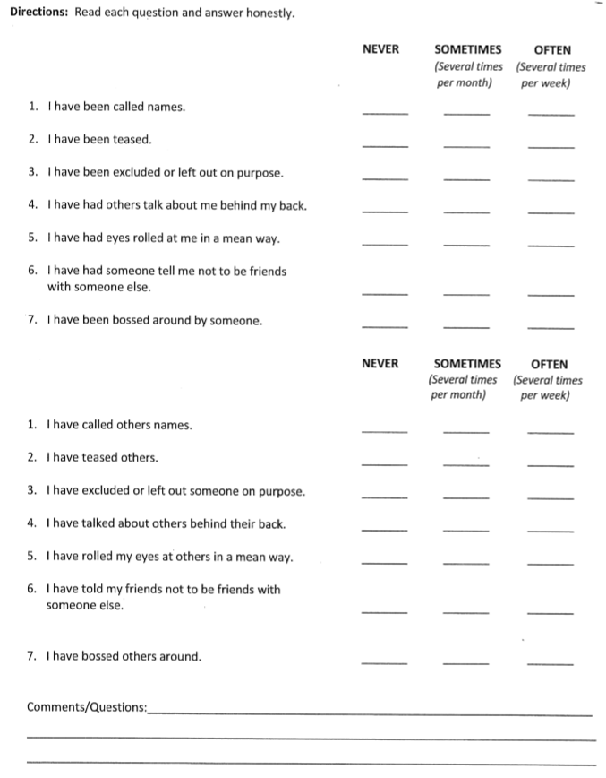
Appendix A

Appendix B


CHAPTER IV
RESULTS
The data presented is this chapter is only the pre-intervention data. Due to the pandemic, schools were shutdown before the intervention could be implemented; therefore, no post-intervention surveys were administered. In this study, there was one group of subjects viewed from two perspectives: “what others do to me,”, and “what I do to others.”.
Table 1
Comparison of when student bossed other students versus when they were bossed by other students
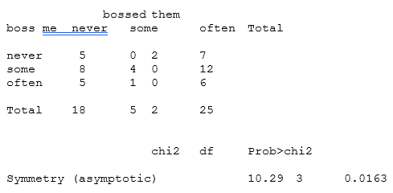

Table 2
Comparison of when student excluded other students versus when they were excluded by other students
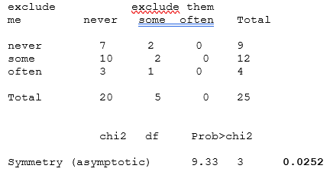

Table 3
Comparison of when student teased other students versus when they were teased by other students
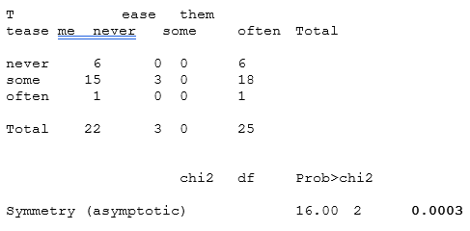
Table 1 indicates subjects’ responses for when they boss others as well as when others boss them. Table 2 shows subjects’ responses for when they exclude others and when they are excluded. Finally, Table 3 illustrates subjects’ responses for when they tease others versus when they are teased. These are the three actions that deviated significantly. Therefore, the null hypothesis can be rejected with at most a 5% chance of false positives. When the null hypothesis was rejected for bossing, excluding, and teasing, the subjects tended to perceive that what others did to them was more frequent than what they did to others.
Table 4
Comparison of when student called other students names versus when they were called names by other students

Table 5
Comparison of when student talked about other students versus when they were talked about by other students
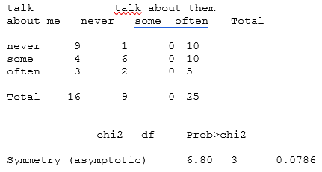
Table 4 illustrates subjects’ responses to when they called other people names and when they have been called names. Table 5 shows subjects’ responses when they talked about other people versus when other people talked about them. When the null was not rejected for calling names, talking about others, rolling eyes, and not being friends, the frequencies of bullying from the opposite viewpoints were more similar. However, for calling others names and talking about others, the null would have likely been rejected with a larger sample.

CHAPTER V
DISCUSSION
The original null hypothesis of this study was that the use of a Morning Meeting would not improve positive relationships among students. Due to the Coronavirus pandemic, a posttest was not able to be administered following the intervention. Therefore, it cannot be determined whether the null hypothesis was supported or not.
Implications of the Results
There are no results for the original hypothesis. However, utilizing the pre-intervention data enabled a comparison of student responses based on what others had done to them versus what they had done to others. This was done by comparing their responses from what they do to others and what others do to them. For example, a null hypothesis would claim that if a student had answered that others sometimes call them names, they would also indicate that they call others names sometimes. This could determine whether there was a form of symmetry. The results indicated from this data that the null hypothesis could be rejected for teasing, excluding others, and telling others what to do. On the other hand, the null hypothesis could not be rejected for name calling, talking about others, not being friends, and rolling their eyes at others.
Theoretical Consequences
According to the test of symmetry results, subjects answered similarly to what others had been done to them and what they had done to others for certain kinds of bullying. A consequence of these results could be that subjects when exposed to a specific behavior or action, they are more likely to also illicit that behavior whether it be positive or negative. In addition to that, it is not logical to assume that children will exhibit positive behaviors or actions a 100% of the time.
Threats to Validity
The null hypothesis could only be rejected for some of the negative behaviors listed on the pre-assessment. These behaviors teasing, excluding others, and telling others what to do. One threat to the validity of this study involves trying to determine whether subjects were honest in their responses. If the frequency of teasing, excluding others, and telling others what to do is less than the frequency of name calling, talking about others, not being friends, and rolling their eyes at others, does that explain the presence or absence of symmetry? Moreover, without a posttest there is no way to tell if the symmetrical types of bullying would have remained symmetrical after treatment. Further, there is no way determine whether the overall incidence of bullying would have decreased between pre and post. Finally, without a control group, changes from pre to post intervention could not definitely be attributed to the treatment.
Connections to Previous Studies
There is literature that supports the notion of morning meeting improving student relationships. One of these examples is The Social Benefits of the Morning Meeting. Allen-Hughes, 2013, noted that when a morning meeting was utilized, student relationships improved, more positive behavior was exhibited by students, and classroom performance increased. However, a key difference was that Allen-Hughes surveyed and utilized two separate classrooms while in this action research project there was one set of participants. Most of the data from that study was gathered from observation and anecdotal notes as well. In this action research project, data was gathered using a self-reported pretest. A posttest would have also been utilized if schools had not been shut down due to Covid-19 pandemic.

Implications for Future Research
This study points to the benefit of a future study investigating how students view positive behaviors exhibited by themselves and others. The data from the current study illustrates that for some behaviors, there was some symmetry among negative behaviors produced by students to others as well as negative behaviors exhibited upon them. A future study could identify whether there is also some symmetry among positive behaviors as well. A key part of future research would be to identify why there is symmetry among some of these behaviors and not others. The study should be expanded to include other classrooms within the same school and among different schools, as well as control sites.
Summary
Unfortunately, this study was not implemented by original design due to the Covid-19 pandemic. Only the pre-test was administered while neither the intervention nor the post-test could be completed. However, by using a symmetry test, the data from the pre-test was analyzed. The data illustrated that for some negative behaviors, there was a semblance of negative behaviors produced by students had also been done to them. For example, if they were teased by others, they also teased others. It would be beneficial to determine whether there was a similar correlation among positive behaviors as well.

References
Allen-Hughes, L. (2013). The social benefits of the morning meeting: Creating a space for social and character education in the classroom.
Anyon, Y., Nicotera, N., & Veeh, C. A. (2016). Contextual influences on the implementation of a schoolwide intervention to promote students’ social, emotional, and academic learning. Children & Schools, 38(2), 81-88.
Borer, M. (2017). Integrating technology into morning meeting in early childhood (Master's thesis, Northwestern College, Orange City, IA). Retrieved from http://nwcommons.nwciowa.edu/education_masters/29/
Boyd, M. P., & Smyntek-Gworek, S. (2012). Morning meeting in a third-grade classroom: Literacy and learning [standards]. Journal of Classroom Interaction, 4-12.
Bruce, S., Fasy, C., Gulick, J., Jones, J., & Pike, E. (2006). Making Morning Circle Meaningful. TEACHING Exceptional Children Plus, 2(4), n4.
Davis, S. (2018). The Effect of Daily Classroom Meetings on 4th Grade Students' Perceptions of Themselves and School (Master’s thesis, Goucher College, Baltimore, MD). Retrieved from https://mdsoar.org/handle/11603/10724
Frey, L. (2013). The Importance of Character Education: A Study of Increased Structure and Focused Character Education in Morning Meetings (Master’s thesis, Goucher College, Baltimore, MD). Retrieved from https://mdsoar.org/handle/11603/2402.
Gardner, C. (2012). Morning meeting and science-a winning combination. Science and Children, 50(1), 60.
Glick, A. (2010). Research Study (Master’s thesis, University of Buffalo, Buffalo, NY). Retrieved from https://eric.ed.gov/?id=ED511125
Gray, L. S., & Richards, J. J. (1992). In Front of and Behind the Camera: Two Perspectives on “Morning Meeting.”
Horsch, P., Jie-Qi, C., & Nelson, D. (1999). Rules and rituals: Tools for creating a respectful, caring learning community. Phi Delta Kappan, 81(3), 223.
Hume, K. (2006). Making the most of morning meeting. The Reporter, 11(3), 10-14.
Parelius, Lisa, "How Morning Meetings Impact Classwork Productivity" (2018). Graduate Master's Theses, Capstones, and Culminating Projects. 313. Retrieved from
https://doi.org/10.33015/dominican.edu/2018.edu.13
Simonsen, B., Sugai, G., & Negron, M. (2008). Schoolwide positive behavior supports: Primary systems and practices. Teaching Exceptional Children, 40(6), 32-40.
Williams, A. (2011). "The Use of Morning Meeting to Develop Social and Emotional Skills" Education Masters (St. John Fisher College, Rochester, NY). Retrieved from
https://fisherpub.sjfc.edu/education_ETD_masters/200

