Supplementary Information

Optimizing Automated Layer-by-Layer Deposition of Engineered ECM-like Microenvironments for Mammalian Cell Culture
Luis Pinzon-Herrera¹, Ian Popp², Roaa Hadi³, & Jorge Almodovar^{1a*}
¹ Department of Chemical, Biochemical and Environmental Engineering, University of Maryland Baltimore County, 1000 Hilltop Circle Baltimore, MD 21250, USA.
² Ralph E. Martin Department of Chemical Engineering, University of Arkansas, 3202 Bell Engineering Center, Fayetteville, AR 72701, USA.
³ Cell and Molecular Biology Graduate Program, University of Arkansas, 3202 Bell Engineering Center, Fayetteville, AR 72701, USA.

*Corresponding author
ª Current Address: Department of Chemical, Biochemical and Environmental Engineering, University of Maryland Baltimore County, 1000 Hilltop Circle Baltimore, MD 21250, USA. Phone: +1 410-455-8152; email: almodova@umbc.edu

Figure S1. Large-area 3D topographical images of automated and manual (HEP/COL)₆ deposition on silicon wafers. A–B) Automated deposition performed in two independent runs; C–D) Manual deposition carried by two independent users; and E) Uncoated silicon wafer imaged under identical conditions.

Figure S1 presents large-area 3D topographical scans comparing automated and manual (HEP/COL)₆ deposition on silicon wafers. Automated coatings generated in two independent runs show uniformly smooth surfaces with minimal surface features (Panels A–B). In contrast, manually prepared samples from two different users exhibit heterogeneous morphologies with noticeable aggregates and irregularities (Panels C–D). An uncoated silicon wafer imaged under identical conditions is shown for reference (Panel E). This supplemental data further illustrates the improved uniformity achieved through automated layer-by-layer deposition.
PROTOCOL
Creating an OT-2 sample protocol file for (HEP/COL)₆ over 4 well in a 24-well plate using the online Protocol designer offered by Opentrons®.

1. Setup into OT-2 webpage

- Navigate to https://designer.opentrons.com/ Protocol designer is a free-access tool. Note: Opentrons® updates to the protocol designer may change the webpage interface.

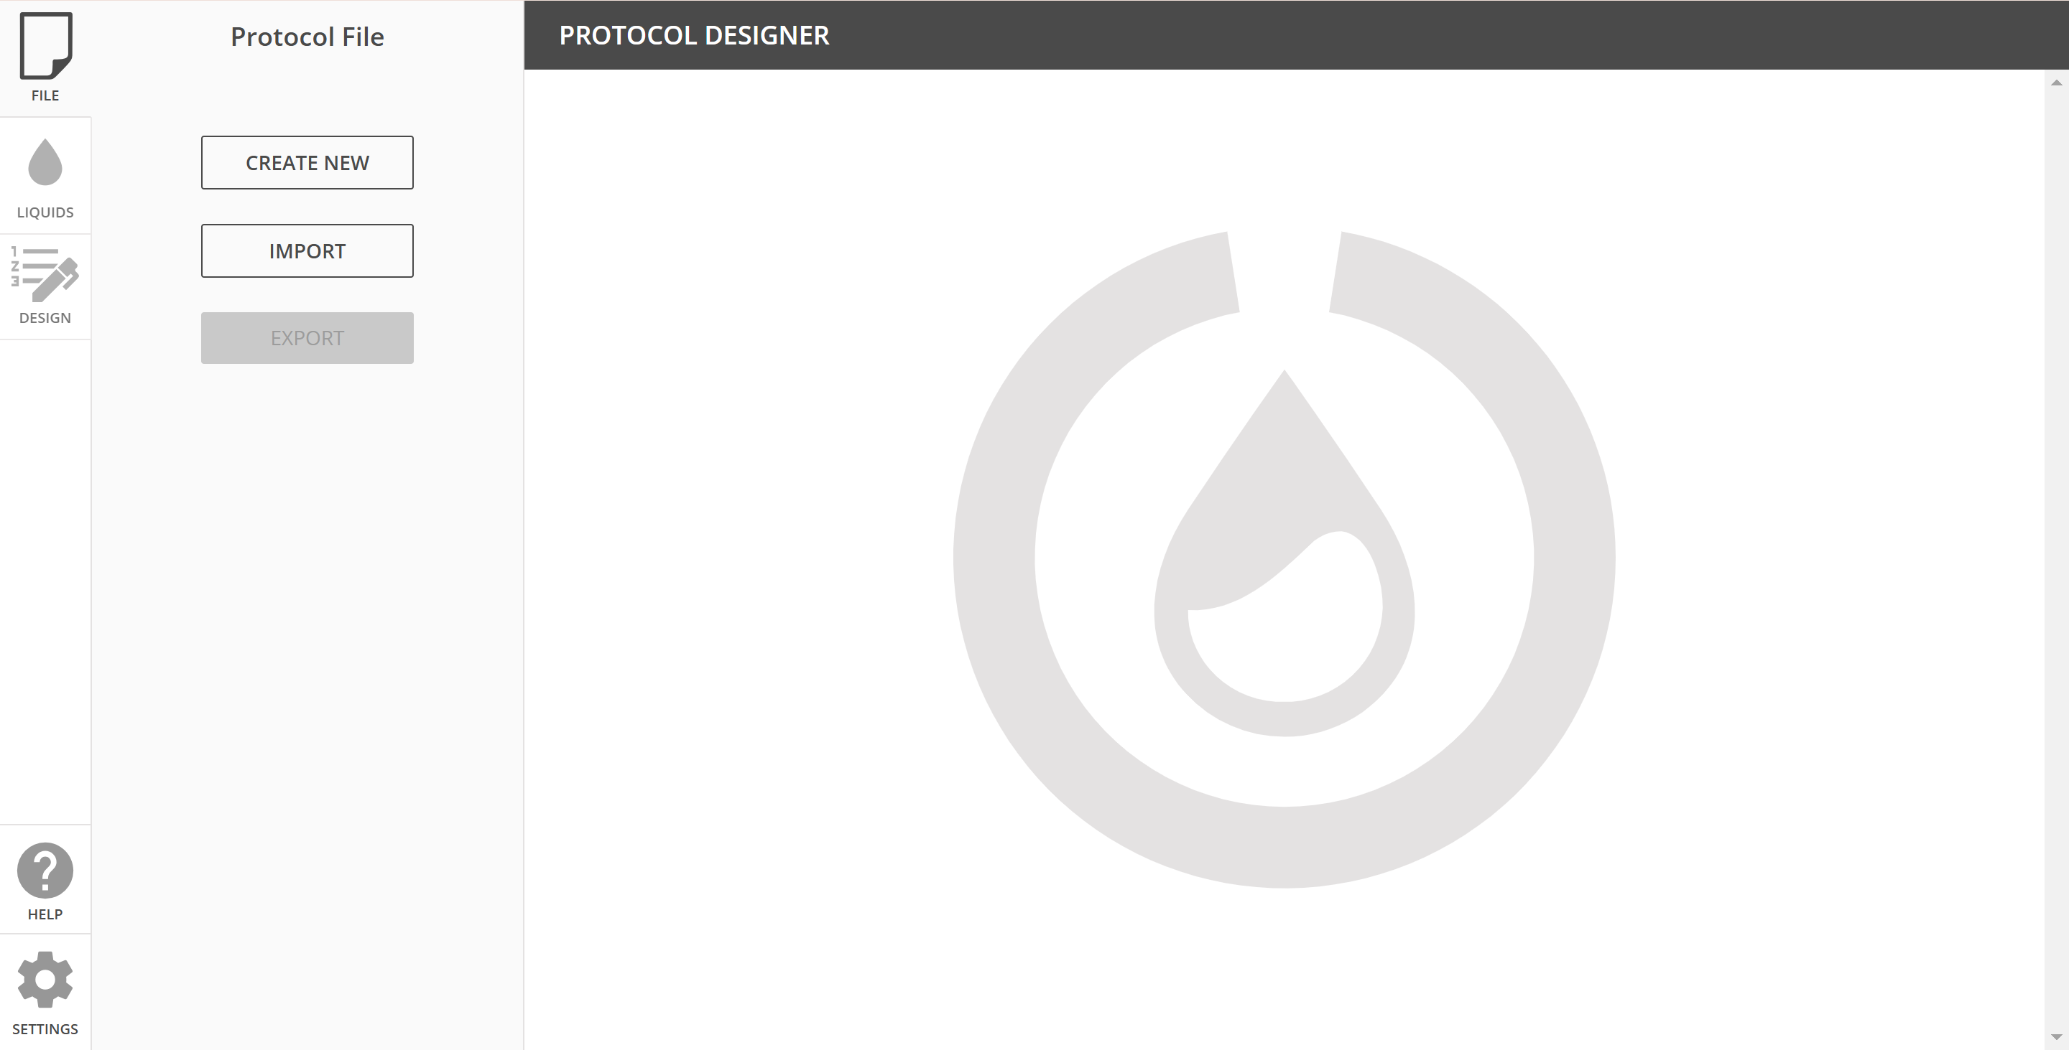
- Select Create New (or import previous protocol)

- Choose the robot type: OT-2
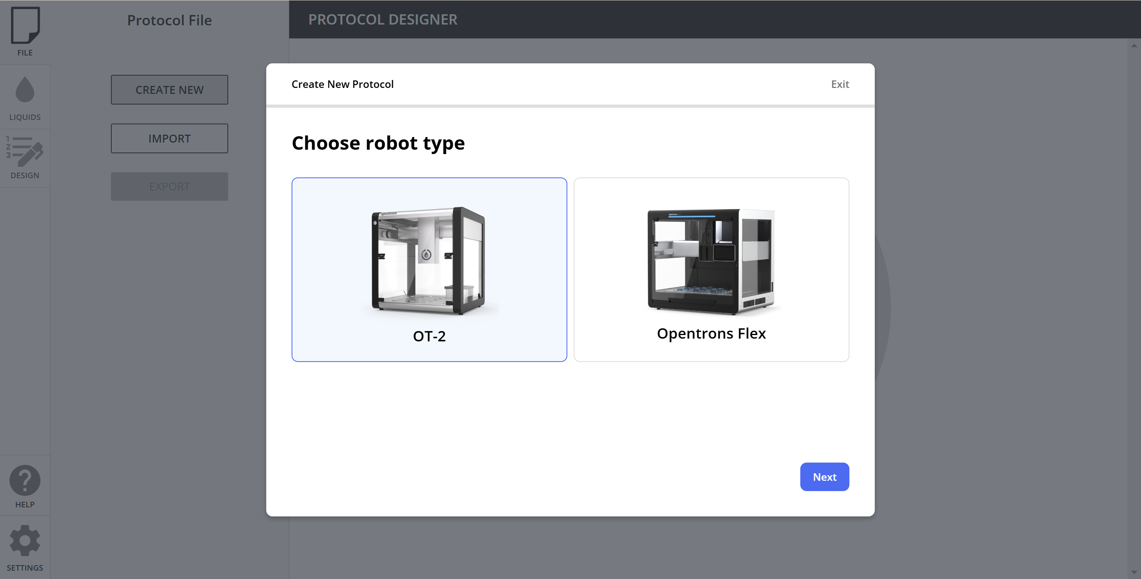
- Click on Next and name the protocol. Adding a description or author is optional.
- Choose left pipette: Select P-1000 Single Channel Gen-2 or the reference installed in the left side.
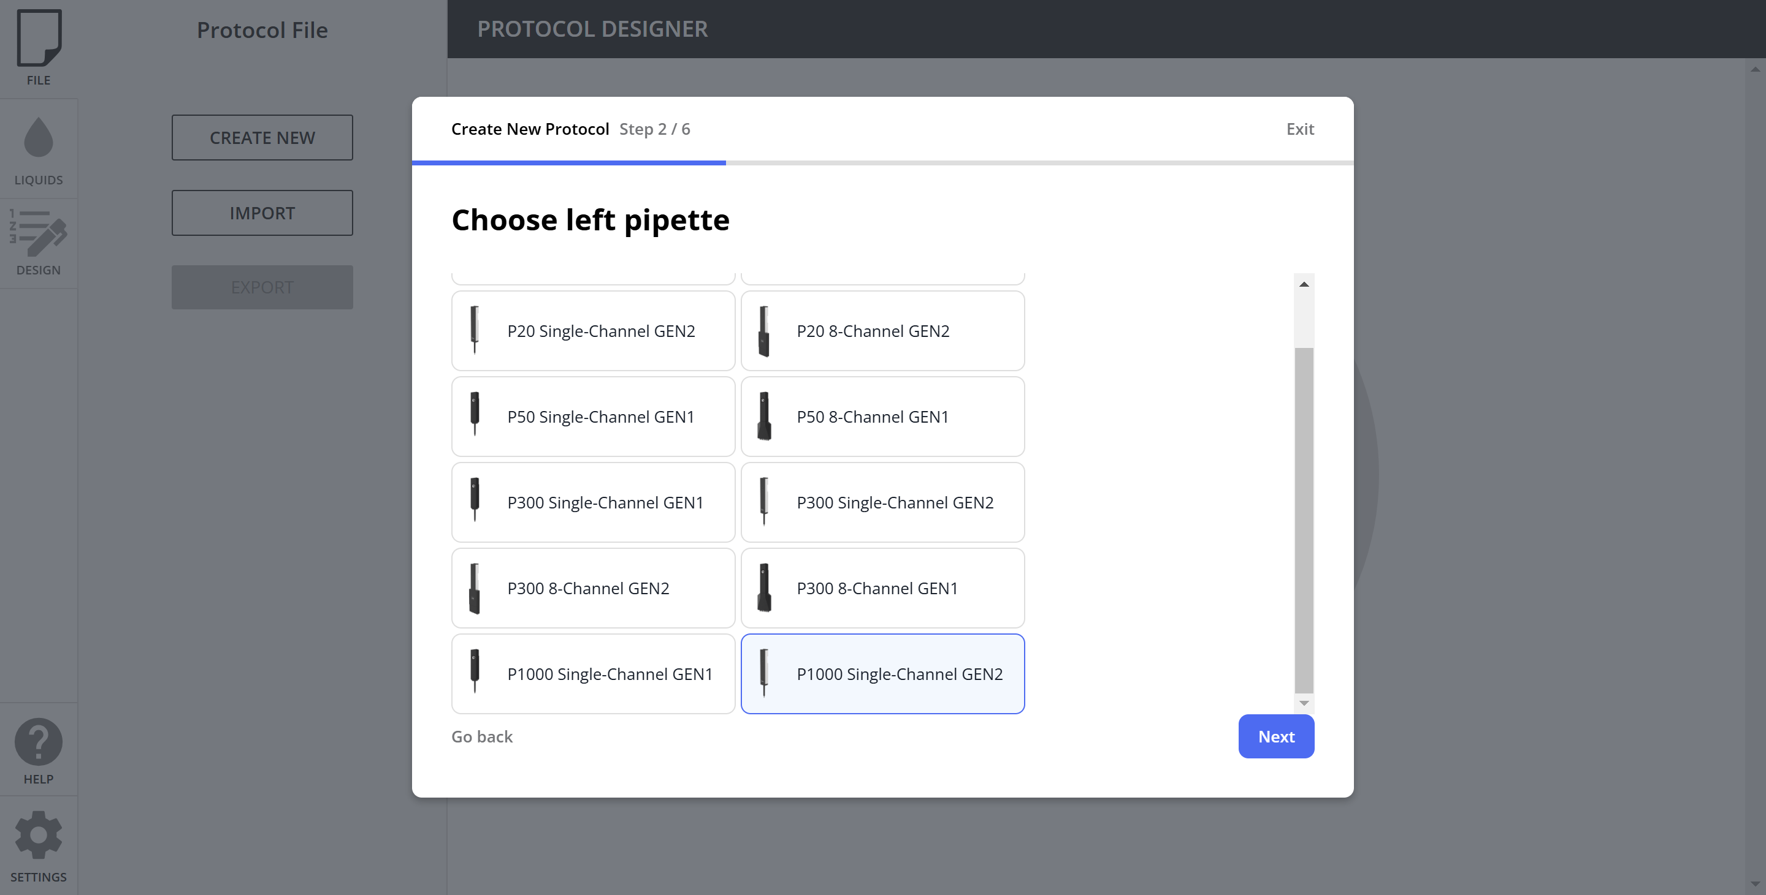

- Choose tips for pipette: select Opentrons OT-2 96 Tip Rack 1000 µL
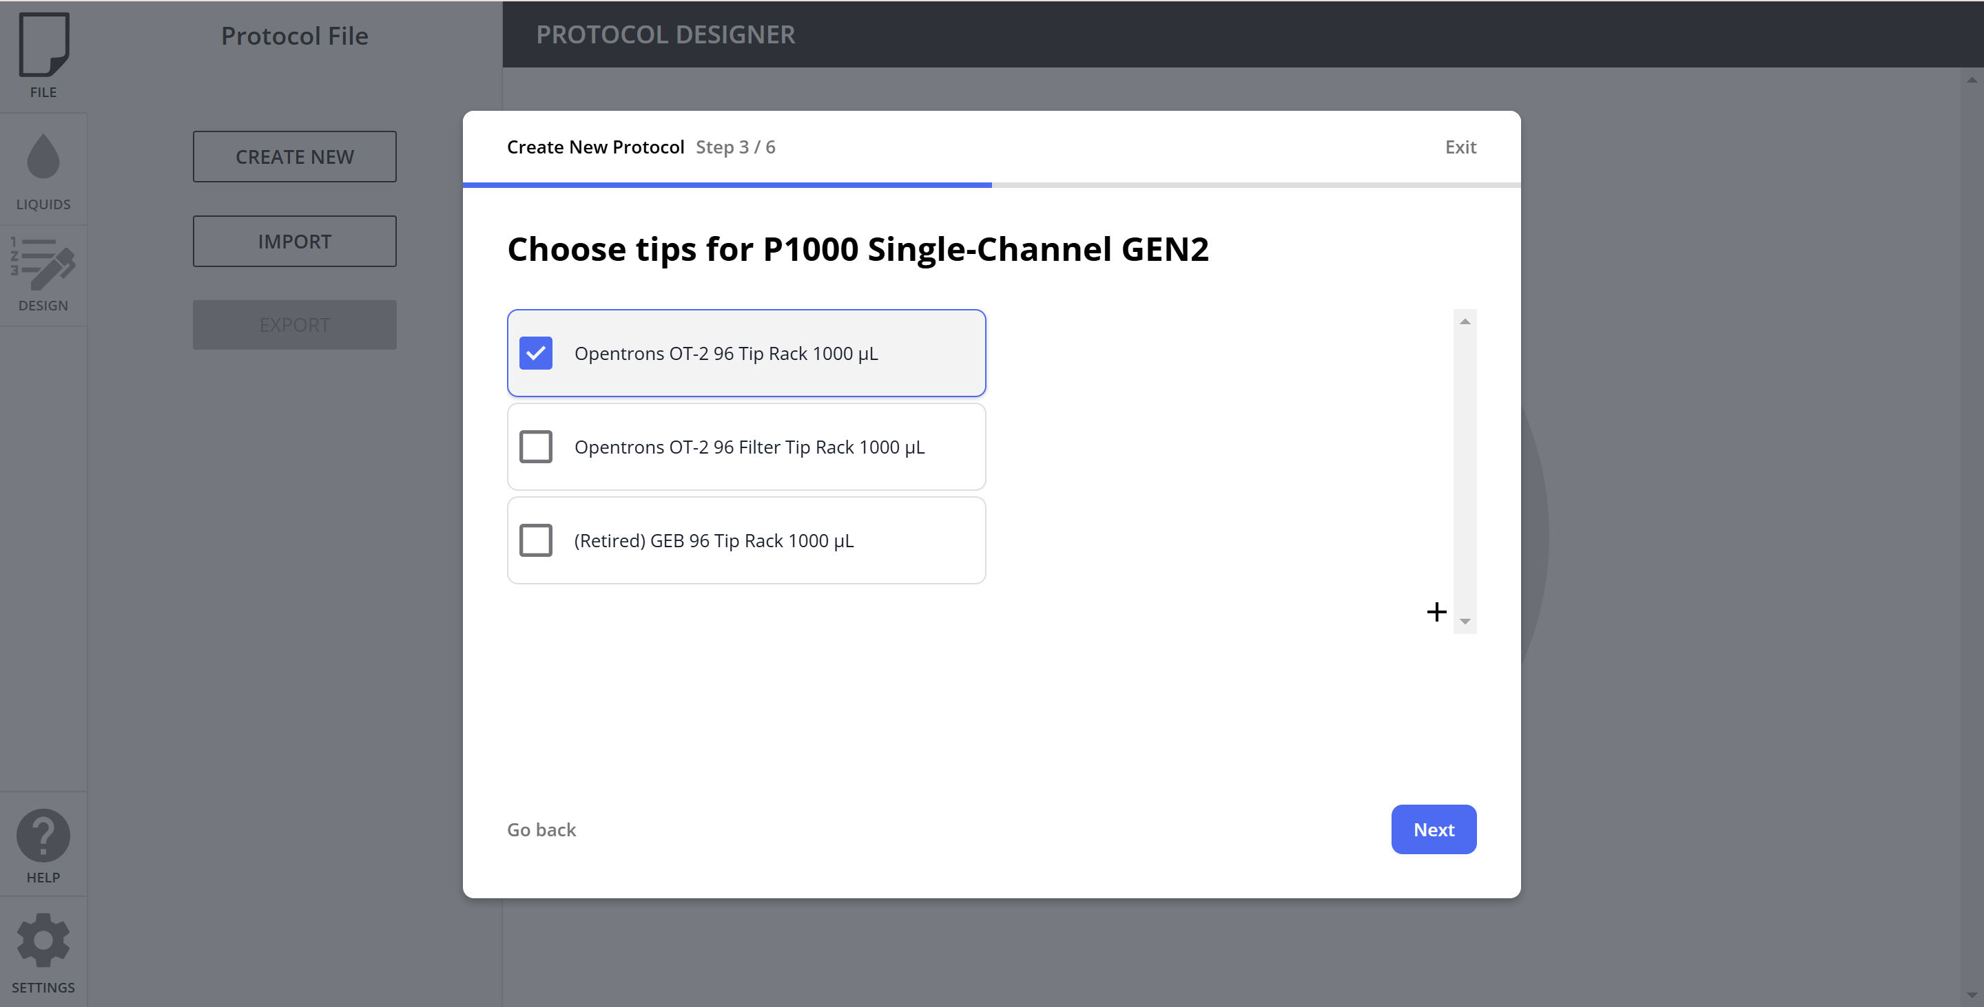
- Continue twice on Next with no right pipette

2. Adding Liquids

- Back to the main webpage, continue to Liquids.
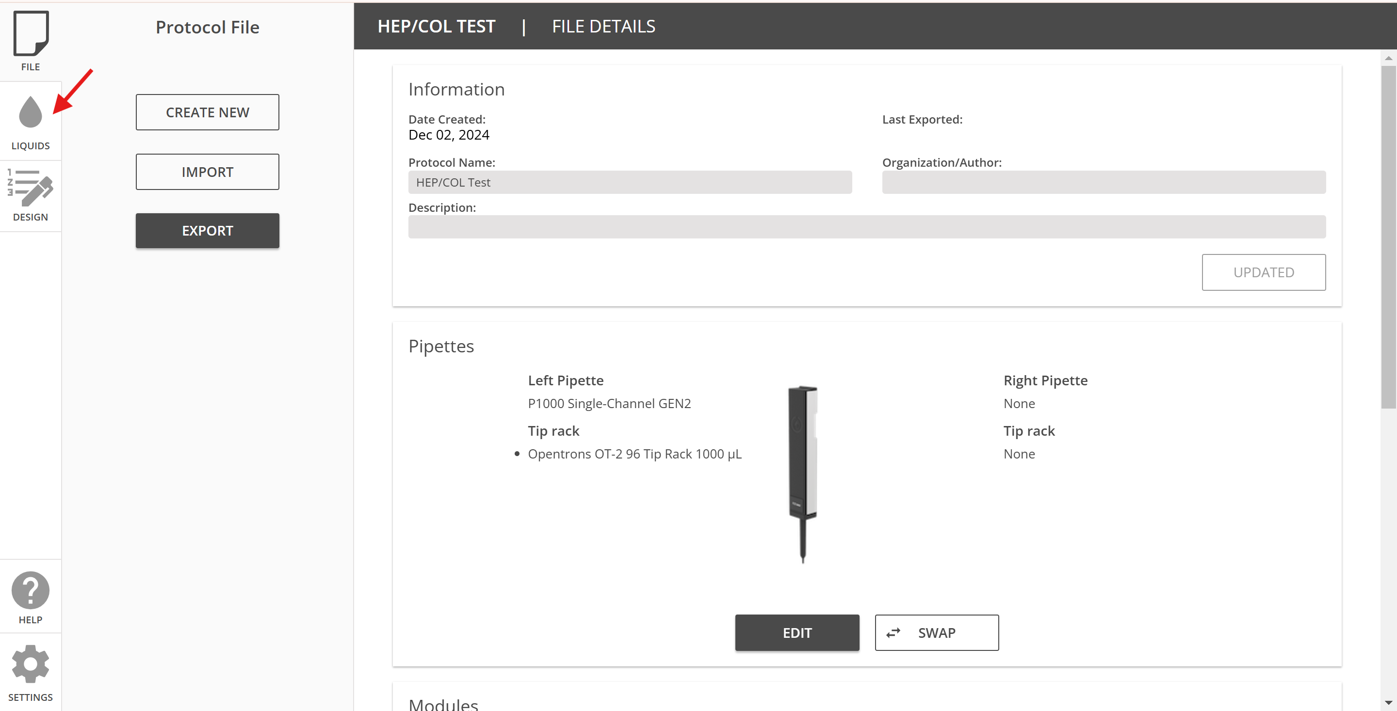

- Select New Liquid and enter the solutions to be used
- Add Heparin then Save, Collagen then Save, and Rinse then Save
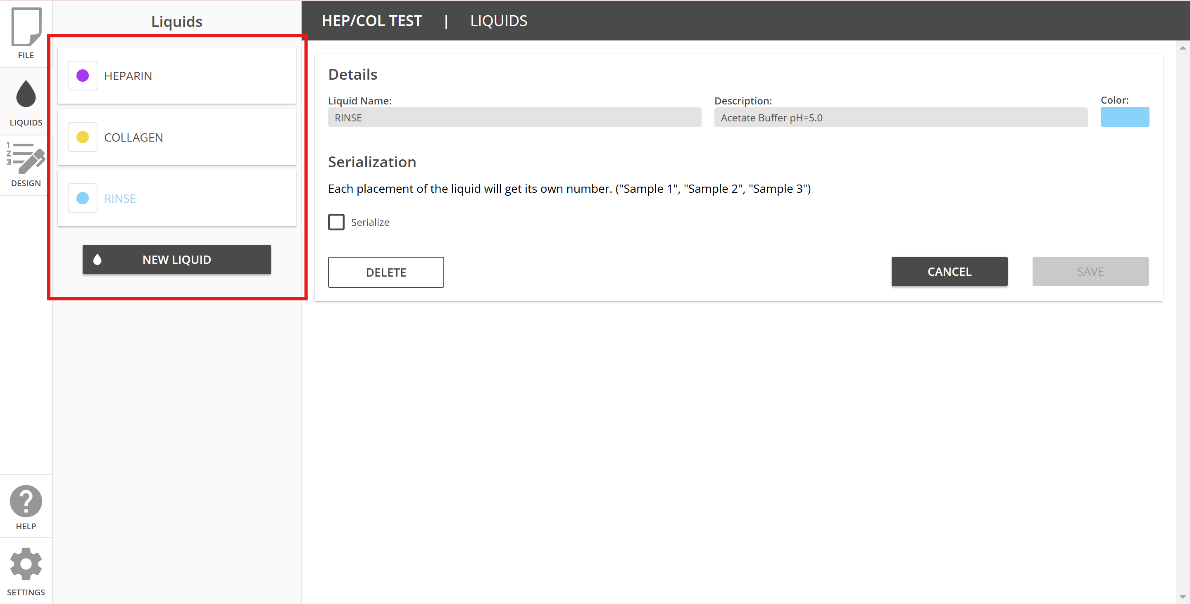

3. Designing the Deck

- In the main options, continue to Desing and then click on OK
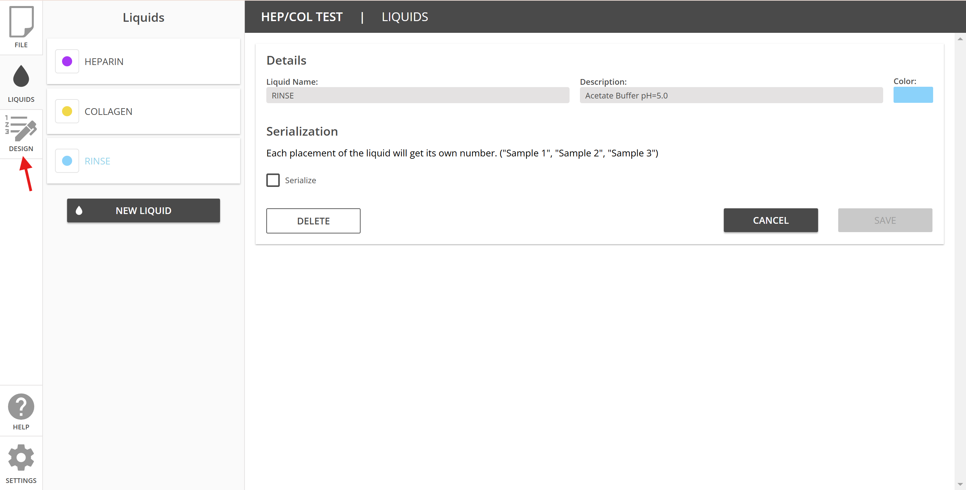

- Add the tip racks, well plates, tube racks or reservoirs into the desired slot
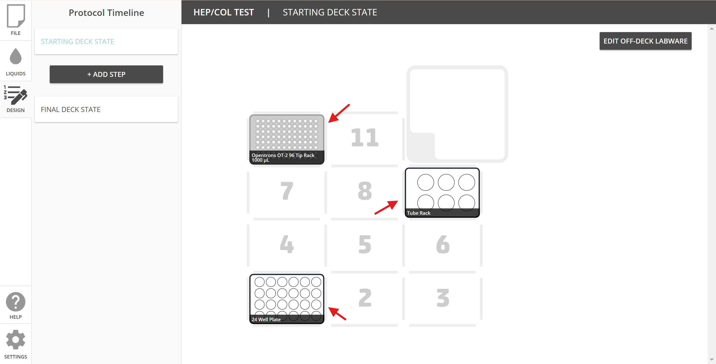

- Go to the Tube rack (or reservoir) and click on Name & Liquids
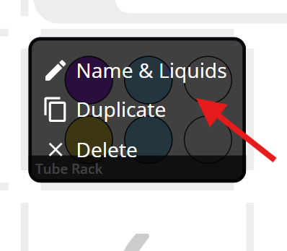

- Add the liquids in the desired slot for reagents and the volume for each container.
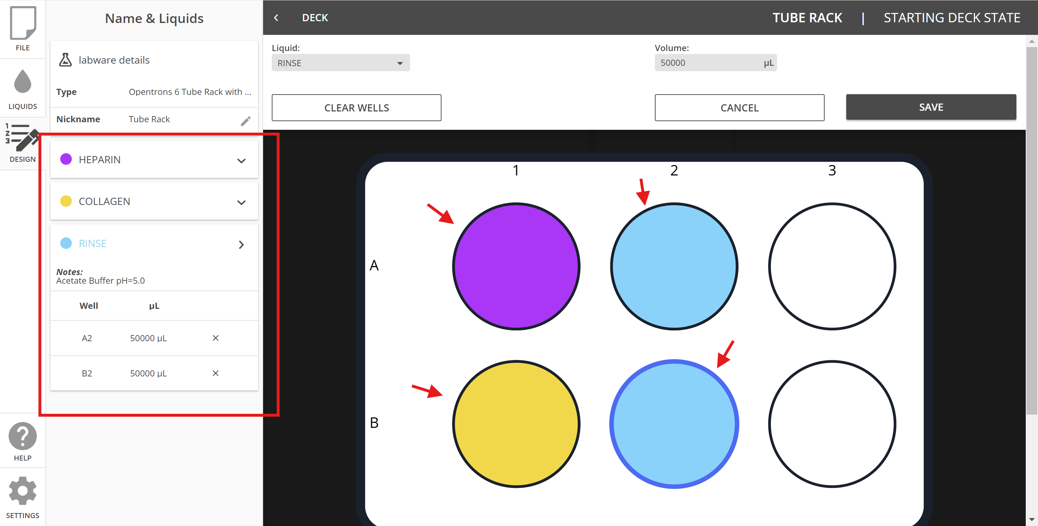

4. Designing the process for first bilayer

- Heparin Layer

- To transfer heparin solution from the tube to the wells, click on Add Step and select Transfer
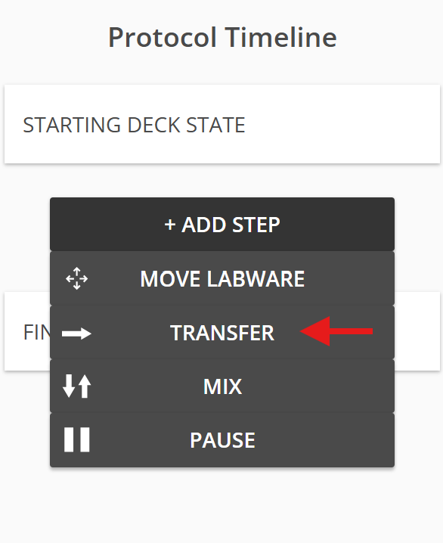

- You will need to choose some options in the Transfer menu.
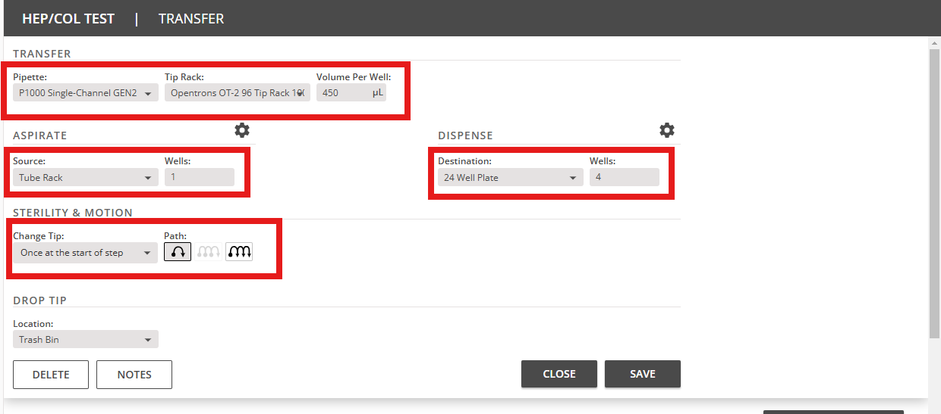

- Click on Source and choose either the tube rack or reservoir where the Heparin solution is located.
- Click on Wells (Source), select heparin solution, and click on Save selection.

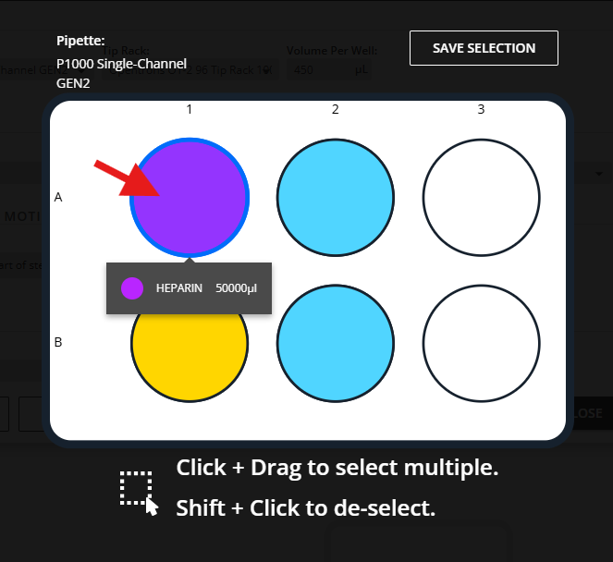

- Click on Destination and choose the well plate where the heparin solution is going to be dispensed.
- Click on Wells (Destination), select the desired wells to be coated, and click on Save selection.

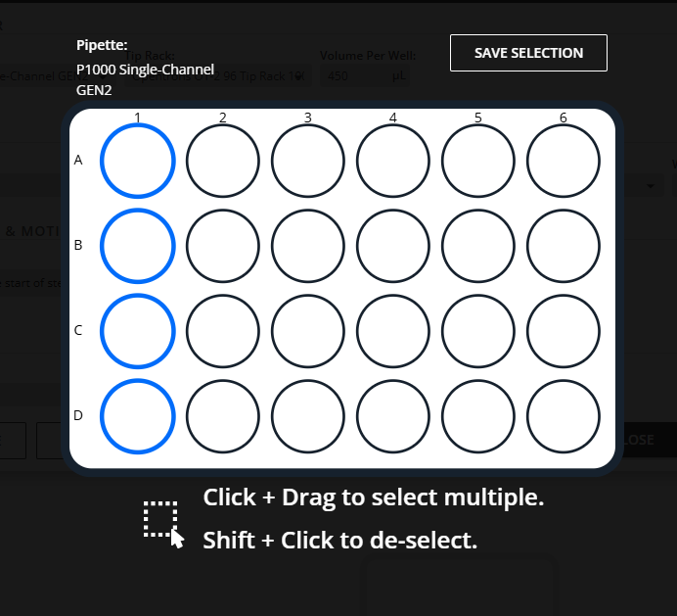

- Clicking on Advanced Settings will display different options.
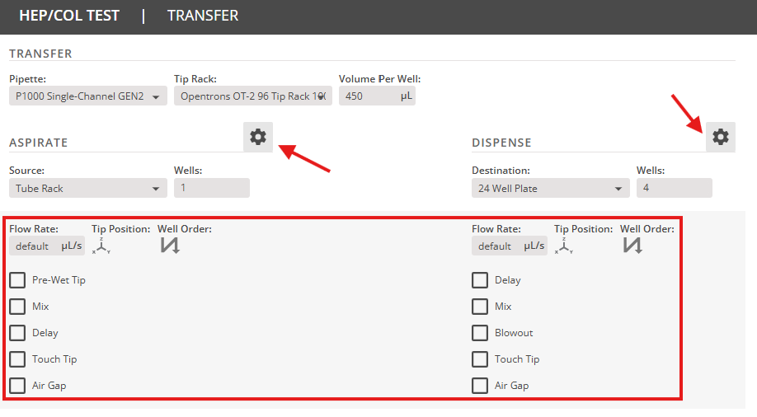

- You can change the Flow Rate, Tip Positioning to dispense and aspirate, Well order among others.
Note: Proper tip positioning for dispensing and aspirating is crucial, as it can prevent tips from becoming blocked when touching surfaces or pipettes from becoming wet when submerged in liquids.

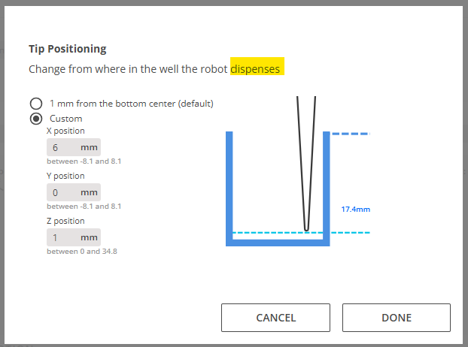
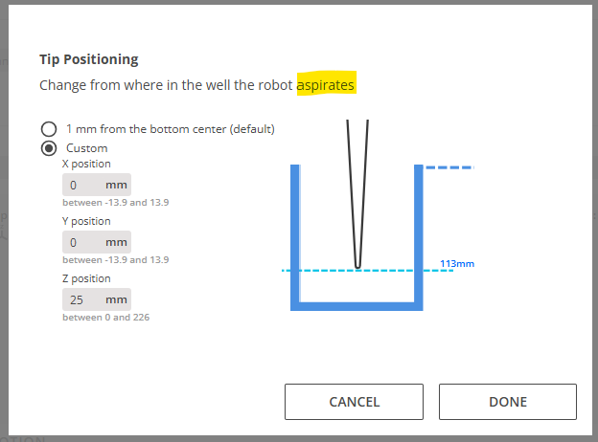

- For the first step, Change Tip option should be Once at the start of step. Click on Save to finish the step.
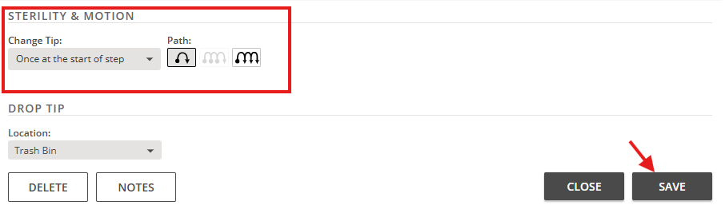

- After transferring heparin, an incubation period is necessary. Click on Add Step and select Pause.
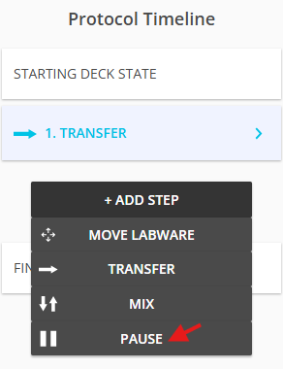

- Click on Delay for amount of time and set 5 minutes. Then click on Save to finish the step.
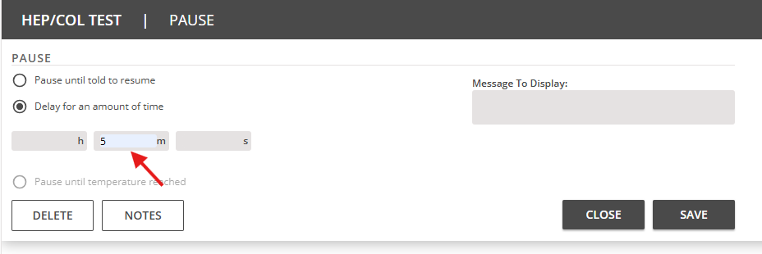

- Proceed to remove the heparin solution after the incubation period. Click on Add Step and Transfer.

- Set the options in the Transfer menu:
Volume per well: 450 µL
Source: 24 well plate
Wells: choose the wells where the heparin solution is located
Destination: Trash Bin
Chage tip: Never

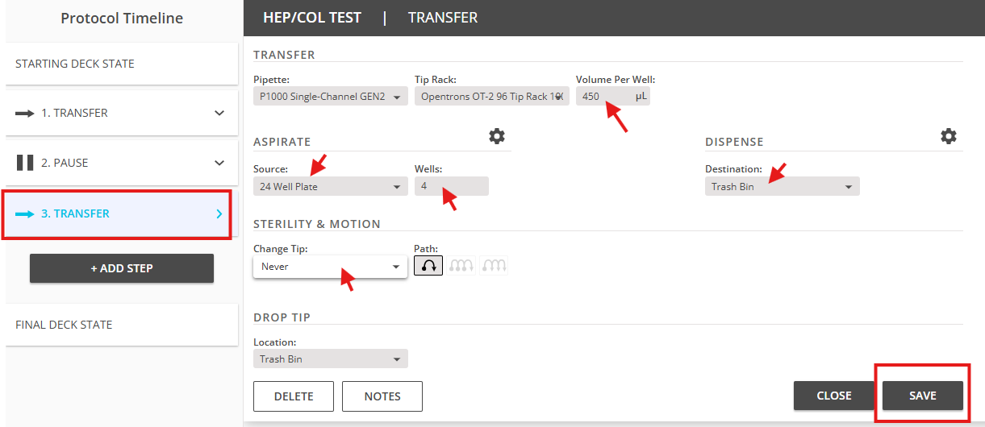
- Click on Save to finish the step.

- Rinse step

- Proceed in a similar manner to creating a Transfer step to add the wash solution to the wells.
- Be careful when changing the aspirating solution. Click on Wells (Source), select Rinse solution, and click on Save selection.
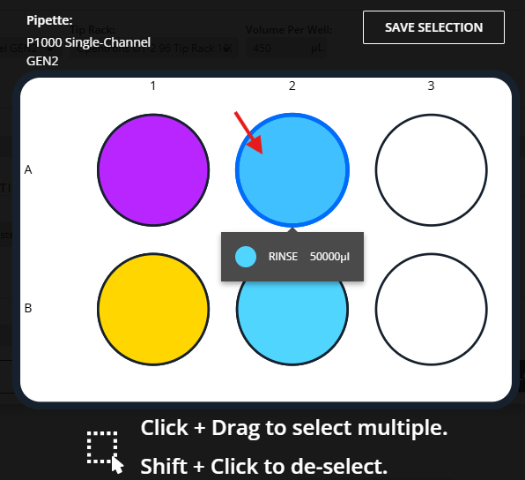
- Change Tip option should be Never or Once at the start of step. This option is optional if you want to reuse the tips.

- Click on Save to finish the step.

- After transferring rinse solution, an incubation period is necessary. Click on Add Step and select Pause.

- Click on Delay for amount of time and set 3 minutes. Then click on Save to finish the step.

- Proceed to remove the rinse solution after the incubation period. Click on Add Step and Transfer.

- Set the options in the Transfer menu:
Volume per well: 450 µL
Source: 24 well plate
Wells: choose the wells where the rinse solution is located
Destination: Trash Bin
Chage tip: Never

- Click on Save to finish the step.
- Collagen Layer

- Proceed in a similar manner to creating a Transfer step to add the wash solution to the wells.
- Be careful when changing the aspirating solution. Click on Wells (Source), select Collagen solution, and click on Save selection.
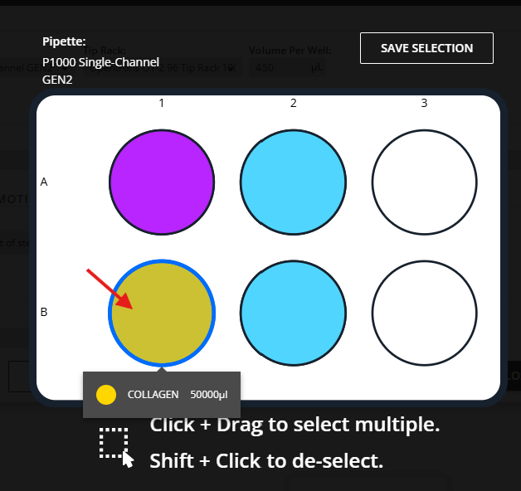
- Change Tip option should be Once at the start of step.

- Remember to add a Pause step.
- Set the Delay for amount of time to 5 minutes.

- Proceed to remove the collagen solution by creating a Transfer step.

- Set the options in the Transfer menu:
Volume per well: 450 µL
Source: 24 well plate
Wells: choose the wells where the rinse solution is located
Destination: Trash Bin
Chage tip: Never

- Click on Save to finish the step.

- Final Rinse step

- Note: Repeat the Rinse Step procedure after the Collagen Layer for one complete bilayer. Be careful when changing the aspirating solution.

5. Designing the process for 6 or 6.5 bilayers
- Once the first bilayer is completed, this protocol should have a total of 12 steps (3 steps for each solution: dispense, pause, and aspirate).
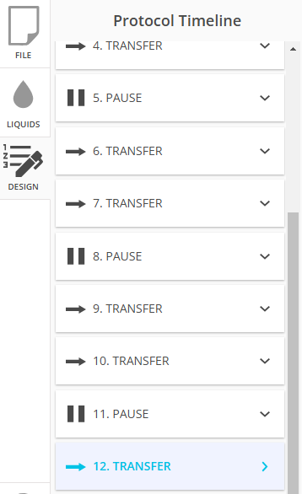
- You will have the option to select all the steps and duplicate them. Click on Duplicate all the steps 5 additional times for a total of 6 layers.
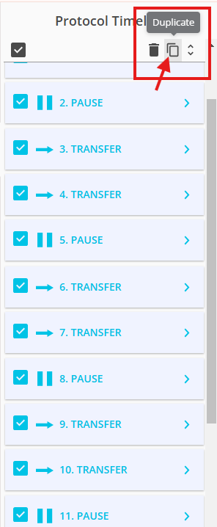

- (Optional) Add an additional Heparin Layer and a Wash Step for a 6.5-layer coating.
6. Export protocol to computer

- Go back to File option and then click on Export.
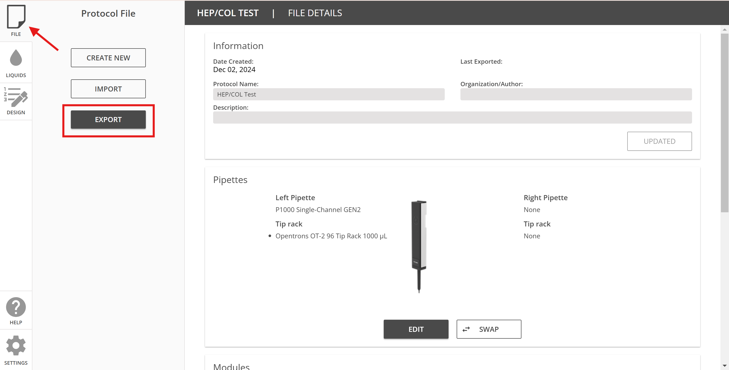

- Click on Continue. The file will be downloaded to your computer with a .json file extension.

- Transfer the file to the Protocols section in the OT-2 software and procced to set up the machine.

Special note: Before running this protocol, the plates must be pre-coated with PEI solution for 15 minutes followed by a 3-minute rinse step. This protocol does not include step for the PEI anchoring layer.

