Supporting Information for
Elevated temperature and nutrients lead to increased N₂O emissions from salt marsh soils under cold and warm climates
Sophie A. Comer-Warner^{1,2}, Sami Ullah^{2,3}, Arunabha Dey¹, Camille L. Stagg⁴, Tracy Elsey-Quirk⁵, Christopher M. Swarzenski⁶, Fotis Sgouridis⁷, Stefan Krause^{2,3}, Gail L. Chmura¹
Affiliations
1. Department of Geography, McGill University, Montreal, Quebec H3A 0B9, Canada
2. School of Geography, Earth and Environmental Sciences, University of Birmingham, Edgbaston, Birmingham B15 2TT, UK
3. Birmingham Institute of Forest Research, University of Birmingham, Edgbaston, Birmingham B15 2TT, UK
4. U.S. Geological Survey, Wetland and Aquatic Research Center, Lafayette, LA, USA
5. Department of Oceanography and Coastal Sciences, Louisiana State University, Baton Rouge, LA, 70803, USA
6. U.S. Geological Survey, retired
7. School of Geographical Sciences, University of Bristol, Bristol BS8 1SS, UK

Table S1. Results of the Wilcoxon signed rank test to test whether differences in fluxes between ambient and elevated treatments were significant at each site. Significant differences were tested at a 95% confidence level. DNT = denitrification, NIT = nitrification.
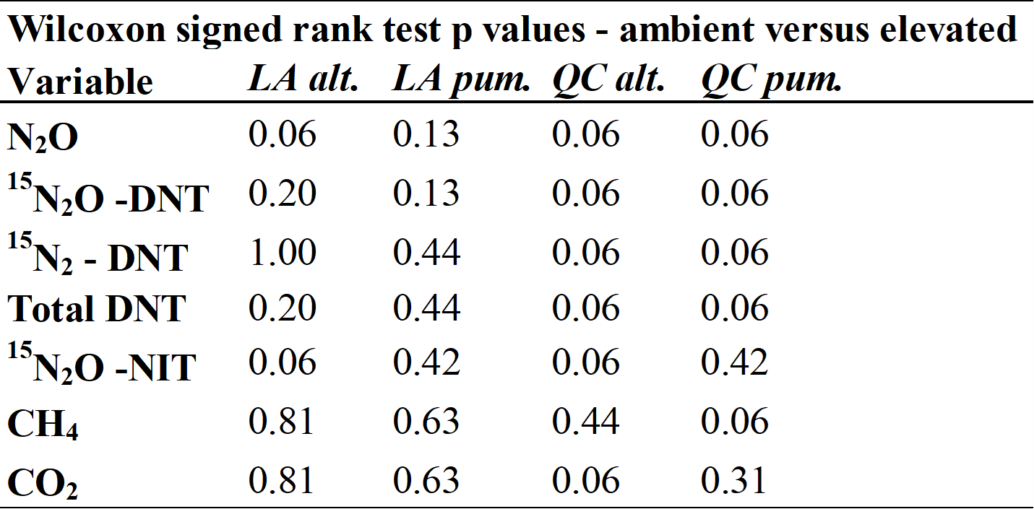

Table S2. Results of the Kruskal-Wallis with post-hoc Dunn test to assess whether differences in fluxes between sites (i.e. climatic region and vegetation type) were significant. Significant differences were tested at a 95% confidence level. DNT = denitrification and NIT = nitrification.
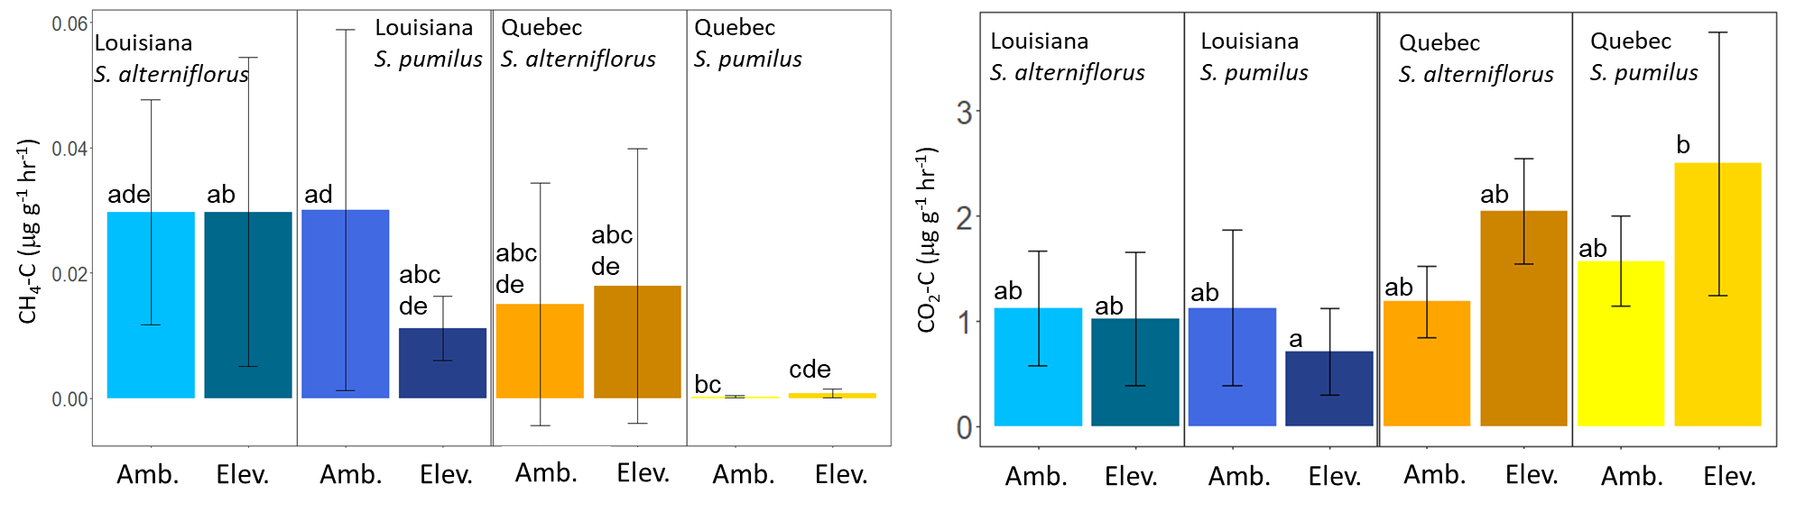
Figure S1. Potential rates of CH₄ and CO₂ fluxes in μg C g dry soil⁻¹ hr⁻¹ across the four salt marsh sites (Louisiana S. alterniflorus, Louisiana S. pumilus, Quebec S. alterniflorus and Quebec S. pumilus) under ambient (amb., in-situ soil temperature and nutrient concentration) and elevated (elev., soil temperature + 5 ℃, double nutrient concentration) treatments. N = 5 and all error bars represent 1 standard deviation, significant differences between fluxes are indicated by different letters.

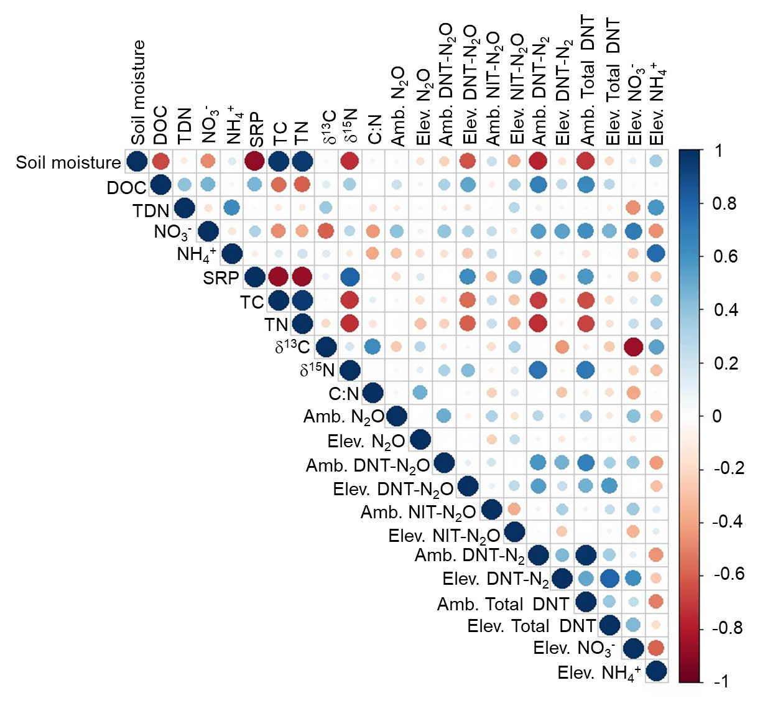

Figure S2. Spearman’s R correlations between environmental parameters and potential biogeochemical reaction rates. Positive correlations are shown in blue and negative correlations are shown in red with larger and darker circles representing stronger correlations. Variable abbreviations are: DOC – dissolved organic carbon, TDN – total dissolved nitrogen, SRP – soluble reactive phosphate, TC – total carbon, TN – total nitrogen, amb. – ambient treatment, elev. – elevated treatment, DNT – denitrification, NIT – nitrification.

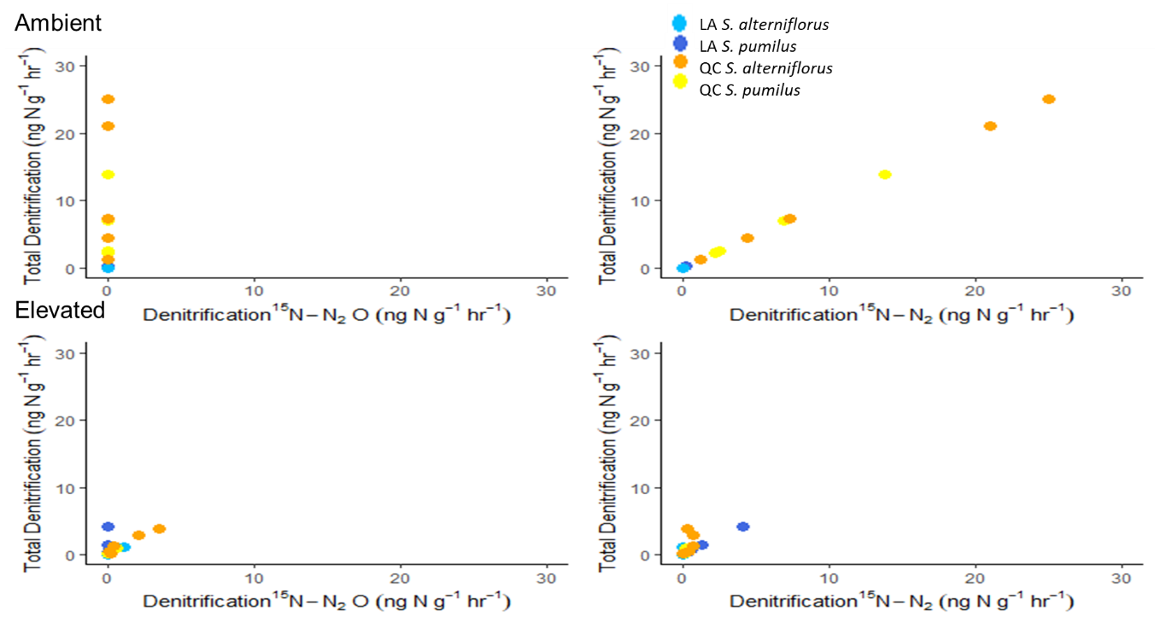
Figure S3. Bivariate plots of potential total denitrification versus potential denitrification-derived N₂O and potential denitrification-derived N₂ under ambient and elevated treatments.

