Supplemental Material
Table S1. Same as Table 2, except for fine-mode AOD. For each of 21 AERONET sites used in this study, AERONET Version3 Level1.5 mean fine-mode AOD at 550nm and root mean square error (RMSE) for 6-hr and 72-hr forecasts from the four core ICAP models and the ICAP-MME for June 2016-May 2017. RMSE values are listed in order from low to high, and ICAP-MME results are shown in boldface. Sample size refers to the number of valid 6-hour average AERONET AOD observations over this 12-month time period.

Table S2. Same as Table S1 or Table 2, except for coarse-mode AOD.

Table S3. Coefficient of determination (r²) between 2 out of 3 variables: ensemble mean, ensemble spread and absolute forecast error (AFE) of the ICAP MME for 72-hr forecast of total, fine and coarse AODs at 550 nm at the selected AERONET sites. All calculations are based on model and AERONET V3 Level1.5 data during Jun 2016-May 2017. Value less than 0.04 means the correlation is not statistically significant at 95% level by student-t test.
Site | ens mean & AFE |  |  | spread & AFE |  |  | ens mean & spread
 | Total/Fine/Coarse AOD |  |  | Total/Fine/Coarse AOD |  |  | Total/Fine/Coarse AOD
Alta Floresta | 0.34 | 0.50 | 0.15 | 0.16 | 0.24 | 0.01 | 0.52 | 0.54 | 0.21
Amsterdam Island | 0.59 | 0.80 | 0.60 | 0.38 | 0.67 | 0.43 | 0.55 | 0.72 | 0.71
Banizoumbou | 0.12 | 0.03 | 0.12 | 0.09 | 0.01 | 0.13 | 0.48 | 0.58 | 0.56
Beijing | 0.16 | 0.20 | 0.36 | 0.07 | 0.14 | 0.30 | 0.62 | 0.61 | 0.84
Capo Verde | 0.12 | 0.09 | 0.08 | 0.09 | 0.02 | 0.07 | 0.52 | 0.48 | 0.56
Cart Site | 0.38 | 0.64 | 0.03 | 0.37 | 0.59 | 0.01 | 0.55 | 0.61 | 0.57
Chapais | 0.28 | 0.60 | 0.01 | 0.29 | 0.55 | 0.01 | 0.63 | 0.69 | 0.71
Chiang Mai | 0.13 | 0.24 | 0.00 | 0.03 | 0.13 | 0.00 | 0.54 | 0.62 | 0.59
Gandhi College | 0.00 | 0.01 | 0.05 | 0.00 | 0.01 | 0.06 | 0.50 | 0.52 | 0.81
GSFC | 0.38 | 0.60 | 0.01 | 0.36 | 0.46 | 0.00 | 0.51 | 0.53 | 0.53
Ilorin | 0.29 | 0.00 | 0.22 | 0.22 | 0.03 | 0.11 | 0.57 | 0.45 | 0.72
Kanpur | 0.00 | 0.04 | 0.13 | 0.00 | 0.01 | 0.08 | 0.62 | 0.59 | 0.78
Minsk | 0.40 | 0.46 | 0.31 | 0.38 | 0.41 | 0.28 | 0.77 | 0.80 | 0.91
Moldova | 0.12 | 0.35 | 0.06 | 0.11 | 0.23 | 0.11 | 0.63 | 0.66 | 0.71
Monterey | 0.21 | 0.23 | 0.00 | 0.21 | 0.23 | 0.02 | 0.92 | 0.92 | 0.70
Palma de Mallorca | 0.50 | 0.27 | 0.51 | 0.50 | 0.17 | 0.46 | 0.64 | 0.34 | 0.74
Ragged Point | 0.20 | 0.56 | 0.25 | 0.13 | 0.40 | 0.15 | 0.45 | 0.67 | 0.48
Rio Branco | 0.18 | 0.39 | 0.00 | 0.15 | 0.31 | 0.00 | 0.77 | 0.78 | 0.87
Singapore | 0.04 | 0.09 | 0.03 | 0.02 | 0.05 | 0.03 | 0.49 | 0.56 | 0.64
Mezaira | 0.78 | 0.23 | 0.87 | 0.76 | 0.10 | 0.81 | 0.82 | 0.46 | 0.84
Yonsei University | 0.11 | 0.13 | 0.12 | 0.03 | 0.06 | 0.09 | 0.54 | 0.59 | 0.82

Table S4. Contribution of each individual model to the ICAP MME in the 6-hr and 72-hr forecasts for total AOD at 550 nm. Absolute forecast errors from the ICAP MME are listed, as well as those from ensembles based on 3 of 4 full-species models with Model 1 (M1), Model 2 (M2), Model 3 (M3) and Model 4 (M4) removed from the ensembles respectively. Change of absolute forecast error in percentage resulted from the removal of each individual model at each site and the average change of all sites are also shown.
Table S5. Same as Table S4, except for fine-mode AOD.

Table S6, Same as Table S4 and S5, except for coarse-mode AOD.
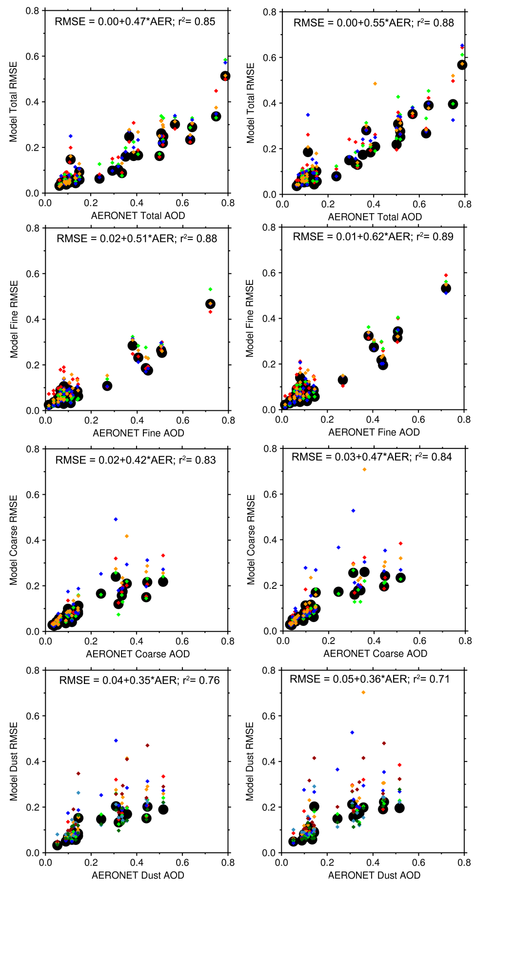
Figure S1. Same as Fig. 2, except that AERONET AODs are binned into two bins (greater than 0.2 and less than 0.2) for each site. RMSE is only calculated for sites and AOD bins with sample number greater than 60.
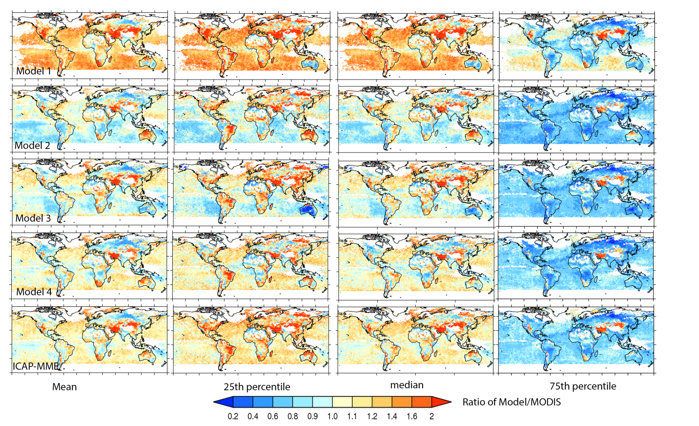
Figure S2. Similar to Fig. 6, except for ratios of the individual models and the ICAP-MME’s mean, median, 25th and 75th percentiles of total AOD at 550 nm to those of DA-quality MODIS AOD. 6-hr forecasts data for Jun 2016 – May 2017 time period from the models are used and spatially and temporally sampled to match the MODIS data. Only area with DA-quality MODIS data count greater than 15 is shown.
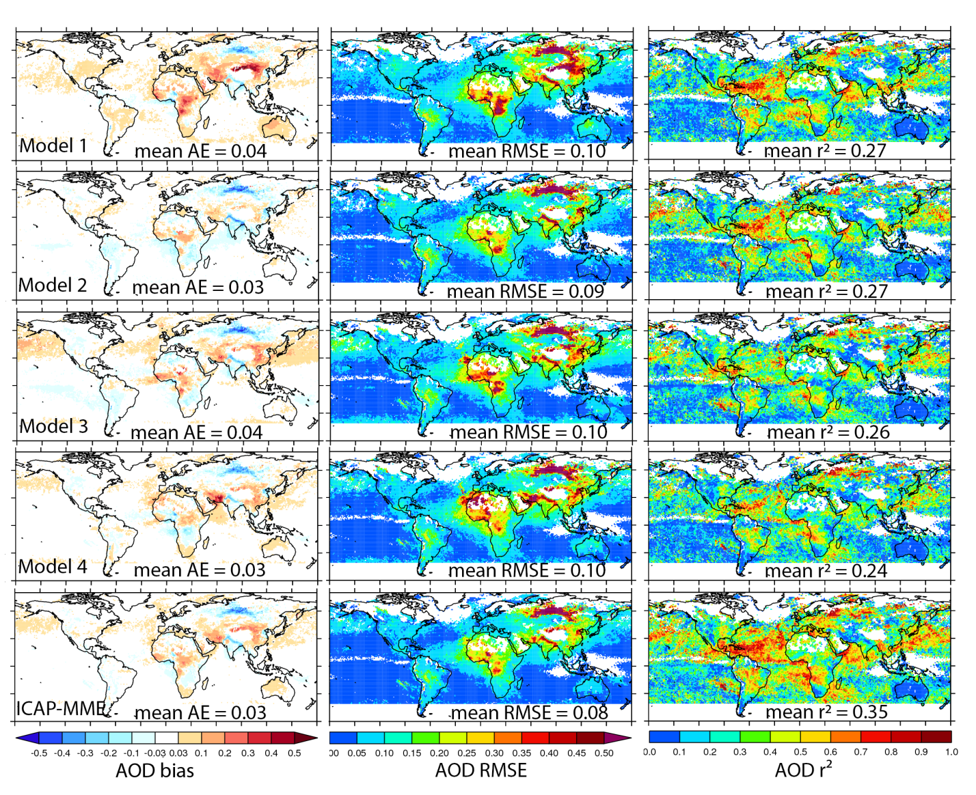
Figure S3. Same as Figure 7, except for the 72-hr forecasts. 550 nm mean AOD bias, RMSE and coefficient of determination (r²) of the 72-hr forecasts (initialized with 00Z analysis) from the four ICAP core models and the ICAP-MME verified against the DA-quality MODIS C6 data for Jun 2016 – May 2017 time period. The numbers inside AOD bias, RMSE and r² plots are global mean absolute error (AE), RMSE and r².
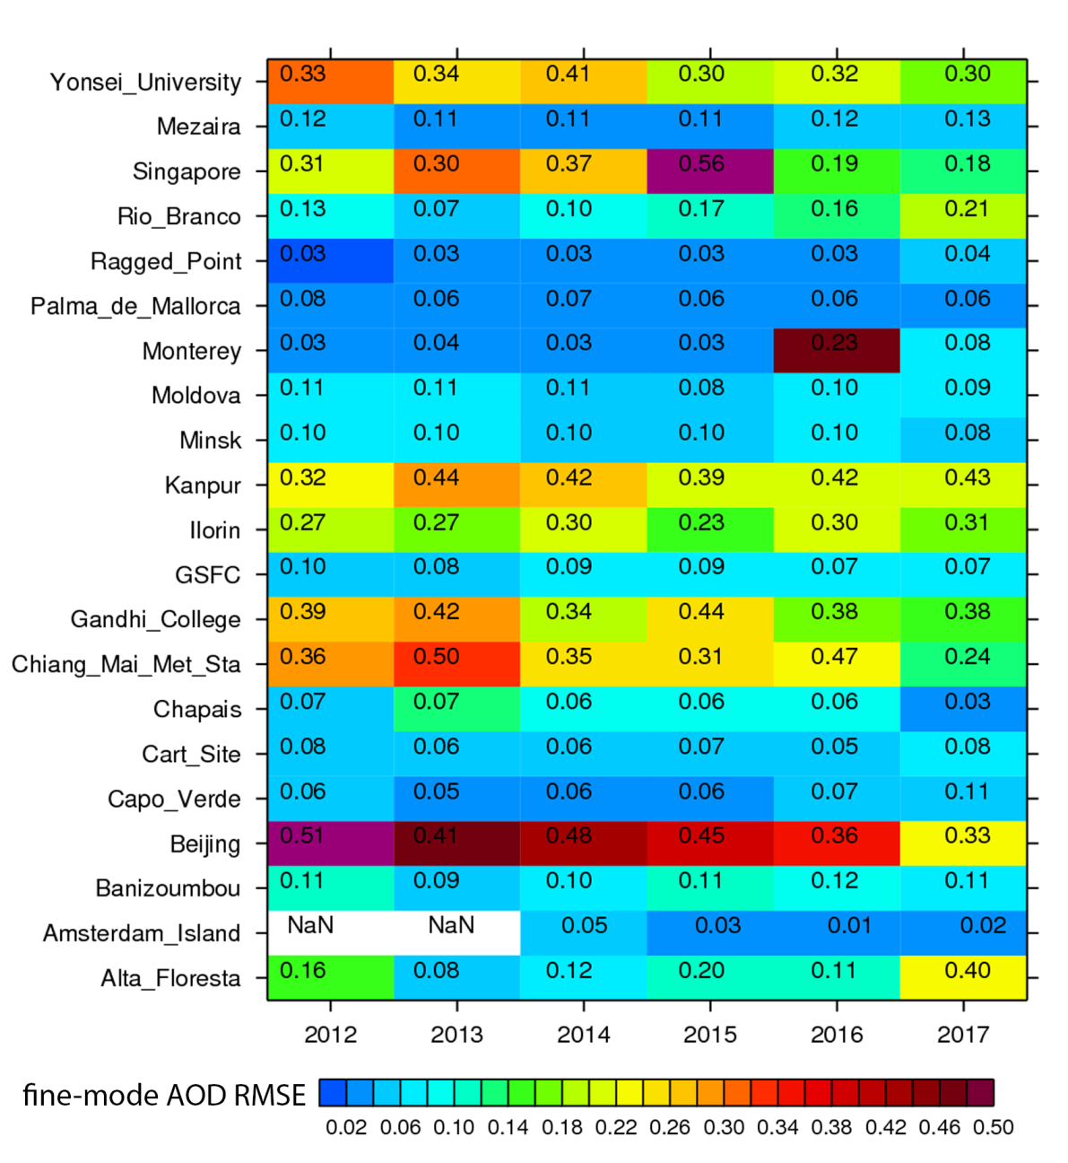
Figure S4. Same as Figure 11, except for fine-mode AOD. Evolution of ICAP-MME performance in terms of RMSE of fine-mode AOD at 550 nm of the 6-hr forecasts for the 21 AERONET sites shown in Table 1, over 2012-2017 time period. The number inside of each grid represents yearly mean AERONET V3L1.5 fine-mode AOD at 550 nm for the site and year. RMSE is shown in color. “NaN” means not enough data points (at least 100) for evaluation.
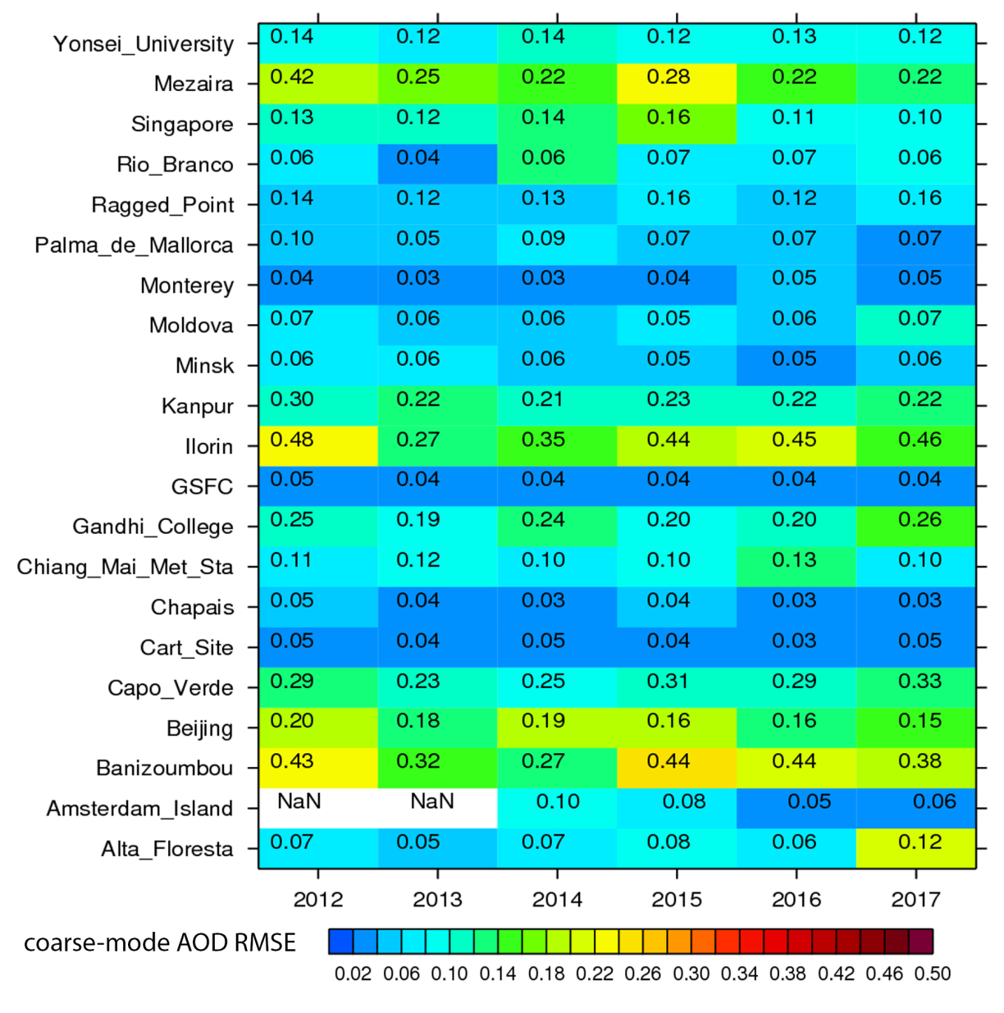
Figure S5. Same as Figure 11 and Figure S4, except for coarse-mode AOD.
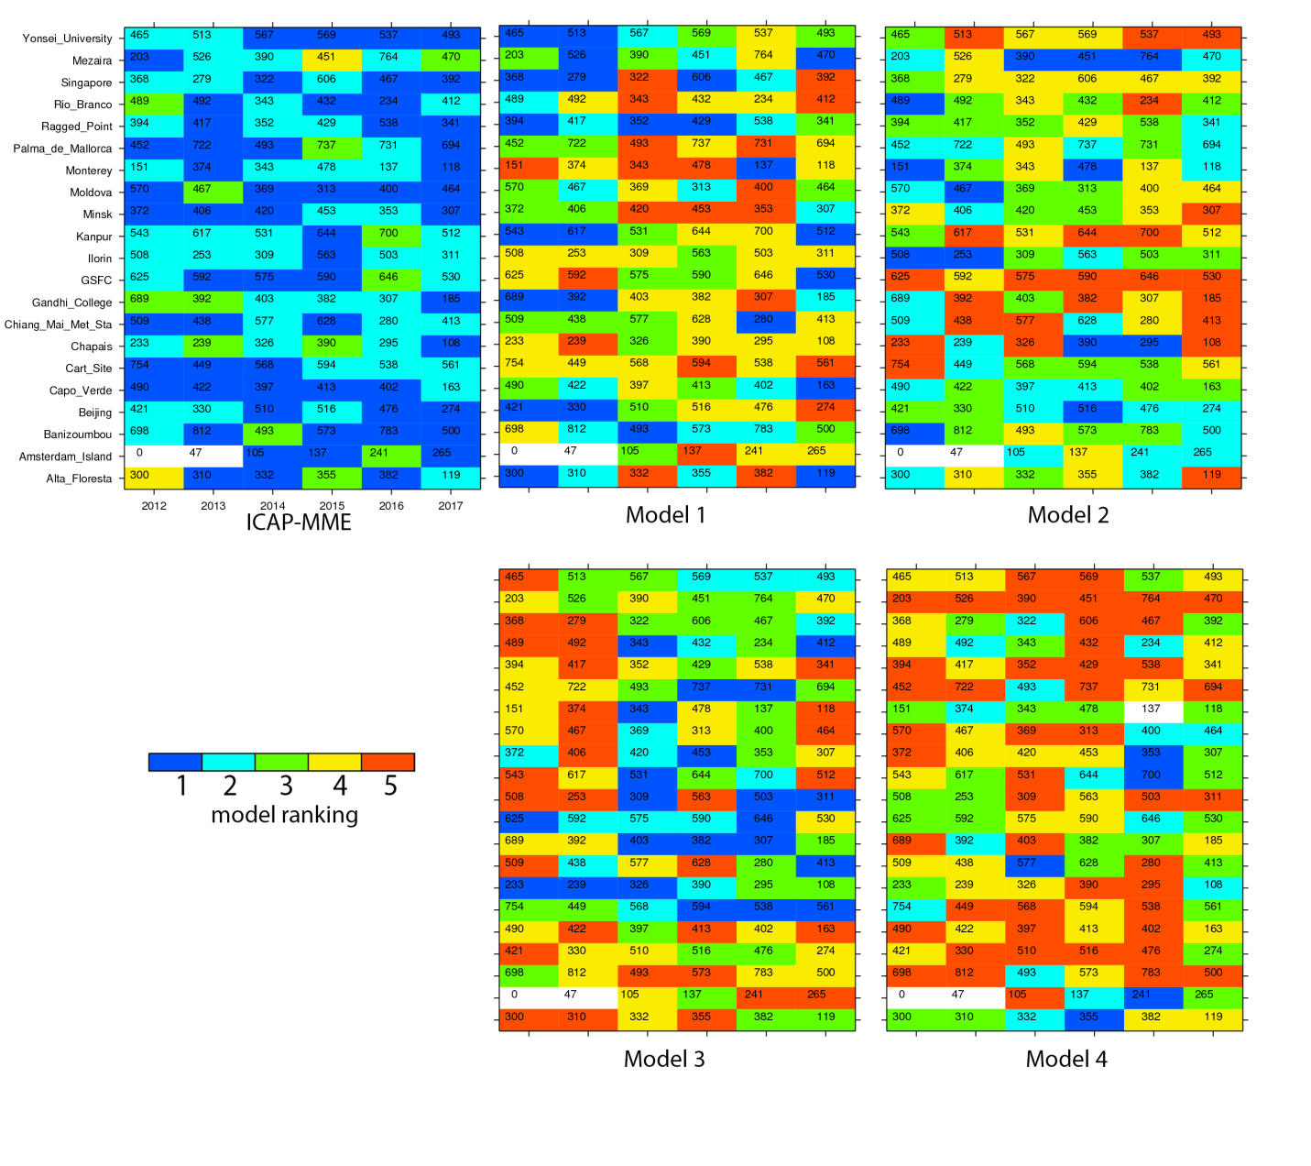
Figure S6. Same as Figure 13, except for rankings of ICAP-MME and the four full-species models in terms of total AOD RMSE over 2012-2017 for the 72-hr forecasts. The number inside of each grid represents total number of paired 6-hrly AERONET and ICAP-MME data for the site and year. Blank means not enough data points (at least 100). Axes of site and year for the four individual models are omitted to save space.

