Abstract
Mento music—Jamaica’s first popular musical form—has long existed in the shadows of more globally recognized genres like reggae and dancehall. With its roots in African and European folk traditions, mento once served as a vibrant form of cultural storytelling, yet today it faces fading relevance amid generational shifts, media neglect, and a lack of accessible archival resources. This thesis explores how integrated digital design can serve as a powerful tool for cultural preservation, using mento music as a case study. Through historical research, user-centered design strategies, and the development of a prototype for an interactive website called The Mento Music Museum, this project demonstrates how multimedia storytelling, and responsive technology can help revive cultural memory. Grounded in principles of accessibility, participation, and authenticity, the site aims to reintroduce mento to younger audiences while honoring its historical legacy. By designing with purpose and cultural sensitivity, this work offers a scalable model for preserving endangered art forms and re-centering overlooked cultural narratives in the digital age.
Keywords: mento, music, Caribbean, cultural preservation, accessibility, availability, user research

Acknowledgments
Thank you to my mom, my biggest supporter and cheerleader. Praise God because without him none of this is possible. Thank you to my friends and family who kept me grounded and motivated to accomplish this goal I set for myself many moons ago.
Special thanks to my advisor and committee chair Megan Rhee and committee member Renata Keck whose feedback, knowledge, guidance and support lead to the hard-fought completion of this project I hold dear to me.
And finally, to everyone who helped in any conceivable way shape the outcome of this thesis project: Thank You!

Dedicated To:
Michael Chance and Akeem Chance
Your memories will never be forgotten.

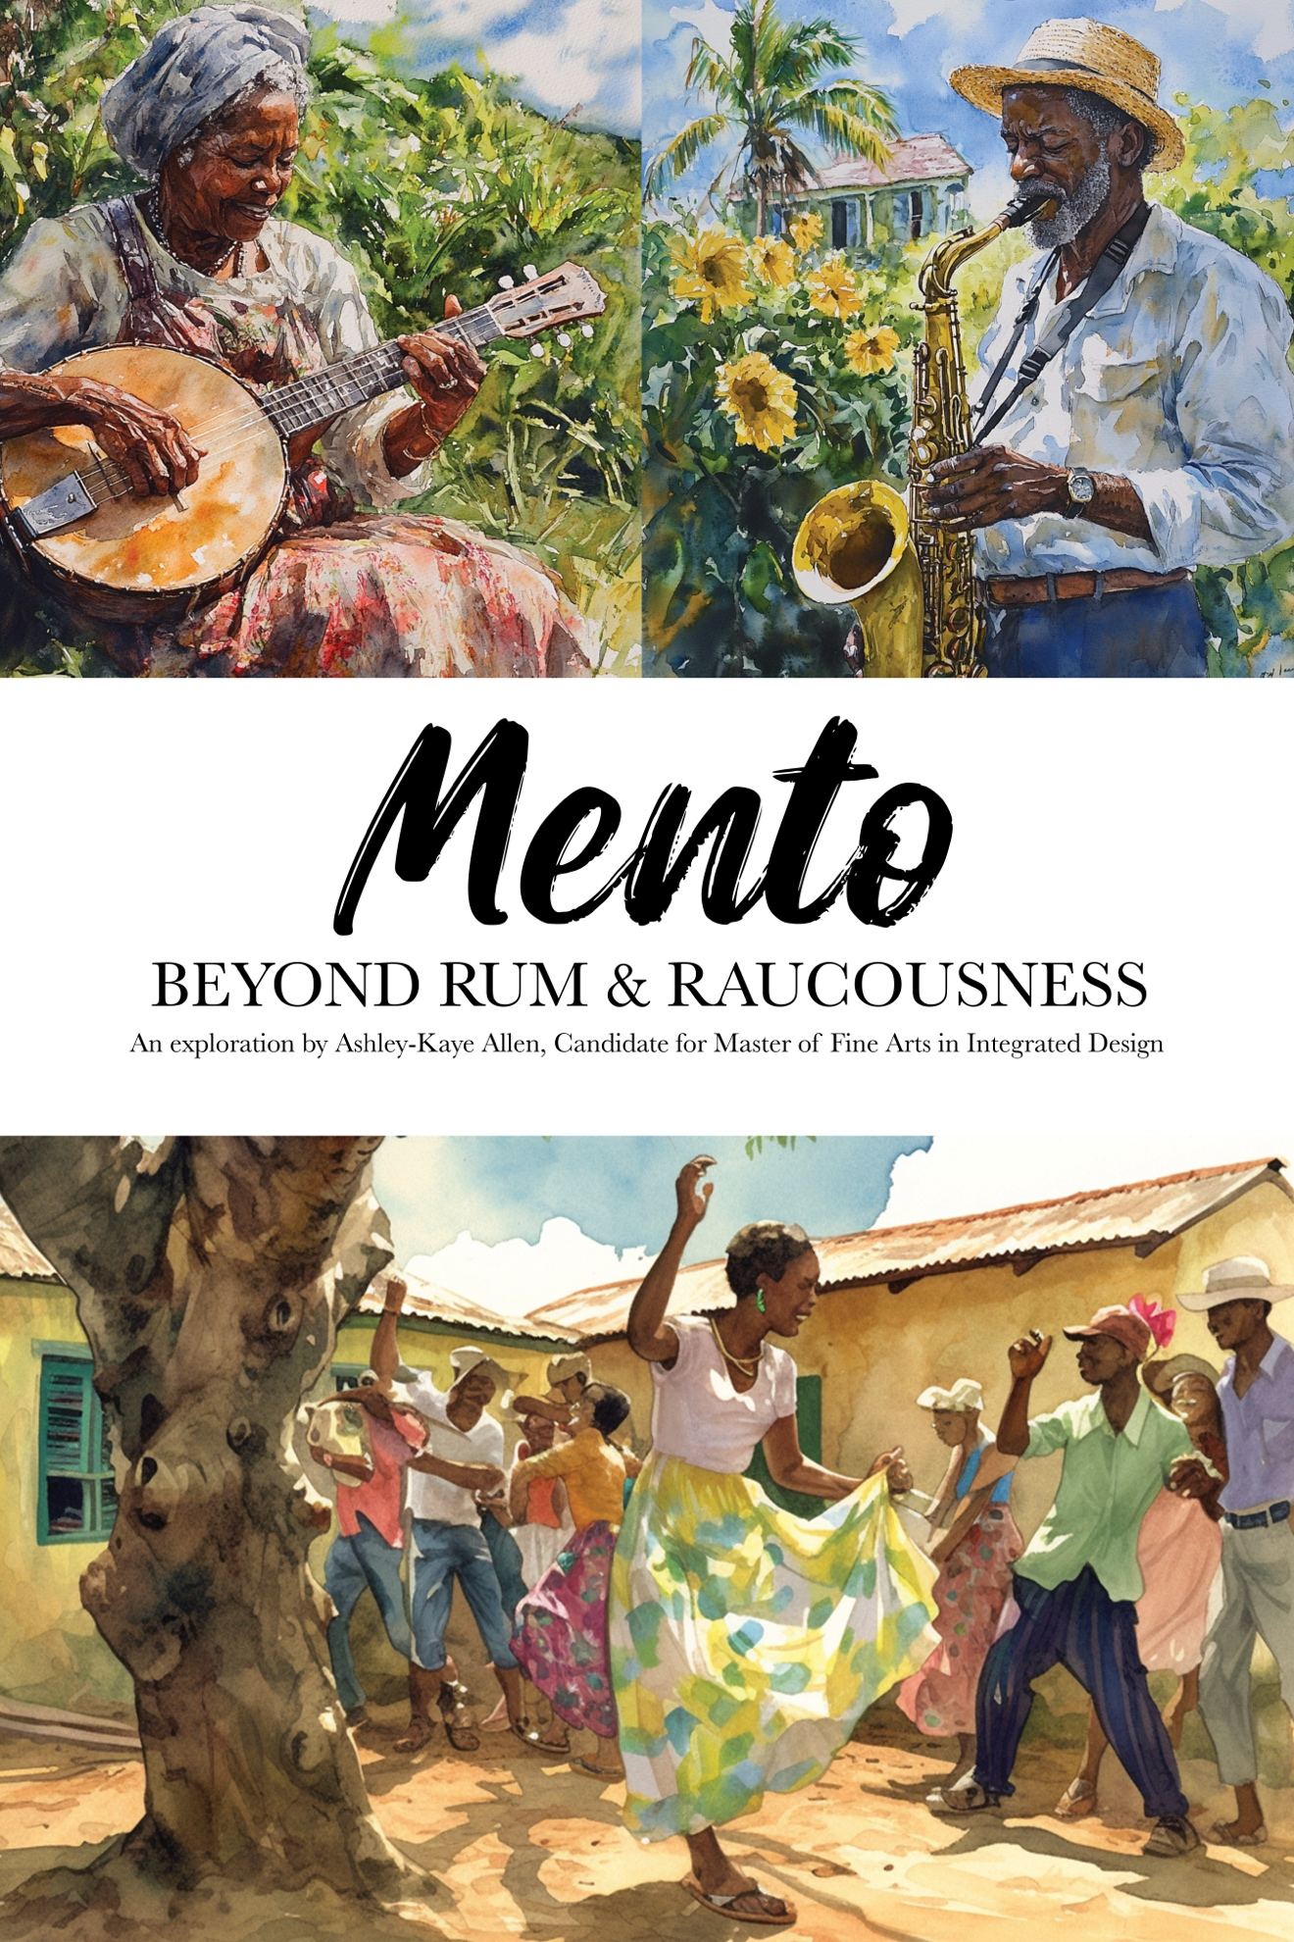
Introduction
As an immigrant, my heritage and culture are cornerstones of my identity. According to Ivey (2008) “Heritage is the part of our expressive life that tells us where we came from by preserving and presenting voices from the past, grounding us in the linkages of family, community, ethnicity, and nationality, giving us our creative vocabulary. It is the heritage of our expressive life that provides permanence and continuity; the half that connects us to our story, providing the resilience that comes with a sense of self in a particular place” (pp. 55-56). It is a teaching mechanism utilizing places, historical artifacts, and tangible skills to pass along practices from one generation to the next. While being raised in Jamaica, I performed folk songs and dances at school events. As an adolescent, I performed those same songs and dances at cultural festivals around the island. As an adult, deciphering my thesis topic, I chose to examine cultural preservation by curating and creating an online museum for mento music, the mother of all Jamaican music.
When explaining the importance of heritage, Logan (2007) stated:
Heritage usually comprises those things in the natural and cultural environment around us that we have inherited from previous generations – or were sometimes created by the current generation – and that we, as communities and societies, think are so important we want to pass them on to the generations to come . . . these things can be tangible (places, artifacts) and intangible (practices and skills embodied in people) . . . Heritage is the result of a selection process. It is not everything from our history – heritage and history are not one and the same. The aim of heritage is to pass on this selection of things with their values intact and in authentic condition (p. 34).
With multiple museums dedicated to renowned artists (Bob Marley, Peter Tosh),
music genres (Jamaica Music Museum, Reggae Museum) and culture (African Caribbean Institute of Jamaica/Jamaica Memory Bank), Jamaica has already begun its selection process. Preserving those bits of its culture it deems valuable and worth passing on to new generations with “their values intact and in authentic condition” (Logan, 2007, p. 34). But what does preserving a culture look like in a digital age? This thesis examines how Jamaicans could use digital design to preserve culture allowing it to be passed on to new generations.
Though reggae music is synonymous with Jamaican culture, mento, Jamaica’s indigenous folk music is where it all began. As a fusion of African and European rhythmic elements, mento gained popularity during the late 19th century. Bands played music from homemade instruments, creating a style natives refer to as country music. Lyrics typically have a humorous tone, painting pictures of issues occurring in Jamaican daily life, food, the island itself, and the Jamaican migration to England. Popular singers included Lord Flea, Lord Fly, Count Lasher, and Everard Williams, reflecting the genre’s overwhelmingly male roster.
Mento “occupies a very important place in Jamaica’s popular music, being the most indigenous along with having the distinction of being Jamaica’s first commercially recorded music”, yet it “has been given scant respect by musicologists and music aficionados, perhaps because it emerged at a time when the Jamaican music industry was not yet established” (Black, 2019). However, “to this day, mento has remained a popular draw at hotels and is still . . . the music of choice for visitors to the island. As Black (2019) stated, “a visitor’s first experience to live music would most likely be by a mento band”. To further this point, Neely (2014) stated “…in spite of the ubiquitous presence of tourism throughout the [Caribbean] region, the roles and importance of music and musical performance within the tourism sector are generally overlooked by scholars. The local music makers and entertainers that provide vacationers with sound tracks to their leisure often remain little more than invisible women and men—unknown, undocumented, and under-theorized.”
In response to the growing dependence on technology and the abandonment of traditional methods of preservation, I decided to analyze the practice of cultural preservation in a digital age. Using mento music as a case study, I examine how Jamaicans could preserve their rich music heritage digitally using an online museum.

Cultural Significance
Unlike other popular genres (ska, dancehall, reggae), mento originated from the slave plantation systems of Jamaica. It is a combination of the music brought to the island by enslaved Africans, with English folk songs and religious material that came out of the United States after the Civil War and the Great Revival. Mento songs are “an ode to life’s struggles – ‘man and woman problems’ and social issues as well as folklore delivered with music fused with rib-tickling metaphors” (Lyew, 2018). Song lyrics range from rural themes of food to more cosmopolitan images of relationship issues and risqué topics as evidenced in songs like “Linstead Market” (Bennett, 1954) and “Fat wife” (Jolly Boys, 1977).

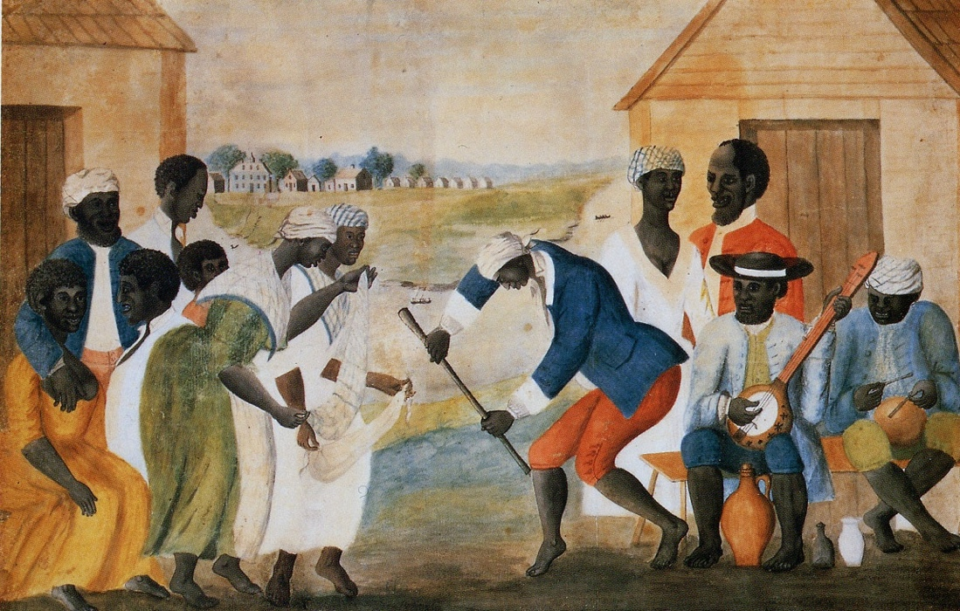

Figure 1.

Slave Dance and Music. This historical painting depicts enslaved Africans using music and dance as expressions of cultural identity and resistance.

Note. From Slave dance and music [Image], n.d., Wikipedia. https://en.wikipedia.org/wiki/File:SlaveDanceand_Music.jpg. In the public domain.

Mento’s sound combines sacred and secular music elements, mixing Pocomania church music, Junkanoo fife and drum sounds, the European quadrille, slave-era work songs, and even elements of American jazz (Moskowitz, 2006). The two main types of mento are classic and urban mento. Classic mento or “country music”, uses acoustic instruments, creating an informal folk quality. Instruments include the banjo, acoustic guitar, homemade reed instruments, and hand percussion instruments like the rhumba box. Whereas the slicker, more urban version of mento takes its cue from Caribbean jazz bands, featuring instruments like the saxophone, clarinet, bass, and piano (Moskowitz). As Neely (2014) stated, Mento should be danced to and sung passionately … [it] is one of Jamaica’s great social dance musics. It’s … a song type, a specific rhythm, a dance style, a dance event, and the generic local name for small, rustic community-based bands.
During the 1950’s as mento’s popularity increased, it found success in the American music market with “Day O” (Belafonte, 1956) and “Naughty Little Flea” (Flea, 1957). However, as sound recording grew in popularity locally, mento music began its metamorphosis into ska, reggae then dancehall music. Fortunately, for today’s music enthusiasts, traces of mento are still present in reggae and dancehall music as they mimics mento’s thematic styles by illustrating daily life and relationship struggles (Moskowitz, 2006) and syncopated beats (Mento Yaad, 00:37).
Yet, despite its foundational role in Jamaican music history, mento itself is rarely celebrated, studied, or performed with the same prominence. As globalized music trends and digital media shape cultural attention, mento faces the risk of being forgotten—not for lack of value, but for lack of visibility. The instruments, stories, and social commentaries once central to Jamaican life now struggle to find space in the digital landscape of playlists and smartphones of a new generation.

A Lack of Digital Presence and Immersive Tools
While mento is the first musical encounter a tourist experiences on the island, locals rarely listen to the twangy lament of elderly singers backed by home-made instruments. According to Neely (2014) “contemporary Jamaicans are far more likely to encounter mento as nostalgic entertainment for tourists than as a living tradition taught, shared, or actively performed”. As a Blue Glaze Mento Band banjo player and bandleader puts it, “Younger persons don’t gravitate to mento or the idea of being in a band that plays that type of music. As a matter of fact, many of the present-day recording artistes do not know the real root is mento, that it is a foundation” (Lyew, 2018).
In everyday media, education, and social life, mento has all but disappeared. Musicians, educators, and cultural workers have expressed concern that mento is not only underrepresented in national discourse but that many young Jamaicans have never heard of it at all (Lyew, 2018). The genre that once served as both entertainment and social commentary now risks being remembered only in fragments—if it is remembered at all. Nevertheless, there is a glimmer of hope in keeping mento alive among the youth, with March for Music Education’s exchange program. With the help of Brian Thomas, a Boston-based music instructor, students from Alpha Institute in Jamaica, and Canton High school in Massachusetts participated in a cultural exchange program where the students played “American music, including Jazz and Jamaican folk songs” (Paris, 2020). Musician and ethnomusicologist Daneil T. Neely also plays an active role in the preservation of mento music acting as a special consultant during the filming of Pimento and Hot Pepper-The Mento Story (Bilmon Productions, 2018).
“…for a century, mento music and its performers have hidden in plain sight. Early in the music’s history, its socially aware and often bawdy lyrics spoke to the lives of the people of the countryside and downtown, but they didn’t square with the sensibilities of uptown Kingston. In the 1930s, a “polished” version of mento was presented in nightclubs and hotels for tourists. Marketed to capitalize on the popularity of its Trinidadian cousin, Jamaican “calypso” delighted foreign visitors – especially in the 1950s – but it did little to inspire local interest as new musical forms like ska began to emerge. And while mento became a symbol of cultural identity in the years after Jamaican independence in 1962, the contributions of its many players were overshadowed by reggae’s international superstars. Despite its persistence and stylistic diversity over the years, it seems mento’s only constant has been its invisibility” (Bilmon Productions).
As the first documentary to explore mento music, Pimento and Hot Pepper-The Mento Story carefully examines the genre “through in- depth interviews with practitioners, critical commentary from experts, and rare archival audio and visual materials” telling a “new story about old Jamaica” (Bilmon Productions). Now that we’ve seen the delicate state of mento music, I’ll explore why it is imperative to keep our cultural heritage alive.

Using Design as A Preservation Tool
Design is often misunderstood as surface-level decoration. In practice, it is a tool of intentional cultural storytelling—a method that centers on community needs, narrative clarity, and long-term access. Design theorist Sasha Costanza-Chock (2020) emphasized in Design Justice that design also carries power: it shapes whose stories get told, who builds the platforms we use, and who those platforms serve. In cultural heritage work, design thus becomes a form of justice that amplifies marginalized narratives, particularly those excluded from institutional archives or top-down histories.
Rather than placing culture in a glass case, design enables a living, interactive framework where heritage is experienced rather than merely observed. This is especially urgent for communities whose heritage is intangible, rooted in oral traditions, embodied rituals, and communal memory that cannot be fully captured in static text or image. For example, in Nigeria, digital repositories of Igbo folk music use reimagined formats—audiovisual storytelling, hybrid musical arrangements, and online databases—to reconnect youth with ancestral sound (Nwamara, 2016). This aspect of design shows that it is not simply a delivery method but also a cultural interface shaping how users emotionally, visually and socially engage with the past.

Applying Design Thinking to Cultural Work
When creating this museum, I followed a Design Thinking approach — a human-centered problem-solving process, offering a compelling structure for preservation work. It uses five iterative stages—Empathize, Define, Ideate, Prototype, and Test prioritizing the lived needs of users. When applying Design Thinking in cultural contexts, empathizing means asking: What do community members remember? What sounds or images resonate? What feels authentic and what alienates? Participatory design invites those same users into the process of creating, ensuring that preservation efforts are not extractive but collaborative. This is especially critical when working with historically marginalized groups whose expressions have often been misrepresented or misunderstood.
Throughout this process, I spoke with several people to gain a better understanding – outside of my own – of the current state of mento music. At the Jamaican Embassy in Washington D.C. I learned curators were eager to share more current cultural artifacts with its visitors. Craving the opportunity to share more current glimpses into the culture, embassy employees were highly interested in the creation and sharing of a mento music museum. Conversely, when speaking with museum employees at the Institute of Jamaica, I learned that though there was high need for creating a physical mento museum, both funding and interest waned as the project progressed. However, while attending the Google IO conference, several Googlers expressed excitement for this project, commenting on its ability to highlight the union of technology –the possibility of using artificial intelligence to do so– and cultural heritage.

Why Design is Essential for Mento.
In the case of mento music, design offers a unique opportunity to resuscitate a genre at risk of disappearing. While archival recordings provide musical snapshots, they tend to lack the environmental and emotional depth that makes mento come alive: the informal humor, the communal energy, and the physicality of live performances. This is where I believe the Mento Music Museum fills that gap.
Through interactive tools (see Figure 2), embedded audio (see Figure 3), culturally informed visuals (see Figure 4), and mobile-responsive features, the site bridges the past and present, making mento music accessible to the youth, educators, enthusiasts and diaspora communities alike. Rather than letting mento fade into silence, design lets it adapt, connect, and be heard anew—preserving not just the sound, but the soul, of a culture.

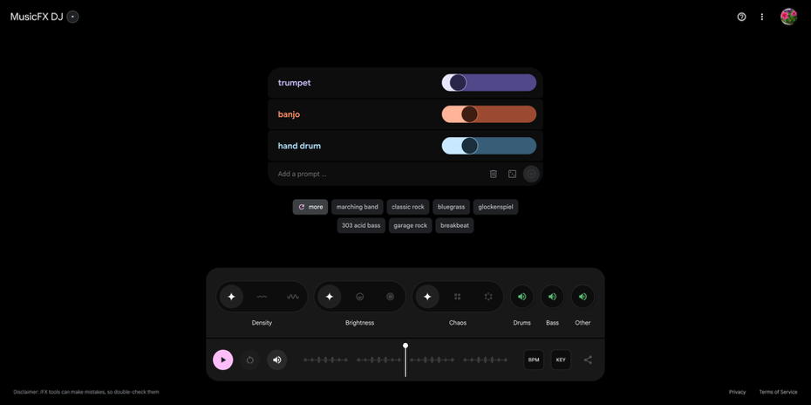

Figure 2

MusicFX DJ Interface. This screenshot shows the Google Music’s FX DJ user interface where users can input musical instruments and then “play” them.

Note. Screenshot of Goggle’s Music FX interface created by Ashley-Kaye Allen, 2025. Used under fair use for educational and illustrative purposes.

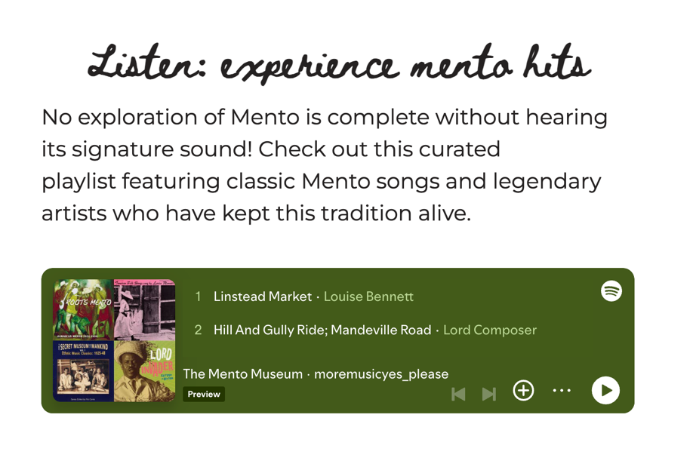
Figure 3
Spotify playlist interface for “The Mento Museum.” This curated playlist features classic mento tracks by artists like Louise Bennett and Lord Composer.
Note. Screenshot of Spotify playlist created by moremusicyes_please, 2025. Used under fair use for educational and illustrative purposes.

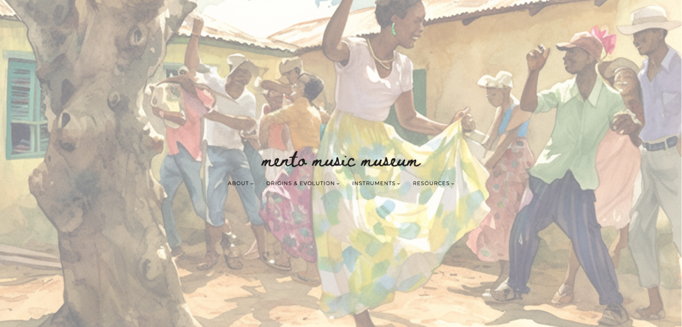
Figure 4
Homepage for “The Mento Music Museum.” This website is an online museum, a collection of artifacts and history about mento music.
Note. Screenshot of the Mento Music museum’s homepage by Ashley-Kaye Allen, 2025. Used under fair use for educational and illustrative purposes.

The Process
As Jamaica’s first popular music genre, mento music gave birth to ska, dancehall and reggae but is often overlooked, under shared and misunderstood. Her instruments, her stories and history are often missing from the digital world which is why I decided to preserve mento’s rich history by creating an engaging online experience called the Mento Music Museum. As Elizabeth Hartley stated, “Without preservation, we risk homogenizing the world’s cultural landscape, losing the richness of languages, art forms, and traditions that define humanity” (Hartley, 2024). Therefore, when designing this project, I aimed to create an authentic experience drawing inspiration from the landscape of Jamaica's rural interior, using vibrant colors and watercolor styled images to reflect daily life. The Bandana, Jamaica’s national costume worn during festivals and other cultural events, and the tradition of oral storytelling also inspired my designs. To solidify authenticity, I also decided to leverage modern tools such as image generators, online databases and streaming services.
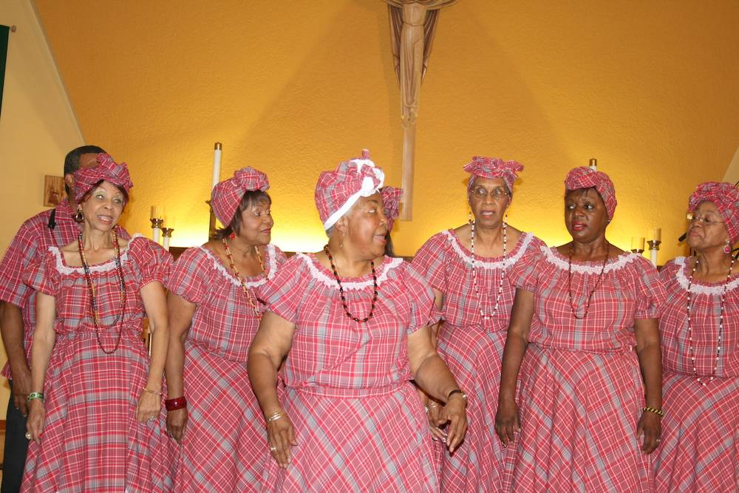

Figure 5

The History of Jamaican Bandana, Jamaica National Costume at Olive Lewin Celebration. This photo depicts a group of women participating in the oratory traditions of Jamaica.

Note. From Olive Lewin Celebration by Xavier Murphy. Used under fair use for educational and illustrative purposes.

The Approach
Preserving a cultural practice like mento music requires a process that is both structured and empathetic. To guide the creation of the Mento Music Museum, I followed the Design Thinking framework—a human-centered methodology used to solve complex challenges through creative, iterative learning. This approach enabled a flexible process keeping the needs of its users and the cultural specificity of mento at the center of each design decision.
The framework unfolded across five core phases: Empathize, Define, Ideate, Prototype, and Test.
- Empathize. This phase focused on building a foundational understanding of mento’s current perception—among the diaspora, Jamaican communities, educators, and music enthusiasts. I conducted an IRB-approved online survey (see Figure 6) with 35 participants, gathering insight into users’ familiarity with mento, learning preferences, and digital habits. Additional research included interviews with musicians, museum staff, and cultural scholars, as well as audits of existing music education websites. This work ensured that the museum would reflect user needs while honoring the cultural roots of mento.
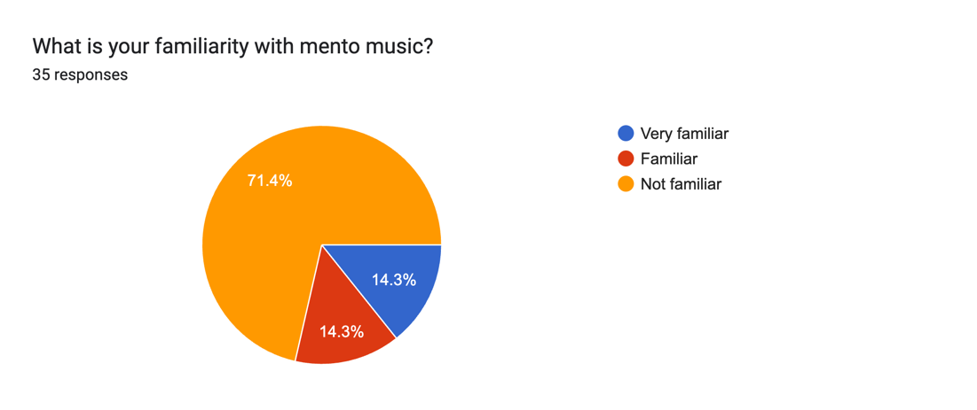

Figure 6

Online User Interest Survey. This screenshot shows the response to a question from the user survey.

Note. Screenshot of user interest survey created by Ashley-Kaye Allen, 2025. Used under fair use for educational and illustrative purposes.
- Define. Analysis of this research revealed the core design challenge: How can we present mento music as a living cultural experience through an engaging digital platform? To respond to this question, I created two detailed user personas (see Figure 7, Figure 8):
    - Andre, a music producer seeking authentic Jamaican sounds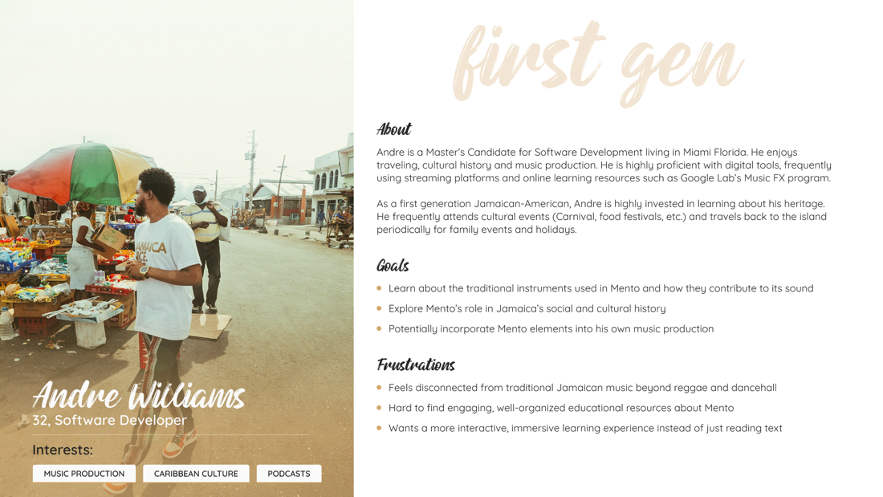

Figure 7

User persona card. This card shows the goals frustrations and background of the project’s primary persona.

Note. Screenshot of user persona created by Ashley-Kaye Allen, 2025. Used under fair use for educational and illustrative purposes.
    - Olivia, a cultural explorer and influencer interested in immersive storytelling
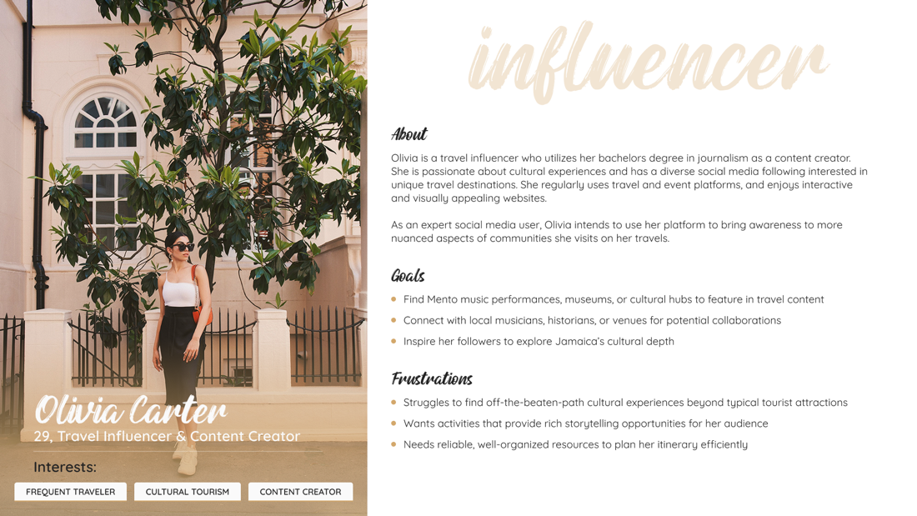

Figure 8

User persona card. This card shows the goals frustrations and background of the project’s secondary persona.

Note. Screenshot of user persona created by Ashley-Kaye Allen, 2025. Used under fair use for educational and illustrative purposes.
These personas shaped core priorities around navigation, sound interactivity, and visual richness.
- Ideate. In the ideation phase, I explored a range of content formats and user journeys (see Figure 9). I created low-fidelity wireframes and sketches in Figma, mapping user flows and layout structures. I drew visual inspiration from traditional Jamaican design elements (color, texture, typography) while balancing contemporary UI trends. A key goal was to design an interface that allowed users to experience mento as both music and culture.
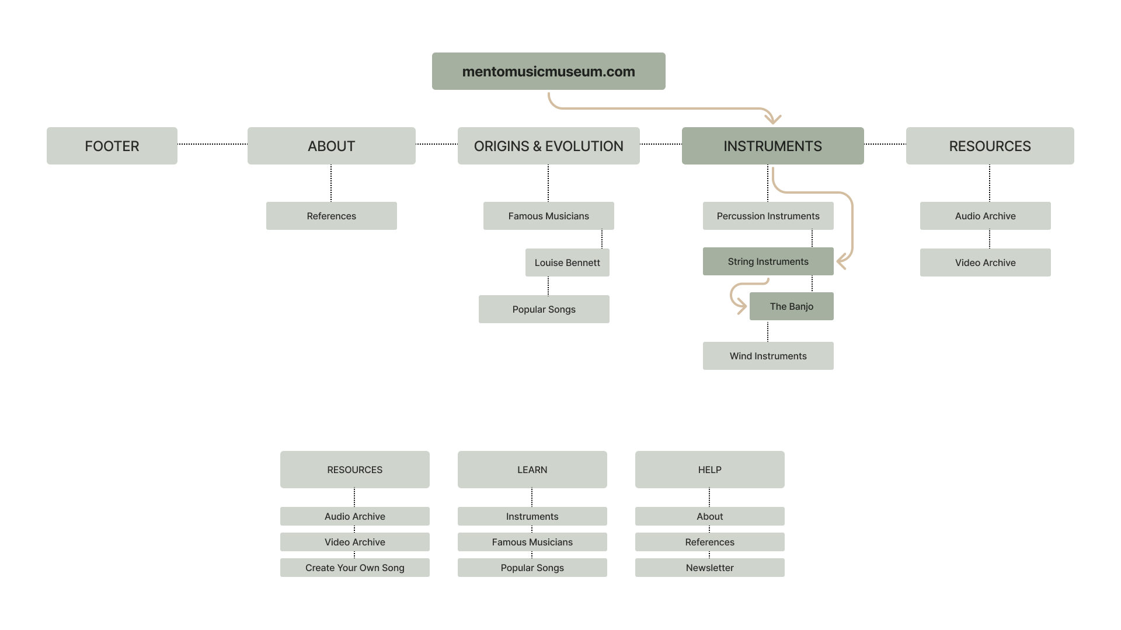

Figure 9

Andre’s User Flow. This screenshot shows the user journey of the primary persona.

Note. User flow screenshot created by Ashley-Kaye Allen, 2025. Used under fair use for educational and illustrative purposes.
- Prototype. Using WordPress as the platform, I developed a functional prototype featuring curated instrument pages, embedded Spotify and SoundCloud audio, interactive MusicFX tool and generated visuals (see Figure 10) for cultural context.
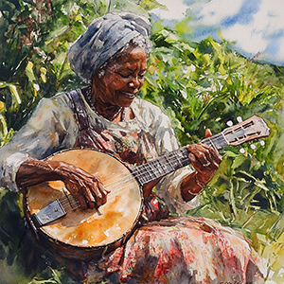

Figure 10

Garden Playing. This image depicts a woman playing the banjo in a rural setting.

Note. Garden Playing was created by Ashley-Kaye Allen using Midjourney. Used under fair use for educational and illustrative purposes.
The design emphasized accessibility and responsiveness across devices, with high-fidelity mockups created for desktop and mobile use.
- Test. Multi-device usability testing and open-ended user feedback were gathered through informal interviews and observation. Participants responded positively to the site’s interface, accessibility, and immersive sound design. Based on this feedback, minor changes—such as improved contrast ratios and clearer visual labels—were implemented. This iterative cycle ensured that the final product supported both cultural preservation and user engagement.

Collecting The Data
User research and testing were integral to refining the Mento Music Museum's user experience. Therefore, I focused on qualitative and quantitative feedback to evaluate usability, interest, and alignment with user expectations.
- Card Sorting (see Appendix E)
- I conducted two card sorts focused on how users would label and categorize the site’s main, footer and sub menus. Participants of the first sort reported not being clear on how to sort the labels due to lack of familiarity with mento music. They were also not sure on how to sort the cards among main menu, footer menu and sub menu.
- Based on those results, I conducted a second card sort with modified labels, this feedback led to the site’s current menu structure.

- Online Survey (see Appendix F)
- I conducted an unmoderated, IRB-approved online survey with 35 participants aimed at learning the level of interest in the topic, what users would anticipate seeing on the website, and how they would anticipate using the website. There were 6 focus areas, including general user information, content preferences, user experience, accessibility and usability, additional features, and participant demographics.
- Key findings included:
    - 71% were unfamiliar with mento music
    - High interest in learning about mento instruments
    - Top content preferences: historical background, sound clips, and visuals
    - Preferred interactive element: educational and interactive videos
These findings from the card sort and online survey validated design decisions ensuring the final content structure aligned with cultural integrity and audience interest.

Features and Accessibility
Designed as an engaging and immersive website presenting mento music not only as sound but as a cultural experience, the Mento Music Museum’s features were developed to reflect the genre’s spirit of storytelling, rhythm, and community while remaining accessible to modern users. The following components work together to create an engaging environment for cultural exploration:
Embedded Media: SoundCloud and Spotify embeds were used to improve user experience and allow users to engage in a more thorough exploration of instrument sounds
Curated Educational Content: To enrich the museum experience I curated archival videos, artist interviews, documentaries, and conversations with instrument makers — offering users a multidimensional look into mento.
Accessibility Testing: Accessibility played a big role in this website's design. To ensure it follows current ADA standards, I checked the contrast ratios of images and text, labeled images and videos throughout the website and used an accessibility evaluation tool.

Impact and Reflection
While this prototype provides a foundation for ongoing work, it also spotlights critical areas requiring caution, collaboration, and creative problem-solving. One of the central challenges in developing the Mento Music Museum was navigating questions of access and ownership. Although the site aims to increase public engagement with Jamaica’s musical heritage, the absence of clear licensing pathways for many historical recordings, photographs, and other documents complicates decisions around what could be shared responsibly.
Many mento recordings circulate informally online, with unclear provenance or legal standing. This lack of formal archival infrastructure limited the quantity and quality of usable content, raising important ethical considerations around authorship, attribution, and fair use. As a result, the museum took a conservative approach, prioritizing freely available media and materials with verified permissions. Still, the need for a more cohesive, rights-conscious cultural licensing framework remains a barrier to full access.

Artificial Intelligence (AI) Ethics.
In response to gaps in visual documentation, I used artificial intelligence tools such as Midjourney to generate context-appropriate imagery (see Appendix M). These AI-generated visuals provided aesthetic and thematic consistency across the site, particularly where photographic records were limited or inaccessible. However, the use of generative AI in a cultural context is far from neutral.
Questions emerged around cultural authenticity, bias in training data, and the implications of visualizing heritage through algorithmic models. To answer those concerns, artificial intelligence was used sparingly and strategically to mitigate them, acting as a bridge rather than a substitution. Visuals were reviewed for cultural sensitivity and paired with descriptive text to maintain contextual integrity.

Limited Archival Content
The most persistent limitation throughout this project was the scarcity of accessible, well-preserved archival materials related to mento. Unlike more well documented genres such as reggae or ska, mento has not been widely digitized or institutionally cataloged. Much of its history remains in oral forms, held by aging musicians, local collectors, or informal recordings scattered across outdated formats. This in turn helped shaped the project’s methodology, pushing the design toward interpretive storytelling with artificial intelligence creating a visual aesthetic, and using artist interviews to give a first-person view of mento and its cultural impact rather than exhaustive documentation. Together, these challenges point to the evolving nature of cultural preservation in a digital age, where access, ethics, and memory must constantly be negotiated.

What Lies Ahead?
Just like the culture it honors, the Mento Music Museum has room to grow. This is just the beginning. Future directions include expanding the instrument database, building educational partnerships, developing promotional materials, and encouraging user-generated content. Each of the following opportunities affirms the project’s original vision: to preserve, interpret, and celebrate mento music through an inclusive and adaptable digital platform. As cultural heritage work intersects with technology, the Mento Music Museum offers a scalable model for amplifying oral traditions and empowering community-centered storytelling.
Archival Expansion: Complete expansion of archival images, instruments, sounds, interviews, and documentaries.
Collaborations with Educational Institutions: Formal partnerships with schools, universities, museums, collectors, cultural historians, cultural programs and archives.
User-Generated Content: Users can contribute their audio, family stories, and musical interpretations, transforming the site into a participatory cultural space.
Promotional Content (see Appendix N): The museum could produce promotional content, including documentary shorts, social media reels, educational videos, and printable exhibits, to support audience growth and long-term sustainability. These materials would help disseminate Mento’s story to broader audiences and position the museum as a cultural resource at the intersection of heritage and innovation.

For The Preservation of Culture
Mento is more than music—it reflects Jamaica’s humor, struggle, pride, and resilience. Yet despite its foundational influence on Jamaica's sound and identity, mento has largely been left behind by its more commercialized and hipper offsprings, reggae, ska and dancehall. As the digital world becomes a new repository for memory, there is an urgent need to reimagine how we preserve and share our cultural legacies.
This thesis demonstrated how integrated design helps bridge generational and geographic gaps by transforming mento from a fading memory into an accessible, digital experience. Through the development of the Mento Music Museum, I explored how web-based storytelling, sound interaction, and inclusive UX design can work together to honor tradition while embracing innovation.
Ultimately, this project offers a model for preserving culture in the digital age: not by freezing it in time, but by inviting users to revisit and reimagine it. It invites further exploration, broader collaboration, and deeper commitments to the communities whose stories are being told. In preserving mento, we do not simply save sound—we preserve identity, memory, and the rhythms that continue to shape Jamaica’s cultural identity.

References
African Caribbean Institute of Jamaica/ Jamaica Memory Bank. (n.d.). V200. v20 – mento yaad.mp4 [Recorded Video].
Belafonte, H. (1956). Day-O (the banana boat song) [Record]. RCA Victor. https://open.spotify.com/track/4fHDlIntTsRGSyTg5UYZYC?si=QBWQcCqRQbO_61PZTK6jZw
Bennett, L. (1954). Linstead market [Record]. https://open.spotify.com/track/3xkgbIYccnQzTCuqMhQGe4?si=FCRSVnMvTHqMxtyuWcPZLg
Bilmon Productions. (2018a, May 3). Special consultant | the mento story (Pimento and hot pepper) - bilmon productions, LLC. The Mento Story (Pimento and Hot Pepper) - Bilmon Productions, LLC |. https://www.mentostory.com/special-consultant/
Bilmon Productions. (2018b, May 3). Synopsis | the mento story (Pimento and hot pepper) - bilmon productions, LLC. The Mento Story (Pimento and Hot Pepper) - Bilmon Productions, LLC |. https://www.mentostory.com/synopsis/
Black, R. (2019, July 7). Vintage voices | mento Jamaica’s calypso. Jamaica-Gleaner.com. https://jamaica-gleaner.com/article/entertainment/20190707/vintage-voices-mento-jamaicas-calypso
Costanza-Chock, S. (2020). 3: Design narratives: From txtmob to twitter. In Design justice: Community-Led Practices to Build the Worlds We Need (pp. 103–134). The Mit Press. https://doi.org/10.7551/mitpress/12255.001.0001
Flea, L. (1957). Naughty little flea [Record]. Capital Records.
Hartley, E. (2024, December 13). The importance of cultural preservation in modern times. MeshPedia. https://www.meshpedia.com/the-importance-of-cultural-preservation-in-modern-times/
Ivey, B. J. (2008). Arts, inc. : How greed and neglect have destroyed our cultural rights (1st ed., pp. 55–56). University of California Press.
Logan, W. (2007). Chapter 2 closing pandora’s box: Human rights conundrums in cultural heritage protection. In Cultural Heritage and Human Rights (pp. 33–52). Springer. 10.1007/978-0-387-71313-7
Lyew, S. (2018, June 5). Traditional bands a big part of tourist entertainment – Mento bands, still relevant to growth of current . Jamaicagleaner.com. https://jamaica-gleaner.com/article/entertainment/20180708/traditional-bands-big-part-tourist-entertainment-mento-bands-still
Moskowitz, D. V. (2006). Caribbean popular music : An encyclopedia of reggae, mento, ska, rock steady, and dancehall. Greenwood.
Nwamara, A.-I. O. (2017). Repackaging Igbo folksongs for global acceptance: Towards reviving and preserving the musical heritage of a Nigerian community. Journal of the Musical Arts in Africa, 14(1-2), 53–67. https://doi.org/10.2989/18121004.2017.1410989
Paris, C. (2020, June 19). CHS students make music with Jamaican visitors | Canton Citizen. Thecantoncitizen.com. https://www.thecantoncitizen.com/2020/06/19/jamaican-musical-guests/
Rommen, T., & Daniel Tannehill Neely. (2014). Sun, sea, and sound : Music and tourism in the circum-Caribbean. Oxford University Press.
The Jolly Boys. (1977). Fatwife [Record]. https://open.spotify.com/track/3U5Ka3iMLw2XQFkRK65kOd?si=-qVxOtuURx-Ls341bDgyMw

Appendix A: Popular Placements Matrix

Card | Main Menu | Sub Menu | Footer Menu
Home | 80% | 20% | 0%
Origins and Evolution | 80% | 20% | 0%
Multimedia Archive | 80% | 0% | 20%
Making The Band | 60% | 20% | 20%
Famous Musicians | 60% | 40% | 0%
Educational Resources | 60% | 20% | 20%
Audio Clips | 20% | 80% | 0%
Images | 20% | 80% | 0%
Videos | 20% | 80% | 0%
Instruments | 20% | 60% | 20%
Visitor Information | 0% | 0% | 100%
Get Involved | 40% | 0% | 60%

Appendix B: Navigation Menus

Figure 1. The Mento Music Museum’s main navigation menu.


Figure 2. The Mento Music Museum’s footer navigation menu.

Appendix C: Project Poster

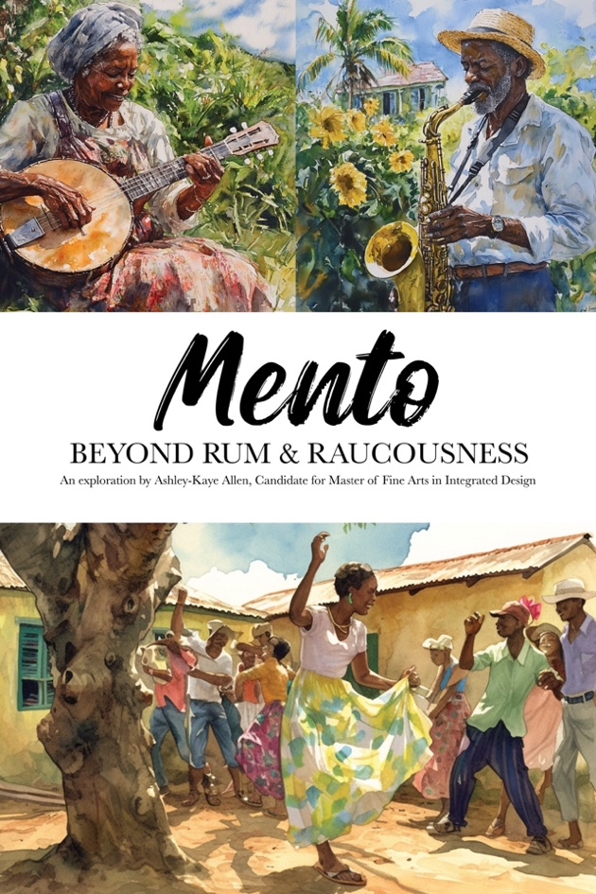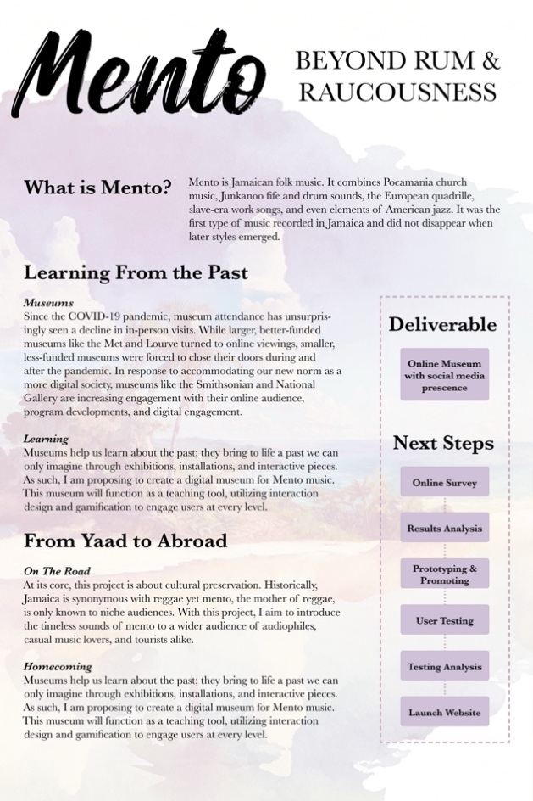

Appendix D: IRB Certification

Appendix E: Card Sorting Results

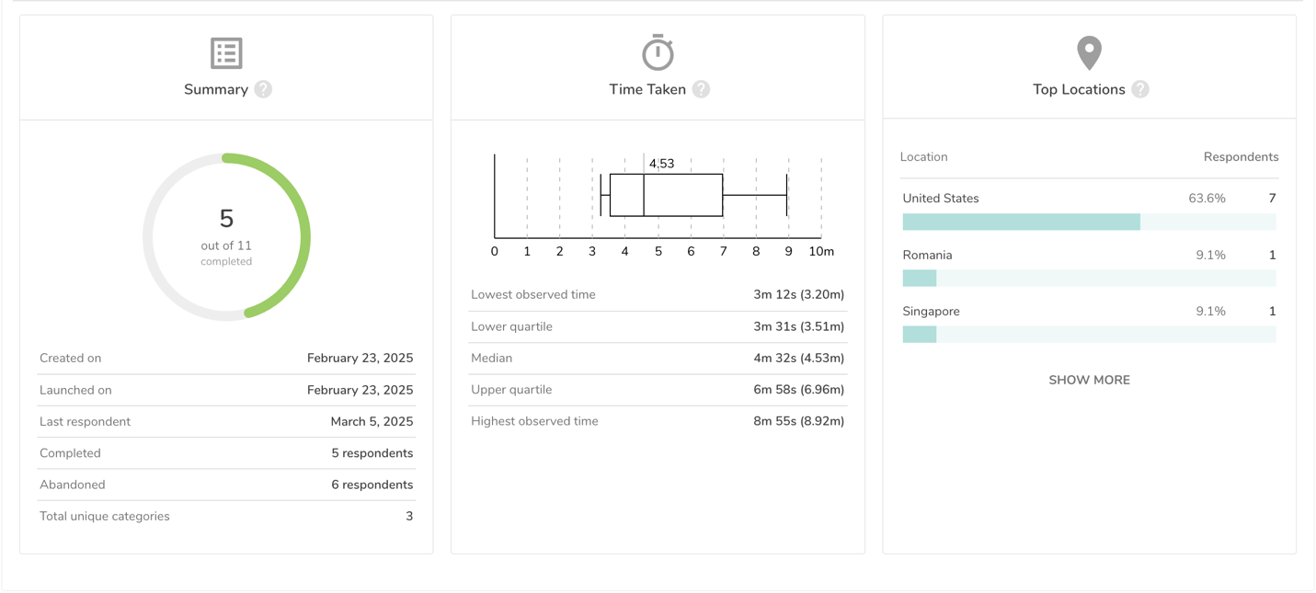
Cards
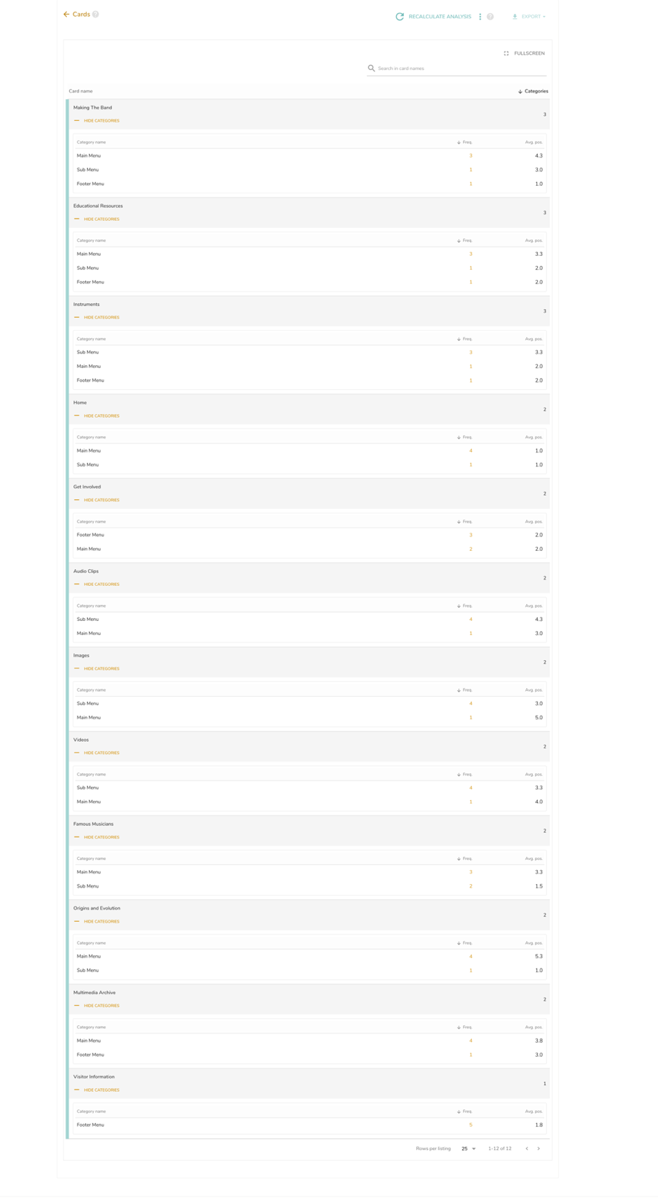

Categories
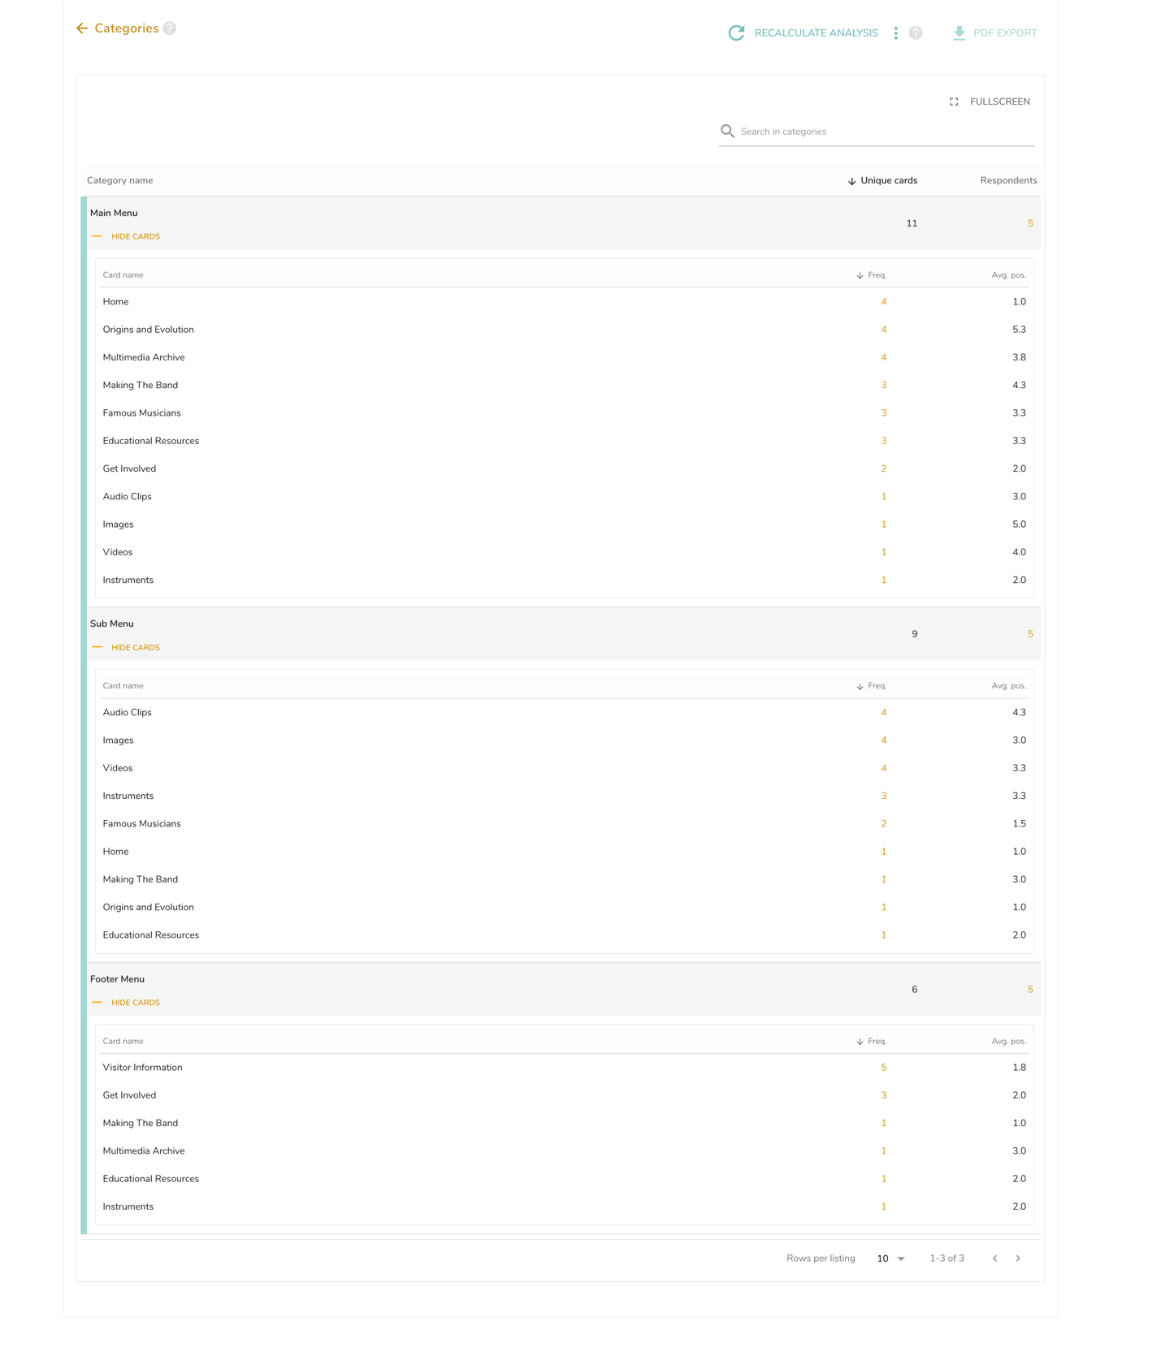

Matrices

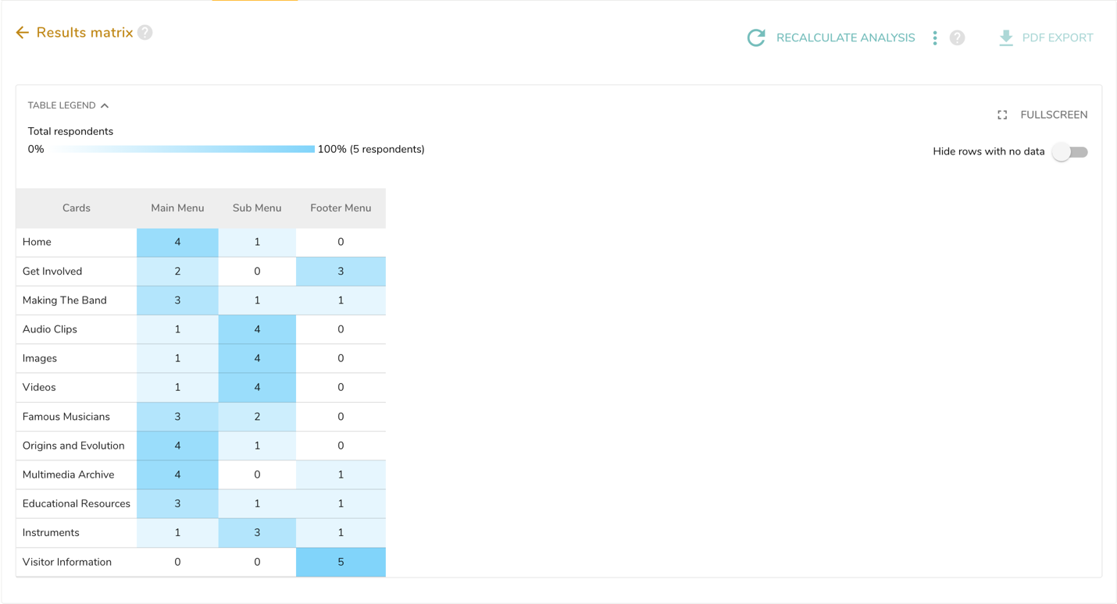

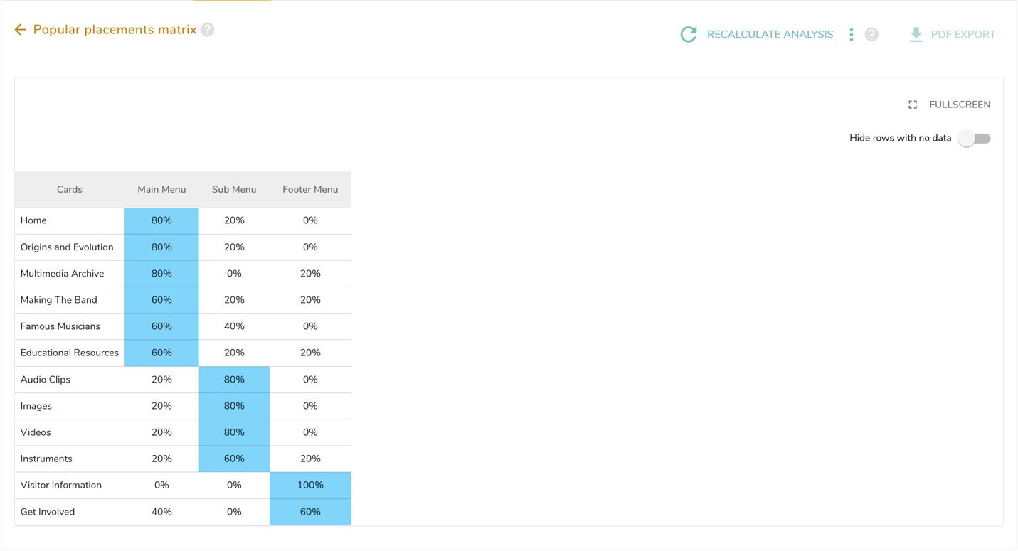
Post Survey Questionnaire

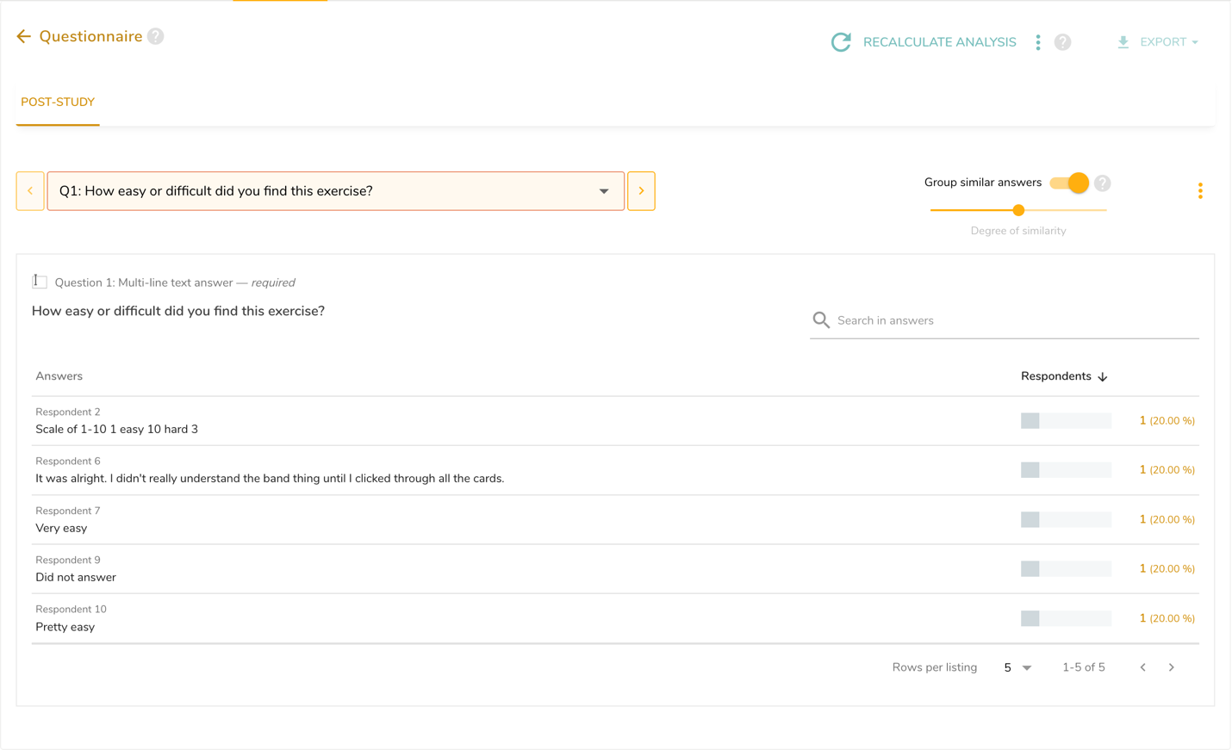

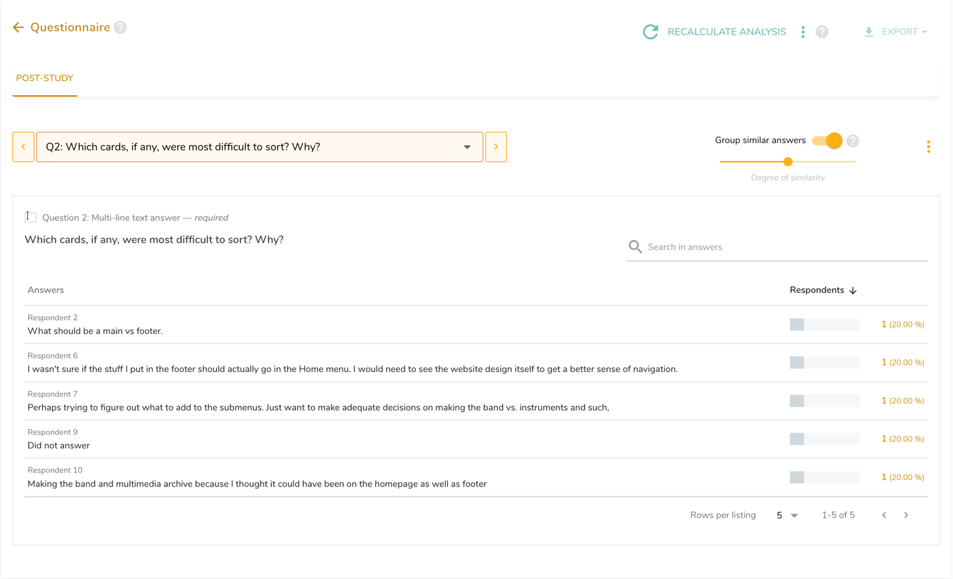
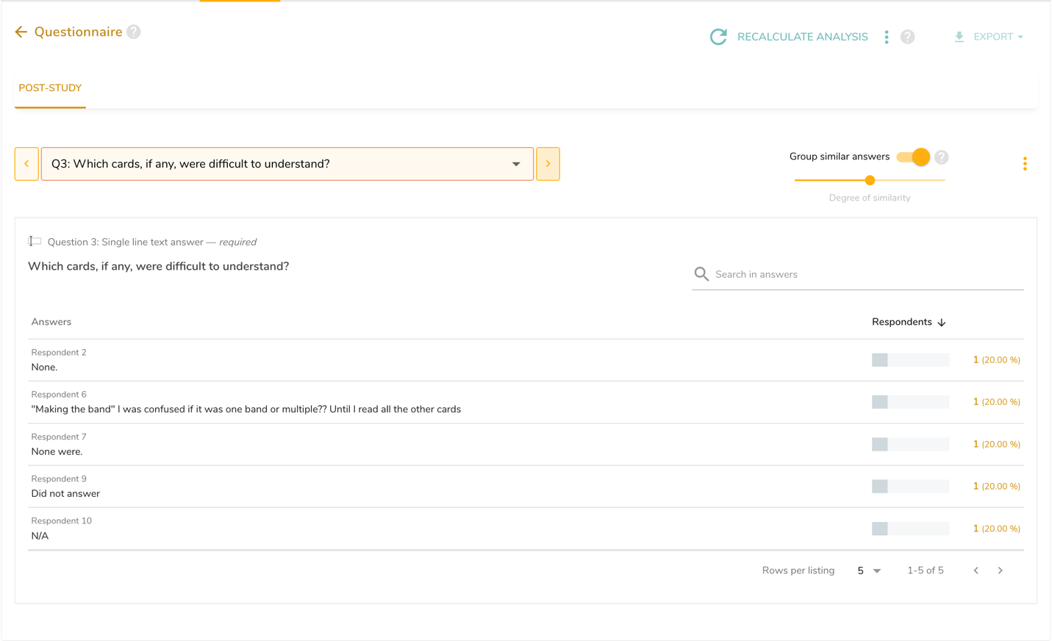

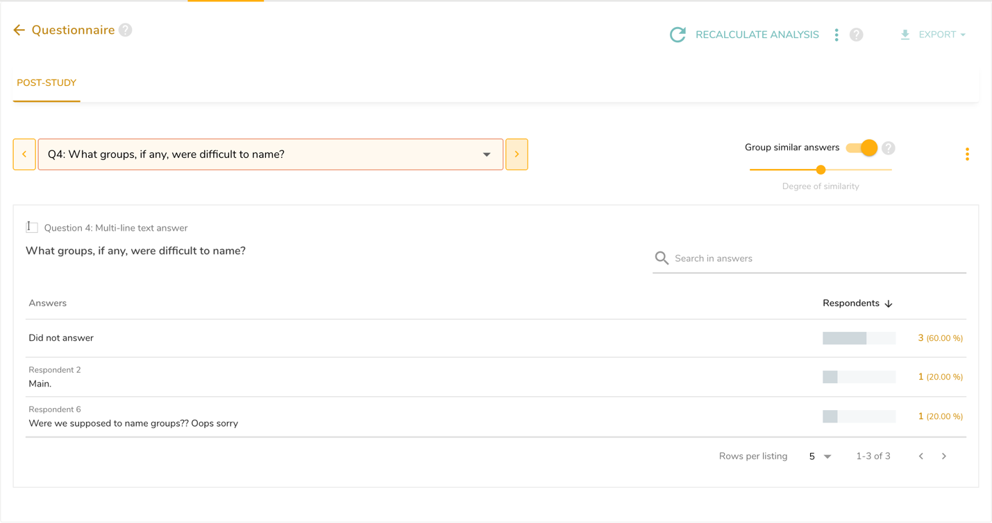

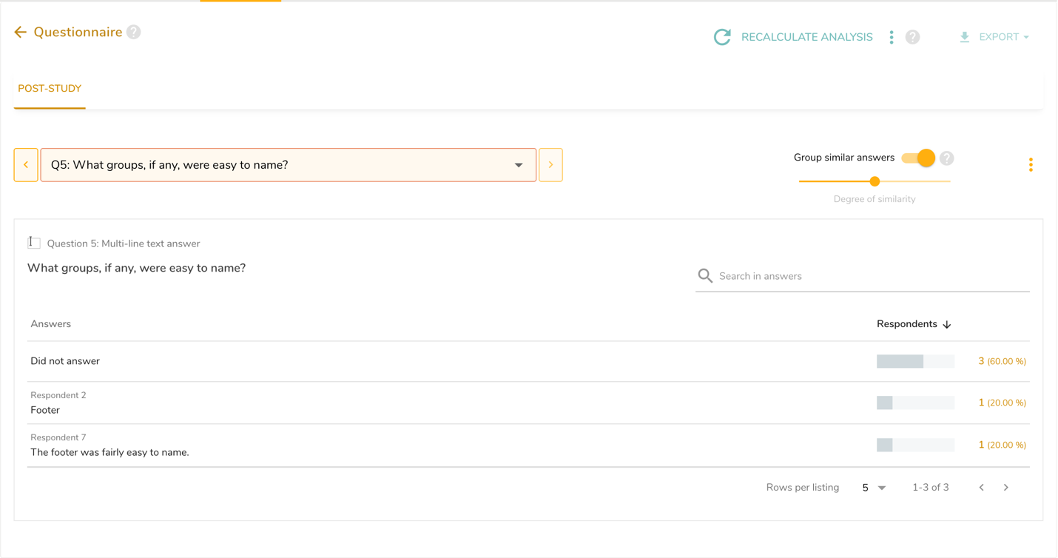

Appendix F: Online Survey Results

General User Information: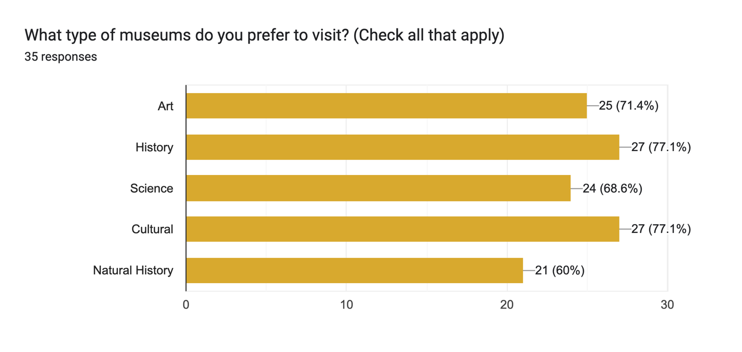

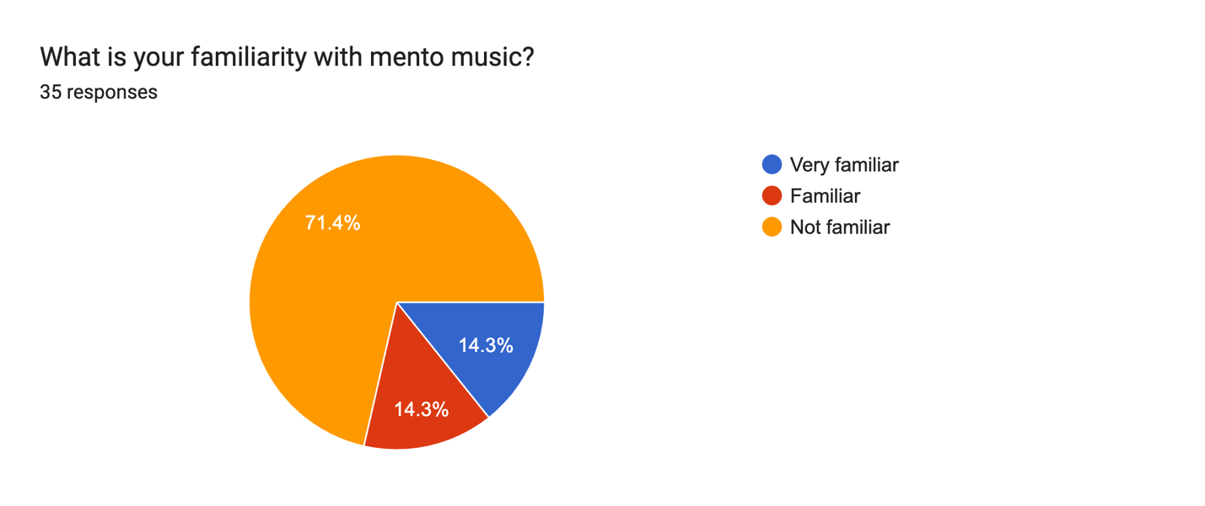
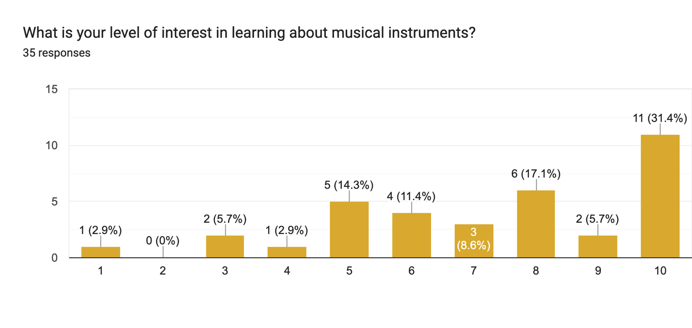

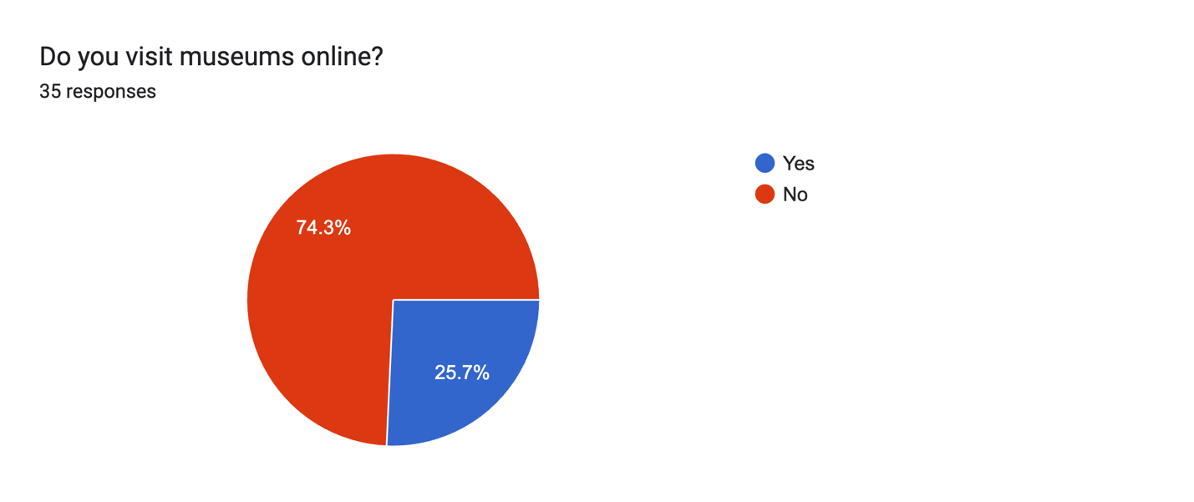

Yes
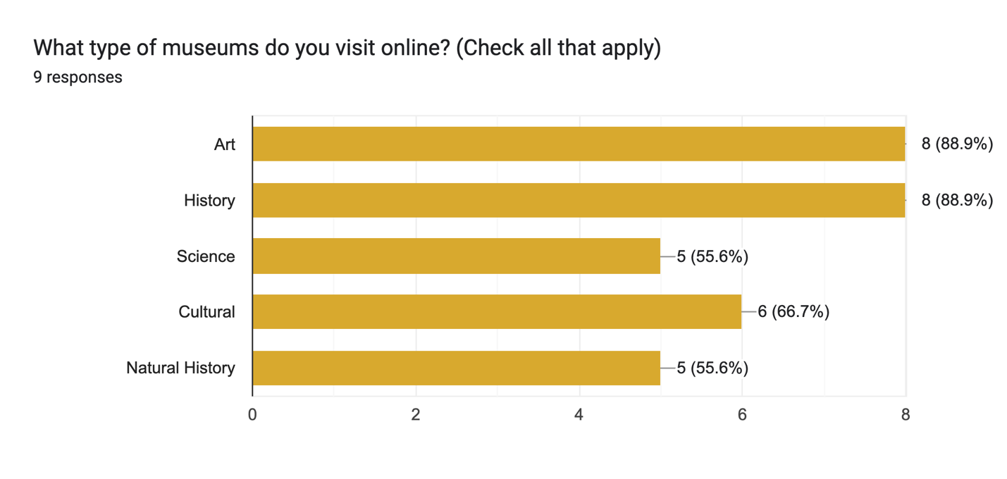

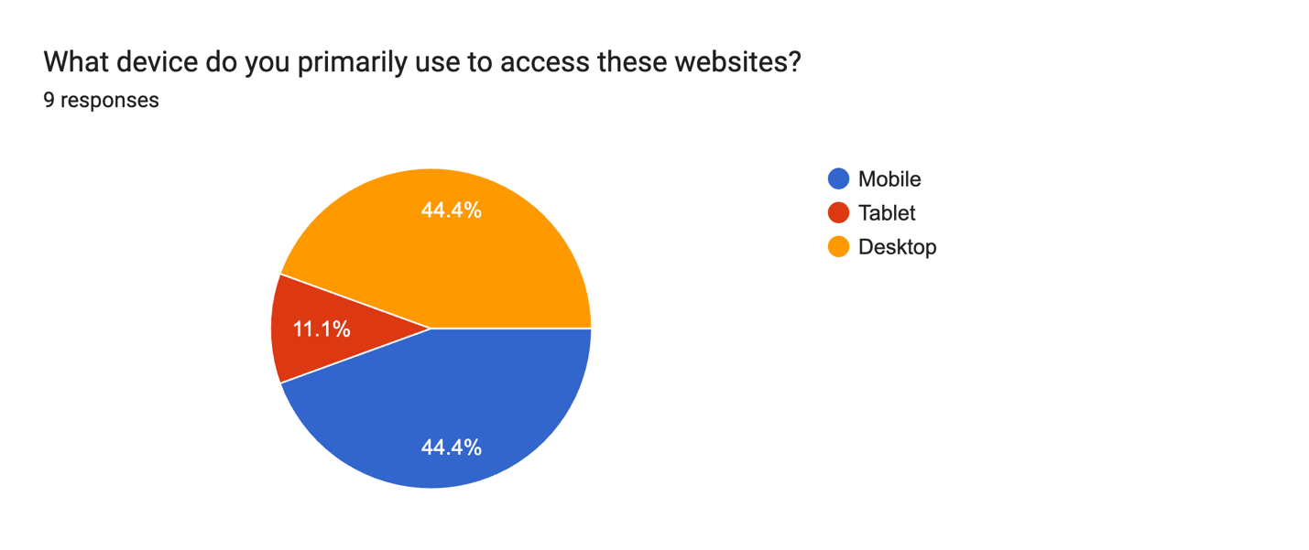

Content Preferences
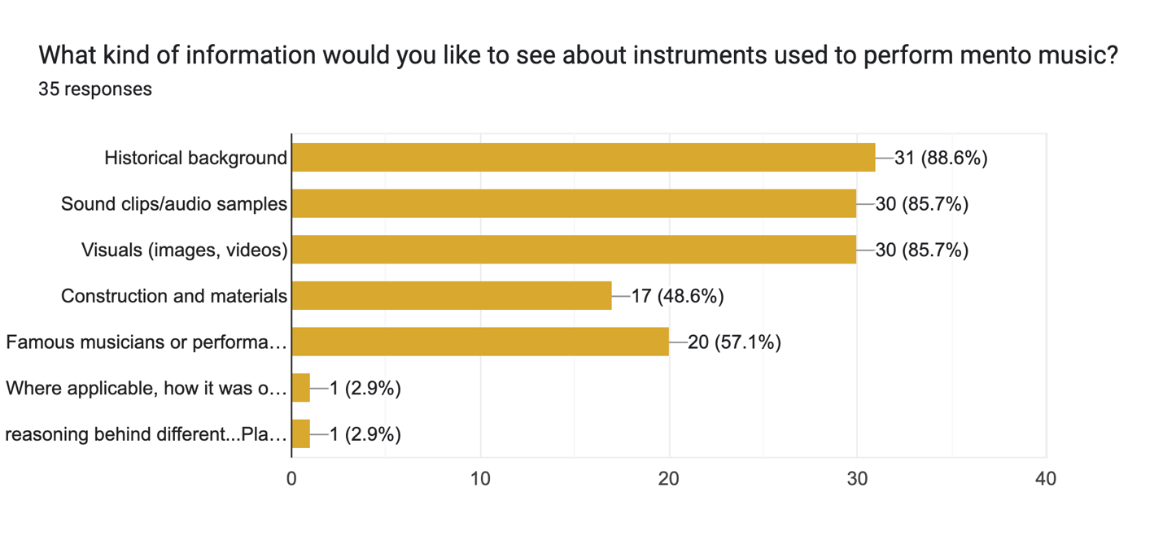

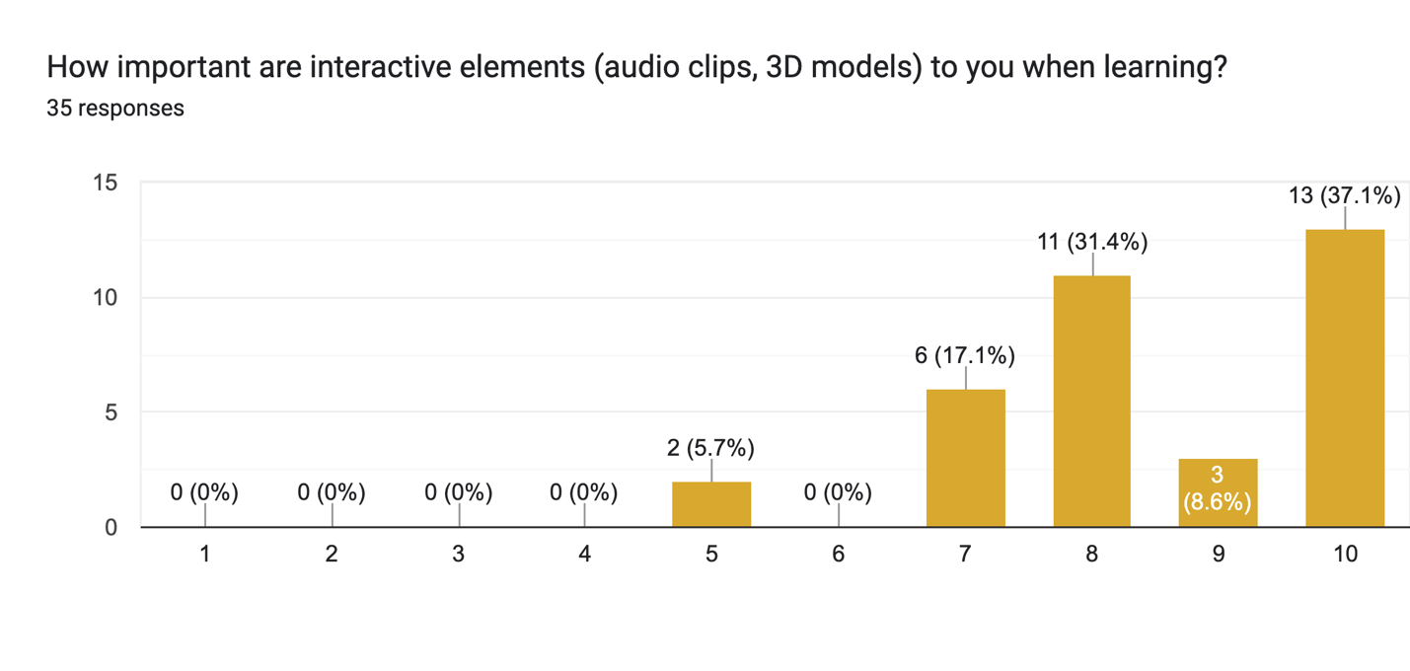
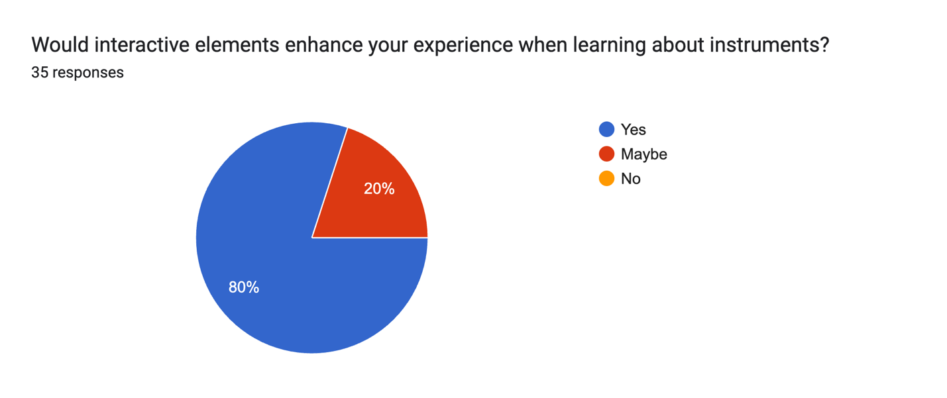

Yes
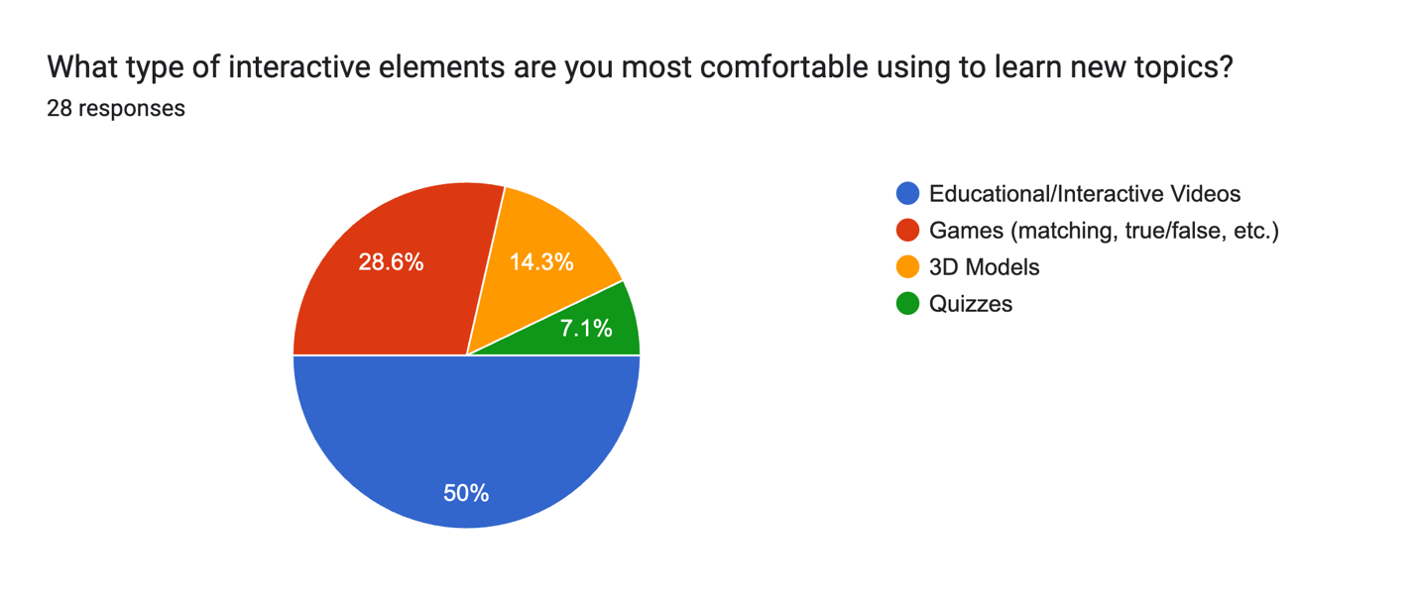

Maybe
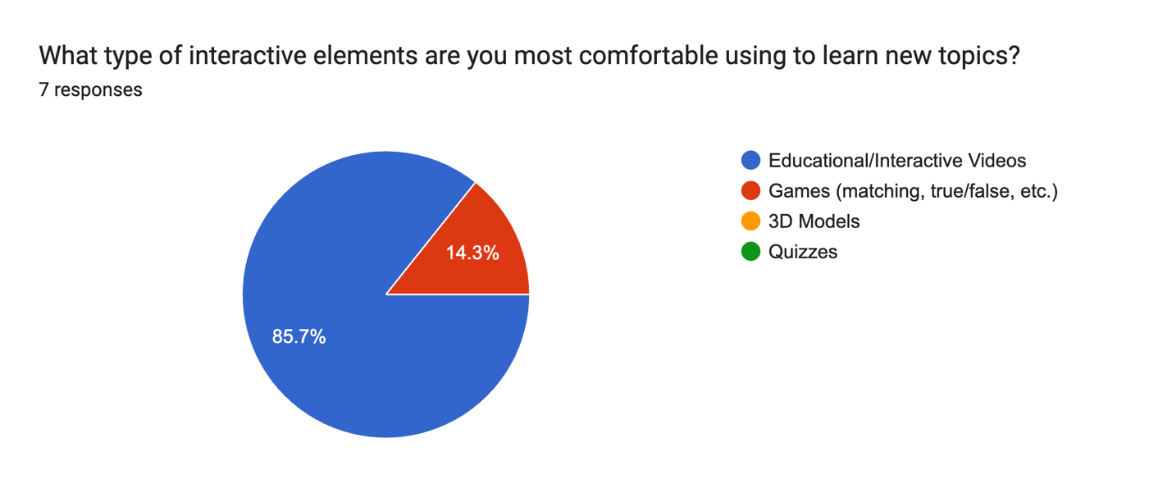

User Experience
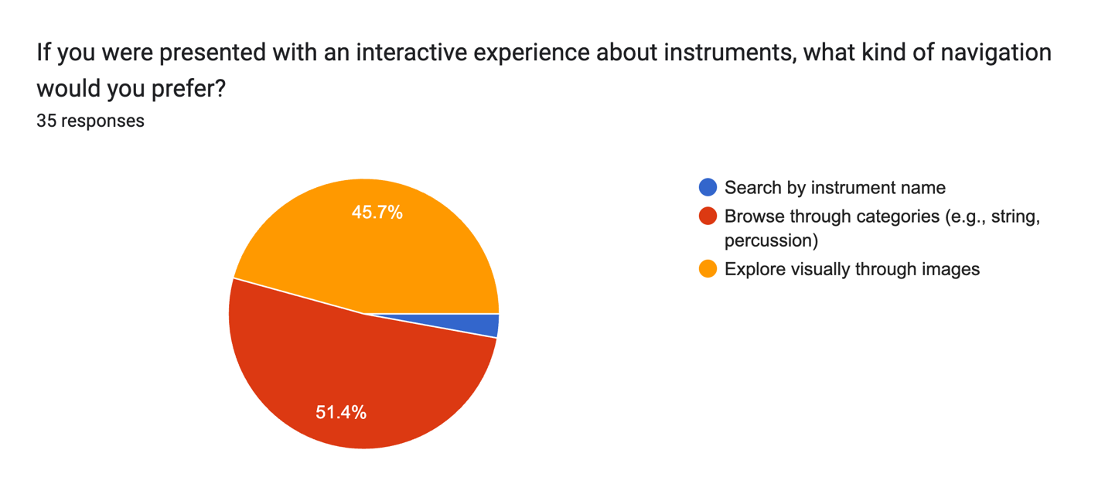

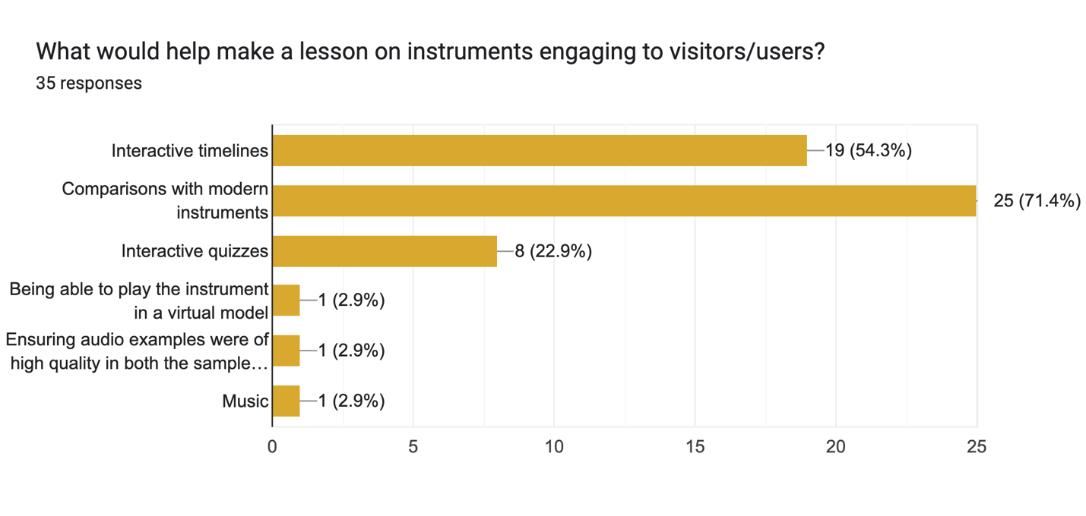

Accessibility & Usability
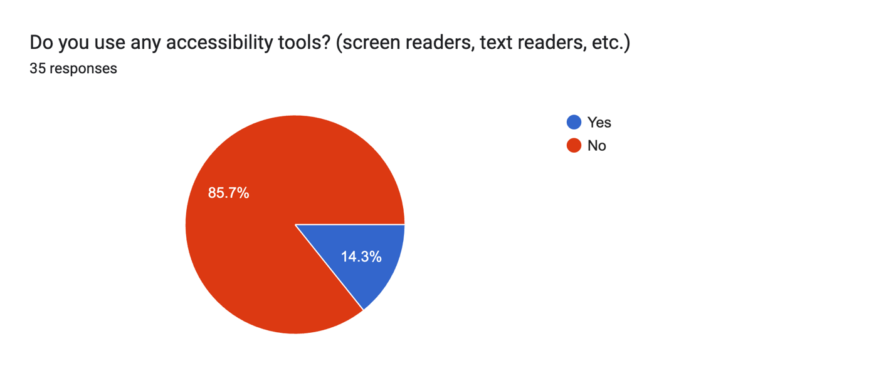

Yes
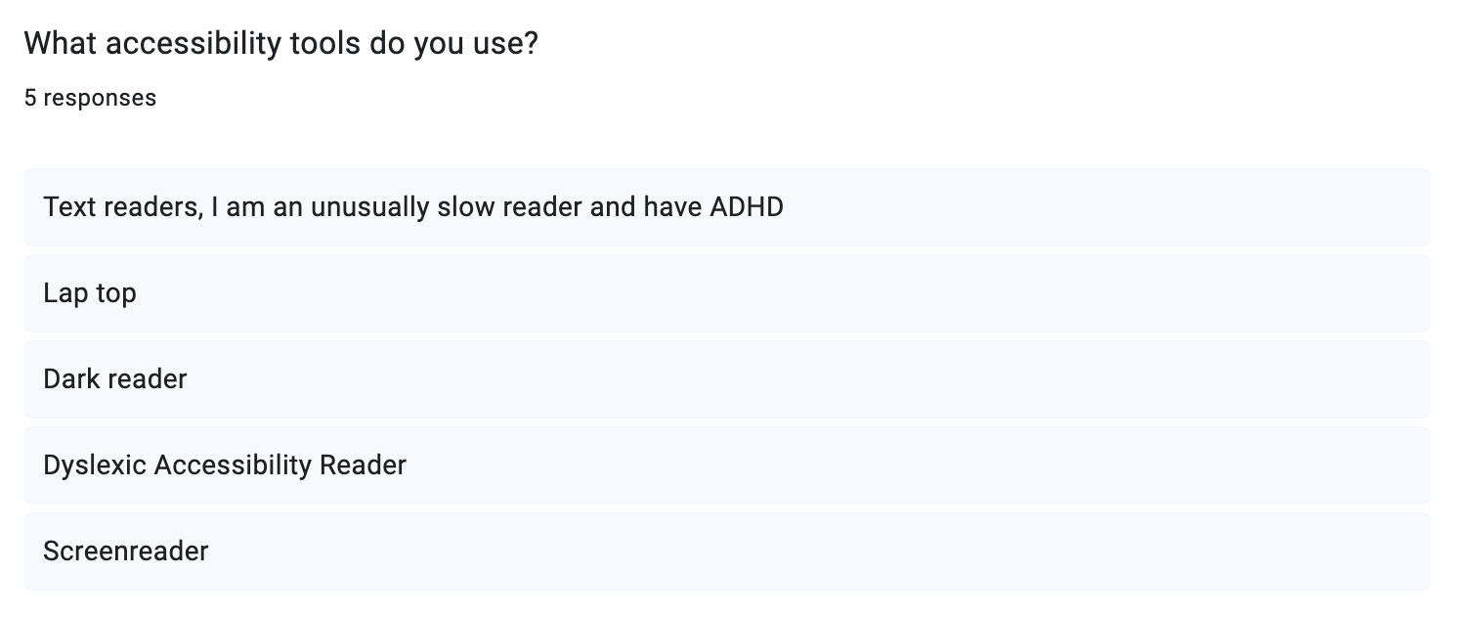

Additional Features
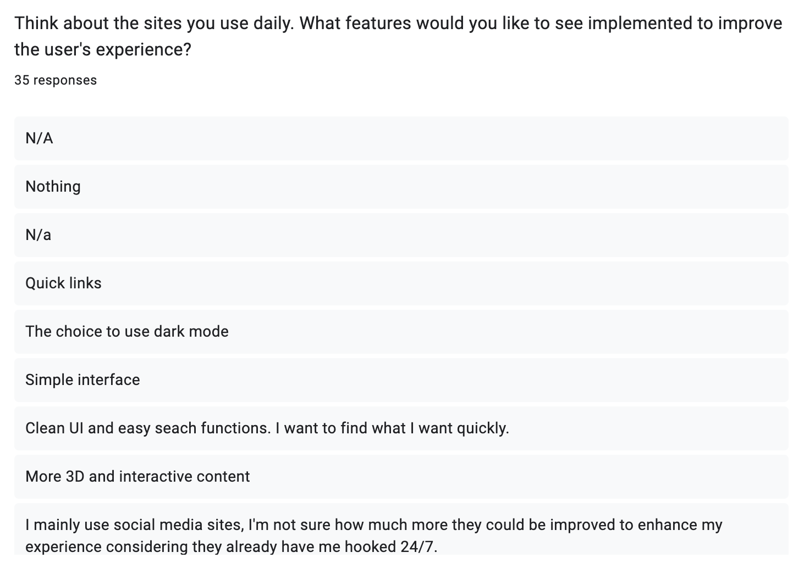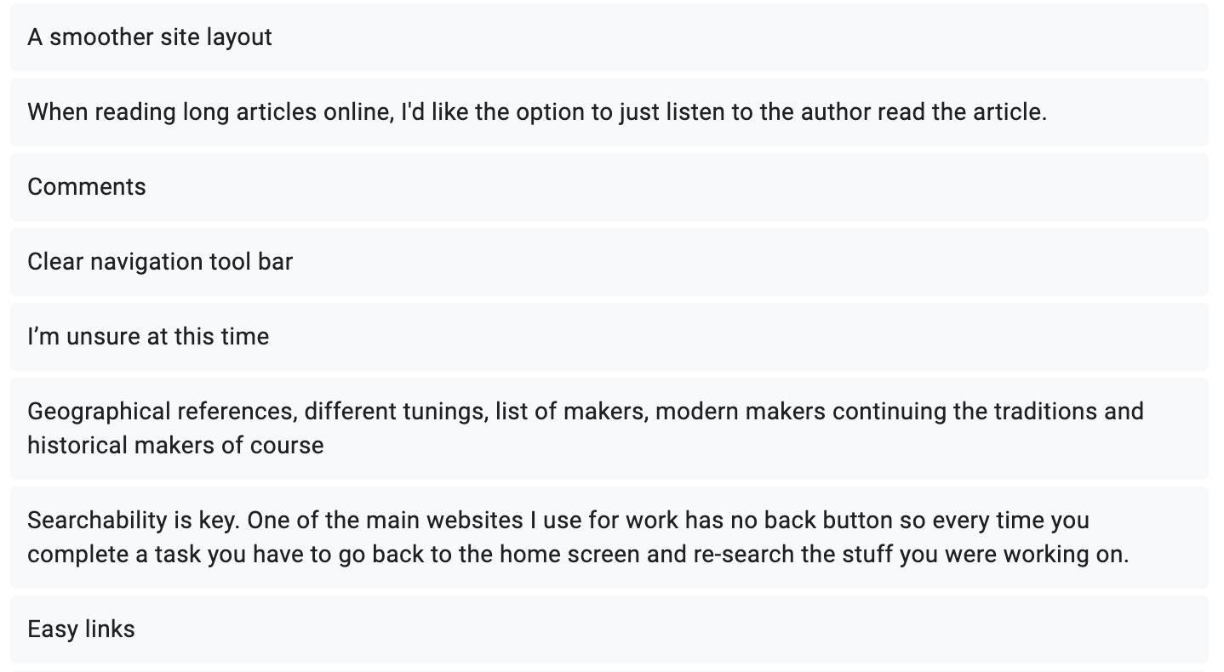
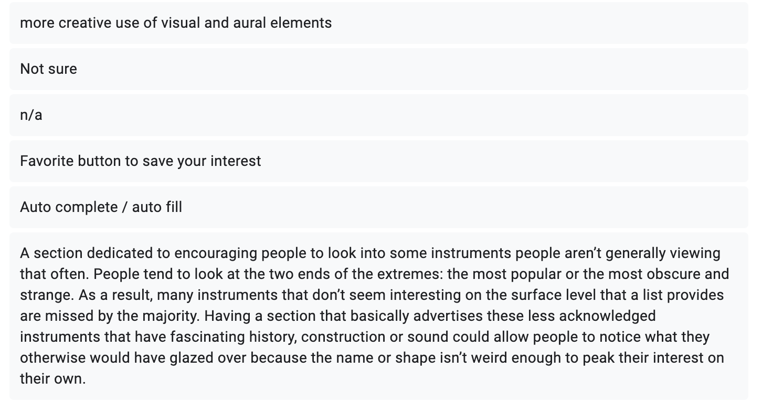
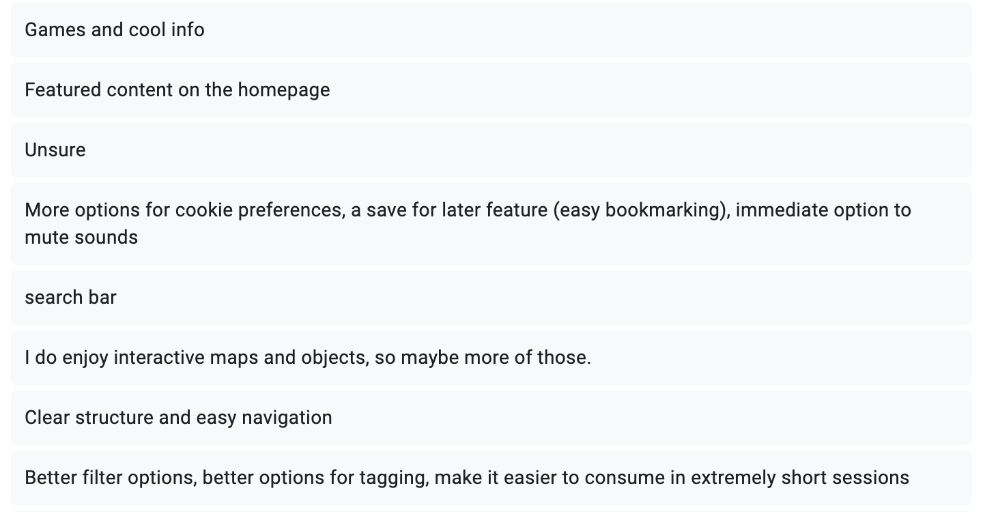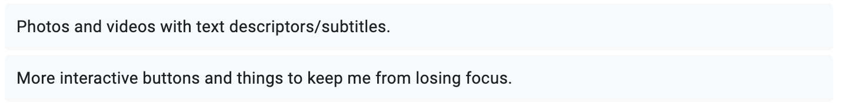

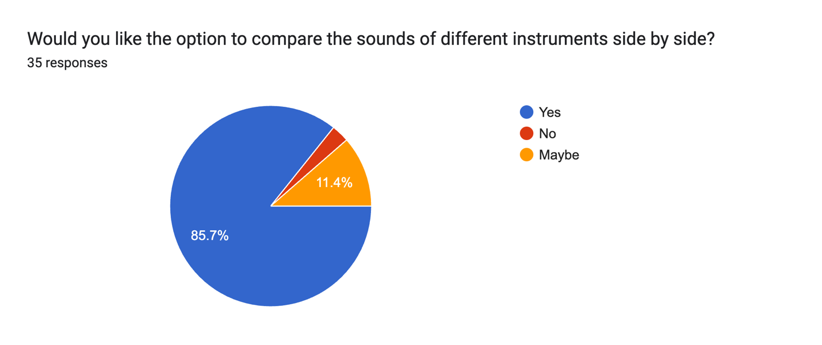

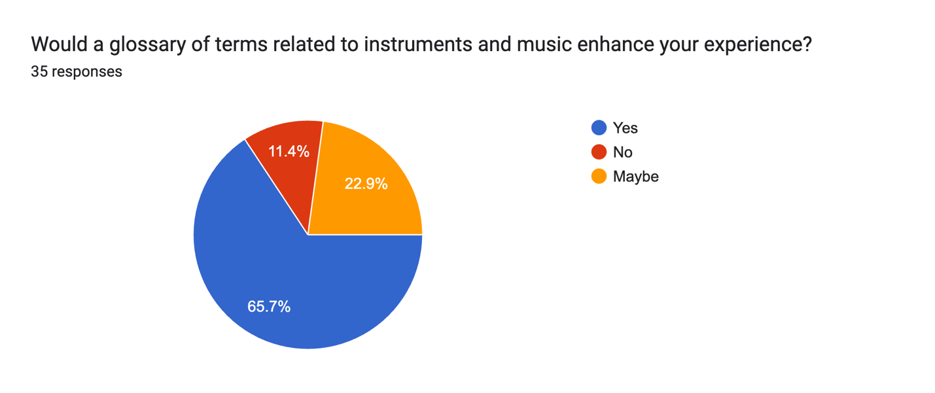
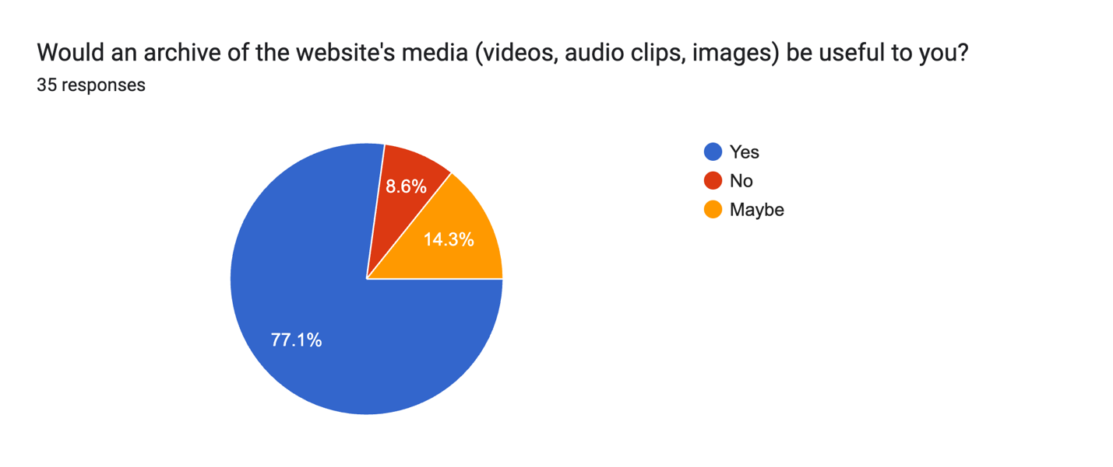

Yes
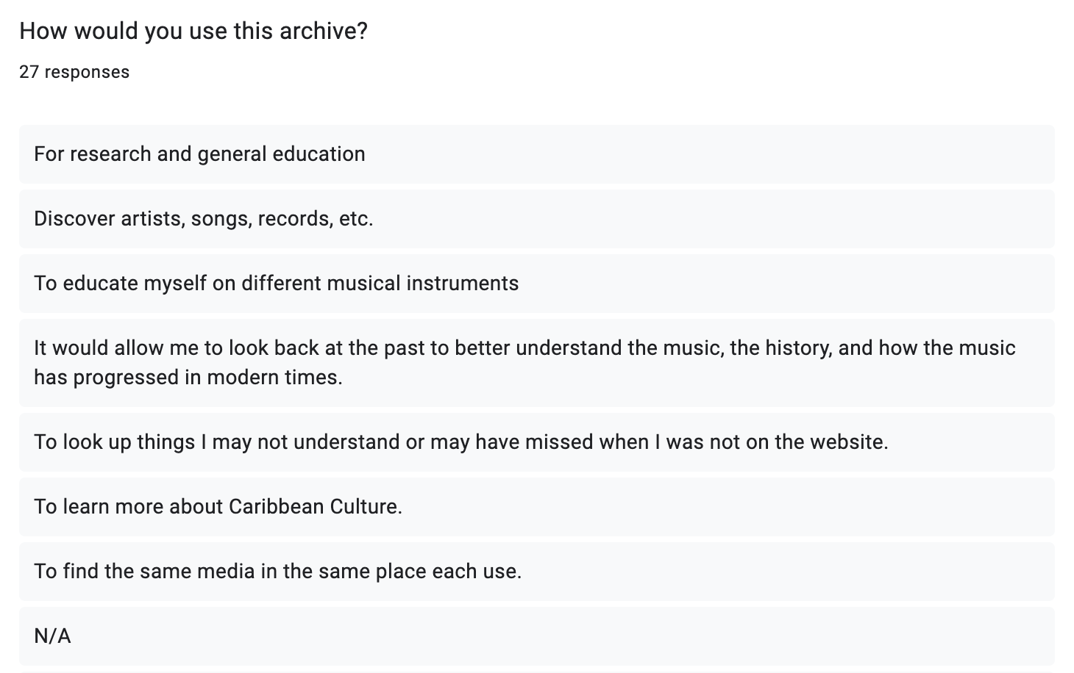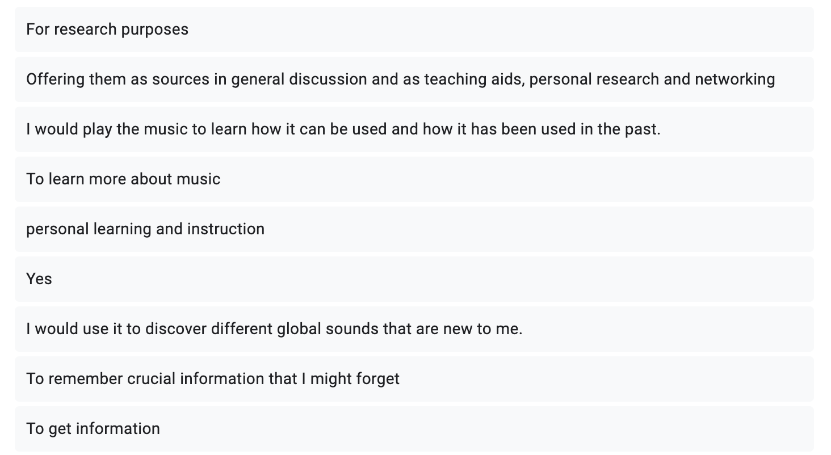
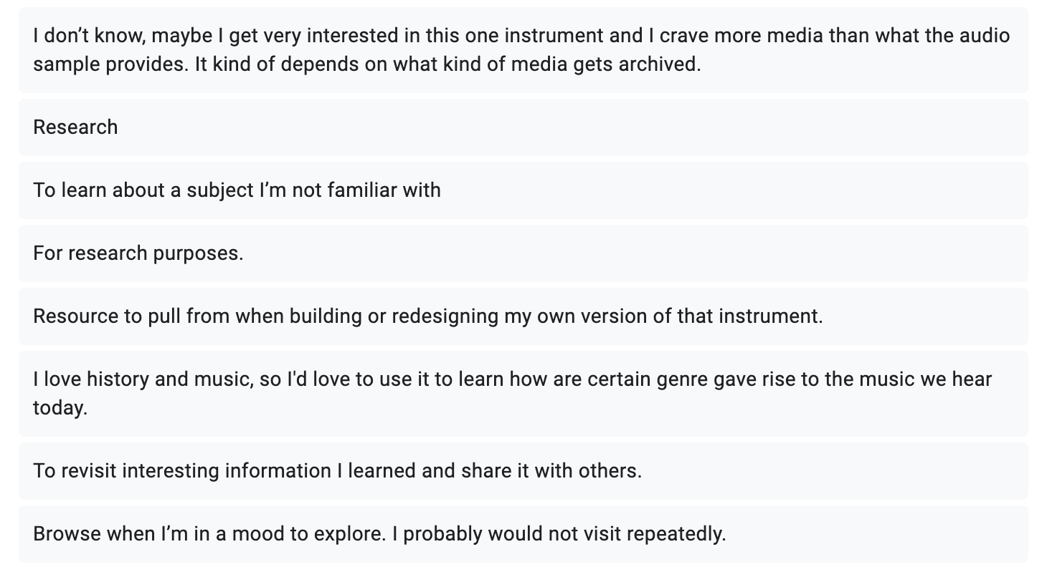
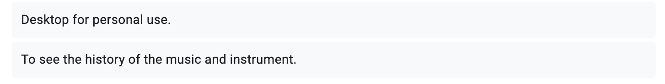

Demographics
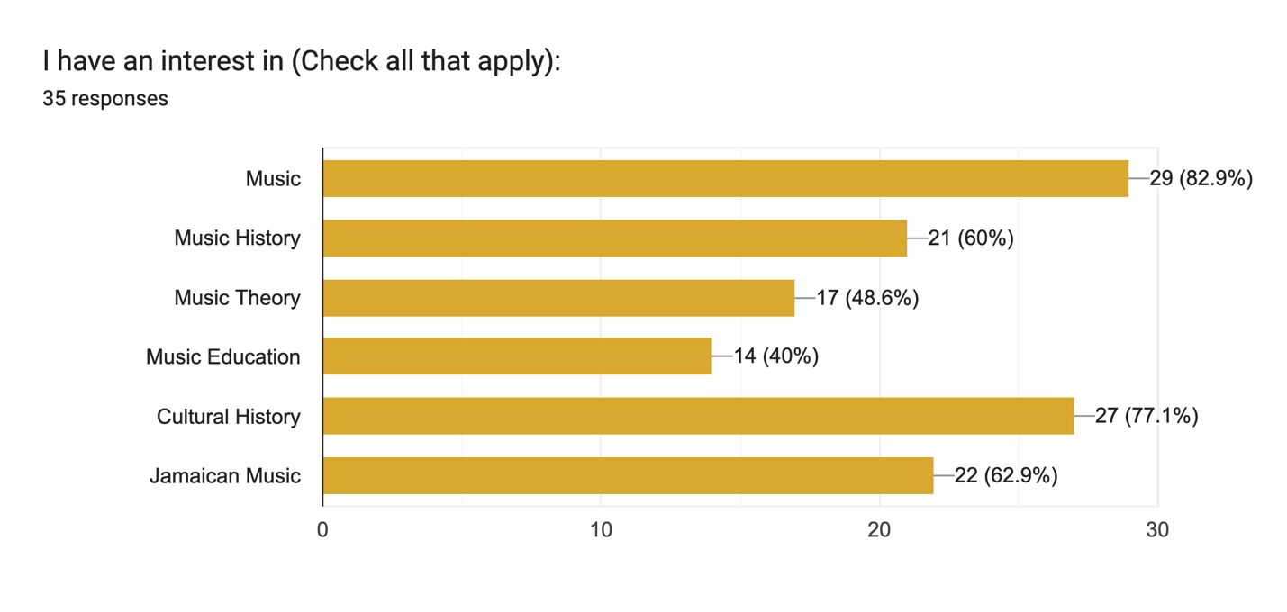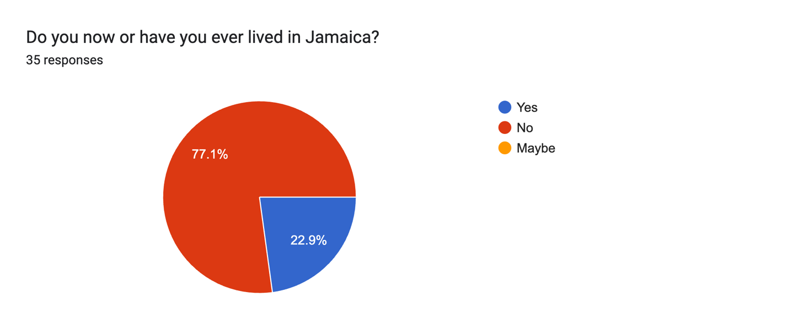
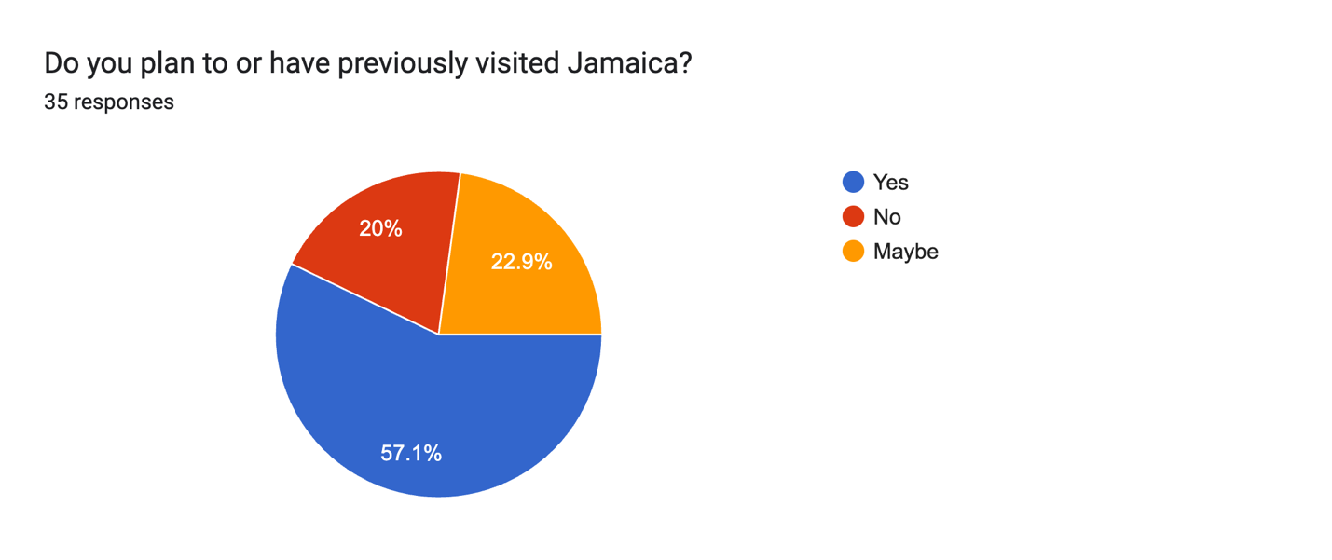
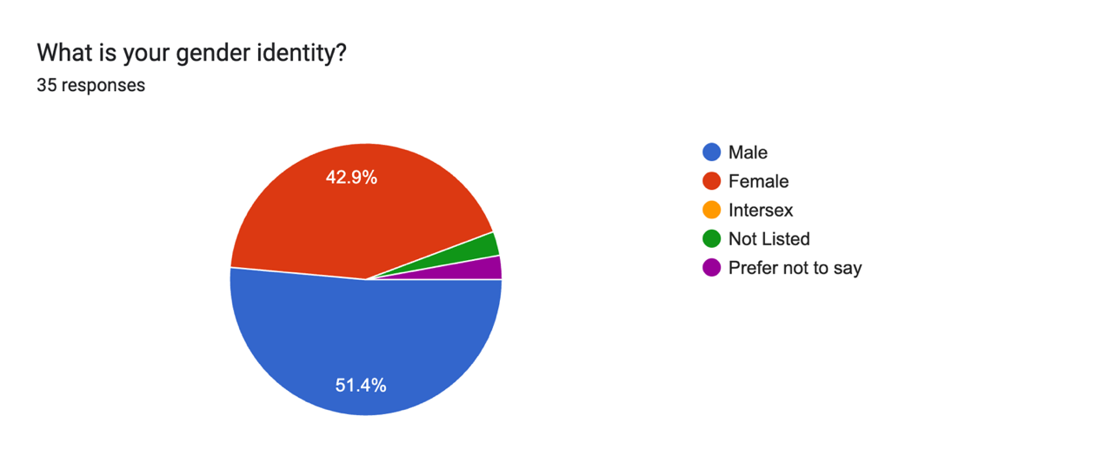

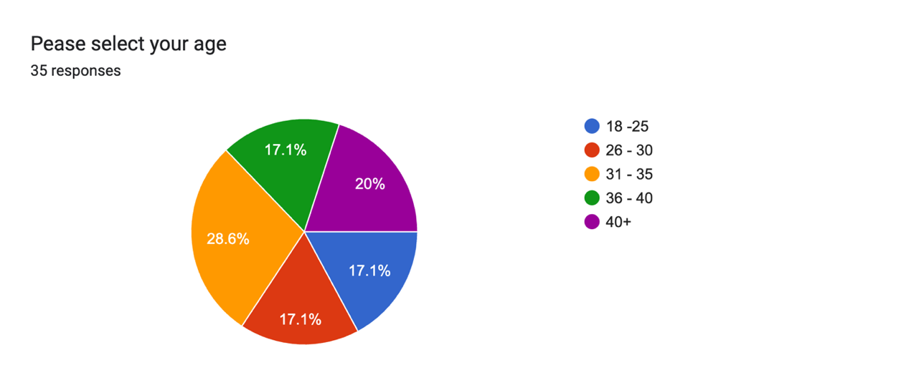

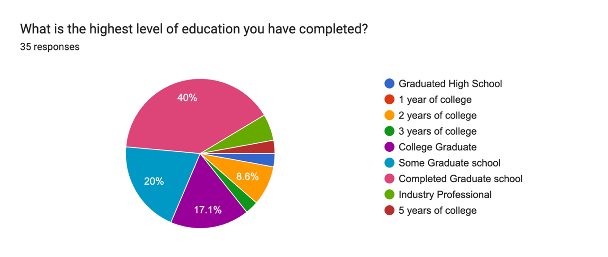
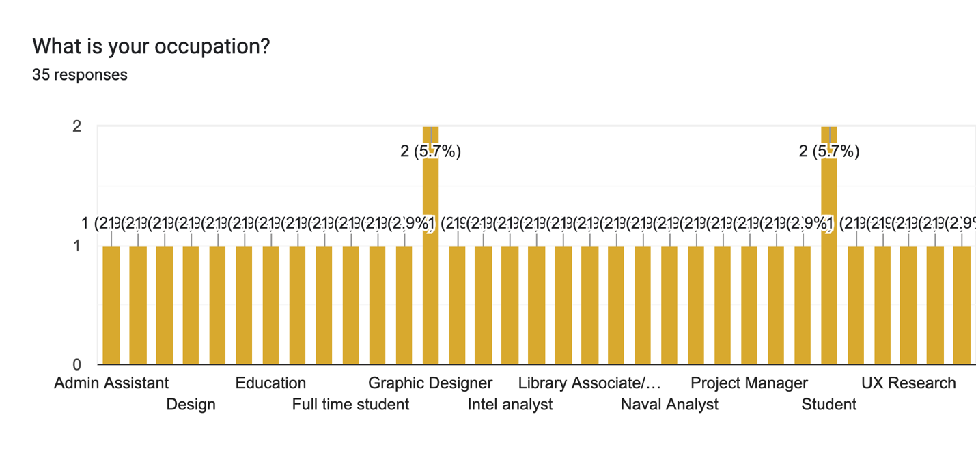

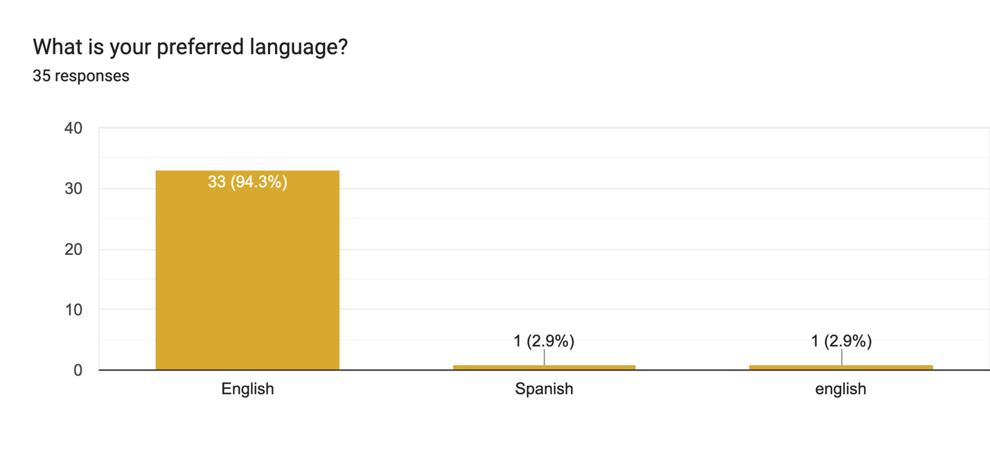
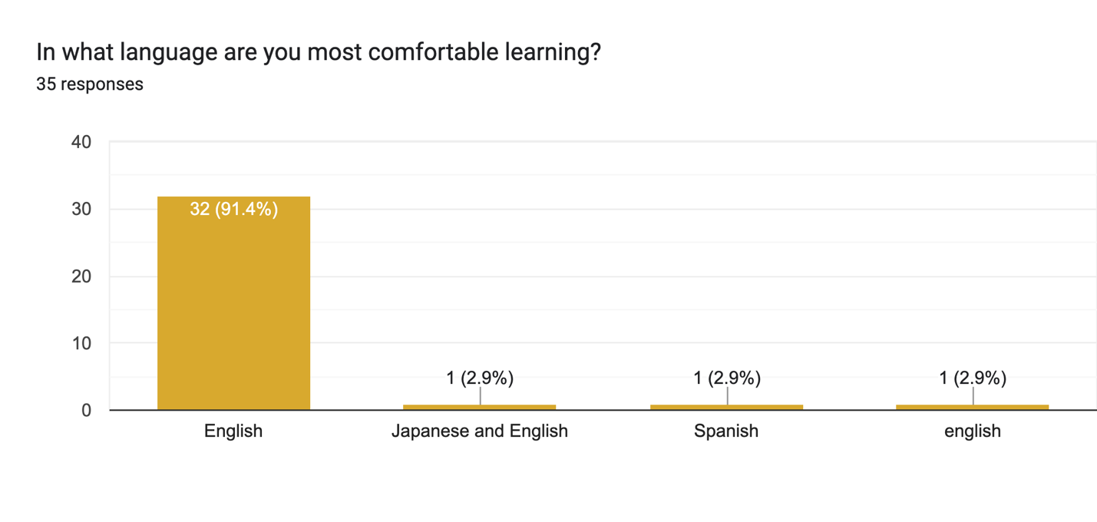

Further Participation
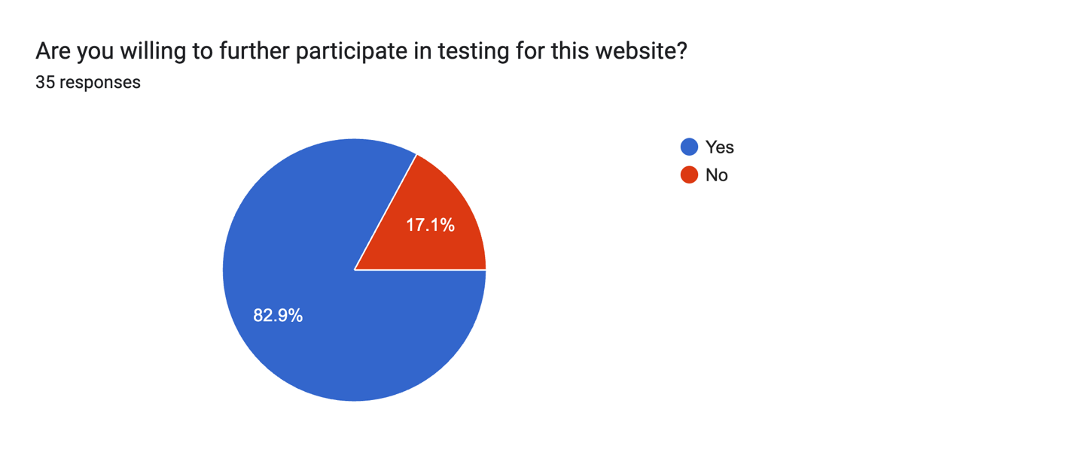

Appendix G: User Personas
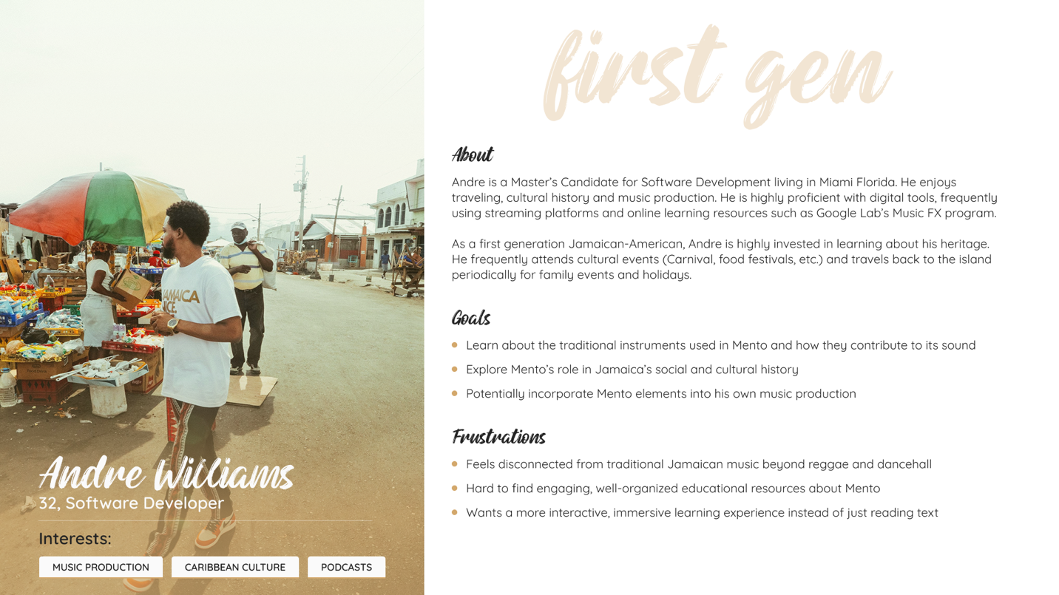

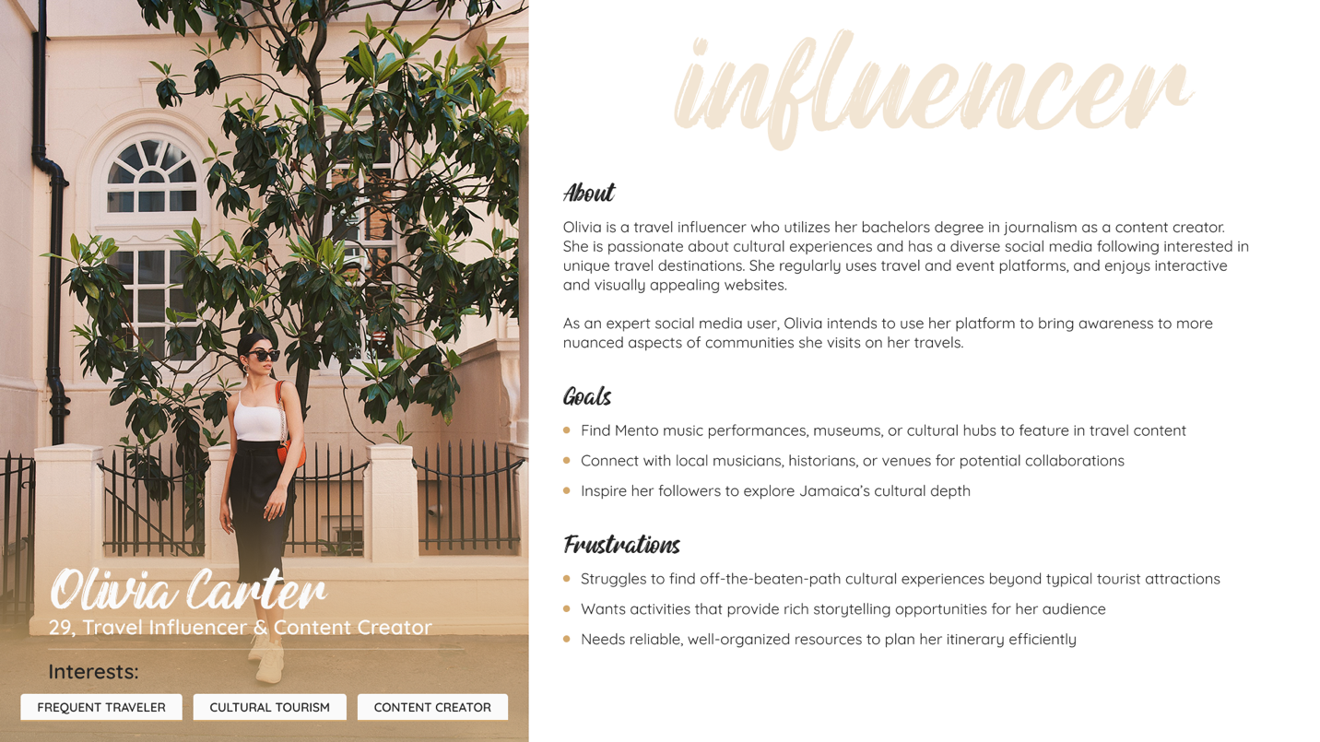
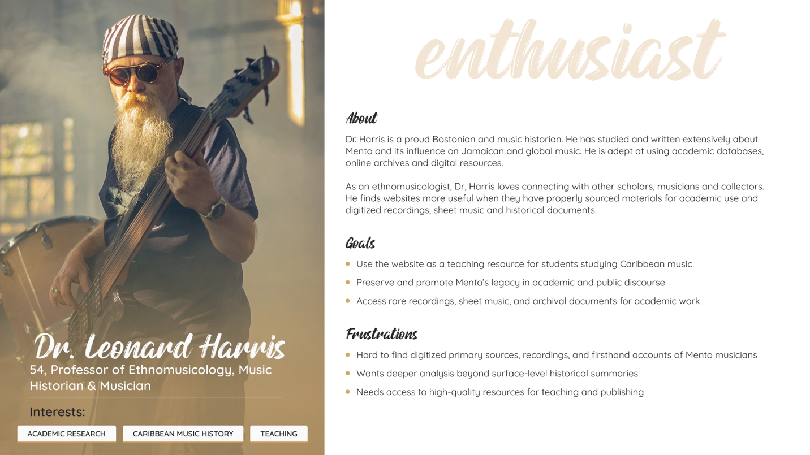

Appendix H: Site Map

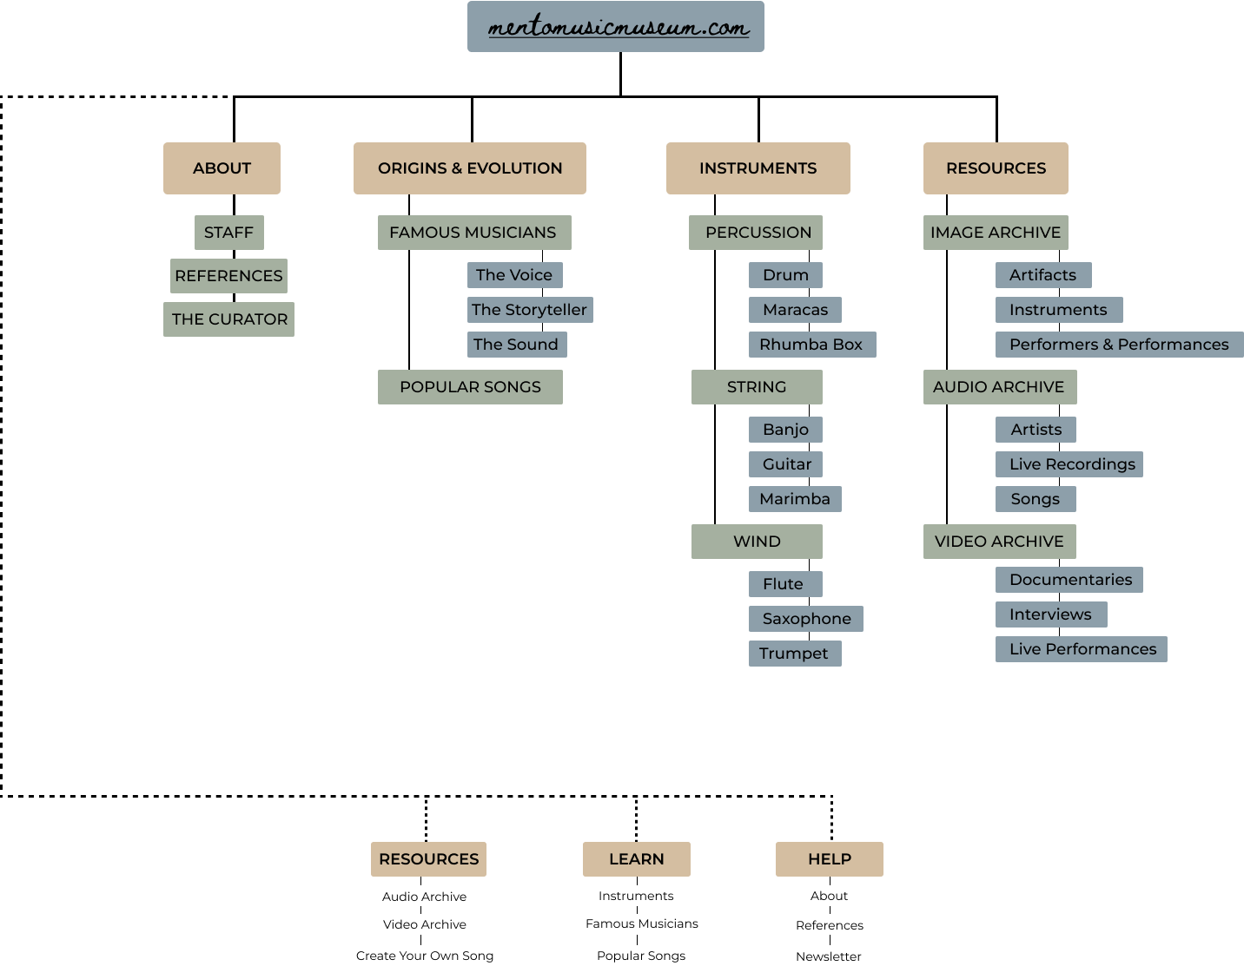

Appendix I: Wireframes (Homepage, Landing Page, Instruments Page)





Appendix J: Prototypes (Archives)

Option A
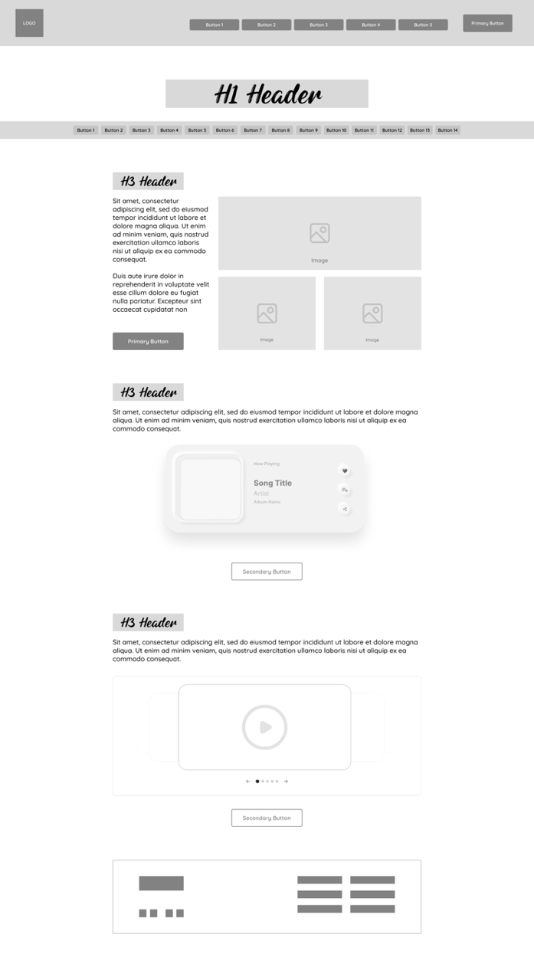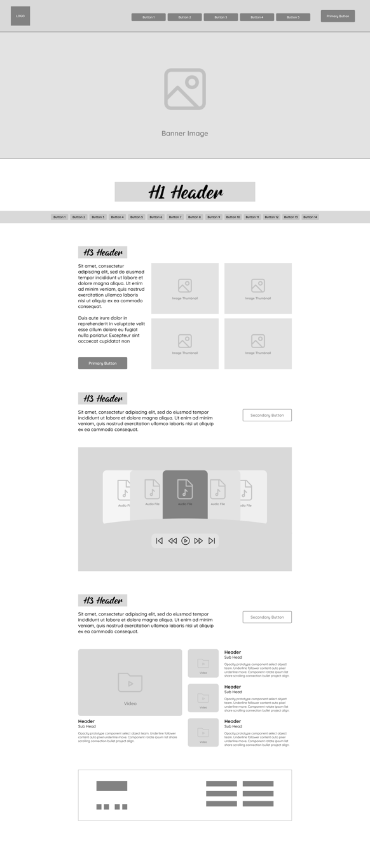

Option B

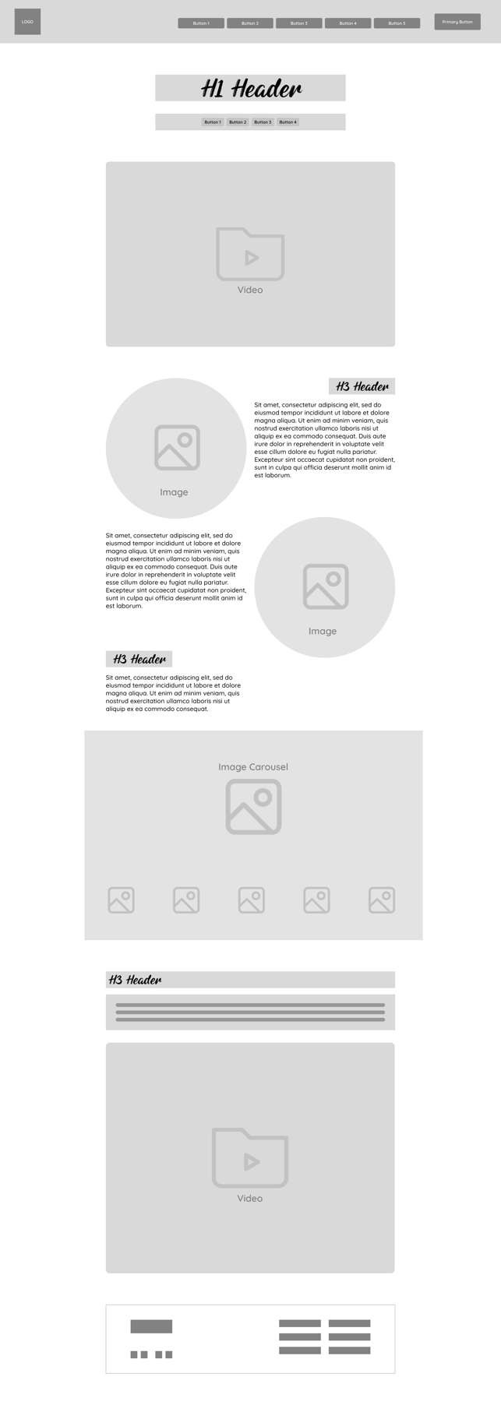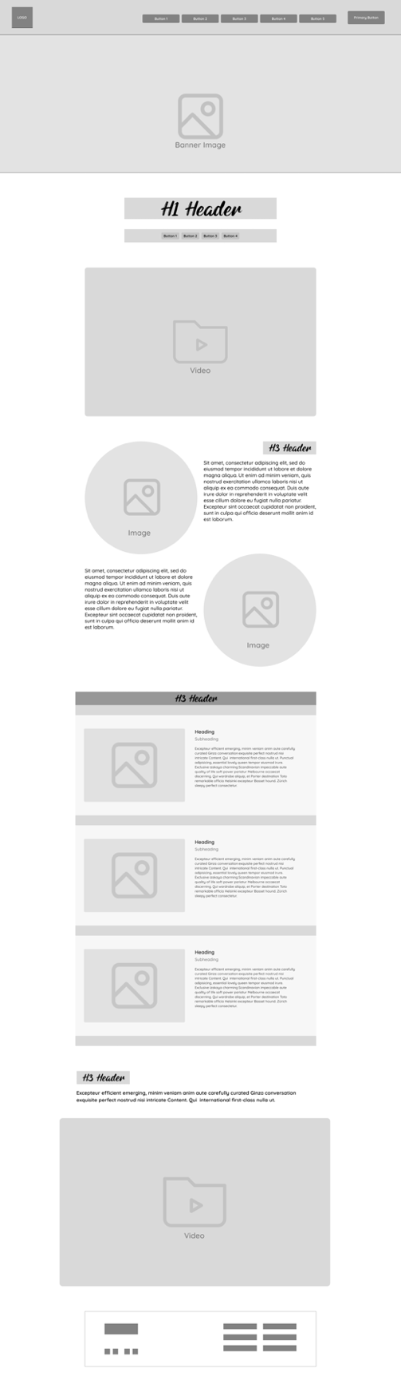

Appendix K: Accessibility Testing

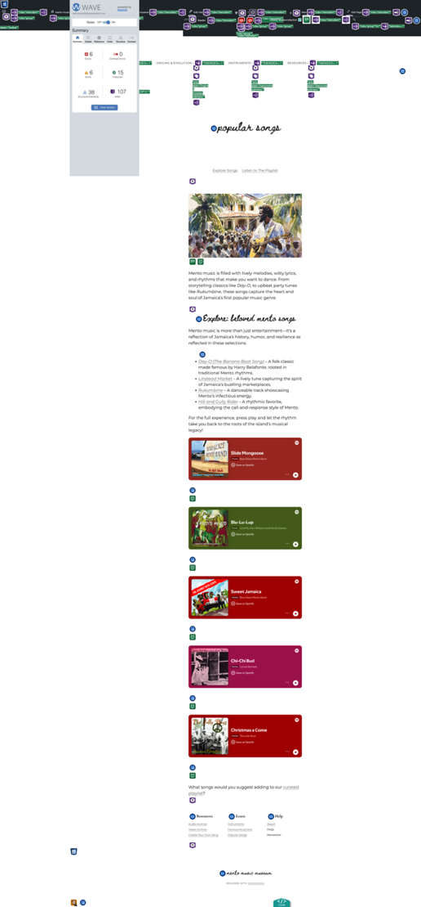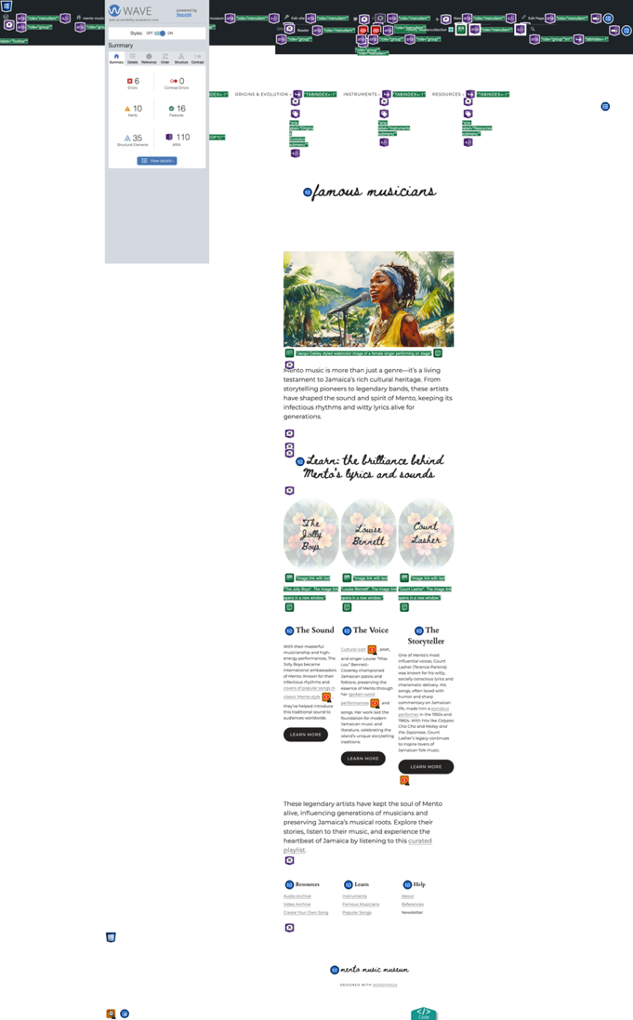

WAVE tool results
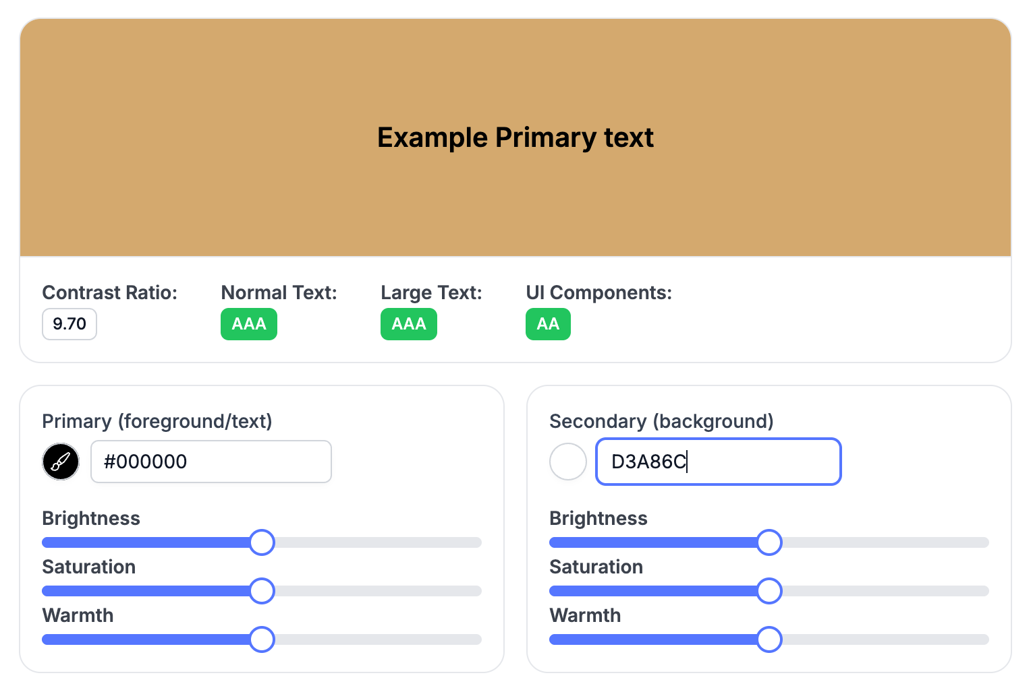
Color Contrast Checker

<figure class="wp-block-image size-full"><img src="https://mentomusicmuseum.wordpress.com/wp-content/uploads/2025/04/children_dancing.jpg" alt="Watercolor image of children dancing in front of home" class="wp-image-1026" style="aspect-ratio:16/9;object-fit:cover"/><figcaption class="wp-element-caption"><em>School Over created by Ashley-Kaye Allen using Midjourney, © 2025</em></figcaption></figure>

Source code for About Page’s banner image

Appendix L: Website Design

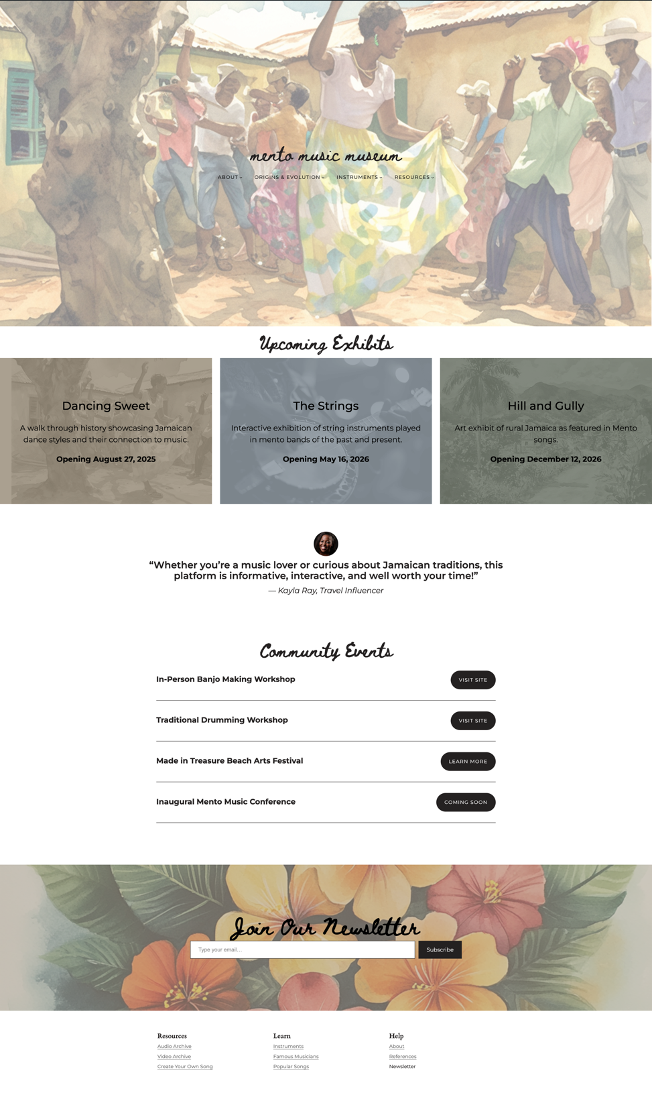

Homepage

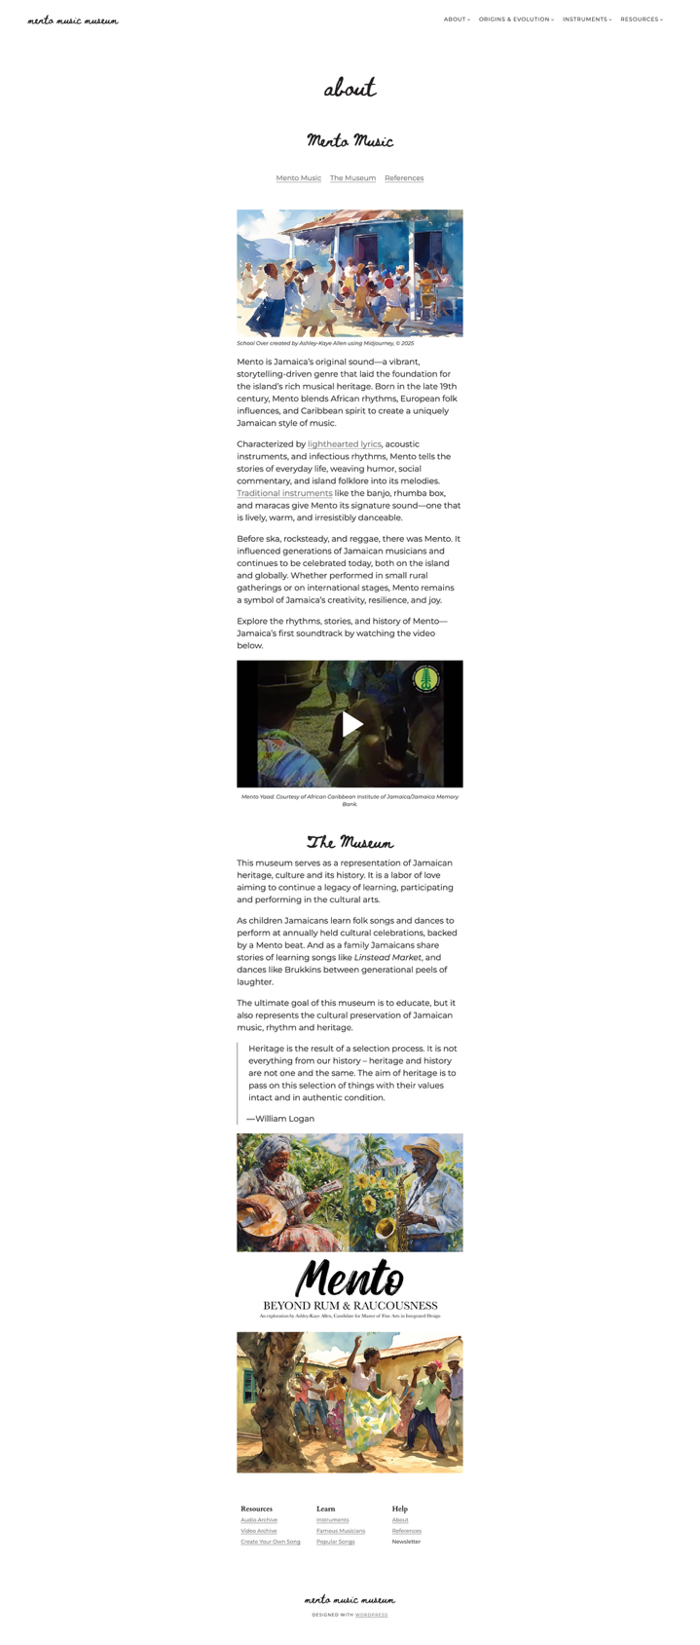

About Page
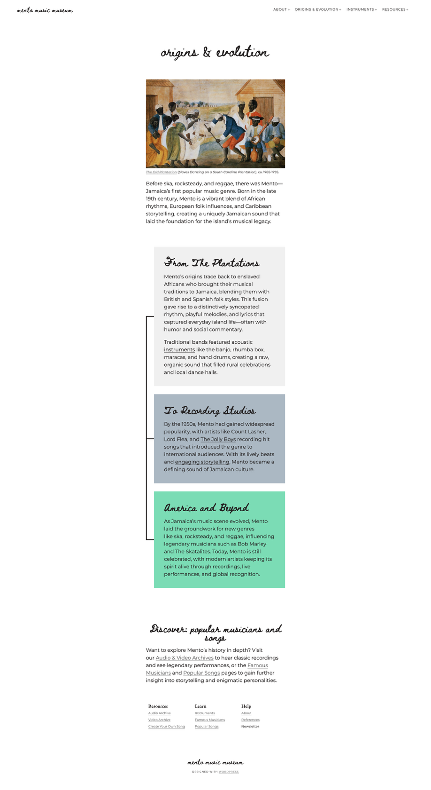

Origins & Evolutions Page
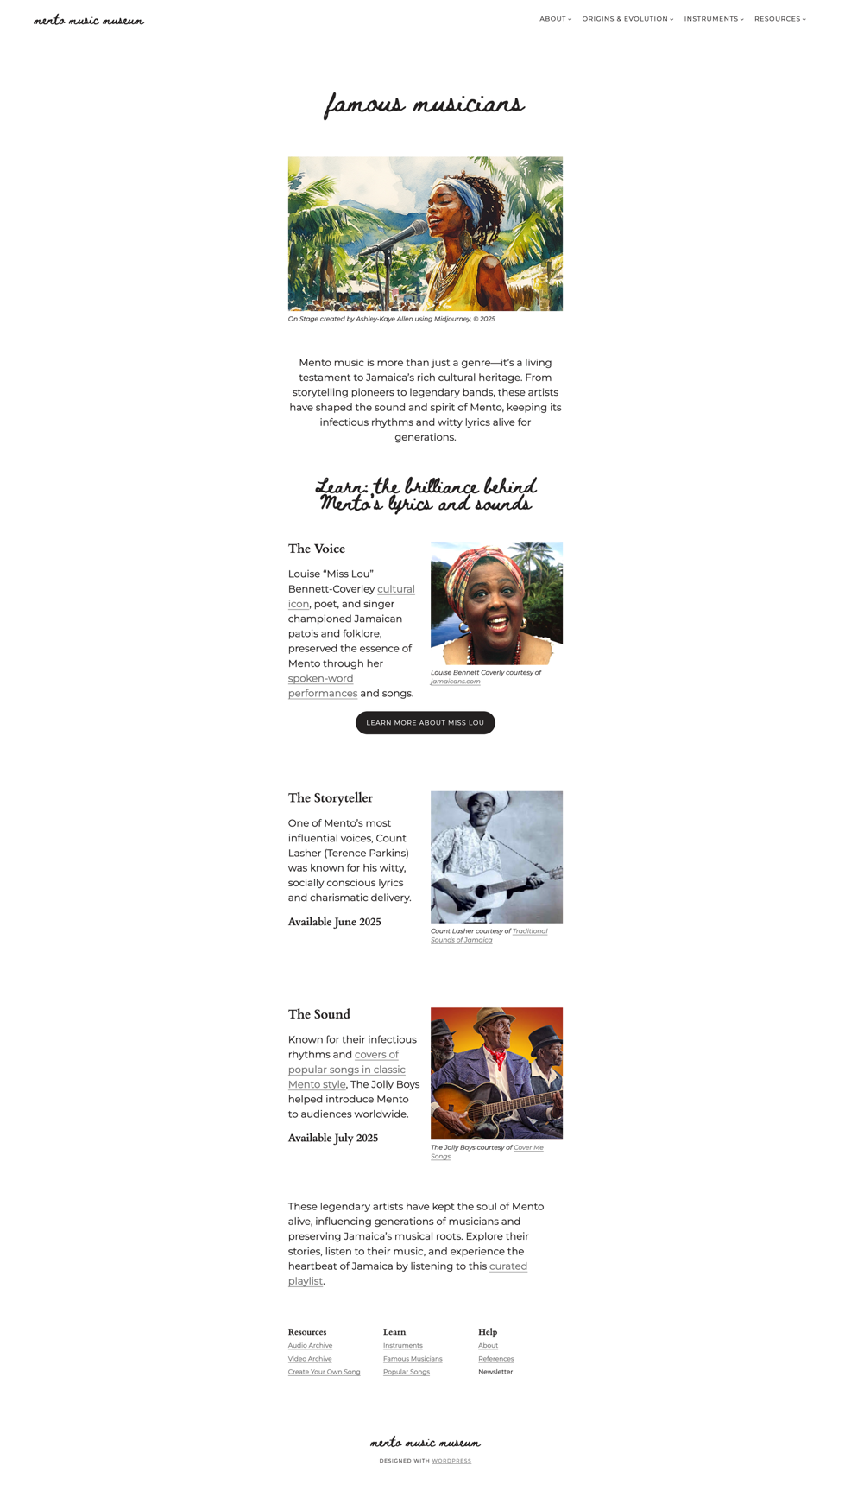

Famous Musicians Page

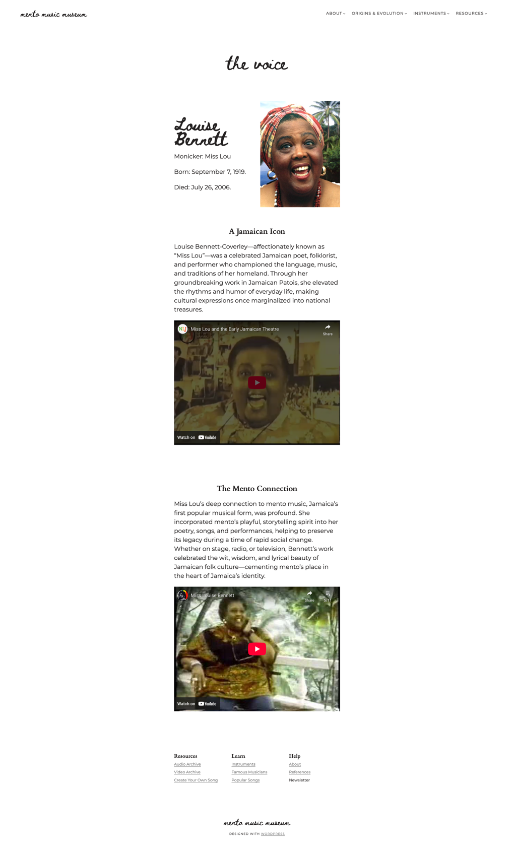

Selected Musician Page
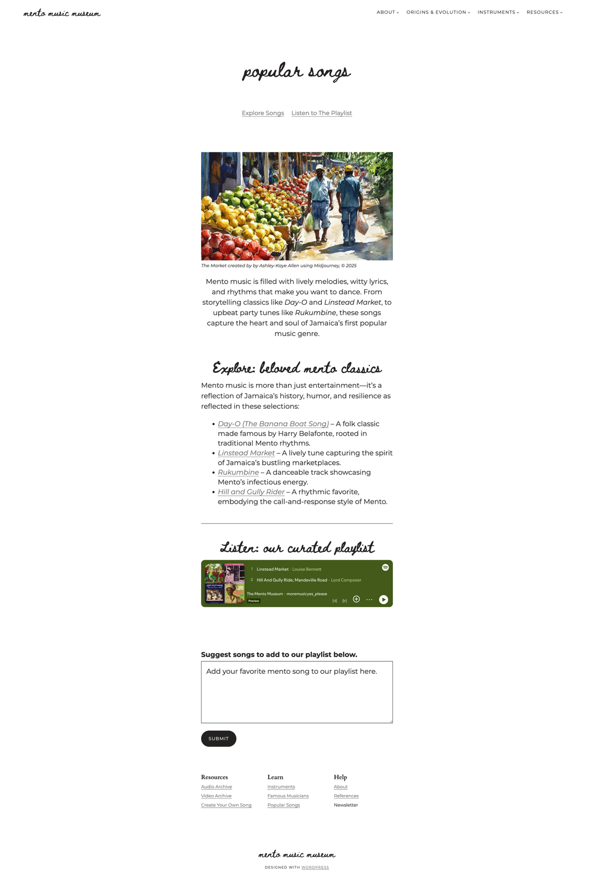

Popular Songs Page
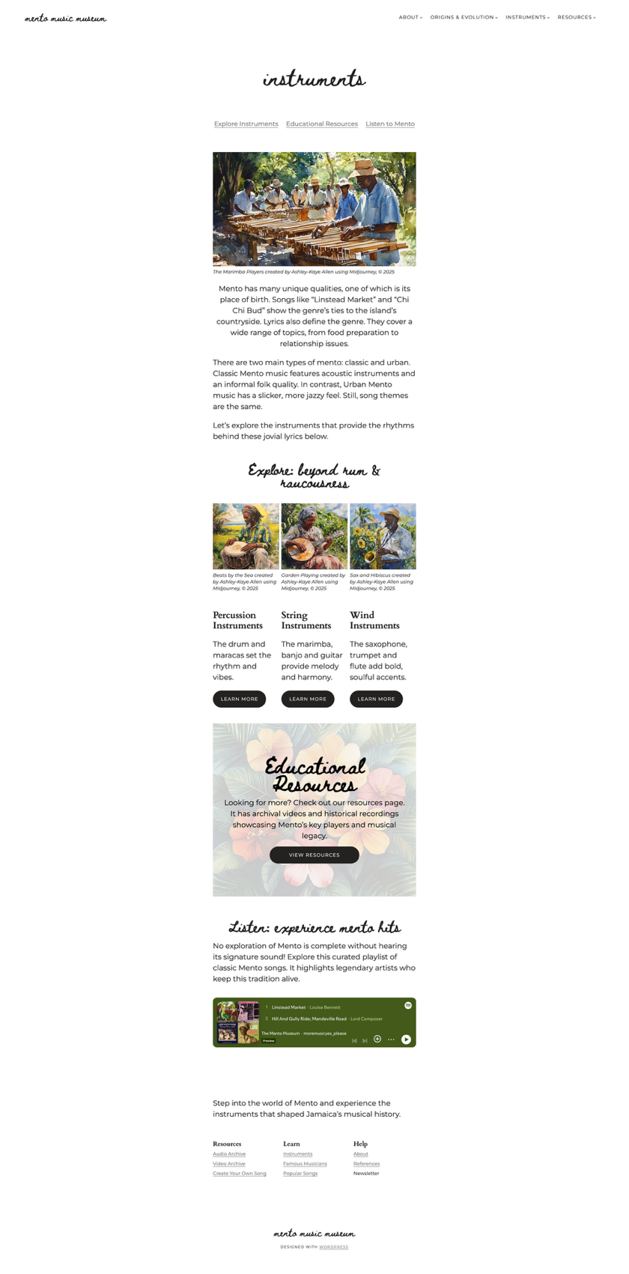

All Instruments Landing Page
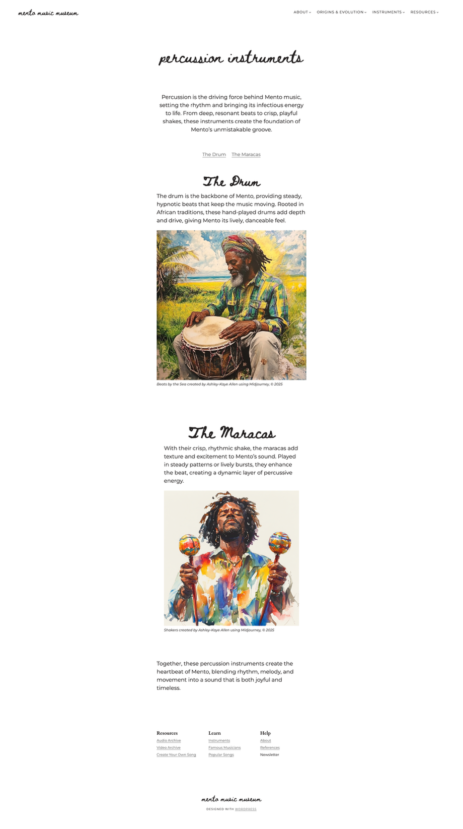

Percussion Instruments Landing Page
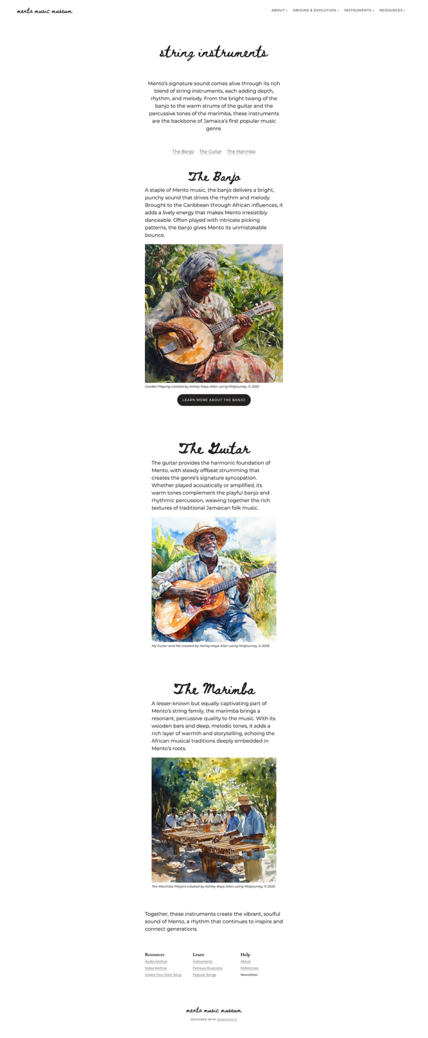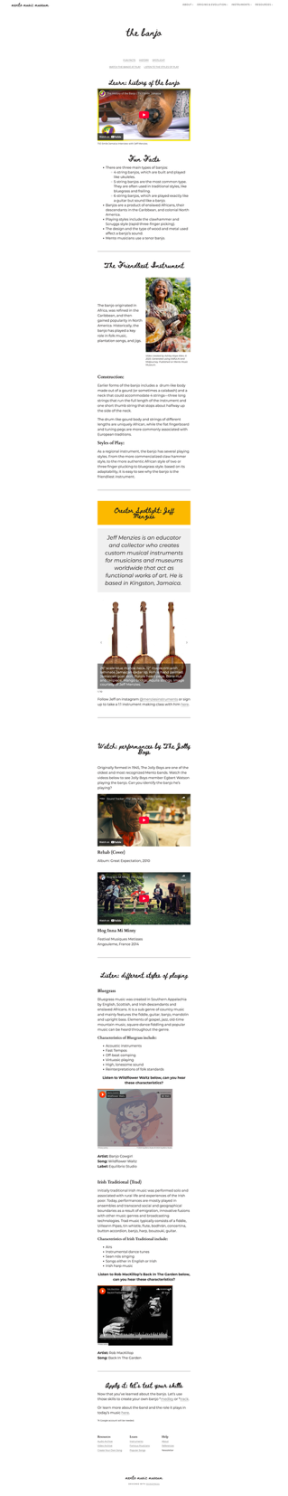

String Instruments Landing Page Banjo Page
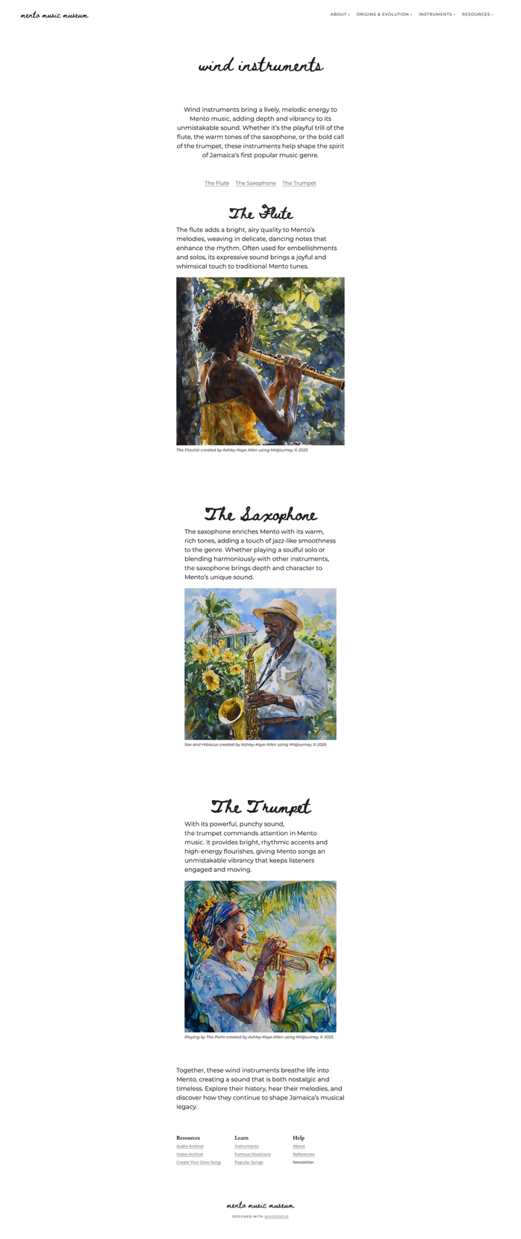

Wind Instruments Landing Page
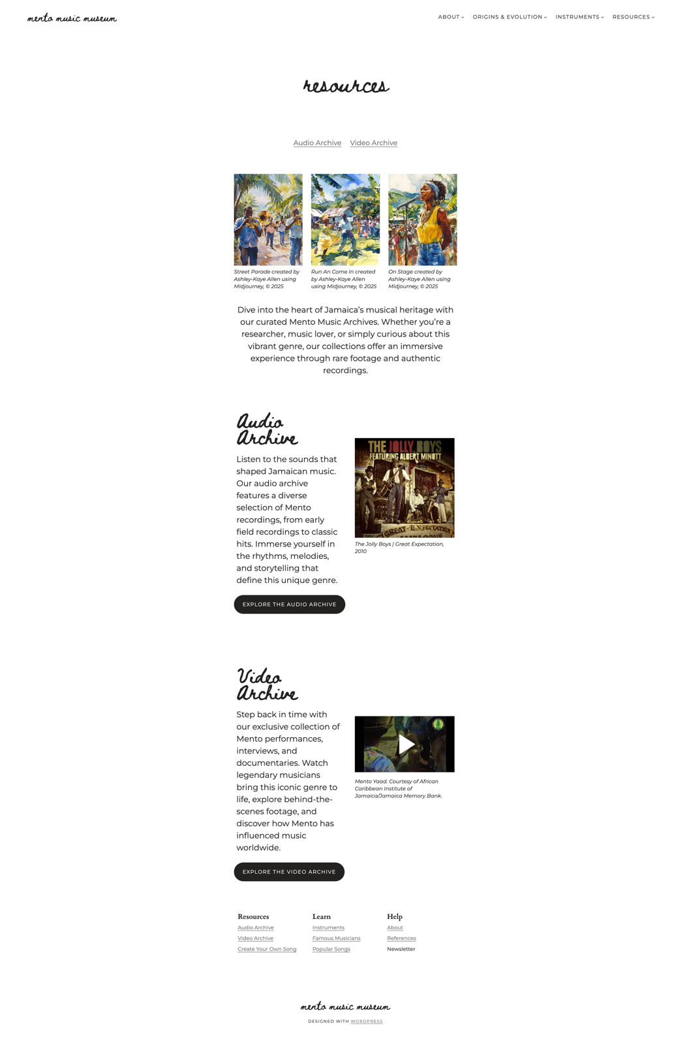

Resources Landing Page
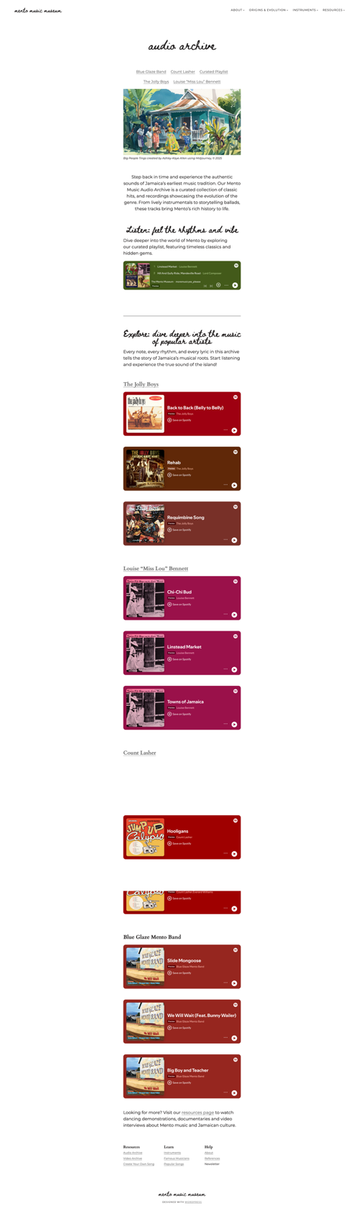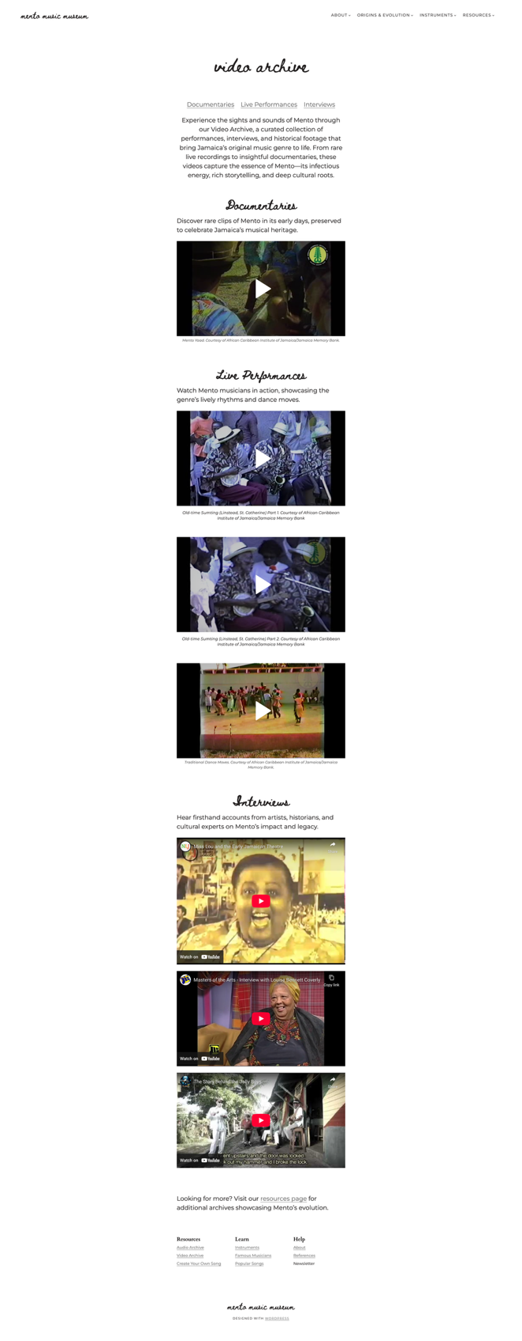

Audio Archive Page Video Archive Page

Appendix M: Generated Images

Date | Prompt | Image result
5/9/2024 | “people dancing to music in remote Jamaica, watercolor painting, in the style of Jacqui Oakley --niji 6” | 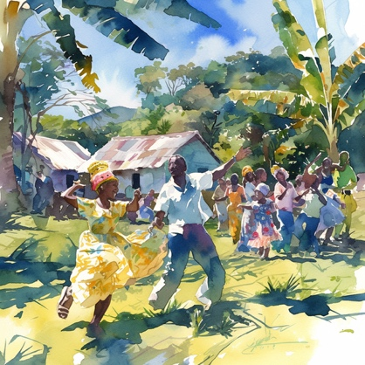
6/14/2024 | “people dancing to music in remote Jamaica, watercolor painting, in the style of Jacqui Oakley --niji 6” | 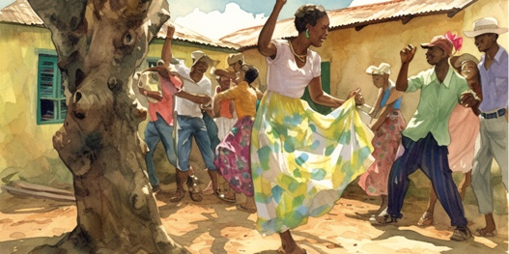
1/31/2025 | “black person playing the banjo in rural jamaica, watercolor painting in the style of Jaqui Oakley --s 250 --v 6.1”
1/31/2025 | “black people playing the marimba in rural jamaica, watercolor painting in the style of Jaqui Oakley --s 250 --v 6.1” | 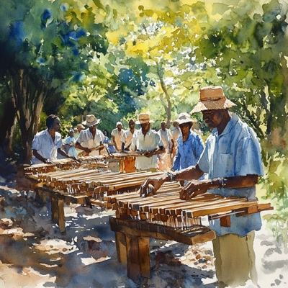
1/31/2025 | “black people playing trumpets in rural jamaica, watercolor painting in the style of Jaqui Oakley --s 250 --v 6.1” | 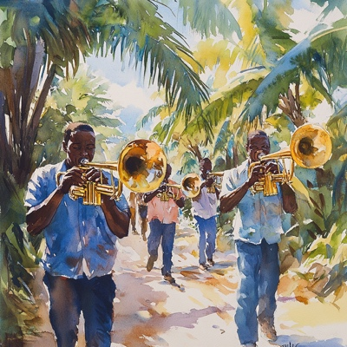
1/31/2025 | “black person playing the saxophone in rural jamaica, watercolor painting in the style of Jaqui Oakley --s 250 --v 6.1” | 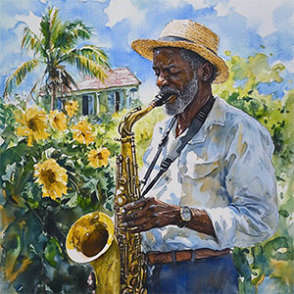
2/24/2025 | “black person playing maracas, watercolor painting in the style of Jaqui Oakley --s 250 --v 6.1” | 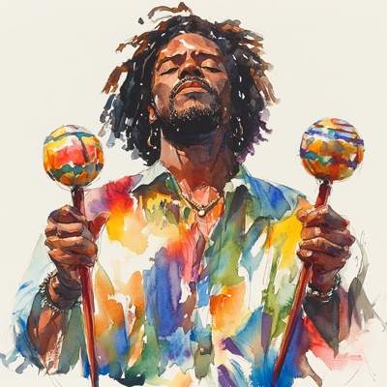
2/25/2025 | “hyperalistic photo of person paying the banjo in a mento band --s 250 --v 6.1” | 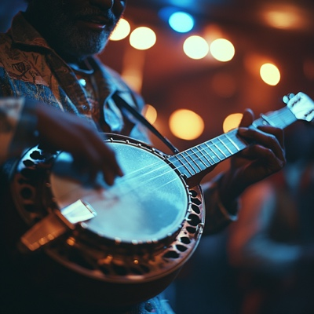
2/25/2025 | “rural Jamaica, watercolor painting in the style of Jaqui Oakley --s 250 --v 6.1” | 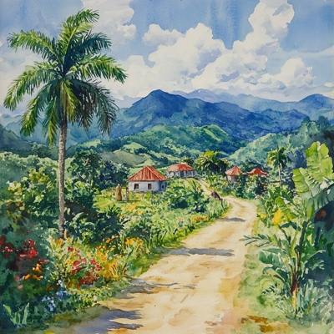
3/7/2025 | “black person playing the guitar in rural jamaica, watercolor painting in the style of Jaqui Oakley --s 250 --v 6.1” | 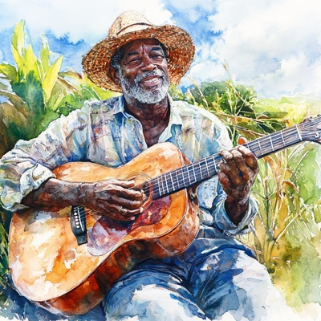
3/7/2025 | “tropical flowers watercolor painting in the style of Jaqui Oakley --s 250 --v 6.1” | 
3/21/2025 | “singer of a mento band performing for a crowd in rural Jamaica watercolor painting in the style of Jaqui Oakley --s 250 --v 6.1” | 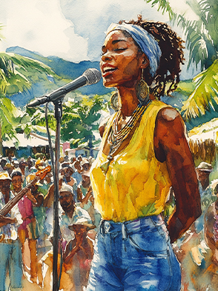
3/22/2025 | “water color painting in the style of Jaqui Oakley of a black person playing the flute in rural Jamaica --s 250 --v 6.1” | 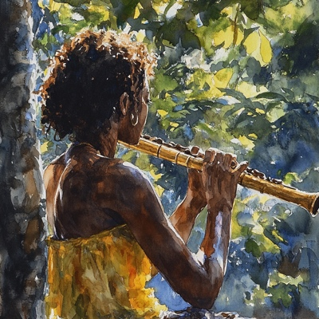
3/22/2025 | “water color painting in the style of Jaqui Oakley of a black woman playing the trumpet in rural Jamaica --s 250 --v 6.1” | 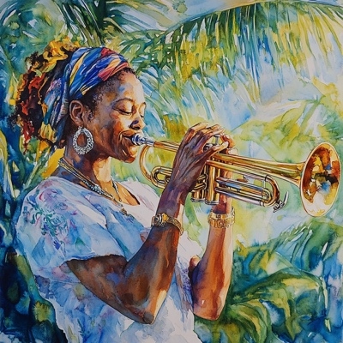
3/22/2025 | “water color painting in the style of Jaqui Oakley of a black person playing the drum in rural Jamaica --sref https://s.mj.run/uHMj4CqY3JM --s 250 --v 6.1” | 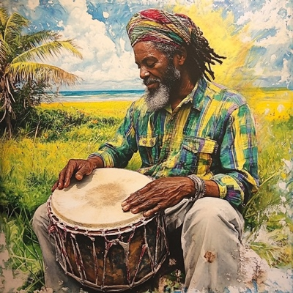
3/23/2025 | “people dancing to music in remote Jamaica, watercolor painting, in the style of Jacqui Oakley --niji 6” | 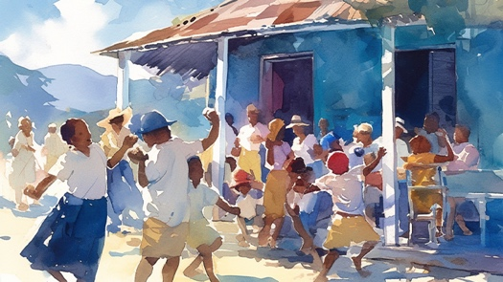
3/24/2025 | “people dancing to music in remote Jamaica, watercolor painting, in the style of Jacqui Oakley --niji 6” | 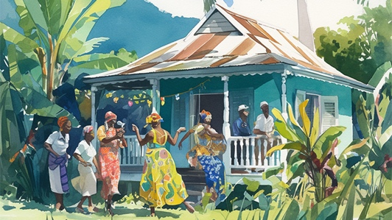
4/2/2025 | “watercolor image of Linstead Market, Jamaica --s 250 --v 6.1” | 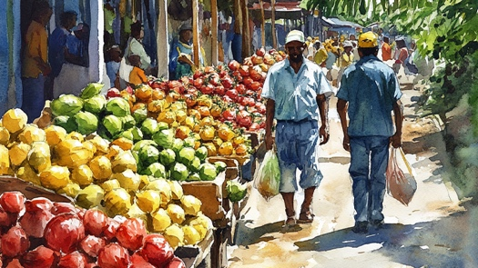

Appendix N: Promotional Posts

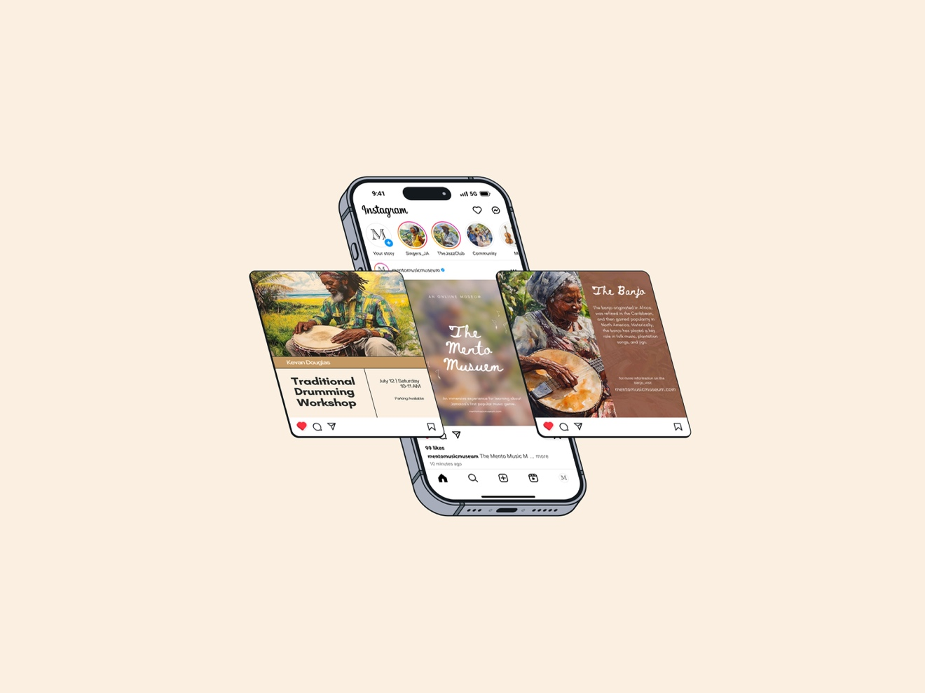

Instagram Feed

Classic mento has an acoustic, informal folksy rural style Jamaicans refer to as country music.
See Figure 1
See Figure 5
See Appendix D
See Appendix G for all personas
See Appendix I - Appendix J
See Appendix H
See Appendix K
See Appendix A
See Appendix B
See Appendix D

