

Geophysical Research Letters
Supporting Information for
Large-scale climate features control fire emissions and transport in Africa
Amin Dezfuli^{1,2*}, Charles M. Ichoku², Michael G. Bosilovich¹

¹Global Modeling and Assimilation Office, NASA Goddard Space Flight Center.
²University of Maryland, Baltimore County

Contents of this file

Figures S1 to S3

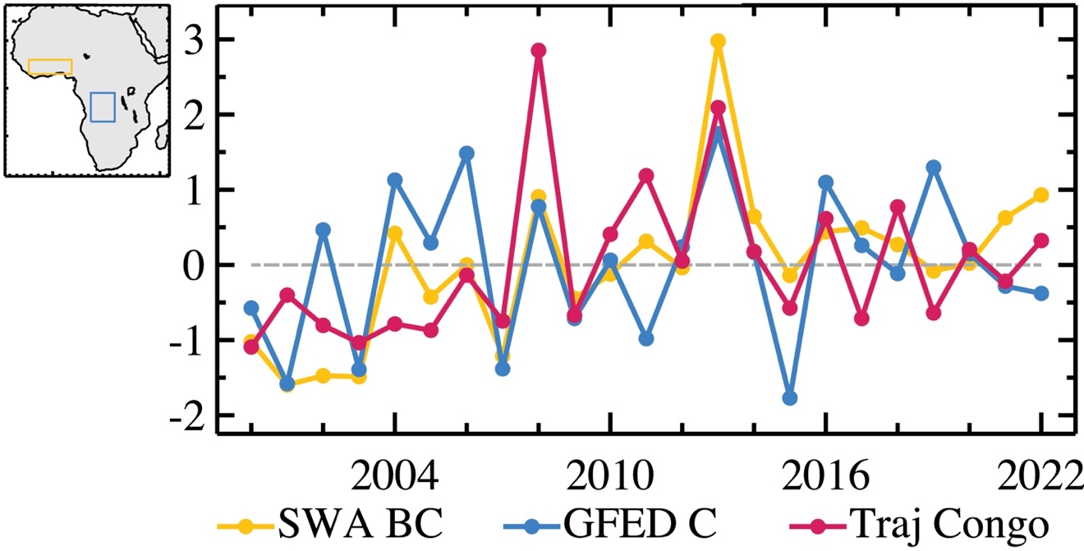

Figure S1. Comparing time-series of black carbon in SWA (orange line) with carbon emissions due to biomass burning in SCB (blue line) and the back trajectory counts from SWA to SCB (red line).

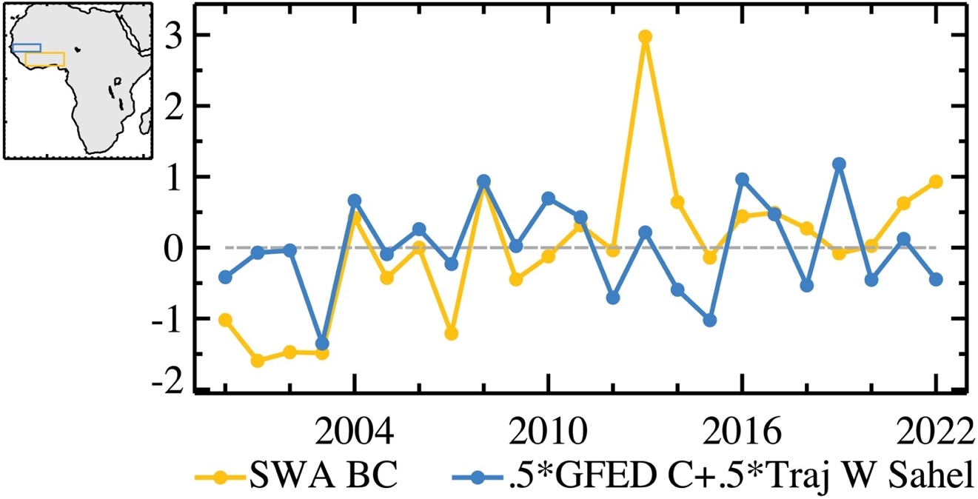

Figure S2. The same as Figure 3A but for a linear combination of carbon emissions due to biomass burning in Western Sahel and the associated back trajectory counts between that region and SWA.

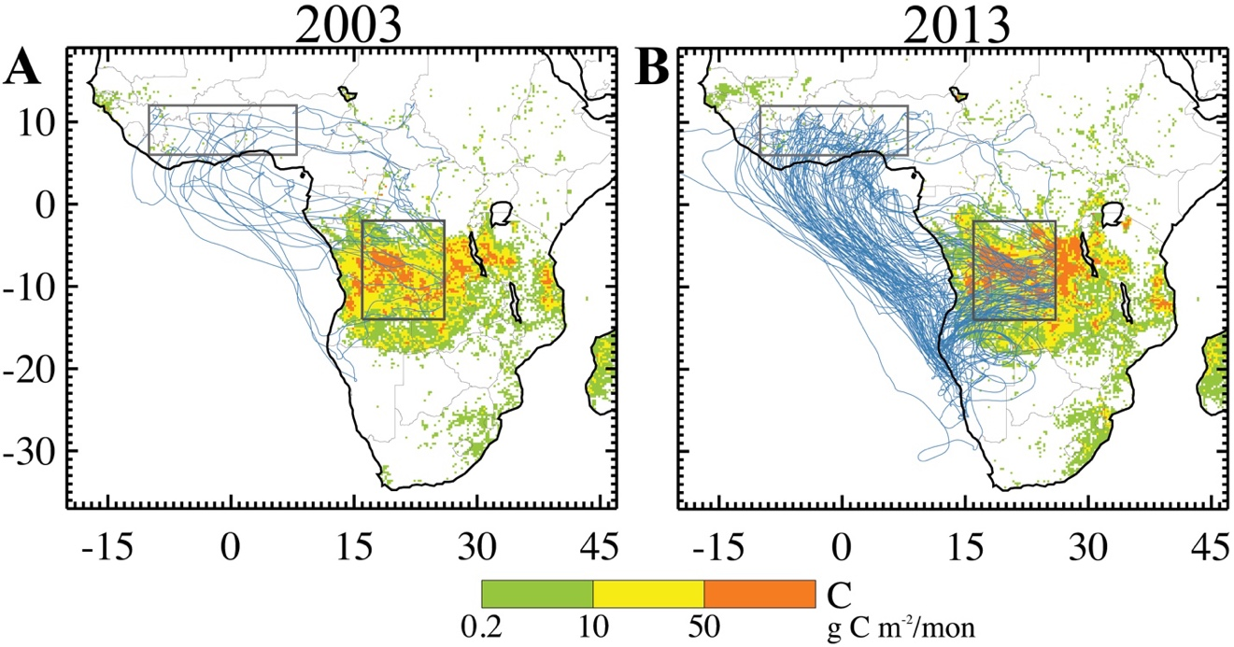

Figure S3. (A) Spatial distribution of carbon emissions due to biomass burning in 2003 where BC is low in SWA. (B) the same as (A) but for 2013 where BC is high in SWA. For visual clarity, only one out of every ten trajectories is plotted due to their large number.

