Chapter 6 - From Idea to Instagram: How an Academic Library Marketing Committee Created a Character for the YouTube Generation

Published and shared with permission from Brad Eden (Ed.), Marketing and outreach for the academic library: New approaches and initiatives. Lanham, MD: Rowman & Littlefield.

Abstract
After observing low usage statistics for a handful of library services, Albert S. Cook Library’s Marketing Committee decided to create videos to promote underutilized resources. In past videos, the library relied on student actors, but it became increasingly difficult to find students willing to participate. As a result, the library purchased a puppet and then created videos featuring him. This chapter details how committee members created the puppet’s persona and scripted, filmed, edited, promoted and assessed the effectiveness of these videos. The chapter concludes with considerations for other libraries wishing to develop their own character-centric promotional campaigns.

Authors
Joyce Garczynski – Communications and Development Librarian, MLS, MA
Laksamee Putnam – Science Librarian, MLIS
Lisa Woznicki – Performing Arts Librarian, MLS, MS

Background
Librarians spend inordinate amounts of time creating help guides and pathfinders, as well as other tools, to entice students to use their services. As more of these items find their way to library web sites, course management programs, and other venues, one challenge seems to always rear its ugly head: how do we get students to access and view these tools and take advantage of library services? At Towson University’s Albert S. Cook Library, this was a puzzle that many of the librarians tried to solve. Print as well as video tutorials and help guides were created, flyers and signs were posted around the physical library alerting students to services and policy changes, but these seemed to have little impact. [To view the library’s current print help guides and video tutorials visit this link: http://libraries.towson.edu/help-guides] It was apparent that the library needed to find a new way to reach its students to pass on information beneficial to their academic careers as well as getting them to utilize library services. After much discussion, the library’s Marketing Committee suggested that a handful of library staffers try their hand at creating an informative but humorous library related public service video. While none of the staff had any formal experience in film, the group decided to try scripting and creating a quick video that could be used on the library’s web page to advertise a change in printing procedure, and the library’s Video Subcommittee (and ultimately their YouTube Channel) was born.
The subjects of the initial videos were dictated by the need to inform students of policy and procedural changes at the library. The early video topics included procedures for printing in the library, upcoming programs that the library was hosting for National Library Week, publicizing the library’s Amazon.com wish list, and utilizing the library’s new text messaging service. In each instance, two library staff members put together a scenario and one created a script. To infuse the project with humor, the original videos were often parodies of popular commercials; the video advertising the new print debit card system was based on the ‘What Would You Do for a Klondike Bar’ commercial showing students going to exaggerated lengths to obtain the new print card. Library staff and student workers were recruited to act in the videos, and props were simple and homemade.
Finding student actors was often a problem as many of the employees were not comfortable appearing on film. Repeated requests went out to students asking them to volunteer for a few minutes of filming. Usually, the library staff had to approach students individually and plead with them to participate, promising that they would ultimately enjoy the experience. One librarian contacted the Theatre Arts department and tried to find student actors, but because of the students’ commitments to departmental productions, they had no time for extra acting jobs, and the request met with little success. Because of the small number of available students used as actors, scene changes and transitions were limited. As a result, the Video Subcommittee decided to try using a puppet as a common actor who could be filmed doing an activity while a narration was read over the film sequence. Initially, a ventriloquist puppet was used as a character appearing in numerous videos (See Figure 1 - Image of First Library Puppet). The Subcommittee felt that his attempts to perform activities typically done by students such as typing, dialing a phone, using the library catalog (all filmed showing the puppet’s small plastic hands) were very humorous. The videos were all filmed in various locations in the library and were completed without any budget. Upon completion, the videos were uploaded to YouTube and advertised on the library’s web site. Judging by the comments posted, viewers enjoyed the videos and found humor in the obvious low-budget, homespun quality that was evident in each film. This gave the Subcommittee courage to expand their fledging efforts and attempt longer, more elaborate films. Overtime, however, it became apparent that students were identifying the ventriloquist puppet with a horror movie character, this negative connotation convinced the Subcommittee to stop using the puppet but video projects continued.
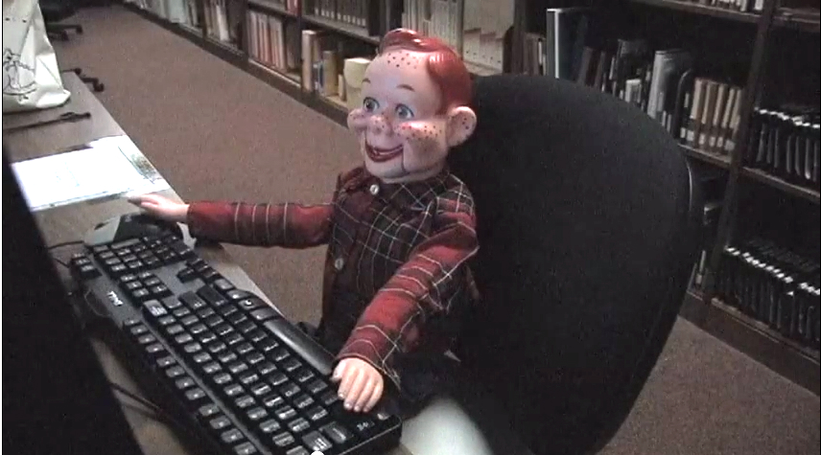
Figure 1- Image of First Library Puppet

Upping the Ante
A more complicated video was planned involving a common general complaint in the library over students being too noisy, messy, and generally disrespectful of the space and the patrons around them. The Subcommittee designed a video that was modeled after a Liberty Mutual television commercial focusing on the benefits of random acts of kindness. When the Association of College and Research Libraries (ACRL) announced their President’s Program Innovation contest (Free, 2011) in early 2011, the Subcommittee submitted the Liberty Mutual parody idea and won the “In-progress” category! This positive support provided a higher level of motivation and expectation for the end result. The award enabled the library to recruit and pay student actors. In order to insure student participation, the library advertised for student actors and compensated them for their time with a small cash payment and a pizza lunch. After actors were recruited, students signed recording releases, and filming was completed over a four hour period. The completed video, “Civility: That’s Our Policy”, can be viewed here: http://youtu.be/XHd2tCWFXoA The simplicity of the video message has allowed it to be shared over an extended period of time, and it is continually aired throughout the year on the library lobby video monitors. Encouraged by the award recognition, the Subcommittee envisioned a further series of videos to be produced. However, the previous award money had been spent and there was still the problem of enlisting student actors.
Rethinking Puppets
Because of the success of the initial videos, the Subcommittee began to think about using a different type of puppet, which would eliminate the need to find at least one student actor. Instead, a library employee would take on the role of puppeteer. The previous ventriloquist style puppet, while fine for the initial ‘amateur’ videos did not fit with the Subcommittee’s vision for a higher quality series. Initially, the new puppet search centered on locating a suitable tiger puppet, a nod to the school’s mascot. However, finding the right puppet, proved to be more problematic than expected. First, if the puppet is to actually speak directly to the camera, a moveable mouth is required. Second, if the puppet is to hold something, or type, it needs to have arms and fingers that can be manipulated by the puppeteer. The Subcommittee could not find a tiger puppet that satisfied these requirements. Additionally, the library could have also faced problems creating a mascot that did not align with the university brand requirements. One evening, as a committee member was watching a tv show featuring Jim Henson’s muppets, the answer was clear: use a muppet. A muppet could easily match the mouth and hands requirements, portray a student character in any persona needed for the film series, and lend a sense of whimsy and fun to the message. After a lengthy internet search, the committee decided to order a blue, furry puppet from the Luna’s Puppets website: https://www.lunaspuppets.com/

Building a Character
The next step was creating an identifiable character who would be the protagonist throughout the subsequent films. As the puppet traveled on his journey to become “information literate” with the help of the library, the Subcommittee hoped students could identify with his experiences. The puppet would be our “information novice” and needed to be paired with an older, wiser student who could show him the ropes. This description became the driving force in creating the initial dynamic between the two main characters; a young, novice researcher with a more experienced guide to lead the way. In searching for a name for the furry character, many possibilities were bandied about, but the Subcommittee struggled to find a name clear of connotations of television, movie, and literary characters. Because the library is named for its benefactor, Albert S. Cook, the puppet became Al Burt. Limitations from University Marketing would not allow Al to be called a mascot, so instead his title became ‘Cook Library’s Biggest Fan.’
After choosing a puppet and while developing main characters, a puppeteer needed to be found among the library staff. As a puppet, Al is very easy to control, requiring only one person to move his head and a single arm to animate his hand. A hand could be placed into Al’s head either from directly behind through an opening or from his bottom half (the puppet does not have legs). Both his arms are open from the elbow to his four fingers, making it simple for the puppeteer to use either arm (See Figure 2 – Photo of Al and Puppeteer). However, after a librarian volunteered to act as puppeteer it became clear that practice was required. A master’s student in the Theater Arts department who focused his thesis on puppetry provided a basic instruction session. The most important element in puppetry is motion. Even when standing still, the puppet needed to always interact with his environment. As each video was developed and filmed, the puppet became easier to animate as the librarian became familiar with controlling Al. Specific skills which required practice included connecting voice to mouth movement and understanding the puppet’s physical location; because the puppeteer was not able to see through Al’s eyes and was often reading a script it was difficult to make Al speak with emphasis and look at an item or person. Ultimately, practice along with the ability to film a scene and allow the puppeteer to review immediately after filming helped all those involved to improve acting and animation skills. A library film star was born, but he needed a partner in crime.
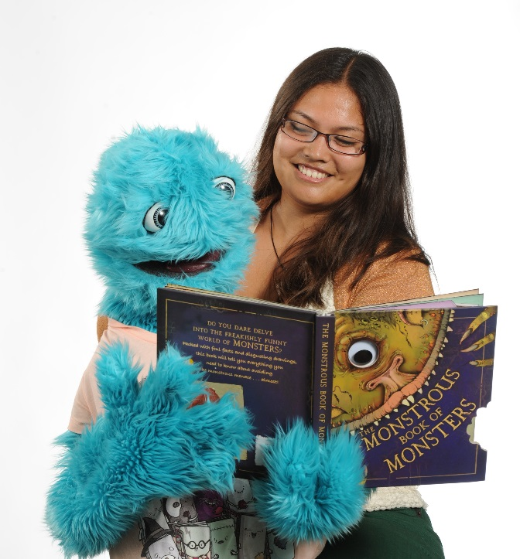
Figure 2 - Photo of Al and Puppeteer

The Subcommittee decided that Al’s wiser guide would be his roommate. This would require a single student actor to film a few episodes over the course of the school year. Rather than try to recruit multiple student actors, the Subcommittee hoped a single actor would be easier to cast and schedule. Luckily, a theatre student and son of a library employee was willing to sign up and add the film series to his CV. The character he would portray was named “Bill” and the two interacted as if they were both two young students; no references were ever made regarding Al’s puppet nature. The relationship between the two was based on the characters Wally and Beaver from the old television series, Leave It to Beaver. This meant that in most of the videos, Al gets in trouble because he does not understand how to perform basic research tasks, or avail himself of services offered at the library. This would be followed up with Bill patiently explaining tools like an APA citation guide and services such as Text a Librarian, which allowed Al to complete assignments and survive his first semester at college. The hope was that the video series would appeal to undergraduates: presenting Al as a character unfamiliar with college and learning about all the different ways the library was available to help. (See Figure 3 - Photo of Al and Bill)
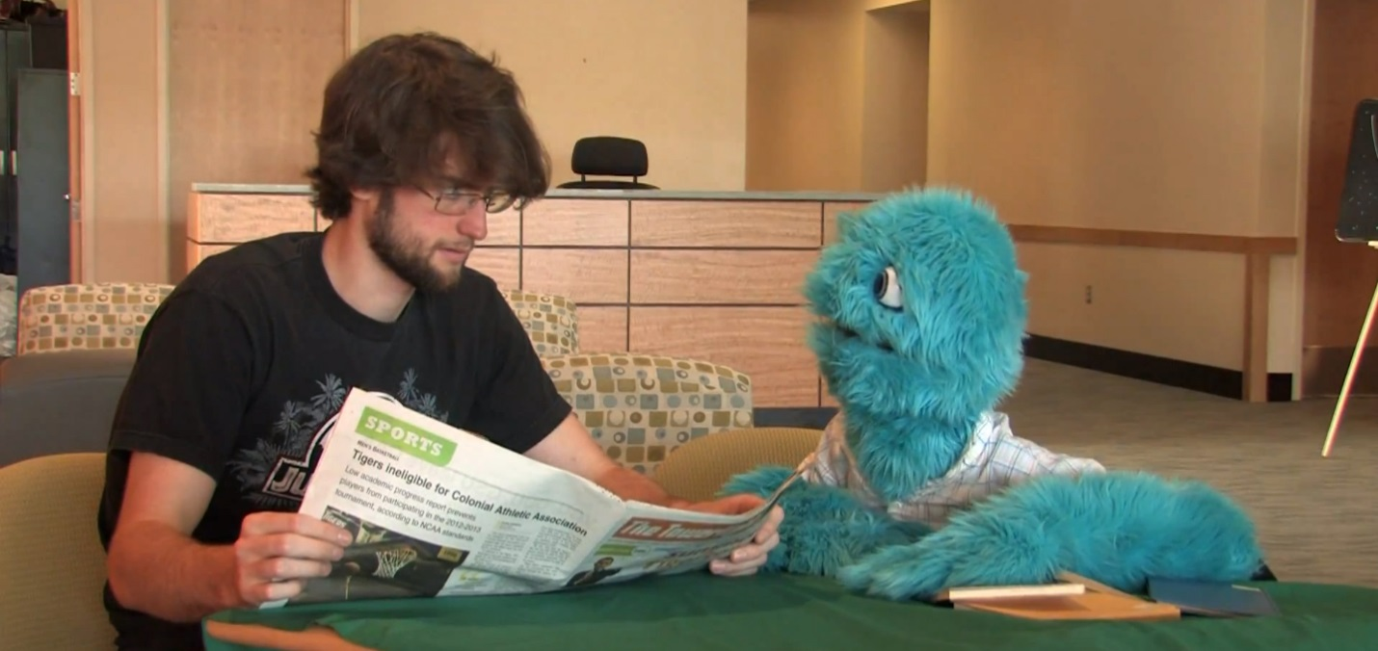
Figure 3- Photo of Al and Bill
Scripting and Series Consistency
When the Subcommittee began to talk about creating a series of videos featuring Al and Bill, the general consensus was that there would be a series of four initial films focusing on the services that the library wanted to highlight for that school year: outreach research assistance held in academic buildings outside the library, the text-a-librarian service, library help guides for citing sources (specifically APA), and in-person assistance offered at the Research Help Desk. The Subcommittee decided to organize the sequence of videos based on their sense of when students may need to use each resource or service. The videos were not meant to be step by step tutorials, instead they served much like public service announcements, pointing students in the direction of resources they could utilize. The Subcommittee envisioned each topic as a separate video, much like the episodes in a situation comedy. Therefore, each was given a title and a storyline was created so that viewers would learn about the service, but also get to know the two main characters. The initial idea of calling the sequence The Al and Bill Show was dropped; instead, the videos were each identified by their title. However, a persistent tagline emerged in every video: “Cook Library has the Answers” and became the unofficial title of the series. There was a point towards the end of each video where the all-knowing experienced student, Bill, would utter these words or a phrase with the same intent. That phrase was then used as the unifying agent to tie the videos together and help viewers link the library to these services and the characters.
After the primary topic for each show was chosen, a script was written. One key object needed by the puppeteer is a script. The scripts, written by the Performing Arts librarian, set up the scenario, listed props needed, provided actors with overall tone and gave the videographer directions on focus and transitions. The lines for each actor were never memorized; actors were given the flexibility to change lines so long as the important points were not left out. The script also noted scene locations and a list of props needed for each scene. These choices were influenced by multiple factors. Prior to filming, the videographer and author of the script would block out each scene, visiting the locations selected and taking photos to document the space, placement of windows, amount of light, and any other details that could affect filming. The lighting, available outlets, homemade props, and pieces of furniture all needed to be considered and, if possible, written into the script to help everyone understand how filming would progress. Overall, the script helped build consistency throughout the video series, by describing each individual storyline and insuring it connected to previous videos.
Additionally, “Cook Library Has the Answers” included a variety of features which linked videos and made them identifiable as a series. For example, each video begins with the same music. The soundtrack was selected from Soundtrack Pro, a royalty free music application offered by Apple. The opening sequence always introduced the two main characters, Al and Bill, and provided the episode title, similar to modern television shows. After the opening sequence, the episode would begin by clearly identifying campus buildings where the primary scenes were taking place. Each video lasted between two to three minutes in duration, based on the Subcommittee’s understanding that students would not want to watch anything much longer (Attebury, 2010).
Initially, the videos included cutaway scenes that added content that was strictly for entertainment purposes - a practical joke played by Al, or a silly stunt that was referenced in conversation between Al and Bill. However, these sequences added to the length of the scripts and made filming complicated. After the Subcommittee held focus groups asking students for their critiques of the series, it was decided the cutaways diluted the informative message of the videos. The next ‘season’ in the series eliminated the cutaway scenes. The following titles were produced during that initial season of video filming and can be viewed through this link http://bit.ly/alburtvideos : “Al Finds Research Relief,” “Al Discovers Text and Chat,” “Who is Apa,” and “Monster Mash Up”.
Choosing Locations
After the scripts were developed for each topic, and settings around campus were selected, filming began! People were alerted if included in the background of a shoot but if possible, an early film time, or summer timeframe, was chosen to minimize disruptions. However, students seemed to enjoy seeing Al being filmed, which often lead to students snapping a photo and being directed to the library’s YouTube channel to find out more.
In most cases, the crew was small and consisted of the following: our puppeteer, student actor, videographer, and an additional staff person who handled props, microphone, lights, and other technical equipment. Since most of the filming was done on campus, it was easy to load equipment onto carts, or when necessary, into a car to drive to another building. Having compact equipment that can be easily transported and stored in ready to go packaging simplified the process. Because the locations had already been examined for lighting and electrical needs and the action sequences blocked, once the crew arrived on the scene, filming could start with a minimum of set up time. In some cases, permission needed to be sought from building managers before the crew could begin setting up equipment, but this was not an issue if filming was done outside of buildings or within the library. The Subcommittee tried to make the most of available space in the library, often using staff areas when filming scenes that were to represent a dorm room or personal living space.
In some cases, a green screen was used if the videographer wanted to edit in background film to complete a scene. Because the library had no budget for this project, the Subcommittee used an actual green table cloth, pinned behind the actors. Later, the videographer would edit a different background behind the characters to achieve the desired effect. Props were simple and homemade with household items repurposed for many shots. Al’s wardrobe came from a local thrift store, and over the span of a few months, the Subcommittee had amassed a number of interesting t-shirts for him to wear. For legal reasons, the crew asked that student actors not wear outfits with designer logos or recognizable images that were protected by copyright. If possible, university themed apparel was used to identify Al with his school.
When locations were scouted, it was essential to remember that any scene is limited by the physical needs of the puppeteer and the puppet. Because Al does not have a lower torso, he must always be filmed sitting at a desk, table, or behind a counter. Each scene must be carefully staged so that the puppeteer is hidden out of sight. In many scenes, a tablecloth was used to cover the open space under a table where the puppeteer was kneeling. Our puppeteer often wore a black top that could fade into the background of different camera angles. The crew went to great lengths to make sure that her arms, head, and even her hair were never included within any shot.
The placement of the puppeteer often meant that a microphone needed to be used to make sure that her voice sounded natural on film. In scenes with Al’s roommate, the actor could direct his lines across the table to Al, but when replying, the puppeteer was actually below the table’s surface and had to work to project her voice. The crew often had to move the microphone in various test positions so that the puppeteer’s voice would sound natural on camera, free from echoes, with a sound quality that matched the surroundings.
The puppeteer’s work was more physically demanding than the Subcommittee had expected. In many cases, she was kneeling for large blocks of time, or sitting on a small step stool. The puppet is covered with faux fur, so it is heavy and holds heat, and to keep him at eye level with his human counterpart, the puppeteer had to keep her arm extended for the duration of each shot. As a result, it was important to build in breaks in the shooting schedule to keep the puppeteer feeling refreshed and energized.
Film Equipment and Video Editing
The equipment used to film and edit the series has expanded and improved over time. However, with a limited budget and fast production time frame, most of the videos created did not require a high level of technical skill. The videographer involved in creating this series, did have a learning curve; his skills in this area were entirely self-taught and when necessary, the University’s Electronic Media and Film Department was consulted. Typically the videographer spent three to six hours per video in post-production editing. Specific hardware and software used for this project will be detailed here, but technology today has made it possible to do most of this from a smartphone alone.
The filming was done on a Canon XHA1 HD video camera attached to a tripod. This camera is tape based, however, in order to make editing easier we utilized a Direct-to-Edit (DTE) recorder. This digital recorder made it much easier to transfer video to the computer, rather than adding an additional step converting from a tape recording. The camera was usually utilized in an automatic setting, however, this meant that light was an important consideration, and often scenes needed to be adjusted so background windows would not wash out the actors. To fix some of the light problems, a basic soft box light can be used to add illumination without glare. As mentioned previously, a microphone was used to insure the puppeteer could be heard despite needing to be hidden from view. Specifically a lavalier microphone was used by the puppeteer and occasionally a unidirectional condenser microphone was held over head to capture overall sound. A microphone helps cut back on ambient background noise, however, when using separate microphones instead of the built in-camera microphone one must be sure everything is connected correctly! A few times filming needed to be redone because the crew managed to turn the camera on but not the microphones. It is a good idea to record multiple shots of a scene to insure there is enough content to create the video. Additionally, playing back any recordings during the filming process allows everyone to be sure the equipment is working properly and make adjustments as needed. A piece of helpful but not essential equipment is a video monitor which allows the crew and actors to view how the scene looks from the camera. This is especially helpful to the puppeteer to provide a better understanding of where the puppet appears within the camera frame and how to move in a realistic way.
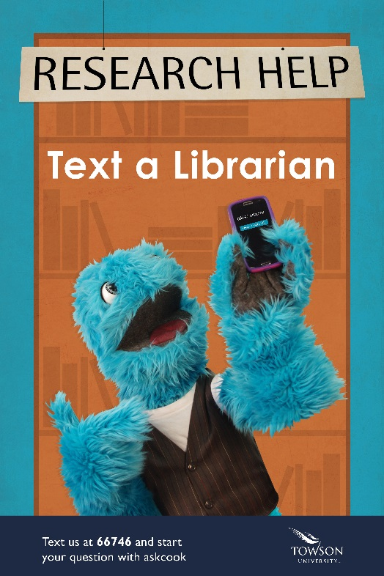
Filming was done in a 4:3 aspect ratio, to make it easier for the video to be broadcast on various lobby televisions in the library. However, with video quality improvements, a 16:9 ratio and higher definition are preferred. Higher definition is a simple way to make videos look higher quality. Professional quality can also be achieved by editing the video into a cohesive final product. The video editing software used for this series was Final Cut Pro 7, however, basic video editing can be accomplished through free programs that come with any non-linear editing software, such as Windows Movie Maker or iMovie. As mentioned previously, adding an opening and closing sequence and soundtrack to the series help tie the videos together. This consistent branding is connected to numerous other projects which involved Al, all of them showcasing a positive message about the library. (See Figure 4 – Al in public service poster)

Figure 4- Al in public service poster

Promotion and Assessment
Since October 2012, the Video Subcommittee has ultimately released six completed videos starring Al. In order for these videos to effectively promote the library's most under-utilized services, they needed to be seen by a wide variety of students. As a result, the library Marketing Committee initially decided to designate the broad category of undergraduate students as the target market for the Al videos.
Since all of the Al videos are listed on the library’s YouTube channel (http://bit.ly/alburtvideos) a new video is simple to share. Once a new video is published, the library publicizes the new title by sharing a link to the playlist which starts with the new content. This approach encourages viewers of one video to check out previous titles that they may not have seen. The link to the new video is then distributed via the library's social media channels (Facebook and Twitter), a spotlight on the library website, and a post on the daily email announcement that is sent to all university affiliates.
The Video Subcommittee thought that undergraduate students who have some connection with the library would be a good market segment to approach, so they devised a series of promotional tactics in an effort to reach that audience. When the first Al videos were released, the Video Subcommittee encouraged all of the librarians who teach library instruction sessions to show these new videos as the students were coming into the room. This strategy takes advantage of the eager-to-learn captive audience that is waiting for instruction to begin. Similarly, the Subcommittee created post-it notes with Al's picture, the words "Have you met Al?" and a link to the library's YouTube channel. These notes were placed at the library's Research Help desk and whenever a student asked for a book in the library, the library staff members working at the desk were encouraged to write the call numbers down on these branded notes. On more than one occasion, a library patron who received a note asked to know more about Al. In addition, the Subcommittee began to use Al to promote other library programs. For example, Al's photo was placed on an American Library Association (ALA) READ poster that hangs on the library's main floor (See Figure 5 – Al READ poster), his videos are shown on a loop on a video screen in the library lobby, and the Subcommittee created short videos with Al to introduce two contests that the library held to promote their new Instagram account (http://instagram.com/cooklibraryoftowsonu/). These strategies are meant to help solidify the connection in students' minds between the library and Al.
About one year after the release of the first videos, the Subcommittee decided to expand promotional efforts to attempt to reach undergraduate students outside the library. They decided to hold a launch party for a new Al video in the student union around lunchtime. As students came into the building, they were given candy that included a tag with Al's picture, an encouragement to watch the video, and a link to the library's YouTube channel. Also Al himself was on hand at the party to sign autographs and say hello. Much to the surprise of the Subcommittee, this event did not provide the promotional opportunity that the group wanted. Many students were not interested in the candy or in Al and said that they did not have the time to take a few seconds to speak to library staff members about the videos. In retrospect, the Subcommittee realized that this approach might not have been effective because students are accustomed to vendors and other organizations using that same space and employing similar tactics to try and sell them things. In addition, some of the students who did stop by said they were not interested in learning more about the videos because Al was "creepy". Given that the launch party strategy prompted less than enthusiastic responses to Al, the Subcommittee felt they needed to gather more information about how students perceive Al, the Al videos, and what students think are the best ways to promote both.
In order to gain some clarity about student perceptions of Al and the Al videos the Subcommittee would need to hold focus groups. This research methodology is a fantastic way to introduce new media productions and gather information by informal conversation. Focus groups, however, do not provide data that is representative of the opinions of a whole population so it is a good idea to hold more than one group on a topic and look for similarities across groups.
The Subcommittee held two focus groups related to Al and the Al videos with a member leading the facilitation. They held the focus groups at lunchtime and offered free pizza as an incentive to participate, but the number of students who signed up for the groups was low until one of the Subcommittee members convinced a faculty member teaching a social science research methods class to offer focus group participation as extra credit. Ultimately, the first focus group had three participants and the second had twelve.
In terms of the focus group questions, the facilitator distributed a questionnaire before the group began in order to obtain participants’ demographic information such as class and college affiliation. She began the focus group with the broad question, “What library service do you use most frequently and what is your opinion of that service?” in order to break the ice and get the group participants talking. Then the facilitator showed three of the previous Al videos, making sure to show examples that demonstrated both the short, commercial format and others with the longer cutaway segments. Finally the facilitator asked the focus group participants questions about Al as a character (“If you had to describe Al in one word, what word would that word be and why?”), the format and content of the videos (“Which library service or services would you recommend and why?”), and the target market for these videos (“Would you be interested in seeing Al in future library promotions? If so, what should Al promote and why? If no, who would you rather see in library promotions?”).
The focus groups yielded information that supported the previous efforts of the Subcommittee and some suggested a course correction might be needed. No one in the focus groups had seen or heard of Al, nor did they think that he was creepy or too juvenile for a college audience, thus the character of Al could remain intact. Many of the focus group participants did take issue with the format and the content of the videos, and these responses suggested a few changes should be made. Both focus groups preferred the shorter commercials to the longer videos with cutaways. Also, participants in both groups said they wanted the videos to be more informative and less focused on entertainment, which they perceived to be a waste of their valuable time. Finally, the groups suggested that the Al videos would best be suited for new or first year students because the groups felt that upper level students should already know about the services promoted.

Changes and Looking Toward the Future
Given the focus group feedback that students do not connect Al with the library and that first year students would most benefit from the Al videos, the new target market for the Al videos has become new students. Al is now a more visible part of the library's program during new student orientation, a campus-wide program designed to make first year students feel more comfortable as they make the transition to college. During this orientation, new students who come to the library are given a postcard that has Al's picture on the front and on the back it lists the top ten things that every new student should know about the library. In addition, students who come to the library during orientation have the opportunity to have their picture taken with Al in a makeshift photo booth. The library then shares these photos on their social media accounts. The results of a recent new student orientation photo booth can be seen at this link: http://instagram.com/cooklibraryoftowsonu/
The content of new Al videos also has changed to reflect the feedback from the focus groups and this new target market. New videos are shorter and no longer have cutaways. Also, the topics covered focus on services that are most beneficial to new students. For example, the first video produced after the focus groups was "Why Cook Library Rocks" (http://youtu.be/FX2pnRxcAg4) which is only a minute and a half long and briefly highlights some of the library's most popular services.
Although the focus groups indicated that students were happy with Al's persona, this new shortened format and new target market meant that the Al character needed a personality change. There was no longer enough time in the videos to establish and build the relationship between Al and Bill. It was necessary for Al to stand on his own. As a result, the character of Bill has graduated, and Al serves as a guide for new students introducing them to library services. The first scene in the "Why Cook Library Rocks" video reflects the attempt to make that transition.
In the future, the Video Subcommittee would like to more firmly establish the association between Al and the library in the minds of undergraduate students. The hope is that by focusing on creating and marketing content that is meaningful to new students this connection will only grow stronger as each new class enters. In addition, the Subcommittee hopes to expand the promotion of the videos on social media. They have established a Facebook page for Al (https://www.facebook.com/cooklibrarybiggestfan), but staff cutbacks and lack of time have prevented this promotional channel from reaching its full potential. By having Al regularly comment on library and campus happenings through social media, he could become part of the campus community and his relationship to the library will only grow.
Conclusion
A series of library promotional videos starring a puppet named Al started out as simply an idea. Through careful planning, scripting, and filming, the library struck out on a new path to connect with students. Utilizing popular modes of interaction (social media and YouTube) libraries can move from traditional print communication into an appealing and meaningful conversation with patrons. The key is to remain flexible and listen to users and their habits. Libraries open to popular trends and focused on designing library services centered on the needs of their audience can establish new relationships and deliver service that is more personal. By doing exactly this, the Albert S. Cook Library was able to transform a puppet into an effective promotional tool.
References
Attebury, R.I. (2010) Perceptions of a profession: Librarians and stereotypes in online videos. Library Philosophy and Practice, 433. Retrieved from http://digitalcommons.unl.edu/libphilprac/
Free, D. (2011) 2011 ACRL President’s Program Innovation Contest winners. ACRL insider. Retrieved from http://www.acrl.ala.org/acrlinsider/archives/3676

