ABSTRACT

Title of Thesis: LOST EDGEHILL: URBAN RENEWAL, COLLECTIVE AGENCY,

AND GENTRIFICATION IN A SOUTH NASHVILLE NEIGHBORHOOD

Degree Candidate: Drew Mahan

Degree and Year: Master of Arts in Historic Preservation, 2024 Thesis Directed by: Betsy H. Bradley, Ph.D.
Welch Center for Graduate and Professional Studies Goucher College

In 2022, the Nashville Chamber of Commerce announced that the city was growing by 98 individuals per day. This explosive growth has put an unprecedented strain upon the city’s historic resources, predominantly affecting historic neighborhoods occupied by people of color. As historic preservation professionals, it is our mission to tell the fuller American story, and in this case the fuller story of Nashville. The portion of the Edgehill neighborhood that this study focuses on has been the site of erasure, followed by a period of community-based activism to prevent a large-scale housing project, and concluding with hyper-gentrification in the past decade. In the late 1960s, the Nashville Housing Authority documented the area, resulting in a collection of 35-millimeter slides that show the Edgehill neighborhood on the cusp of demolition. The images were captured to justify the buildings impending demolition. This collection exists as the only photographic evidence of the buildings that once existed there.

This thesis project explores these themes from 1940 to the present day, using Nashville’s Edgehill neighborhood as a model. To combat erasure and the loss of the memory of a neighborhood, the project utilizes an archival collection to tell the story of a place that no longer exists. Using social media as a medium, the project seeks to keep Edgehill’s memory alive, inspire a new generation of preservationists, create a forum for conversations surrounding Nashville’s growth and gentrification, provide access to a previously unseen photo collection, and tell the fuller Nashville story.
This study produced two products: this framework paper and a social media project. From August to December 2023, I posted archival images from Metro Housing and Development Agency’s photo collections housed at Metro Nashville Archives to Facebook and Instagram. The images and stories in those posts went on to inform the content in this paper and vice versa.

Subject Headings: Nashville, Edgehill, Urban Renewal, activism or agency, gentrification, archival collections, historic photographs, Black history, erasure, social media, Instagram, Facebook, sense of place, community engagement

LOST EDGEHILL: URBAN RENEWAL, COLLECTIVE AGENCY, AND GENTRIFICATION IN A SOUTH NASHVILLE NEIGHBORHOOD

DREW JOSEPH MAHAN

This project is committed to the faculty of Goucher College in partial fulfillment of the requirements for the degree of
Master of Arts in Historic Preservation 2024

Advisory Committee:
Betsy H. Bradley, Ph.D., Director
Sarah Arntz
Scarlett Miles

Copyright © by
Drew Mahan
2024

PREFACE

I was initially drawn to the Edgehill neighborhood while working as an archivist at Metro Nashville Archives, where my daily tasks included processing and digitizing 35-millimeter slides. I had moved to Nashville in 2012, just as the city began its ascent to becoming “It City.” The physical environment was changing every day, particularly the historic neighborhoods surrounding the urban core. At work I stumbled upon an unidentified, unprocessed collection of slides that were simply labeled “Edgehill.” The slides provided a vivid glimpse into the buildings that once occupied the hillside on the eastern edge of the neighborhood, which was a stark contrast to the small, Ranch-style homes that lined the streets I knew. One of my coworkers confirmed that this collection had most likely been viewed by less than five individuals, and it became my mission to make these images more accessible.
Edgehill’s historic fabric was destroyed by eager city planners when it was demolished in the late 1960s, creating a blank canvas for the “new” neighborhood. The Nashville Housing Authority’s plan to build a large-scale housing project on the site was met with instant criticism by the residents in the area. These people had already seen the loss of over a dozen stores and six churches when the area was razed, and they wanted a say in what would be built here. Formed in the 1960s, the Edgehill Area Project Committee was one of the first community organizations in Nashville that fought to have their voice heard in relation to public projects. The committee took the Housing Authority to court and won, ultimately creating a path for single-family homes via the Turnkey III program. With the legal process halting construction in the area for six years, the first Turnkey homes were not constructed until 1976. As Nashville became a global destination in the early aughts, original owners of Turnkey homes sold their homes for significant profits to developers. These developers have demolished the small Ranch-style homes and constructed modern mansions, dwarfing the remaining Turnkey homes in the area and pushing out older residents.
As preservationists, we seek to preserve the forgotten and erased, and to connect places and people. At Metro Archives, there was a strong relationship between the organization and historically-wealthy, White communities, with a noted absence of resources regarding historic Black communities.
This project was undertaken to tell the stories of the people, spaces, and buildings of Edgehill prior to urban renewal, tell the fuller Nashville and American story, provide accessibility to a previously “unseen” collection, inspire a new generation of preservationists with social media, create a forum for conversation surrounding Nashville’s urban renewal history and current gentrification, and create relationships with Edgehill residents, past and present. This project is meant to be a conversation starter for the community regarding ways we can apply these archival collections to persevere memory and place. By using social media, I’m hoping this project will shine a light on a community that has been erased, and that I can use my microphone to amplify the voices of Edgehill before they are lost forever.

ACKNOWLEDGEMENTS

I would first like to thank my committee members, Betsy Bradley, Sarah Arntz, and Scarlett Miles, for their support. Your guidance, knowledge, and most importantly patience has been invaluable to making this project the best it can be.
I would not have been able to complete this project without the love and support of my wife, Brittany. Thank you for always believing in me, I love you. This project is dedicated to my boys Myles and Levi, who complete my world. You are my sunshine, and I love you both.

TABLE OF CONTENTS

ABSTRACT I
PREFACE V
ACKNOWLEDGEMENTS VIII
TABLE OF CONTENTS VIIII
LIST OF FIGURES XI
CHAPTER I: AN INTRODUCTION 1
The Edgehill Archival Project 3
Defining Urban Renewal and Erasure 4
Community Agency 8
Gentrification 9
Themes and Questions 10
CHAPTER II: INTRODUCTION TO EDGEHILL 12
The Early History of Edgehill: 1865 to 1950 12
The Urban Renewal Era: 1950 to 1970 14
The Turnkey Era: 1970 to 2010 15
The Gentrification Era: 2010 to Present 16
CHAPTER III: ERASURE, AGENCY, AND GENTRIFICATION 20
Erasure of a Black Community 21
The Edgehill Area Project Committee’s Fight 33
Hyper Gentrification in “South Gulch” 43
CHAPTER IV: CONCLUSIONS AND SUGGESTIONS FOR FUTURE PROJECTS 47
Why This Matters 47
Conclusions and Social Media Recommendations 49
BIBLIOGRAPHY 54

LIST OF FIGURES

- The Project Area in Edgehill 4
- Nashville Housing Authority Site Status Map, 1954 6

- New Developments on Rock Crusher Hill, 1963 9

- An Unpaved Section in Edgehill, 1965 22

- Privies in Edgehill, 1966 23
- The Gulch, south of Edgehill, 2017 24

- The east Edgehill Area Before Urban Renewal in 1966 and 1980 25

- 2nd Baptist Church, 1950 27
- The Washington home at 1004 11th Avenue South, 1966 31

- A High-Rise Tower and Housing Projects In South Edgehill, 1960s 39

- Turnkey III Homes Under Construction on Archer Street, Mid-1970s 40

- The Fuqua family outside of their Turnkey Home, 1979 41

- Melanie Grendell with her sons inside their Turnkey home, 1982. 42

- A luxury "VIP" Short Term Rental in Edgehill, 2024 46

- 939 South Street. Sold for $1.175 Million on 5/19/2022 47

THESIS FRAMEWORK PAPER

CHAPTER I: AN INTRODUCTION

This two-part thesis project shows how a collection of archival images can be used to explore urban renewal, community agency, and gentrification using social media. It argues that there are nuanced perspectives that exist within these themes, and that taking an absolutist stance—as in all good or all bad—surrounding these issues is futile and often misguided. As Edgehill’s housing stock was demolished, the community lost third spaces where they gathered, urban density, social infrastructure, as well as the emotional connection to their sense of place. In contrast, the housing stock was visibly aged and dilapidated in many cases, with some residents pleading for demolition in the area. After the demolition, the city was determined to build a “superblock” public housing project and a multi-story tower for the elderly in the area, while the Edgehill Area Project Committee fought for a project that would result in less density, single-family houses, and more community resources. Finally, while long-time landowners in Edgehill reap the profits of a gentrifying neighborhood, developers construct three-story mansions on one of the last “affordable” areas near the downtown core.
As social media becomes the de facto communication and news source, historians need to recognize that it can be a powerful tool to promote the work they do. There are thousands of photographic collections of urban renewal projects throughout the United States at other archives, and this project seeks to provide a format and model to showcase them so they will be accessible to a wider audience and provide a source for showcasing a nuanced understanding of Urban renewal, community agency and activism, and gentrification.

The Edgehill Archival Project

This study argues that the buildings, stories, and people of Edgehill deserve to have their story told and explores the use of a social media project to do so. Edgehill’s story, from urban renewal to Turnkey III housing, to the modern mansions of today, is a nuanced one with no clear “winners” and “losers.” The stories about razing, then erasing, Edgehill’s history before 1966 can co-exist with the fact that many of the residents that lived there hoped to move into more stable housing that was sanitary and safe.
This premise will be examined by following the chronology of Nashville’s Edgehill neighborhood from 1950 to the present day. Using archival images, Google Street Views, and Sanborn maps, this project has traced the built environment in specific locations in a “then and now” format, making it accessible to a general audience. When I worked at Mero Archives, I digitized and identified the 35-millimeter slides that became the impetus for this project. Using Sanborn Maps, I cross-referenced anything I could find in the images to provide the exact location of the view. The social media aspect of this project exists on Instagram and Facebook, two of the most popular sites that allow the sharing of images with captions. The physical boundaries that were used for this project are Interstate 40 to the north, 8th Avenue South to the east, 12th Avenue South to the west and Edgehill Avenue to the south (Figure 1).
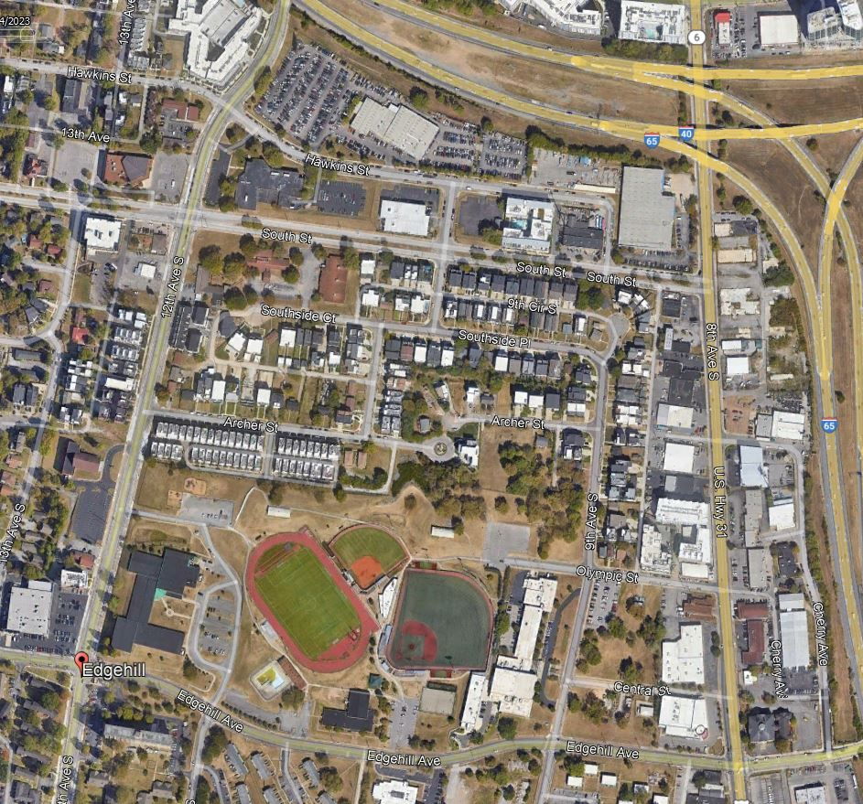
Figure 1. The Project Area in Edgehill. 8th Avenue North at far right, 12th Avenue South at far left.
Source: Google Earth 2023

Defining Urban Renewal and Erasure

Urban renewal is “the process of seizing and demolishing large swaths of private and public property for the purpose of modernizing and improving aging infrastructure. Between 1949 and 1974, the U.S. government underwrote this process through a Department of Housing and Urban Development (HUD) grant and loan program. Although the money was federal, renewal plans originated with and were implemented at the local level.” These projects destroyed historic buildings, displaced populations, and removed key community resources like stores and churches. Because urban renewal was often used as a tactic to clear “slums,” neighborhoods occupied by lower income individuals and people of color were often targeted. Cities were remade as more “car-centric,” benefiting those in power and wealthy suburbanites. Most experts would agree that urban renewal in the United States was a failure because it wasn’t an equitable process that benefited displaced people and new residents equally; instead, the social and emotional cost fell on poor people and people of color. Urban affairs journalist Scott Beyer asserts that urban renewal was “an assault on black neighborhoods that undermined liberty, free markets, and human dignity—and was one of America’s great, and unrecognized, twentieth-century tragedies.”
Communities that are destroyed by urban renewal often experience “root shock.” Social psychiatrist Dr. Mindy Thompson Fullilove describes this phenomenon as “traumatic stress reaction to the destruction of all or part of one’s emotional ecosystem.” Her research indicates that the destruction of a community can “threaten the whole body’s ability to function.” This experience can “stay with the individual for a lifetime” and “affect generations and generations of people” because “each person in his social and geographic slot is destroyed.” She claims that “even if the neighborhood is rebuilt exactly as it was, it won’t work. The repaired geography is not enough to repair injuries to the multiple maze ways that make up a community.”
The justification of urban renewal projects was often framed within community and economic language. When the Nashville Housing Authority was formed in 1939, the city claimed that they were taking “an objective look” at the physical makeup of Nashville.” Early studies of the housing stock had revealed that “there were areas of extensive slums in the most degrading order.” The Nashville Housing Authority’s public housing projects sought to remedy this issue with “new housing developments with adequate sunlight and air and sufficient space for decent living, enabling Nashville families to obtain suitable accommodations for rearing their children, and through them the city itself will benefit by better citizens of the future.” This justification for action was difficult to push back against due to its framing as undeniable progress.
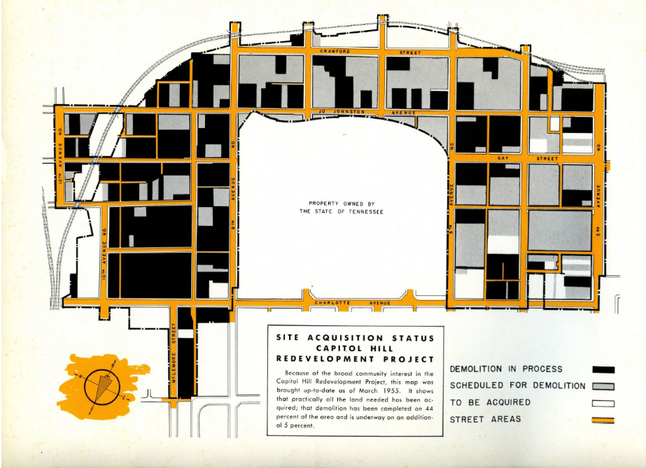
City officials used this powerful language of outside of the United States as well. In Halifax, Nova Scotia, proponents of early urban renewal efforts described efforts in inclusive terms. Projects were meant to benefit and improve the lives of the “overall population” or the “city as a whole.” City leaders noted that “modern planning was not about expensive boulevards and parks available only for the rich,” but its purpose was to improve “the health, happiness and prosperity of the overall population.” Health of the “people” was paramount to these planning principles, with “convenience next, and economy considered through[out].” The United States President’s Advisory Committee on Government Housing Policies and Programs underscored the economic importance of improving neighborhoods as well. The 1954 Nashville Housing Authority’s annual report features quotes from the committee on the inside cover, “constant improvement of the living conditions of all people is best accomplished under a strong, free competitive economy, and every action taken by the government should be for the purpose of facilitating the operation of that economy to provide adequate housing for the people.” This report also touts the accomplishments of the development division of the housing authority. Regarding the Capitol Hill Redevelopment project, they noted that “72 acres of land in the heart of the city, by-passed by modern urban growth, is being acquired and redesigned for sale to private businesses as a means of reclaiming land use that has been lost to obsolescence and putting it back to work as a part of an expanded central business district (Figure 2).” The area had only produced “$23,000 in tax revenue” before urban renewal, and after it will produce “$178,000 annually.”
Figure 2. Nashville Housing Authority Site Status Map, 1954
Source: Nashville Housing Authority
One of the major consequences of urban renewal was erasure. Erasure can be defined as “the practice of collective indifference and willful ignorance that renders certain people and groups invisible, ignoring their creation and contribution to the culture.” This project aims to counter erasure and keep the memory of Edgehill alive, so that the social media generation will be aware of the neighborhood’s contributions to Nashville‘s history. We need to be careful in the way we depict minorities and those who are historically oppressed in our stories and give credit to their contributions. With this in mind, I come to this project as a White historian, so I will not be telling the complete stories of Edgehill. Instead, I am sharing what the neighborhood was like before urban renewal, using primary sources to find stories of community resilience during urban renewal, and the consequences and opportunities residents faced after the area was demolished. Ultimately, this project uses an archival collection that I had access to as a window into the stories of this neighborhood and provides an archival framework for the experiences of Edgehill residents who lived through these eras.

Community Agency

In the context of Edgehill, community agency can be defined as “the capability of achieving change or action when needed and is closely related to empowerment.” Mats Malquist writes that “When intervening in the community there are four dimensions of community agency that need consideration: (3.1) the local culture and tradition; (3.2) the hegemonic belief systems; (3.3) the political tradition and system; and (3.4) the socio-economic conditions. These four elements interact and reinforce each other to further create and maintain the level of agency within a community.” Indeed, these elements are evident in the Edgehill Area Project Committee’s work. It’s important to recognize the agency of those who lost something that was so important to them. Recognizing community agency during a traumatic time can be a mechanism for soothing the pain caused by racist government policies and outsiders that abused their power when they destroyed the area. Additionally, including these stories tells a more complete recounting of urban renewal.
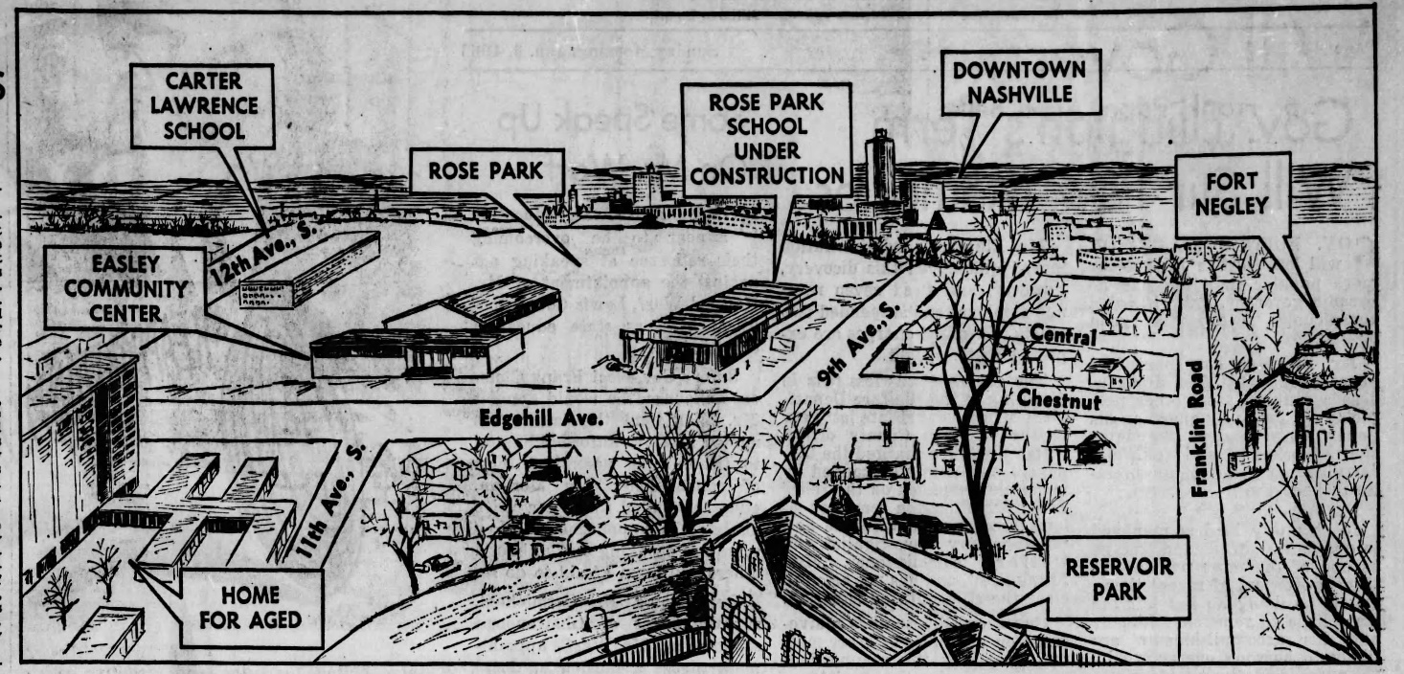
While Federal and local governments led by majority-White individuals sought to “beautify” the “slums” in order to maximize property taxes, Black residents resisted. The language that local newspapers used affected the reputation of the area, calling the hilltop the “ugliest, hottest, most dangerous, and most miserable spot in Nashville.” To the occupants of these neighborhoods, they were not “slums” but, as historians have noted, areas that “had been contained into through private covenants, government zoning and mob violence. While the housing was run-down due to overcrowding and poverty, the neighborhoods at large were still functional, full of churches, groceries, restaurants, and shops.” This was the case in Edgehill as a Black neighborhood. In Edgehill, a community organization used its agency to fight for single-family housing in the area and won. In addition to single-family housing, two neighborhood groups were able to lobby the city to build a new elementary school and community center on the site formerly known as “rock crusher hill” (Figure 3).
Figure 3. New Developments on Rock Crusher Hill, 1963
Source Tennessean 1963:17

Gentrification

The Urban Displacement Project defines gentrification as “a process of neighborhood change that includes economic change in a historically disinvested neighborhood — by means of real estate investment and new higher-income residents moving in – as well as demographic change – not only in terms of income level, but also in terms of changes in the education level or racial make-up of residents.” Gentrification has become widespread in the neighborhoods surrounding the downtown core in Nashville since 2012. Gentrification has come to Edgehill in the classic sense, with lower-income residents of color being displaced by wealthy White residents. This project notes that gentrification is complex, and that we must consider historic conditions, disinvestment and investment patterns, and impact on communities to understand it. Edgehill is engaged in a second phase of gentrification, with smaller homes from the 1970s being demolished to construct modern, three-story dwellings. At the time of writing, real estate data shows that dwellings valued at under a $1 million are rare in the neighborhood.
There is one trait of a neighborhood that research suggests it is more likely to gentrify: It’s proximity to a wealthy neighborhood. Since the 1990s, a close-in neighborhood was 97% more likely to gentrify. The farther a neighborhood was from a rich area, the less likely it was to gentrify. Edgehill is just a short walk across the interstate from the affluent and uber-trendy Gulch neighborhood and downtown Nashville. Realtors have gone so far as to place signage at the entrance of the Edgehill neighborhood that reads “Gulch South,” hoping to rebrand and erase Edgehill for good.

Themes and Questions

In this paper, these themes will be explored using the evolution of Nashville’s Edgehill community from 1950 to the present day. Throughout the three eras, there is a complicated story of erasure, community agency, and gentrification. Some of the questions I explored include: Why did these things occur in Edgehill? Who held power in each era? What was the government’s role versus the citizen’s? Who benefited and who faced the consequences? My social media project explores these three themes visually, providing context to the historic photographs. My goal is to resurrect and sustain the memory of the built environment and people of Edgehill in a digital space.

CHAPTER II: INTRODUCTION TO EDGEHILL

This chapter will outline the history of Edgehill through three defined eras, exploring the role government and citizens played throughout each. To understand the neighborhood that we see today, it’s important to know the broad patterns that brought about major changes in Edgehill. These patterns and themes will be explored in more depth in Chapter III.

The Early History of Edgehill: 1865 to 1950

The origins of Edgehill can be traced back to the estate of Robert Brownlee Currey, postmaster and mayor of Nashville in the early 1820s. Currey’s mansion was located at the peak of his namesake “Currey’s Hill,” where Rose Park is now located. A small group of people settled around the mansion, forming a small neighborhood. The area would be known as Currey’s Hill until the Civil War.
When the Union Army marched to Nashville in 1862, they instructed Black laborers to construct Fort Morton, Fort Casino, and Fort Negley atop three hills south of downtown. In 1864, the Union Army created a contraband camp for fugitive enslaved people near Fort Negley. When the Union Army pulled out of the area, the contraband camp evolved into one of Nashville’s earliest Black neighborhoods. Edgehill’s population grew as freed enslaved people migrated from plantations to the city to look for work. By 1892, the community had established at least four churches in the area, and commercial corridors began to develop along South Street and 12th Avenue South.
The extension of the streetcar line south to Edgehill in 1890 made it a popular place for workers who commuted downtown. A White population settled along 8th and 9th Avenue South to the east, and along 15th Avenue to the West. Around this time, the great migration brought rural Blacks north toward Nashville seeking work, with many settling in the neighborhood. All of these things coincided with the rise of the automobile, which caused the White population to move outwards towards the suburbs, leaving the Black enclave of Edgehill that would thrive until government forces intervene.
In the early twentieth century, the citizens of Edgehill created a self-sustaining, insular community with grocery stores, drug stores, meat markets, taverns, laundromats, and restaurants. Popular Black-owned establishments along South Street and 12th Avenue South included Hick’s Grocery, Clemon’s Drug Store, and Patton’s Funeral Home. Edgehill remained culturally and economically vibrant into the 1950s, until the Nashville Housing Authority set their sights on the “blighted area” using dollars from the new federally-funded urban renewal program.

The Urban Renewal Era: 1950 to 1970

When the Federal Housing Act of 1949 allocated $1 billion for “slum clearance and community development” in American cities, Nashville’s leaders were ready. Nashville Housing Authority leader Charles Hawkins immediately began to develop a plan for the 97 acres surrounding Capitol Hill in downtown Nashville (See Fig. 2). In March of 1953, the 200-unit, $2.2 million dollar Edgehill Homes public housing project was completed on the western edge of the neighborhood, near Music Row. As the first decade of Nashville’s urban renewal came to a close, Black communities noticed that they were being disproportionately affected by these projects, and they began to resist their forced removal from their homes and communities.
On August 15, 1961, Nashville City Council approved three new urban renewal projects with a total area of 3,243 acres across the city: A reimagining of Nashville’s Public Square, the University Center at Vanderbilt University, and second housing project in Edgehill. By the mid-1960s, the Nashville Housing Authority began to purchase homes north of Rose Park, hoping to create another 380-unit housing project there. The plan was to create an ultra-dense housing project and a tower to house elderly residents.
As word spread, the community organized, forming the Edgehill Area Project Committee, an opposition group that took legal action against the city to stop it. The community knew the writing was on the wall: Edgehill would be demolished, but what would replace it? Led by prominent Civil Rights attorney Avon Williams, Sr., the Edgehill Area Project Committee eventually forced the Nashville Housing Authority to halt its plans for the project. Nevertheless, the Nashville Housing Authority demolished every structure in the area between 1966 and 1970, and the development of the area hung in limbo as both sides were locked in litigation.

The Turnkey Era: 1970 to 2010

Litigation against Nashville Housing Authority dragged on into 1972, when the agency asked for a 90-day extension to try and convince residents to approve of their latest proposal: a 320-unit apartment complex. Residents, including the Reverend Andrew White, proclaimed that “concentration camp type units have always been distasteful to those of us who are trying to better people’s living conditions.” White went on to say that “when you cut down on density, you cut down the potential development of slums, and you make people feel like they are a part of something worthwhile even if they have a low income.” Finally, members of the area project committee embraced a scattered-site, low density plan for single-family homes and commented that this type of housing should provide “a racial and economic mix.”
In 1974, after nearly a decade of opposition and litigation, the local FHA and HUD branches were given approval to construct 180 homes in Edgehill as part of the Turnkey III program. Rebranded as the Metro Development and Housing Agency, Nashville’s housing agency began to construct 120 houses in 1976, reducing the number initially approved by 60. The four million dollar project completed the initial wave of Turnkey homes in 1977, 11 years after the first homes were razed in Edgehill.
A product of the Lyndon B. Johnson presidential administration, the Turnkey III project was Nashville’s first single-family public housing program designed to offer residents a chance to purchase their homes. Applicants of the program had to undergo homeownership counseling, participate in a home-buyer’s association, and provide proof of financial stability to participate. After qualifying and moving in, buyers could build up credit toward the purchase by performing their own maintenance that was usually done by the housing agency. “When the family's income and equity accounts increased to the point where it could obtain permanent financing for the unit, or when the equity account equaled the unamortized debt and closing costs, ownership passed to the family. Turnkey homes were amortized over a 30-year period.” In 1979, one of the first families to participate in the program was able to purchase their home on 9th Avenue South after three years of occupation. A Nashville Tennessean article from 1982 highlighting the program proclaimed that the “American Dream” was “alive and well in Nashville.” By 1985, 63 of the 120 single-family homes built under the program had been purchased by their occupants.

The Gentrification Era: 2010 to Present

In 2016, the Nashville Tennessean announced that a local healthcare provider was moving its offices into a new building in the “South Gulch” in November. Riding high from the New York Times article from 2013 that claimed Nashville as “It City,” developers, real estate professionals, and journalists were eager to tout the positives of the growing metropolis along the Cumberland River. The new Apricity Resources office was not in the “South Gulch” after all, but in the heart of where South Street’s historic Black commercial district once was. Dennis Gale, the author of The Misunderstood History of Gentrification, writes that “developers resort to rebranding target neighborhoods by creating new names and advertising copy that seek to camouflage or distort historic identities once associated with poor or working-class communities.” In fact, the lot in the “South Gulch” on which the building was located was sold to the Nashville Housing Authority by Ophelia Ransom, a Black maid, for $11,500 in 1966. The same 1.14-acre parcel was sold for $10 million dollars in 2016.
Dennis Gale defines this modern period of change as “advanced gentrification.” This phenomenon can refer to any form of urban development that displaces low-income individuals, particularly those of color, by those of a higher socio-economic class. Gale notes that this “advanced stage” is “propelled by commercial real estate interests such as banks, corporations, and investment trusts, all for the benefit of middle- or upper-income people. He also argues that current usages of the term “gentrification” have deviated from the original meaning, and that what was once labeled as urban development has transformed into gentrification.
As demand for housing in inner-city neighborhoods rapidly increased, developers began to notice this area of Edgehill. The once-thriving Black business district had been wiped clean during urban renewal and then was completely rebuilt with a new street grid, infrastructure, and larger lots that could accommodate two houses in accordance with Nashville’s zoning law.
Edgehill’s proximity to downtown, the Gulch neighborhood, and its sweeping city views created the perfect mix, making it ripe for development. The first Turnkey III homes were demolished in early 2016 along South Street, at the entrance to the neighborhood. In 2015, Key Properties, LLC was one of the first developers to buy one of these Turnkey Homes for $420,000. The developer constructed a side-by-side duplex that consisted of two, 3,000 sq. ft. units, and sold each side for around $700,000 in 2016. Destruction of the Turnkey Homes spread like wildfire as developers worked to build a new neighborhood while demand was hot. As of late 2023, 25 of the original Turnkey Homes are extant, and there is not one house listed for sale in Edgehill for less than $1.2 million dollars.

CHAPTER III: ERASURE, AGENCY, AND GENTRIFICATION

From 1966 to 1970, the majority of Edgehill’s historic fabric was erased from the earth, repeating an American story of Black spaces being wiped clean with a tabula rasa approach. This chapter will examine the physical attributes and themes of study during the three eras. I have included samples of social media posts to highlight these themes.

Erasure of a Black Community

In 1965, the Edgehill area was wiped clean “to raze dilapidated or slum structures and provide land for construction of new and safer housing.” Official city publications highlighting urban renewal projects note that these projects were necessary to “clear out the slums and to redesign and redevelop the land for healthful residential areas to meet the needs of low-income families. Dr. Mindy Fullilove describes these slums as areas “filled with buildings that have lost their sparkle and their profit margin.” Fullilove highlights how historian Mark Weiss sums up the 24-year Urban Renewal program. “Agencies in many cities demolished whole communities inhabited by low-income people in order to provide private development of office buildings, sports arenas, hotels, trade centers, and high-income luxury buildings.” His research also showed that rather than provide “suitable living environments” and proper homes, urban renewal programs caused a “massive housing crisis.” By June 1967, over 400,000 residential units had been demolished by urban renewal programs in the United States, while only 10,760 units of public housing had been re-built on those sites. Fullilove argues that a program that often-subsidized developers and made life worse for the underprivileged had become the law of the land. In Edgehill, office buildings were constructed on the south side of the former commercial corridor at South Street, removing vital housing and community amenities.
The 1959 annual report of the Nashville Housing Authority mentions that families who live in the new superblock-style housing projects in west Edgehill are now “raising their families in a clean, safe, and sanitary housing that replaced slums and obsolete structures once considered detrimental to good health and good citizenship. During this time, every physical structure was removed from the landscape and the street grid was completely re-drawn. To justify the demolition of the structures in the area in press materials and city publications, the 35-millimeter slides that comprise this archival collection show the evidence of the physical conditions months before the demolition started. These photographs taken 57 years ago have become a way to combat erasure as they are shared on two large social media platforms.
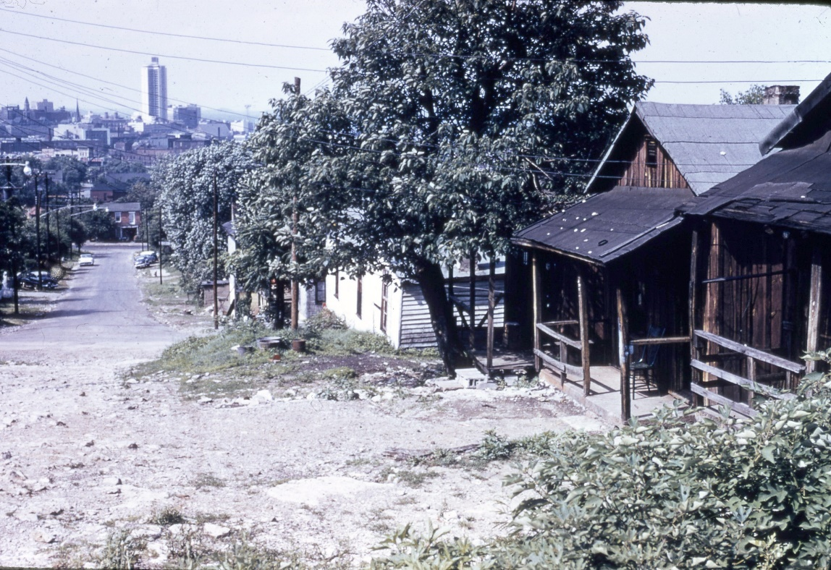
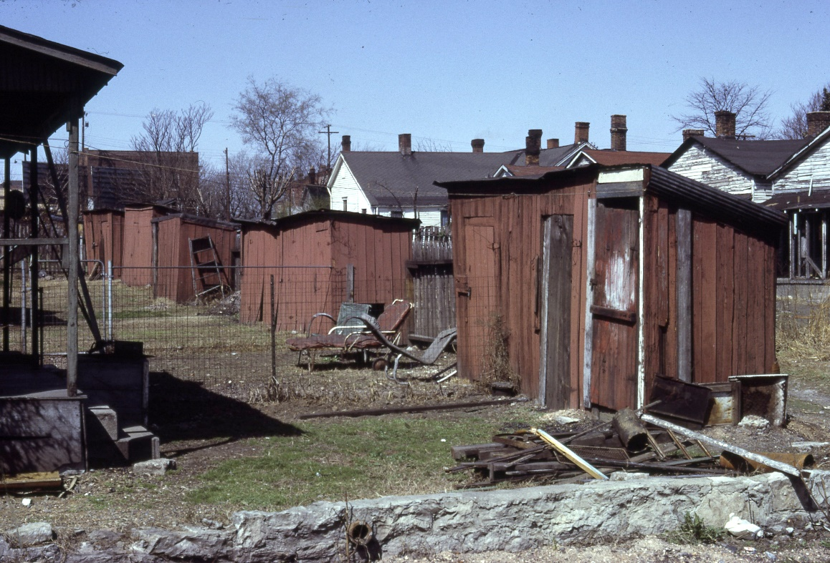
Many streets in the south section of Edgehill remained unpaved, and some dwellings lacked indoor plumbing into the late 1960s (Figures 4-5). The City of Nashville failed to provide the basic utilities to Edgehill that it did in other White neighborhoods. As planners framed urban renewal and city planning as an improvement to the overall “public,” their actions proved that “the public” referred to something less than the entire population of Nashville. In Halifax’s Africville neighborhood, a similar sentiment prevailed. Author Ted Rutland explains that citizens would note that the community would become known for its inconveniences and absence of pavement when they said, “where the road ends, that’s Africville.” Rutland also notes that “improving public convenience did not mean improving the lives of all residents. It required, in fact, that a boundary be drawn, and that some resident’s lives be purposely left unserved, inconvenient, and less than agreeable.”
Figure 4. An unpaved section in Edgehill, 1965
Source: Metro Nashville Archives.
Figure 5. Privies in Edgehill, 1966
Source: Metro Nashville Archives.
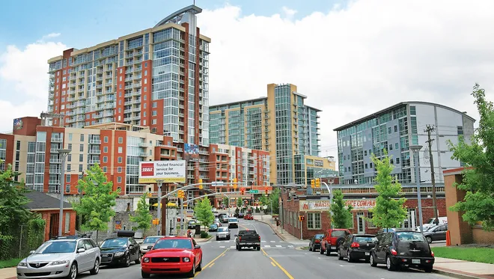
In Halifax, the 1915 city plan “sealed off any infrastructure improvements that the city might eventually have considered appropriate, while they were provided to the semicircle of residential communities” on Africville’s perimeter. In Nashville, the neighboring areas along 8th Avenue, Music Row, and Hillsboro Village received the attention of planners, thriving during a period of widespread change and renewal. In the 21st century, two neighborhoods bordering Edgehill, the Gulch and 12south, became some of the most expensive real estate in the entire city, largely due to the city’s thoughtful planning and economic development programs.
Figure 6. The Gulch, north of Edgehill, 2017
Source: The Tennessean.
Before Urban renewal, Edgehill was characterized by through streets that provided access to the commercial areas along South Street and 12th Avenue South. Ninth Avenue South, 10th Avenue South, Overton Street, and 11th Avenue South provided unimpeded access from Olympic Street at the south end to South Street at the north end. Archer Street, Grand Avenue, and Olympic Street allowed for east-west travel from 8th Avenue South to 12th Avenue South (Figure 7).
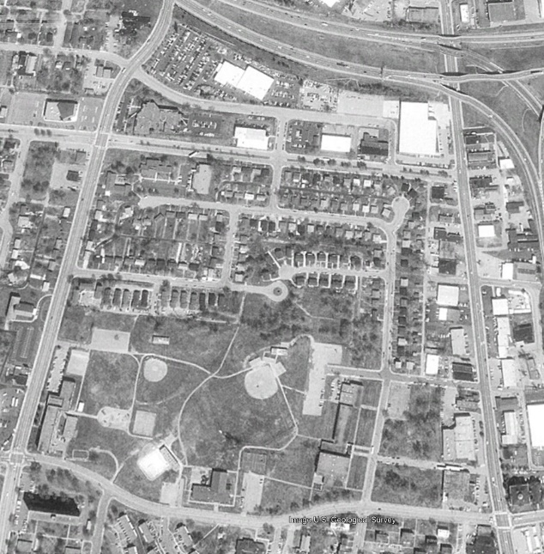
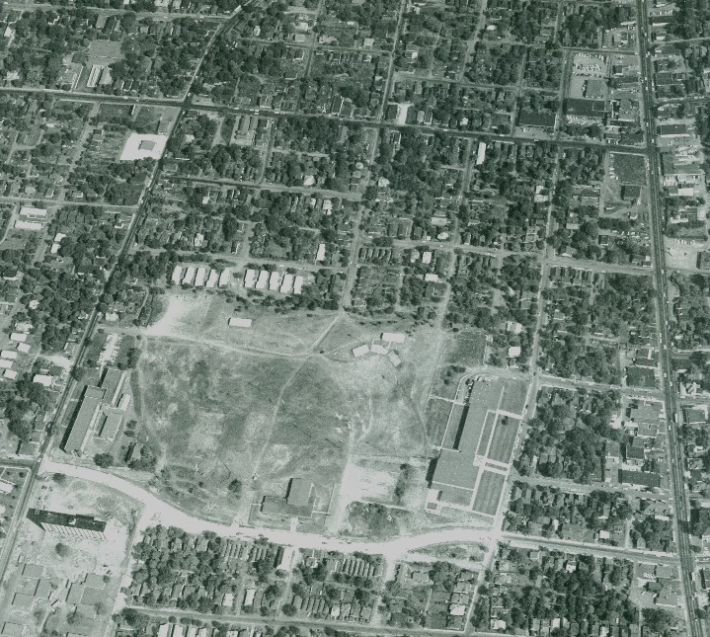
After reconfiguration, the area featured at least six dead-end or truncated streets, a widened South Street containing a median, and large swathes of vacant land designed for commercial use at the north and south ends. All the commercial buildings at the nexus of the business center of 12th Avenue South and South Street were turned into parking lots or empty land.
Figure 7. The east Edgehill area before Urban Renewal in 1966 (left) and after in 1980 (right)
Source: Metro Nashville Archives.
Edward Relph’s concept of sense of place explores “the wide range of connections between people and places that develops based on the place meanings and attachment a person has for a particular setting.” Individuals in Edgehill experienced a specific sense of place in the dense urban environment of the neighborhood. Residents were able to work, shop, and eat within the confines of the 100-block area. Before Nashville began to purchase buildings in the area through eminent domain, South Street was a thriving commercial district. During this time, the corridor featured seven grocery stores, a machine shop, two restaurants, a community center, a filling station, two dry cleaners, and a church. Prominent businesses included the aforementioned Hick’s Grocery, B.F. Martin’s Grocery, and Brown’s Dry Cleaners.
Douglas Boyd uses oral histories to preserve the collective memory of a demolished place in Crawfish Bottom: Recovering a Lost Kentucky Community. He describes Jim Wallace’s 1991 interviews with those who lived in “Craw” as filled with “discussions surrounding public buildings, business establishments, and other physical landmarks.” Interviewee Henrietta Gill described the heart of the neighborhood as “further down, to Mero, where the Tiger Inn was. The Church on Mero, the school on Mero, and at the other end, the groceries on Mero.” The Craw’s segregated schools and Black churches were featured prominently in many of the residents’ oral histories as meaningful institutions that were imprinted within their public memory. Boyd adds that “much of the discussion regarding significant places in the neighborhood included structural entities infused over the years with meaning and memory, a process that transformed buildings made of wood, brick, and mortar into symbolic representations of a living human community.” Using primary source material and first-hand accounts, I’ve woven some of the former fabric that Edgehill was made from back together in this project.
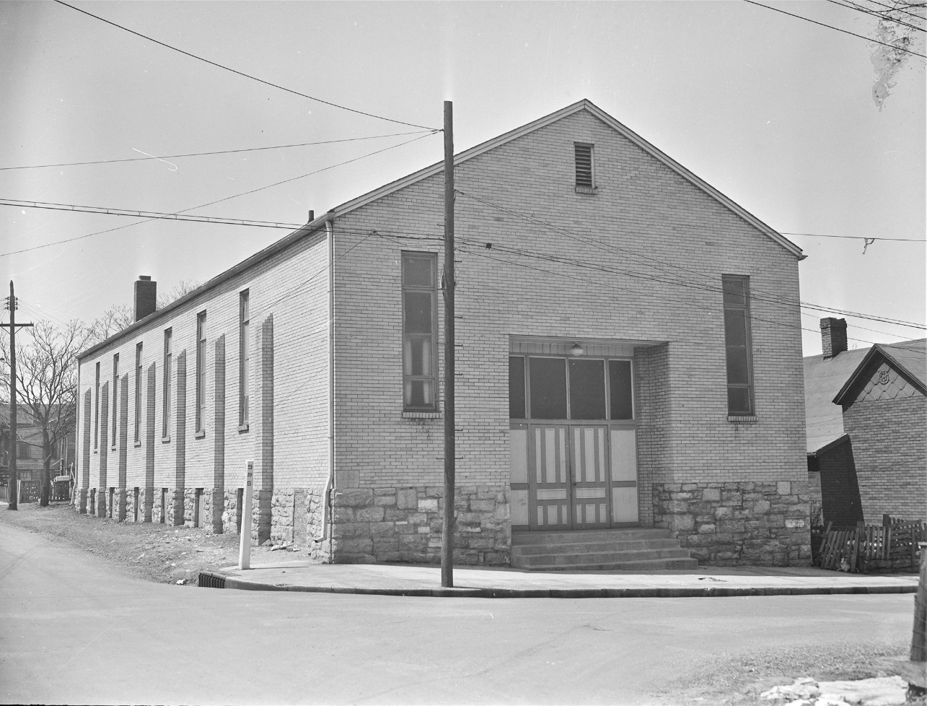
The Crawfish Bottom study also highlights the importance of neighborhood churches to its residents. Multiple residents expressed that “churches played a large role in the Black community.” One resident, James Graham, offered a particularly painful anecdote about the destruction of the Corinthian Baptist Church he attended in the area. “When Urban renewal forced the church to move in 1966, the loss of the organ was a particular blow. The cost estimate to move the “beloved instrument of praise” was $10,000, so the church left it behind.” Interviews of residents in 1991, some 25 years after the loss of their church, remained a “memorable tragedy to the congregation.” The organ was a “powerful symbol of the gross injustices perpetrated on poor people by urban renewal.” In Edgehill, at least four congregations had their buildings destroyed by the city of Nashville between 1960 to 1970, including 2nd Baptist Church at 9th Avenue South and Stevens Street(Figure 8).
Figure 8. 2nd Baptist Church, 1950. Demolished for” improvements” in Edgehill.
Source: Metro Nashville Archives.

Constructed in 1912, The B.F. Martin grocery store was a one-story, brick commercial building at 927 10th Avenue South. Benjamin F. Martin and his wife Mary Martin lived in the home attached to the store until they constructed a four-room frame house at 1011 Archer Street in 1924. The Martin family operated the grocery store until the early 1960s, when the city demolished both the store and house on the lot. In 1968, they listed the grocery store fixtures for sale via an advertisement in the Nashville Tennessean. The B.F. Martin grocery was one of 14 grocery stores in the area that closed during the Edgehill Urban renewal Project.
During the Urban renewal Project, 10th Avenue South was completely erased from the street grid in this area, and this portion of Archer Street was truncated with a cul-de-sac. A small, Ranch-style dwelling was constructed near the site of the grocery in the mid-1970s.
Constructed in 1922, the two-story, brick commercial building at 1037 South Street was at the heart of the Black business district in this area of Edgehill. C.L. Harding opened a grocery store here in 1922, making this one of the earliest Black-owned stores to operate in the area. From 1923 to 1924, a White grocer named E.E. Birchett opened a meat market and grocery in the building. Around 1925, C.R. Sandman took over the building to operate his grocery store. Walter L. Hicks, a Black businessman, entrepreneur, and reverend, opened his grocery store on this site in 1930.
The grocery store was converted into a dry cleaner when Jason Franklin opened his business here in the late 1930s. In 1946, Aaron Brown took over the dry-cleaning business, posting frequent advertisements in the newspaper in search of “wool and silk finishers” and truck drivers. The building was vacant for nearly a decade before being demolished during the Edgehill Urban renewal Project in 1970. The Brown Dry Cleaner mural can be seen on the west side of the building in the archival image from 1966.
During the Urban renewal period, the brick sidewalks were removed and South Street was widened and turned into a "boulevard" with a median. This reconfiguration further distanced South Street from its recent identity. The building at 1037 South Street was one of dozens of Black-owned businesses that were demolished because of the project.
The two-story building at 1104 South Street was constructed circa 1908. A series of residents occupied the space during its first decade of existence, with its most notable use being the Lawrence school annex in 1916. The brick building would not be occupied by a commercial business until 1922, when J.C. Thagard opened a grocery store there. Around 1930, Rena Hicks opened a restaurant in the space, starting a 45-year run of Hicks family-owned businesses that would occupy 1104 South Street.
Walter L. Hicks operated a grocery store and restaurant out of this brick commercial building from 1933 to 1967. The restaurant served "pit barbecue" and purchased several ads in the Tennessean proclaiming, "barbecue eaters and beer drinkers wanted." Hicks was also a reverend who started churches in the surrounding areas. Walter L. Hicks was married to Bernice, who died in 2002 at the age of 102. For most of the twentieth century, the Hicks family lived at their home at 911 Villa Place. Newspaper articles indicate that Hicks and his wife Bernice welcomed many students from rural Perry County to stay in the rental units behind this building on South Street, so they could attend public school in the city and work at Hick’s restaurant.
In 1966, the Metro Development and Housing Authority purchased the property at 1104 South Street as part of the urban renewal project. The buildings were vacant from 1968-70 and were razed sometime around 1970.
These are just a few of the stories surrounding spaces that had meaning to the citizens of Edgehill. To tell a fuller story of the people and places of Edgehill, more in-depth research is needed. This project is the start of a conversation that could lead to further investigation which could include oral histories of residents that once lived in the area.
By 1970, roughly 1,700 of the 2,100 families in the area were relocated, mostly to rental homes in the surrounding areas where they were often forced to crowd two or more families into a single dwelling. Noticing an increased demand for housing, real estate developers began to exploit those who were relocating, charging exorbitant rents and offering fewer amenities. The general trend of loss of housing units due to urban renewal was felt in Nashville.
Psychiatrist Mindy Fullilove writes that “buildings, neighborhoods, cities, nations—are not simply bricks and mortar that provide us shelter. Because we dance in a ballroom, have a parade in a street, make love in a bedroom, and prepare a feast in a kitchen, each of these places becomes imbued with sounds, smells, noises, and feelings of those moments and how we lived them.” Dr. Fullilove coined the term “root shock” to describe the phenomenon of the “traumatic stress reaction to the destruction of all or part of one’s emotional ecosystem.” According to Fullilove, “the cues from place dive under conscious thought and awaken our sinews and bones, where days of our lives have been recorded.” She also argues that people and places can become one through experiences when she says that “buildings, neighborhoods, and nations” are not independent of each other, but more like “Siamese twins, conjoined to the locations of our daily life, such that our emotions flow through places, just as blood flows through two interdependent people.” The people of Edgehill experienced this root shock when their homes and businesses were completely erased.

“All of the neighbors on the block knew each other. We were like one big, happy family.”
Deborah Washington
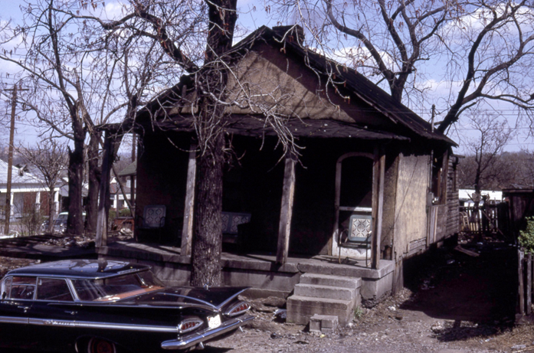
In 1956, Deborah Washington moved into a three-room house at 1004 11th Avenue South with her family (Figure 9). Deborah’s account of her house mentions that there was “no indoor plumbing in any of the houses” along this block of 11th Avenue South. She went on to describe the family’s living situation: “We had a hydrant outside for water and we had an outhouse. Inside the house we used chamber pots. We had a water bucket with a dipper that we would fill and use for drinking water. We had tin wash tubs, foot tubs and wash pans.” At the time, the neighborhood had “lots of grocery stores,” including Mr. Billy Martins store at 10th Avenue South and Archer Street. “Mr. Billy Martin would let families get food on account. My grandmother would send me to his store with a list and no money. He would gather the items, bag them, and send me on my way.”
Figure 9. The Washington home at 1004 11th Avenue South, 1966
Source: Metro Nashville Archives
Deborah recalled that “we loved to go to Clemons’ Pharmacy because he had a soda fountain and he served ice cream and other soda fountain treats. He also had a wide selection of candy in a display case. On the corner of 12th Avenue South and Edgehill, there was a park called Edgehill Park. When we had recess in school, the teachers would take us across the street to play in the park. It was lots of fun. When they filled in the quarry to make Rose Park, they took the land Edgehill Park was on and built the senior citizen high rise.”
Deborah Washington’s personal experience and memories are intertwined with the places where everyday events took place, just like the thousands of families who called Edgehill home. Upon the realization that the family would have to move due to the Urban renewal Project, she wrote that they “did not want to move. We were happy there. Some during that time and a lot of people today do not understand this. They do not understand that you do not need material things to be happy.” Clearly her sense of happiness was tied to her memories of the place she was going to have to leave. When the Washington family was forced to move to the old Edgehill housing project in 1968, only two houses were standing in the old neighborhood. After four years of living in the Edgehill Homes, the Washingtons were given the option to return to the area where their former house was. In 1972, they moved into their new Turnkey home at 1017 Southside Court, which they owned outright in just a few years. “The tree that was in the front yard of our old house was now in the backyard of our new house. They got as close as they could to the spot that the old house was located.”
Douglas Boyd, who chronicled a Black neighborhood that was demolished by urban renewal, argues that areas like “Craw” and Edgehill often had their reputations imposed on them through “narrowly focused newspaper accounts,” when in reality, residents “witnessed the unfolding of everyday life combining in the routine formation of community. They raised their children in Craw; went to work to earn their survival in the craw; passed the time with friends and family in the Craw; worshipped, laughed, loved, and died and mourned together in the Craw.”
Mindi Fullilove writes that “root shock, at the level of the individual, is a profound emotional upheaval that destroys the working model of the world that had existed in the individuals head.” This traumatic process “undermines trust, increases anxiety about letting loved ones out of one’s sight, destabilizes relationships, destroys social, emotional, and financial resources, and increases the risk for every stress-related disease, from depression to heart attack.” Essentially, destroying all traces of a community that a person used to know can even be a determent to your mental and physical health.
After the erasure of the physical community, the Nashville Housing Authority began to plan for what this “new” Edgehill would look like. The result was a culmination of almost a decade of community organizing against a 320-unit public housing project on the north side of Rose Park, which will be discussed in the next section. Ultimately, the large-scale housing project was scrapped in favor of a scattered-site model featuring single-family “Turnkey Homes.”

The Edgehill Area Project Committee’s Fight

In response to the total demolition of their neighborhood, a group of concerned citizens created the Organized Neighbors of Edgehill (ONE) in the Spring of 1966. Edgehill’s residents used the organization to voice their concerns and take action. As one of the first community groups within the city limits, ONE became a valuable tool in reducing crime in the area, advocating for better public schools, and pushing developers to build humane housing for low-income residents.
Another organization, The Edgehill Area Project Committee (PAC), challenged the Nashville Housing Authority regarding its plans for the then vacant land north of Rose Park. As the community awaited news on the proposed development, the committee turned its attention to the lack of amenities that existed in the area post-demolition. In January of 1970, the committee argued that the Nashville Housing Authority should provide free bus service to citizens living in the area effected by urban renewal. The PACs chairman, Charles Pruitt, noted that “people in the Edgehill Urban renewal Area have no place to shop for clothes, food, or anything else.” He added that “all the chain stores and businesses of any size have been displaced by Urban renewal, leaving the citizens in a desperate plight, which the Housing Authority could do much more to alleviate.” Some of the larger stores that were forced to relocate or close following the demolition of the area included Mandell’s Department Store, Neely and Sons Pharmacy, H.G. Hill Grocery, and BIRite Food Store. In a move some would find counterintuitive to business, the remaining grocery owners were advocating that there needed to be more places for community members to shop. Goron Vance, owner of the Service Drive-In Market, said “I am for anything that would develop the area. We don’t have enough stores of sufficient size. Urban renewal has torn down just about everything, and they haven’t put back anything.”
In 1970, John Batson told the Tennessean that residents would make the one-mile walk from Edgehill to his store to get basic groceries. He was concerned about the lack of options for citizens to purchase basic garments, saying that “the closest the residents can buy clothes or shoes is down near 8th Avenue and South Street.” Dr. Hubert Crouch, the Nashville Housing Authority’s (NHA) chairmen claimed that “I don’t think we will be able to provide bus service for residents to go on shopping trips. That would be extremely complicated and Federal regulations would not permit it.”
PAC chairman Pruitt said that “the lack of shopping facilities” was the “number-one complaint” of Edgehill’s citizens. Estimates showed that over 3,000 people lacked access to places to shop for food and clothing, with the heaviest burden placed on the residents of the newly-constructed Gernert Tower for the elderly. Pruitt argued that the NHA had removed valuable resources from the community, and it was their responsibility to provide free bus service for citizens until new amenities were constructed in the area. After seeing housing projects in other areas of the city inundated with new White-owned businesses after Urban renewal, Pruitt was insistent that “the development of shopping facilities in Edgehill be developed and carried out by Black businessmen, with preference going to those who were displaced by Urban renewal. He added that “we would object to NHA allowing White businessmen to come into the area after Urban renewal has taken property from the Black businessmen. We think first choice in any development should be given priority to our own people.”
After seeing their requests fall on deaf ears, the PAC filed an injunction to halt NHA’s housing project in the area in January of 1970. The PAC sought a halt to the project until “NHA provides more housing for displaced residents and until demands by Edgehill citizens are met.” The petition asked “NHA to provide transportation to shopping facilities, conveniently schedule to accommodate the basic weekly grocery needs of site residents.” Metro councilman Mansfield Douglas, whose district included the Edgehill project area, praised the “tremendous amount of participation among project residents to reduce the possibilities of individuals to neutralize and compromise the issues and problems that are a direct result of the urban renewal program.”
Three weeks after filing an injunction, councilman Douglas arranged for a privately-funded bus service for three days. The three-day service was intended to be seen as a model that the NHA could follow eventually. The PAC’s leader, Charles Pruitt, argued that “three-day service won’t accomplish anything.” Mr. Pruitt was adamant that the housing authority “owes it to the community” because of urban renewal. PAC coordinator Sherry Myers said that “they were not going to let the NHA off the hook and promised to “keep the pressure on them or protest” until they get the bus service.
In February of 1970, a fissure began to develop within the Project Area Committee. Empowered by federal law that encouraged citizens to become more involved with Urban renewal projects, the PAC was supposed to be a liaison between the NHA and the citizens of Edgehill. During this time, members of the committee began to question the loyalty of some of the leadership of the PAC. Sherry Myers, coordinator for the PAC, announced her resignation on February 11, 1970. In an impassioned speech against the NHA, Mrs. Myers said that Edgehill was a “colony” being led by the “colonist administration” of the NHA. She added that “the housing authority is a tool being used by rich people to get the land belonging to the poor Black people of Edgehill.”
Even with uncertain leadership, the group soldiered on to better their community. As a next step, the PAC petitioned Secretary George Romney of the Housing and Urban Development Authority with a list of demands. They demanded that the “housing project in Edgehill be discontinued and that all development in the area should be halted, pending reappraisal and replanning.” The petition charged that “areas for the Urban renewal project were drawn to exclude White-occupied areas and that Blacks that were displaced to the surrounding areas have been exploited by real estate speculators.”
In protest against the 320-unit project north of Rose Park to be named project 5-18, the group argued that the proposed site “promoted, concentrated, and intensified racial and socio-economic segregation” of Black people, deprived Black citizens of their property in the area in favor of private, White business interests, displaced families without adequate relocation provisions, and that there were no Black citizens who lived in the area that were involved in the planning of the Urban renewal project or the housing which was to be built.”
As design plans for the area took shape, NHA offered meetings between the Middle Tennessee chapter of the American Institute of Architects and the citizens of Edgehill. Representing the PAC, Aaron Lawson pleaded that “we need help designing and planning a counter-proposal to NHA. Under present plans, we will have 3,500 people living within a four-block area, which will become another ghetto within a few years.” During this meeting, Mrs. Zulee Ursery, an Edgehill resident, gave an impassioned speech that voiced her frustrations. “I came here to look at you, and to aggravate you. I am bitter and angry. Is money so important to you architects that you come into our Black community and act as if you’ve never seen a poor person or Black person before? What we think of the NHA can’t be said here, but you are all just as bad. But there ain’t no way to get rid of us, we’re closer to you than you think. We serve you at the dinner tables, we take your children to the park. We may not be as well educated, but we have feelings, and you need us much as we need you.”
As the year wore on, activists in Edgehill kept true to their mission. By 1971, residents had their sights set on a new idea for the area: single-family homes. The NHA was prepared to offer three alternatives for housing on the site, and the PAC wanted to be involved or they would “prepare and present their own” ideas. Joe Kelso of the PAC stated that “land-use and land ownership are very important to us, we have got to get a slice of the pie.”
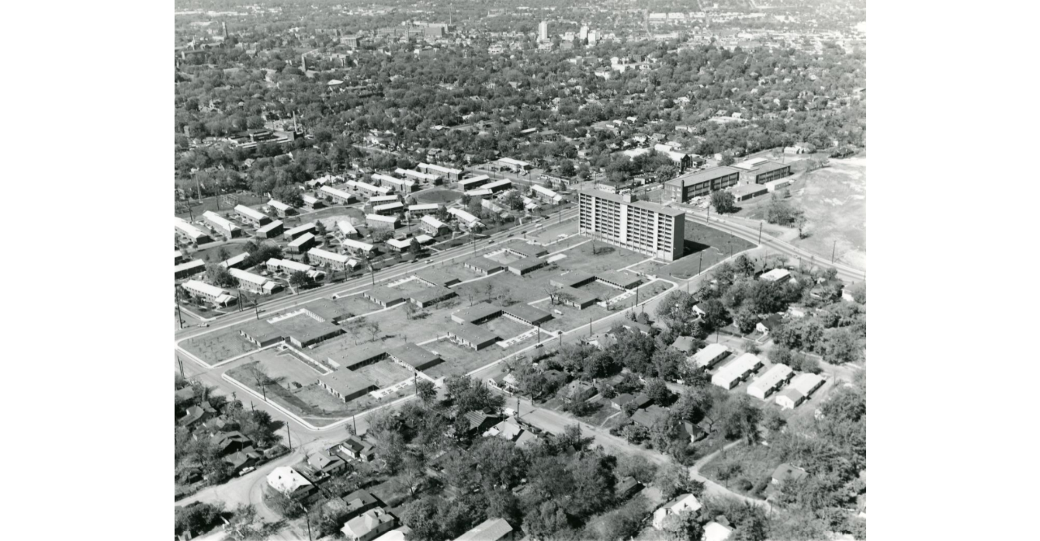
With the assistance of attorneys Avon Williams and Jeffrey Mintz, the citizens of Edgehill filed a lawsuit against the NHA in Federal Court in April 1971. The citizen committee had been fighting development in the area for five years by the time the NHA finally scrapped their plans for a 320-unit project in 1972. As the years passed between the initial plans and the NHA conceding to the citizen group, a new program became available. The Turnkey III program was an attractive option, offering public housing to residents in the form of single-family homes. The residents could build up equity by performing their own maintenance, eventually owing the unit outright. The Turnkey III program finally became available to the NHA in August of 1974, paving the way for 120 single family units in Edgehill instead of the proposed tower and multi-family buildings that had been built in other parts of the city (Figure 10).
Figure 10. What could have been: A high-rise tower and housing projects that was completed in south Edgehill, 1960s.
Source: Metro Nashville Archives

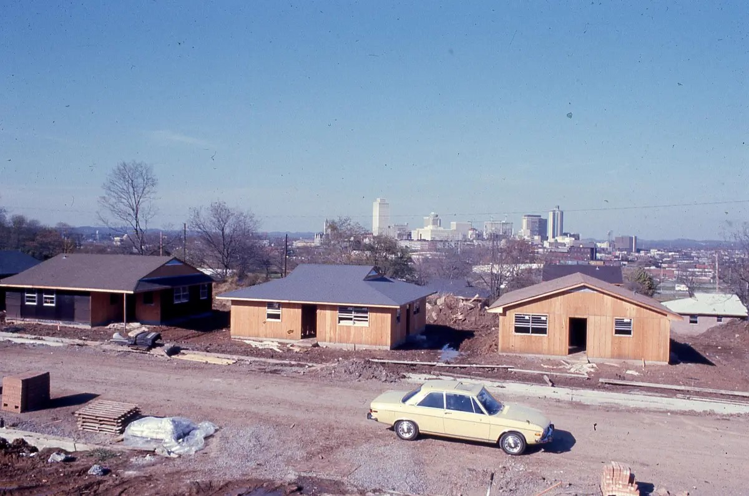
In February of 1976, a nail hammering ceremony was held to commemorate Nashville’s first public single-family housing units. The first round of Turnkey III homes were completed in 1977 on a stretch of 9th Avenue South, south of South Street (Figure 11). The first batch of the four-million-dollar project offered three, four, and five bedrooms homes, with preference going to current residents of public housing, those displaced by Urban renewal projects, and qualified applicants on public housing waiting lists.
Figure 11. Turnkey III homes under construction on Archer Street, mid-1970s.
Source: Nashville Civic Design Center
Over a decade after the initial Urban renewal plans were proposed for Edgehill, success stories began to emerge from the Turnkey homes. The collection of 120 homes, now known as Edgehill Estates, were 99 percent occupied by 1982. Mark Walker, a communications supervisor at St. Thomas Hospital, closed on her Turnkey home in 1982. She said that “I just wanted to own my own home. I was living in an apartment before with seven children. When I was younger, we always had a home.”
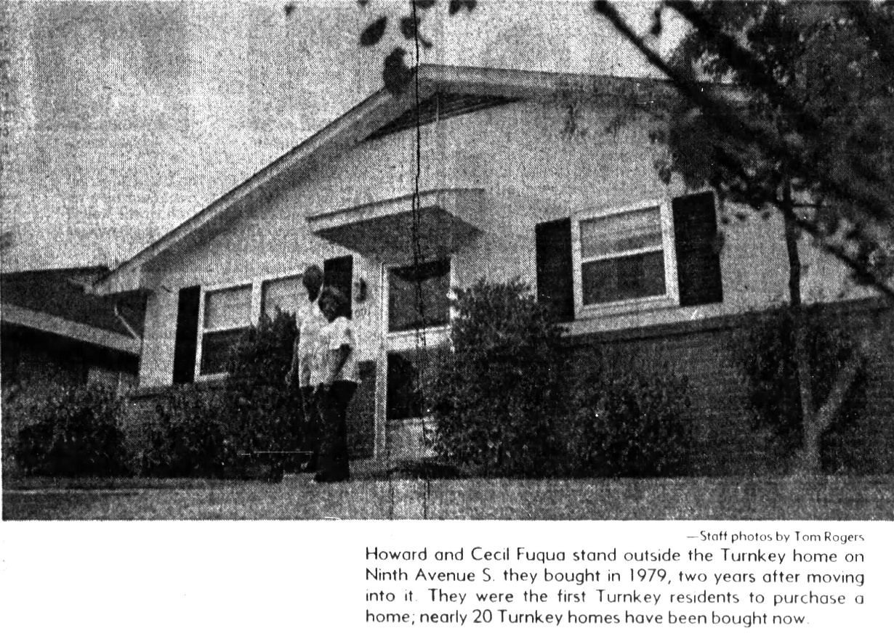
Howard and Cecil Fuqua were some of the first occupants of a Turnkey home in 1977. In 1979, they became the first household to own a home through the program. Having previously lived in public housing for 37 years, the Fuqua family had always wanted to own a home. “We could have bought a home, but instead, we educated our four children.” One day, Metro Nashville erected a retaining wall near the back corner of their property. In response, the Fuquas went to the store and purchased nine rose bushes to cover the wall and fence. The simple act of being able to plant roses on their own property had fulfilled a lifelong dream of home ownership (Figure 12).
Figure 12. The Fuqua family outside of their Turnkey Home, 1979
Source: The Tennessean
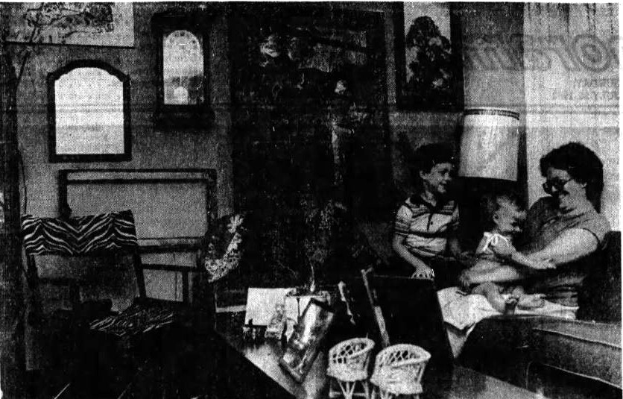
Jay and Melanie Grendell were the first White residents to live in this area of Edgehill since the turn of the century. They had moved to the area in 1977, along with several other White friends. The family said that they “hadn’t really noticed” their “minority status” in the area in the five years they had been in their home. “Hopefully, someday, we will be able to own our home,” they said in a newspaper account from 1982. “Oh boy, a yard for the children, and a chance to get out of all those rent payments,” the Grendells recalled in response to their new place. The Grendell family grew excited at the prospect of personalizing their home, constructing built-in bedframes, bookshelves, and adding wallpaper. Outside, the Grendell’s built a treehouse for their two children, ages five and ten months. Undeterred by the routine maintenance of owning a lot, the family said, “it’s just the yard, which is kind of enjoyable.” When asked if they would move into this home again the family responded “yes, this is our home” (Figure 13).
Figure 13. Melanie Grendell with her sons Brandon, 5 and Brooke, 10 months, inside their Turnkey home, 1982.
Source: The Tennessean
Some Edgehill residents who were able to purchase their homes through the Turnkey program were able to reap significant financial benefits if they sold during Nashville’s 21st-century era of gentrification. Starting around 2015, developers began to target the area, hoping to cash in on Nashville’s growth and demand for modern, high-end housing. In 2017, members of the Fuqua family sold their Turnkey home for $526,000 to a developer. Having purchased the home for around $30,000 in 1979, this windfall was life changing for the family. Real estate records show that many of the Turnkey homes sold for between $400,000 and $600,000 from 2014 to 2023. According to the Federal Reserve Bank of St. Louis, the racial wealth gap in the United States is stark. For every one dollar of wealth a White family holds, a Black family had just 25 cents in 2022. Home ownership can be a key indicator of wealth, with only 44 percent of Black Americans owning a home versus close to 74 percent of White Americans. The Turnkey homes were the first step in securing generational wealth for the citizens of Edgehill.

Hyper Gentrification in “South Gulch”

Gentrification has been a common thread in the history of Edgehill. During two of the three distinct eras, residents, buildings, and their stories have been replaced with something new that some would argue was “better.” During Urban renewal, thousands of residents were displaced, the buildings were razed, and those who could qualify for the Turnkey III program replaced them. During the last decade, developers have purchased Turnkey III homes from families that were part of the program and built multi-million-dollar, modern mansions in their place. The Turnkey homes left in the area are the exception, not the rule, as the neighborhood has become one of the most expensive near the downtown. In many ways, the demolition of the Turnkey III homes parallels the razing of the “substandard slums” during Urban renewal. A new generation has deemed that these homes are not fit to live in, and that they should just be demolished. Most of the Turnkey homes were well-maintained and featured most of their original elements. In 2027, the first batch of Turnkey homes will be eligible for the National Register of Historic Places, but will Nashville residents be interested in preserving them? It seems unlikely.
The Turnkey years offer an opportunity to study the citizens that occupied them. Those who were able to move into Turnkey Homes and purchase them were distinct in the history of public housing in Nashville and beyond. Extensive research should be done regarding those who moved from large-scale public housing into the Turnkey III homes and were able to become homeowners, and eventually sell to acquire wealth. The stories of those remaining in the original Turnkey III homes have value as well. As of this report, there are approximately 25 Turnkey III homes remaining in Edgehill. Further study of the area could reveal why those people have stayed, and why developers and new residents have sought out the area now.
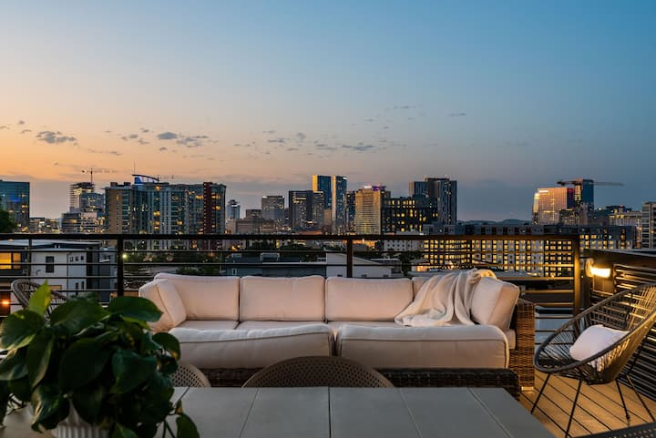
Author Dennis Gale argues that America’s “comeback metros” have all experienced significant levels of gentrification. He highlights several coastal cities, noting that many of them have developed global economies. Gale mentions that “cities such as Nashville and Austin have developed distinctive identities as the nation’s commercial music capitals, drawing musicians, recording companies, and millions of tourists. In 2022, a report concluded that tourist spending in Davidson County generated nearly $10 billion that year, a 35% increase from 2021. This number equates to roughly $27 million per day in Nashville. A quick search on the short-term rental site Airbnb.com reveals that the Edgehill area has at least 15 tourist rentals listed in the area, with prices ranging from around $130 to $675 per night. These rentals have not only displaced former residents, but they have also created few residential units for those who actually want to live within the city limits.
Figure 14. A luxury "VIP" Short Term Rental in Edgehill, 2024
Source: Airbnb.com
In the past decade, a new neighborhood has been created in the area. What was once small single-family homes has given way to two- and three-story mansions that tower over the original Turnkey homes. As of this study, the least expensive single-family home in the area is listed at $1.2 million. This process has been repeated in many American cities, as Americans move closer to downtown areas and physically change the landscape by demolishing older homes and building larger ones in their place. Will there be a sense of community in this new place? DiGregorio writes that “the longer one resides in an area, the more time one has to build
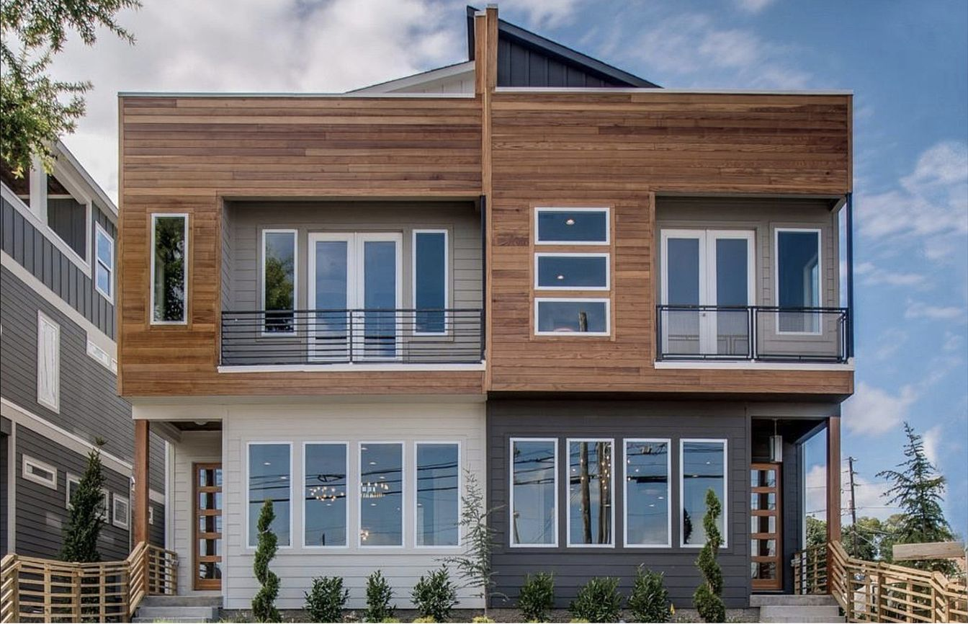
connections to the area and as one gets older, one also has more time to form connections to the area around them.” This is essentially saying that only time will tell if the new residents of Edgehill will feel a strong connection to the neighborhood. He also notes that “being more educated, married, and having children all provide more social spheres that one may form connections in, allowing for increased group cohesion.” Statistically, we know that the new Edgehill residents are highly-educated, but the other factors are unknown. The “new” Edgehill has all the makings of a neighborhood that could have a strong sense of place in the future with dense, modern development, highly educated residents, and semi-cohesive architecture that contributes to a sense of place. It could also be argued that the new Edgehill is set up to become an area of “placelessness.” These large, tall and skinny homes have been constructed throughout the city in the past decade, creating a uniform modern look that would fit in any neighborhood here. The topography, streetscape, and location make Edgehill an interesting study for the sense of place theory. Only time will tell if it emerges as a location with a rich sense of place.
Figure 15. 939 South Street. Sold for $.1.175 Million on 5/19/2022.
Source: Zillow.com

CHAPTER IV: CONCLUSIONS AND SUGGESTIONS FOR FUTURE PROJECTS

This chapter will offer some conclusions and share my experiences while working on the project. As a White historian who does not live in the area, I feel like it’s inappropriate for me to claim to tell a full story of Edgehill. Instead, I have studied this area because I was lucky enough to have primary and secondary resources available to me, access to a photo collection, and knowledge of the broad patterns of United States and Nashville history. I hope that the information shared in the social media postings will lead to a better understanding of the history of this area of Edgehill and the people that shaped it.

Why This Matters

Virginia Hamilton, the author of If People Could Fly, wrote “that storytelling was the first opportunity for Black folks to represent themselves as anything other than property.” The late Civil Rights leader John Lewis said, “the movement without storytelling, is like birds without wings.” As a White historian, it’s important for me to amplify voices that have not been heard, even as I wonder if it is my story to tell. This framework paper offers a small glimpse into the stories of some of the people and places that made up the Edgehill neighborhood during a specific time. This is not a complete history, but the start of a larger conversation about telling stories that have not been highlighted for a variety of reasons. Highlighting Black stories is more important than it ever has been. Telling the story of Edgehill’s urban renewal is important because it pushes the memory of these places and people into the future.
“As of November 1, 2022, 16 states had passed laws restricting the ability of educators to talk about race and racism in the curriculum. In 2019, only one state had such a law. All 16 states provide details of the specific concepts that cannot be taught; five states explicitly prohibit teaching “critical race theory.” In 2023, Florida Governor Ron DeSantis’ administration “banned an Advanced Placement class on African American studies, released new social studies standards that require some students to learn that enslaved people enjoyed “personal benefit” from skills they developed, and censored math and social textbooks and other materials.” Sterling Johnson writes that “these teachings subvert dominant paradigms of Black inferiority and helps ground Black students in their own sense of self. Black history integration in U.S. history can encourage equity in schools, as it shows that U.S. society cares about Black history and Black people’s humanity. It may be a significant symbolic step toward reaching racial equity in all policies.”
Doctor Mindy Thompson Fullilove offers us some solutions for communities that have been uprooted and experienced the trauma of “root shock.” She writes that we must “acknowledge that root shock exists, strive to create connections within our communities, actively engage in community-building initiatives, create inclusive spaces, support local organizations and businesses, and prioritize our mental health and well-being.” Incorporating these practices into our daily lives can “create more resilient communities, combat root shock, and promote social and spatial justice.”

Conclusions and Social Media Recommendations

Author Amy Jo Martins says that social media is “a dialogue, not a monologue, and some people don’t understand that. Social media is more like a telephone than a television.” With this project, my goal was to start a dialogue surrounding erasure, agency, and gentrification using the lens of Edgehill’s history. I am hoping that this before and after convention that I used with the built environment of Edgehill could be repeated in other neighborhoods who have experienced total demolition so that their stories will not be forgotten. Benjamin F. Martin, Mary Martin, C.L. Harding, Walter L. Hicks, Jason Franklin, Aaron Brown, J.C. Thagard , Rena Hicks , Deborah Washinton, Mr. Billy Martin , Charles Pruitt, Goron Vance, Mansfield Douglas, Sherry Myers, Zulee Ursery, Joe Kelso, Mark Walker, Cecil Fuqua, and Jay and Melanie Grendell should not be forgotten.
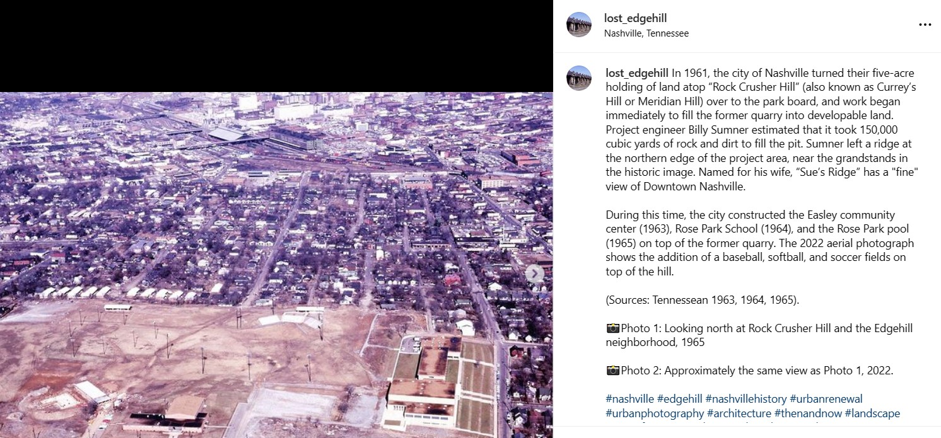
As of November 2023, the Lost Edgehill Instagram page has 268 followers and the Facebook page has 100 followers. Examples of some of the posts can be viewed below.
Instagram Post, September 28, 2023
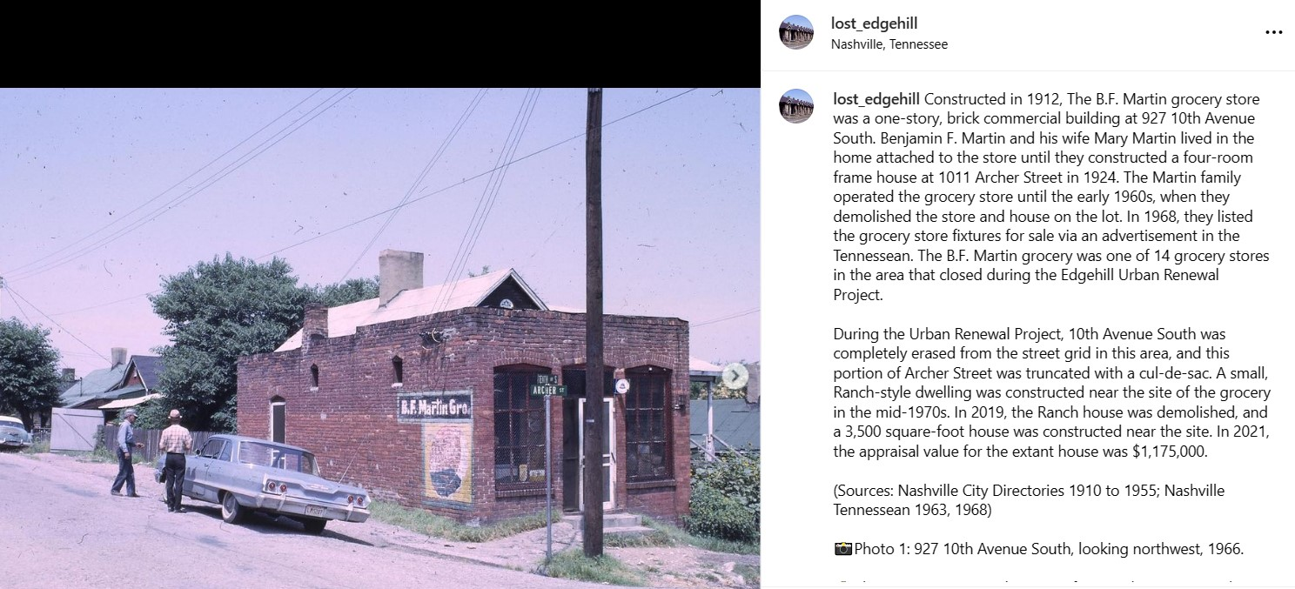
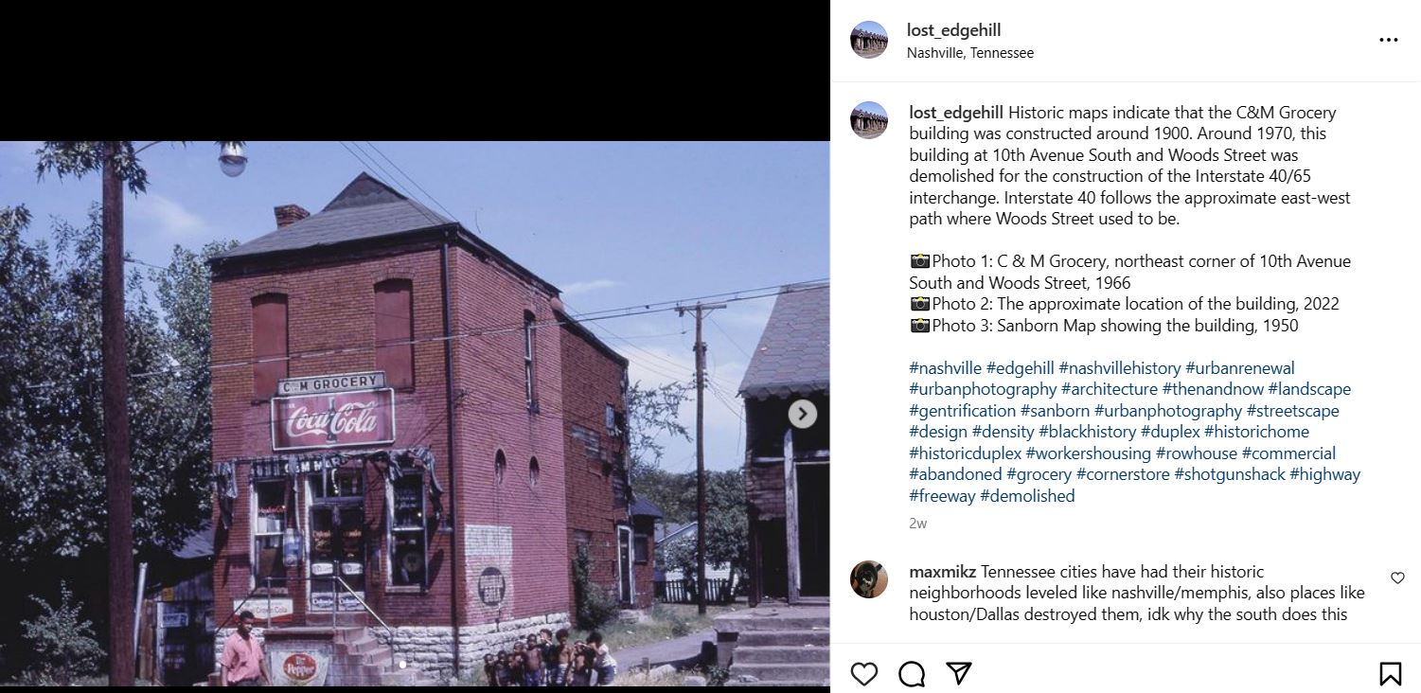
Instagram Post, September 25, 2023
Instagram Post, November 9, 2023
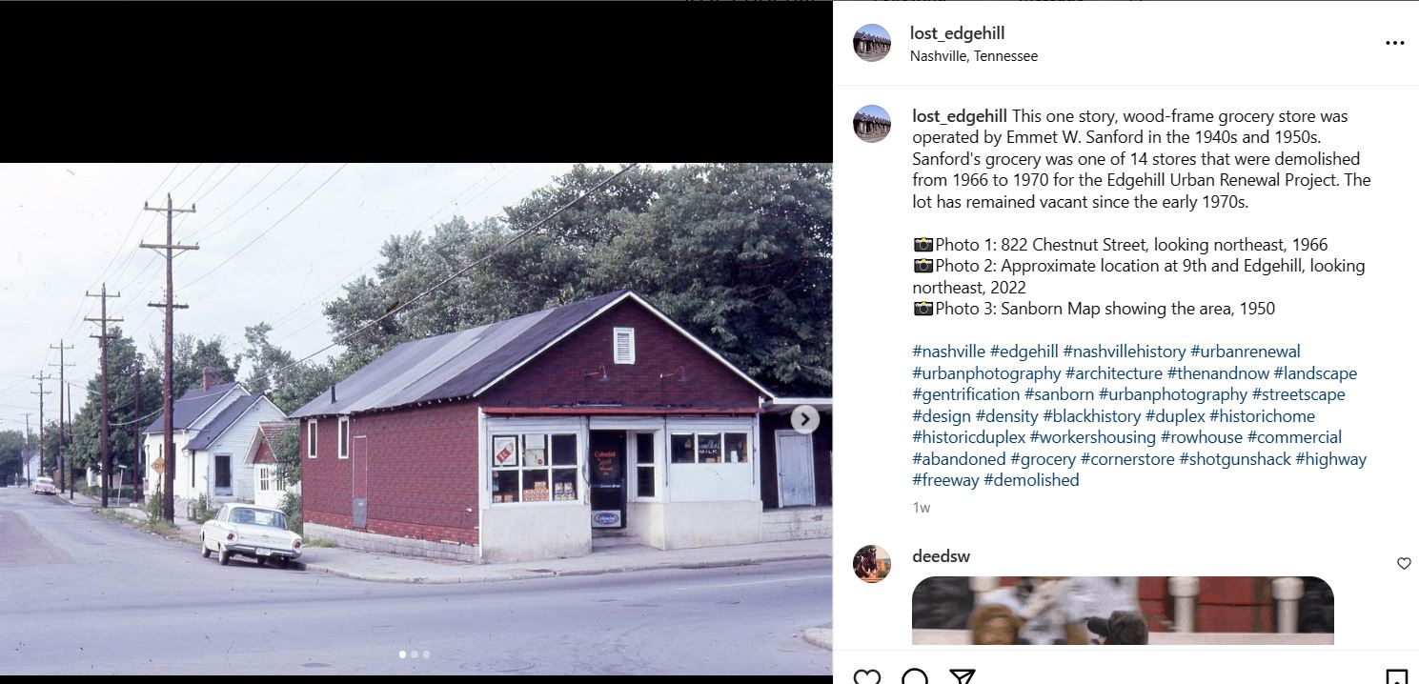
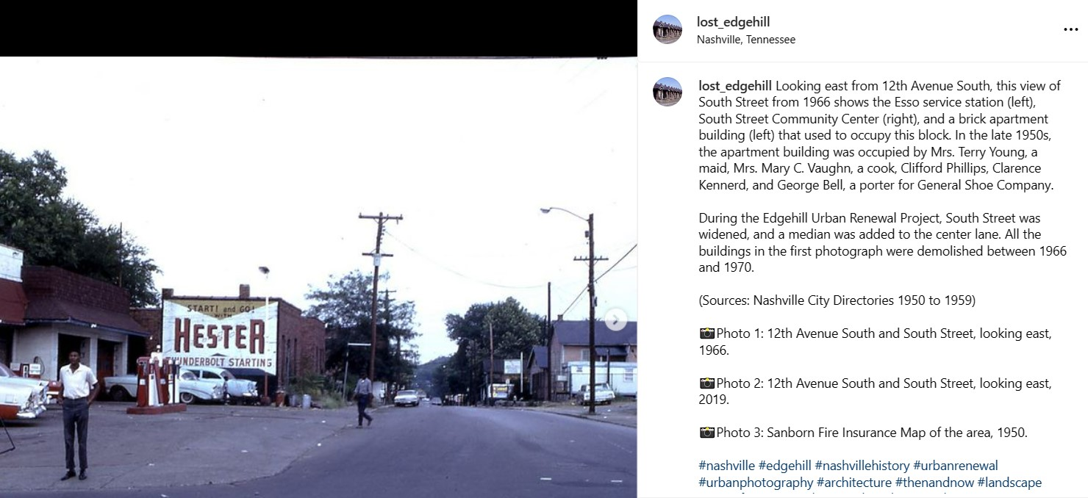
Instagram Post, October 20, 2023
Instagram Post, November 20, 2023
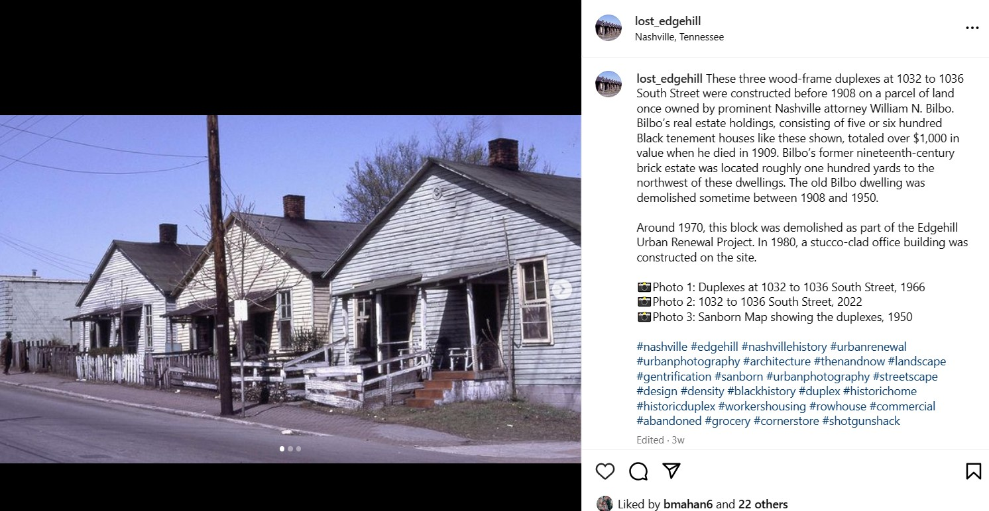
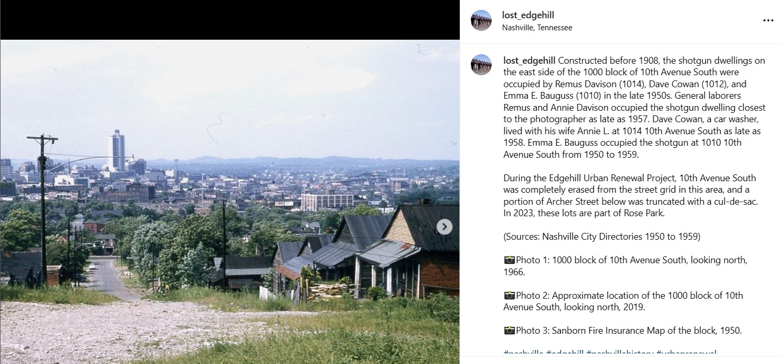
After posting for three months, certain things became apparent. Some of the broader, aerial views of the area seemed to generate the most responses and shares. If I could start the project over, I would have started a “teaser” campaign months in advance of the project. However, I wanted to make sure to not use all my content before the actual project began.
Instagram Post, October 12, 2023
Instagram Post, November 3, 2023
Secondly, I would have educated myself more on how to use social media in the most effective way. According to research, four in ten Americans use Instagram, while seven in ten ages 18 to 29 use the platform. My goal was to appeal to younger Americans, and Instagram is the place I should have focused on. According to Social Pilot, the best times to post to social media are before and after work hours and during lunch time. The worst times to post are on the weekends. Other social media projects should involve more “scheduled” posts at specific times of the day.
Ultimately, I’m happy that these previously unseen images will live on the internet in perpetuity. I’m also proud that they will be accompanied with well-researched contexts that place them in a time and place in a neighborhood that was leveled in the name of urban renwal. This project will keep this part of Edgehill alive for the next generation to discover. Although the landscape has been demolished, the memory of this place can now live on.

BIBLIOGRAPHY

Airbnb Nashville listings. 2024
Anoob, P.T. “When Is the Best Time to Post on Instagram in 2024?.” Accessed December 11, 2024. https://www.socialpilot.co/blog/best-time-to-post-on-instagram#:~:text=Based%20on%20our%20study%2C%20we,%3A%20Well%2C%20that%27s%20not%20suprising
Bell, Natalie. “Lost: South Nashville.” Accessed February 10, 2024. https://aahgsnashville.org/author/natbellus/.
Beyer, Scott. “How the U.S. Government Destroyed Black Neighborhoods.” Accessed February 14, 2024. https://catalyst.independent.org/2020/04/02/how-the-u-s-government-destroyed-black-neighborhoods/
Boyd, Doulgas. Crawfish Bottom: Recovering a Lost Kentucky Community. Lexington, Kentucky: University of Kentucky Press, 2013.
Carey, Bill. “A City Swept Clean.” Accessed September 14, 2023. https://www.nashvillescene.com/news/a-city-swept-clean/article_6c3a1c80-ea61-57be-b973-03cad5a6506b.html
Collier, Andrea, “Why Telling Our Own Story Is So Powerful for Black Americans.” Accessed September 22, 2023. https://greatergood.berkeley.edu/article/item/why_telling_our_own_story_is_so_powerful_for_black_americans#:~:text=It%27s%20the%20way%20we%20witness.as%20anything%20other%20than%20property
Cowell, Craven. “Edgehill Project Halt Asked.” The Tennessean. February 24, 1970.
Cozzi, Lauren. “More Americans Own Their Homes. but Black-White Homeownership Rate Gap is Biggest in a Decade. NAR Report Finds.” Accessed September 23, 2024. https://www.nar.realtor/newsroom/more-americans-own-their-homes-but-black-white-homeownership-rate-gap-is-biggest-in-a-decade-nar#:~:text=While%20the%20U.S.%20homeownership%20rate.rate%20gap%20in%20a%20decade
Crowell, Craven. “Halt Asked to Renewal in Edgehill. The Tennessean. February 24, 1970.
Davidson County Register of Deeds. 2016,2016, 2017.
Digregorio, Bernard. “The Effects of Gentrification on Residents’ Sense of Place and Group Cohesion: A Study of Pittsburgh Neighborhoods.” Graduate Thesis. Accessed September 10, 2024. https://researchrepository.wvu.edu/etd/7733
Edmondson, Carolyn. “Public Housing Residents Given Ownership Option.” The Tennessean June 26, 1985.
Fullilove, Mindy Thompson. Root Shock: How Tearing Up City Neighborhoods Hurts America. And What We Can Do About It. New York, New York: Village Press, 2016
Gale, Dennis. The Misunderstood History of Gentrification: People, Planning, Preservation, and Urban Renewal, 1915-2020. Philadelphia Pennsylvania: Temple University Press, 2021.
Gillem, Tom. “NHA Program Halt Sought.” The Tennessean. January 6, 1970.
Hall, Doug. “Free 3-Day Bus Service Arranged for Edgehill.” The Tennessean. January 24, 1970.
Hall, Lawrence. “Black Erasure.” Accessed February 10, 2024. https://www.lawrencehall.org/blog/brave-conversations-black-erasure/#:~:text=What%20is%20Black%20erasure%3F.and%20contribution%20to%20the%20culture
Hieronymus, Clara. “Architects Get Earful on Housing Needs.” The Tennessean. June 18, 1970.
Ingram, Tom. “Edgehill PAC Seeking Role in Planning Future Housing.” The Tennessean. July 8, 1971.
Ingram, Tom. “Scattered Project Reactions Mixed.” The Tennessean. July 26, 1972.
Johnson, Sterling. “Legislating Black History.” Accessed November 11, 2023. https://blog.petrieflom.law.harvard.edu/2023/04/10/legislating-black-history/
Knueven, Liz. “The barriers Black families face in building generational wealth.” Accessed December 22, 2024. https://www.cnbc.com/select/3-barriers-to-building-generational-wealth-for-black-families/
Lambert, Emily. “What is the Key to Gentrification?” Accessed September 12, 2023. https://www.chicagobooth.edu/review/what-is-the-key-to-gentrification
Malquist, Mats. “Community agency and empowerment—a need for new perspectives and deepened understanding.” Accessed November 10, 2023. https://www.tandfonline.com/doi/full/10.1080/03009734.2018.1474303
Marshall-Bruce-Polk Company. Nashville City Directories. Nashville, Tennessee, 1910 to 1950.
Nashville Civic Design Center. “Edgehill Neighborhood Study.” Accessed October 10, 2023. https://issuu.com/civicdesigncenter/docs/edgehill_book
Nashville Housing Authority. Nashville Housing Authority Annual Report. 1953.
Nashville Housing Authority. Nashville Housing Authority Annual Report. 1954.
Pfau, Ann David Hochfelder, and Stacy Sewell. “Urban Renewal.” Accessed March 20, 2024. https://inclusivehistorian.com/urban-renewal/#:~:text=Urban%20renewal%20is%20the%20process,HUD)%20grant%20and%20loan%20program
Rajala, Kiandra, Michael G. Sorice and Valerie A. Thomas. “The Meaning(s) of Place: Identifying the Structure of Sense of Place Across a Social–ecological Landscape.” Accessed December 2, 2023. https://besjournals.onlinelibrary.wiley.com/doi/full/10.1002%2Fpan3.10112
Ritter, Frank. “Edgehill Area Project Chairman Refuses to Resign.” The Tennessean. February 12, 1970.
Rogers, Tom. “The American Dream: It’s Alive and Well in South Nashville.” The Tennessean. July 25. 1982.
Rutland, Ted. Displacing Blackness: Planning, Power, and Race in Twentieth Century Halifax. Toronto, Ontario: University of Toronto Press, 2018.
Schaffer, Katherine. “7 Facts about Americans and Instagram.” Accessed January 10, 2024. https://www.pewresearch.org/short-reads/2021/10/07/7-facts-about-americans-and-instagram/
Schwab, Katharine. “The Racist Roots of Urban Renewal and How it Made Cities Less Equal.” Accessed January 20, 2024. https://www.fastcompany.com/90155955/the-racist-roots-of-urban-renewal-and-how-it-made-cities-less-equal#:~:text=But%20the%20federal%20policy%20of.million%20people%20from%20their%20homes
Severson, Kim. “Nashville’s Next Big Hit Could Be The City Itself.” The New York Times. January 8, 2013.
Sloan, Tony. “Tourism in Davidson County sets $10 billion record for visitor spending in new Economic Impact report.” Accessed September 1, 2024. https://www.newschannel5.com/news/tourism-in-davidson-county-sets-10-billion-record-for-visitor-spending-in-new-economic-impact-report.
Squires, Jim. “NHA to Build 4 Housing Projects.” The Tennessean. October 7, 1965.
Strauss, Valerie. “The irony of Black history legislation in Florida.” Accessed December 16, 2023. https://www.washingtonpost.com/education/2023/08/17/irony-black-history-legislation-florida/
The Nashville Housing Authority. Nashville Housing Authority Annual Report. 1959.
The Tennessean. “Barbeque Eaters and Beer Drinkers Wanted at Hicks New Pit and Roof Garden.” May 12, 1934.
The Tennessean. “Free Edgehill Bus Service Asked.” January 2, 1970.
The Tennessean. “Home Finishing by July Slated.” February 28, 1976.
The Tennessean. “Housing Program Certified.” August 8, 1974.
The Tennessean. “MDHA Starting New Housing Aid Program.” March 29, 1976.
The Tennessean. “The American Dream: Its Alive and Well in Nashville.” July 25, 1982.
United States Department of Housing and Urban Development. “Turnkey III Homeownership Opportunities for Indian Families.” Accessed September 22, 2023. https://www.hud.gov/programdescription/turnkey3
Urban Displacement Project. “What are Gentrification and Displacement.” Accessed October 15, 2024. https://www.urbandisplacement.org/about/what-are-gentrification-and-displacement/
Walker, Hugh. “From Gravel Pit to Ping Pong on Rock Crusher Hill. The Tennessean. November 28, 1965.
Ward, Getahn. “Health Care Consulting Firm to Create 200 Jobs.” The Tennessean. November 4, 2016.
Zillow.com 2023.
Zillow.com 2024.

Ann Pfau, David Hochfelder, and Stacy Sewell, “Urban Renewal,” accessed March 20, 2024, https://inclusivehistorian.com/urban-renewal/#:~:text=Urban%20renewal%20is%20the%20process,HUD)%20grant%20and%20loan%20program.
Katharine Schwab, “The Racist Roots of Urban Renewal and How it Made Cities Less Equal, accessed January 20, 2024, https://www.fastcompany.com/90155955/the-racist-roots-of-urban-renewal-and-how-it-made-cities-less-equal#:~:text=But%20the%20federal%20policy%20of,million%20people%20from%20their%20homes.
Scott Beyer, “How the U.S. Government Destroyed Black Neighborhoods,” accessed February 14, 2024, https://catalyst.independent.org/2020/04/02/how-the-u-s-government-destroyed-black-neighborhoods/.
Midy Thompson Fullilove, “Root Shock: How Tearing Up City Neighborhoods Hurts America, And What We Can Do About It,” (New York: New Village Press, 2016)
Nashville Housing Authority, “Nashville Housing Authority Annual Report,” 1953:10.
Ibid
Ibid
Ted Rutland, Displacing Blackness: Planning, Power, and Race in Twentieth Century Halifax, (Toronto: University of Toronto Press, 2018). 75.
Nashville Housing Authority, Nashville Housing Authority Annual Report, 1954:2.
Ibid
Lawrence Hall, “Black Erasure,” accessed February 10, 2024, https://www.lawrencehall.org/blog/brave-conversations-black-erasure/#:~:text=What%20is%20Black%20erasure%3F,and%20contribution%20to%20the%20culture.
Mats Malquist, “Community agency and empowerment—a need for new perspectives and deepened understanding,” accessed November 10, 2023, https://www.tandfonline.com/doi/full/10.1080/03009734.2018.1474303.
Ibid
Hugh Walker “From Gravel Pit to Ping Pong on Rock Crusher Hill, Tennessean, November 28, 1965:17.
Beyer, 2020
Urban Displacement Project, “What are Gentrification and Displacement,” accessed October 15, 2024, https://www.urbandisplacement.org/about/what-are-gentrification-and-displacement/.
Ibid
Emily Lambert, “What is the Key to Gentrification?” accessed September 12, 2023, https://www.chicagobooth.edu/review/what-is-the-key-to-gentrification.
Nashville Civic Design Center, “Edgehill Neighborhood Study,” accessed October 10, 2023, https://issuu.com/civicdesigncenter/docs/edgehill_book.
Ibid
Nashville City Directories 1910 to 1950.
Ibid
Ibid
Bill Carey, “A City Swept Clean,” accessed September 14, 2023, https://www.nashvillescene.com/news/a-city-swept-clean/article_6c3a1c80-ea61-57be-b973-03cad5a6506b.html.
Ibid
Tom Ingram, “Scattered Project Reactions Mixed,” The Tennessean, July 26, 1972.
The Tennessean “Housing Program Certified” August 8, 1974.
The Tennessean, “Home Finishing by July Slated,” February 28, 1976.
Ibid
United States Department of Housing and Urban Development, “Turnkey III Homeownership Opportunities for Indian Families.” Accessed September 22, 2023, https://www.hud.gov/programdescription/turnkey3.
The Tennessean, “The American Dream: Its Alive and Well in Nashville,” July 25, 1982:84.
Carolyn Edmondson, “Public Housing Residents Given Ownership Option,” The Tennessean June 26, 1985:55.
Getahn Ward, “Health Care Consulting Firm to Create 200 Jobs,” The Tennessean, November 4, 2016:D1.
Kim Severson, “Nashville’s Next Big Hit Could Be The City Itself,” The New York Times, January 8, 2013.
Denis Gale, The Misunderstood History of Gentrification: People, Planning, Preservation, and Urban Renewal, 1915-2020, (Philadelphia: Temple University Press, 2021:187.
Davidson County Register of Deeds, 2016.
Dennis Gale, 187
Davidson County Register of Deeds, 2015, 2016.
Zillow, 2023.
Jim Squires, “NHA to Build 4 Housing Projects, The Tennessean, October 7, 1965:77.
Nashville Housing Authority Annual Report, 1953.
Mindy Thompson Fullilove, Root Shock: How Tearing Up City Neighborhoods Hurts America, And What We Can Do About It, (New York: New Village Press, 2016:58).
Fullilove, 59.
Ibid.
The Nashville Housing Authority, Nashville Housing Authority Annual Report, 1959.
Rutland, 88.
Ibid
Rutland, 101.
Kiandra Rajala, Michael G. Sorice, Valerie A. Thomas, “The Meaning(s) of Place: Identifying the Structure of Sense of Place Across a Social–ecological Landscape,” accessed December 2, 2023, https://besjournals.onlinelibrary.wiley.com/doi/full/10.1002%2Fpan3.10112.
Douglas A. Boyd, Crawfish Bottom: Recovering a Lost Kentucky Community, (Lexington: University of Kentucky Press, 2013.
Boyd, 92-93
The Tennessean, “Barbeque Eaters and Beer Drinkers Wanted at Hicks New Pit and Roof Garden.” May 12, 1934.
Craven Cowell, “Edgehill Project Halt Asked,” The Tennessean 1970, Feb 24, 1970:1
Fullilove, 11
Ibid
Ibid
Ibid
Natalie Bell, “Lost: South Nashville,” accessed February 10, 2024, https://aahgsnashville.org/author/natbellus/.
Ibid
Ibid
Ibid
Ibid
Ibid
Boyd, 5
Fullilove, 14
Nashville Civic Design Center, 11
The Tennessean, “Free Edgehill Bus Service Asked,” January 2, 1970.
Ibid
Ibid
Ibid
Ibid
Ibid
Ibid
Tom Gillem, “NHA Program Halt Sought,” Tennessean January 6, 1970.
Ibid.
Ibid.
Doug Hall, “Free 3-Day Bus Service Arranged for Edgehill,” Tennessean, January 24, 1970: 5.
Frank Ritter, “Edgehill Area Project Chairman Refuses to Resign, February 12, 1970:47.
Craven Crowell, “Halt Asked to Renewal in Edgehill, February 24, 1970:1.
Ibid
Ibid
Clara Hieronymus, “Architects Get Earful on Housing Needs,” Tennessean, June 18, 1970:34.
Ibid
Tom Ingram, “Edgehill PAC Seeking Role in Planning Future Housing,” Tennessean, July 8, 1971:43.
The Tennessean, “MDHA Starting New Housing Aid Program,” March 29, 1976:18.
Tom Rogers, “The American Dream: It’s Alive and Well in South Nashville,” July 25, 1982:84.
Ibid
Davidson County Register of Deeds, 2017
Liz Knueven, “The barriers Black families face in building generational wealth,” accessed December 22, 2024, https://www.cnbc.com/select/3-barriers-to-building-generational-wealth-for-black-families/.
Lauren Cozzi, “More Americans Own Their Homes, but Black-White Homeownership Rate Gap is Biggest in a Decade, NAR Report Finds” accessed September 23, 2024, https://www.nar.realtor/newsroom/more-americans-own-their-homes-but-black-white-homeownership-rate-gap-is-biggest-in-a-decade-nar#:~:text=While%20the%20U.S.%20homeownership%20rate,rate%20gap%20in%20a%20decade.
Gale, 195
Ibid.
Tony Sloan, “Tourism in Davidson County sets $10 billion record for visitor spending in new Economic Impact report,” accessed September 1, 2024, https://www.newschannel5.com/news/tourism-in-davidson-county-sets-10-billion-record-for-visitor-spending-in-new-economic-impact-report.
Airbnb Nashville listings, 2024
Zillow, 2024
Bernard D. Digregorio, “The Effects of Gentrification on Residents’ Sense of Place and Group Cohesion: A Study of Pittsburgh Neighborhoods,” (2020). Graduate Thesis accessed September 10, 2024, https://researchrepository.wvu.edu/etd/7733.
Ibid
Andrea Collier, “Why Telling Our Own Story Is So Powerful for Black Americans,” Accessed September 22, 2023, https://greatergood.berkeley.edu/article/item/why_telling_our_own_story_is_so_powerful_for_black_americans#:~:text=It%27s%20the%20way%20we%20witness,as%20anything%20other%20than%20property.
Sterling Johnson, “Legislating Black History,” accessed November 11, 2023, https://blog.petrieflom.law.harvard.edu/2023/04/10/legislating-black-history/.
Valerie Strauss, “The irony of Black history legislation in Florida,” accessed December 16, 2023, https://www.washingtonpost.com/education/2023/08/17/irony-black-history-legislation-florida/.
Johnson
Fullilove
Katherine Schaffer, 7 Facts about Americans and Instagram,” accessed January 10, 2024, https://www.pewresearch.org/short-reads/2021/10/07/7-facts-about-americans-and-instagram/.
Anoob P.T., “When Is the Best Time to Post on Instagram in 2024?,” accessed December 11, 2024, https://www.socialpilot.co/blog/best-time-to-post-on-instagram#:~:text=Based%20on%20our%20study%2C%20we,%3A%20Well%2C%20that%27s%20not%20surprising.

