
Geophysical Research Letters
Supporting Information for
Atmospheric Acetaldehyde: Importance of Air-Sea Exchange and a Missing Source in the Remote Troposphere
Siyuan Wang ^{1, 2,} †, Rebecca S. Hornbrook ², Alan Hills ², Louisa K. Emmons ², Simone Tilmes ^{2,3}, Jean-François Lamarque ^{2,3}, Jose L. Jimenez ^{4,5}, Pedro Campuzano-Jost ^{4,5}, Benjamin A. Nault ^{4,5}, John D. Crounse ⁶, Paul O. Wennberg ⁶, Thomas B. Ryerson ⁷, Chelsea R. Thompson ^{5,7}, Jeff Peischl ^{5,7}, Fred Moore ⁷, David Nance ⁷, Brad Hall ⁷, James Elkins ⁷, David Tanner ⁸, L. Gregory Huey ⁸, Samuel R. Hall ², Kirk Ullmann ², John J. Orlando ², Geoff S. Tyndall ², Frank M. Flocke ², Eric Ray ⁷, Thomas F. Hanisco ⁹, Glenn M. Wolfe ^{9,10}, Jason St.Clair ^{9,10}, Róisín Commane ^{11,12}, Bruce Daube ¹¹, Barbara Barletta ¹³, Donald R. Blake ¹³, Bernadett Weinzierl ¹⁴, Maximilian Dollner ¹⁴, Andrew Conley ², Francis Vitt ², Steven C. Wofsy ¹¹, and Daniel D. Riemer ¹⁵, Eric C. Apel ²,

¹ Advanced Study Program (ASP), National Center for Atmospheric Research, Boulder CO, 80301
² Atmospheric Chemistry Observations and Modeling, National Center for Atmospheric Research, Boulder CO, 80301
³ Climate and Global Dynamics, National Center for Atmospheric Research, Boulder CO, 80301
⁴ Department of Chemistry and Biochemistry, University of Colorado Boulder, CO 80309
⁵ Cooperative Institute for Research in the Environmental Sciences, University of Colorado Boulder, CO 80309
⁶ Division of Engineering and Applied Science, Division of Geological and Planetary Sciences, California Institute of Technology, Pasadena, CA 91125
⁷ Earth System Research Laboratory, National Oceanic and Atmospheric Administration, Boulder, CO 80305
⁸ School of Earth and Atmospheric Sciences, Georgia Institute of Technology, Atlanta, GA 30332
⁹ Goddard Space Flight Center, National Aeronautics and Space Administration, Greenbelt, MD 20771
¹⁰ Joint Center for Earth Systems Technology, University of Maryland Baltimore County, Baltimore, MD 21228
¹¹ Harvard School of Engineering and Applied Sciences, Department of Earth and Planetary Sciences, Harvard University, Cambridge, MA 02138
¹² Department of Earth & Environmental Sciences, Lamont-Doherty Earth Observatory, Columbia University, Palisades, NY 10964
¹³ Department of Chemistry, University of California Irvine, Irvine; CA 92697
¹⁴ Faculty of Physics, Aerosol Physics and Environmental Physics, University of Vienna, Wien, Austria
¹⁵ Apel-Riemer, Environmental Inc., Miami, FL 33169

† Corresponding author: Siyuan Wang (siyuan@ucar.edu)
Atmospheric Chemistry Observations and Modeling (ACOM)
National Center for Atmospheric Research (NCAR)
3450 Mitchell Lane, Boulder CO, 80301

Contents of this file
- Text S1 to S4
- Table S1 to S2
- Figures S1 to S11

S1. Airborne measurements involved in the analysis
OVOCs were measured using the NCAR Trace Organic Gas Analyzer (TOGA) (Apel et al., 2015). PAN was measured using the PAN and Trace Hydrohalocarbon ExpeRiment (PANTHER, a gas chromatography equipped with electron capture detectors) and the Georgia Institute of Technology chemical ionization mass spectrometer (CIMS). Peroxy acetic acid (PAA) was measured using the California Institute of Technology (CIT) chemical ionization time-of-flight mass spectrometer (CIT ToF-CIMS) (Crounse et al., 2006). Organic aerosol mass concentration in PM₁ (non-refractory particles with vacuum diameter of 1 μm or less) was measured using a High-Resolution Time-of-Flight Aerosol Mass Spectrometer (HR-AMS) (DeCarlo et al., 2006; Nault et al., 2018; Schroder et al., 2018). OH radical mixing ratios was measured using the Pennsylvania State University Airborne Tropospheric Hydrogen Oxides Sensor (ATHOS) (Faloona et al., 2004). NO and O₃ were measured using the NOAA NO_{y}O₃ 4-channel chemiluminescence (CL) instrument (Ryerson et al., 2000). Photolysis frequencies for relevant compounds were calculated using the CCD Actinic Flux Spectroradiometers (CAFS) measurements (Shetter & Martin, 1999). Aerosol surface area concentrations (nucleation+Aitken+accumulation; 2.7-500 nm) were calculated using the combined measurements from a suite of condensation and optically based particle counters (Brock et al., 2000; Kupc et al., 2018; Williamson et al., 2018). Cloud influence was indicated by the measurements using the onboard Cloud, Aerosol and Precipitation Spectrometer (CAPS).

S2. TOGA measurement details
There have been several detailed studies of acetaldehyde measurement artifacts (e.g. Apel, 2003; Northway et al., 2004), and a large-scale blind intercomparison study by Apel et al. (2008). A conclusion from these studies is that measurement artifacts for this compound generally manifest as a background problem and is most significant in clean background air. The literature also contains a significant number of references to sampling and analytical systems producing aldehyde artifacts observed during the course of obtaining data. For example, Goldan et al. (2004) stated that in typical clean marine air conditions with ambient ozone mixing ratios 20-40 ppbv, they observed an acetaldehyde artifact in the 100-150 pptv range with their system, “a significant but not overwhelming fraction of the acetaldehyde observed in such air masses”. These levels of artifacts, believed to be induced primarily from ozone, preclude a meaningful analysis of background or remote air. For this reason, the Millet et al. (2010) global acetaldehyde budget paper focused their measurement-model comparisons mainly on the continental boundary layer and continental outflow, where measured concentrations are elevated and correlate well with other continental tracers. It should be noted that Singh and co-authors (Singh et al., 2000; Singh, 2004; Singh et al., 1995) conducted acetaldehyde measurements in the remote atmosphere but there is no mention in these papers that their system was tested for artifacts.
Both the inlet and analytical system of TOGA have been designed to minimize artifact formation for aldehydes. We have found that the best tubing to use for sampling OVOCs is SulfinertTM-treated stainless steel (SS) tubing (Restek Corporation, Bellafonte, PA). A near-equivalent product (we believe) is SiloniteTM-treated SS tubing (Entech Instruments, Simi Valley, CA), but we have less experience with this product. Each of these products has an inert silicon coating deposited on the inside tubing surface to prevent surface adsorption of volatile compounds. Deming et al., (2019) have demonstrated the efficacy of SiloniteTM-treated tubing for minimizing surface adsorption of VOCs. In their paper, TeflonTM PFA tubing was shown to be a good medium for gas and particle sampling as well, but we have documented acetaldehyde artifacts from Teflon tubing exposed to ozone and so have assiduously avoided using any Teflon in our system. Eliminating or minimizing surface adsorption is important as retained organic material on surfaces can cause artifact formation when exposed to oxidants such as ozone.
The TOGA inlet system is a simple design that mounts on an aircraft window plate (Figure S1). A ¼" SulfinertTM lined SS tube extends from the TOGA analytical system through the inlet strut and is orthogonal to the ram air flow that is directed through a highly electropolished inlet tube (Figure S1). This inlet system was used during ATom-2 (and 3 and 4). During ATom-1 the inlet we planned to use, an NCAR-designed HIMIL (HIAPER Modular Inlet), was found to induce a resonance frequency in the aircraft at certain speeds and altitudes. Thus we had to improvise and use a high-flow inlet designed for aerosol sampling located near our rack. In this case we inserted ¼" SulfinertTM tubing into the center of the high flow inlet (away from the walls) and this extended to the TOGA analytical system.
The hardware for the analytical system is composed of the cryogenic preconcentrator, gas chromatograph, and mass spectrometer, with all surfaces that come in contact with sample air designed to be as inert as possible. The preconcentrator uses three traps: a water trap, an enrichment trap and a cryofocusing trap with silanized glass wool in the enrichment trap and open tubes for the water trap and cryofocuser. All tubing in the analytical system was SulfinertTM-treated, 1/16" for the water trap and enrichment trap and 0.029" for the cryofocuser. The only polymeric materials in the sampling train are found in two valve rotors (Valco Instruments Co., Inc., Houston, TX). The trapping media is ultra-cleaned glass wool – no adsorbants of any kind are used as they are known to cause artifacts (e.g. Bates et al., 2000), nor are scrubbers of any kind used. The GC uses a Restek MXT 624 8-m column (0.18 mm ID) and the mass spectrometer is an Agilent 5973N inert mass selective detector.
In the TOGA system, the sample throughput is rapid which keeps the system well-flushed. Sample trapping time is 30 seconds and the ozone present in the air is not retained in our trap at our sample trap cold temperature, -130°C and sample flow rates (25 sccm). Total sample processing time was two minutes during the ATom experiment. Very importantly, TOGA samples directly off the inlet sampling line upstream of the pump so the sample is never exposed to the surfaces of a pump, unlike many other techniques.
Prior to the ATom mission, we performed laboratory studies following Apel et al. (2003) to test TOGA for possible artifact formation in the presence of ozone at levels expected to be encountered during ATom measurements in the troposphere (< 100 ppbv); no artifacts were found. We also had the opportunity during ATom to sample stratospherically-impacted air with ozone reaching up to about 1 ppmv. This provided a good test case to see if we observed artifacts in our data at varying and high levels of ozone in a real world situation as we expect acetaldehyde to be present in vanishingly low levels in this type of air. Figure S2 shows a plot of acetaldehyde mixing ratios versus ozone observed during ambient sampling of the ATom-2 mission. The most important point to note is that the filtered data used in this paper were taken where [O₃] << 100 ppbv (see Figure S2) and these data are not impacted by an O₃ interference. Furthermore, the ozone interference is modest at intermediate levels (e.g., at O₃ ~ 150 ppbv, the artifact in CH₃CHO < 10 pptv) but increases linearly with O₃. Although not relevant for this paper, the ATom acetaldehyde data were corrected for the O₃ interference for all data where O₃ > 150 ppbv.
Sampling artifacts in early measurements were speculated in Millet et al. (2010) to be typically on the order of 100 ppt: a model sensitivity run was performed in Millet et al. (2010) with a minimum acetaldehyde concentration of 100 ppt imposed throughout the troposphere (an approximate lower bound based on the average profiles in Fig. 10 in Millet et al. (2010)). In fact, Northway et al. (2004) indicated that at background tropospheric conditions (O₃ < 50 ppb), the contribution of artifact could be as high as 250 ppt. The limit of detection (LOD) of the NCAR TOGA for CH₃CHO is 5 ppt, which is much lower than 100 ppt. Moreover, TOGA measured acetaldehyde in the remote upper free troposphere (ATom campaign, this work) and in the Arctic boundary layer (OASIS campaign, Hornbrook et al., 2016) frequently drops to the LOD (5 ppt),suggesting the TOGA performance is improved compared to the early measurements as discussed in Millet et al. (2010).

S3. On the air-sea exchange of acetaldehyde
Johnson (2010) evaluated a number of parameterizations for the air-side and water-side transfer velocities (k_{a} and k_{w}, respectively) in great detail, including a comparison of the water-side transfer velocity to a number of observations. Also included in Johnson (2010) is a default scheme for the air-sea transfer, in which the water-side transfer velocity parameterization yields overall best reasonable agreement at the moderate-high wind speed regime. This default scheme in Johnson (2010) is adopted in this work, which is also consistent with that used in the works of Yang et al. (2014; 2013), who compared the calculated fluxes of methanol, acetone, and acetaldehyde to those measured using Eddy covariance method. The uncertainty of the air-sea exchange framework is commonly quoted to be on the order of 200%, possibly larger (Carpenter & Nightingale, 2015; Johnson, 2010).
The steady-state CH₃CHO concentration in the surface seawater also depends on its biological lifetime in the seawater. Dixon et al. (2013) reported the biological lifetime of CH₃CHO in different ocean provinces in the Atlantic, which ranges from 0.08-0.19 day in the open ocean Atlantic (30N-40S) to 0.25-1 day in the Mauritanian upwelling region, with a mean biological lifetime is 0.3 day (7 measurements in total). Our current understanding of the biological consumption of CH₃CHO in the surface seawater does not allow a more quantitative parameterization. Therefore a constant value of 0.3 day (7 hours) is used in this work. A mechanistic understanding of CH₃CHO production and removal in the seawater is desired in future studies.

S4. CIT ToF-CIMS measurement details
Peroxyacetic acid (PAA) was quantified during ATom via its cluster with CF₃O⁻ reagent ion (CH₃C(O)OOH∙CF₃O⁻, m/z = 161) with the Caltech chemical ionization mass spectrometry (CIT ToF-CIMS) instrumentation (Crounse et al., 2006). In-flight relative calibrations were conducted about once every three hours, using PAA evolved from a glass diffusion vial containing a commercially available PAA reagent (39% peracetic acid in acetic acid, Sigma-Aldrich), and held at constant pressure using a pressure controller (Horiba-STEC) and constant temperature (via submersion in ice water bath). A constant flow of N₂ (controlled using a critical orifice) over the top of the diffusion vial provided for a constant source of PAA which was periodically directed into the CIMS flowtube using a TeflonTM (NReaserch) solenoid valve. Absolute PAA sensitivity quantification was conducted in the laboratory setting using gas-phase mixing ratios quantified using FTIR and cross-sections provided by John Orlando of NCAR (personal communication). We estimate the accuracy of PAA determinations to be ~50% in the absence of mass analog interferences. During ATom, the precision of the PAA observations were ~30 pptv in the free and upper troposphere, increasing to ~50 pptv (1-sigma) in the boundary layer environment for 1 second data.

S5. On the vertical transport in CAM-chem
Figure S9 shows the median profiles of the TOGA measured and CAM-chem modeled DMS during the recent CONvective Transport of Active Species in the Tropics (CONTRAST) in the tropical western Pacific in January – February 2014, as well as ATom-2 in the tropical Pacific in January – February 2017. CAM-chem in general overestimates DMS by a factor of 3-5 but the modeled vertical gradients below ~1 km (i.e. within the marine boundary layer) are in excellent agreement with TOGA measurements, as indicated by the dashed blue lines which are the scaled CAM-chem median profiles (scaled to observations; scaling factor: 0.2 and 0.3 for CONTRAST and ATom-2, respectively). This implies the vertical transport of short-lived marine tracers in the marine boundary layer (i.e. below ~1 km) is reasonably captured by CAM-chem.
However, we cannot rule out the possibility that CAM-chem vertical transport during ATom-2 may be too weak, as the observed DMS vertical profile above ~1 km during ATom-2 was less steep than CAM-chem predicted. The possibly underestimated vertical transport in CAM-chem should have a smaller impact on CH₃CHO than on DMS, because the chemical lifetime of CH₃CHO in the marine boundary layer is shorter than DMS. As discussed, CH₃CHO in the marine boundary layer is chemically removed mainly via OH oxidation, while DMS chemical removal involves BrO and OH oxidation (Burkholder et al., 2015). Assuming a mean temperature of 280 K, mean OH concentration of 3×10⁶ molec cm⁻³, and a mean BrO concentration of 0.1 ppt (Wang et al., 2015) in the marine boundary layer, the estimated chemical lifetime of CH₃CHO is 5.7 hours, more than two times shorter than that of DMS (13.7 hours). Moreover, our argument that additional CH₃CHO source(s) may be needed in the majority of the lower-middle free troposphere is mainly based on observations (see Figure 2), in which measurements below ~3 km (affected by direct CH₃CHO emissions from the ocean) were all filtered out. Therefore, although the vertical transport in CAM-chem may be subject to uncertainties, the subsequent impact on CH₃CHO in the free troposphere may be small.
Table S1. Airborne measurements (2-minute merge) used as box model inputs. The model is spun up for 3 days and integrated until reaching steady-state. Values below limits of detection (LOD) are replaced by 50% of LOD. More details of the instruments and techniques are available at: https://espo.nasa.gov/atom.

Box-Model Input Parameters | Instrument | Reference
Photolysis frequencies (j-values) | CCD Actinic Flux Spectroradiometers (CAFS) | (Shetter & Müller, 1999)
Water vapor (H₂O) | Diode Laser Hygrometer (DLH) | (Diskin et al., 2002)
Hydrogen peroxide (H₂O₂), Peroxynitric acid (PNA), Peroxyacetic acid (PAA) | Caltech Chemical Ionization Time of Flight Mass Spectrometer (ToF-CIMS) | (Crounse et al., 2006)
Methyl hydrogen peroxide (MHP, CH₃OOH) | Caltech Chemical Ionization Triple Quadrupole Mass Spectrometer (Triple-CIMS) | (Crounse et al., 2006)
Hydrogen (H₂), Peroxyacetyl nitrate (PAN) | PAN and Trace Hydrohalocarbon ExpeRiment (PANTHER) | (Elkins et al., 1996)
Ozone (O₃), Nitrogen monoxide (NO) | NOyO3 4-channel chemiluminescence | (Ryerson et al., 2000)
Carbon monoxide (CO) | Quantum Cascade Laser Spectrometer (QCLS) or Picarro Analyzer (if QCLS not available) | (McManus et al., 2005)
Methane (CH₄) | Picarro Analyzer | (Crosson, 2008)
Ethane (C₂H₆) | Whole Air Sampler (WAS) | (Blake et al., 2003)
Propane (C₃H₈), i-/n-butane (i-/n-C₄H₁₀), isoprene (C₅H₈), benzene (C₆H₆), toluene (C₇H₈), acetaldehyde (CH₃CHO), acetone (CH₃COCH₃), propanal (C₂H₅CHO), butanal (C₃H₇CHO), methyl ethyl ketone (MEK, CH₃COC₂H₅), methyl vinyl ketone (MVK, CH₃COCH=CH₂), methacrolein (MACR, CH₂C(CH₃)CHO), methanol (CH₃OH), ethanol (C₂H₅OH) | Trace Organic Gas Analyzer (TOGA) | (Apel et al., 2015); (Hornbrook et al., 2016)
Formaldehyde (HCHO) | In Situ Airborne Formaldehyde (ISAF) | (Cazorla et al., 2015)
Aerosol size distribution (2.7-500 nm) | 5-chan CPC (N-MASS), ultra-high sensitivity aerosol size spectrometer (UHSAS), laser aerosol spectrometer (LAS) | (Brock et al., 2000; Kupc et al., 2018; Williamson et al., 2018)

Table S2. CAM-Chem model scenarios.

 | Model scenario | Ocean emissions? | Additional atmospheric source? | Color-code*
A | BASE | No | No | Red
B | OCEAN | Yes | No | Blue
C | OCEAN, OA+hv | Yes (same as B) | OA photolysis: τ_{OA}≈9 days; CH3CHO yield = 50% (carbon basis) | Green
D | OCEAN (C_{sw}x1.5), OA+hv | Yes (50% higher surface seawater concentration) | Yes (same as C) | Green (dashed)
E | OCEAN, O3 het | Yes (same as B) | O3 het: γ_{O3} = 5×10⁻⁵ | Yellow
* Color-code as in Figure 1.

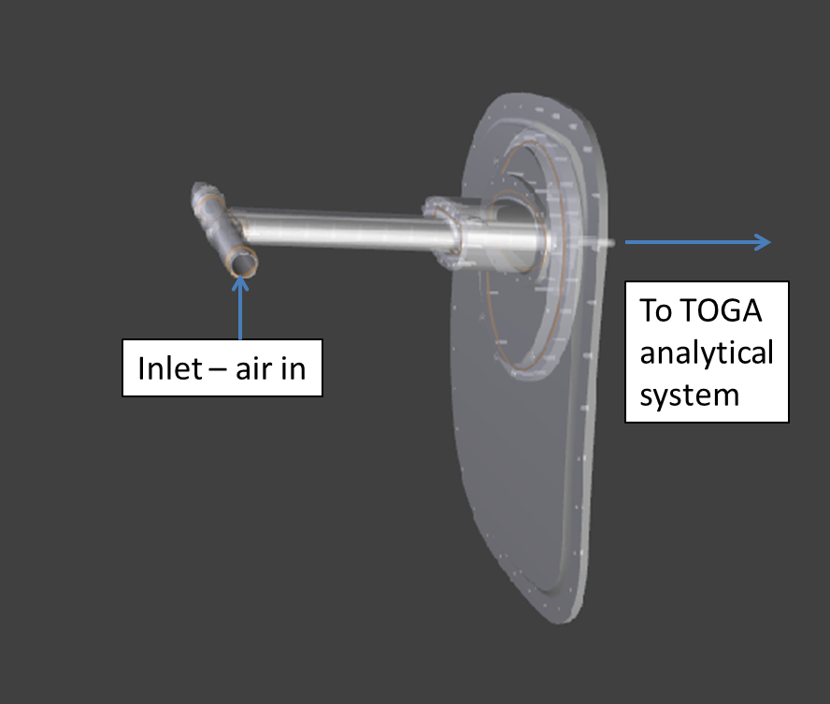
Figure S1. TOGA inlet system design (on an aircraft window plate).

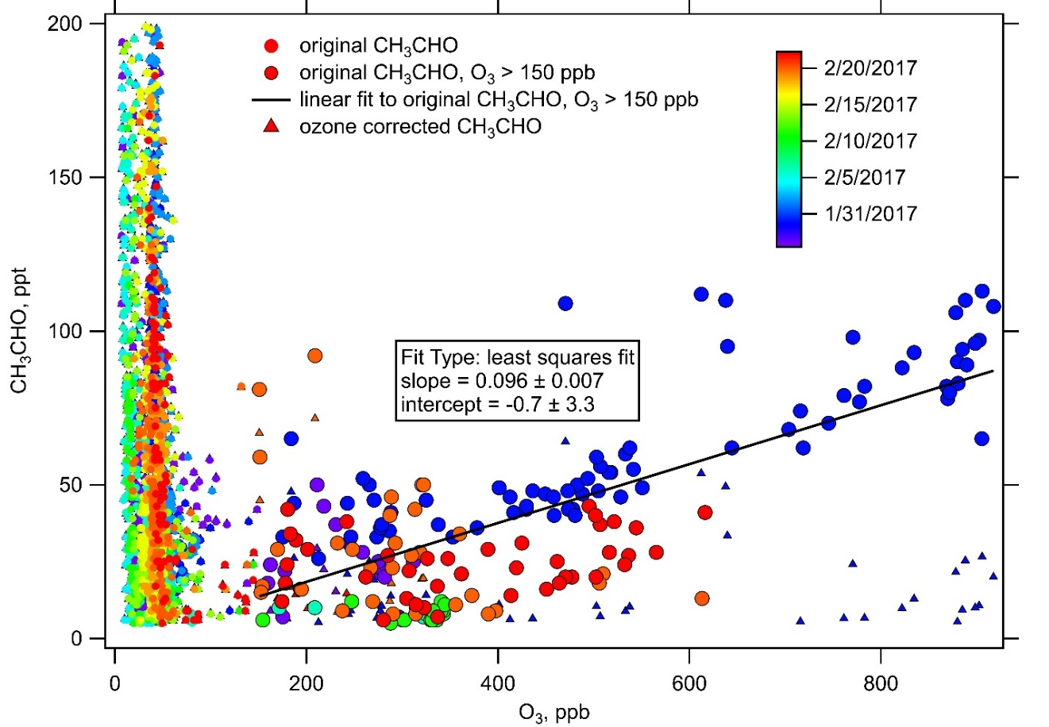
Figure S2. TOGA-measured CH₃CHO vs O₃ during ATom-2.

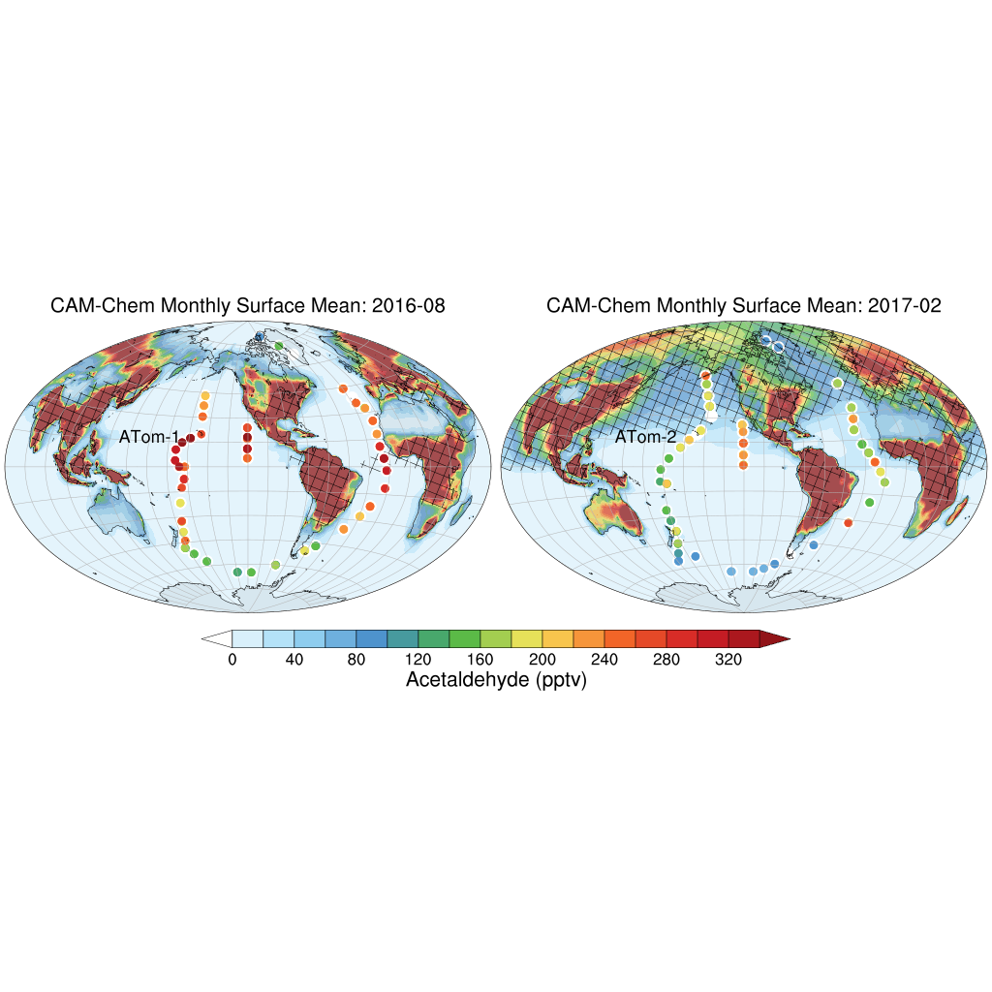

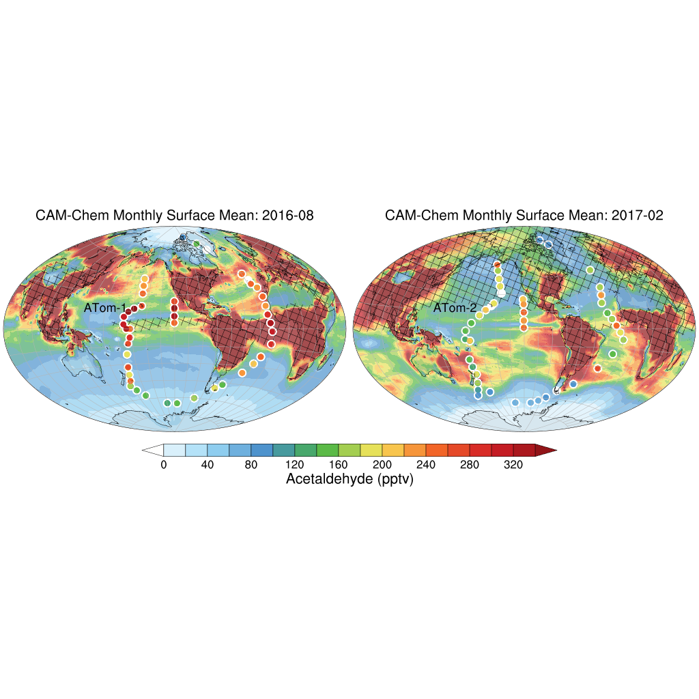

Figure S3. Airborne TOGA measurements of CH₃CHO at 0-200 m altitude during ATom-1 and ATom-2 (non-filtered data), overlaying on top of CAM-Chem predicted monthly mean surface (below ~200 m) concentrations of CH₃CHO. Top panel: no oceanic emissions; bottom panel: with oceanic emission (i.e. dashed green line in Figure 1). Shading indicates grids with CO>80 ppb.

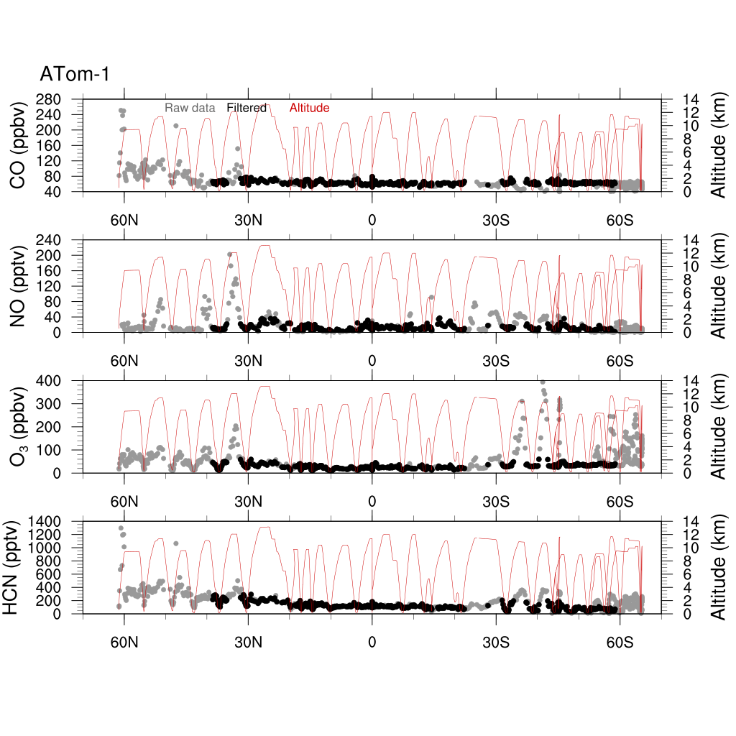

Figure S4. Flight tracks and latitude-curtains of CO, NO, O₃, and HCN during ATom-1 over the Pacific Ocean. Grey dots are raw measurements (2 minute) at all altitudes and black dots are the filtered results, i.e. anthropogenic influence (CO ≥ 80 ppbv), biomass burning (HCN ≥ 450 pptv or CH₃CN ≥ ~220 pptv), stratospheric influence (O₃ ≥ 70 ppbv), as well as measurements right after aircraft taking off and right before landing are all removed. Red lines indicate the aircraft altitude.

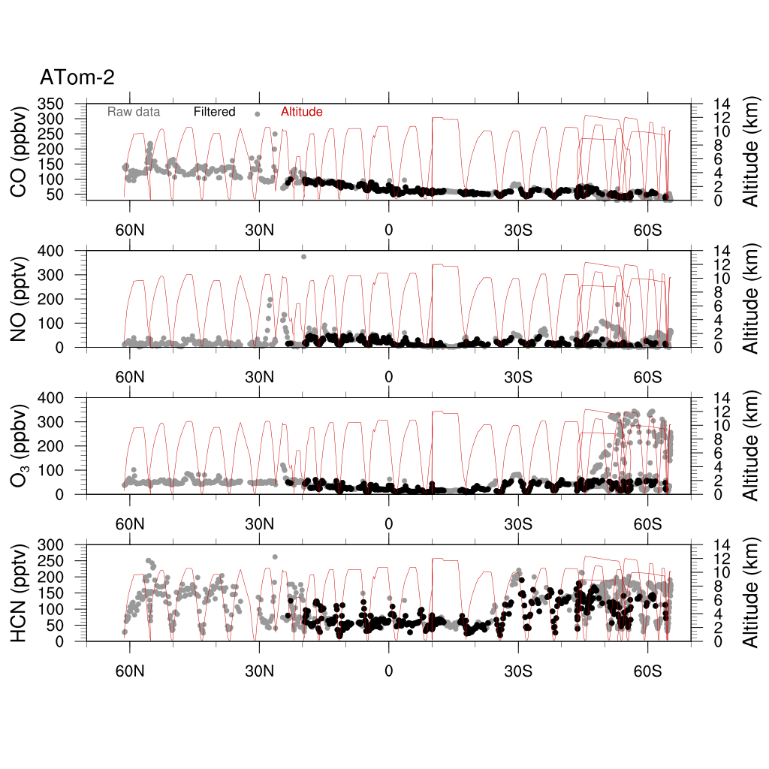

Figure S5. Same as Figure S2 but for ATom-2.

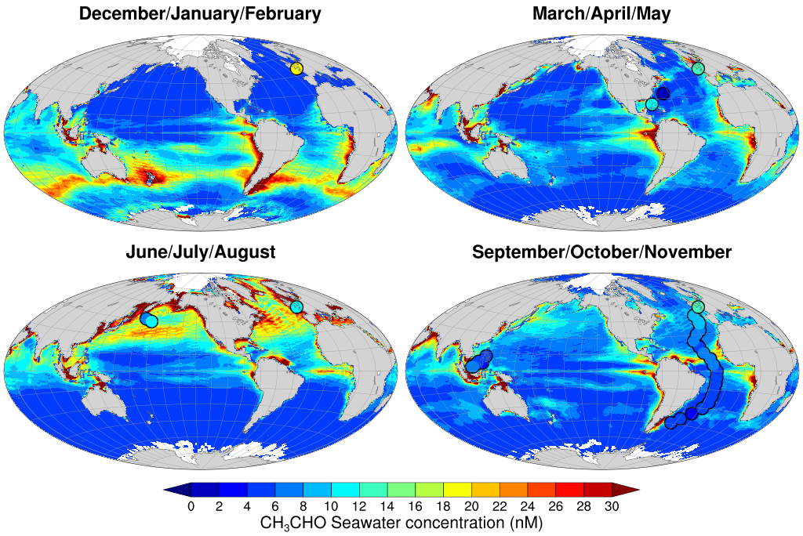
Figure S6. Model predicted surface seawater concentrations of CH₃CHO in different seasons, as well as all available measurements in the literature shown as circles.

Figure S7. Campaign averages of CIT ToF-CIMS measured and box-modeled PAA. Anthropogenic, biomass burning, stratospheric influence are removed. The blue lines indicates results from box model constrained to all measurements available, including CH₃CHO, while yellow line indicates box model constrained to all measurements except for CH₃CHO. The blue shading represents the modeling results with PAA+OH rate coefficient ranging from 1.0-3.7×10⁻¹² cm³ molec⁻¹ s⁻¹. Error bars are propagated from the standard error of mean in each vertical bin and the CIT ToF-CIMS measurement uncertainty, and are dominated by the measurement uncertainty, which is 50% + 30 ppt. With the PAA+OH rate coefficient being 1.0×10⁻¹² cm³ molec⁻¹ s⁻¹, the steady-state box-model predicted up to 50% higher PAA in the MBL (still within measurement uncertainty), possibly due to the lack of physical processes (e.g. wet/dry deposition) in the model.

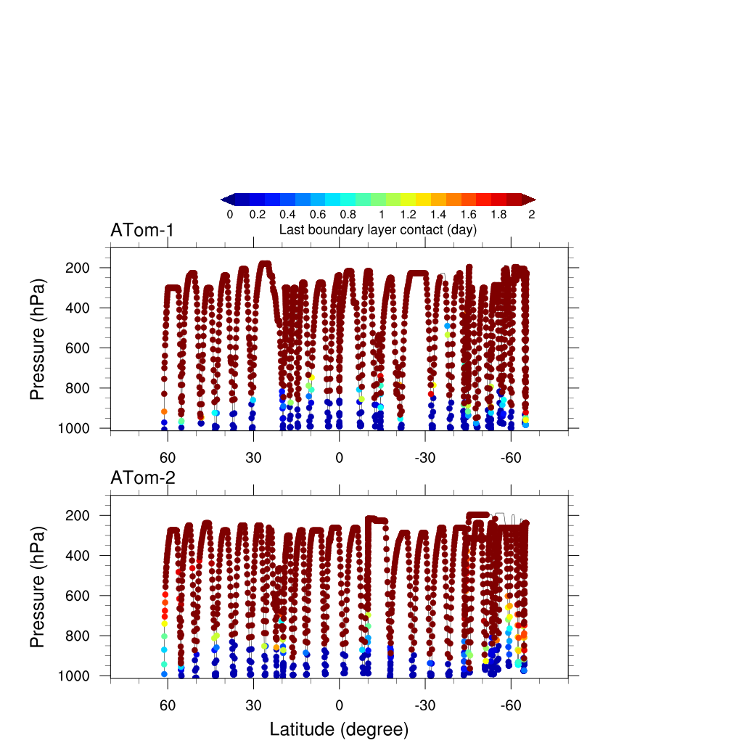
Figure S8. Most recent boundary influences for research flights during ATom-1 and ATom-2 over the Pacific, calculated based on backward trajectory analysis (Eric Ray, NOAA). Meteorology for trajectories and boundary layer data are from NCEP GFS (http://www.nco.ncep.noaa.gov/pmb/products/gfs/).

Figure S9. Median profiles of the TOGA measured and CAM-Chem modeled DMS during the recent CONvective Transport of Active Species in the Tropics (CONTRAST) in the tropical western Pacific in January – February 2014, as well as ATom-2 in the tropical Pacific in January – February 2017. Red error bars and blue shadings both represent 25% and 75% percentiles. Blue dashed lines represent the scaled CAM-Chem median profiles (scaling factor: 0.2 and 0.3 for CONTRAST and ATom-2, respectively).

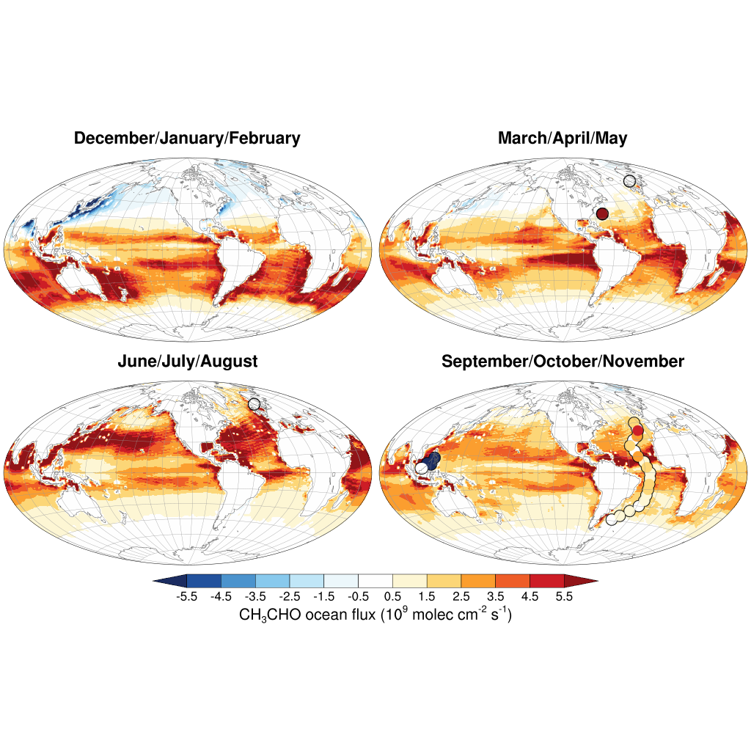

Figure S10. Modeled oceanic flux of CH₃CHO, using seawater concentration shown in Figure 1, and additional CH₃CHO production from the photolysis of OA. Observations available in the literature are shown as circles. In this scenario, the model predicts that the high latitude northern Atlantic and Pacific are net sinks for CH₃CHO during the cold season, while the majority of the global ocean is still a net source of CH₃CHO.

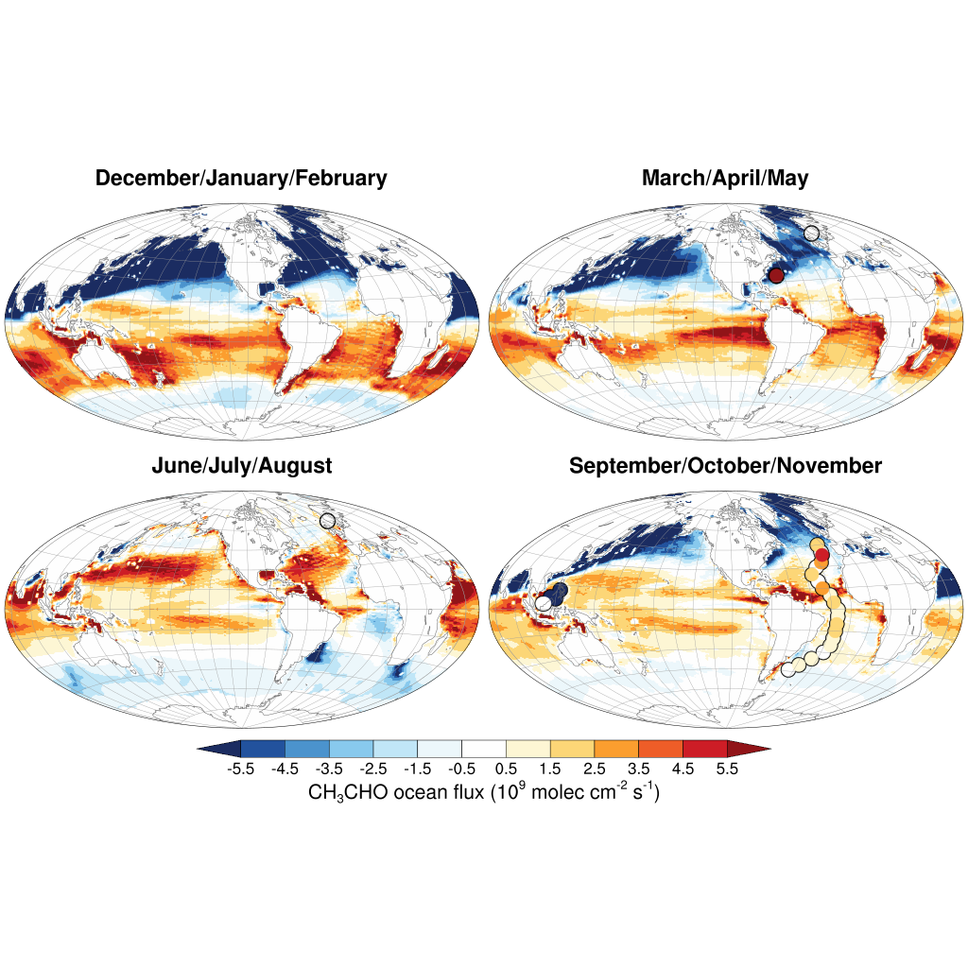

Figure S11. Modeled oceanic flux of CH₃CHO, using seawater concentration shown in Figure 1, and additional CH₃CHO production from ozonolysis of aerosols (γ_{O3} = 5×10⁻⁵). Observations available in the literature are shown as circles. In this scenario, the model predicts that the high latitude northern Atlantic and Pacific, and Southern Oceans (both Pacific and Atlantic) are a net sink for CH₃CHO, which appears to be inconsistent with flux observations (Yang et al. 2014, Zhou and Mopper 1990).

References

Apel, E., Brauers, T., Koppmann, R., Bandowe, B., Bo\s smeyer, J., Holzke, C., et al. (2008). Intercomparison of oxygenated volatile organic compound measurements at the SAPHIR atmosphere simulation chamber. Journal of Geophysical Research: Atmospheres, 113(D20). https://doi.org/10.1029/2008JD009865
Apel, E., Hornbrook, R., Hills, A., Blake, N., Barth, M., Weinheimer, A., et al. (2015). Upper tropospheric ozone production from lightning NOx‐impacted convection: Smoke ingestion case study from the DC3 campaign. Journal of Geophysical Research: Atmospheres, 120(6), 2505–2523. https://doi.org/10.1002/2014JD022121
Apel, E. C. (2003). A fast-GC/MS system to measure C ₂ to C ₄ carbonyls and methanol aboard aircraft. Journal of Geophysical Research, 108(D20). https://doi.org/10.1029/2002JD003199
Bates, M. S., Gonzalez-Flesca, N., Sokhi, R., & Cocheo, V. (2000). Atmospheric Volatile Organic Compound Monitoring. Ozone Induced Artefact Formation. Environmental Monitoring and Assessment, 65(1), 89–97. https://doi.org/10.1023/A:1006420412523
Blake, N. J., Blake, D. R., Simpson, I. J., Meinardi, S., Swanson, A. L., Lopez, J. P., et al. (2003). NMHCs and halocarbons in Asian continental outflow during the Transport and Chemical Evolution over the Pacific (TRACE-P) Field Campaign: Comparison With PEM-West B. Journal of Geophysical Research: Atmospheres, 108(D20). https://doi.org/10.1029/2002JD003367
Brock, C., Schröder, F., Kärcher, B., Petzold, A., Busen, R., & Fiebig, M. (2000). Ultrafine particle size distributions measured in aircraft exhaust plumes. Journal of Geophysical Research: Atmospheres, 105(D21), 26555–26567. https://doi.org/10.1029/2000JD900360
Burkholder, J. B., Sander, S. P., Abbatt, J., Barker, J. R., Huie, R. E., Kolb, C. E., et al. (2015). Chemical Kinetics and Photochemical Data for Use in Atmospheric Studies, Evaluation No. 18. JPL Publication 10-6, Jet Propulsion Laboratory, Pasadena, Http://Jpldataeval.Jpl.Nasa.Gov .
Carpenter, L. J., & Nightingale, P. D. (2015). Chemistry and Release of Gases from the Surface Ocean. Chemical Reviews, 115(10), 4015–4034. https://doi.org/10.1021/cr5007123
Cazorla, M., Wolfe, G. M., Bailey, S. A., Swanson, A. K., Arkinson, H. L., & Hanisco, T. F. (2015). A new airborne laser-induced fluorescence instrument for in situ detection of formaldehyde throughout the troposphere and lower stratosphere. Atmos. Meas. Tech., 8(2), 541–552. https://doi.org/10.5194/amt-8-541-2015
Crosson, E. R. (2008). A cavity ring-down analyzer for measuring atmospheric levels of methane, carbon dioxide, and water vapor. Applied Physics B, 92(3), 403–408. https://doi.org/10.1007/s00340-008-3135-y
Crounse, J. D., McKinney, K. A., Kwan, A. J., & Wennberg, P. O. (2006). Measurement of gas-phase hydroperoxides by chemical ionization mass spectrometry. Analytical Chemistry, 78(19), 6726–6732. https://doi.org/10.1021/ac0604235
DeCarlo, P. F., Kimmel, J. R., Trimborn, A., Northway, M. J., Jayne, J. T., Aiken, A. C., et al. (2006). Field-deployable, high-resolution, time-of-flight aerosol mass spectrometer. Analytical Chemistry, 78(24), 8281–8289.
Deming, B., Pagonis, D., Liu, X., Day, D., Talukdar, R., Krechmer, J., et al. (2019). Measurements of Delays of Gas-Phase Compounds in a Wide Variety of Tubing Materials due to Gas-Wall Interactions. Atmospheric Measurement Techniques Discussions, 1–19. https://doi.org/10.5194/amt-2019-25
Diskin, G. S., Podolske, J. R., Sachse, G. W., & Slate, T. A. (2002). Open-path airborne tunable diode laser hygrometer (Vol. 4817, pp. 4817–4819).
Dixon, J., Beale, R., & Nightingale, P. (2013). Production of methanol, acetaldehyde, and acetone in the Atlantic Ocean. Geophysical Research Letters, 40(17), 4700–4705. https://doi.org/10.1002/grl.50922
Elkins, J. W., Fahey, D. W., Gilligan, J. M., Dutton, G. S., Baring, T. J., Volk, C. M., et al. (1996). Airborne gas chromatograph for in situ measurements of long-lived species in the upper troposphere and lower stratosphere. Geophysical Research Letters, 23(4), 347–350. https://doi.org/10.1029/96GL00244
Faloona, I. C., Tan, D., Lesher, R. L., Hazen, N. L., Frame, C. L., Simpas, J. B., et al. (2004). A Laser-induced Fluorescence Instrument for Detecting Tropospheric OH and HO2: Characteristics and Calibration. Journal of Atmospheric Chemistry, 47(2), 139–167. https://doi.org/10.1023/B:JOCH.0000021036.53185.0e
Goldan, P. D., Kuster, W. C., Williams, E., Murphy, P. C., Fehsenfeld, F. C., & Meagher, J. (2004). Nonmethane hydrocarbon and oxy hydrocarbon measurements during the 2002 New England Air Quality Study: NMHC AND OXY HC NEAQS 2002. Journal of Geophysical Research: Atmospheres, 109(D21), n/a-n/a. https://doi.org/10.1029/2003JD004455
Hornbrook, R. S., Hills, A. J., Riemer, D. D., Abdelhamid, A., Flocke, F. M., Hall, S. R., et al. (2016). Arctic springtime observations of volatile organic compounds during the OASIS-2009 campaign. Journal of Geophysical Research: Atmospheres, 121(16), 9789–9813. https://doi.org/10.1002/2015JD024360
Johnson, M. T. (2010). A numerical scheme to calculate temperature and salinity dependent air-water transfer velocities for any gas. Ocean Sci., 6(4), 913–932. https://doi.org/10.5194/os-6-913-2010
Kupc, A., Williamson, C., Wagner, N. L., Richardson, M., & Brock, C. A. (2018). Modification, calibration, and performance of the Ultra-High Sensitivity Aerosol Spectrometer for particle size distribution and volatility measurements during the Atmospheric Tomography Mission (ATom) airborne campaign. Atmos. Meas. Tech., 11(1), 369–383. https://doi.org/10.5194/amt-11-369-2018
McManus, J. B., Nelson, D. D., Shorter, J. H., Jimenez, R., Herndon, S., Saleska, S., & Zahniser, M. (2005). A high precision pulsed quantum cascade laser spectrometer for measurements of stable isotopes of carbon dioxide. Journal of Modern Optics, 52(16), 2309–2321. https://doi.org/10.1080/09500340500303710
Millet, D. B., Guenther, A., Siegel, D. A., Nelson, N. B., Singh, H. B., de Gouw, J. A., et al. (2010). Global atmospheric budget of acetaldehyde: 3-D model analysis and constraints from in-situ and satellite observations. Atmos. Chem. Phys, 10(7), 3405–3425.
Nault, B. A., Campuzano-Jost, P., Day, D. A., Schroder, J. C., Anderson, B., Beyersdorf, A. J., et al. (2018). Secondary Organic Aerosol Production from Local Emissions Dominates the Organic Aerosol Budget over Seoul, South Korea, during KORUS-AQ. Atmos. Chem. Phys. Discuss., 2018, 1–69. https://doi.org/10.5194/acp-2018-838
Northway, M. J., de Gouw, J. A., Fahey, D. W., Gao, R. S., Warneke, C., Roberts, J. M., & Flocke, F. (2004). Evaluation of the role of heterogeneous oxidation of alkenes in the detection of atmospheric acetaldehyde. Atmospheric Environment, 38(35), 6017–6028. https://doi.org/10.1016/j.atmosenv.2004.06.039
Ryerson, T., Williams, E., & Fehsenfeld, F. (2000). An efficient photolysis system for fast‐response NO2 measurements. Journal of Geophysical Research: Atmospheres, 105(D21), 26447–26461. https://doi.org/10.1029/2000JD900389
Schroder, J. C., Campuzano-Jost, P., Day, D. A., Shah, V., Larson, K., Sommers, J. M., et al. (2018). Sources and Secondary Production of Organic Aerosols in the Northeastern United States during WINTER. Journal of Geophysical Research: Atmospheres, 123(14), 7771–7796. https://doi.org/10.1029/2018JD028475
Shetter, R. E., & Martin, M. (1999). Photolysis frequency measurements using actinic flux spectroradiometry during the PEM‐Tropics mission: Instrumentation description and some results. Journal of Geophysical Research: Atmospheres, 104(D5), 5647–5661. https://doi.org/10.1029/98JD01381
Shetter, R. E., & Müller, M. (1999). Photolysis frequency measurements using actinic flux spectroradiometry during the PEM‐Tropics mission: Instrumentation description and some results. Journal of Geophysical Research: Atmospheres, 104(D5), 5647–5661. https://doi.org/10.1029/98JD01381
Singh, H., Chen, Y., Tabazadeh, A., Fukui, Y., Bey, I., Yantosca, R., et al. (2000). Distribution and fate of selected oxygenated organic species in the troposphere and lower stratosphere over the Atlantic. Journal of Geophysical Research: Atmospheres, 105(D3), 3795–3805. https://doi.org/10.1029/1999JD900779
Singh, H. B. (2004). Analysis of the atmospheric distribution, sources, and sinks of oxygenated volatile organic chemicals based on measurements over the Pacific during TRACE-P. Journal of Geophysical Research, 109(D15). https://doi.org/10.1029/2003JD003883
Singh, H. B., Kanakidou, M., Crutzen, P. J., & Jacob, D. J. (1995). High concentrations and photochemical fate of oxygenated hydrocarbons in the global troposphere. Nature, 378, 50.
Wang, S., Schmidt, J. A., Baidar, S., Coburn, S., Dix, B., Koenig, T. K., et al. (2015). Active and widespread halogen chemistry in the tropical and subtropical free troposphere. Proceedings of the National Academy of Sciences, 112(30), 9281–9286. https://doi.org/10.1073/pnas.1505142112
Williamson, C., Kupc, A., Wilson, J., Gesler, D. W., Reeves, J. M., Erdesz, F., et al. (2018). Fast time response measurements of particle size distributions in the 3–60 nm size range with the nucleation mode aerosol size spectrometer. Atmos. Meas. Tech., 11(6), 3491–3509. https://doi.org/10.5194/amt-11-3491-2018
Yang, M., Nightingale, P. D., Beale, R., Liss, P. S., Blomquist, B., & Fairall, C. (2013). Atmospheric deposition of methanol over the Atlantic Ocean. Proceedings of the National Academy of Sciences, 110(50), 20034 LP – 20039. https://doi.org/10.1073/pnas.1317840110
Yang, M., Beale, R., Liss, P., Johnson, M., Blomquist, B., & Nightingale, P. (2014). Air–sea fluxes of oxygenated volatile organic compounds across the Atlantic Ocean. Atmospheric Chemistry and Physics, 14(14), 7499–7517. https://doi.org/10.5194/acp-14-7499-2014

