Supplemental Figures:

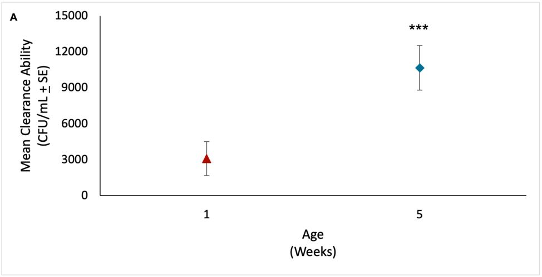
Figure S1: Mean clearance ability (CFU/mL +SE) for 1 and 5 weeks of age averaged across all genotypes in common across the two ages. Clearance ability significantly decreases with age (p<0.0001), indicated by the increase in CFU/mL.

Supp. Table 1: GWA of effect of genotype on clearance ability at 1 and 5 weeks of age, separately, and from those common lines across ages.
Age  (Weeks) | No.  of lines | No.  of Indels | No.  of SNPs | No.  of Genes
1 | 175 | 7 | 60 | 25
5 | 183 | 7 | 66 | 35
Common | 155 | 25 | 171 | 89
The values shown for “Common” are the total SNPs, INDELs, and genes identified in the common-line GWA. For complete GWA outputs, see Supp File S2.

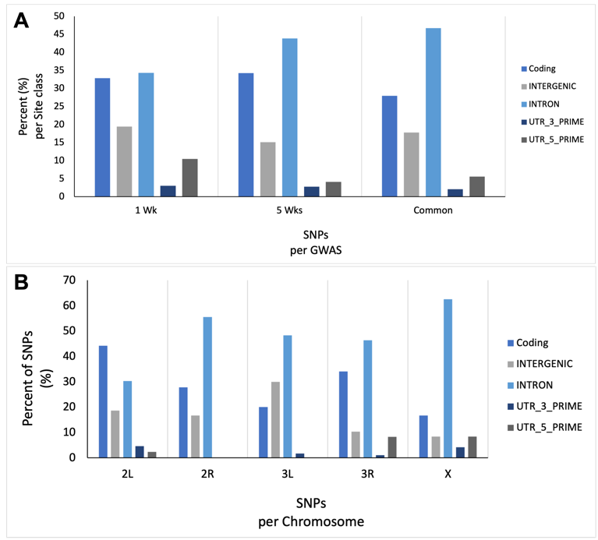
Figure S2: Distribution of SNPs by site class per GWAs (A) or per chromosome (B). The site class ‘coding’ includes any polymorphism within a coding sequence/region (ex: synonymous, non-synonymous, start-gain, codon-insertion, or exon). B) Includes all SNPs by site class per chromosome, from the 3 GWAs combined, removing any duplicate SNPs.

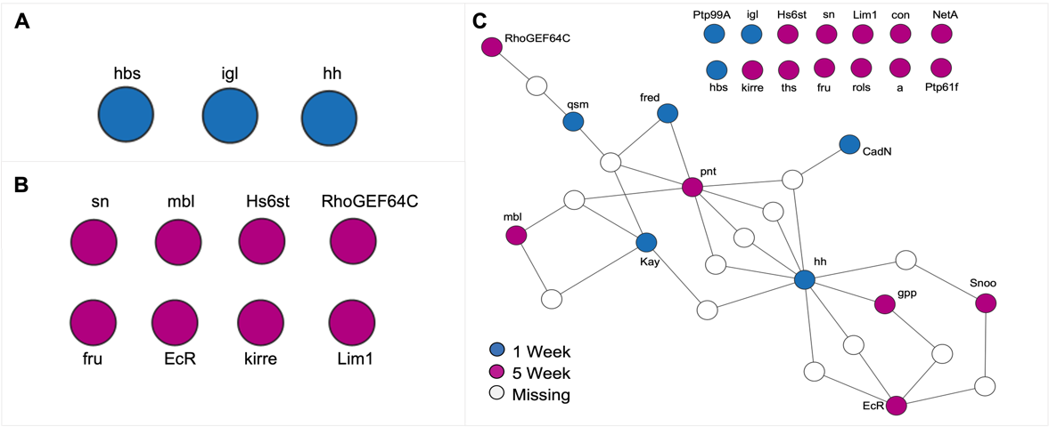
Figure S3: Genetic network analysis of candidate genes identified at 1 week (A) and 5 week (B) of age, separately, and across ages (C). The genetic network analyses shown in C includes 1-missing gene (white). These networks were derived from candidate genes identified in the three GWAs for clearance ability. At 1 week of age (A) 25 unique gene IDs were included in the analysis and only 3 capable of being mapped to the global network. In B) 35 unique gene IDs were included with 8 capable of being mapped to the global network, and in C), 107 unique gene IDs were included in the analysis with only 25 capable of being mapped to the global network.

