Students' Perceptions of Their Learning Spanish in an Online Class Setting Versus a
Face-to-Face Class Setting.

By Michele Hackshaw

Submitted in Partial Fulfillment of the Requirements for the
Degree of Master of Education

July 2021

Graduate Programs in Education
Goucher College

Table of Contents
List of Tables iii
Abstract iv
I. Introduction 1
Statement of the Problem 2
Statement of Research Hypothesis 2
Operational Definitions 2
II. Literature Review 3
Overview 4
Benefits of An Elementary World Language Programs 4
Motivation Factors for Second Language Acquisition 5
Learning Preferences of Gen Z Learners 7
III. Methods 9
Design 9
Participants 9
Instrument 10
Procedure 10
IV. Analysis & Discussion 12
Analysis of the Data and Discussion of the Data 12
Threats to Validity 15
Conclusions/Summary and Recommendations 15
Suggestions for Future Research 17

References 19
Appendix A 20
List of Tables
- Measures of Central Tendency on Preference for Online versus
In-Person Instruction 13
- Tests of Statistical Significance Using the Paired or Dependent t Test 13
- Measures of Central Tendency for Online Versus Effectiveness
of Online 14

- Statistical Analysis of Central Tendency for Online Versus
Effectiveness of Online 14

- Measures of Central Tendency for In-person Learning Effectiveness in
the Perceptions of Students 15

- Statistical Comparison of Student Perceptions of the Effectiveness
of In-Person Instruction 15

Abstract
The purpose of this study was to gain information about students' perceptions of their learning Spanish in an online class setting versus a face-to-face class setting. More significantly, the study aimed to examine the data from students' perceptions and feedback to provide further recommendations about creating online lessons that contain strategies that are more effective in sustaining student involvement in an online Spanish class. In this study, the researcher used a descriptive methodology through a survey with a conveniently selected sample of 72 students of fifth-grade elementary who were in their second year at the Spanish Passport Program at Baltimore County Public Schools, Maryland. The results indicate that relationships between students and teachers are among the most important things in students' motivation to learn Spanish. In addition, students preferred learning in person and the classroom over virtual learning, as analyzed statistically. Overall, the help of teachers to students was cited many times.
CHAPTER I
INTRODUCTION
Overview
Back in March 2020, in response to the COVID-19 global health pandemic, policymakers and school systems leaders decided to close schools all around the country to help stop the spread of the COVID-19 virus. Consequently, teachers and students were forced to switch from the conventional face-to-face classroom setting to the online education class setting. Therefore, even though online education has been around for many years, the term online education was used every day in the 2020-2021 school year. Nevertheless, what exactly is online education?
The term online education is equal to mobility and flexibility because it allows the learner to take courses through different virtual platforms and electronic tools such as computers, laptops, tablets, and phones.
Initially, there were two approaches to online or virtual learning: asynchronous – the student could work at any time of their choice but only needed to submit assignments on a given date while the teacher may have held office hours or Google meetings to help students. Then, more common was synchronous learning, where the teacher and the students met simultaneously. Finally, when the virus started to subside, hybrid learning became common. In that situation, the students were in class (face-to-face) sometimes and online in synchronous mode at other times.
This situation brought on by the COVID virus permits teachers and researchers to examine the impacts of these new instructional techniques. However, there is little information that exists on all the various contents, grades, and learner types to guide current and future instruction. Thus, this study aims to gain information about student perceptions of their learning Spanish in an online setting versus their previous experiences in a face-to-face class setting. Further, the researcher hopes that the study may provide data to give recommendations on Spanish teaching with online lessons that engage students and maintain their motivation and involvement.
Statement of Problem
What are students' perceptions of their learning Spanish in an online class setting versus a face-to-face class setting?
Hypothesis
In this descriptive study, no hypothesis is posited.
Operational Definitions
COVID-19 virus: based on the World Health Organization, COVID-19 is caused by a new coronavirus called SARS-CoV-2.
COVID-19 pandemic: based on the World Health Organization, is a severe acute respiratory syndrome caused by a coronavirus (SARS-CoV-2). In March 2020, the World Health Organization announced that it had categorized COVID-19 as a pandemic. COVID-19 is an ongoing global pandemic discovered during December 2019 in the Chinese city of Wuhan.
Online education: type of education a type of education that allows the learner to take courses using the internet and virtual platforms and using different electronic tools such as computers, laptops, tablets, and phones. That way, the learner does not need to be physically present at the school building. (Singh & Thurman, 2019).
Face-to-Face education: refers to a type of education that happens when the instructor and learner are physically present at the same time in the school building.
Second language acquisition (SLA): refers to the process of acquiring or learning an additional language that is not one's first
The literature used to support this study spans from 1967 to 2019. Unfortunately, there is not much literature specifically about students' perceptions of their learning Spanish in an online class setting versus a face-to-face class setting while in the middle of a pandemic.

CHAPTER II
REVIEW OF THE LITERATURE
Overview
This literature review discusses the benefits of elementary World Language programs, the motivation factors for second language acquisition, and the learning preferences for Gen Z learners.
This literature review is organized into three major sections. Session one explains the best ages to learn a second language and the benefits of elementary World Language programs. Section two discusses the motivation factors for second language acquisition. Lastly, section three discusses the learning preferences of Gen Z learners.
Benefits of An Elementary World Language Programs.
Over time, different researchers have concluded that the younger one studies a second language, the better the chances are to learn a second language. For children, learning a second language come easier than it does for adults. Lambert and Kleinberg (1967) called the period between the age of two and puberty the "critical period" of learning a second language. Research based on brain development has concluded that people will have more chances to achieve full second language proficiency if they know a second language before the age of ten. However, recent research has found that the critical period of learning a second language is more extended than previously thought and can go up into late adolescence and early adulthood, about 17 to 18 years old. However, that does not mean that people cannot learn a second language in adulthood, but it will happen at a different pace (Hartshornea et al., 2018).
According to Larson-Hall (2008), age plays an essential role in learning a second language. She states that the younger a student is, the better they are able to learn a second language, but what matters most is the amount of input to which the language learner is exposed. Therefore, studying a second language at a younger age is beneficial, even when input is minimal, because it will ensure that the learner is exposed to more significant amounts of language input over time.
Research has found benefits of elementary world language programs not only on the cognitive and academic results but also on behavior development.
Armstrong and Rogers (1997) analyzed the effects of foreign language education on the basic skills of elementary school students. They studied a group of third-grade students given three 30-minute Spanish language lessons per week. Their research demonstrated that the study group performed as well as or better than a control group (given no second-language instruction) on academic achievement tests.
According to Stewart (2005), learning a second language increases a child's cognitive abilities, enhances achievement in other subjects, and positively correlates with higher scores on achievement tests. In her work, she demonstrated that children who study a second language in elementary school transfer the skills learned to reading, math, and other subjects. She also explains that these results go hand in hand with the No Child Left Behind goals of ensuring high student outcomes.
In summary, learning a second language in elementary school has cognitive benefits, increases academic performance, and can improve standardized test results. Moreover, it has a positive effect not only on second language acquisition but also in other subject areas.
Motivation Factors for Second Language Acquisition.
Motivation is one of the most important factors for learning a second language (Dörnyei, 1994). Motivation is the force that will encourage the learner's put effort into learning another language. There is a considerable amount of research about the role motivation plays in second langue acquisition and the factors that influence motivation. Therefore, understanding the significant factors driving second language learners' motivation might help if teachers want to keep the second language learner motivated and engage in learning, especially if these factors can be transferred to the online setting.
Krashen (1982) explains that language acquisition can occur only in the presence of certain affective conditions: the learner is motivated, self-confident, and has a low level of anxiety. If motivation and self-esteem are low while stress is high, language input will be blocked by a filter, and the opposite is true, as well.
Gardener and Lysynchuk (1990) define two kinds of motivation that influence second language acquisition. First, instrumental motivation refers to learning a second language for a practical purpose (learning a language to get a better job or fulfilling an academic requirement). Second, integrative motivation refers to learning a second language to interact with another ethnographic group (learning a language to fit native speakers). They concluded that creating real bonds and relationships with other people drives the desire to learn another language and keeps the language learner engaged in learning.
Dörnyei (1994) explains two types of motivation: intrinsic and extrinsic motivation behaviors. Extrinsically motivated behaviors are when the individual performs to receive some extrinsic reward (e.g., good grades) or avoid punishment. On the other hand, in intrinsically motivated behaviors, the rewards are internal (e.g., the joy of doing a particular activity or satisfying one's curiosity). In Dörnyei's research, there is a list of motivation strategies classified in three significant categories (Language Level, the Learner Level, and the Learning Situation Level) that assist the second language teacher in including some of these motivation factors into instruction.
Tatar (2017) explains that there are internal and external factors for motivation in their research. The internal factors are the personal beliefs, values, or perceptions of the language learner that lead to learning the second language. External factors are related to the environment around the learner, such as good relationships with others and suitable materials that enhance learning. They concluded that both internal and external factors are essential to keep motivation levels high.
Motivation factors play an essential role in learning a second language, and many of these factors influence and affect the disposition of the language learner to learn in the classroom. The second language classroom should be welcoming, a positive place where communication needs are met and where language anxiety is minimum, and the student seems to enjoy many of the practice opportunities. Teachers have the power to control how lessons are taught and how interesting the lessons are for the second language learner, so there could be a stimulating, supportive environment that fosters self-esteem and interest in learning.
Learning Preferences of Gen Z Learners
This section discusses the learning preferences for the Gen Z learners, which is the age group of the subjects of this study.
Schwieger and Ladwig's (2018) research indicates that Generation Z was born between 1996 and 2012. Therefore, understanding their learning preferences is essential. In addition, it will help teachers find new ways to motivate and keep second language learners involved in classes, especially online classes.
Seemiller and Grace (2017) describe Generation Z as loyal, thoughtful, compassionate, open-minded, and responsible. This generation is digital with access to broadband internet and smartphones since they were born. They have always had access to instant and infinite information. Their proficiency in technology and access to digital information has made them aware of social justice movements they want to make fundamental changes.
Technology has made Generation Z visual, observers, and intrapersonal learners. They are comfortable with and accustomed to learning independently. They can complete an online module or watch an instructional video if they are engaged. They have a short attention span; therefore, they like hands-on learning opportunities with real-life applicability.
Consequently, according to Seemiller and Grace (2017), teachers should become more skilled in different programs and applications integrated into the classes. Teachers should develop activities related to the course but, at the same time, are meaningful to the students' lives. Some effective strategies to keep Generation Z involved and motivated in learning utilize video-based knowledge such as YouTube videos and social media platforms. This way, they can use their visual and observatory skills and incorporate their intrapersonal learning characteristics. Even though they are intrapersonal learners, publishing (or "posting" as they call it) their assignments online is a success because they enjoy feedback from their teachers and peers.
Therefore, Schwieger and Ladwig (2018) suggest that online technology courses or courses conducted in a blended online and face-to-face format may help attract Gen Z learners.
How can we assess this generation? In summary, much research proposes using games, short online quizzes, small groups discussion and making them work on active learning activities such as projects that make a social difference. This way, teachers could get the most of this generation of students.
CHAPTER III
METHODS
Statement of Problem
The purpose of this study was to gain information about students' perceptions of their learning Spanish in an online class setting versus a face-to-face class setting.
Design
This study used a descriptive methodology utilizing an online survey. The researcher created the online survey to identify students' perceptions of an online class setting versus a face-to-face class setting. The survey contains three major categories: students' views/preferences of online versus face-to-face learning, significant difficulties students face while learning online, and significant students' suggestions to improve learning Spanish online. It is important to note that the students in the study had experienced in-person Spanish classes before COVID-19.
Participants
There are 72 participants in this study. One hundred percent of the participants were students from fifth grade and were in their second year at the Spanish Passport Program at Baltimore County Public Schools, Maryland. Thirty-nine (54.2%) were students from school one, 55.1% of fifth-graders at that school. Furthermore, 33 (45.8%) were students from school number two; 35.10% of fifth-graders at that school. The participants' ages ranged from 11 to 12 years old.
Two different schools participated in this study. Based on the Maryland Report Card, school number one is not a Title I school. Only 5% of the total students are from low-income families. Thirty students are eligible for free lunch, and five are eligible for reduced-price lunch.
It has 509 total students, and 85 are fifth-grade students, 39 of those participating in the survey. It was rated five out of five stars, and its percentile rank was 99 (among elementary schools).
Additionally, school number two is a Title I school. Sixty percent of the total students are from low-income families. Three hundred sixteen students are eligible for free lunch, and 64 are eligible for reduced-price lunch. It has 588 total students, and 94 are fifth-grade students; 33 of those students participated in the survey. It was rated as three out of five stars, and its percentile rank is 31.
Instrumentation
The instrument utilized in this study was an online survey. The researcher created this instrument to gain information on students' perceptions about their learning Spanish in an online class setting versus a face-to-face class setting. The survey was approved by the researcher's design advisor. The survey has three major categories: students' views/preferences of online learning versus face-to-face learning, major difficulties students faced while learning online, and significant suggestions to improve learning Spanish while doing it online. The survey contained 23 questions in total. The two first questions identify school name and grade, then eight open-ended questions, four linear scale questions, two multiple-choice questions, four multiple-choice grids, and lastly, six checkbox grid questions. A copy of the survey is shared in this link: https://forms.gle/UkX1i8pptUVN62QZ7 and in Appendix A at the end of this research.
Procedure
The survey was administered to the sample. All participants were given the exact directions: to click on the link, "Online School Survey," provided in Schoology in their Spanish class folder. They were instructed to think back on their online school learning experience and then answer the questions in the survey to the best of their abilities. Students had the same amount of time, 50 minutes (one Spanish class period), to complete the survey. Once the surveys were submitted, the results were reviewed, analyzed, summarized by the researcher, and shared in Chapter IV and discussed in Chapter V. To better understand the survey data, Chapters IV and V have been combined.

CHAPTERS IV AND V
ANALYSIS OF THE DATA AND DISCUSSION OF THE DATA
The purpose of this study was to gain information about students' perceptions of their learning Spanish in an online class setting versus a face-to-face class setting. A sizable number of questions were asked of students and yielded a rich data set. Those data directly pertinent to the online versus in-person instruction will constitute the basis of the data set analysis. In addition, much other useful information can be obtained from the data.
Table I compares how students perceived "liking" online versus in-person instruction. Table I has the measures of central tendency, and Table II has the tests of statistical significance.
Table I
Measures of Central Tendency on Preference for Online versus In-Person Instruction
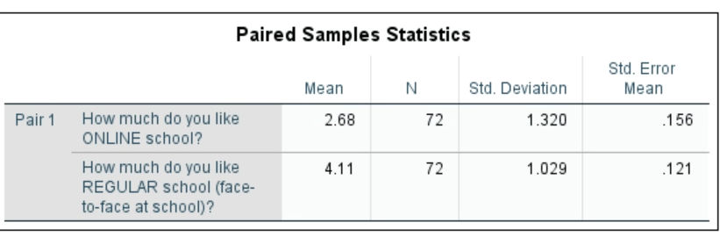
Table II
Tests of Statistical Significance Using the Paired or Dependent t Test
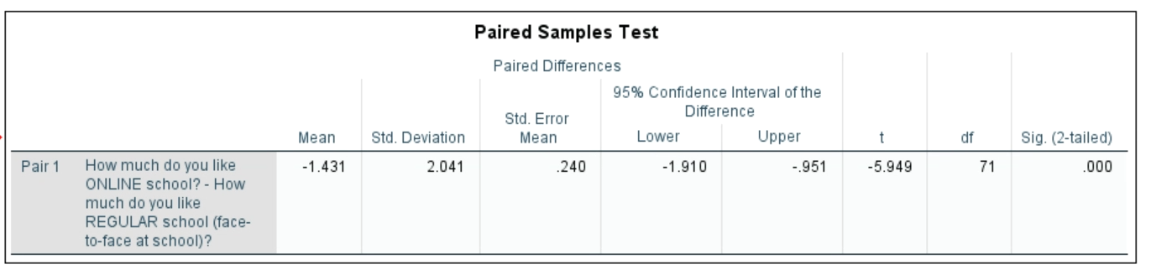
Clearly, students prefer being in the in-class environment versus the online environment.
These analyses can be further developed by contrasting the students' views of online and in-person but examining how "effective" they perceived those approaches to be. Table III presents the Measures of Central Tendency for how students perceived online and how effective that instructional mode was for them.
Table III
Measures of Central Tendency for Online Versus Effectiveness of Online
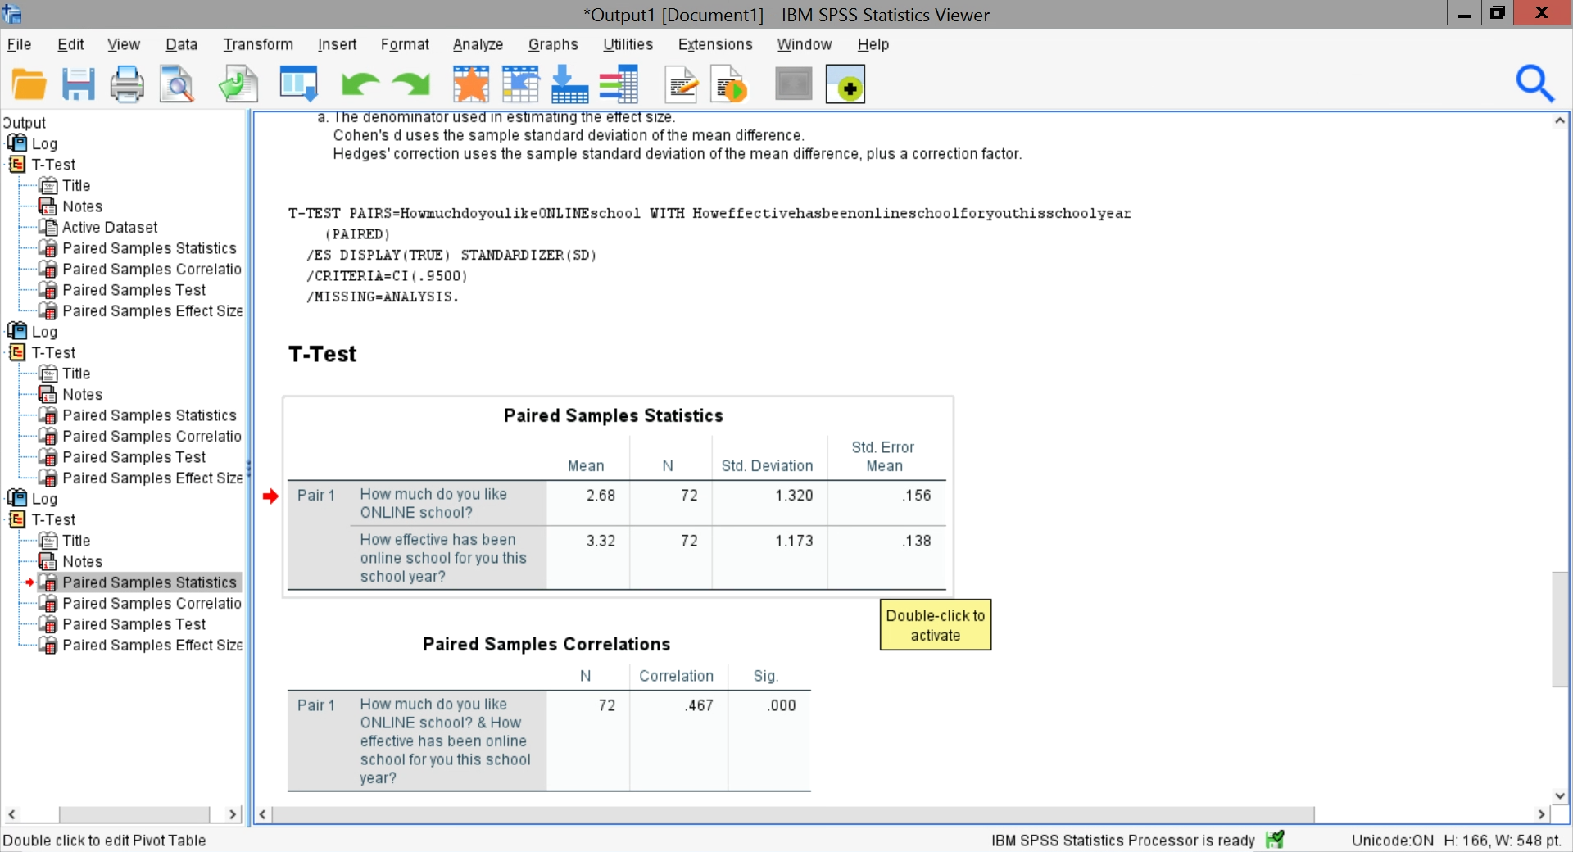
Table IV performs a statistical analysis of the data in Table III.
Table IV
Statistical Analysis of Central Tendency for Online Versus Effectiveness of Online
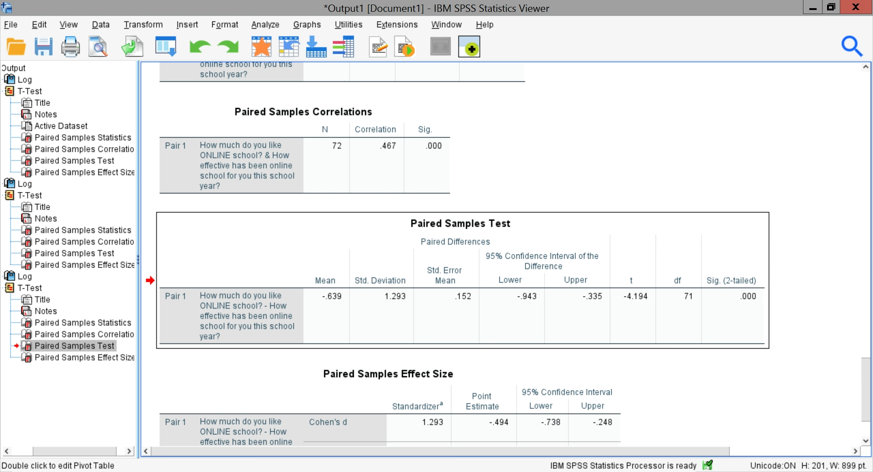
Although, students preferred in-person to online, they did see that online was effective for them.
Table V asks a similar question to that posed in Table III, except now the comparison is in-person and how effective it is as perceived by students.

Table V
Measures of Central Tendency for In-person Learning Effectiveness in the Perceptions of Students
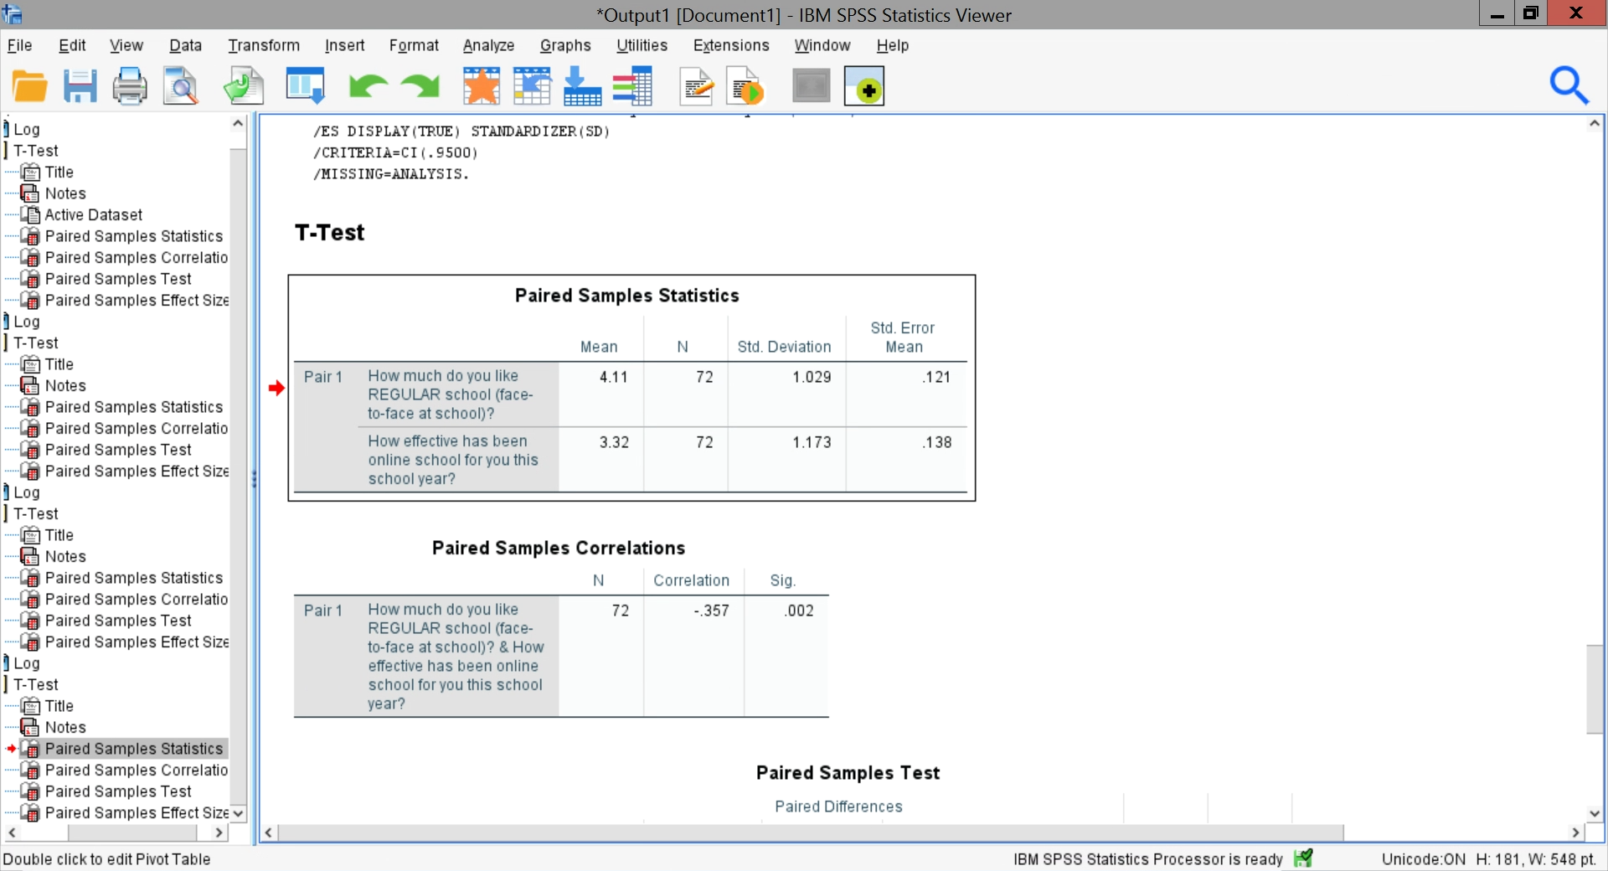
Table VI
Statistical Comparison of Student Perceptions of the Effectiveness of In-Person Instruction
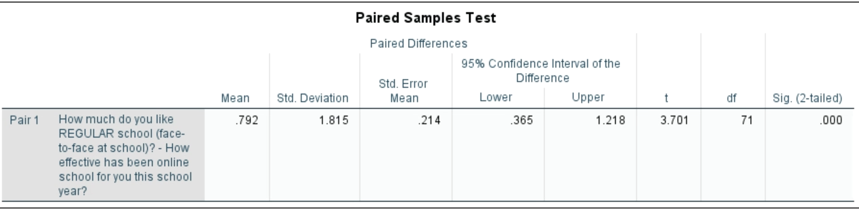
Thus, in summary of these six analyses, it is clear that students preferred in-person (face-to-face) learning over online. The critical question now to be examined is why and what may be done.
Students who liked online cited the less stress involved in learning Spanish.
In contrast, those that did not like it had reasons like technology issues with the internet, low computer skills on the part of the student, a noisy environment in which to work at home, losing interaction with their peers, or "I do not like to learn that way."
Students often mentioned how they missed activities that they enjoyed in the classroom.

Threats to Validity
All research has threats to validity. These threats are categorized as threats to external validity and threats to internal validity. External validity refers to the type of sample and its size. Clearly, this convenience sample, although large, cannot be generalized beyond the current teaching situation and may be different for different teachers or different students. Internal validity refers to the design of the study. Descriptive research always suffers from how honest and truthful the respondents are and how far one might generalize. In reading the student responses, they seem quite honest, but the type of sample generalization beyond these classrooms taught by this teacher cannot be made.
Summary, Conclusions, and Recommendations
The purpose of this study is to gain information about students' perceptions of their learning Spanish in an online class setting versus a face-to-face class setting.
Thus, this study aims to gain information about student perceptions of their learning Spanish in an online setting versus their previous experiences in a face-to-face class setting. Further, the researcher hoped that the study could provide data to give recommendations on Spanish teaching with online settings and create lessons that engage students and maintain their motivation and involvement.
Results from this study show that students prefer face-to-face school over online school. However, at the same time, students reported that online school was effective to them.
Therefore, in order to answer the critical question of why students prefer face-to-face school over online school, some possible answers could be related to the fact that students reported a lack of access to reliable internet services, low computer skills on the part of the student, a noisy environment in which to work at home and not having enough help from teachers.
Additionally, the social implications of face-to-face school were essential for them, which is what students missed the most while doing online school. They missed connections with friends, teachers, sitting in the classroom with friends and teachers having discussions and working in small groups, talks with friends while hallway walks, field trips, and sports.
Now, what can be done to make online school more appealing to enhance students' online classroom experience? Based on this study's results, to engage students and maintain their motivation and involvement in Spanish online classes, the researcher recommends incorporating teaching methods and online lessons that contain the components of what students reported on the survey that they love about online learning. For example, students reported that while doing online school, they love doing online games. Therefore, online games such as Kahoot, Quizlet/Quizlet Live, Gimkit, Quizizz, and Blooket could be excellent tools for learning new and reviewing old materials.
Additionally, students reported that they learn better working in small teams working on virtual team projects and active learning activities that involved sharing ideas on class activities such as breakout rooms, collaborative documents, chat boxes, discussion posts on boards such as Padlet, Google Jam Board.
Moreover, on the survey, students also reported that they would like to have more relevant topics to students' lives while having real-life conversations that involved complete Spanish sentences. Therefore, incorporating in the curriculum online lessons that consider what is relevant for the students or what is essential for them to learn could be another essential factor in keeping students engaged and motivated while learning Spanish in online settings. Using survey and polling programs such as Google Forms, and Mentimeter are excellent tools to collect information on student opinions and interests.
Another critical factor to keep students motivated and engaged in learning a second langue is to keep students' low level of anxiety. Therefore, based on the results of this survey, it is also recommended to have the online lessons in which the work is broken down into small pieces to feel less work since one general complaint obtained from the survey was that online school was much work. Therefore, adding to the online lessons' specific expectations, checklist, graphic organizers, examples, choice boards, among others will help the students be organized and accountable would be another recommendation.
Since one of the aspects that students missed the most was the social interactions and relationship with the teachers, and this is an essential factor to keep students motivated, it is recommended to have included in the curriculum starting or end every lesson with a daily check using Google Forms or other survey tools. Additionally, adding more time to one-on-one meets, open communication channels so they can share part of their personal life, and posting the specifics of how the teacher can be reached are some strategies that will help students and teachers can build stronger relationships and students feel supported.
Suggestions for Future Research.
The purpose of this study is to gain information about students' perceptions of their learning Spanish in an online class setting versus a face-to-face class setting. Results of this research showed that students prefer face-to-face class settings over the online class setting. However, it is essential to mention that this research was done in the middle of the COVID-19 pandemic, where schools were forced to close and switch from the face-to-face setting to the online setting without much information and knowledge about strategies to keep students motivated and engage on the online setting. Therefore, further study should involve students' perceptions of their learning Spanish in an online class setting versus a face-to-face class setting after putting into practice the recommendations of this study post-COVID-19 pandemic.

References
Armstrong, P. W., & Rogers, J. D. (1997). Basic skills revisited: The effects of foreign language instruction on reading, math, and language arts. Learning Languages, 2(3), 20-31.
Dörnyei, Z. (1994). Motivational and motivating in the foreign language classroom. The Modern Language Journal. 78(3), 273-284
Gardner, R. C., & Lysynchuk, L. (1990). The role of aptitude, attitudes, motivation, and language use on second-language acquisition and retention. Canadian Journal of Behavioural Science / Revue Canadienne des sciences du comportement, 22(3), 254–270.
Hartshornea, J., Tenenbauma, J., & Pinkerc, S. (May 2018). A critical period for second language acquisition: Evidence from 2/3 million English speakers. Cognition. 177, 263-277. https://doi.org/10.1016/j.cognition.2018.04.007
Krashen, S. D. (1982). Principles and practice in second language acquisition. Oxford, UK. Pergamon Press.
Lambert, W., & Kleinberg (1967). Children’s views of foreign people. Appleton-Century-Crofts. New York.
Larson-Hall, J. (2008). Weighing the benefits of studying a foreign language at a younger starting age in a minimal input situation. Second language research, 24(1), 35-63. DOI:http://dx.doi.org.goucher.idm.oclc.org/10.1177/0267658307082981
Schwieger, D., & Ladwig, C. (2018). Reaching and retaining the next generation: Adapting to the expectations of Gen Z in the classroom. Information Systems Education Journal. 45. https://files.eric.ed.gov/fulltext/EJ1179303.pdf
Seemiller, C, & Grace, M. (2017). Generation Z: Educating and engaging the next generation of students. About Campus 22(3), 21-26 http://dx.doi.org.goucher.idm.oclc.org/10.1002/abc.21293
Singh, V., & Thurman, A. (Oct 2019). The American Journal of Distance Education. Philadelphia. 33(4), 289-306. DOI:10.1080/08923647.2019.1663082.DOI: http://dx.doi.org.goucher.idm.oclc.org/10.1080/08923647.2019.1663082
Stewart, J. H. (2005). Foreign language study in elementary schools: Benefits and implications for achievement in reading and math. Early Childhood Education Journal, 33(3), 11-16.
Tatar, S. (Oct 2017). An overview of research on second/foreign language learner motivation and future directions. Çukurova University. Faculty of Education Journal. 46(2), 697-710. DOI: http://dx.doi.org.goucher.idm.oclc.org/10.14812/cuefd.282067

Appendix A
