Supplement of
A novel retrieval of dust optical depth and effective diameter based on MODIS thermal infrared observations

Jianyu Zheng et al.

Correspondence to: Jianyu Zheng (jzheng3@umbc.edu)

1 The summary of all variables that are used in the retrieval.

Table S1: Values of variables from satellite observations and reanalysis data that are used in this study
Satellite sensors | Product names | Variable names
MODIS  MxD:  MYD (Aqua)  MOD (Terra) | MxD021KM | Radiance (BT) at Band 29, 31, 32
MODIS  MxD:  MYD (Aqua)  MOD (Terra) | MxD03 | Sensor viewing zenith angle  Surface elevation
MODIS  MxD:  MYD (Aqua)  MOD (Terra) | MxD04_L2 | AOD at 550 nm (Dark_Target_Deep_Blue_Combined)  Mean_Reflectance_Ocean  Wind_Speed_Ncep_Ocean
CALIOP | LID_L2_05kmAPro-Standard-V4-20 | CAD_score
CALIOP | LID_L2_05kmAPro-Standard-V4-20 | Particulate_Depolarization_Ratio_Profile_532
CALIOP | LID_L2_05kmAPro-Standard-V4-20 | Extinction_QC_Flag_532
CALIOP | LID_L2_05kmAPro-Standard-V4-20 | Total_Backscatter_Coefficient_532
Auxiliary data | Product names | Variable names
ERA5 | Pressure Level | H, P, T, QV, O3
ERA5 | Single Layer | Surface skin temperature
MODIS | MxD21C3 | Land surface emissivity at Band 29, 31, 32
CRTMv2.3 | Nalli.IRwater.EmisCoeff | Ocean surface emissivity at Band 29, 31, 32

2 The a priori monomodal lognormal volume size distribution

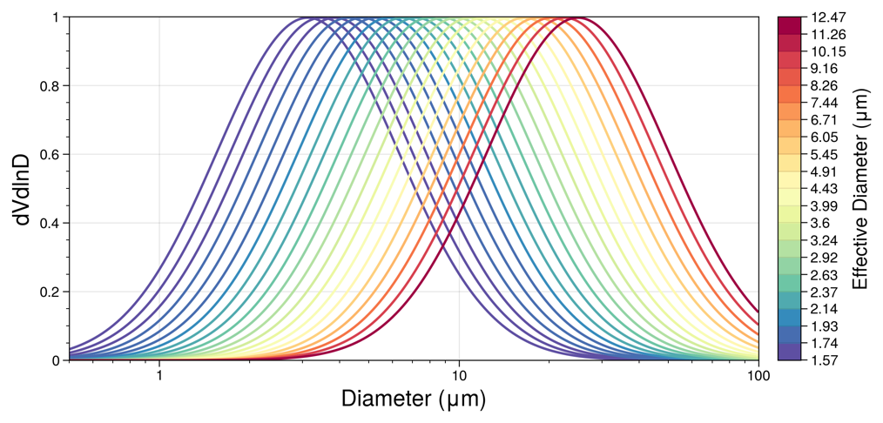
Figure S1: The log-normal volume size distribution of dust assumed in the TIR retrieval.

