Authors: Alonzo, M., Baker, M.E., Gao, Y., Shandas, V.
Title: Spatial configuration and time of day impacts the magnitude of urban tree canopy cooling

Supplementary Materials:
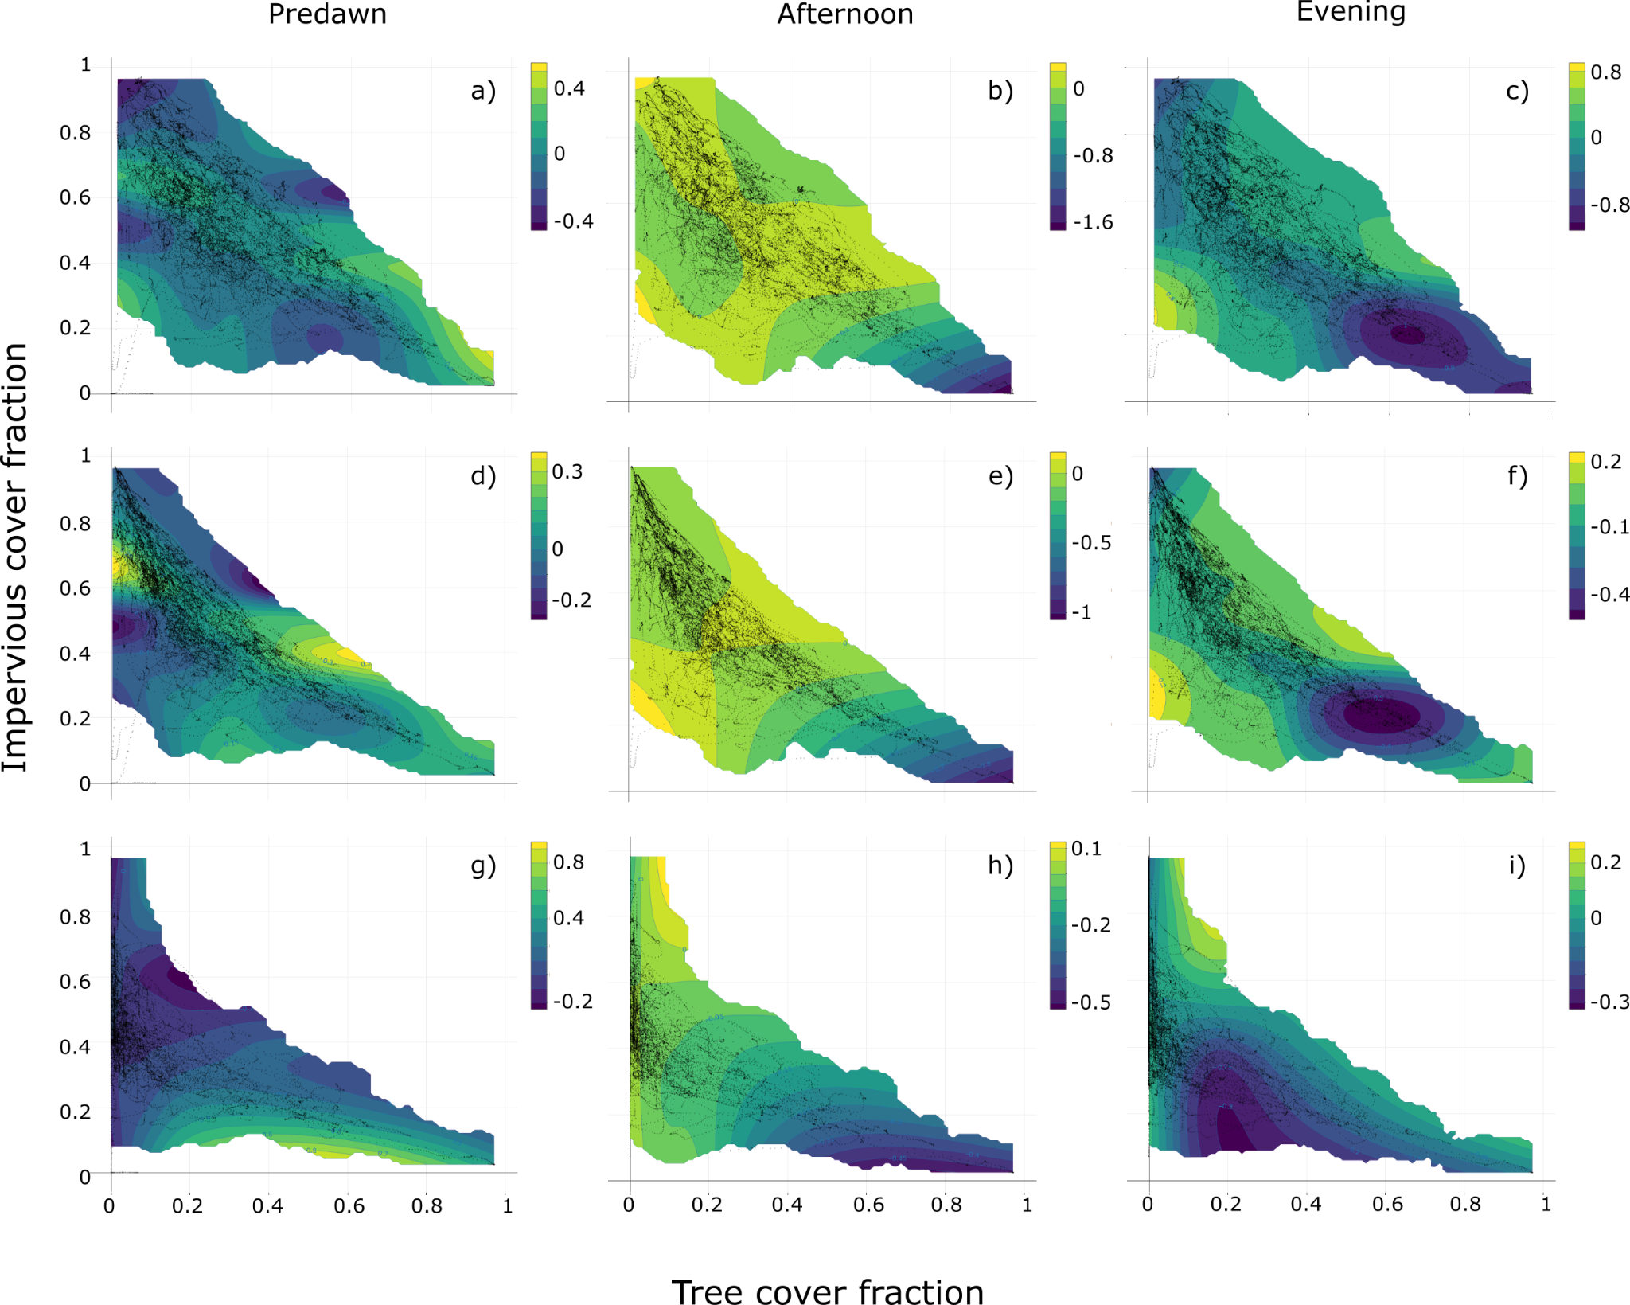
Figure S1: Significant (p<0.05) interactions between canopy and impervious surface by time of day. Colors indicate warming (positive) or cooling (negative) effect. a-c: Tree canopy fraction (TCF) and impervious; d-f: Soft canopy fraction (SCF) and impervious; g-i: PATCH and impervious. Predawn is 5:00 to 6:00, afternoon is 14:00 to 15:00, and evening is 18:00 to 19:00.

