
Geophysical Research Letters
Supporting Information for
Changes in extreme precipitation and landslides over High Mountain Asia
D. Kirschbaum¹, S. Kapnick², T. Stanley^{3,1}, S. Pascale⁴
¹ Hydrological Sciences Laboratory, NASA Goddard Space Flight Center, Greenbelt, MD.
² NOAA/Geophysical Fluid Dynamics Laboratory, Princeton, NJ.
³ Universities Space Research Association, Columbia, MD.
⁴ Department of Earth System Science, Stanford University, Stanford CA.

Contents of this file

Text S1 to S3
Figures S1 to S3
Table S1
Introduction
The supporting information provides further descriptions of the methods, model settings and additional results that support the findings provided in the manuscript. This includes one table and three figures.

Text S1. GCM Simulation, Satellite Precipitation, and Socioeconomic Data Description
In this study we use two separate configurations of the GFDL FLOR model (Vecchi et al., 2014) to generate daily precipitation at 0.5˚ x 0.5˚ global resolution. At this horizontal resolution, we are able to generate a sufficiently large data set—hundreds of years of data—to study precipitation extremes. FLOR data from this study is available at: ftp://data1.gfdl.noaa.gov/users/Sarah.Kapnick/HiMAT/GFDL-FLOR/Kirschbaumetal/. The FLOR model has been previously used to produce precipitation extremes and project future changes over the United States (van der Wiel et al., 2016). A similar GCM to FLOR sharing the same 0.5˚ atmosphere and a higher resolution ocean component was previously found to reasonably reproduce the seasonal cycle of precipitation in HMA, a region where GCMs at lower atmospheric resolutions, such as those found in the Coupled Model Intercomparison Project Phase 5 database, cannot (Kapnicket al., 2014). Two configurations are used to generate separate simulations to explore precipitation extremes and landslides.

The first set consists of a nudged simulation with the FLOR components (Nudged GCM) to generate output where individual years can be compared directly with remote sensing and observed landslides. In this configuration, sea surface temperatures (SSTs) were restored to the National Oceanic and Atmospheric Administration (NOAA) optimum interpolation SST (OISST) analysis (Reynolds et al., 2002) and the atmosphere was nudged with values for surface pressure, three-dimensional temperature and horizontal winds from Modern-Era Retrospective analysis for Research and Applications, Version 2 (MERRA-2) every 6 hours from 1982-2017 (Yang et al., 2018). The Nudged GCM output is critical for validating present-day landslide hazards generated from simulated daily precipitation values.

This analysis provides a bridge to conducting climate change simulations of landslides using the GCM Ensemble using the fully coupled version of FLOR to project future climate. A 30-member ensemble (GCM Ensemble) (Zhang & Delworth, 2018) using historical radiative forcing and projected forcings from the Representative Contribution Pathway 8.5 (RCP8.5) are used to force a fully coupled configuration of FLOR. The individual ensemble members differ in their initial conditions at year 1920, generated by choosing different start years from a control simulation of year 1920 where radiative forcings are held fixed.

The TMPA product is developed using an international constellation of microwave and infrared instruments to produce 3-hourly, near real-time estimates of precipitation from 50˚N-S from 2000 to the present. The data is available at 0.25-degree resolution and is publically available at https://pmm.nasa.gov/. While the Global Precipitation Measurement (GPM) GPM Integrated Multi-Satellite Retrievals for GPM (IMERG; (Huffman et al., 2018) product is not considered in this analysis due to the absence of a long record (though one will be anticipated in 2019), the IMERG data is used to force the near real-time LHASA mode. These data are available at https://pmm.nasa.gov/precip-apps.

Table S1. Precipitation Products Considered
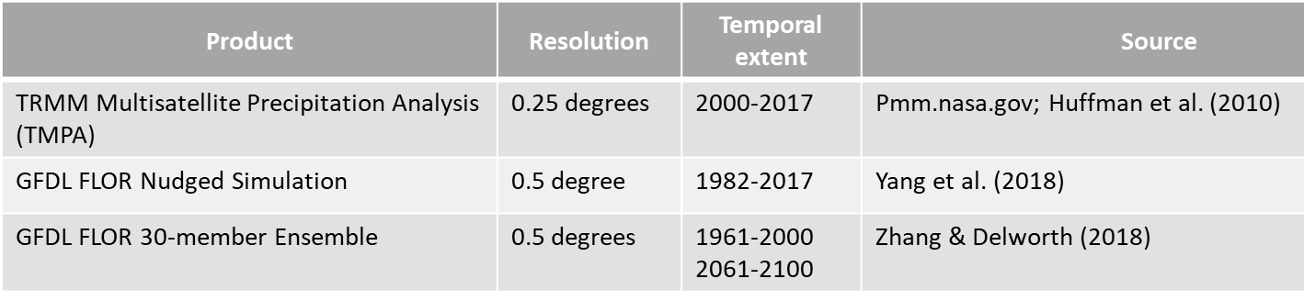

The projected population data for 2100 was evaluated for five socioeconomic pathways (SSPs) from the Global Population Projection Grids Based on Shared Socioeconomic Pathways dataset (Jones & O’Neill, 2016). The SSPs provide five different baselines for potential population, technological and economic growth based that are largely driven by variations in climate policies. In this study, we consider the projected population changes only to specifically evaluate the potential change in populate exposure to landslide activity at the end of the century. To do this, we compare the intersection of the forecasted potential landslide changes to that of population change at each grid cell across the study area. We then aggregate this information across the study area and classify the percent change in landslide potential into 10% bins. Results are shown in Fig 4 in the manuscript.

Text S2. Distributions of Extreme Precipitation

The HMA region of focus in this study (i.e., our study area) is that with the highest number of landslides along the Himalayan foothills and mountains, which correspond to locations featuring very steep terrain (Main manuscript, Fig. 1). The analysis of daily precipitation extremes in FLOR is therefore restricted to only those grid-points with a slope threshold of 0.6 degrees. While somewhat arbitrary, this choice effectively selects a band of grid points along the zone of rapid elevation increase where most landslides take place (Fig. 1). This study area, originally defined on the FLOR horizontal grid, is then re-gridded onto the TMPA horizontal grid using the nearest-neighbor method.
To characterize the probability distribution of daily precipitation, we take the daily precipitation amounts occurring during the winter November-April (NDJFMA) and summer May-October (MJJASO). We consider all the grid-points within the study area without area-averaging, and for the FLOR ensemble, all 30 ensemble members. An empirical probability distribution function (histogram) is then obtained by computing the density function for each value within a discrete daily precipitation amounts array (bin of 0.5 mm/day).

Results indicate that the precipitation distributions for winter precipitation does not align as closely with the TMPA product, which may be due to several factors. First, the TRMM instruments are specifically designed to measure moderate to heavy rainfall and fails to resolve falling snow and light rain processes. This may serve to underestimate the precipitation from winter westerlies. Second there are challenges with accurate retrievals with ice clouds over snow and ice surfaces. For the FLOR ensembles, the microphysics relating to frozen precipitation may require further adjustment to reduce bias over complex terrain (e.g. Pavelsky et al., 2012). These issues are areas of active research with new satellite products such as the Global Precipitation Measurement (GPM) mission as well as model analyses.

For additional verification of the differences in distributions of precipitation extremes, we also calculated quantile-quantile plots for the present and future precipitation values in the FLOR model and TMPA. The closer the individual points are to the y=x line (plotted as a dotted line), the closer the distributions are to each other. In the present climate comparisons, the FLOR Ensemble simulations diverge the most from TMPA at the highest values (Fig. S1a, S2a); this is an expected outcome given the shorter TMPA record. They have relatively good agreement at lower values, particularly in summer (Fig. S1a). Some of the difference in distributions in winter (Fig. S2a) may be due to lower accuracy of TMPA in winter due to retrieval issues over snow and biases in capturing frozen precipitation (Andermann et al., 2011). The FLOR nudged simulations and FLOR Ensemble present climate (1961-2000) simulations similarly are not perfectly matched, especially at higher values, which can be attributed to slightly different periods being compared with differences in radiative forcing during the time periods of coverage and longer record of the FLOR Ensemble.

In the present versus future comparisons (Figs. S1b, S2b), the distributions are similar at lower values, but diverge as values become more extreme. This is particularly pronounced during the summer (Fig. S1b).
Figure S1: Quantile-quantile plots for various summer season precipitation extremes in estimates of (a) the present climate, including TMPA, FLOR nudged, and FLOR Ensemble for the present climate 1961-2000 and (b) the FLOR present climate (1961-2000) versus the future climate (2061-2100).
Figure S2: Same as Fig. S1, but for the winter season.

The analysis of potential landslide activity was also compared between winter and summer months considering both current and future conditions, which is highlighted in Figure S3. Results indicate the most significant changes in potential activity will occur during the summer months due to the intense monsoon rains that occur during this period.
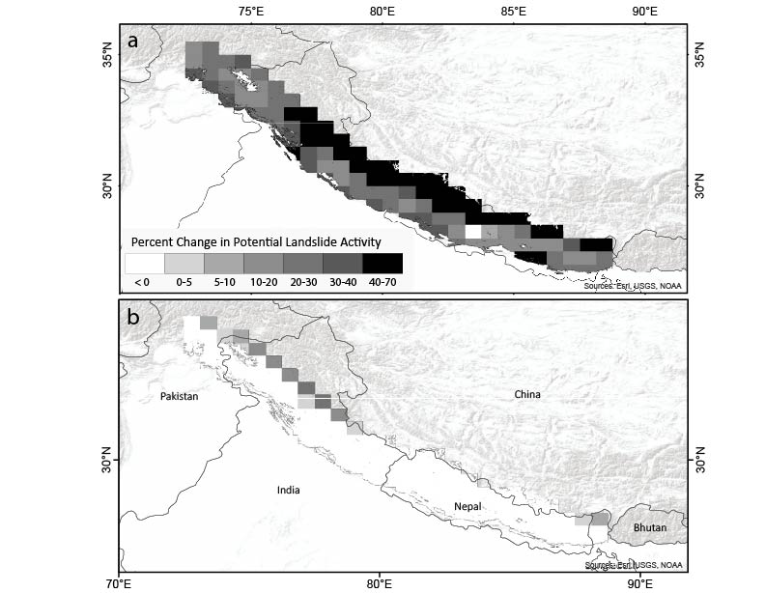
Figure S3: Percent change in potential landslide activity for the future scenario (2061-2100) relative to baseline conditions for present scenario (1961-2000) for a) summer and b) winter months.

Text S3: Glacial Lake Dynamics
The study finding that landslide frequency may increase within areas of current glacial lakes has implications for how these glacial systems may respond. One consideration in the future scenario of rapidly retreating glaciers is the presence of more runoff. Today, landslides may block rivers and create artificial lakes. In the future, glaciers may generate more meltwater, leading to larger lakes and greater opportunities for landslide generated dams of lakes or rivers (Nie et al., 2017; Zhang et al., 2015). Conversely, meltwater may decrease due to smaller glacial volumes, which could minimize these impacts by causing smaller glacial lakes. While studies shows continued mass loss from glaciers, the projected onset of peak meltwater can significantly vary by region and climate change scenarios (IPCC, 2014). The meltwater coming from these changing glaciers can also be considered as a benefit to communities within HMA who rely on the fresh water for consumption (Jones et al. 2018).

References
Andermann, C., Bonnet, S., & Gloaguen, R. (2011). Evaluation of precipitation data sets along the Himalayan front. Geochemistry, Geophysics, Geosystems, 12(7). https://doi.org/10.1029/2011GC003513
Huffman, G. J., Bolvin, D. T., Braithwaite, D., Hsu, K., Joyce, R. J., & Xie, P. (2018). Algorithm Theoretical Basis Document (ATBD) for NASA Global Precipitation Measurement (GPM) Integrated Multi-satellitE Retrievals for GPM (IMERG) v5.2. Retrieved from https://pmm.nasa.gov/sites/default/files/document_files/IMERG_ATBD_V5.2_0.pdf
Jones, D. B., Harrison, S., Anderson, K., Selley, H. L., Wood, J. L., and Betts, R. A. (2018). The distribution and hydrological significance of rock glaciers in the Nepalese Himalaya. Glob. Planet. Change 160, 123–142. https://doi.org/10.1016/j.gloplacha.2017.11.005.
Jones, B., & O’Neill, B. C. (2016). Spatially Explicit Global Population Scenarios Consistent with the Shared Socioeconomic Pathways. Environmental Research Letters2, 11(084003). https://doi.org/doi.org/10.1088/1748-9326/11/8/084003
Kapnick, S. B., Delworth, T. L., Ashfaq, M., Malyshev, S., & Milly, P. C. D. (2014). Snowfall less sensitive to warming in Karakoram than in Himalayas due to a unique seasonal cycle. Nature Geoscience, 7, 834. Retrieved from https://doi.org/10.1038/ngeo2269
Nie, Y., Sheng, Y., Liu, Q., Liu, L., Liu, S., Zhang, Y., & Song, C. (2017). A regional-scale assessment of Himalayan glacial lake changes using satellite observations from 1990 to 2015. Remote Sensing of Environment, 189, 1–13. https://doi.org/10.1016/J.RSE.2016.11.008
Pavelsky, T. M., Sobolowski, S., Kapnick, S. B., & Barnes, J. B. (2012). Changes in orographic precipitation patterns caused by a shift from snow to rain. Geophys. Res. Lett. 39. doi:10.1029/2012GL052741.
Reynolds, R. W., Rayner, N. A., Smith, T. M., Stokes, D. C., & Wang, W. (2002). An Improved In Situ and Satellite SST Analysis for Climate. Journal of Climate, 15(13), 1609–1625. https://doi.org/10.1175/1520-0442(2002)015<1609:AIISAS>2.0.CO;2
van der Wiel, K., Kapnick, S. B., Vecchi, G. A., Cooke, W. F., Delworth, T. L., Jia, L., … Zeng, F. (2016). The resolution dependence of contiguous U.S. precipitation extremes in response to CO2 forcing. Journal of Climate, 29(22), 7991–8012. https://doi.org/10.1175/JCLI-D-16-0307.1
Vecchi, G. A., Delworth, T., Gudgel, R., Kapnick, S., Rosati, A., Wittenberg, A. T., … Zhang, S. (2014). On the Seasonal Forecasting of Regional Tropical Cyclone Activity. Journal of Climate, 27(21), 7994–8016. https://doi.org/10.1175/JCLI-D-14-00158.1
Yang, X., Jia, L., Kapnick, S. B., Delworth, T. L., Vecchi, G. A., Gudgel, R., … Zeng, F. (2018). On the seasonal prediction of the western United States El Niño precipitation pattern during the 2015/16 winter. Climate Dynamics, 51(9), 3765–3783. https://doi.org/10.1007/s00382-018-4109-3
Zhang, G., Yao, T., Xie, H., Wang, W., & Yang, W. (2015). An inventory of glacial lakes in the Third Pole region and their changes in response to global warming. Global and Planetary Change, 131, 148–157. https://doi.org/10.1016/J.GLOPLACHA.2015.05.013
Zhang, H., & Delworth, T. L. (2018). Detectability of Decadal Anthropogenic Hydroclimate Changes over North America. Journal of Climate, 31(7), 2579–2597. https://doi.org/10.1175/JCLI-D-17-0366.1

