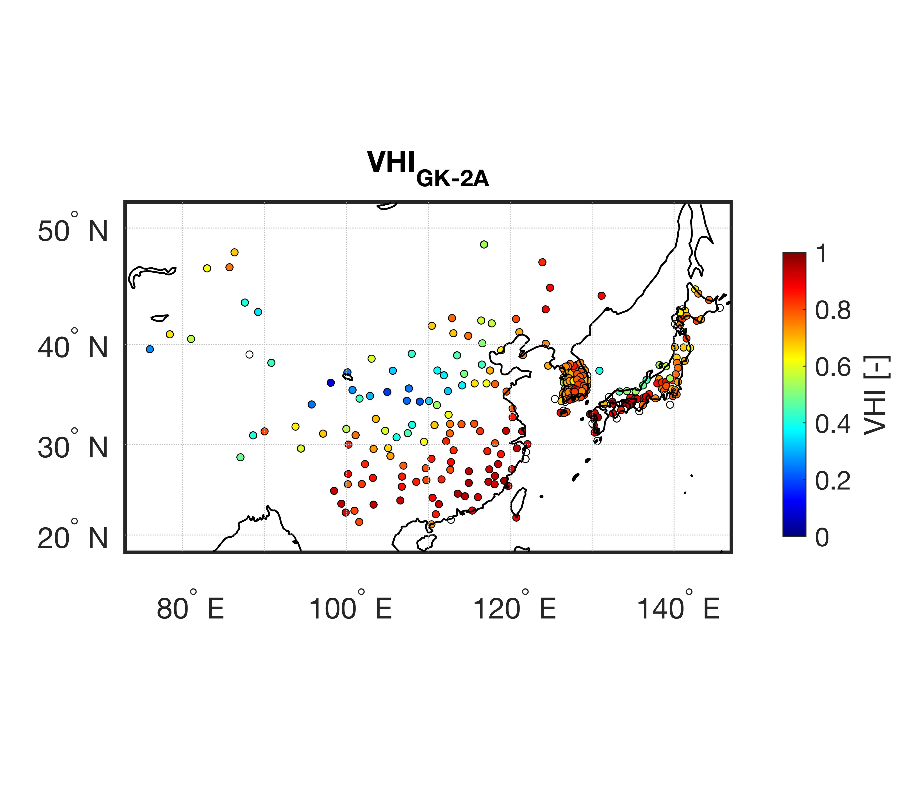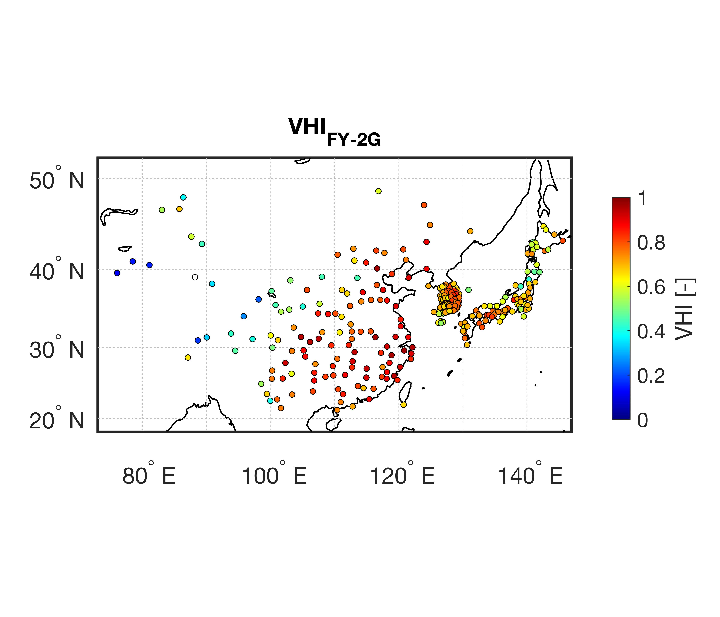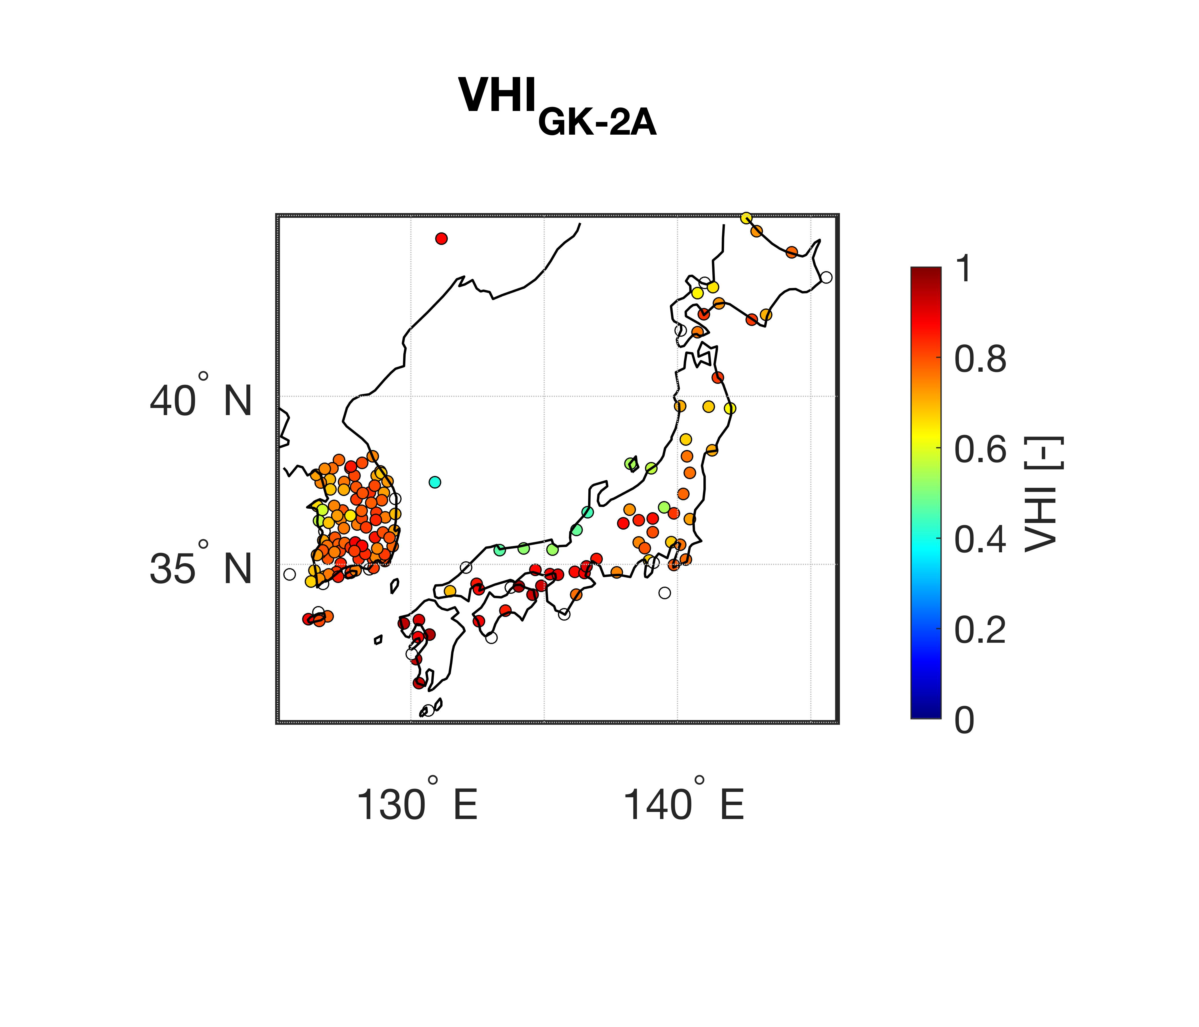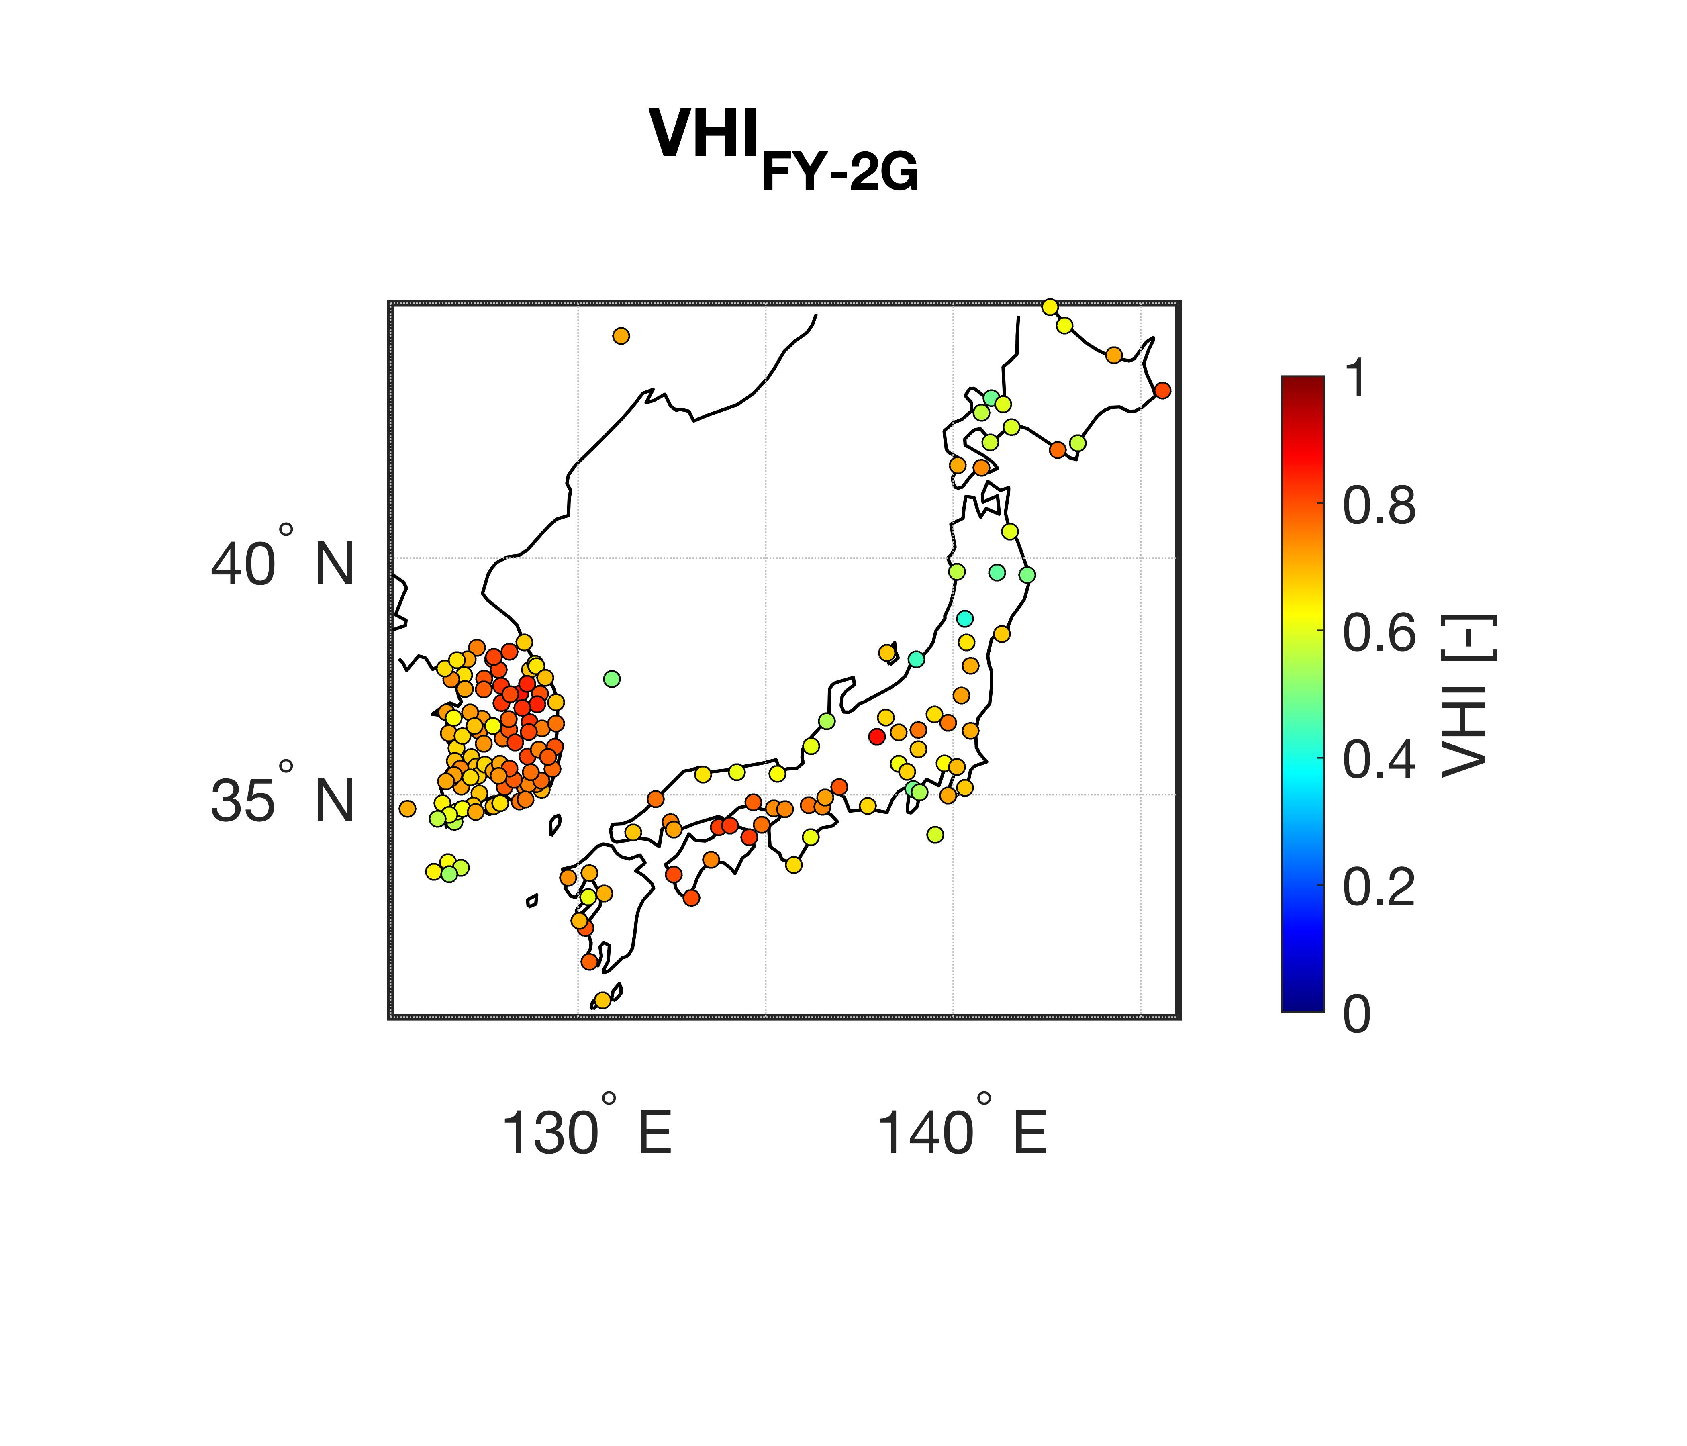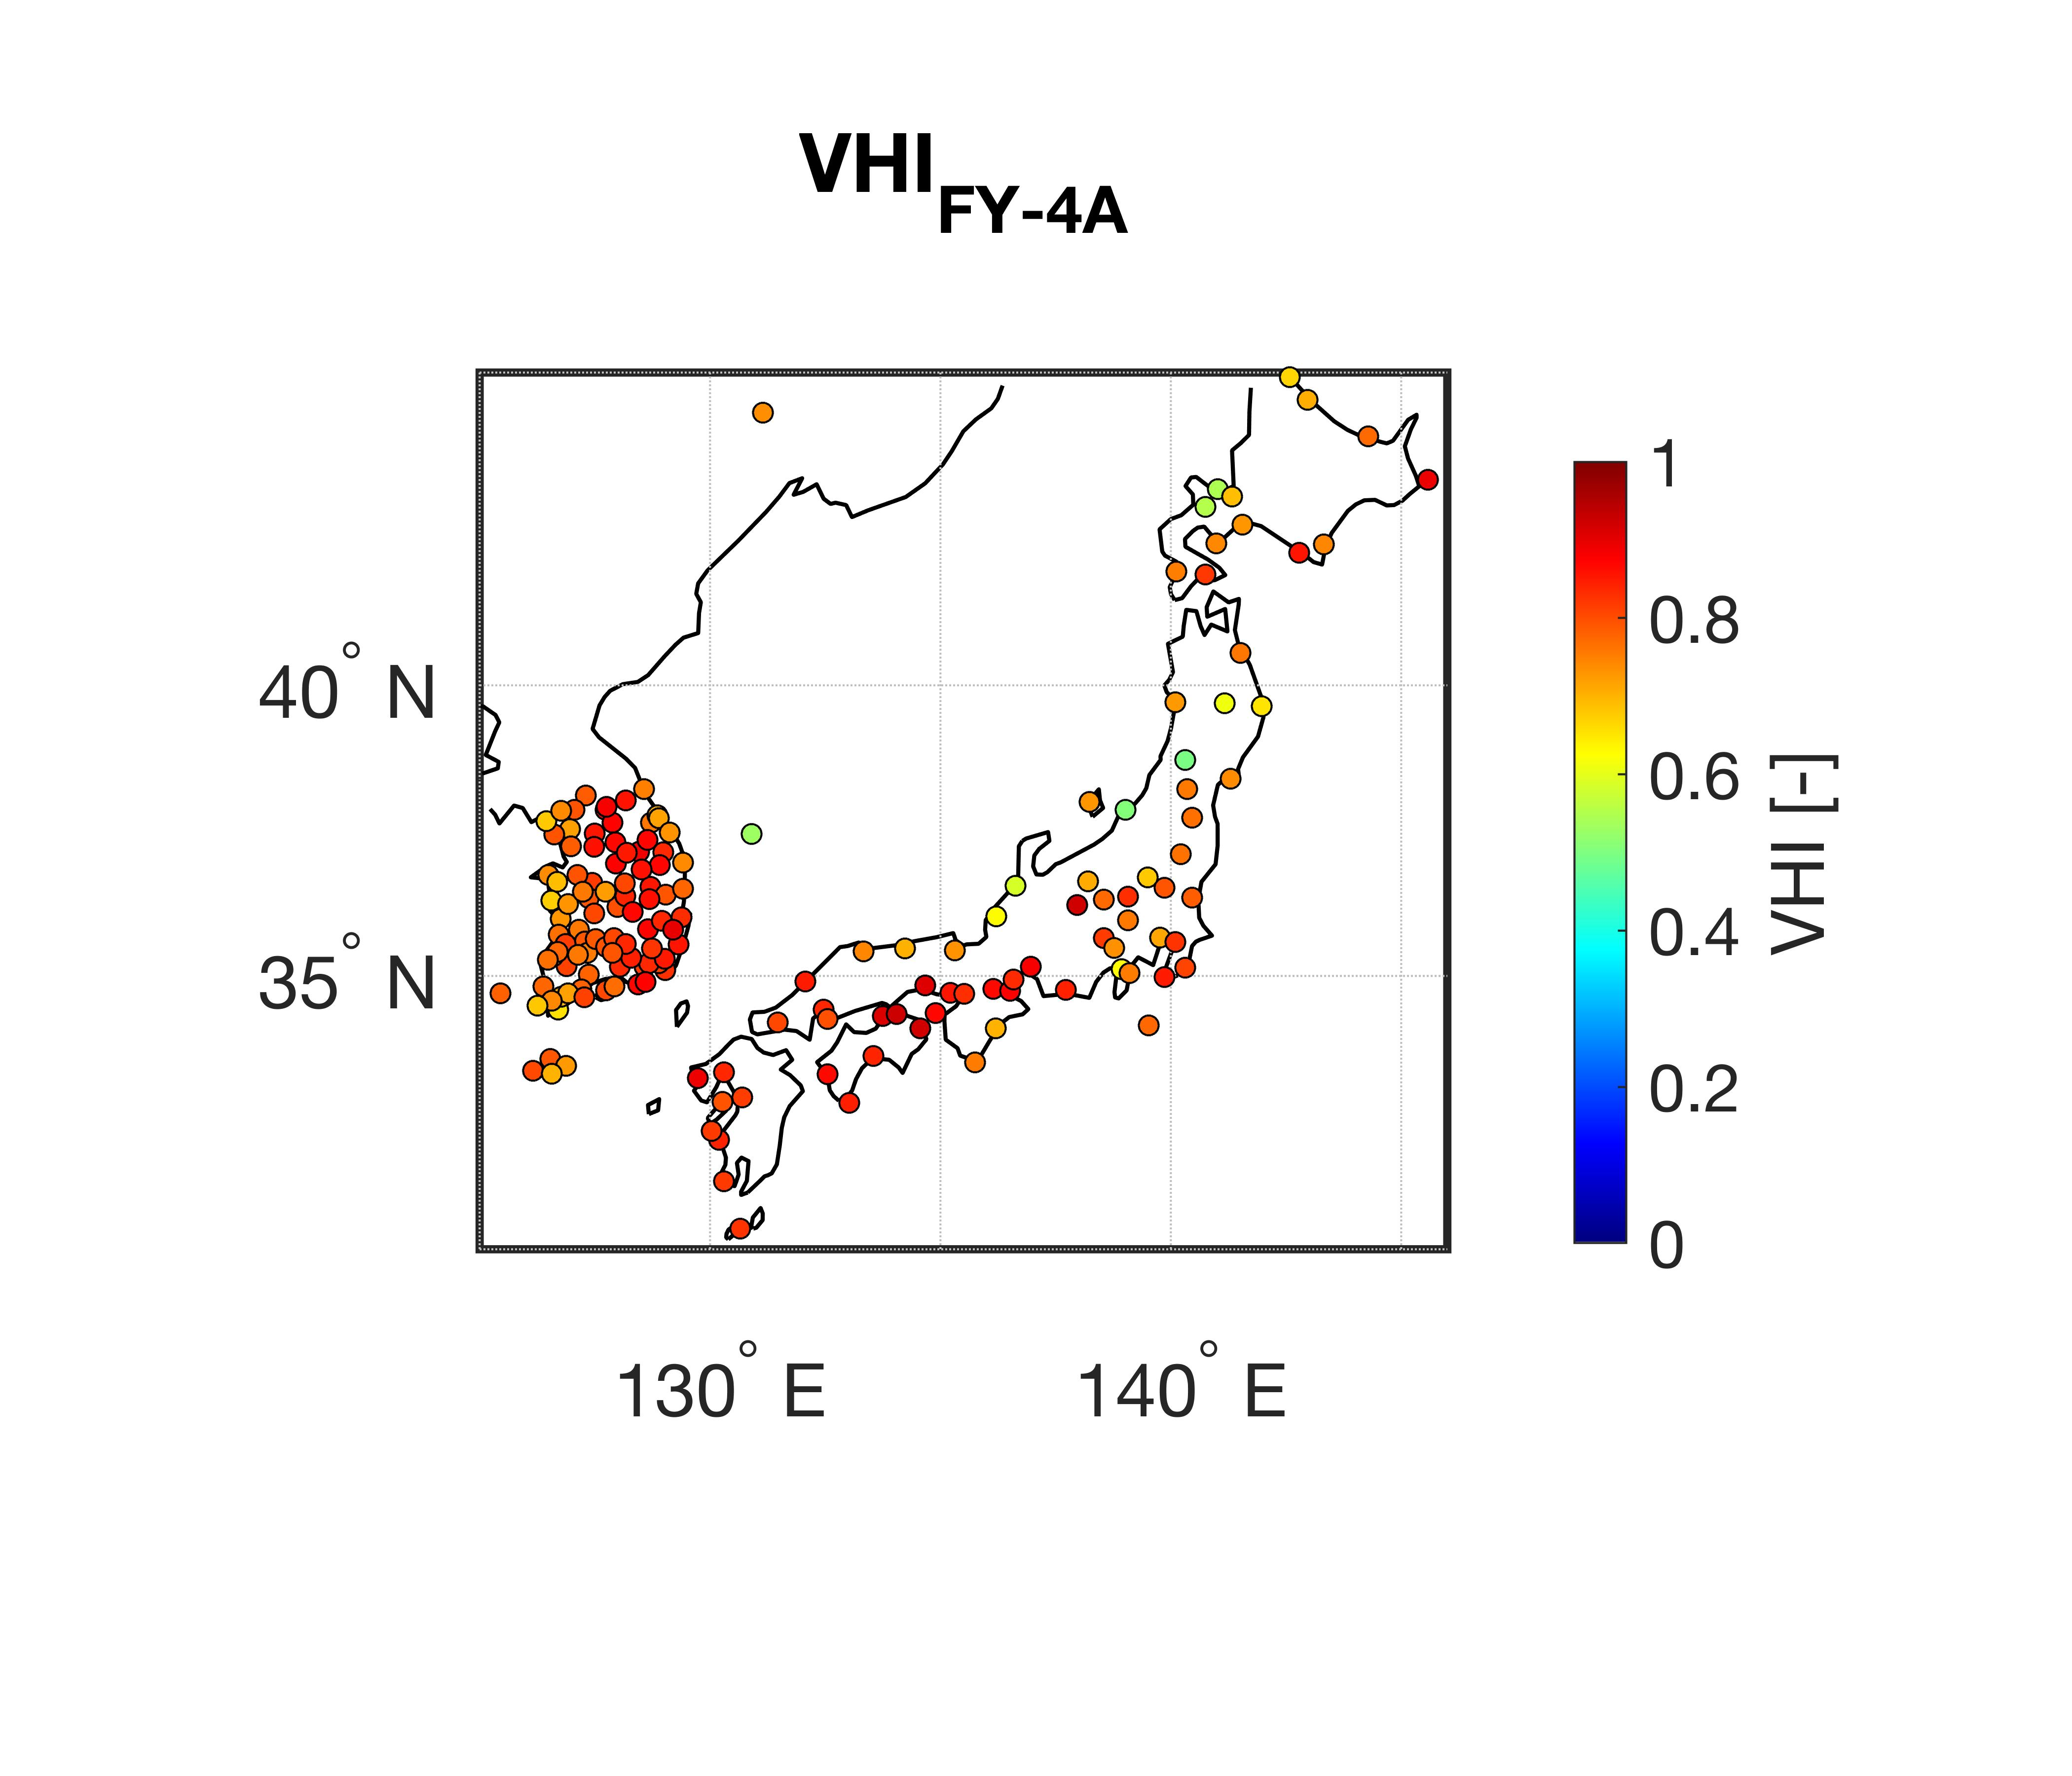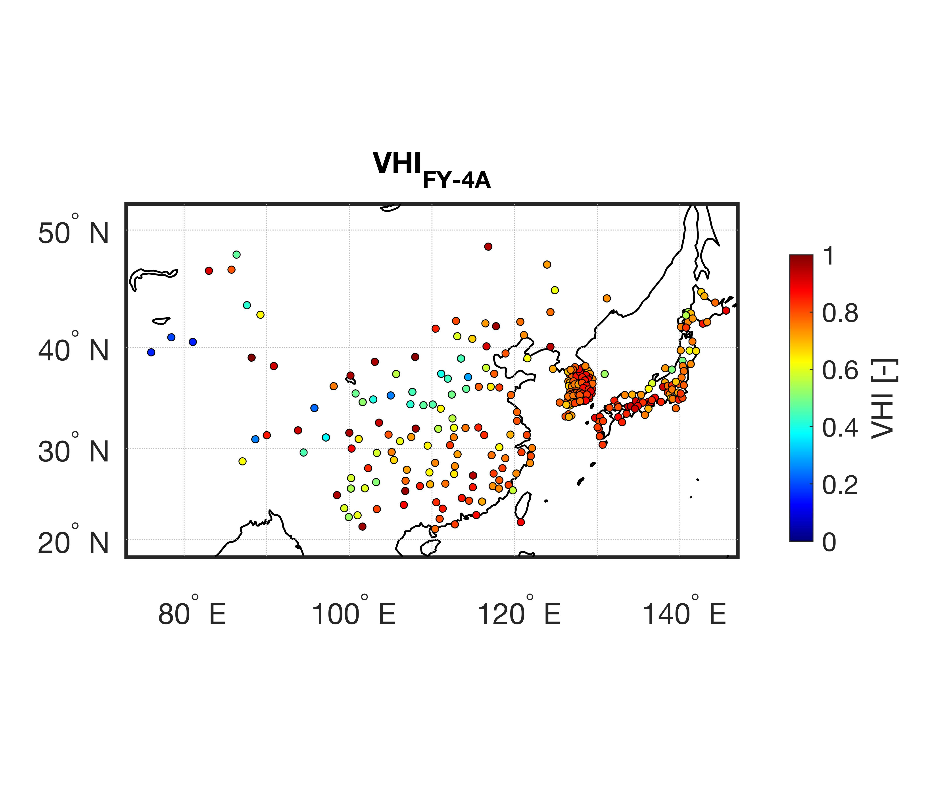
(a)
(b)
(c)
(d)
(e)
(f)

Figure S1. Spatial distribution of volumetric hit index (VHI) for 6-hourly precipitation in 2020 between (a) FY-2G and ground-based stations, (b) FY-4A and ground-based stations, and (c) GK-2A and ground-based stations.

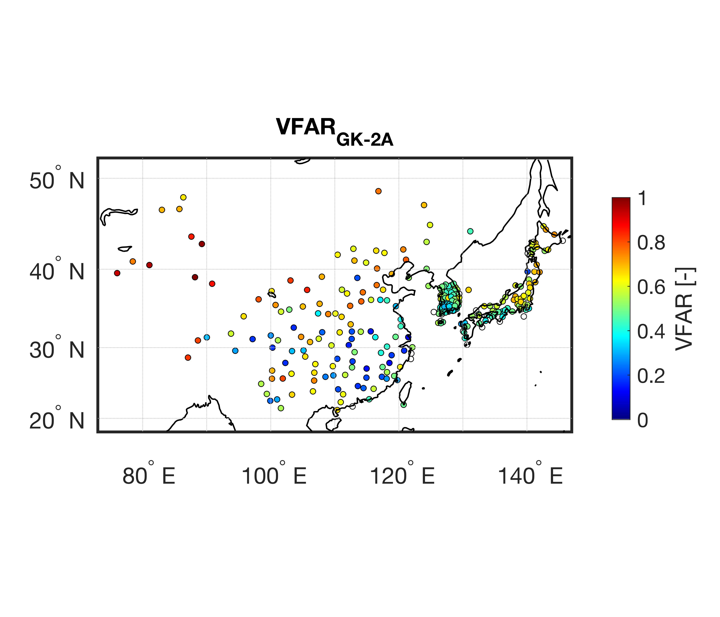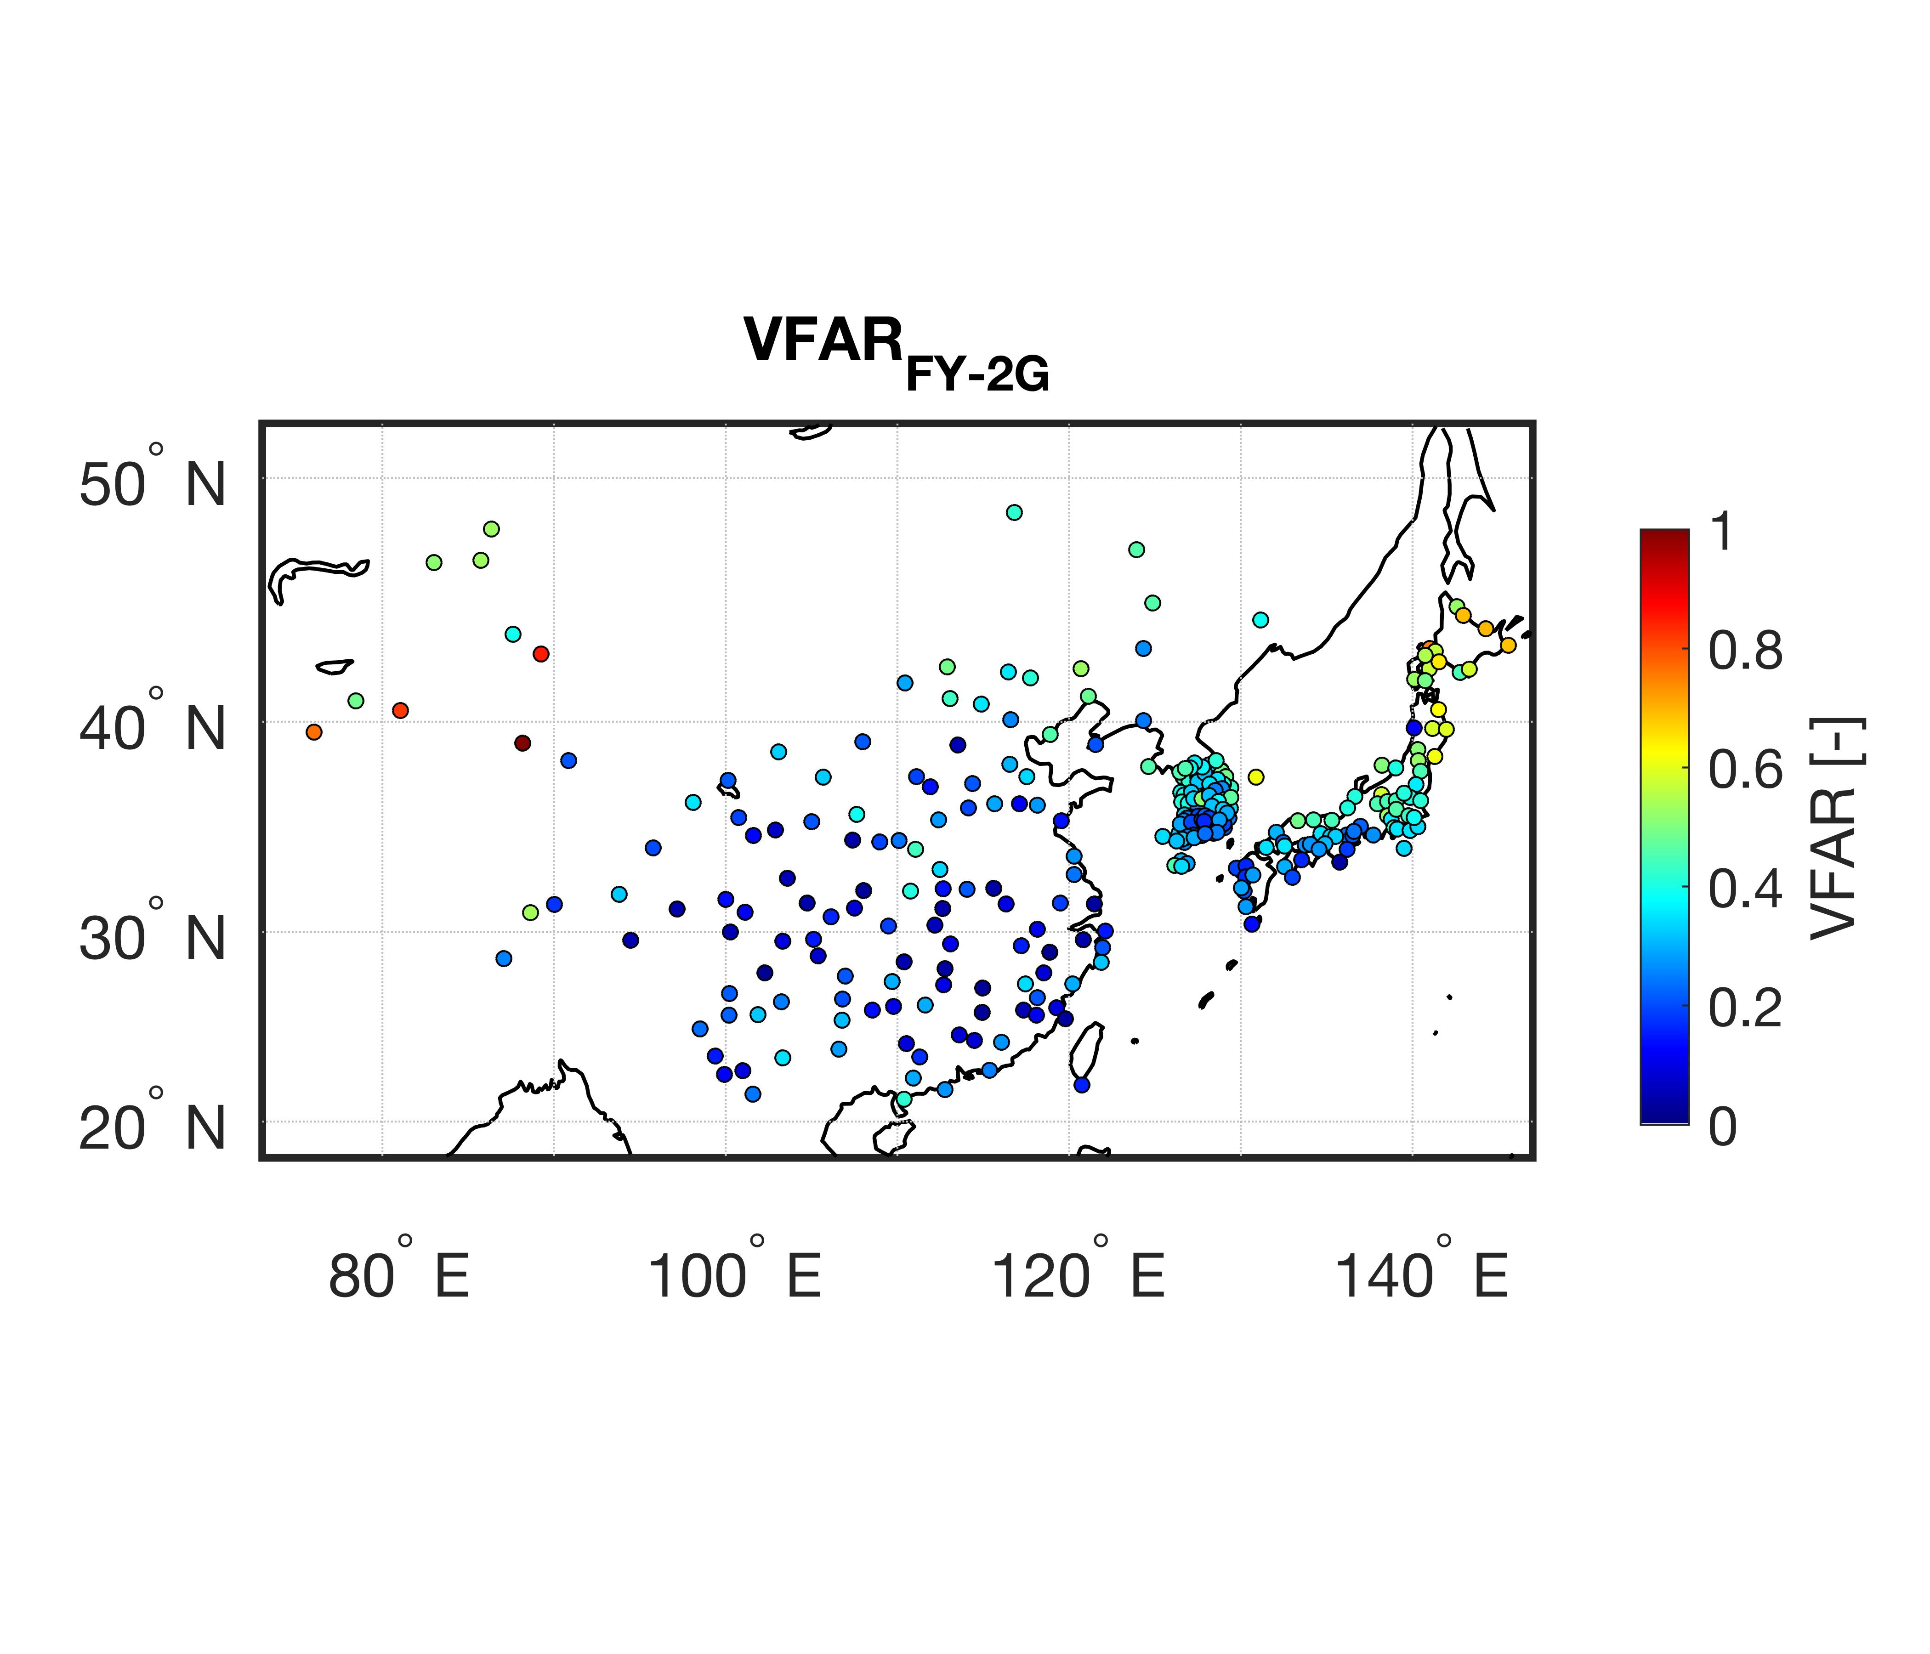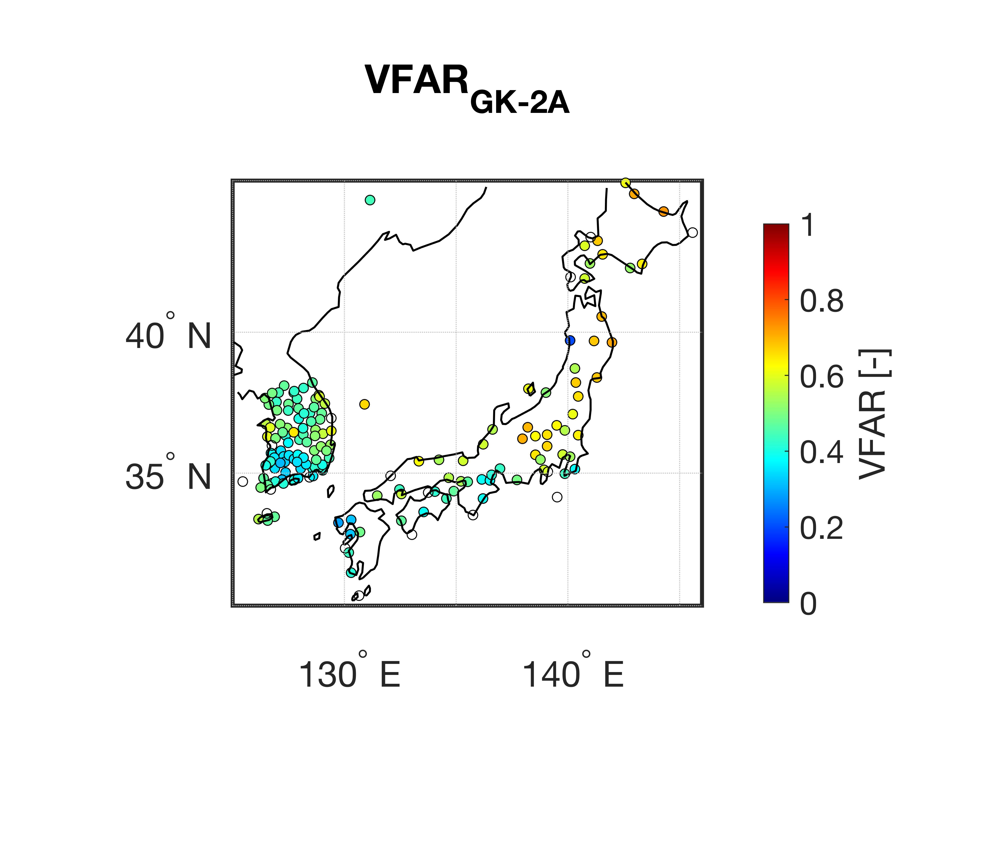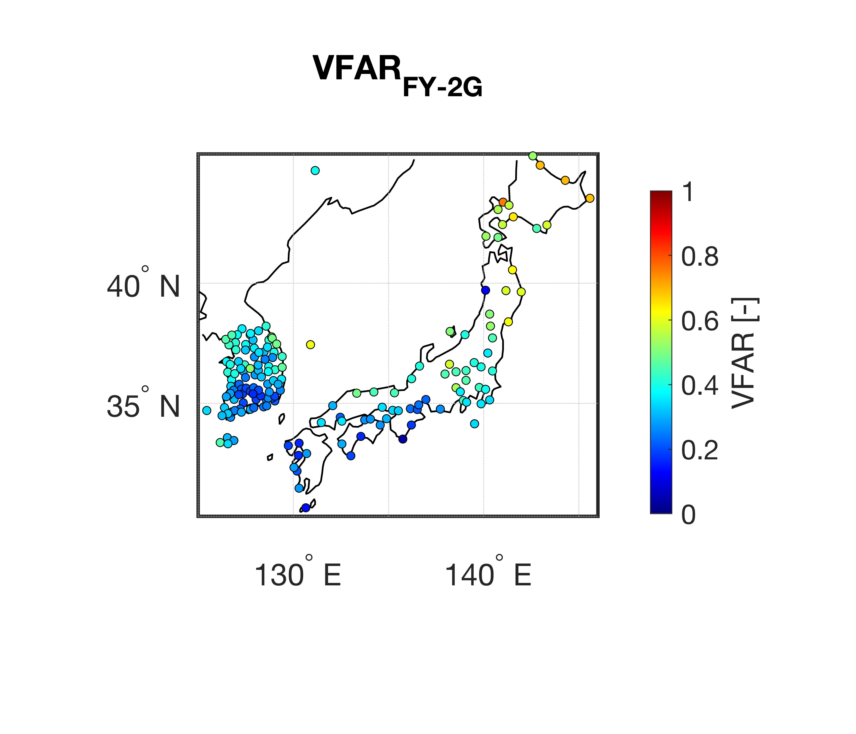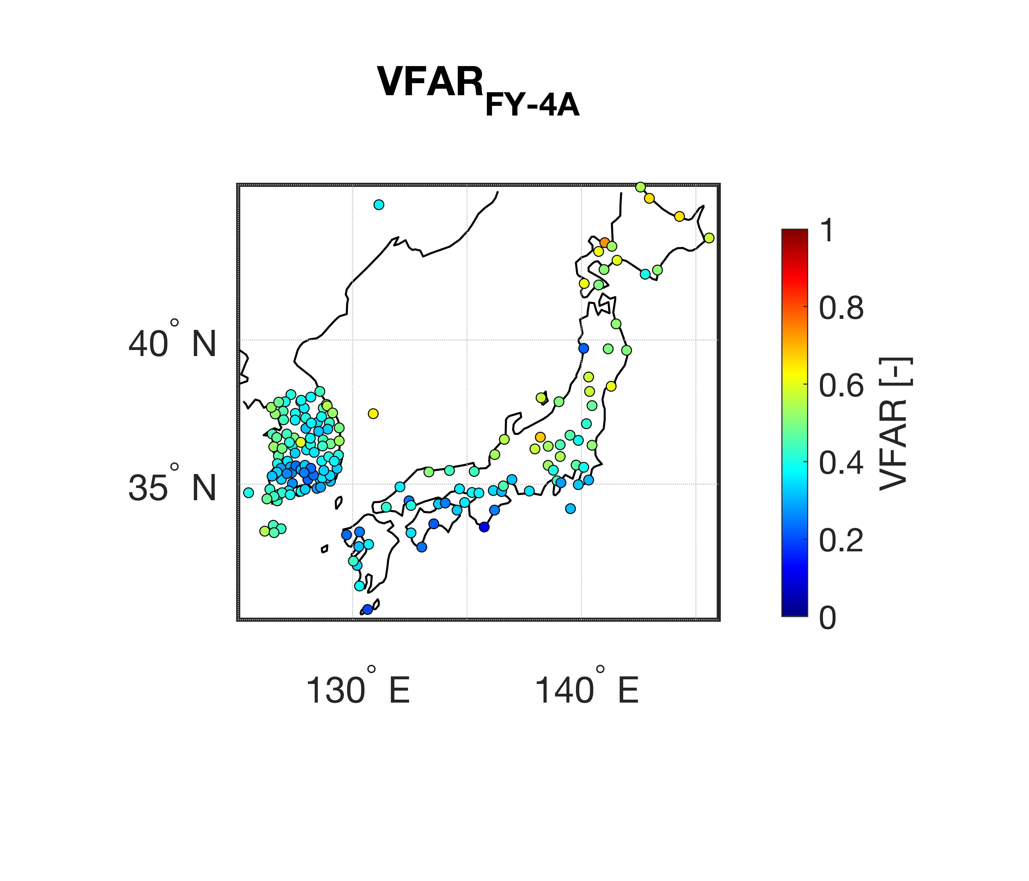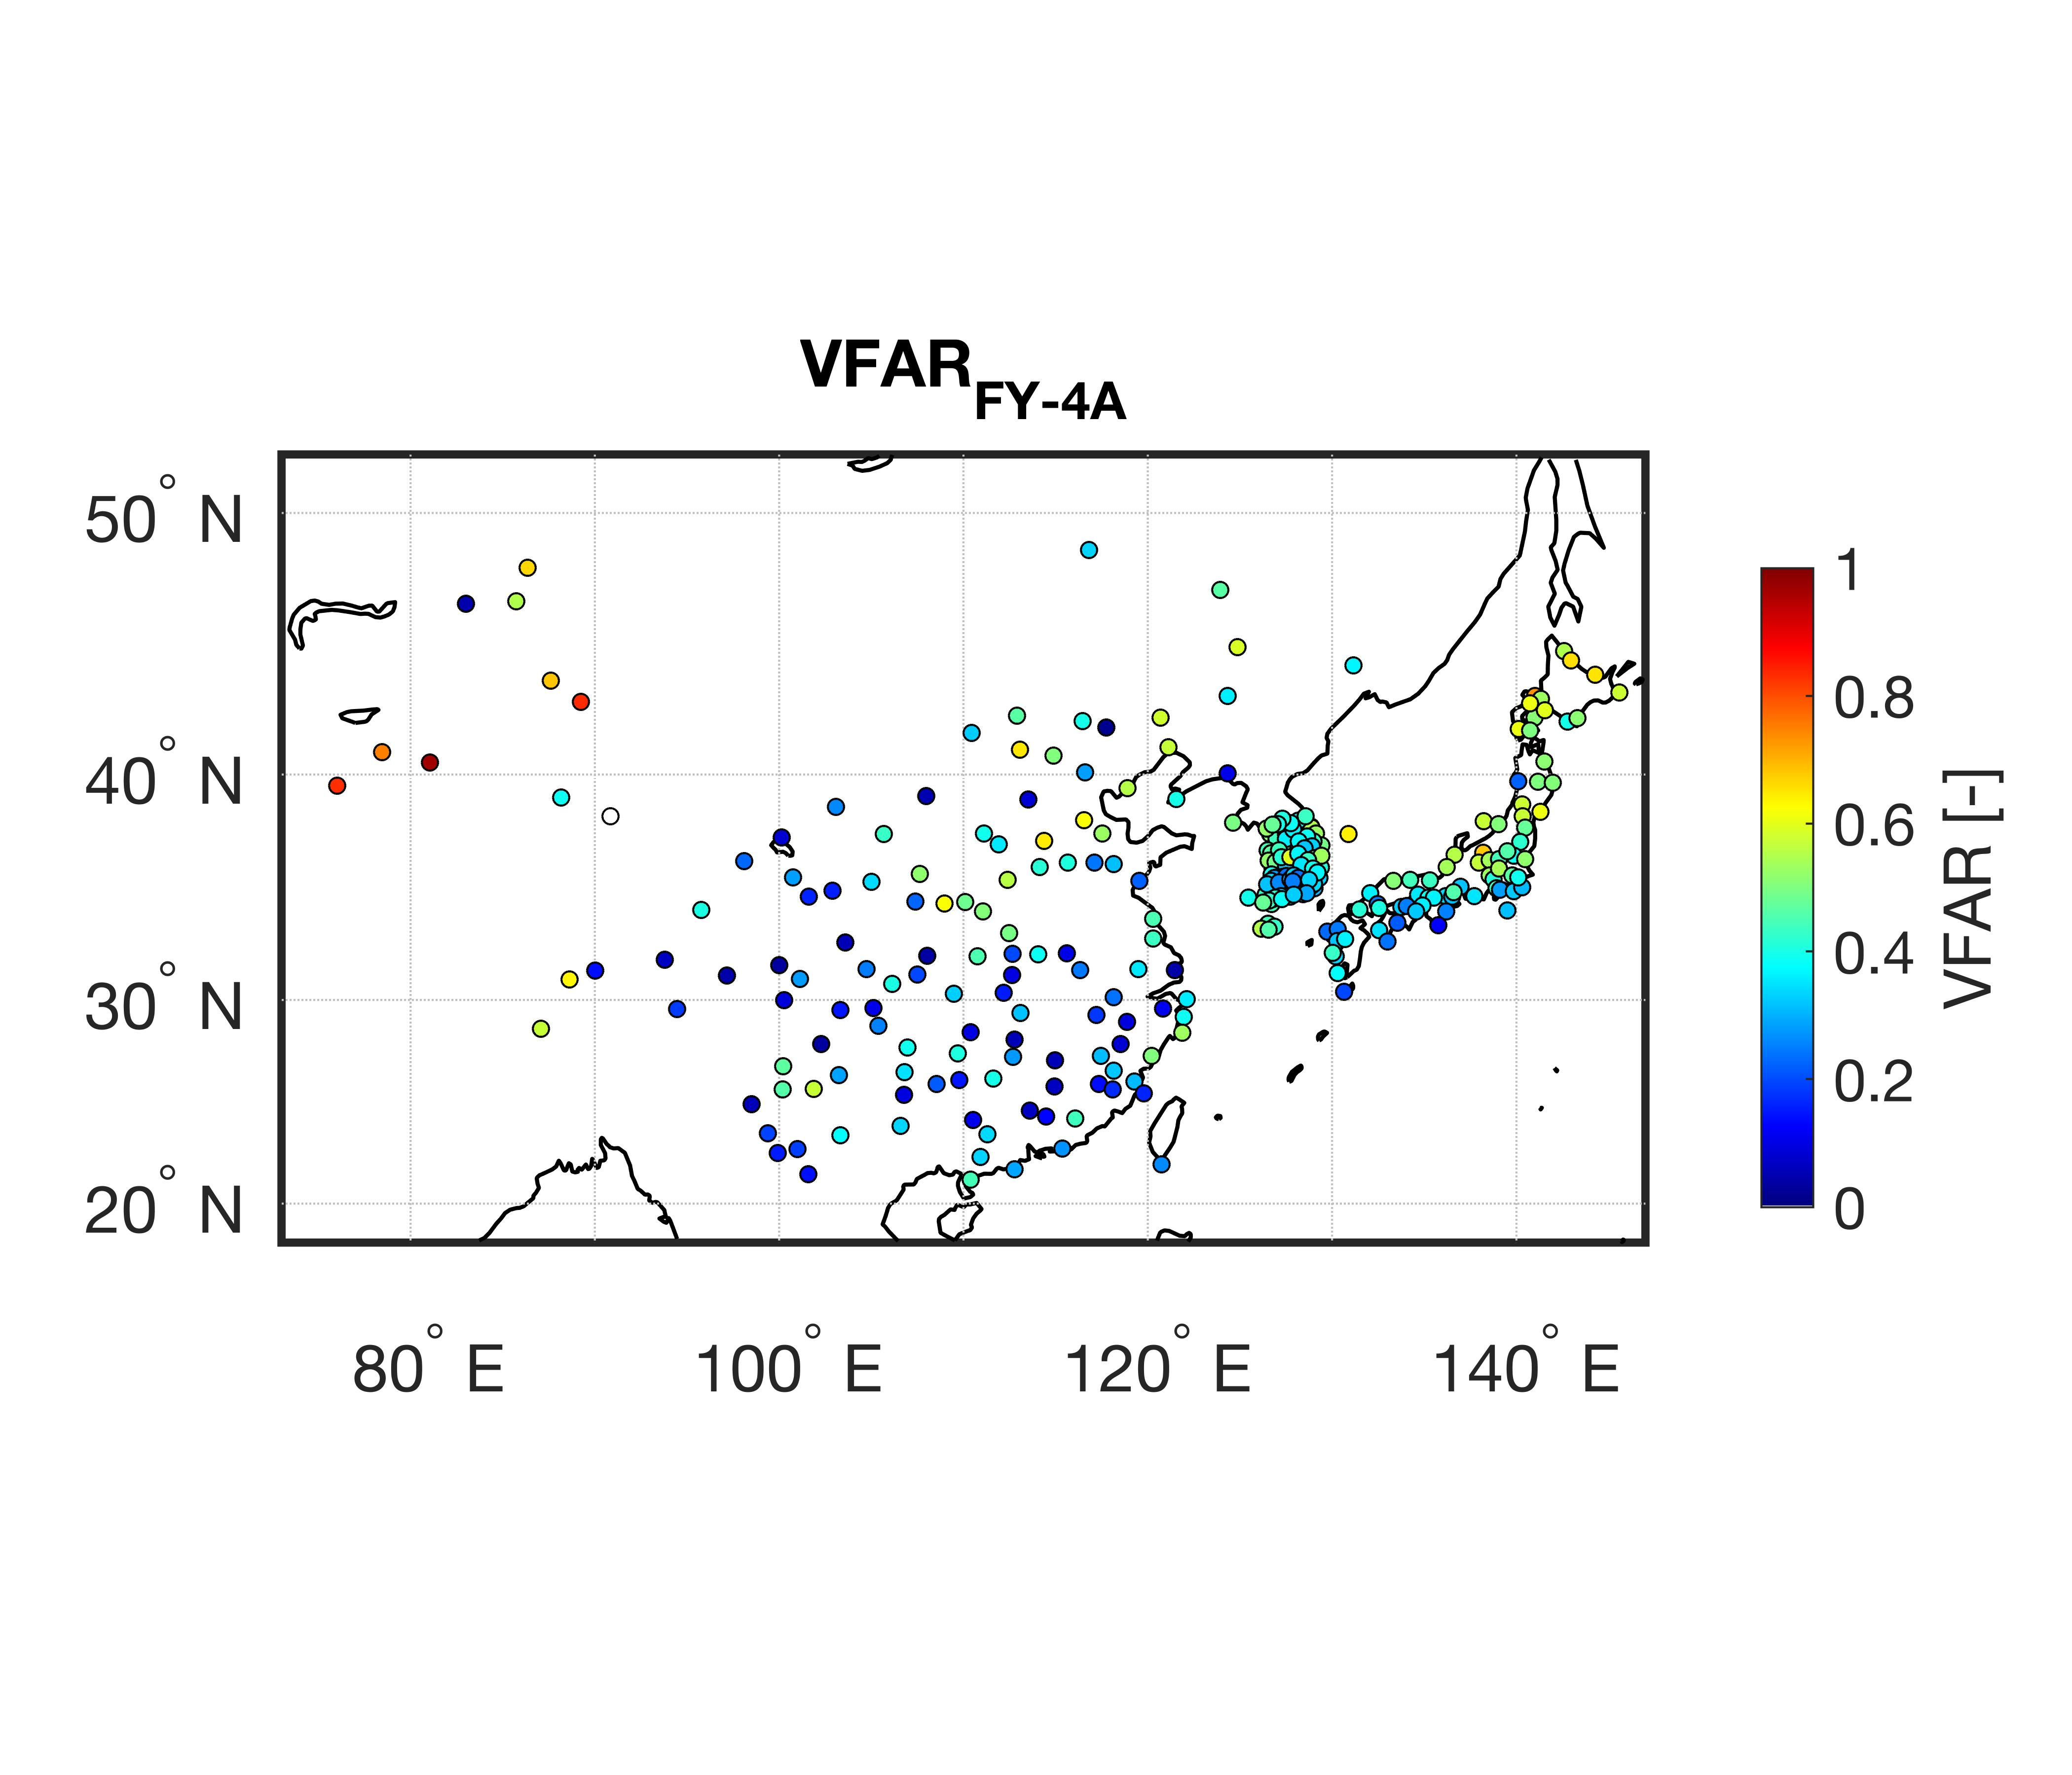
(a)
(b)
(c)
(d)
(e)
(f)

Figure S2. Spatial distribution of volumetric false alarm ratio (VFAR) for 6-hourly precipitation in 2020 between (a) FY-2G and ground-based stations, (b) FY-4A and ground-based stations, and (c) GK-2A and ground-based stations.

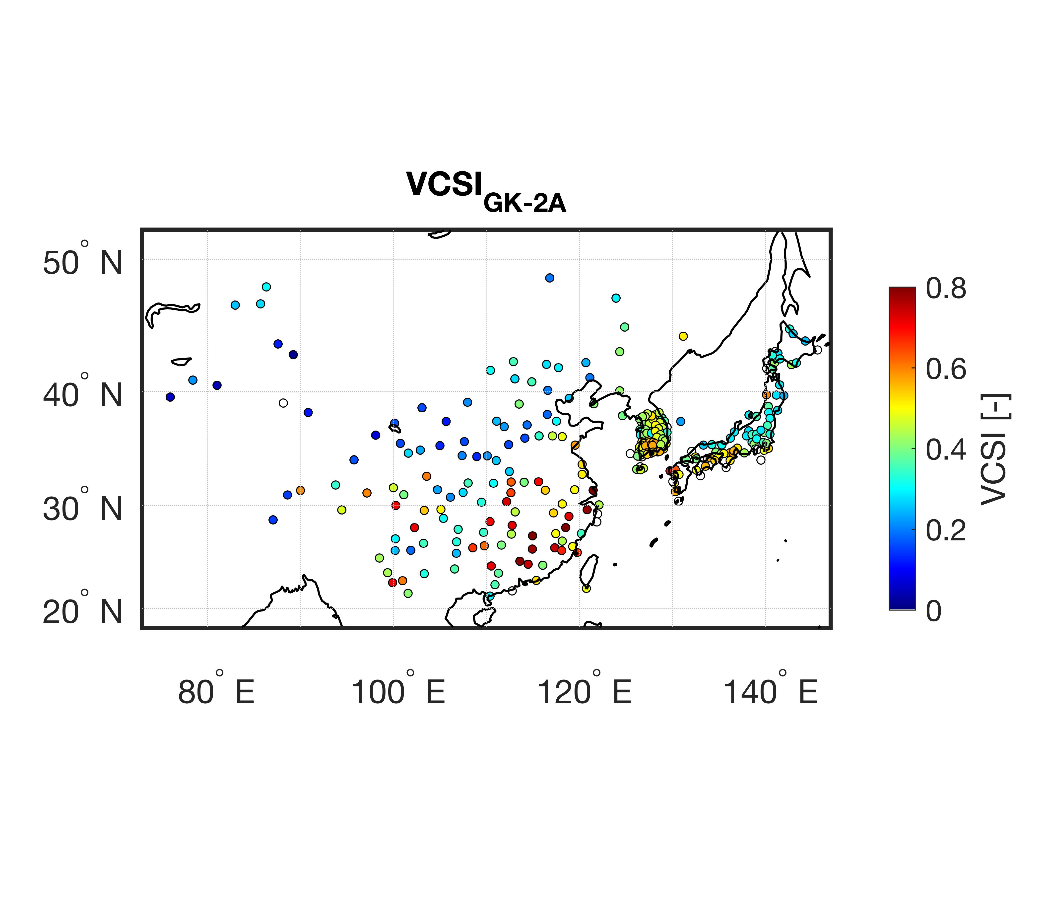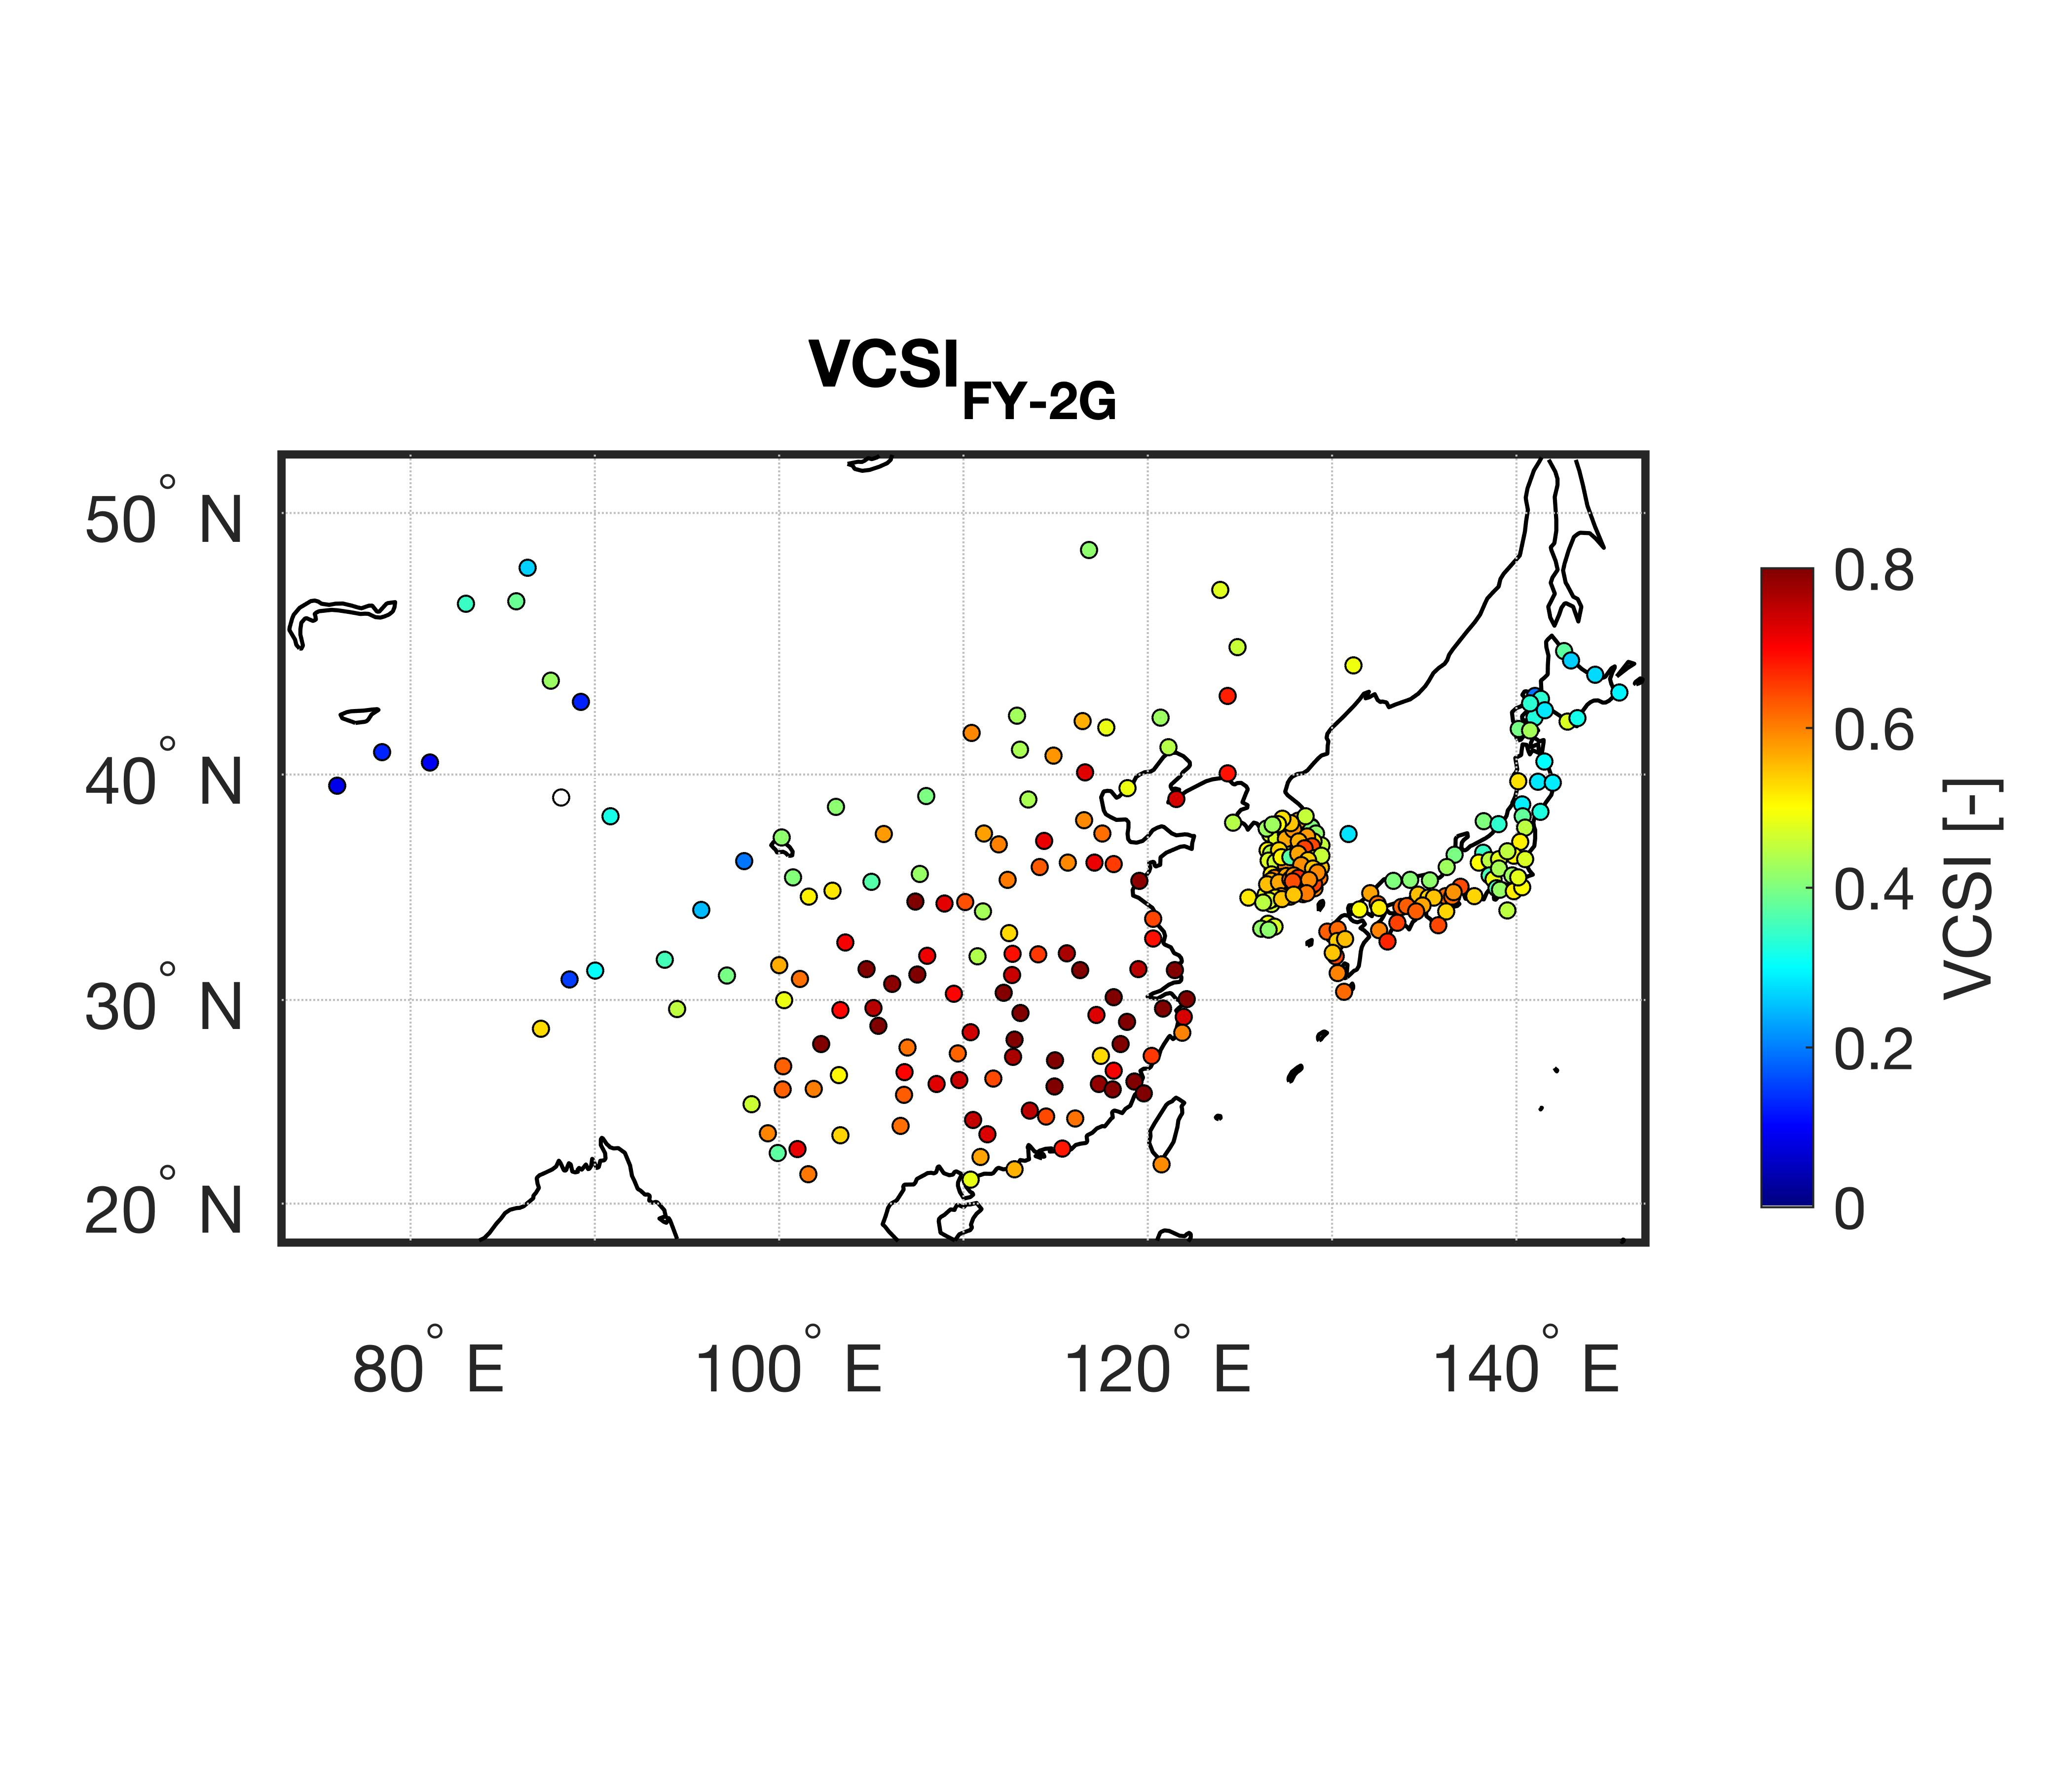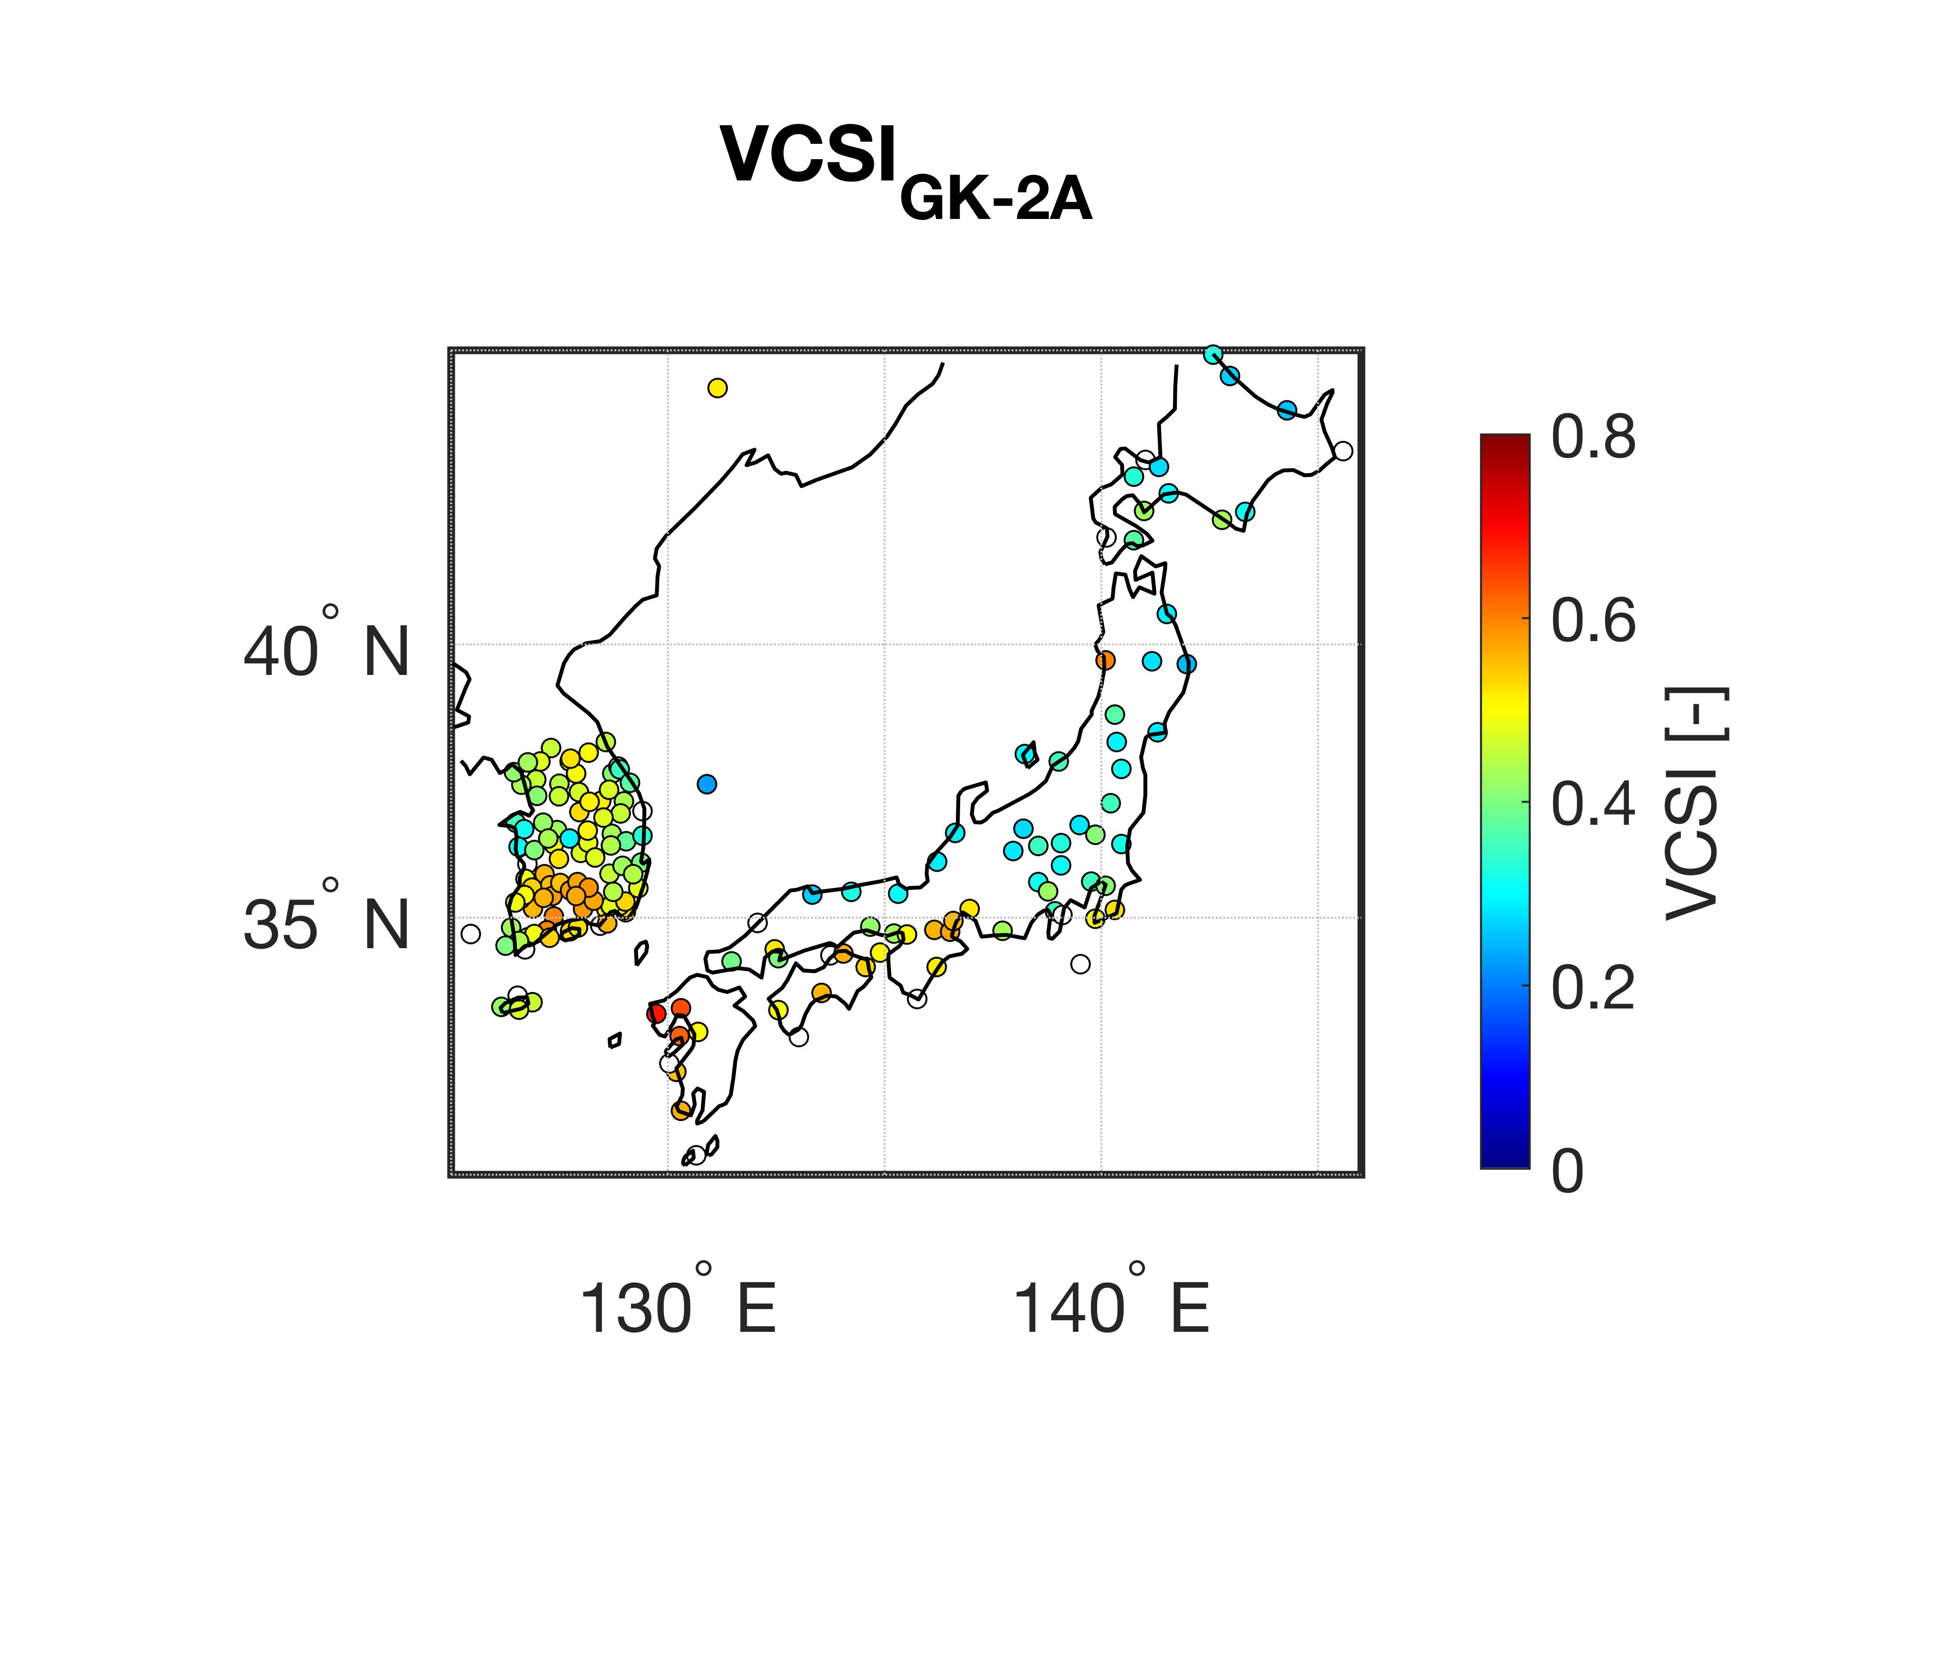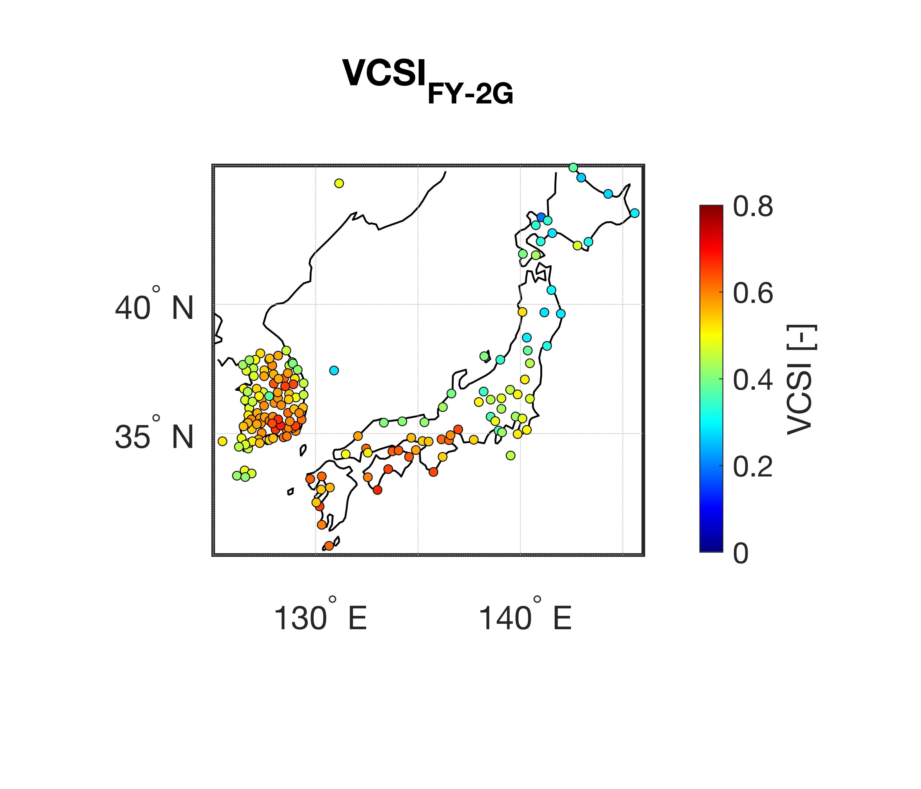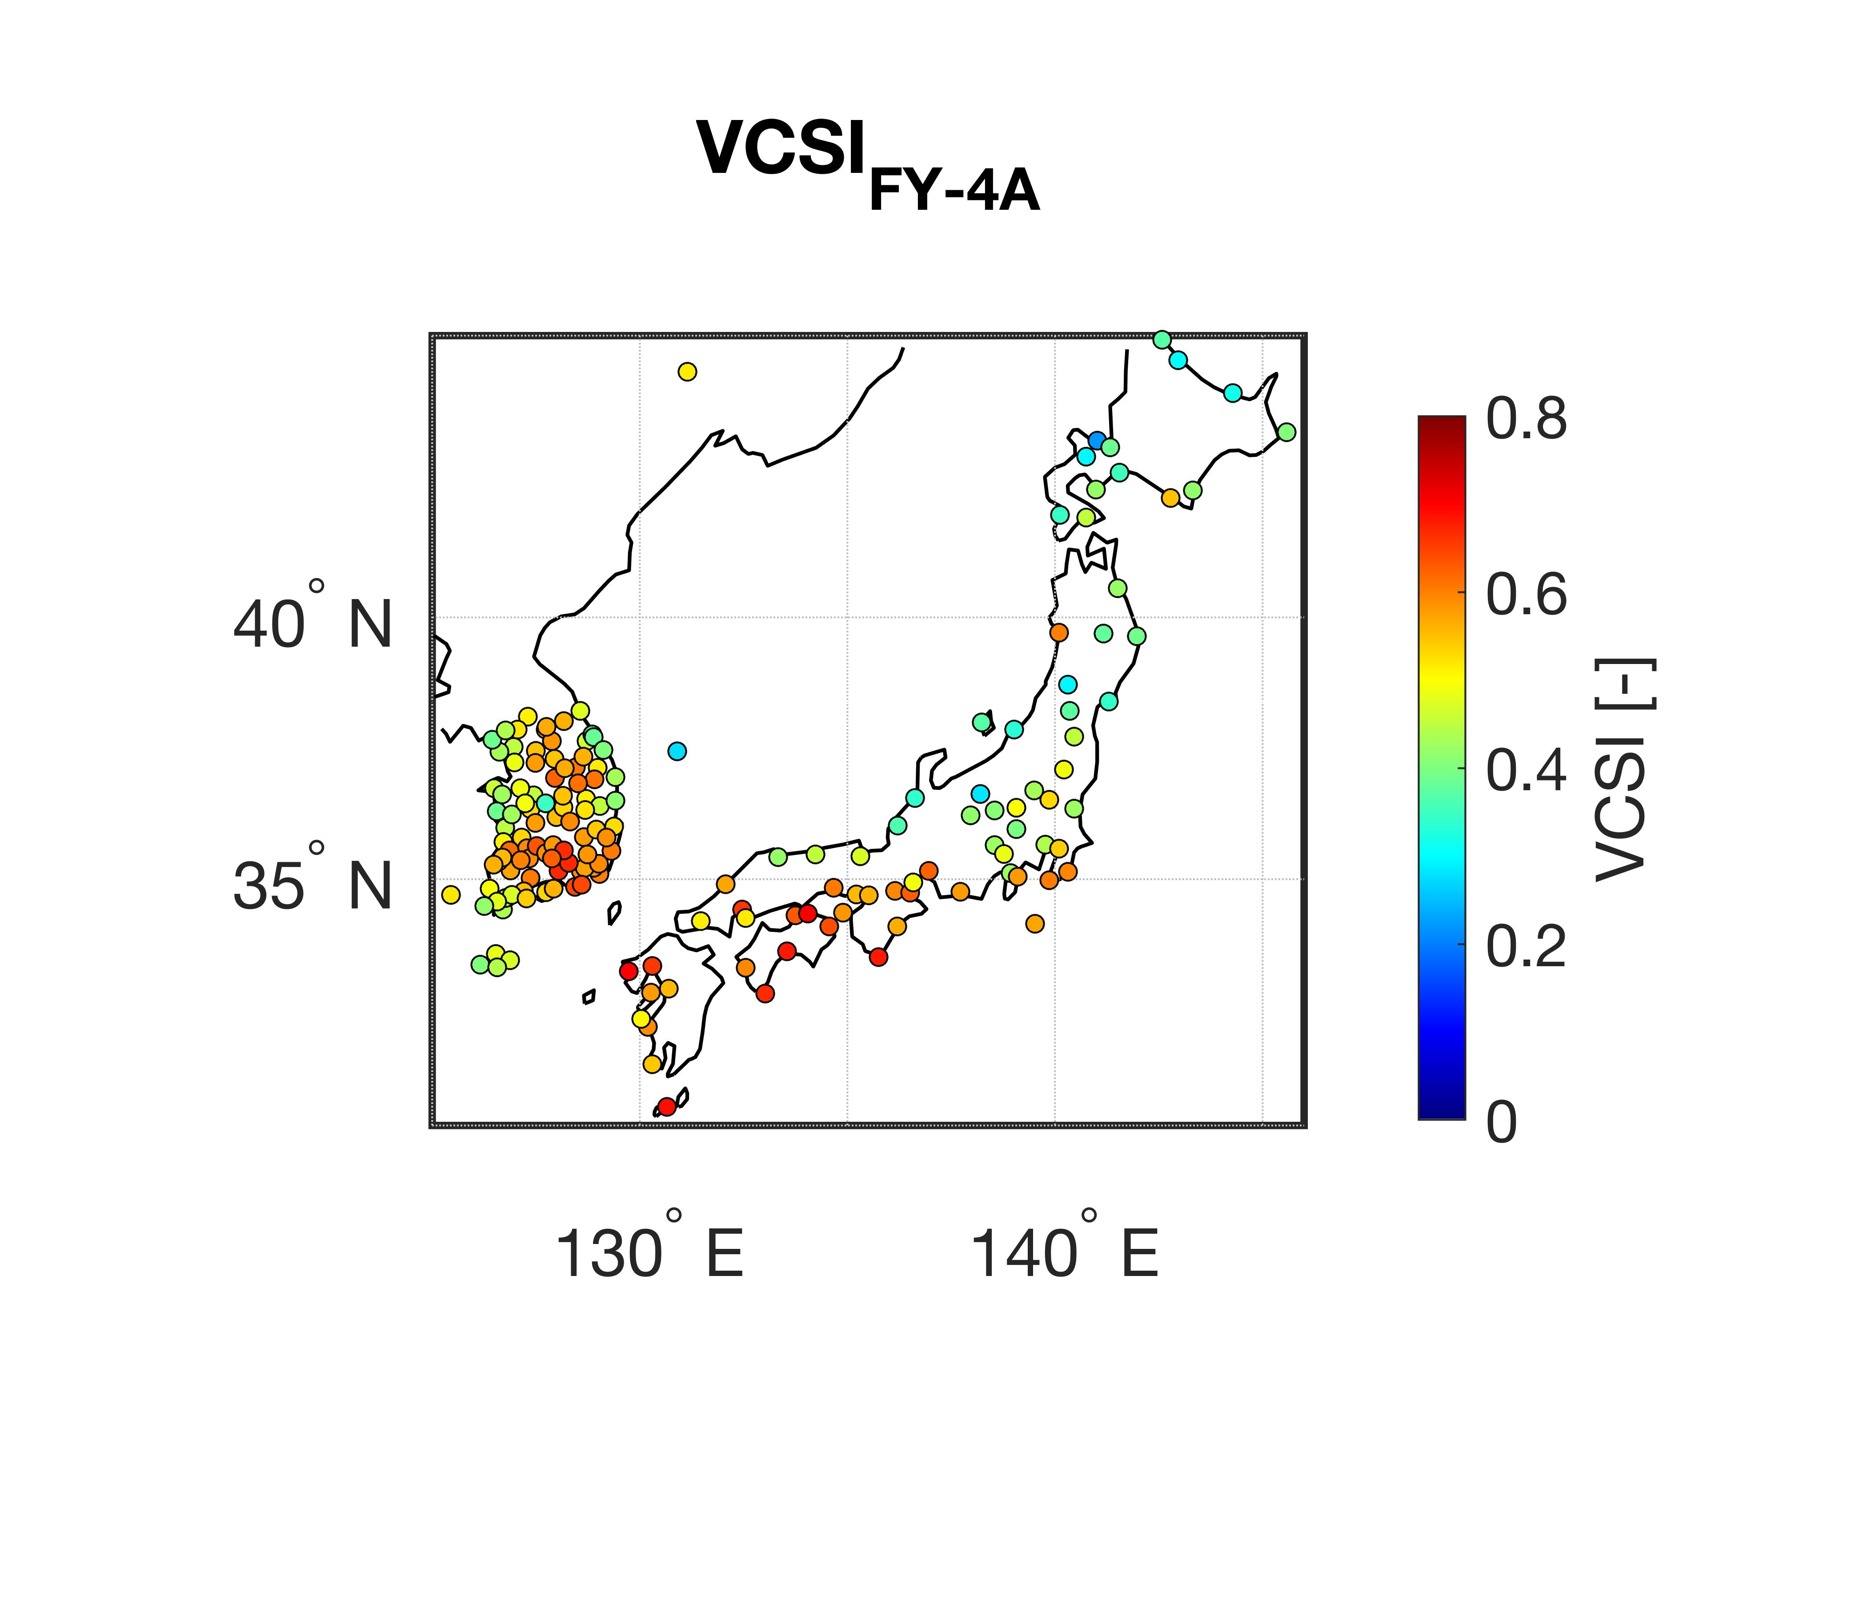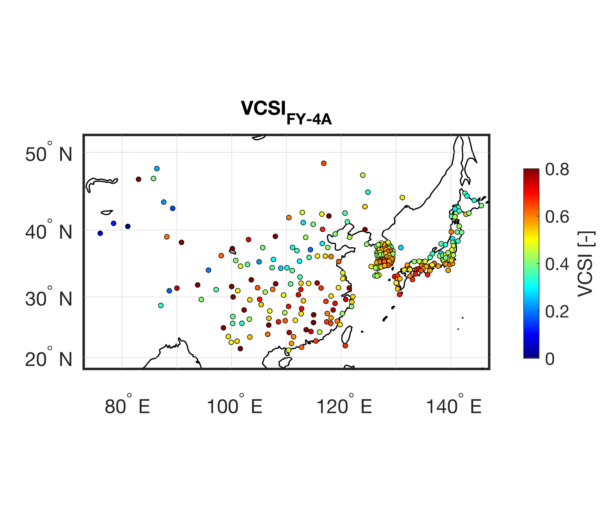
(a)
(b)
(c)
(d)
(e)
(f)

Figure S3. Spatial distribution of volumetric critical successful index (VCSI) for 6-hourly precipitation in 2020 between (a) FY-2G and ground-based stations, (b) FY-4A and ground-based stations, and (c) GK-2A and ground-based stations.

