For Online Publication Only
Supplemental Description and Data Appendix to
The Net Benefits and Residual Cost
from US Border Management of the Initially Inadmissible

This appendix provides additional detail for numerous theoretical, modeling and data issues. The sections in this appendix roughly follow that of the manuscript: 1) theory, 2) population proportions, and 3) valuation including present value, equity and uncertainty. The workbook on which it is based is BorderJBCA3.xls.

Section 1: Theory and baseline

Theory:
Border management is primarily about controlling “bads” while allowing good things to happen. This is analogous to controlling pollution as a by-product of the production of ‘goods’. The core theoretical structure of the benefit-cost analysis of pollution control is applied to border management.

Foundational graphs for pollution control show the optimal control of that negative externality with the choice variable of either emissions as the bad activity, or emissions control (its negation) as a good (see figures at end from environmental texts). These figures are so ubiquitous that the original citation has been hard to find. Consequently, the basic theory with both choice variables is developed below, focusing on the first order conditions for optimality although government actions are unlikely to be at the optimum.

In the pollution case, one typically assumes that Government is designing policies to be implemented by polluting firms and government must control through policies directed at firms. The border management is somewhat simpler in that government itself is doing the controlling the border, although other macro-options are possible (Dixon, et al, 2011).

Define functions first in terms of border illegal actions (analogous to emissions); not yet actions controlled.
D(X): damages (costs) from illegal actions such as criminals or illegal workers getting past border; D’(X)>0 as damages increase the more illegal activity occurs.
C(X): border management control cost of illegal activity with Marginal Cost of Control, C’(X) < 0, if more illegal activity is allowed to occur then management costs are reduced.

Social cost minimization framework: When defined in terms of illegal activity, the optimization problem is Min D(X) + C(X) as both are costs; first order condition requires C’ = -D’ or the equality of marginal cost of controlling another illegal activity with the marginal damages avoided (negative sign). Second order conditions are assumed met.

Net benefit framework: This framing, in terms of illegal activity controlled is more easily translated to benefit-cost analysis, to the controlling actions and is the form cited in the text.

Assume D(-X) = - D(X) . This is true if the function is linearly homogenous, a common assumption. It assumes that the damages from reducing (controlling) illegal activity (-X) are equal to the negative of the damages from another event occurring. Note that – D(X) appears in the first order condition of the social cost min approach. As a caveat, behavioralists may be less comfortable with equating the value of avoiding an action being the negative of an action occurring. Similarly for management costs,
C(-X) = -C(X) .

Given the homogeneity assumption:
Net Benefit = -D(X) – C(X) [benefits from costs avoided less costs of control; from D(-X) + C(-X) ]
First order condition: -D’ = C’ the same first order condition as previously but can now be graphed in terms of illegal actions controlled D’(-X) and C’(-X)

The marginal graph that results, assuming D’ is a constant as will be empirically assumed, is as below

Figure 1: Optimal managed and residual (unmanaged) net benefits and residual costs

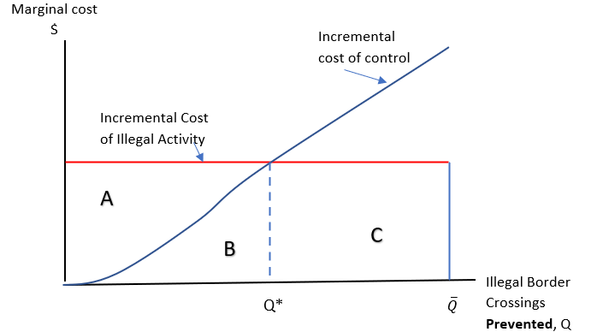

The (unlikely) optimum is at Q* indicating the amount of illegal activity controlled. The amount Qoverbar less Q* is the amount of illegal activity that still occurs given optimal control, referred to as the unmanaged or residual in the text. The total benefits of illegal activity avoided is A+B; the total cost of control is B, with net benefits (A+B) – B equal to area A. Residual cost (risks) is area C that is also the maximum potential benefit to be gained from additional control.

Implications of this approach for the baseline are below.

Baseline: The paper is evaluating the status quo, not a new technology. Usually, the baseline would be the status quo and changes would be evaluated compared to the status quo. In order to assess the status quo (“with” condition) compared to a without state of the world, the counterfactual is imagined where there is no border control (“without” condition). One could imagine a very complex migration dynamic in such a situation but the “without” initially inadmissible is tightly defined here. The counter-factual number of initially inadmissible attempts without the status quo technology is the total estimated for 2017 plus the (significant) amount of distant deterrence that would have led to attempted crossings in the absence of border management.

Hence there is both a base case (status quo) technology and a baseline “without enforcement” condition.

Baseline and base case detail

Baseline is "without" border enforcement as in the figure above where Qbar are the number of what are now initially inadmissible attempts to cross the border.

The baseline (omitting legal/documented entrants) has
1) Law breakers ("criminal" or "immigration law") who would break the law, enter the US, and carry-out planned actions.
Criminal law breakers would commit crimes (occur)
Immigrant criminals would commit immigration crimes such as using fiscal services or working illegally.
3) Asylees (in baseline) without an enforcement process would be indistinguishable from immigrant law breakers.

The with Border Management/base case technology (focusing on the points of contention).
1) Some, but not all, criminals are prevented from carrying out the "crimes" assumed to be committed in the baseline. Thus, costs are avoided compared to the baseline. Other criminals successfully carry out their "crimes" if they are not prevented and the crimes are forecast to "occur".
2) "Successful" asylees are distinguished from illegal border crosses (correct signal detection) and so their benefits can be separated and counted compared to the baseline.
3) Some deterrence is estimated based on the literature but it probably understates the true flow of "illegals" if there were no border enforcement.

Consequently, "costs avoided" from management applies to both criminal and illegal immigration crossers compared to the baseline of their getting through. Unsuccessful (unjustified) asylees are assigned an illegal crossing status.

Section 2: Population proportions

Purpose: Summarize steps to calculating proportions (probabilities) along branches of decision tree to which a total “Attempts” might be applied to aggregate results.

The “tree” for which proportions are sought is Figure 3 on page 12. Note that as this is for 2017 and there can be substantial year to year changes in flows and policy, small errors in proportions for this year are likely overweighed by external changes in flows.

More detailed data discussion follows tables.

The 14 outcomes defined by the decision tree for managed outcomes and proportions. Proportions are category count/total managed. The component probabilities leading to these values are in the decision tree where the components are “multiplied forward” to get the same proportion.

Table 1: Managed Outcomes and Proportions

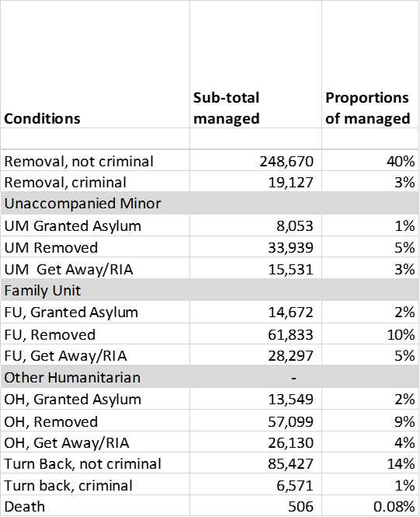

The total values for residual outcomes (unmanaged), including RIAs (Remove in Absentia, part of the unsuccessful asylum outcomes). Proportions are residual category count/total residual outcomes.

Table 2: Residual Outcomes and Proportions

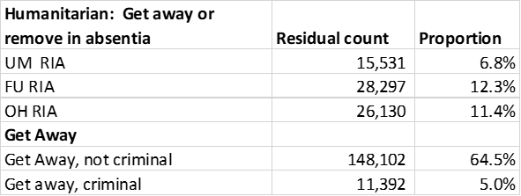

Text summaries of proportion calculations

Apprehensions, Turn back, Get Away, Death

Total Attempts =
Total Enforcement Actions + Turn-back + Get Away (detected + undetected assumed to include deaths)
= 778,899 derived from below sub-components
Total Managed = Total Attempts less Get Away (not RIAs) + adjusted deaths
= 619,405
Residual: Total Attempts – Total Managed = 159,494 + Remove in Absentia (RIAs show up in both managed and residual as they are managed for part of the time but then “Get Away”.)

Enforcement Actions sometimes named “Apprehensions” : for 2017, 526,901
Actually the sum of BP Apprehensions and CBP “Inadmissible” so actually Total Enforcement Actions which include those seeking humanitarian protection. Base year 2017.
https://www.cbp.gov/newsroom/stats/cbp-enforcement-statistics-fy2018

Table 3: CBP Enforcement Actions (BP and OFO)

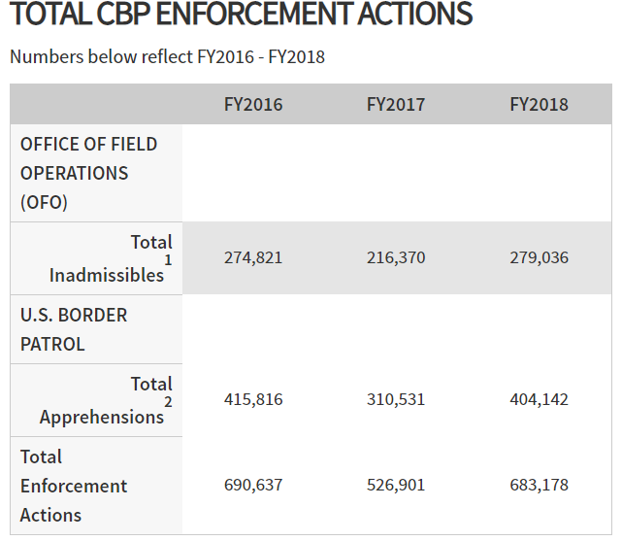
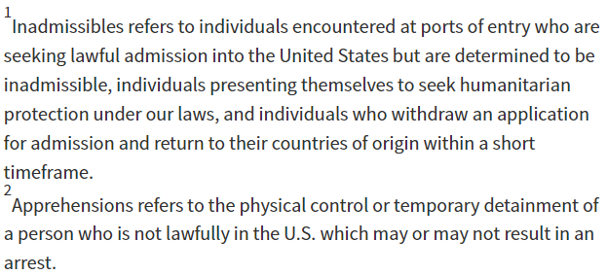

Issues: includes all borders although more detail (and vast majority of cases) on SW border. Also a breakdown by border available with title U.S. Border Patrol Nationwide Apprehensions by Citizenship and Sector in FY2017 .

Turn Back and Get Away: from NDAA(National Defense Authorization Act) Border Patrol metrics report
https://www.dhs.gov/publication/fy2018-border-security-metrics-report

Turn Back: NDAA, p. 15 for 2017 91,998
Turn backs – An estimate of the number of subjects who, after making an illegal entry into the United States, return to the country from which they entered, not resulting in an apprehension or got away. Turn backs are an activity measure that USBP uses for tactical decision-making

Method: direct and indirect observation from individual agents.

Issues: Divided into criminal and non-criminal based on those shares of those apprehended and removed.

Get Away (detected + undetected - death): NDAA, p. 13-14, 17, for 2017; 104,000 + 56,000 -506 = 159,494
Find in text near the bottom of the page.
Got aways (detected) – An estimate of the number of subjects who, after making an illegal entry, are not turned back or apprehended, and are no longer being actively pursued by USBP agents.

Direct and indirect observation.

Issues: Estimated Total Successful Unlawful entries was estimated to be 160,000. Some of these are no doubt criminals. Non-criminal and criminal shares are based on those shares of apprehended and removed.

Detected got-aways are adjusted for DHS estimates of undetected get-aways (undetected successful unlawful entries). This is the difference between modeled Total Successful Unlawful Entries less detected get-aways.

Deaths, below, are to be subtracted since presumably they got away. To create a separate classification, “deaths” are subtracted from got-aways.

Death: 506,
(total number, 2017, to be added to obtain total attempts) 506 = 298*1.7 as described below.
Introduction: near border migrant deaths may occur on both sides of any border but the available reporting is focused on the SW border and marine environment. Deaths are at least in part based on remains within a near border zone of “security”, in which the BP plays a part and works with a county coroner. Deaths can occur in which the BP is not part of reporting. Outside groups including Humane Borders who focus on Pima County/Tucson area have a more complete analysis of total remains found, and a report Left to Die from an advocacy group has anecdotes (NEW REPORT: Left to Die: Border Patrol, Search & Rescue and the Crisis of Disappearance | No More Deaths • No Más Muertes). See also NY Times (8/26/2021 for report of additional deaths in a Texas County and reference to Humane Borders)

Table 4: DHS Reported deaths:
US BP stats and summaries/deaths at the SW border by year (2017 reported as 298)
https://www.cbp.gov/newsroom/media-resources/stats
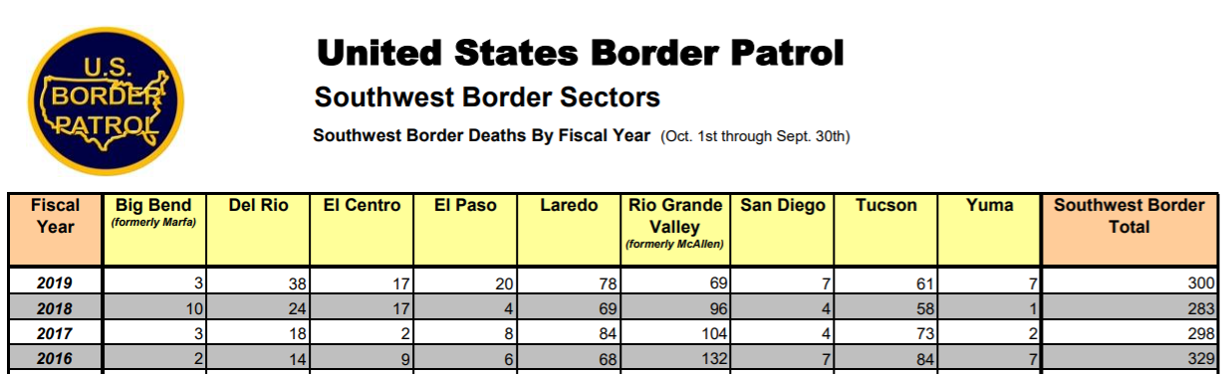

Under-reporting: As stated by K. McAleenan before the confirmation committee to be Acting Secretary of DHS:
CBP defines a border-related death as a suspected,
undocumented migrant who died: (1) while in furtherance of an illegal
entry; (2) within a designated target zone whether or not the Border
Patrol was directly involved; and/or (3) outside the designated target
zone when the Border Patrol has direct involvement with the incident.

Under-reporting may be due to: 1) remains never found, 2) outside target zone when BP not directly involved, 3)?

Under-reporting adjustment: Human Borders annual data with Pima County Coroner
The US Border Patrol regularly reports remains inside the US border believed to be those of migrants attempting to illegally cross the border. Using 2017 as base year, BP reports 298 deaths across total SW border. Of that number, 73 are reported in BPs Tucson sector (covering the counties of Pima, Santa Cruz and Cochise with Pima Count the largest). These counts are acknowledged as an undercount as some remains are not found and may not include remains found by other organizations. Humane Borders, a non-profit in Arizona, has a multi-year relationship with the Pima County Coroners Office to identify human remains and associated data. For the base year of 2017, they report 124 identified remains for the area that comprises the largest part of the Tucson sector. This ratio (124/73 = 1.7) is used to adjust the estimated number of total migrant deaths across the SW border to 506 for 2017 which is still almost certain to be an undercount both for that area and as it excludes other borders including ocean borders.

Near the US border but in Mexico (international effects): Wikipedia has some prior years reports of illegal migrant deaths on the Mexican side of the border. A more extended information search could be carried out for the number of migrant deaths inside Mexico but near the US border. These deaths outside the US are not included in the analysis as they are outside the direct management of the US.

Sub-outcomes: terminology and data

General: The focus is border management and initially inadmissible and hence excludes refugees (since that process is beyond borders) and visa overstays (since that is entirely inside border). Model could be expanded for both. At times DHS refers to Humanitarian (below) as Not Impactable and Non-Humanitarian as Impactable by border policy.

Humanitarian: Refugee and Asylum report states: “Applicants for refugee status are outside the United States, whereas applicants seeking asylum are either in the United States or arriving at a U.S. port of entry (POE).” Both seem to require credible fear among other criteria which later leads to estimating the value of additional security from being in the US if granted asylum. https://www.uscis.gov/humanitarian/refugees-and-asylum/asylum/obtaining-asylum-in-the-united-states.

Unaccompanied Children (UAC or UM) are < 18 and are not with parent or legal guardian (so issues of Aunts, Uncles, etc. may not apply unless legal guardian). Remanded to HHS.

Family Units (FU): Children with (documented) parents or legal guardian. Each member of the unit counts in a family unit, e.g. parent and 1 child is 2 family units.

Impacted: criminal/not criminal
Criminal: Reported as the sum of Criminal Aliens encountered from both Office of Field Operations and BP. Arrests listed in the source seems to be a subset of the criminals encountered so only the “encounters” are listed for this group. https://www.cbp.gov/newsroom/stats/cbp-enforcement-statistics-fy2018 .
Not Criminal: Residual: Total Apprehensions – criminals – Humanitarian (UAM, FAC, Other Humanitarian (OH)). Expressed as proportion of impacted.
Not Impacted (UAM, FAMU, Not UAM or FAMU--Other Humanitarian)
This is an area that could be improved with better data. A problem is that some public data double-count UAM, FMUs and asylum as some people can be in two categories and likely are.
Impacted/UAM, https://www.cbp.gov/newsroom/stats/usbp-sw-border-apprehensions-fy2017 ; also in NDAA p. 59 as UAM on SW border with other border UAM in text on p. 25. This however, just reports numbers for the Border Patrol. Values for the Office of Field Operations (POE) was obtained in a GAO report GAO-20-245 “Actions Needed to Improve DHS Processing..” Southwest Border: Actions Needed to Improve DHS Processing of Families and Coordination between DHS and HHS | U.S. GAO especially Table 12.
Impacted/Family Unit. NDAA p. 25. Can be double counting among categories of FAU and UAC and Asylum as noted in footnote to table. Family Units from other borders in NDAA text on p. 27 .
Impacted/not UAC or UAM: This takes all requested (filed) affirmative or defensive asylum cases and subtracts the count of UAM and FAMU. This assumes all UAM and FAMU request asylum (with initial screened credible fear). This may understate cases as not all who pass credible fear actually file a case.
Impacted: Those not in Humanitarian (UAC, FU, OH, Asylum).
Computed as total enforcement actions minus (-) “not impacted”. If “not impacted” is overstated, then “impacted” will be understated.

Asylum, UAM or Family Units--sub-outcomes of Legal, Returned, Get Away (RIA)

- Source: Executive Office for Immigration Review, Operational Statistics/Credible Fear and Asylum summary as below.
https://www.justice.gov/eoir/statistics-and-reports then https://www.justice.gov/eoir/file/1216991/download for 2008 to 2019

Method: DOJ graphic below gives breakdown per 100 people who claim a credible fear often but not only at the border, includes more detailed than Legal/Returned/Get Away
States that: 14/100 granted asylum
27/100 never appear shown as “?” and are stated as Removed in Absentia (RIA)
59/100 Removed derived as remainder (100-14-27)/100 = 59 are either immediately or
after a delay, evidently “Removed.

Issue: While this category represents my understanding of “Not Impacted” from BP, there may well be additional complications and data about as this includes all borders, ports of entry, and internal requests.
Figure 2: Outcomes of Asylum Requests
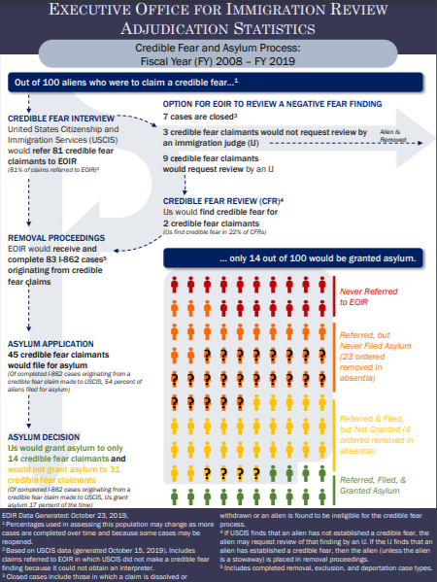
Figure 3: Proportions and calculations as 11/17/2022 in decision tree format (excludes residual outcomes done separately). Values are explained in the following section. Values include Direct, multi-market and Distant Deterrence.
Source: BorderJBCA3.xls
Section 3: Valuation notes including present value, equity and uncertainty

Purpose: Summarize steps to calculating values for terminal points of decision tree for 2017.

For the decision tree above, valuations are sought for each managed and residual outcome above. However, the focus here is on the managed outcomes as unmanaged outcomes typically have a simpler structure or are opposite in sign. In addition to the outcome format from the previous section, summations for each impact category across outcomes provides the BCA format organized by these impact categories.

Valuations are needed for the 14 final outcomes in the DA and for the 5 outcomes in the residual analysis. The values are “built up” typically from multiple impacts (consequences) for each outcome that later are the benefit and cost impact categories.

Impact categories for which valuations are used (some weighting occurs as with adult and children in Family Units). The consequences are first computed for the initial year, and then a PV is calculated based on the time path of impacts (see Figure 5). The headings below are the impact categories, potentially for each outcome although many are zeros, from the Present Value worksheet that include some columns of aggregation. See also Table 8 in the text for BCA categories reported where the near-border deterrence (both called out in first year and PV in other categories) is included in Direct estimates in text.

Figure 4: Impact (not outcome) categories

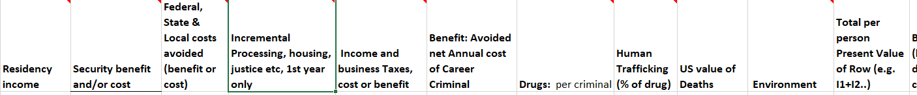

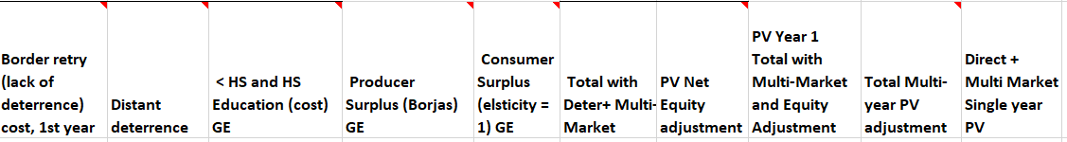

The DA analysis sums the appropriate columns for each outcome row. The BCA analysis sums over all outcomes for each impact column. Below is Table 8 from the text showing what categories (other than equity weighting) go into the aggregates of Direct (Green), Direct plus Multi-Market (add orange), Direct + Multi-Market + Distant Deterrence (add Blue).

3.1 Text summaries of valuation calculations

Cross-cutting issues
- Standing: If the person does not achieve “legal” standing then their own benefits and costs do not count. The only “legal” standing among the initially inadmissible is if Asylum is granted and so their personal benefits and costs count.
- Weighted averages
  - Re-try: A portion of Immediate returns and Turn-back are assumed to retry within 3 months based on surveys of returned immigrants to Northern Mexico. Result: a fraction of these two categories only get ¼ year of cost saving benefits.
  - Family unit: weighted with proportion of adults and children.

Individual Impact Values (Aggregation for each Outcome Value (V) is in a later section)

Residency income after taxes and security, a benefit. Successful asylees with standing have their own direct benefits counted. This is in contrast to those with “no standing”.
- Other Humanitarian (standard adult) per initial year: Income $20,060 pre-tax; $18,479 post tax (based on $1,581 taxes including income and social security per FAIR): Per Borjas (, southern border Not Initially Admitted (NIA) are heavily Mexican and Northern Triangle (Honduras, Guatemala, El Salvador). He places the unadjusted annual income male and female of Mexicans recently admitted at (rounded) the 17th percentile in the US income distribution in 2000 (census obs. For male and female about even, see note to Table 5). Data for the US income distribution in 2017 are linearly extrapolated to the 17th percentile based on 0 and the 20th percentile (CBO https://www.cbo.gov/publication/56575#data . ) Since the CBO table is the whole distribution, unadjusted, it is used as an approximation. The time path of income would be positive and Borjas outlines rates of growth, 1% annual real growth relative to native born is used as the base value here.
- Security: all ages. There are substantial differences in intentional homicide rates between US, Mexico and Northern Triangle countries. The average difference in intentional homicide risk compared to the US, and valued at the US VSL (since those for whom this counts now have a type of legal resident standing) is $3,693 rounded to $4,000. As these people pass a Credible Fear review, they are likely to have above average risk in their home country. How far above average risk is not known (or at least no literature found). A scaling parameter here assumes their risk is 3 times the average level in their country for an annual security/risk benefit of $12,000. Note that there is a maximum multiple of about 2,500 that would yield a risk of 1 (certain death) for homicide between the averages of these countries.
- Family Unit: Children are assumed to have no immediate income. Adults are assumed to have the same income as in “a” above from the “standard adult”. The value here weights the two incomes by the proportion of minors.
  - Proportion of minors in Family Units: from the DHS, Refugee and Asylee Flow report 2017. This is the share of <17 yrs old granted affirmative asylum. However, children don’t earn income until age 18 so this is an under-estimate of those < 18. Data issue may have to do due with the granting of affirmative asylum.
- Unaccompanied Minors: assumed to not work. What is the benefit here? (and for some individuals it might be argued there is a cost, a weighted average is used as below.) There is a handoff from DHS to HHS (Health and Human Services). The DHS/HHS view seems to be that they are caring for the UAM until they can turn them over to a responsible adult, ideally quickly, or care for them until they are 18. One argument is that DHS/HHS are avoiding a case of child maltreatment which is valued by Cohen, et al. in the benefit-cost literature (2021).
  - Value used: tricky valuation, weighted outcome by proportion of age of asylees granted.
    - UAC < 15 years. These outcomes, including separation, are assumed to “cause” the equivalent of a case of child mal-treatment based on SRCD ( The Science is Clear: Separating Families has Long-term Damaging Psychological and Health Consequences for Children, Families, and Communities | Society for Research in Child Development SRCD ) .
    - UAC > 15 years, these outcomes, are assumed to avoid a case of child-maltreatment where the social value of one case of non-fatal child maltreatment avoided. $79,320 (Miller, Cohen et al, 2021)
    - Note: average age of initially inadmissible children estimated as 14 (https://www.acf.hhs.gov/orr/about/ucs/facts-and-data ).

Federal, State & Local costs avoided (benefit or cost) See Table 5 below
Fiscal burden, aggregated: This impact aggregates a number of costs at all levels of government. The Federation for American Immigration Reform (2017, against immigration) has compiled several reports over the years by scrubbing Federal, state and local budgets for impacts. Their values for 2017 (one of the reasons why 2017 is used as the base year) are taken verbatim EXCEPT for where they explicitly include fiscal costs associated with US born children of what they take to be illegal immigrants. Those children are legally US citizens and so have standing and their costs are not included in the data for this analysis . Other groups have pointed out other elements that may or may not be mis-estimates (e.g. see Cato institute (arguing FAIR costs are too high https://www.cato.org/blog/fairs-fiscal-burden-illegal-immigration-study-fatally-flawed ).
- Worksheet nets out the items listed as being associated with US born children (such as education).
- Costs associated with annual “at the border” activities are used in a different location. This includes relevant CBP cost (FAIR already netted out legal travel activity to focus on illegal control activity) and HHS and DOJ costs associated with asylum. The average cost of these elements (average of illegal attempts for CBP or asylum seekers) are used as one time cost elements in the first year. These could be broken out separately but are currently in Border Average and Processing cost. Some costs are added to the FAIR estimates where specific border processing cost is estimable.
- DHS’ illegal population as of 2015 of 12 million is used to calculate per person estimates for costs within the country. FAIR’s illegal population estimate of 12. 5million in 2017 is a possible alternative before they add in a variety of other categories of people some of whom have standing.

Bottom line values: More detail below and some notes also available in spreadsheet
- Standard case:
  - $ 6,799 in fiscal costs net of taxes for in-country per person cost. Note that this is a benefit (costs avoided) if the person is apprehended and removed but a cost if they are a “get away” or “removed in absentia”.
  - Average cost for UAC, $17,613, (FAIR)
  - Average cost for asylum review: $649 (FAIR), a part of Humanitarian costs
  - Average cost for CBP $9,636. (FAIR)
- Criminals: As incarcerated at least some period of time, assumed to not be active for 1 year, then benefits are not carried forward (assumed to retry). Costs are adjusted for a longer time in detention based on an average cost per day of $134 from an NBC report. See below on taxes.
- Taxes: Federal, state, local (including sales): $1,581 based on the FAIR category of Net Federal and State receipts. Also includes Social Security and Medicare. This is a benefit is someone non-criminal “gets away” or is legal, but a cost if it is an illegal entry and they are returned.
- Weighted cases: Duration of time for the year. A significant percent of those returned try again after 3 months (DHS, NDAA report to Congress). Consequently, only a partial year of benefits may be received is a person is returned. (applies to Standard Returns and to Turn-backs). This is a “lack of deterrence” adjustment in the first year. For PV, a proportion is used but it is called out with its own column in the first year.
Table 5 FAIR categories and their total values from 2017 before adjustments (in yellow)

Border average cost and Incremental Processing, housing, justice etc
This impact is trying to include an average cost of the CBP system for Initially Inadmissibles and to distinguish between outcomes that involve extra housing and time. While this may somewhat double-count as the average CBP cost is applied to all illegal outcomes, these costs seem worth calling with specific categories as the costs are not homogenously spread among all Initially Inadmissible. Except for minors, this is an “average days of detention” times a cost per day. For minors, there is an annual HHS cost of housing.
- Standing: These are social costs only for ultimately illegal outcomes, whether specifically criminal or not. For legal asylum outcomes, these costs are transfers from US taxpayers for the benefit of the process to identify the legal individuals.
- Standard/assumed quick release. 1.5 hours (based on Rogers) valued at $50/hr (based on $100k/yr for 2,000 hours).
- Adult asylum/non-criminal ($9,636 - 75).
- “other immigrant violator” based on length of stay: DHS detention reports, and NBC report on cost per day based on ICE budget. Marginal housing, especially for minors, may be much more expensive (FAIR calls out UAC housing cost). Articles in 2018 (NBC) reporting on ICE budget give $134 for adult. (see Migrant Shelter Costs word document) about $100 Based on state incarceration average costs.

Income and business Taxes, cost or benefit
This is the estimated per person value of federal, state and local tax receipts for an illegal immigrant as estimated by FAIR (2018) and includes estimates of Social Security and Medicare taxes paid in and various payouts. This is a cost to these governments if a worker is turned away, and a benefit if they arrive (even if the illegal worker themselves have no standing in this analysis).

Benefit: Avoided Annual cost of Career Criminal
The core challenge is what benefits occur if a criminal is detained and removed at the border, other than drugs or other contraband captured. Alternatively, if a criminal is let through, what costs occur? There is evidence of a wide range of criminality from relatively minor to major.
Most BCA crime literature looks at crime as an event. In that case the question would be what specific events are prevented (or not prevented) which is hard to forecast. But there is another literature on costs of a career criminal where researchers asses the time path and pattern of career criminals committing a variety of crimes. The value of about $50,000 used here for a returned criminal is the value of avoiding one (annualized) year of a career criminal who is at age 22 who would have a 10 year crime career. The present value cost of the 10 year career is about $430,000 that is used for a criminal get-way into the interior.
Source: Miller, Cohen, et al. (2021) values were applied to evidence on the type of documented crimes of those apprehended as from ICE Annual Enforcement reports. A multiple for unreported crimes from Cohen and Piquero (2019) was used since “convictions” in the ICE data are clearly reported crimes. This was a “bottom-up” approach tailored to evidence related to border management. Had a generic “top-down” criminal career been applied from Cohen and Piquaro, the value used would have been several time larger. That higher value is used as the upper bound in sensitivity.
This cost also appears in criminal Turn-Backs and residual Get-Aways and Turn-backs.

Drugs per criminal
DHS reports seizures of several types of drugs. Those drugs are valued at Mexican wholesale prices (UN Office on Crime and Drugs) as the cost of replacement to the criminal organization. The “per criminal” is per aggregate caught criminal in DHS records which clearly will be spreading the value over a larger number than those actually caught with drugs. The one-time value of the drug seizure is added to the annualized cost of the career criminal. The literature appears uncertain on the effect of drug captures on drug prices in the interior. Here no effect on interior drug price is assumed or alternatively, that there is zero elasticity of drug demand to any price impact caused by border management.

Human Trafficking
I didn’t find specific evidence in DHS reports on trafficking. The value used is based on estimates of the black market in the United States in which Prostitution is reported as ten percent of the cost of drugs (Soloveichik, 2019). That proportion is applied here to the value of captured drugs.

US Value of (foreign) deaths

Issue: for technologies that affect mortality on both sides of the border, what are the issues and guidance regarding standing; is there mortality and what is its approximate size; and what values might be used in a US BCA?

Bottom line: While the exact number is unknown, at least several hundred migrants die trying to enter the United States illegally each year. The number report by the US Border Patrol (BP) is adjusted for partial under-reporting based on an overlapping data set in Pima County, Arizona see Human Borders, Map (Migrant Death Mapping - Humane Borders) so that deaths are estimated as 1.7 times those reported by DHS. More detail available from author.
Guidance and practice on who has standing for US government benefit-cost analyses indicates that foreign nationals do not have standing in a base case. In the case of mortality risks to migrants seeking to enter the US, the issue of standing is further complicated by attempted illegal entry. If there foreign nationals do not have standing themselves, a literature in benefit-cost analysis discusses using US citizen values for others although it is somewhat controversial. What is done in this study is: 1) US citizen values for mortality risks to foreign nationals is used, 2) US citizen values have a wide potential range. A lower bound for a US value of the statistical life (VSL) for a Mexican national at the border is estimated to be $1,000 based on search and rescue efforts of the BP. A useful median value is $684,000 based on US aid contributions with no waste (Kopczuk, Slemrod and Yitzhaki, 2005 applying the proportion used for Mexico) and a higher value of $ 1.6 million would result from adjusting the median value for perceived corruption and normalization to the US level of perceived corruption (Farrow calculations). This study uses $684,000 as the base case VSL for any foreign national who dies. The uncertainty analysis explores the effect of using different proportions of the US VSL for citizens, from 0 to 100 percent.

Environment
In part this is a placeholder as the discussion around building the border wall included concerns about species and ecosystem disruption, use of scarce groundwater for construction, and so on. I found little on specific environmental damage except for significant amounts of trash that Initially Inadmissible bring between ports of entry.
The rough cost estimate on trash…start with trash cost from site https://www.azbordertrash.gov/about.html . As reported there, “Past cleanups by organizations, such as the BLM and Tohono O'odham Nation, estimate that border crossers leave approximately six to eight pounds of trash in the desert during their journey. The cost of disposing of this trash could be high for local communities. Landfill fees range from $24 to $64 per ton in Southern Arizona. These fees do not include costs for materials, equipment, labor and transportation for the collection and transfer of the trash to the landfill.”

Consequently, I assumed avg. trash per person =7lbs, tipping fee avg $43/ton but no explicit source to link to cost of collection. As collection involves wide open terrain away from roads, collection and transportation to a dump is likely to be many times the tipping fee. Here I using an arbitrary multiple of 4; leading to a $3 per person “trash” cost. Clearly could be improved upon in this analysis is more important as a placeholder for some technologies that may be more environmentally intrusive.

Deterrence

This topic fits with the general economics of crime literature as specific or general deterrence (Nagin, 2013). Near border deterrence can be viewed as specific meaning the deterrence effect on those who have already offended and been punished, while distant deterrence is more associated with the general deterrence, the threat of punishment. As reviewed in Nagin, the literature suggests that probability of capture is the most important component of deterrence compared to consequence.

At border lack of deterrent: This adjusts downward the impact if a non-criminal removal or non-criminal turn-back. This first subtracts a portion of the year benefits as those people re-try entry and are assumed to appear as another “count” in the numbers. For the present value analysis, instead of “lack of deterrence”, the value is taken as a proportion that is deterred. Data are based on surveys of those returned to Mexico on probability of trying to re-enter after 90 days and result in the reported value being .75*full PV (end of year) plus the first year deterrence. The .75 is based on proportion of people who retry and the duration of time they wait to retry. Both the first year and the proportional PV effect are included in Direct effect estimates as they are tagged to the original inadmissible. Besides survey evidence cited in the text, there are academic articles cited that also refer to the displacement effect of some policies such as fences.

Distant Deterrence: Little evidence appears to exist in the economic literature. Roberts (2017) summarized an unreleased econometric analysis report from the Institute of Defense Analysis with a figure that showed the number of distant male Mexican nationals deterred by BP patrols and policies. He reviews some other efforts to estimate deterrence, including the role of endogeneity (several cites now included in the main text). Data for the number “deterred” were inferred from the chart as a proportion of those, total Mexican male nationals trying to illegally cross and who might be impacted by policy (i.e. excludes asylees). As the analysis is for Mexican males, a question is the extent it applies to more distant countries and to other genders. Some experimentation with weighted averages of deterrence for Mexicans and Others could be used but would still depend on an arbitrary deterrence for other countries and genders. For transparency the Mexican male result is divided by an ad-hoc “2” (halved) to reflect movement from more distant countries and other genders. The result is that about .46 people are deterred for every “impacted” outcome. The Distant Deterrence effect is separated in the scope analysis of Table 6 (earlier estimates set Distant Deterrence to zero) as other authors are more skeptical of a deterrence effect, e.g. Massey, Durand and Pren (2016). Distant Deterrence sensitivity is also reported for slope, elasticity and scenarios

Multi-Industry costs

Issue: Legal and illegal workers affect the labor market, particularly the markets where the entrant is a close substitute for native workers (National Academy of Science, 2017; Borjas, 2009). As reviewed in the NAS report, modelers using a spatial approach tend to find minimal effect while those using a structural simulation model find a larger effect. Most of the effect found is a transfer from “native” workers to immigrant workers whose wage income is reduced, but also to owners of capital and/or consumers as profits increase and prices are less than they otherwise would have been. As these multi-industry distributional effects are a salient part of the border management debate, they are included here although they do not change the results significantly until later equity weighting.
These effects are tracked for both legal and removed adults. If they enter the market they earn income) but they affect the income of others. The effect of “Get Away” workers on the distribution is included in the residual cost estimates but not in the core results.
  - Labor market parameter used: Borjas: < High school, -8% income; HS only, -1 percent; other categories only minorly affected.
Created: 1) Hispanic population share of HS or less labor market per BLS survey (https://www.bls.gov/cps/cps_aa2017.htm#empstat, table 7, so understates) , 2) weighted average decline in wages for Non Hispanic (-1.9%). 3) created non-hispanic ratio to Hispanic ratio in HS or less labor market (2.62). So total, per Hispanic per person negative labor market effect was -5.058% of Hispanic gains. This was adjusted for Family Units by the proportion of adults, all of whom are assumed to be working.
- Capital: From Borjas (2014, p. 163) Assuming constant returns to scale, owners of capital receive about 1.1 times the negative labor market impacts. The constant returns to scale model assumes that consumers don’t gain, but a more realistic apportioning of the producer surplus gains would show a gain to consumers, see below
- Consumer Surplus: While formally the assumption of constant returns to scale means that prices would not change with lower costs and that all gains would go to owners of capital, the gains here are split equally between owners of capital and consumers which implicitly assumes an elasticity of demand equal to -1. These results are theoretically inconsistent (CRS and elasticity) but to me it seems better to have some indication that consumer’s gain rather than force the result that prices don’t change. The assumption could easily be changed but it would not change the dollar value here, only the distribution of gains.
- Scope sensitivity analysis allows the multi-market effect to be zero while slope, elasticity and scenarios are investigated for values that differ from the baseline value.

Present value
- Present value of those attempting to cross in a single year (cohort): Border outcomes can have different future time paths and so have different present values in a single year. See Table 6 below.
  - Some outcomes occur in year 0 and do not occur later for instance, a person can “retry” at the border (criminals are modeled in this way), or the outcomes are single period (costs of detention at the border).
  - Some outcomes lead to future year impacts such as letting a person in legally and the income in each future year is a benefit, similarly with security benefits for that person.
    - Adult PV impacts begin in first year.
    - Child impacts are delayed (deferred annuity). From children’s worksheet, the average age to 18 (working age) is 4 years. The PV of their worktime is then PV(20 years of income)-PV(4 years of income). The PV formula assumes income starts immediately so this subtracts the initial (highest in PV) income years.
  - Each impact is modeled for the time path with that year’s initial outcome (see Figure 5 below)
    - If the first year impact differs from the later 19 (as with minors), then the number of years discounted should include the first year plus (20-1) different years of PV so excel would be X0 + PV(%,19,Xlater) using the default (end of period discounting) so the first “discounted” year is actually the beginning of the 2nd year (year 1, not year 0).
    - If the initial year is not different, then Excel is PV(%,20,X,,1) for start of year (means that the initial year is not discounted).

The PV of the initial cohort has a time path as discussed in the main text. The data underlying the key items are below (F&T are fiscal and taxes).
Table 6: Time Paths of Key Impacts

Equity weighting: See Farrow blog at Society for Benefit-Cost Analysis Site.
Equity Weighting Calibrated to the Value of a Statistical Life: All (US) Lives Matter Equally

Stylized facts and implication
- Economists: VSL reflects individual choices changes with income. An equation using an elasticity adjustment for relative income usually assumes the elasticity (and constant of proportionality) is constant across populations (e.g. Hammitt/Robinson, 2008; Viscusi/ Masterman 2017).

- Public Policy and law for US: Domestic policy--VSL is assumed constant across all populations regardless of income, race, age, or other identifying characteristic. This is also consistent with laws against discrimination in employment for protected classes.
    - Calibration implication: Given constant income elasticity (of VSL), the policy decision for a constant VSL across income groups implies an equity weighting adjustment by the same ratio of income raised to the negative of the VSL income elasticity. Such an “equity” adjustment just returns the base VSL. Equity weighting is thus the negative (-) of the VSL income elasticity, often assumed to be 1 but other values are sometimes reported.
      - Evidence reviewed in Farrow suggests a US income elasticity of the VSL to be about .5, so weights used are 2.1 for the lowest income earners and .75 ((1+.5)/2) for the upper half of the distribution.
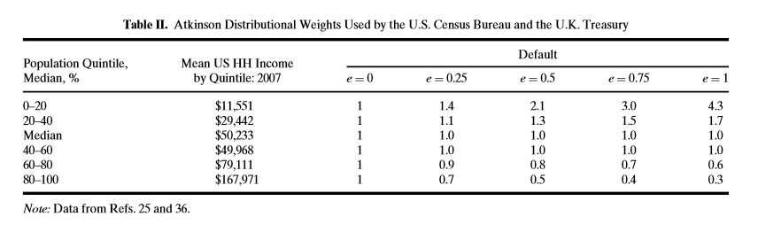

Uncertainty: focusing on valuation uncertainty

- Parameter uncertainty in valuation
- Percentage changes: With linear changes for the expected value, PiVi,, if every element is multiplied by 1+α then the change in ENPV is αPiVi. Hence the ranked expected ENPV provides the ranking for a tornado type diagram and any percentage change in value would just calibrate that adjustment to the base ENPV. See Figure for ENPV in body of paper.
- Slope and elasticity: TreePlanSensit/Excel was used to calculate changes in EPV from changing one identified parameter at a time. The empirical slope was then estimated as the change in EPV/change in parameter value. The elasticity was computed as an arc elasticity from the first to the last input parameter value. Note there are multiple spreadsheets copied from MonetizedPV to focus on BCA comparability and some uncertainty evaluations. For the slope and elasticity, where possible, the “parent” parameter is in the UncertBCAMonetizedPV file as a fixed value although the parameter may appear in other spreadsheets as a computed value (this is done because Sensit cannot use a referred value).

- Scenarios: A group of parameters are changed simultaneously to define a bad and a good case (not exactly the same as Worst and Best). See description and table in body of paper and note above on location of parameter changes.
- Macro simulation uncertainty: a triangular distribution for an error term was developed by expanding the bad and good cases by 5 percent with the point estimate as the mode.

Added references with a few repeats (otherwise see text):

Borjas, G. and L. Katz, 2007. The Evolution of the Mexican-Born Workforce in the United States , in Mexican Immigration to the United States, Borjas. 2007.

Borjas, G., 2014. Immigration Economics, Harvard University Press.

Cohen, M. and A. Piquero, New Evidence on the Monetary Value of Saving a High Risk Youth. J Quant Criminology 25:25–49 DOI 10.1007/s10940-008-9057-3

Congressional Budget Office (CBO), 2020. The Distribution of Household Income, 2017. Downloaded detailed tables, available at https://www.cbo.gov/publication/56575 .

DHS (Department of Homeland Security), 2018. Population Estimates of the Illegal Population Residing in the US in 2015. Available at https://www.dhs.gov/sites/default/files/publications/18_1214_PLCY_pops-est-report.pdf .

DHS, ICE Detention Statistics fy2019 https://www.ice.gov/detain/detention-management see previous year-end reports.

Federation for American Immigration Reform (FAIR), 2017. The Fiscal Burden of Illegal Immigration. M. O’Brien, S. Raley, and J. Martin.

Kopczuk, W., J. Slemrod and S Yitzhaki, 2005. The limitations of decentralized world redistribution: An optimal taxation approach, European Economic Review, 49(4):1051-1079.
Massey, D., J. Durand, and K. Pren, 2016. Why Border Enforcement Backfired. American Journal of Sociology, 121 (5): 1557–1600.
Miller, T, M. Cohen, D. Swedler, B. Ali and D. Hendrie, 2021. Incidence and Costs of Personal and Property Crimes in the USA, 2017. Journal of Benefit-Cost Analysis, 1-31.

Nagin, D., 2013. Deterrence in the 21st Century. in Crime and Justice in America: 1975-2025, ed. M. Tonry, Chicago, Ill.: University of Chicago Press, 2013: 199-264.
Roberts, B., 2017. Illegal Immigration Outcomes on the Southern Border. Cato Journal, 37(3): 555-572.

Soloveichik, S., 2019. Including Illegal Activity in the U.S. National Economic Accounts , Bureau of Economic Analysis from https://www.bea.gov/research/papers/2019/including-illegal-activity-us-national-economic-accounts .

United National Office of Crime and Drugs, 2021. Drug Prices by Country, available at https://www.unodc.org/unodc/en/data-and-analysis/statistics/drug-trafficking.html .

https://www.cbp.gov/document/stats/us-border-patrol-fiscal-year-southwest-border-sector-deaths-fy-1998-fy-2019
BP report to congress on SAR indicates that “A border-related death is defined as a suspected, undocumented migrant: 1) while in furtherance of an illegal entry; 2) within a designated target zone whether or not the Border Patrol was directly involved; and/or 3) outside the designated target zone when the Border Patrol has direct involvement with the incident.”
https://humaneborders.org/migrant-death-mapping/
- Present value, Excel note.: be careful that Excel PV returns a “payment” or negative number for a positive annuity. The sign can be changed by putting “-“ (minus) in front of the value in the PV formula. NPV does not, but it excludes the initial year that must be added on.
On Balance: When All Lives Matter Equally: Equity Weights for BCA by Combining the Economics of VSL and US Policy - Society for Benefit-Cost Analysis (benefitcostanalysis.org)

