Effectiveness of Stormwater Control Measures in Protecting Stream Channel Stability

Sami Towsif Khan ¹, Theresa Wynn-Thompson ¹, David Sample ¹, Mohammad Al-Smadi ¹, Mina Shahed Behrouz ², and Andrew J. Miller ³
¹ Department of Biological Systems Engineering, Virginia Tech, Blacksburg, VA, USA
² Stantec Consulting Services Inc, Sacramento, CA, USA
³ Department of Geography & Environmental Systems, University of Maryland Baltimore County, Baltimore, MD, USA

Corresponding Author: Theresa Wynn-Thompson, 155 Ag Quad Ln, Blacksburg, VA 24060, tthompson@vt.edu

SUPPORTING INFORMATION
S.1 Hydrologic model
A catchment-level Stormwater Management Model (SWMM version 5.1.013) (Rossman, 2015) was developed to simulate the hydrologic conditions in the catchment, specifically focusing on the post-2017 period. SWMM, a 1-dimensional, lumped, physically-based hydrologic model, is capable of simulating both individual storm events and continuous time periods. The model incorporates key hydrologic processes such as surface runoff, infiltration, evaporation, snowmelt, surface water routing (including kinematic and dynamic wave approximations for unsteady flow), surface water storage, groundwater flow, and water quality. SWMM employs a representation of overland flow as a series of nonlinear reservoirs, which are subsequently routed to a link-node network that emulates the urban stormwater conveyance system. Additionally, storage nodes within the model possess the capability of simulating water quality treatment processes. However, it is important to note that while SWMM is able to calculate erosion and washoff of suspended sediment during overland flow, it lacks the capability of simulating channel aggradation or degradation. Therefore, to assess channel stability and related phenomena, a separate model was utilized, as discussed in section 2.2.

S.1.1 SWMM model construction and SCM representation
The study catchment was delineated into 214 subcatchments based on multiple considerations including stream/conduit network connectivity, the existence of SCMs, and locations where simulated flow outputs were needed for the calibration process (Figure 1b). Topography within each subcatchment was based on a 0.91-m resolution digital elevation model derived from light detection and ranging (LiDAR) data provided by Montgomery County, MD (Metes & Jones, 2021). Hydraulic width was obtained by dividing the subcatchment area by the longest flow length within each subcatchment. Impervious percent within each subcatchment was based on the county-provided geographic information system (GIS data representing impervious structures including roads, buildings, sidewalks, driveways, and parking lots). Guidelines provided within the SWMM documentation were used to assign Manning’s roughness coefficient and depression storage estimates for both impervious and pervious surfaces (James et al., 2010; Rossman and Huber, 2016).The Green-Ampt equation was used to simulate infiltration within the pervious areas and through the simulated SCMs (Heber Green & Ampt, 1911). A shapefile representing the soil saturated hydraulic conductivity was extracted from the Soil Survey Geographic Database (SSURGO) (Soil Survey Staff, 2014) and intersected with the subcatchment shapefile to obtain the saturated hydraulic conductivity of the subcatchments. Subcatchment groundwater parameters were determined through calibration utilizing observed baseflow.

The following five types of SCMs were explicitly simulated using SWMM (Figure 1b):

- Detention/retention ponds: Six detention ponds were represented as storage nodes in the model using depth-surface area curves and information from as-built drawings provided by Montgomery County, MD. Multiple outfall types, such as weirs and orifices, were incorporated for each pond. The ponds were designed with a multi-stage outlet structure to provide 12-hr extended detention of runoff from the 1-yr, 24-hr storm and to safely convey runoff from the 10-yr, 24-hr and 100-yr, 24-hr design storm events.

- Sand Filters (SF): A total of 11 sand filters were employed either independently downstream of infiltration basins or in conjunction with detention ponds to provide water quality control and additional storage. Inflows to sand filters were simulated as diversions from the main stormwater drainage network, with smaller diameter pipes capturing the “first flush” of runoff needing water quality treatment. The design of the sand filter outfall structures aimed to ensure containment of the WQ_{v} (Water Quality Volume), thus preventing any runoff overflow from 90% of the average annual rainfall, which amounts to 25 mm for the study watershed.

- Underground storage (UGS): To accommodate limited above-ground space, an underground stormwater storage system consisting of pipes or vaults was implemented. Data from as-built drawings, including length, diameter, slope, and inlet and outlet attributes, were utilized. This system gradually released stored stormwater to local streams or the stormwater drainage network. A total of 17 underground storage systems were incorporated into the model.

- Infiltration basins/trenches (IT): Infiltration trenches were constructed using underground stone reservoirs to collect stormwater and facilitate slow seepage into the ground. Stormwater diversion from the main stormwater drainage network occurred through smaller diameter pipes, with infiltration trenches functioning as storage nodes with higher seepage capacities than the surrounding areas. The design incorporated overflow pipes to redirect any surplus stormwater back into the drainage network, adhering to the same design procedure employed in the design of the sand filters.

- Microbioretention (MBR): A total of 26 MBRs, implemented as LID practices within subcatchments, received runoff from smaller subcatchments, primarily rooftops. The attributes of MBRs, such as depth, surface area, soil mixture, storage volume, and under-drainage, were represented using the LID editor in SWMM. Small street tree boxes and a grass swale were not simulated to reduce model complexity.

S.1.2 Model calibration
The model was calibrated using local precipitation and observed instantaneous stream flow data for water year 2020 and validated for 2019. Observed streamflow data were obtained from the USGS streamflow station. These two years were selected mainly because they occurred after the catchment was fully developed (2017), contained fewer data gaps than other years, and had relatively high maximum annual flow rate. Model parameters adjusted during the hydrologic calibration process included subcatchment hydraulic width, Manning’s roughness coefficient for impervious and pervious land segments, depression storage for impervious and pervious land segments, and groundwater equation coefficients and exponents. Table S1 provides a list of the adjusted parameters. Based on parameter adjustments made during the hydrologic calibration process, good visual and statistical agreements were obtained between the observed flow at the USGS gage and the simulated flow. Goodness-of fit-statistics (Moriasi et al., 2015) for the calibration and validation periods for the SWMM modeling are provided in Table S2.

Table S1. SWMM parameters adjusted during the calibration process.
Parameter | Definition | Unit | Calibrated Range
Characteristic Width | Characteristic width of the overland flow path for sheet flow runoff is a function of subcatchment area and longest flow path | m | 16.15 – 584.3
Impervious Manning’s Roughness | Manning's n for overland flow over the impervious portion of the subcatchment | - | 0.011 - 0.13
Pervious Manning’s Roughness | Manning's n for overland flow over the pervious portion of the subcatchment | - | 0.13 - 0.156
Impervious Depression Storage | Depth of depression storage on the impervious portion of the subcatchment | mm | 1.905
Pervious Depression Storage | Depth of depression storage on the pervious portion of the subcatchment | mm | 5.08 – 5.34
Hydraulic Conductivity | Soil saturated hydraulic conductivity | mm/hr | 1.651 – 3.302
A₁ | Groundwater flow coefficient | - | 0.01
A₂ | Surface water flow coefficient | - | 0.01
B₁ | Groundwater flow exponent | - | 1
B₂ | Surface water flow exponent | - | 0.1

Table S2. Statistics describing the calibration and validation performance of the SWMM hydrologic modeling.
 | Calibration (2020) |  | Validation (2019)
 | Observed | Simulated | Observed | Simulated
Peak flow rate (cms) | 7.53 | 9.3 | 9.57 | 10.11
Mean flow rate (cms) | 0.018 | 0.018 | 0.027 | 0.024
RMSE (cms, daily average) |  | 0.4 |  | 0.5
PBIAS (%, daily average) |  | 0.0 |  | 16.1
NSE (daily average) |  | 0.70 |  | 0.72
R² (daily average) |  | 0.71 |  | 0.73

S.2 Input Data for HEC-RAS Sediment Transport Model

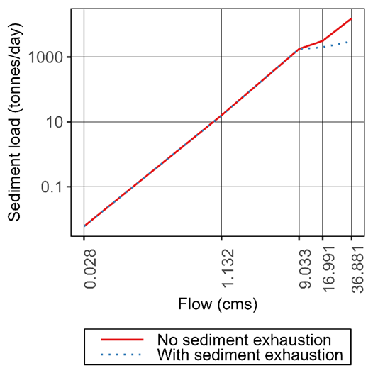
Figure S1. Calibrated inflow sediment rating curve

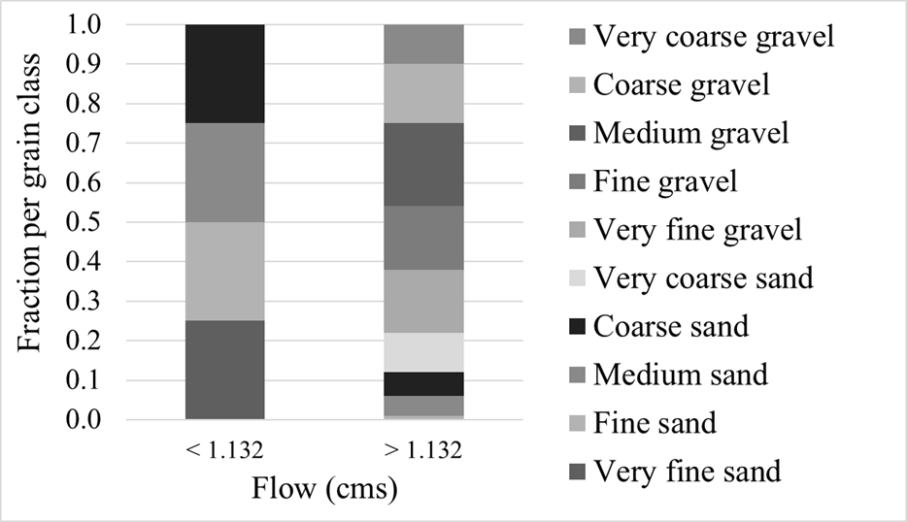
Figure S2. Calibrated inflow sediment load gradation.

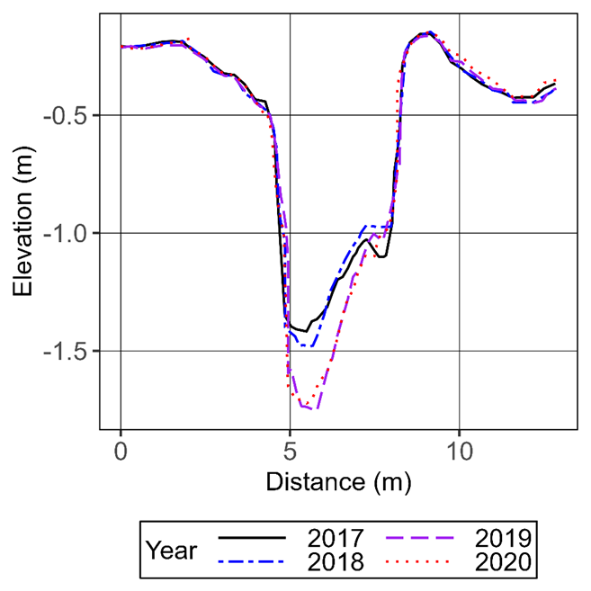
Figure S3. Observed cross-section data for the pool located immediately downstream of the U.S. Geological Survey gage.

S.3 SWMM Simulation Results
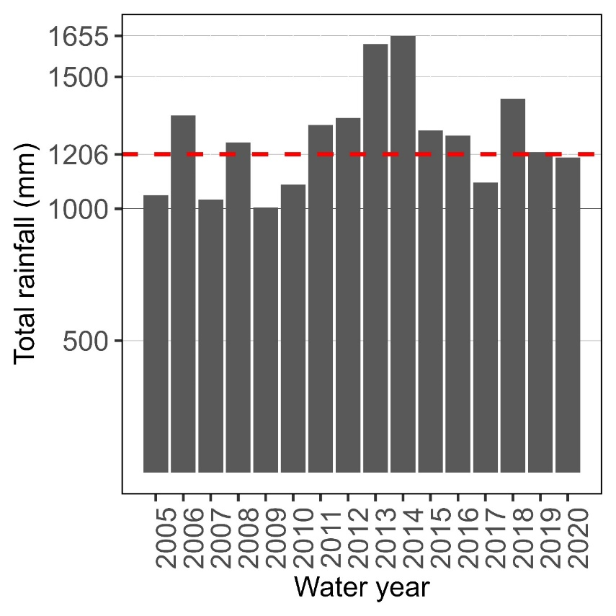
Figure S4. Annual total rainfall (water years 2005 -2020) at the Black Hill rain gauge which was input in the SWMM model along with the average rainfall (water years 1991-2020) for NOAA station US1MDMG0029, situated 3.05 km away from the study site, indicated by the dashed line.
S.3 HEC-RAS Simulation Results
Figure S5. Time series of a) flow; b) channel invert elevation; c) bed material d₅₀; and, d) bed material d₉₀ during the simulation period for the unified stormwater sizing criteria (USSC) scenario.

