Seer (KOR), Thinning and Brief Excursion (2016) are three videogames that attempt to proceduralize characteristics of the experience of the hallucinogenic chemical Salvinorin A, the active component of the sage variety salvia divinorum. The purpose of these experiments is to explore the boundaries of representations of space and self in digital virtual worlds, as well as to attempt to convey the intangible emotional (as well as anti-emotional) and philosophical aspects of the experience. The goal is to evoke in the player sensations of discomfort, loss of direct control and a sense of being outside of assumed videogame space.
My creative research generally involves creating a series of videogame design experiments around a topic, using interaction metaphors, emphasizing game mechanics that are more intuitive, less rational. I am interested in provoking reflection through game rules as much as through narrative.
Explicit intersections between game design and hallucinogens have been few. Connections can be inferred between the size-changing properties of the red-and-white mushroom from Super Mario Bros (1985) and the size-distorting effects of the similarly-colored amanita muscaria mushroom, but that connection has never been explicitly confirmed by the designers. Both videogames and psychedelics have enjoyed a recent surge (or resurgence) in research on their therapeutic potentials. Author Michael Muhammed Knight, in his book Tripping with Allah, highlights a comparison between shamans who facilitate spiritual experiences with hallucinogens and game designers, in that the shaman tries to steer the participant through the “rules and structure of the world that he produces” (2013, 218). I have also noted similarities between the role of a game designer and my past work as a counselor, as the game designer subtly leads the player without explicitly giving advice or telling them what to do. This comes around full circle to the comparisons often invoked between shamans and counselors/therapists.
Less commonly, more explicit connections have been made by game designers who directly reference their own psychedelic inspirations. A recent example of this is Robin Arnott’s virtual reality game SoundSelf (unreleased), a meditative experience that was inspired by the designer’s experience with ego death and universal oneness after taking LSD. This game uses the therapeutic and meditative potential of game mechanics to recreate what he felt were the important results of his work with LSD. Taking a page from the Beatles, Osamu Sato’s LSD Dream Emulator (1998) is a surreal and seemingly hallucinogen-inspired exploration videogame that insists on being coy about the meaning behind the title’s acronym. In the game world, it is defined as “in Life, the Sensuous Dream”, among other phrases, and hallucinogenic inspiration is never acknowledged.
My choice of salvia divinorum over other hallucinogens is due to its unique behaviors. Unlike classic psychedelics, which act on a variety of receptors, Salvinorin A acts entirely on the kappa(κ)-opioid receptor (Shuffler, Roth, 2003, p. 107). Surveying accounts from academic (González, et al, 2006, p. 160) and non-academic research (Arthur, 2010, p. 66), my own personal experience, and traditional religious and medicinal usage, suggests that the chemical has consistent experiential qualities between different users. It is also relatively short-acting: it is an intense five to ten minutes after smoking, or a gentler hour-long experience when chewed, as opposed to what is generally a full-day experience with classic psychedelics. It is non-addictive, and there are no known toxicities (Baggott, et al, 2004, p. 12). Finally, it is currently legal throughout most of the United States.
One of the major characteristics of the experience is a sense of depersonalization, the body dissolving with a physical pins and needles sensation, as well as a loss of understanding of what one is as an individual, combined with a loss in conception of time and location. It has been described as a Zen-like experience (Heaven, 191-2), one of void, emotionally neutral. A common experience is the loss of meaning associated with visuals and sounds: humans become empty husks, the self becomes identified with an inanimate object (Heaven, 46) or an infinitely-repeating piece of geometry. It is this aspect of the experience that is described as at once deeply fascinating and sometimes unpleasant.
Another common characteristic of the experience, and one that more readily brings up notions of game space, is a cognitive break with Euclidian geometry. There is a sense of being apart from three-dimensional space, or drifting between two tangible dimensions. Space is often represented as a spoked wheel, pointing to a world of elliptical geometry. There is a physical feeling of turning, being twisted, falling backward infinitely or being stretched between dimensions.
There have been games that explored the visual, mathematical nature of non-Euclidian geometry, notably the PC game Antichamber (2013) and the mobile game Hyperrogue Gold (2016). Antichamber’s play with geometry uses traditional 3D first-person visuals to break the player’s trust in their mental map of the overall game space. Hyperrogue Gold creates an entire procedural world in a hyperbolic space where parallel lines constantly bend away from each other, altering the player’s sense of distance and spatial relationships. Although the spatial experience of Salvinorin A can be seen as non-Euclidian, there is the challenge of the intangible nature of the experience that would be ignored by treating it as a math problem if one focused solely on the creation of elliptical or hyperbolic spaces.
Throughout history, there have been multiple definitions offered for the term “game”. One of the more restrictive is that defined in the central theory textbook, Rules of Play, as “a system in which players engage in an artificial conflict, defined by rules, that results in a quantifiable outcome" (Salen & Zimmerman, 2003, p. 80). However, historically there have been numerous toys and activities popularly called games that would not fall under this definition. There is also a flourishing avant-garde of experimental game design that rigorously pushes against any perceived boundaries defining the medium, and it would hurt the artistic growth of videogames to define them in a way that excludes this form of experimentation. It is for that reason that I define videogame using the broad term “digital playspace” that game developer David Kanaga uses in his expansive definition (2012). His definition draws from French intellectual Roger Callois’s game definition as activity that is "Free… [as in] not obligatory", "Separate", "Uncertain", "Unproductive", "Governed by Rules", and "Make-believe" (Callois & Barash, 2001, p. 9-10).
In my game design process, I often use what games theorist, Ian Bogost, describes as the Proceduralist Style. The goal of games created in this style, is to use an interactive system to provoke reflection on the part of the player through their performance of certain actions, to come away with questions rather than answers. These actions are the game’s “mechanics”, and they contain their own expressive rhetoric (2007, 28). The mechanics, as well as the aesthetic, tends to favor abstraction over realism, embracing “an ambiguity of both form and signification.” Their embodiment of abstract ideas says “something about the way the world works” (2009).
A major challenge of the original game design experiments to be described, is that of the translation of the intangible, metaphysical nature of the salvia experience. This makes Proceduralist game design techniques, such as those I used in previous projects dealing with religious/spiritual experience [1], useful for achieving my goals. A pitfall I wanted to avoid was an over-reliance on visuals, which can easily veer into conventional representations of “trippy” psychedelic imagery.
A benefit of working with salvia is the short-acting effects of the chemical, which some might find to lend themselves well to a back-and-forth rhythm in one’s artistic process. This can consist of fully entering salvia world for five minutes, returning to create and/or write down ideas for a few minutes, then heading back into salvia world for more inspiration. This contrasts with other hallucinogens, for which threshold experiences might incapacitate one for half of a day or more.

Figure 1: screenshot of Seer (KOR).
My first attempt at proceduralizing an aspect of the experience of salvia was in the game Seer (KOR) (2016). The title is taken from salvia divinorum’s alternate name, “sage of the seers”, with KOR being the abbreviation of κ-opioid receptor. A result of Salvinorin A’s effect on the user’s temporal perception is that a moment of time will appear to repeat infinitely, in what has been called a “reality stutter” (Pendell, 2010, p. 169).
To accomplish a representation of this, I coded a state machine for game time. State machines are algorithms that tell the computer what “state” an object is in. These are often used for simple autonomous systems. Creating this game time object allowed me to slow down, repeat and jump around within time, while at the same time choosing which elements were subject to this time, and which were subject to actual game time. The player experiences a slice of time that repeats, getting shorter and shorter with each repetition. Not all elements are tied to the created game time object, and so the player can observe changes happening between repetitions, as well as have some control over the drifting, twisting camera during the repetitions. 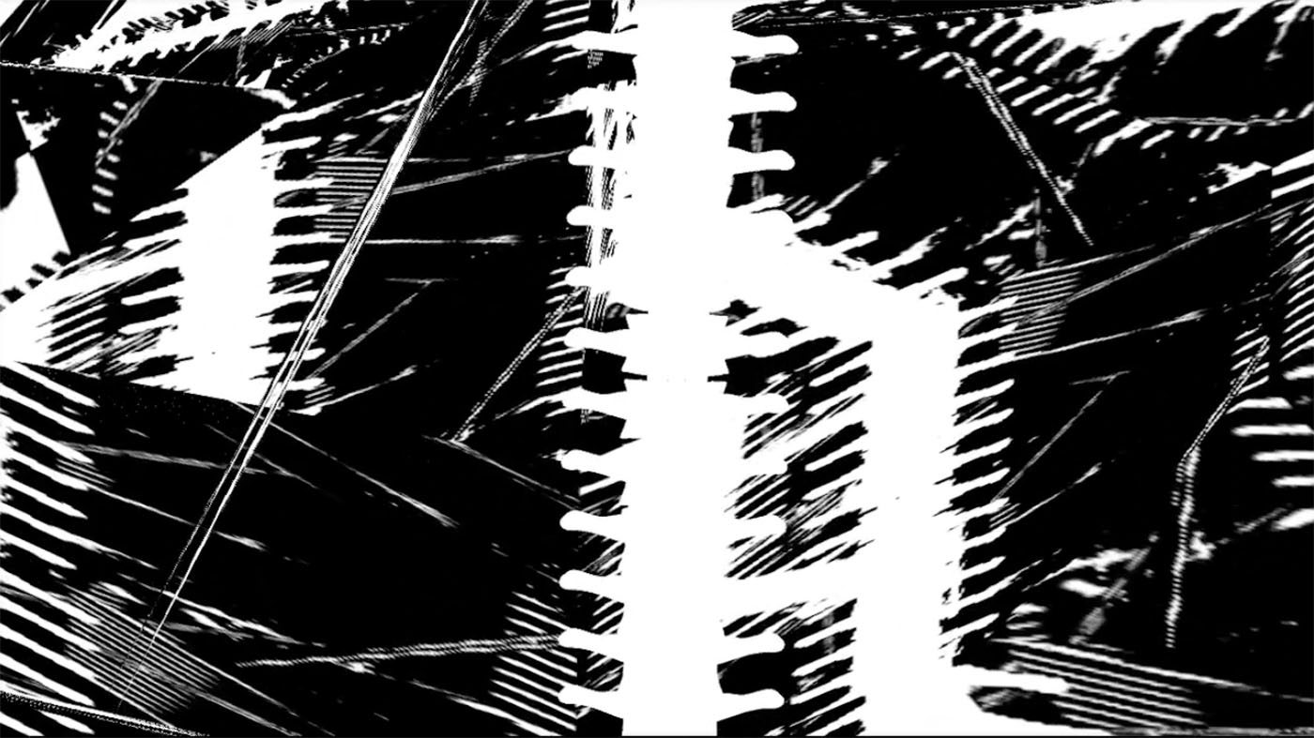
Figure 2: screenshot of Seer (KOR).
Visuals are of a circular spine, audio a mixture of pins and needles crackling and popping with the grating sounds of spinal shifting. This is an attempt to create at least a minimal sensory dysphoria. As the stutter continues, the player’s immediate visuals are repeated endlessly as geometric patterns in the background.
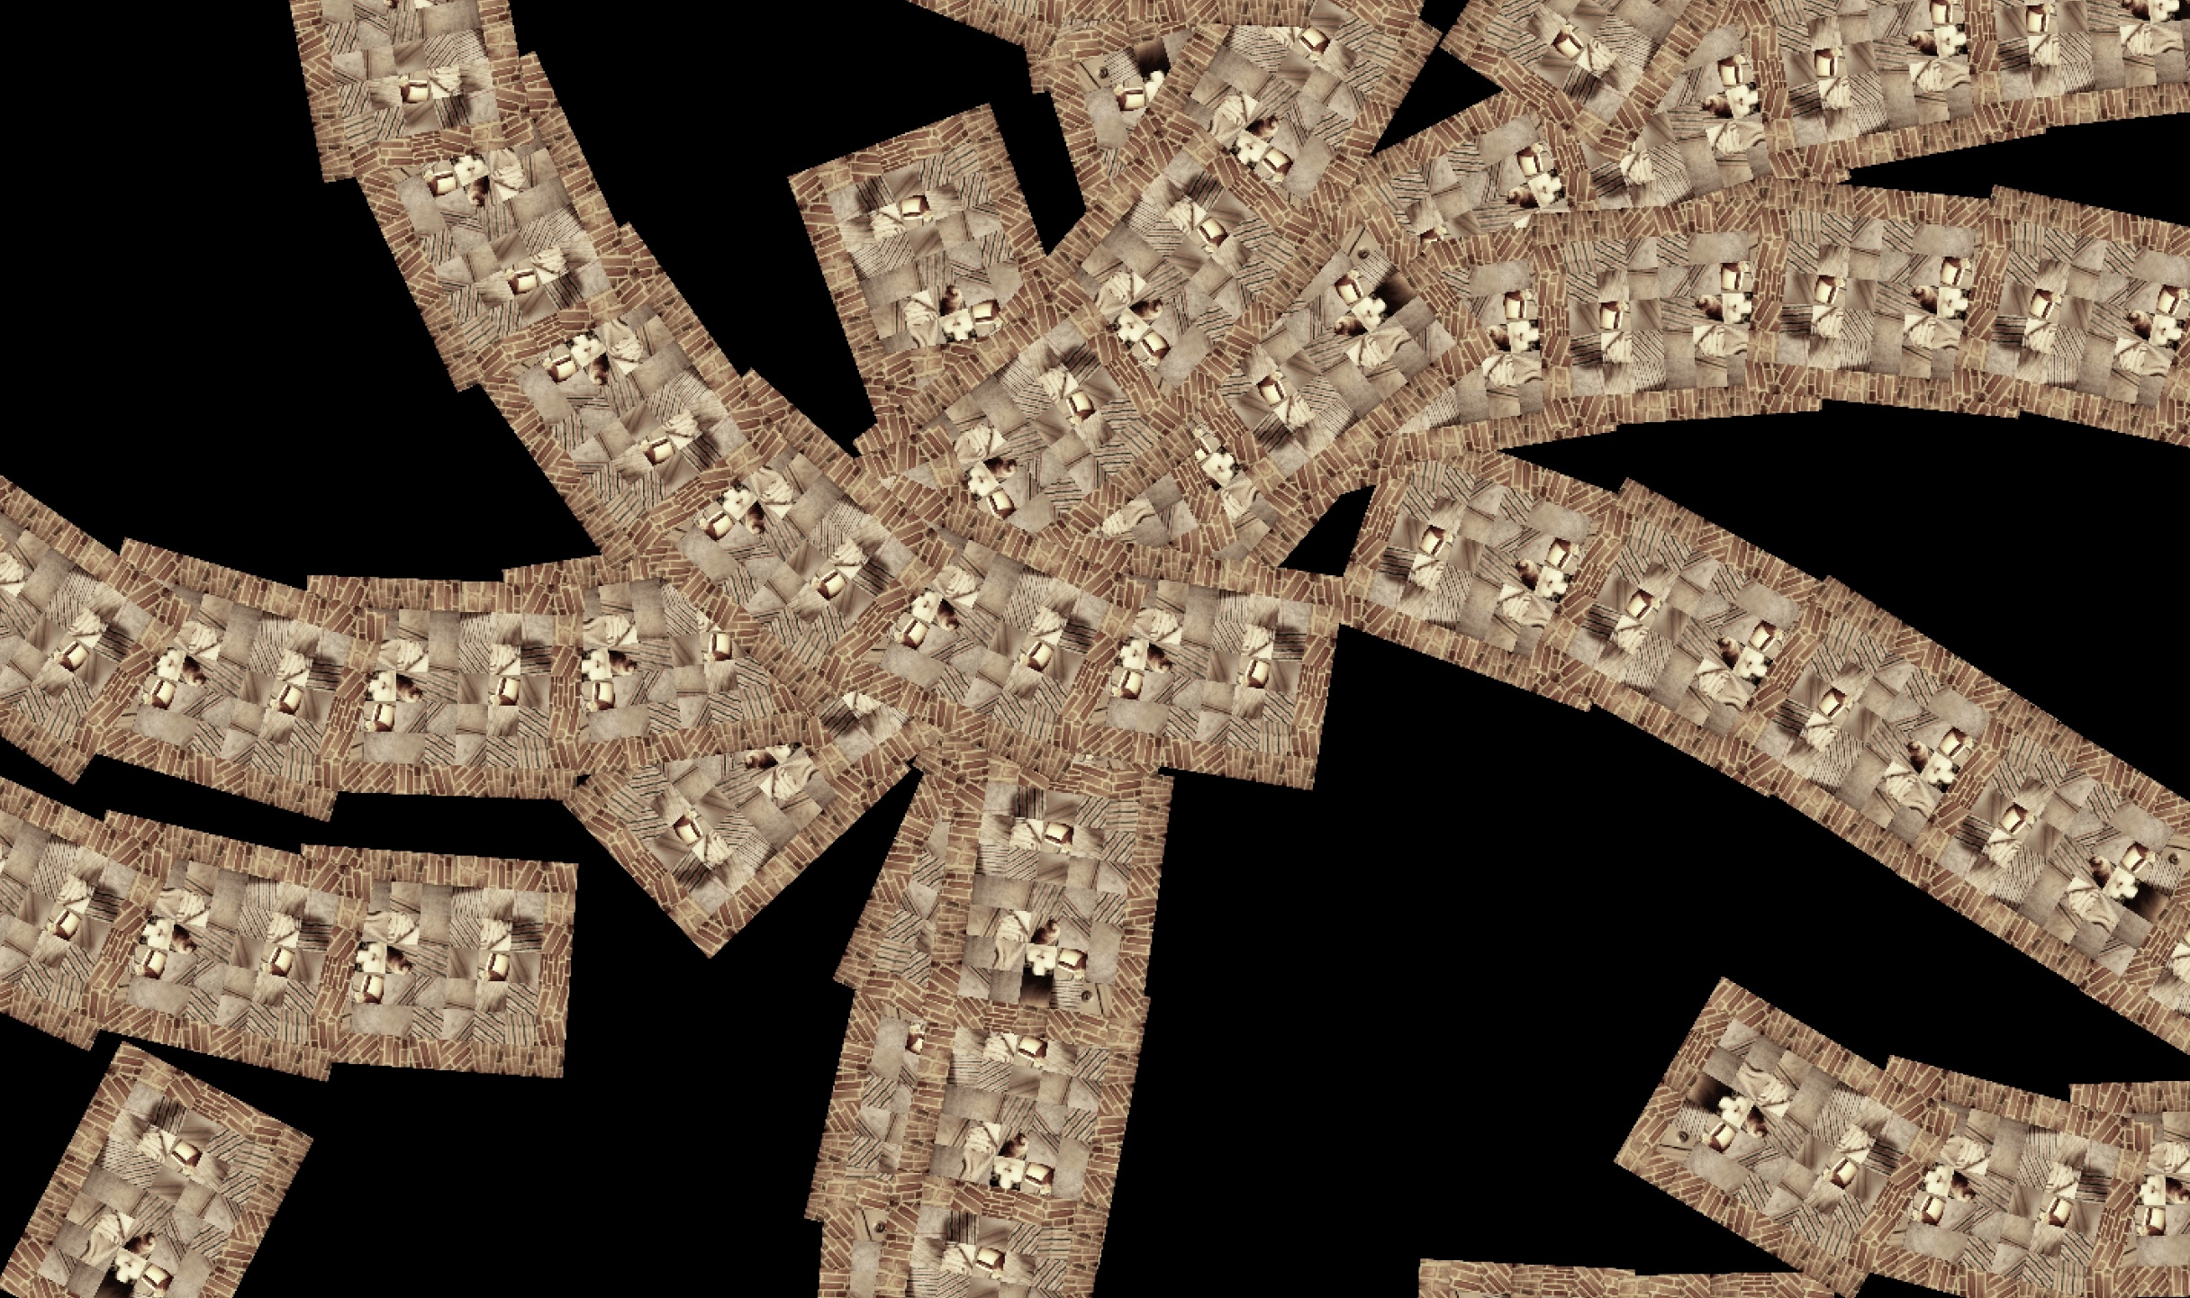
Figure 3: screenshot of Thinning, the repeating world space.
Thinning is my second game experiment, this time focusing on a sense of depersonalization and curved repetition. The player begins in a room of a two-dimensional procedural “roguelike” game. As the player moves from room to room, however, the camera zooms out, showing repetition of the same room. Eventually, the player is using the camera to explore the curving patterns created by the repeating world space, dissociated from the original point of view and navigating the repetition itself.
To create the sense of curved repetition of points of space, I reproduced the game board on separate planes using a technique called render-to-texture. This takes a simulated camera view of the game world and paints it onto two-dimensional game textures, which can be repeated as instantiated game objects. These textures were added to planes, which were duplicated using rules of reproduction that turn space into curving tendrils.
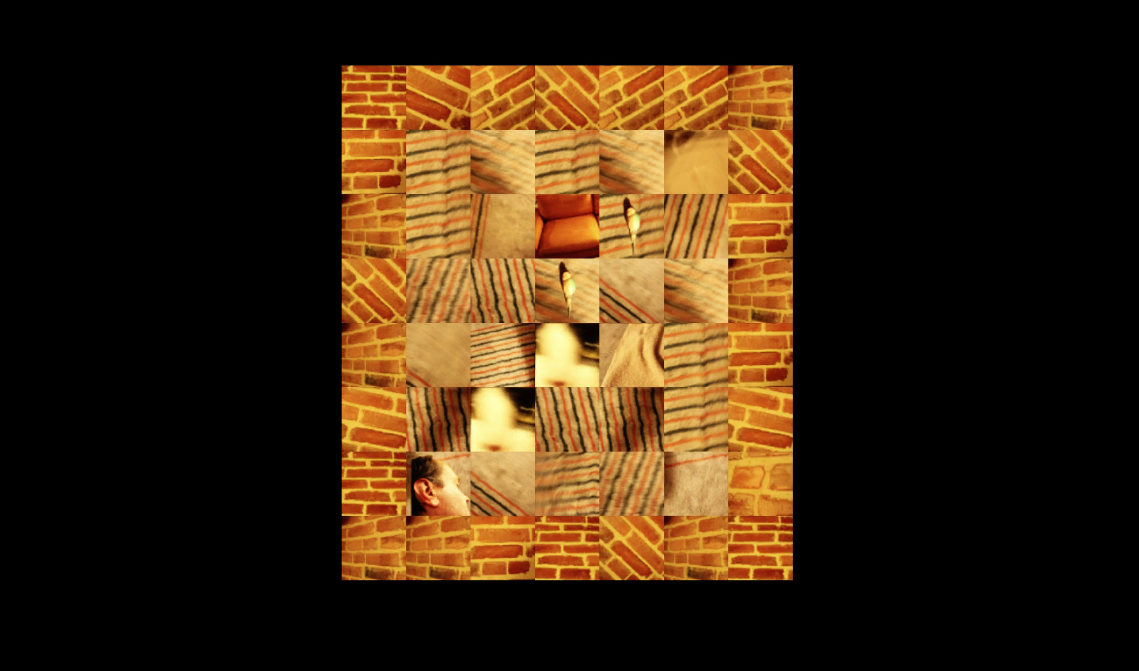
Figure 4: screenshot of Thinning, the singular world space.
I took photos of my living room, with the aesthetic goal of capturing the dissociative flatness that salvia often brings to one’s interpretations of visuals. Arrangement of furniture changes from room to room, but it is clear that it is the same room being entered and exited. My two cats move around and get in the player’s way, contributing to the sense of disorientation.
The goals of the change in perspective and repetition were to explore the loss of understanding of time and location, a meaninglessness discovered in the field of repeating scenes. The curving patterns were an attempt to recreate the ineffable feeling of being in a space between non-Euclidian realities. The player finds themselves outside of three-dimensional space, without a singular “I”.

Figure 5: screenshot of Brief Excursion.
In Brief Excursion, I have made use of a hacked neural headset from the game Mindflex (Mattel, 2009), which roughly reads brainwaves and produces numerical readings from them. The original Mindflex is an exercise in frustration, as the player attempts to levitate a ball by alternating between “relaxation” and “concentration”. My project takes an alternate approach: it uses the lack of control one has over one’s own brain to alter the environment one is exploring. The player is invited to attempt to control and guide the experience, but it does not revolve around the challenge of controlling an object with one’s brain.
The intended focus of the gameplay experience was the exploration of the inter-dimensional space between two worlds of elliptic geometry. The player is encouraged to focus on the space between the two tangible worlds, and with their brain waves, increase or decrease that space, while also indirectly altering the look and constitution of the game world. The idea of the worlds being actual elliptic space, however, was scrapped, and the worlds are simply projected onto spheres.

Figure 6: the hacked Mindflex headset with Arduino microcontroller.
The data I chose to have the game read from the device is what the Mindflex’s documentation says are the mid-gamma waves. I chose these simply because they showed the most interesting variation in readings, but on further research, I found that these waves are associated with the creation of a unity of conscious perception. They are implicated as a possible solution to the problem of “binding” (Buszaki, 2006, 261), the brain’s interpretation of individual parts as a coherent figure or object, as well as separating foregrounds from backgrounds, and other important perceptual mechanisms such as recognition of patterns and common fate, the idea that “features that move together tend to belong together” (232). Could salvia’s ability to dissolve meaning be related to its impact on gamma waves? If so, this was a pleasant accidental alignment with the goal of engaging with the effects of Salvinorin A.
I also explored time manipulation in this project, but eventually removed it to simplify the experience. I experimented with sending time back and forth between the two elliptical dimensions, making one dimension current and the other a repetition of the past. Given the already-abstract visuals that all-but-force one to rely on the audio feedback, I felt the player would have enough challenges making sense of the system without having some of their visuals going back in time.
There seems to be much opportunity, not in using neural headsets to allow the player to levitate game objects “with their mind”, but to use the unconscious to create experiences for the player, change the world’s variables. One can imagine, as a player, populating a world with one’s own obsessive thought patterns, low self-esteem and delusions of grandeur. It is the slippery sense of control that makes mental interfaces interesting. The device is showing the player their own unconscious, not asking the player to attempt to tame a machine with their conscious ego. It is from the vantage point of a feeling of alienation from and observation of one’s own brain that salvia and game spaces can teach us.
Salvia is one of many tools, including those that do not require the addition of external chemicals, such as meditation, for exploring alternate videogame realities. These practices can ground development, give the designer a feeling to return to. Coming back to the feelings of salvia world kept me from going too far into the cleverness of optical tricks. It kept me grounded in the essence of experience.
There are other characteristics of the experience yet to be explored, partly because I stuck to my own personal experiences. Those that I did explore are only a few of the multitude of potential representations of these alternate neurological states.
Endnotes

[1] An example of this is my game After (2010), which proceduralizes an agnostic encounter with one's own belief system and an imagined afterlife after the death of a loved one.
References

Arnott, R. (Unreleased). Soundself. USA: Robin Arnott.

Arthur, J. D., & Arthur, J. D. (2010). Salvia divinorum: doorway to thought-free awareness. Rochester, Vt: Park Street Press.

Baggott, M., Erowid, E., & Erowid, F. (2004). A Survey of Salvia Divinorum Users. Erowid Extracts, (6), 12–15.

Bogost, I. (2007). Persuasive Games: The Expressive Power of Videogames. Cambridge, MA: The MIT Press.

Bogost, I. (2009). Persuasive games: the Proceduralist style. Gamasutra. Retrieved July 6, 2017, from http://www.gamasutra.com/view/feature/3909/persuasive_games_the_.php

Bruce, A. (2013). Antichamber. USA: Demruth.

Buzsaki, G. (2006). Rhythms of the Brain. New York: Oxford University Press.

Caillois, R., & Barash, M. (2001). Man, play, and games. Urbana: University of Illinois Press.

González, D., Riba, J., Carlos Bouso, J., Gómez-Jarabo, G., & Barbanoj, M. (2006). Pattern of use and subjective effects of Salvia divinorum among recreational users. Drug and Alcohol Dependence, (85), 157–162.

Heaven, R. (2013). Shamanic quest for the spirit of Salvia: the divinatory, visionary, and healing powers of the sage of the seers. Rochester, VT: Park Street Press.

Kanaga, D. (2012, June 16). Played Meaning (Concerning the Spiritual in Games). Retrieved November 3, 2015, from http://wombflashforest.blogspot.com/2012/06/played-meaning-concerning-spiritual-in.html

Knight, M. M. (2013). Tripping with Allah: Islam, drugs, and writing. Berkeley, CA: Soft Skull Press.

Mind flex (2009). Board game. El Segundo, CA: Mattel.

Miyamoto, S. (1985). Super Mario Bros. Japan: Nintendo.

Oldenburg, A. (2010). After. USA: Aaron Oldenburg.

Oldenburg, A. (2016). Brief Excursion. USA: Aaron Oldenburg.

Oldenburg, A. (2016). Seer (KOR). USA: Aaron Oldenburg.

Oldenburg, A. (2016). Thinning. USA: Aaron Oldenburg.

Pendell, D., & Snyder, G. (2010). Pharmako poeia: Plant powers, poisons, and herbcraft. Berkeley, Calif.: North Atlantic Books.

Salen, K., & Zimmerman, E. (2003). Rules of Play: Game Design Fundamentals. Cambridge, MA: The MIT Press.

Sato, O. (1998). LSD Dream Emulator. Japan: Asmik Ace Entertainment.

Sheffler, D., & Roth, B. (2003). Salvinorin A: the “magic mint” hallucinogen finds a molecular target in the kappa opioid receptor. TRENDS in Pharmacological Sciences, 24(3), 107–9. http://doi.org/10.1016/S0165-6147(03)00027-0

ZenoRogue (2016). Hyperrogue Gold. Retrieved June 6, 2017, from http://roguetemple.com/z/hyper/

