Tree species diversity drives the apparent lengthening of urban growing seasons more than the heat island effect

Michael Alonzo, Matthew E. Baker, Joshua S. Caplan, Avery Williams, Andrew J. Elmore

Supporting Information Text

S1: A note on data filtering and the use of robust statistics
We have chosen to only implement robust statistics in this work because of the need for strong data filtering and the remaining presence of a small percentage (but large count) of data that are outliers. We ultimately seek an understanding of the “typical” (e.g., median) values for our phenometrics across the landscape. Here are primary examples of data filtration in our workflow. We retained (across all three years):
- PlanetScope scenes with > 90% “clear percent” (accounting for cloud cover and other reductions of atmospheric transparency) and solar elevation angle >20°, only best image per day (based on highest clear percent and highest solar angle). Images downloaded: 499
- Images where empirical line fits (based on invariant targets from a 2019 base image) for NIR band radiance exceed an R² value of 0.85. Images retained: 415
- Urban Forestry Division street tree point locations within our study area (starting n = 63,019 for selected 29 species; Table 2 in main text) for which a double logistic fit converges on a solution with reasonable values (e.g., SOS is between 0 and 180 and EOS is between 180 and 365) with outliers removed on a per species basis. Crowns retained: 47,761
- For PGLS analysis, crowns where tree height (for consistent viewability from satellite sensor) was > 10 m and tree diameter at breast height was greater than 50.8 cm (20 in). Crowns retained: 10,358
Uncertainty is generally reported as 95% confidence intervals on the reported value based on simulation.

S2: Species vs. planting site linear modeling at the tree crown scale
As discussed in main text, we fit linear models to assess variation in SOS and EOS using: 1) ordinary least squares (OLS) models, in which we only incorporated site variables, 2) phylogenetic generalized least squares (PGLS) mixed effects models, which incorporated species as a random effect, and 3) PGLS mixed effects models with site variables as fixed effects and species as a random effect. Modeling was performed with the temporally aggregated dataset (n = 10,358 tree crowns with data from 2018-2020 pooled). Details follow:

- Phylogenetic relatedness was determined after pruning a phylogenetic dataset to include the 29 taxa most closely matching the species in our dataset. There were 23 exact matches after normalizing species names; for an additional five species we were able to substitute closely-related species (based on relationships enumerated in the USDA PLANTS database). In the final case (that of Prunus yedoensis) the closest match in the phylogenetic dataset was Prunus ×.
- A variance-covariance matrix based on phylogenetic relatedness was computed for the 29 species under the assumption that species diversification was a Brownian process. This was done using the function ‘vcv’ in the R package ape.
- The abovementioned variance-covariance matrix was used in PGLS models using the ‘relmatLmer’ function from the R library lmer4qtl. Specifically, it was associated with the random effect for species.
- For initial models, spatial autocorrelation remained an issue, as determined by Moran’s I. We mitigated this in final models (yielding non-significant Moran’s I) in two ways. First, we included Latitude and Longitude in models (Ziter et al., 2019). Second, we randomly sub-sampled 750 crowns, 100 times to increase spacing between crowns.
- The subsampling also facilitated the generation of median parameter estimates and their 95% confidence bounds.

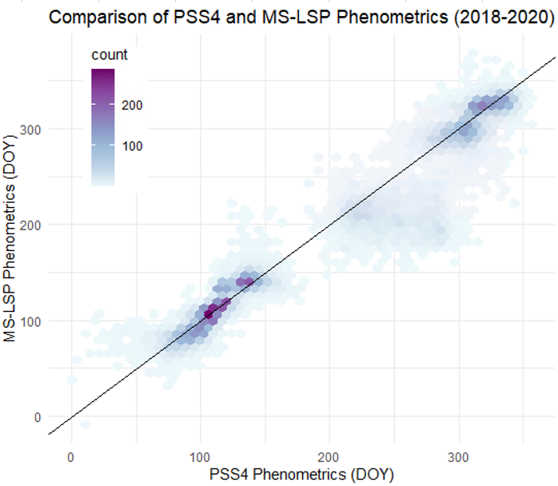

Figure S1: The relationship between PlanetScope and MultiSource Land Surface Phenology (MS-LSP; Bolton et al., 2020) phenometrics extracted from 30 m diameter plots at 1310 locations with vegetation cover >50%. This represents 2018, 2019, and 2020 separately and is based on the MS-LSP metrics: 10% green-up (g10), 50% green-up (g50), 90%, green-up (g90), 10% browndown (b10), 50% browndown (b50), and 90% browndown (b90; r² = 0.94 overall). Average g50 and b50 median absolute deviations in DOY are 4.3 and 11.0 respectively. These are comparable to our SOS and EOS metrics though b50 timing is more strongly influenced by summer greendown.

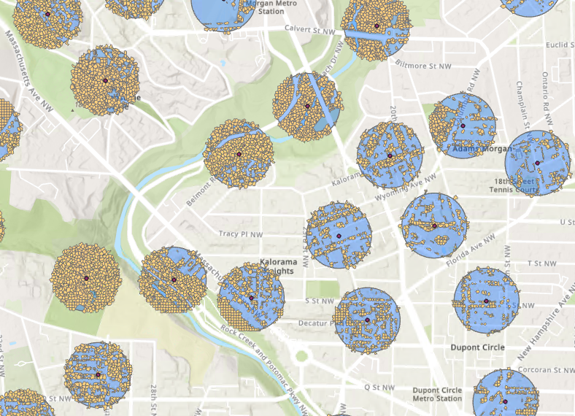

Figure S2: Showing the comparison of 250 m diameter MODIS plots (blue background) with crown-scale segments used for comparison. Crown-scale segments (orange) may include tree crown, low vegetation, or grass. Each segment only contains one PFT.

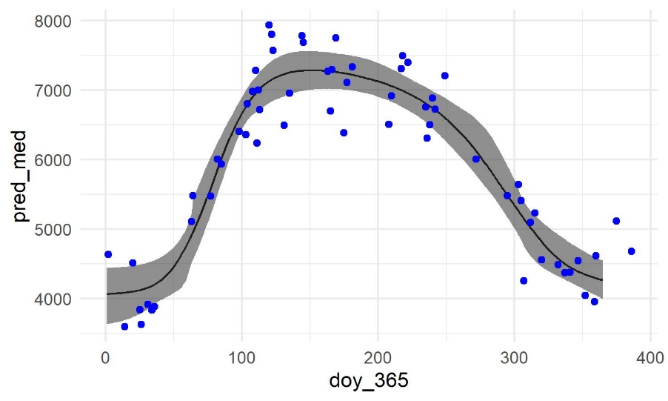
Figure S3: Example of turf grass phenology in 2019. Note the high baseline and the early SOS. Grass phenology varies widely based on the characteristics of winter and management regime.

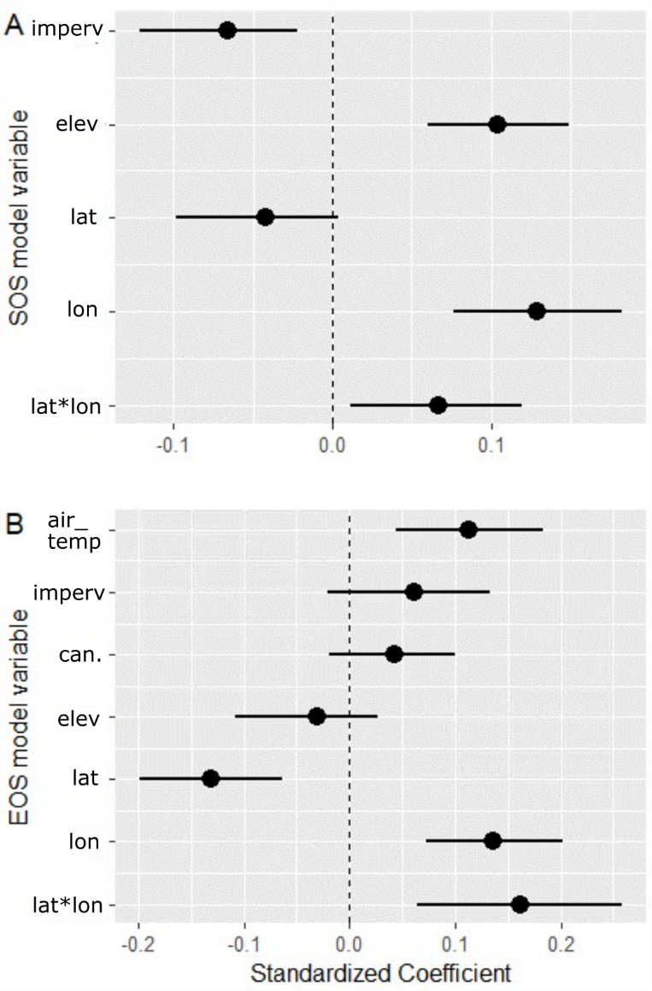
Figure S4: Standardized coefficients for site-predictors after BIC-based model selection. Fixed effect median coefficient values and 95% value ranges based on 100 random draws of 750 crowns from the full PGLS (i.e., accounting for species). A) SOS and B) EOS models.

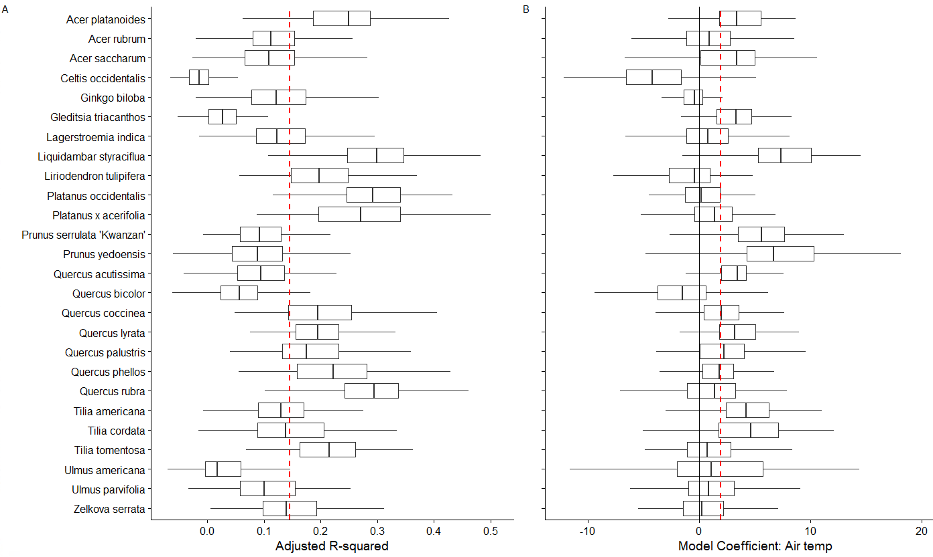
Figure S5: Individual species response to site. A) The extent to which variability in EOS could be modeled for each species using only the fixed effects. B) Species sensitivity to temperature with other site factors held constant. Red dashed line is aggregated median R-squared in (A) and temperature sensitivity in (B). Boxplots are based on 100 model runs per species with randomly sampled crowns. Crowns were included if they had a DBH greater than 12.7 cm (5 in) and height taller than 5 m. This is more inclusive that our thresholds for the PGLS modeling because we wanted to have a larger sample size per crown. However, this likely relates to inclusion of small crowns with very low R² values.

Further context for Figure S5: In our PGLS mixed model, we found that planting site factors did play a role in altering the timing of EOS. We anticipated that different species would react differently to these site factors. In the full model, inclusion of site factors as fixed effects raised overall model R² from 0.42 (only species) to 0.52 (mixed model). In the figure above, you see that the sensitivity of the study species to site varies widely. However, this fit metric also internalizes other issues relating to lower ability to accurately monitor from satellite imagery (e.g., small crowns like Celtis occidentalis). In panel B, it is worth noting that even for species with high R² values, there is high variation in sensitivity to local air temperature anomaly. For example, Liquidambar s. and both Platanus species have relatively high sensitivity but only Liquidambar seems particularly sensitive to temperature anomaly. Further exploration is necessary to solidify conclusions from this analysis.

SI References

Bolton, D. K., Gray, J. M., Melaas, E. K., Moon, M., Eklundh, L., & Friedl, M. A. (2020). Continental-scale land surface phenology from harmonized Landsat 8 and Sentinel-2 imagery. Remote Sensing of Environment, 240(November 2019), 111685. https://doi.org/10.1016/j.rse.2020.111685
Tukey, J. W. (1977). Exploratory data analysis. Addison-Wesley, Reading, MA. Exploratory Data Analysis. Addison-Wesley, Reading, MA.

