Supplemental Figure

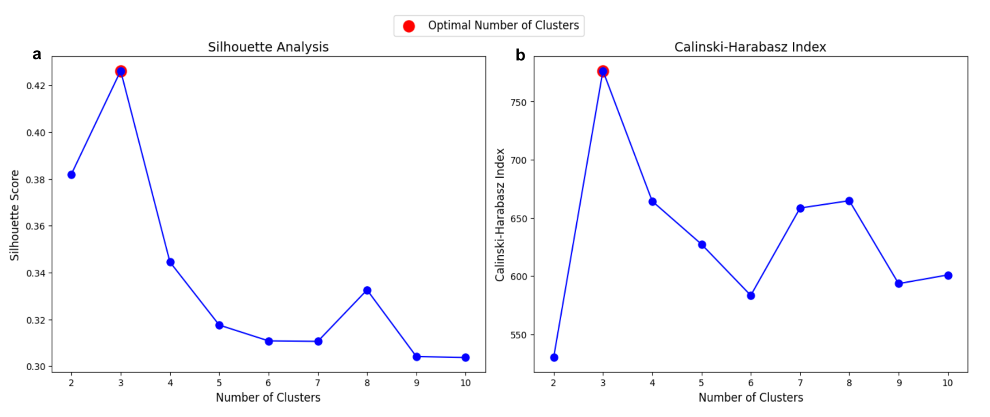
Supplemental Figure 1. Evaluation of Optimal Cluster Number Using K-Medoids. Panel a presents the Silhouette Analysis, where the Silhouette Score is plotted against the number of clusters. Panel b displays the Calinski-Harabasz Index, which evaluates clustering quality by comparing the variance between and within clusters. Both metrics confirm three as the optimal number of clusters.

