Phytoplankton uptake by a resilient urban estuary bivalve, Mytilopsis leucophaeata
Allyson K. Kido¹, Kenneth N. Mansfield ², and Eric J. Schott^{3*}

Supplementary Material
Table S1. Mussel Collection Locations and Experiments
Location | Experiment | Coordinates
Downtown Sailing Center | Salinity Trial 1, Temperature Trial 1, and Trial 2 | (39.274458, -76.600185)
Aquarium East | Algae Experiment | (39.285473, -76.607978)
IMET | Salinity Trial 2 | (39.286472, -76.606360)

Table S2. Pairwise t-test for temperature Trial 1 mussel treatment IVCH
group1 | group2 | n1 | n2 | statistic | df | p | p.adj
T1 | T2 | 12 | 12 | 3.7 | 11 | 0.004 | 0.021
T1 | T3 | 12 | 12 | 5.31 | 11 | 0.00025 | 0.002
T1 | T4 | 12 | 12 | 7.39 | 11 | 0.0000138 | 0.0000828
T2 | T3 | 12 | 12 | 5.15 | 11 | 0.000319 | 0.002
T2 | T4 | 12 | 12 | 7.34 | 11 | 0.0000147 | 0.0000882
T3 | T4 | 12 | 12 | 4.96 | 11 | 0.000427 | 0.003

Table S3. Wilcoxon sum rank test results for salinity trial 1 – IVCH
Treatment | group1 | group2 | n1 | n2 | statistic | p | p.adj
Mussel | T1 | T2 | 12 | 12 | 78 | 0.000488 | 0.003
 | T1 | T3 | 12 | 12 | 78 | 0.000488 | 0.003
 | T1 | T4 | 12 | 12 | 78 | 0.000488 | 0.003
 | T2 | T3 | 12 | 12 | 78 | 0.000488 | 0.003
 | T2 | T4 | 12 | 12 | 78 | 0.000488 | 0.003
 | T3 | T4 | 12 | 12 | 78 | 0.000488 | 0.003
No mussel | T1 | T2 | 12 | 12 | 10 | 0.021 | 0.126
 | T1 | T3 | 12 | 12 | 1 | 0.000977 | 0.006
 | T1 | T4 | 12 | 12 | 1 | 0.000977 | 0.006
 | T2 | T3 | 12 | 12 | 2 | 0.001 | 0.009
 | T2 | T4 | 12 | 12 | 0 | 0.000488 | 0.003
 | T3 | T4 | 12 | 12 | 9 | 0.016 | 0.097

Table S4. Pairwise t-test results for salinity trial 2 – IVCH
Treatment | group1 | group2 | n1 | n2 | statistic | p | p.adj
Mussel | T1 | T3 | 12 | 12 | 10.5 | 11 | 4.52E-07
 | T1 | T4 | 12 | 12 | 9.82 | 11 | 8.87E-07
 | T3 | T4 | 12 | 12 | 3.47 | 11 | 0.005
No Mussel | T1 | T3 | 12 | 12 | -0.945 | 11 | 0.365
 | T1 | T4 | 12 | 12 | -1.25 | 11 | 0.237
 | T3 | T4 | 12 | 12 | -0.117 | 11 | 0.909

Table S5. Pairwise comparisons for clearance rates of salinity experiment
Comparison | Trial 1:  IVCH p - value | Trial 2:  IVCH p - value
5ppt – 10ppt | 0.141 | 0.983
5ppt – 15ppt | 0.455 | 0.140
10ppt – 15ppt | 0.621 | 0.182

Fig. S1 Histogram of temperatures from MD DNR Eyes on the Bay Aquarium East sonde from 2018 – 2022. Temperature data was rounded up to the nearest whole number. Colors represent the mean (orange), median (purple), and first and third quartile (blue).
Fig. S2 Histogram of salinities from MD DNR Eyes on the Bay Aquarium East sonde from 2018 – 2022. Salinities data was rounded to the nearest whole number. Colors represent the mean and median (purple) and the first and third quartile (blue)

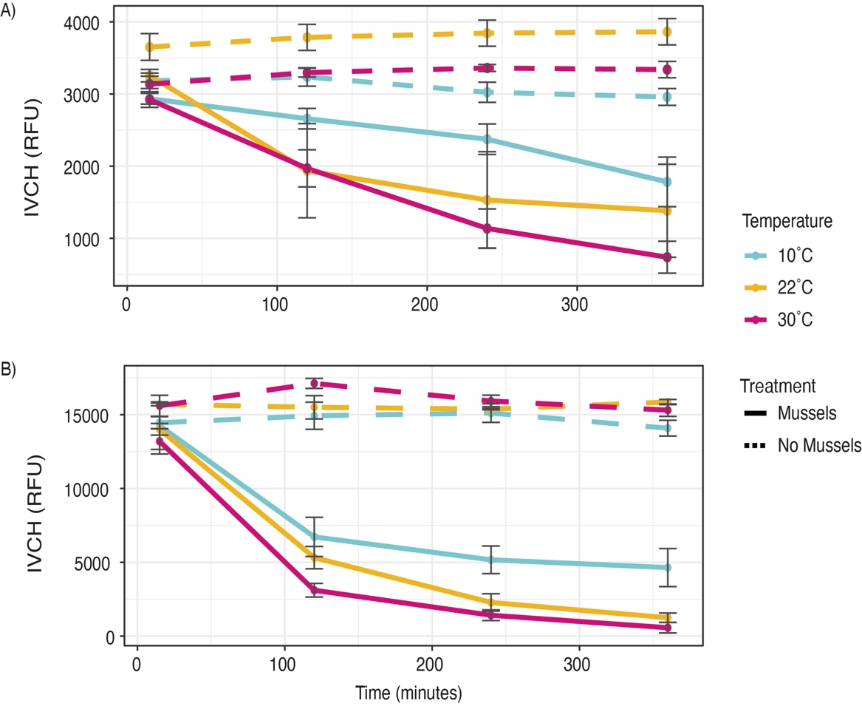
Fig. S3 Change in average IVCH over time for A) Trial 1 and B) Trial 2 of the temperature experiment. Error bars are standard error means. Solid lines represent the Mussel treatment and the dashed lines represent the No Mussel treatment. Colors indicate the temperature of the experiment. Time points are T1 – 10 minutes, T2 – 2 hours, T3 – 4 hours, and T4 – 6 hours

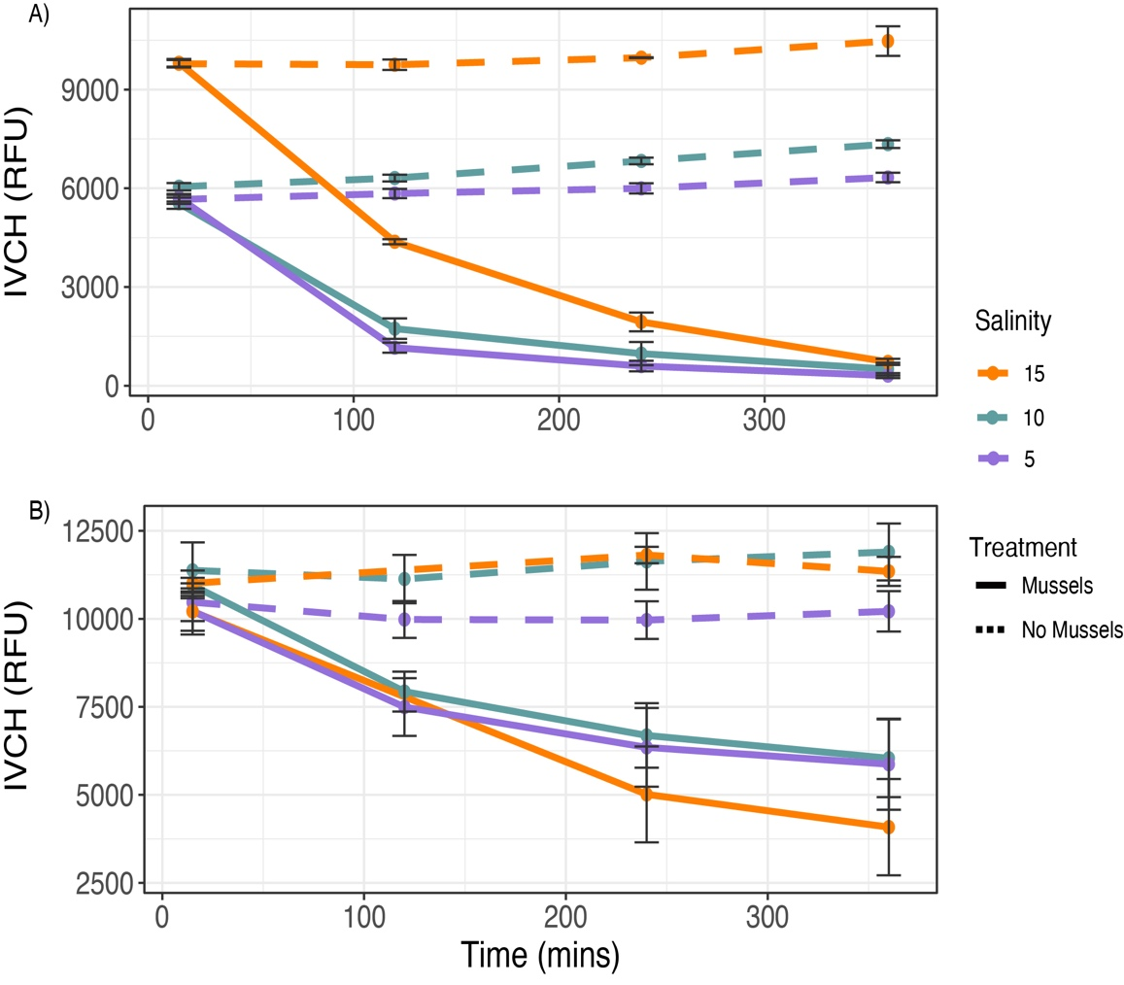
Fig. S4 Change in average IVCH over time for A) Trial 1 (July) and B) Trial 2 (October) of the salinity experiment. Error bars are standard error means. Solid lines represent the Mussel treatment and the dashed lines represent the No Mussel treatment. Colors indicate the salinity of the experiment. Time points are T1 – 10 minutes, T2 – 2 hours, T3 – 4 hours, and T4 – 6 hours. Data for the T2 timepoint for the No Mussel 15 ppt line of Trial 2 are not shown due to a data collection error

