Appendix A. Alternative calculations
A.1. Alternate net erosion results; omitting estimates of floodplain deposition
In order to provide a net erosion rate that omits uncertainty and assumptions associated with our estimates of floodplain deposition, we calculated an alternative version of net erosion as the difference between the measured gross erosion and measured in-channel deposition. In-channel deposition rates ranged from 19 to 266 Mg/km/y, accounting for a mass equal to 20 to 94% of measured gross streambank erosion across the study segments. However, as indicated in the manuscript, there were substantial differences in the particle-size distributions of channel deposits and streambank sediments. The grain size of depositional sediment samples suggested that 30% of the deposition may have originated from streambanks. Therefore reducing the measured in-channel deposition to 30% provided an estimate of streambank redeposition ranging from 7 – 79 Mg/km/y, equivalent to a value between 6 and 28% of gross streambank erosion (Fig. A.1).
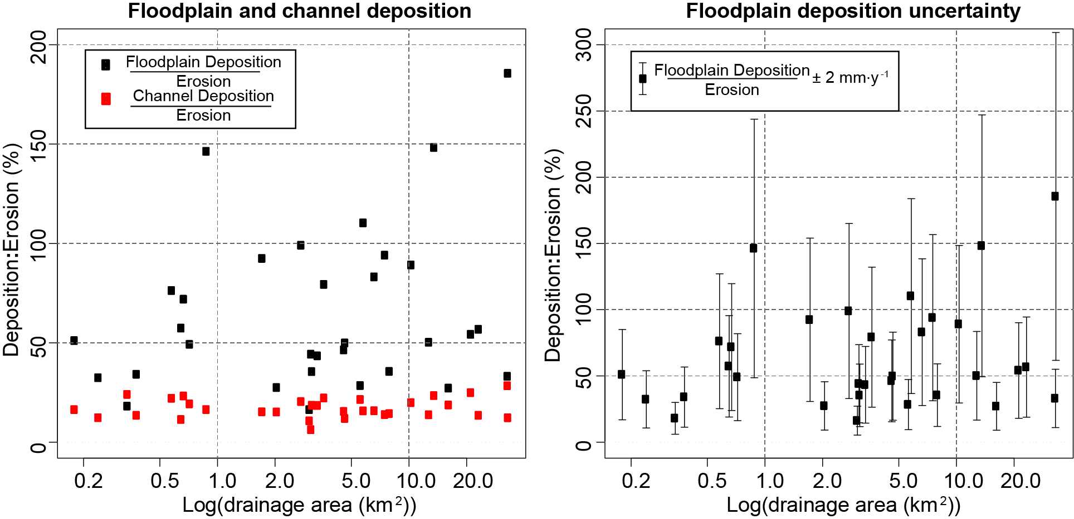
Fig. A. 1 Estimated floodplain deposition (black) is compared to adjusted channel deposition (red). Both are expressed as a fraction of the gross erosion. The floodplain deposition assumes a vertical accretion of 3 mm/y over one-third of the valley floor. Adjusted gross deposition is based on the overlap in grain sizes of channel deposits compared to streambanks.

The rate of in-channel deposition is less than gross erosion, but it generally increased more rapidly than gross streambank erosion with increasing drainage area. If floodplain accumulation rates are assumed to average 3 mm/y over 1/3 of cumulative valley floor area, then floodplains serve as a much larger trap for fine sediment than in-channel deposits, which have very small measured fine-sediment fractions. On the other hand, if floodplains are aggrading more slowly at an average rate of 1 mm/y, floodplain deposition is comparable to the measured channel deposition.
A.2. Measuring discontinuity of floodplains along low-order channels
While research has indicated sediment mobilized along low-order streams is a “blind spot” essential for understanding sediment dynamics (Smith et al., 2011), others have disregarded contributions from such tributaries in sediment budgets owing to a lack of floodplains (Allmendinger et al., 2007). We observed in the field and in lidar-based digital elevation models (DEMs) that there are indeed alluvial deposits bordering first- and second-order streams, but those deposits are patchy and discontinuous. Based on these observations, channel migration along these streams contributes to remobilization of alluvial deposits. In order to ensure that contributions from low-order tributaries were not overestimated from discontinuous floodplain deposition, we measured the proportion of channel length bordered by floodplains along 21 stream segments with drainage areas between 0.07 and 0.5 km² at their downstream extent.
Lidar-based interpretation of floodplain extent suggested that alluvium occupied an average of 63% (median = 69%) of total channel length in smaller drainages. The median was a more accurate representation of central tendency than the mean because of distributional skew (Fig. A.2). Whenever possible, we extended the upstream extent of measurement to channel heads visible on the lidar hillshade. For measurements extending across multiple stream orders, we distinguished estimates separately by each order. The estimates of percent cumulative channel length along low-order channels with floodplain patches or identifiable alluvial deposits were used together with channel migration rates to calculate the contribution to the sediment budget from these floodplain patches (Section 5.3 of the manuscript).
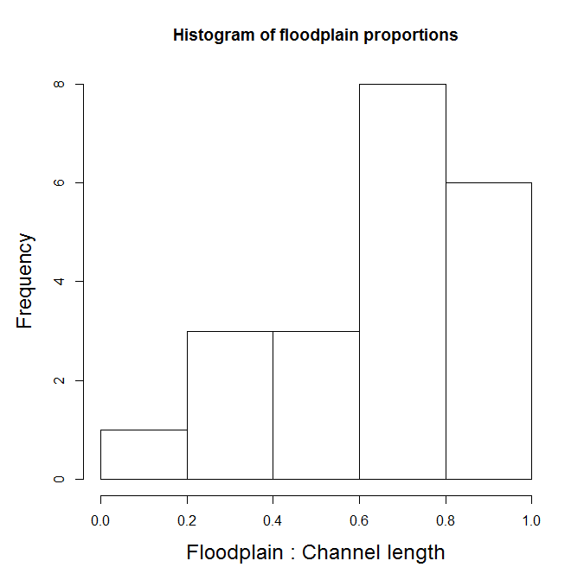
Fig. A. 2. A histogram of the proportion of low-order channel length that was bordered by floodplains for 21 streams. The majority of low-order channels were bordered by floodplains for 60 to 100% of their channel length.

Appendix B. Uncertainty calculations
B.1. Removing erosion and deposition below the level of detection
In order to account for potential error inherent in georectifying the historical maps, we filtered out erosion and deposition from narrow polygon slivers and those with an area less than 1 m² prior to the error propagation. This ensured that the measured changes were above the level of detection possible within the RMSE of the historical data. Additional polygons located between abandoned channels or channel avulsions were removed, because the channel ‘jumped over’ the area, rather than migrating through it. We were able to identify avulsions and meander cutoffs with remnant floodplain patches located between the modern and historical channels on the lidar DEM.
B.2. Propagating multiple sources of uncertainty
When propagating multiple sources of uncertainty, we used the commonly accepted methods outlined in Taylor (1997). When adding, subtracting, or multiplying measurements with quantifiable uncertainty, we used Eqs. (B.1) and (B.2) to bracket the final uncertainty of the results. Details on the applications of each formula are found in the subsequent sections.
Equation B.1. Propagating multiple sources of error during addition or subtraction.
$$Z=X±Y; U_{Z}= \sqrt{U_{X}^{2}+U_{Y}^{2}}$$
Equation B.2. Propagating multiple sources of error during multiplication.
$$Z=X∙Y; U_{Z}= \left|XY\right|\sqrt{{\left(\frac{U_{X}}{X}\right)}^{2}+{\left(\frac{U_{Y}}{Y}\right)}^{2}}$$
B.3. Uncertainty in bulk density
The range of uncertainty around the mean bulk densities for erosional and depositional sediments was calculated as 2 × standard error (SE) of mean density (95% confidence interval). For each study segment, the bulk density confidence interval was multiplied by the volume of erosion (or deposition) to obtain a bracketed range of potential erosion or depositional masses.
B.4. Uncertainty in estimated historical channel widths
For study segments represented as a single channel centerline (rather than a right and left edge of water) on historical maps, we estimated the historical width as the average width of the channel in 2005. The uncertainty in these estimates was obtained by comparing channel widths from historical and modern channel data (Table B.1) at locations where lidar observations were used to confirm that the channel had not moved or changed in width. The comparisons revealed the average absolute change in channel width was 17% with no systematic increases or decreases in channel width over the past 45 years. Therefore we bracketed the historical channel width estimates with channels measuring ±20% of the mean width. Using a percent of the channel width, rather than an absolute width, to bracket the uncertainty avoided over or underestimating the error in small or large channels respectively.
 | Mean channel width (m) |  | Width change
Site | Modern (2005) | Historic (1959-1961) | Linearª (m) | Fractionalᵇ (%)
Bee Tree Run | 3.90 | 3.52 | 0.38 | 11%
Buffalo Run | 2.92 | 4.00 | -1.08 | 27%
First Mine Branch | 4.06 | 3.48 | 0.58 | 17%
Little Falls | 2.88 | 3.98 | -1.10 | 28%
Little Piney Run | 3.48 | 2.88 | 0.60 | 21%
McGill Run at Butler Rd. | 5.32 | 4.68 | 0.64 | 14%
Piney Run at Trenton Rd. | 3.72 | 3.54 | 0.18 | 5%
Piney Run at Mantua Mill Rd. | 5.70 | 6.64 | -0.94 | 14%
Piney Run at Mt. Zion Rd. | 4.32 | 5.40 | -1.08 | 20%
Third Mine Branch | 3.32 | 3.06 | 0.26 | 8%
Western Run at Gadd Rd. | 9.54 | 7.96 | 1.58 | 20%
Western Run at Mantua Mill Rd. | 7.82 | 9.80 | -1.98 | 20%
Western Run at Cuba Rd. | 11.74 | 14.20 | -2.46 | 17%
ªNegative values indicate a decrease in channel width. |  |  | Average = 17%
ᵇPercent channel change was calculated as non-directional change.

Table B. 1. Comparisons of historical and modern channel widths. The columns on the right show the changes in channel widths as an absolute value and as a fraction of the historical channel width.

Additionally, at locations where the historical channel line overlapped meander scars preserved in the 2005 lidar, we compared the buffered width to the channel widths of preserved channel features. Because many abandoned channels were filled in with sediment, the widths of remnant channels were measured at the best approximation of the wetted-channel width. While we did not include these analyses in the estimate of uncertainty, the majority of comparisons fell within the 20% width range used to bracket our results.
Uncertainty resulting from assumptions regarding historical channel geometry were measured by recalculating the mass of gross erosion and deposition with ±20% of the estimated widths. This resulted in a relatively larger error for these sites compared to those with observable historical channel edges. Uncertainty from this assumption was propagated with the other sources of error to obtain a final estimate of uncertainty for gross erosion rates and gross in-channel deposition rates.
Site | # of exposures (n) | Fraction of legacy sediment (µ) | Uncertainty (± 2 x SE)
Bee Tree Run | 8 | 84.5% | 10.4%
Blackrock Run | 9 | 60.6% | 5.3%
Buffalo Run | 16 | 51.7% | 12.5%
Chimney Branch | 2 | 6.3% | 4.4%
Cooks Branch | 9 | 72.4% | 10.1%
First Mine Branch | 9 | 52.2% | 13.9%
First Mine Branch Trib | 9 | 52.2% | 13.9%
Fourth Mine Branch | 5 | 54.7% | 4.1%
Jones Falls | 5 | 83.2% | 6.4%
Keysers Run | 12 | 68.9% | 6.3%
Little Falls | 12 | 74.8% | 9.0%
Little Piney Run | 8 | 40.6% | 17.7%
McGill Run, Butler Rd | 7 | 72.0% | 4.6%
McGill Run, Byerly Rd | 6 | 44.6% | 12.2%
Mingo Branch | 9 | 59.5% | 6.9%
Norris Run | 11 | 62.0% | 7.3%
Panther Branch | 7 | 67.0% | 9.1%
Piney Run, Mantua Mill Road | 7 | 68.4% | 4.7%
Piney Run, Mt. Zion | 8 | 64.5% | 10.6%
Piney Run, Trenton Mill Rd | 10 | 64.6% | 8.2%
Powells Run | 7 | 65.1% | 10.0%
Third Mine Branch | 9 | 72.4% | 8.3%
Western Run, Cuba Rd | 7 | 90.1% | 4.4%
Western Run, Gadd Rd | 9 | 73.8% | 5.4%
Western Run, Mantua Mill Rd | 11 | 71.2% | 4.3%
Average | 8.5 | 63.1% | 8.4%

Table B. 2. The uncertainty for measurements of legacy sediment found in streambanks was calculated as the 95% confidence interval (2 × the SE of mean). The measurements are listed for the original 26 study segments, prior to being divided by their stream orders.
B.5. Uncertainty in the segment-averaged thickness of legacy sediments
Uncertainty of legacy sediment thickness for each study segment (Fig. B.2) was estimated as 2 × SE of mean thickness and combined with uncertainty from gross erosion (using Eq. (B.2)) to estimate uncertainty for gross legacy sediment erosion rates. Gross legacy sediment erosion uncertainty was further propagated with estimates of uncertainty in gross deposition and total deposition in order to obtain the uncertainty of net legacy sediment erosion.
B.6. Uncertainty in net erosion rates
For net streambank erosion, uncertainty from gross erosion, gross in channel deposition, and floodplain deposition were combined using Eq. (B.1.) Estimated floodplain deposition uncertainty was propagated with Eq. (B.2) using cumulative uncertainty from both (i) a range of literature values (1 – 5 mm/y) and (ii) the assumed density value of deposited sediment (1.13 g/cm³). We recognize that in the absence of field measurements of floodplain deposition within our study areas, this latter uncertainty estimate cannot be verified. However we believe that the estimated values and uncertainty provide a better-informed estimate than if floodplain deposition and a potential range of uncertainty were omitted from our calculations.
B.7. Uncertainty in the extrapolated sediment yields
For the classification and regression tree (CART) analysis of net streambank sediment yields and net legacy sediment yields, uncertainty was estimated as mean ± SE for each of the four classes of stream segments used in extrapolation. Uncertainty from each class of the CART analysis was employed to produce the estimated uncertainties for sediment yields found in Table 4. Additional uncertainty (Table 5 in the manuscript) from assumptions inherent in the methods was not quantified directly. Firstly, we estimated 1/3 of the floodplain is an active sediment trap based on our field observations and research demonstrating that a majority of floodplain deposition is stored in near-channel levee deposits (Walling et al., 1998; Schenk et al., 2013; Hupp et al., 2013). We did not quantify the impact of this assumption, but it would likely add considerable uncertainty to the results. Secondly, based on thorough comparisons of grain sizes found in streambanks and channel deposits, we assume that a maximum of 30% of in-channel deposition came from streambank erosion. We consider this a low level of additional uncertainty because of the narrow range of variability in fine-grained material across our channel deposit samples.

