Understanding the Factors Affecting Washington DC's Community Land Trust Start-Up as a Potential Partial Remedy for Affordable Housing and Upward Mobility
By
Dinah R. Carter
2020

Presented to the
Division of Public Administration
University of Baltimore

In Partial Fulfillment
Of the Requirements for the Degree of
Doctor of Public Administration/Program Administration

Someone's opportunity is on the other side of your investment. “BeLead is to Believe and Lead” – Dinah R. Carter




Abstract
Background: The 2018 Menino Survey of Mayors revealed a bipartisan consensus that housing is a significant component of a city's infrastructure and expensive housing rates are a substantial roadblock to city residents' social mobility. Housing affordability issues affect a city's economic growth in its ability to recruit and retain local employees. Although Washington DC is not a state, a compounding factor, it is facing a significant housing crisis as community redevelopment exacerbates poverty levels and displacement. The Social Equity theory emphasizes that administrators play a role in acknowledging that social and economic housing conditions impact citizens differently; citizens are not the same. Therefore, leveling the playing field involves fostering a commitment to provide resources, equal access, and targeted interventions, to correct wrongs and reduce risk factors for historically underserved groups. DC partnered with Building Bridges Across the River (BBAR) to repurpose the 11th Street Bridge into DC's first elevated pedestrian-only Park. This Park project will host community activities and connect wealthier gentrified Ward 6 Navy Yard/Capitol Hill to underinvested Ward 8 Anacostia neighborhoods. To remedy potential residential displacement, BBAR efforts launched Douglass Community Land Trust (DCLT) in DCs Ward 8 to focus on economic, social, and cultural inclusivity. Methods: This study looked at Community Land Trust (CLT) as a potential partial solution to poverty, upward mobility, and displacement. It also identified the possible extent of economic and civic mobility amongst CLT participants. Case Studies, relevant literature research, public documents/reports, and interviews from DCLT stakeholders were used to discover the factors contributing to DCLT start-up ability to create social/spatial equity via Policy Interpretation, Community Land Control, Preliminary Resident Engagement/ Leadership Fostering, DCLT Structure/Capacity, and Collaboration Dynamics. An extensive qualitative/descriptive quantitative case study analysis of the DCLT start-up phase was conducted. Findings: The factors that affected DCLT start-up were: Robust and Cohesive Board, Public's Lack of CLT Knowledge, CLT Skepticism, Lack of Legislation or Substantive Partnership with the City, and DC's Expensive and Limited Land/Housing Stock.

Acknowledgments

Dedicated to my Father who sits in heaven, I love you forever. Jesus is Lord. Special thanks to all the amazing, patient, and supportive people God brought into my life to inspire and strengthen me to complete my research. You are all wonderfully and beautifully made.

Table of Contents
Abstract iii
Acknowledgments iv
Table of Contents i
List of Tables iv
List of Figures v
Key Terms ix
AMI or MFI – Area Median Income or Median Family Income x
Research Step-By-Step Layout to Help Navigate the Reader xi
Chapter 1: Introduction 1
INTRODUCTION 1
Intent: 4
Research Significance: 4
Snapshot: What is a Community Land Trust (CLT)? 11
Figure 4: Picture 1: 12
Community Land Trust (CLT) Common Misunderstandings: 13
Community Land Trust (CLT) Challenges for Residents: 13
Problematic/Opportunistic Circumstances 13
Rationale for the Study 28
Case Study Overview: DC’s Economy Structure/Capacity 29
DCLT Case Study Overview: New Source of Prosperity 34
Ward Eight: The DCLT Client Community 38
Community-Based Social and Economic Segregation: 49
DC’s Douglas Community Land Trust (DCLT): 52
DCLT Exploration Phase 1: 56
DCLT Installation Phase 2: 56
DCLT Initial Implementation Phase 3: 57
Research Inquiry 62
Chapter 2: Literature Review 64
INTRODUCTION 64
Community Land Trust American History (Snapshot): 67
Community Land Trust Outside American History (Snapshot): 70
Communal Land Concepts within US History: 71
Intellectual Origins of American Community Land Trust: 73
Community Land Trust Elements: 74
Ownership, Structure, Participants: 75
Ownership: 75
Structure: 75
Participants: 76
Keeping it Affordable: 76
Wealth Asset Building: 77
Civic Engagement: 79
Working Conceptual Framework: 92
Chapter 3: Methodology 95
Methodology Terse Outline: 95
Investigation Context: 95
Data and sample: 97
Qualitative Design: 97
DCLT Program Staff: Qualitative Portion: 98
Measurement tools: 98
Research Design and Procedures: 99
Limitations: 102
Data Analysis: SWOT AND SOAR MODEL: 102
CHAPTER 4: Research Analysis 107
Part I: From Idea to Launch 107
Part II: Research Inquiry Analysis: 5 Categorical Data-Driven Factors: 118
Factor 1: Policy Interpretation: 122
Factor 2: DCLT Organizational Structure and Capacity 133
Factor 3: Preliminary Resident Engagement/ Leadership Fostering 157
Factor 4: Community Land Control: 183
Factor 5: Collaboration Dynamics: 204
Chapter 5: Conclusion 236
Board: 242
Staffing: 242
Outreach: 243
B.A.C.K.ward Reminders: 246
REFERENCES 248
Appendix A: Interview Informed Consent 282
Appendix B: Transcription Confidential Agreement 285
Appendix C: Demographics Questions 286
Appendix D: Interview/Focus Group Questions 288

List of Tables
Table 1 2019-2020 Property Tax Table 33
Table 2 2019 Housing Conditions Report Survey: Housing Conditions 36
Table 3 DC’s Demographics Comparison; Ward 8, Ward 6, and Citywide (2019) 48
Table 4 SWOT + AR Model 104
Table 5 Demographic Comparison East vs. West of 11th Street Bridge (“11th Street Bridge Park”, 2018) 108
Table 6 Checklist: Key Decisions before Incorporation 116
Table 7 Essential Tasks before Incorporation 116
Table 8 Formative Tasks after Incorporation 117
Table 9 AWORT-AR Analysis Matrix: Factor 1 123
Table 10 SWOT-AR Analysis Matrix Factor 2 136
Table 11 SWOT-AR Analysis Matrix Factor 3 157
Table 12 Advantages and Disadvantages of CLT 164
Table 13 SWOT-AR Analysis Matrix Factor 4 183
Table 14 SWOT-AR Analysis Matrix Factor 5 205
Table 15 Types of Support CLTs have received from their Municipals 219
Table 16 Factors Affecting DCLT Start-up 236

List of Figures
Figure 1. Equity and Equality…………………………………………………………….5
Figure 2. Four Stages of Implementation…………………………………………...……9
Figure 3. National Implementation Research Network (NIRN) ……………………….…9
Figure 4. Community Land Trust Model Explained …………………………….………12
Figure 5. DC housing rates from 2010-2010 ……………………………………...…….14
Figure 6. DC vs. National Average Rent ………………………………………………..14
Figure 7. DMV Jurisdiction…………………………………………………..………….16
Figure 8. Member Jurisdiction.……........………………………………………..………17
Figure 9 (a). Median rent, Prince George’s County, MD, and surrounding jurisdiction (2000 & 2015) ………………………………………………………………………..….17
Figure 9 (b). Median home value, Prince George’s County, MD, and surrounding jurisdiction (2000 & 2015) …………………………………………………………..…..18
Figure 10. Affordable Housing: 2018 Estimated and 2025 Goals…………………….....24
Figure 11. DC’s Neighboring Maryland and Virginia…………………………………...32
Figure 12. The 11th Street Bridge Park Location………………………………………..34
Figure 13(a). 11th Street Bridge Park Project (before)……………………………….….34
Figure 13 (b). 11th Street Bridge Park (after)……………………………………...…….35
Figure 14. DC’s Affordable Housing Units per Ward…………………………………..37
Figure 15. Photo by Unknown Author is licensed under CC BY………………………..39
Figure 16. DC Eight Ward Map……………………………………………………….....39
Figure 17. Anacostia's Art Center, Community Center, Playhouse, Ward 8 housing/apartment styles, St. Elizabeth campus, DC’s Department of Housing and Community Development (DHCD)…………….………………………………………..41
Figure 18: Ward 8 close-up……………………………………………….……………..42
Figure 19. Over 100 years of history: Anacostia Park Timeline…………………….…..43
Figure 20. DC’s Opportunity Zones…………………………………………………….44
Figure 21. District-Supported Real Estate Projects……………………………………..45
Figure 22. Poor & Rich………………………………………………………………….49
Figure 23. EDP Formulation………………………………………………….…………56
Figure 24. Equity Development Collaborative Timeline………………………….....….57
Figure 25. DCLT Stakeholder……………………………………………….…………..59
Figure 26. DCLT Advisory Committee…………………………………………………61
Figure 27. DC Renters Cost Burden by Income Bracket…………………………..……65
Figure 28. Affordable and Available Homes per 100 Renter Households………….……65
Figure 29. Reciprocal Determination………………………………………………….....79
Figure 30. Weir Classification of US CLTs……………………………………………..89
Figure 31. DOI Distribution of Acceptance across Adopters…………………………......91
Figure 32. Measurement Tool Matrix………………………………………………..….99
Figure 33. Research Three Interactive Stages…………………………..………..…….100
Figure 34. CLT Structure and Operation……………………………………………......107
Figure 35. BBAR’s Outreach Area……………………………………………………..110
Figure 36. Factor 1: Policy Interpretation Outreach Areas………………………….….119
Figure 37. Factor 2: DCLT Structure/Capacity……………………………………..…..119
Figure 38. Factor 3: Preliminary Resident Engagement/ Leadership Fostering………..120
Figure 39. Factor 4: Community Land Control…………….……………………………121
Figure 40. Factor 5: Collaboration Dynamics…………………………………………..121
Figure 41. DCLT Organization Structure……………………...……………………….139
Figure 42. DCLT Board of Directors Structure…………………………………………140
Figure 43. DC approximate 12,700 non-profits…………………………………..……147
Figure 44. Non-profits CEO/ED Race……………………...………………………….148
Figure 45. Viewpoints of Non-profits' Employees on Race and Diversity in the Sector………………...…………………………………………………………………149
Figure 46. On the Job Challenges……………………………………………………....152
Figure 47. Three charts showing DC Income by Ward/Race, Rent Burden, and Unemployment rates by ward…………………………………………………………..177
Figure 48. Unemployment by ward…………………………………………………….177
Figure 49. DC Black Population Change from 1970 - 2015)………………...………..178
Figure 50. DC’s Black Displacement Rates near Gentrified Neighborhoods…….…...178
Figure 51. DC Property Assessment from 2006 – 2018……………………………..…186
Figure 52. Impact of DC Property Tax 2009 and 2018……………………………...…187
Figure 53. DC's Vacant Unimproved Land…………………………………………….193
Figure 54. Total Residential and Affordable Unit Goals 2018 – 2050…………….......194
Figure 55. DC Existing Land Use Regulation……………………………………….....202
Figure 56. DC Future Planned Land Use Regulation…………………………………..202
Figure 57. USA CLTs Facts……………………………………………………………214
Figure 58. CLTs in the USA…………….……………………………..…………..…..215
Figure 59. CLTS in the Europe…………………………………………………………215
Figure 60. DOI Distribution of Acceptance across Adopters…………….…..….…….228
Figure 61. DCLT Start-up Pillars and Community………………………...…………..233
Figure 62. Challenges and Advantages of DCLT………………….…………………..236

Key Terms
BBAR: Building Bridges Across the River
CFH: City First Homes, an affiliate of City First Enterprises (CFE)
CLT: Community Land Trust
DCLT: Douglas Community Land Trust (located in DC)
DHCD: Department of Housing and Community Development
EDP: Equitable Development Plan
TOPA: Tenant Opportunity to Purchase Act
DOPA: District Opportunity to Purchase Act
Social Inclusion - the process of improving the terms of participation in society, particularly for disadvantaged people, through enhancing opportunities, access to resources, voice, and respect for the right

AMI or MFI – Area Median Income or Median Family Income
2019 US Department of Housing and Urban Development (HUD) AMI/MFI for District of Columbia’s household of 4 is $121,300. Income bracket categories are as follows:
Income Note
Area Median Income (AMI): Median family household income for urban/rural area
Cost Burdened: Spending more than 30% of household income on housing costs
Severely Cost Burdened: Spending more than 50% of household income on housing costs
Income Levels | Acronyms Definitions
Below 30% of AMI | Extremely Low-Income (ELI) Households with income at or below 30%
31% - 50% of AMI | Very Low-Income (VLI): Households with income between ELI and 50%
51% - 80% of AMI | Low-Income (LI): Households with income between 51% and 80%
81% - 100% of AMI | Middle-Income (MI): Households with income between 81% and 100%


Research Step-By-Step Layout to Help Navigate the Reader
Chapter 1: Describes the Overview of the research, research questions, the dynamics and problematic/opportunistic circumstances leading up to the formation of Washington DC’s Community Land Trust (CLT), and key players involved in DC’s newly launched Douglass Community Land Trust (DCLT).

Chapter 2: An extensive Literature Review related to the research questions and the range of concepts as they relate to one another. Dives deeper into individual and community building, nascent forms of residential connections with CLT and citizen engagement, and this study’s theoretical foundation.

Chapter 3: The Methodology utilized to identify, collect data, and the approach used to analyze the data. (Case Study)

Chapter 4: Analysis report on the critical findings given the research questions. The results are categorized into five data-driven principles Policy Interpretation, Community Land Control, Preliminary Resident Engagement/Leadership Fostering, DCLT Structure/Capacity, and Collaboration Dynamics.

Chapter 5: Concludes the significance of the research and literature review analysis and recommendations

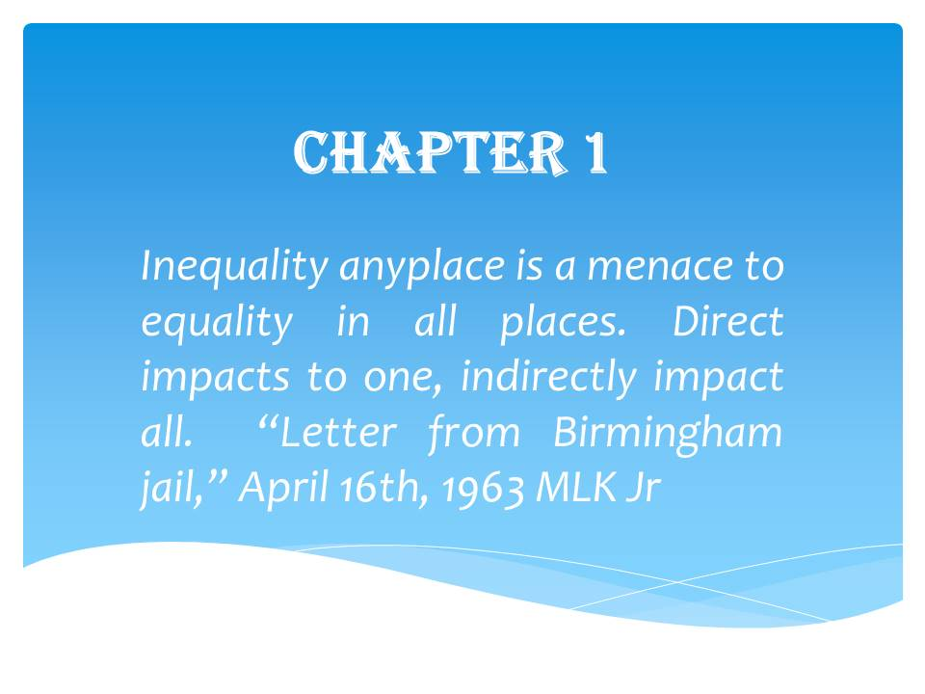

Chapter 1: Introduction

INTRODUCTION
Imagine growing up in a historically-rich neighborhood you perceived as forgotten due to all the desolation, dilapidated buildings, crime, under-invested education, joblessness, and lack of public/private amenities surrounding you to one day seeing your dreams come true, the beautification and investment into your community that you so desperately admired at neighborhoods across from yours. However, as policies formulate and infrastructure investments encroach into your area, your dream quickly fades into a nightmare; your existence in your very own community is no longer wanted. Your nightmare has manifested; you eventually become like an endangered species.
Many low and moderate-income Washington, DC residents or Washingtonians have professed the above scenario. They desire to improve their neighborhood. However, the fears of gentrification and displacement occurring leads them to feel like endangered species. As gentrification marches in loud and proud, many low-and-middle-income residents are tormented by the thoughts of lack of control, housing insecurity mixed with emotions of oppression from displacement, and losing supportive services and neighborhood culture. The same residents that scream out for neighborhood improvement see it improves, then are forced to move; the two-faced gentrification people love and hate. The core tensions in community development versus community displacement are the trilogy of Development, Gentrification, and Displacement. Community development stimulates gentrification leading to the displacement of people. Real people are living in real communities faced with real impacts, which includes diseased perceptions that indigenous displaceable people are against development plans; instead, people are concerned about how redevelopment emerges. Can the two co-exist, or are they mutually exclusive?
Gentrification occurs when more affluent people move into a community, causing home values and rents to rise, neighborhood cultural and character shifts, and displacement of low-income residents (Grant, 2003; Pohorelsky, 2019; Chapple & Miriam, 2016; Flag Wars, 2017). Far too many times, the wealthier in-movers enjoy the re-developments comforts and amenities while the indigenous residents become more and more economically and socially marginalized. According to the (National Low-Income Housing Coalition [NLIHC], 2019, para. 2):
“Many anti-displacement activists define gentrification as a profit-driven, race, and class change of a historically disinvested neighborhood. ”Disinvested" in this context means areas that businesses and governments have abandoned where there has been little new development or maintenance of existing buildings or institutions. Gentrification occurs where land is cheap (so redevelopment spikes) and the chance to make a profit is high due to the influx of wealthier wage earners willing to pay higher rents…. Race is tied to class and power in gentrification; those being displaced are people of color, who typically have less income to bid for housing, and are more often renters at greater risk of eviction. The elite can hold onto their claims to the City because they also have political power.”
Research studies have been consistent in their findings that “in-movers to gentrifying neighborhoods are wealthier, whiter, and of higher educational attainment than incumbent residents, and out-movers are more likely to be renters, poorer, and people of color than in-movers” (Zuk et al., 2018; Zuk et al., 2001).
Displacement is a neighborhood change that forces a person to move out of their home. Displacement takes on multiple forms (Grant, 2003; Pohorelsky, 2019; Chapple & Miriam, 2016). For example, Direct Displacement is when residents are forced to move due to cost or redevelopment; Exclusionary Displacement is limited low-income housing options, and Displacement Pressures are when low-income services & supports disappear from the neighborhood (NLIHC, 2019, Para 9).
Although gentrification and displacement are terms interchangeably used, they do differ. "Gentrification refers to how a place is changing, whereas displacement is something that happens to individual people or communities in that place (NLIHC, 2019).” Trends show Washington DC may be facing an affordable housing crisis as community redevelopment exacerbates poverty levels and displacement. DC has the most gentrified neighborhoods in the US from 2000 to 2013 (Richardson, Mitchell, & Franco, 2019, para. 2). DC urban studies have predicted a massive influx of jobs and residents to the majority of the City's neighborhoods by 2045 (DePuyt, 2019). These shifts may impact DC affordability, making housing difficult for low- and middle-income residents, including those who are gainfully employed.
As a potential partial remedy against the modern-day civil war of community development vs. community displacement, Douglass Community Land Trust (DCLT) has launched in DC's Ward 8 neighborhood. It was founded through Building Bridges Across the River (BBAR) efforts, a Ward 8-based non-profit organization (Building Bridges Across the River [BBAR], 2020). Residents and government desires to improve distressed neighborhoods through public and private investments result in community redevelopment projects and the unfortunate displacement of financially disadvantaged populations. As areas are revitalized, attracting many investors, housing prices soar despite stagnant salaries, potentially forcing many residents, especially long-term residents, to move out of their communities in search of cheaper housing. The Community Land Trust (CLT) innovative concept may limit housing rental costs and enable upward mobility (Davis, 2014). BBAR has partnered with the DC government to rehabilitate the 11th Street Bridge into a Park (BBAR, 2020). The 11th Street Bridge Park Project will be DC's first elevated pedestrian-only park that will (BBAR, 2020) (1) Repurpose and beautify the bridge and its environment (2) Act as a hub for many community activities (3) Pose as a physical and metaphoric bridge against the generational invisible dividing line between Wards 6 and 8 (4) Connect wealthier gentrified Ward 6 Navy Yard/Capitol Hill areas to underinvested Ward 8 Anacostia neighborhoods; which are neighboring communities with polar opposite economic amenities and opportunities and (5) raise Ward 8 property values significantly as one of many investments coming to the area, potentially forcing the indigenous population to leave (Congress for the New Urbanism [CNU], 2019; BBAR, 2020).
As you take this research journey with me, you too will understand the complexes faced by DC’s newly launched affordable housing solution: Douglass Community Land Trust (DCLT), named in honor of Frederick Douglass, a forefather of civil rights social reform, whose house sits in this same community. Douglass Community Land Trust (DCLT) aspires to serve as a partial remedy for displacement, poverty, socio-economic mixing, and upward mobility for DC’s Ward 8 low-and moderate-income households (Douglass Community Land Trust [DCLT], 2020).

Intent:
This study intends to understand and methodically analyze the start-up attitudes, factors, organizational readiness, and practicality to implement DC's Douglass Community Land Trust (DCLT) model as a potential partial solution for affordable housing. This study aspires to make this research easily accessible, easily digestible, and easily applicable to residents, academics, government administrators, and private organizations. This doctoral dissertation offers a complimentary DocuTUTORIAL DocuSPIRE documentary to aid easy access and dissemination of this study.

Research Significance:
Community Land Trusts (CLT) strives to create a community to belong, a community to matter, and a community to believe in, in which each added person builds that community. A place where community problems may not be solved entirely but managed, where the focus is not solely on completing community projects but also on developing the residents residing in that community.
The 2018 Menino Survey of Mayors, a national survey of 110 Mayors across 37 states, revealed a bipartisan consensus that housing is a significant component of a city's infrastructure and plays a vital role in urbanization (Einstein, Glick & Palmer, 2019; Citi, 2019; New Hampshire Business Review [NHBR], 2019). Therefore, decision-making should occur at a municipal level, not the state or federal level. Increasing housing rates, shortages of affordable housing supply, and accessibility for many low-and-middle-income residents are a significant roadblock to city residents' social mobility, furthering economic tensions as disproportionate rates of high housing costs to stagnate salary ratio continues. This multi-regional housing shortage crisis has both Democratic and Republican municipal leaders searching for affordable housing solutions across the United States (Einstein et al., 2019; Citi, 2019; NHBR, 2019). Affordable housing solutions that will recognize the decision-making paradigm and moral implications that fairness and social justice promote equity, enhance social cohesion, and lessen political tensions. This recognition aligns with the Social Equity Theory, H. George Frederickson's (1980) pillar of public administration (Frederickson, 2010). Housing is a multi-faceted issue. Housing affordability shortages affect a city's economic growth in its ability to recruit and retain local employees, especially essential service workers like teachers, nurses, police personnel, and employees of local government agencies, who can make-up the low-and-moderate-income population within a community (Fernando & Hearne, 2017).
DC is a transient federal city and pivot point for global decisions. Where ebbs and flows of people come to change the world, a place where people come to feel important, become essential, mix with the important, influence the important, and those equally important- the indigenous population those born and raised there.
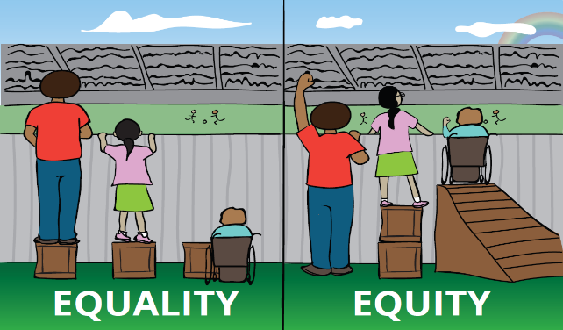
Figure 1: Equity and Equality (Frederickson, 2010)
Figure 1 depicts within many cities; a covert class system exists and plays out in housing. Cities scramble to promote Social Equity, the active commitment to fairness, justice, and equality. Equality hungers to make all people equal, whereas Equity hunger to address the systemic differences of opportunity and access to social resources, and justice removes the causes of inequality (Norman-Major, 2011; Frederickson, 2010). Acknowledging that populations are not the same, some groups need more help than others.
DC is among many prosperous cities flourishing in economic development. DC's housing construction increased from 2001 to 2010, a time when more home building occurred than in its previous 30 years (Tatian et al., 2015). Despite DC's increasing prosperity, significant disparities still exist in wages, job attainment, and education, resulting in residents' inability to afford the rising housing costs (Tatian et al., 2015). According to the Urban Institute, "from 2008 to 2012, 40% of DC households had a high housing cost burden, meaning the rent was over 30% of the household income excluding utilities and other housing fees.” Research from the Institute on Metropolitan Opportunity indicated that from 2000 to 2016, DC had the sharpest displacement and gentrification rates of any city in the United States (Institute on Metropolitan Opportunity, 2018). Moreover, low-income residents, in general, were less likely to reside in neighborhoods experiencing economic expansion; this phenomenon exacerbates wealth and poverty tensions; 28% of DC's low-income residents living in gentrifying areas have left these neighborhoods (Institute on Metropolitan Opportunity, 2018; Institute on Metropolitan Opportunity, 2019).
DC's plan to repurpose the depilated 11th street bridge into a 400-yard (approximate length of 3 football fields) pedestrian-only park is attracting many investors and has sparked controversial concerns amongst Ward 8 stakeholders regarding the mass displacement of residents (BBAR, 2020; Washington DC Economic Partnership [WDCEP], 2019). These displacement concerns also include the many development projects occurring or scheduled in Ward 8, like the Frederick Douglass Bridge Project, Barry Farms Residential Redevelopment, St. Elizabeth's Hospital's overhaul, Amazon's headquarters moving to the nearby Virginia neighborhood and multiple transportation projects and many more in the works (Office of Planning, DC gov, n.d.).
DC 2019 Housing survey indicated that a fifth of Wards 7 and 8 residents stated they are unable to pay housing costs, which will force them to move. Furthermore, approximately 21% of Ward 8 resident survey respondents believed that within the next three years, they will not be able to pay a landlord or bank mortgage (in a foreclosure or short sale) and would need to move (Office of the Deputy Mayor for Planning and Economic Development, 2019).
The DC Office of Planning and Economic Development indicated many circumstances that trigger a resident’s decision to stay or move out of their homes. Those factors include (1) Predatory and unfair lending banking practices blocking inclusive growth, (2) Housing and amenities costs that keep increasing, (3) the concentration of poverty, and (4) inequities in education, health, and other services. (Office of the Deputy Mayor for Planning and Economic Development, 2019).
Some Ward 8 residents are distressed with fears of potential displacement as DC's next big project, the Anacostia 11th Street Bridge Park, plus the many other investments coming. This Bridge Park is expected to generate economic investment in Ward 8 and potentially threaten current population demographics, displacing low-and moderate-income residents. The 11th Street Bridge Park project and other DC public-private investment plans play a role in transforming Ward 8 existing homogenous low-income neighborhoods into a mixed or higher income community by attracting more investments and higher-income residents (Bogle, Diby & Cohen, 2019). Many new Ward 8 project proposals desire to swap affordable housing units with a slew of market-rate units to create potentially 500 market-rate multifamily units. As DC's Ward 8 investment interests and projects increase, many locals contemplate whether they can put their trust in a Community Land Trust as a potential partial solution for affordable housing and upward mobility.
This research focuses on the start-up phase of DC's Douglass Community Land Trust (DCLT) as a potential partial solution to affordable housing, socioeconomic mixing, and upward mobility. This case study critically examined the current status of the DCLT start-up phase as part of its broader policy implications, and the elements affecting its ability to create social/spatial equity via the following five pre-determined data-driven influential factors (1) Policy Interpretation, (2) Community Land Control, (3) Preliminary Resident Engagement/ Leadership Fostering, (4) DCLT Structure/Capacity, and (5) Collaboration Dynamics.
Since a CLT is the representative organization or steward of community land control and planning for the improvement of current and future residents affected by economic redevelopment growth, their grassroots start-up strategy is a critical period to examine. Research interest has grown as local governments initiate efforts to explore the foundational activities and decision-making processes of CLTs’ achievements (Davis & Jacobus, 2008). According to the City–CLT Partnership Municipal Support for Community Land Trusts report a CLT start-up stage is most critical one year before it receives its non-profit incorporation status and the following two years. During this crucial stage, local government agencies can provide an array of support to the CLT by financing its activities and housing/commercial portfolio or help in a smaller role by marketing the CLT collective goals (Davis & Jacobus, 2008).
If the analysis of the CLT start-up phase is disregarded to concentrate on the outcome-focused program/policy integrity, essential insights into determining why an outcome occurs or not occur may be missed. Research indicates that its implementation procedures determine favorable results or disappointments of a policy. Implementation procedures are defined as:
“The policymaking stage between the established system – like the passage of a legislative act, the issuing of an executive order, the handing down of a judicial decision, or the promulgation of a regulatory rule and the consequences of the policy for the people whom it affects” (Edwards, 1980a).
Previously regarded as the broken thread, implementation procedures include the following activities (Hargrove, 1975; Mazmanian & Sabatier, 1981):
“Issuing and enforcing directives, disbursing funds, making loans, awarding grants, signing contracts, collecting data, disseminating information, analyzing problems, assigning and hiring personnel, creating organizational units, proposing alternatives, planning for the future, and negotiating with private citizens, businesses, interest groups, legislative committees, bureaucratic companies, and even other countries.” (Edwards, 1980b).
Research is lucid that implementation occurs in interactive stages that can take anywhere from 2-4 years until completion. Figure 2 and 3 shows that performance tends to occur in 4 steps: Exploration, Installation, Initial Implementation, and Full Implementation (National Implementation Research Network (NIRN), 2016).
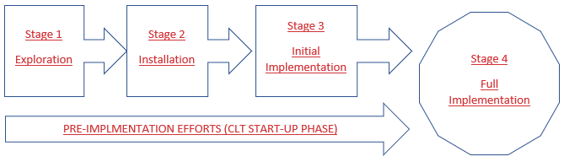
Figure 2: Four Stages of Implementation (NIRN, 2016)
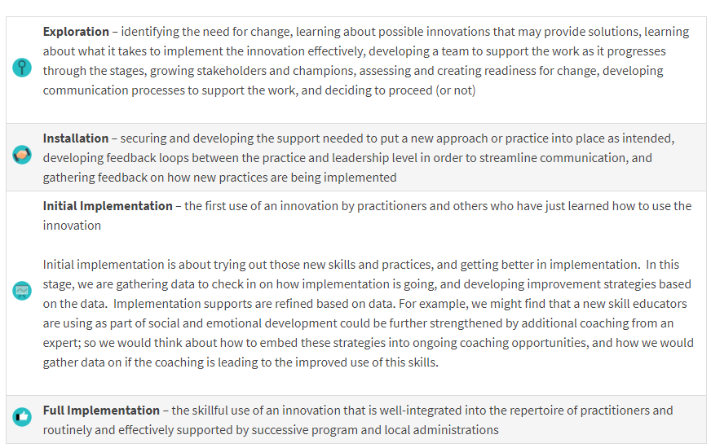
Figure 3: National Implementation Research Network (NIRN), University of North Carolina. (n.d.)
Efforts in stages one, two, and three in Figures 2 leading up to full implementation are labeled pre-implementation or, in the case of this research, the CLT start-up phase, representing a critical time that can determine the successful or flawed implementation of a program. Revelation attained during pre-implementation analysis has been the cornerstone for breakthroughs in the development of required private and public multidisciplinary human service fields like child welfare, community development, corrections, education, health, global health, mental health, public health, social services, substance abuse treatment, genetic diagnosis, assisted reproductive technologies, business, and available programs (NIRN, 2016).
Intentional implementation analysis efforts exist; however, there are insufficient impacts of well-intentioned reform activities in community development, corrections, education, child welfare, mental health, and other fields. It is now clear that knowing what to do is insufficient. The science of implementation that focuses on how innovations need to be supported is essential so that practitioners use good designs in their interactions with others. Information is deficient on which pre-implementation methods and interactions are crucial for successful implementation and clearly defined phases that may or may not zigzagged (NIRN, 2016).
According to Nakamura & Smallwood (1980), implementation can be influenced by organizational structures and bureaucratic norms, like internal transactions (communication channels/administrative complexity), availability of resources (funding/time), and personal motivations; external arbitrators complicate implementation. Research indicates that implementation becomes increasingly problematic when:
- There is more top-down than bottom-up input on implementation; (Elmore, 1978; Hjern & Hull, 1982; Barrett & Fudge, 1981)
- There is limited multi-level integration offered; (Pressman and Wildavsky 1973; Elmore, 1978; Bardach, 1977; Berman, 1978; Mazmanian & Sabatier, 1989)
- There is more behavior change required (Mazmanian & Sabatier, 1981; Edwards 1980; Montjoy & O’Toole, 1979)
- There is too much diversity in the target population; (Mazmanian & Sabatier, 1989)
- The issue being addressed is inflexible; (Mazmanian & Sabatier, 1989)
- There are inadequate resources; (Edwards, 1980; Rein et al, 1978; Pressman & Wildavsky, 1984; Davies & Mason, 1982; Mead 1977; Van Meter & Van Horn 1975; Mazmanian & Sabatier, 1981; Derthick, 1970; Levine 1972)
- There are minimal consequences for noncompliance; (Van Meter & Van Horn, 1975; Montjoy & O’Toole 1979)
- There is a lack or reduced commitment to policy goals (Mazmanian & Sabatier, 1989; Van Meter & Van Horn, 1975)
- The policy is more likely to be viewed as controversial (Van Meter & Van Horn, 1975; Mazmanian & Sabatier, 1989)
- The implementation is structured in a prescribed order; (O’Toole & Montjoy, 1984)
- The collaboration efforts are more complicated (Pressman & Wildavsky, 1973; Lineberry, 1977)
- Communication is unclear, unpredictable, and uneven among players (Mazmanian & Sabatier, 1989; Van Meter & Van Horn, 1975)
By reviewing the implementation activities, researchers and administrators can identify if policy outcomes are meeting policy goals and discover any unintended consequences (NIRN, 2016). Therefore, assessing the transactions during the DCLT pre-implementation or start-up phase will help understand future successful or failed implementation efforts and how it affects or is affected by residents, government entities, community members, and community development efforts. This research will analyze the start-up phase of DC's Douglass Community Land Trust (DCLT).

Snapshot: What is a Community Land Trust (CLT)?
CLT prevents the renter or homeowner from carrying the heavy burden of land expenses. By separating the land from the home purchase averting market forces from increasing housing rates, guarantees affordability for future residents, giving them access to the right to own property in a booming housing market where home values have become unaffordable.
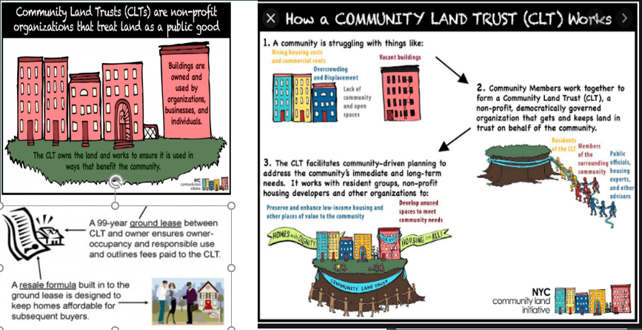

1

3
2

Figure 4: (Picture 1 (top left), Picture 2 (bottom left) Picture 3 (right): Community Land Trust Model Explained (Linton, 2017)
Community Land Trust, also called a CLT, is created by a group of community members who work together to form a non-profit organization. They buy and own land to make it affordable forever.
Figure 4: Picture 1: The CLT rents or sells the physical property on the land to low- and moderate-income residents and small business owners. Owning the land allows the Community Land Trust to keep the home affordable since land can cost 20% of the home price. Picture 2: low-and-middle-income residents sign a 99-year lease contract & agree if they decide to sell the home, they will do so at a pre-calculated affordable rate. Picture 3: A member elected tri-part board (Community Land Trust residents, members of the surrounding community, public officials/housing experts/consultants) governs the CLT non-profit organization activities. The CLT also offers wrap-around services like leadership/personal development, homeownership, employment workshops, and matched savings account incentives and loans, etc. The CLT Board and members make joint decisions on the Community Land Trusts activities like what kind of wrap-around services they will offer, the expanded location for the next residential/commercial units, and resident qualification, etc.

Community Land Trust (CLT) Common Misunderstandings:
Individual community members do not own the CLT resident's home. The CLT residents own their homes; this allows the CLT residents to make repairs and upgrades as they see fit. Residents are limited, like any other homeowner, to the local zoning laws, Homeowners Association (HOA), and lease agreement. Any repairs or upgrades that improve the home's value will benefit the resident at the time of sale.

Community Land Trust (CLT) Challenges for Residents:
1. The Precalculated resale formula does limit the resident's equity or profits at the time of home sale
2. The non-profit Community Land Trust organization owns the land under the home
3. Residents still must get approved for a mortgage loan

Problematic/Opportunistic Circumstances
DC must manage the outcries from local citizens for community development, make room for new residents, and address adverse consequences of displacement from that process. A modern-day civil war: Community Development versus Community Displacement continues. DC is faced with the never-ending feat to house its 705,749 residents (US Census Bureau, 2016). Experts predict the DC population will spike 11,000 annually until the year 2035, making housing an onerous top priority (US Census Bureau, 2016). According to the DC Fiscal Policy 2017 Migration report, the DC population increase also stems from an influx of international migrants (immigrants) and natural births surpassing deaths (birth/death ratio). Also, DC's economy is recognized as recession-proof or the "gold mining town” (Moss, 2009), withstanding economic-financial disasters better than most cities attracting investors and residents (Maciag, 2017). Moreover, according to the Brookings Institute, DC home sales have not been significantly affected by Covid-19, the current viral pandemic causing worldwide quarantine and economic stagnation (Schuetz, 2020). However, DC’s poverty rate ranks as one of the top highest in the US at 16.2%, surpassing the US national rate of 12.7% (Naveed, 2017). Skyrocketing housing costs, gentrification, and sluggish salaries make it difficult to afford housing in DC. Figures 5 and 6 show the average rental unit cost over $1400 in 2019. The median home value has significantly increased from 2010 to 2020 to over 537,400 (US Census Bureau, 2016).
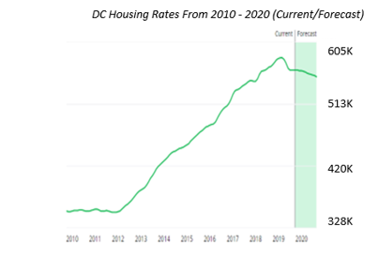
Figure 5: DC Home Values From 2010-2020 (Washington & Values, n.d.)
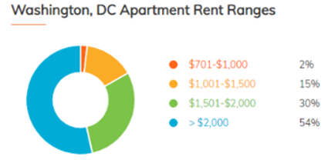
Figure 6: DC vs. National Average Rent (Washington, DC Rental Market Trends, 2020)
The ratio of salary to housing is imbalanced in DC, where the minimum wage is $14/hour in 2019 (DC government, 2020). For example, a DC resident who works 40-hours per week earning minimum wage would have to pay 70% of their salary for market-rate rent of $1400/month, which excludes utilities and other housing costs. DC housing costs have increased from 2018 to 2019 by 2.2% compared to the national rate of 1.5% (Salviati, 2020, July 28). Also, the Department of Housing and Urban Development (HUD) average median income for a DC household of four was $121,300 (Department of Housing and Community Development, DC government, 2020).
Furthermore, the 2019 Census Bureau indicated that DC residents with a bachelor's degree and above made-up 57.6% of the DC population do not reflect the reality of some Ward 8 residents at risk of displacement. Ward 8 residents' average income was $34,824, and those with a bachelor's or higher was 16.7%. These statistics suggest the difficulties Ward 8's residents face in obtaining affordable housing and competing for a higher salary job since education correlates with the amount of salary compensation (US Census Bureau, 2016; “2020 Demographics”, 2020).
Ward 8 suffers from a spatial mismatch in that it has the third-largest population size, but one of the highest unemployment and poverty rates compared to DC citywide. As a result, Ward 8 has the lowest voting history (DC Board of Election, 2018). Studies show neglected communities' mistrust of government manifests into apathetic civic engagement (Wang, 2001). Ward 8 average resident age is 29, which is a little younger than DC city-wide, and Ward 6 average age of 34. These average ages make-up the Millennials generation or those born between 1981-1996 (22-37 years old) (Dimock, 2019). Although Ward 6 and Ward 8 are neighboring communities, separated by a small body of water, they have polar opposite economic amenities and opportunities, prompting massive development and upgrades to Ward 8 neighborhoods. In addition to DC's 11th Street Bridge Park Project, the following investment projects are underway in Ward 8
(1) the Frederick Douglass Bridge Development Project,
(2) Barry Farms Residential Redevelopment,
(3) St. Elizabeth Hospital campus overhaul, including $65M Washington Wizards and Mystics practice facility on the campus
(4) Multiple transportation projects
(5) and Amazon's headquarters moving to the nearby Virginia neighborhood, expected to generate 25,000 jobs attracting more residents to the area but leaving many Ward 8 residents to compete for housing and employment (District Department of Transportation, DC government, 2020).
DC's inundation of residents has caused great concern for metropolitan and regional planners in Montgomery, Prince George's, Frederick, Howard, Charles, Fairfax, Arlington, Prince William, and Loudoun counties and beyond to maintain housing availability and affordability for its low and moderate-income residents. In addition to affordable housing, there are concerns for the maintenance of schools and roads from added residents and traffic, employee retainment for home-health aide's jobs, baristas, store clerks, janitorial jobs, and essential service workers like teachers, nurses, police personnel, and employees of government agencies, in and around this region (DePuyt, 2019). According to the Metropolitan Council of Government DC (Figure 7, 8), surrounding Virginia and Maryland counties are housed within the same jurisdiction and called the National Capital Region or DMV (the acronym stands for each state first letter) (Metropolitan Washington Council of Government, 2016). The US census approximates these three states plus West Virginia population count in 2017 was 6,216,589, making it the 6th largest out of 384 metropolises in the US (US Census Bureau, 2016; Census reporter, 2018; Metropolitan Washington Council of Government, 2016).
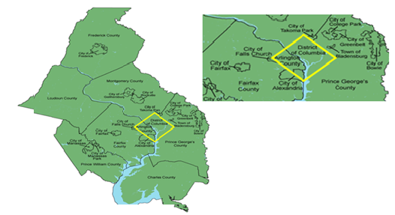
Figure 7: DMV Jurisdiction

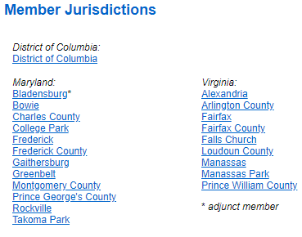
Figure 8: Member Jurisdiction (Prince George’s County, 2018)

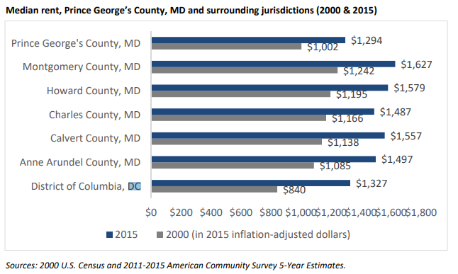
Figure 9 (a): Median rent, Prince George’s County, MD, and surrounding jurisdiction (2000 & 2015) (Prince George’s County, 2018)
The economic impacts of these three states surrounding communities and suburbs influence one another; therefore, urban planning must take that into account. For example, Prince George's County in Maryland (MD) Figures 9(a & b) reflect how DC gentrification has affected its surrounding MD suburbs from 2009 to 2016 when home values spiked by 22% versus 7% statewide in MD; MD home values are mimicking DC's increasing housing rates.
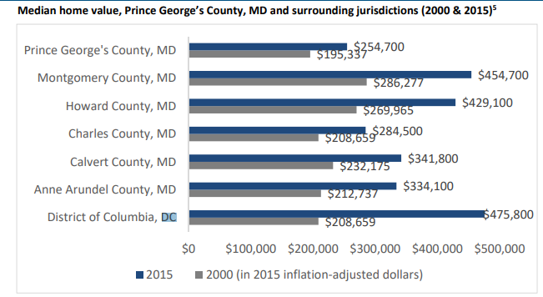
Figure 9 (b): Median home value, Prince George’s County, MD, and surrounding jurisdiction (2000 & 2015) (Prince George’s County, 2018)
According to Prince George's County Housing Opportunity for All: Comprehensive Housing Strategy Draft report and Figure 9b above, the DMV area had increased rental and home values from 2000 to 2015. DC housing prices spiked 128% from 2000 – 2015. In contrast, Montgomery County and Howard County housing prices raised 59%. Residents living in this region are demanding additional affordable housing as prices are steadily and steeply increasing forcing relocation especially among people of color (Prince George’s County, 2018).
DC’s Black population decreased, but MD suburbs near DC saw a spike in Black residents. Although not welcomed by all residents, MD neighborhoods boarding DC’s Ward 8 are known as DC’s Ward 9. Some MD residents living in this area prefer not to be labeled as Ward 9 since Prince George’s county is one of the most concentrated areas of wealthy Blacks in the US, where the Northern part of the county is more affluent than the southern region or Ward 9. As gentrification occurs, displaced residents may migrate in and out of these surrounding DC neighborhoods. In a Prince George's County survey, residents stated they would purchase a home in this county or Virginia due to affordability and proximity to DC (Prince George’s County, 2018).
Residents who move out of DC to surrounding suburbs like MD is not a new trend. DC’s high housing cost caused many low-income residents from 2000-2005 and mid-2000s to move to neighboring Prince George's County for cheaper and more suitable bigger homes (Kneebone & Berube, 2013). Real estate trends show that having fewer affordable housing available and the construction of new housing targeting higher-income residents aids in exacerbating concentrated poverty in DCs distressed neighborhoods and its inner and outer suburbs. The annual median home price in the region soared by 118% and in DC by 275%, but only 53% in the nation (Lung-Amam, 2017).
DC's surrounding suburbs in Maryland may seem like a refuge for priced-out Washingtonians, but this may not be entirely true. DC residents may move from one unhealthy poverty-stricken neighborhood to a similarly underinvested nearby suburban outskirts.
"The eastern half of the region, including the neighborhoods east of the Anacostia River in the District (Ward 7, 8) and large parts of Prince George's County, carries the region's burden of poverty and distress. This region includes neighborhoods with the majority of the region's minority populations, poor residents, subsidized housing, its lowest home values, and its highest crime rates. In contrast, the District's western neighborhoods and suburbs enjoy the bulk of the region's prosperity, jobs, amenities, and high-valued neighborhoods. Various state laws and the lack of a regional government with land use authority give local governments, particularly counties, much discretion in adopting housing policy and contributing to uneven development patterns.” (Lung-Amam, 2017).
Disinvested improvised suburbs can also attract investors, especially investors, who cannot build in DC--pushing them to nearby suburbs' lower land values and close city proximity, making DC neighboring state suburbs ripe for redevelopment also. Potentially resulting in future suburban gentrification leading to further displacements for these already displaced Washingtonians. Regional planners must be aware of population migration and its effects. Although the 20th-century metropolitan patterns revealed wealthier residents moving to suburbs and poverty increasing in cities, the 21st-century designs are shifting where
Poverty persists in the urban core, but poverty has also spread to the suburbs. In the last decades of the 20th century, the suburbs began to undergo many of the population changes previously observed in central cities. They grew more racially diverse and developed large amounts of poverty. Some began to suffer severe economic decay and even depopulation. These trends have continued to the present day.” (Institute of Metropolitan Opportunity, 2019).
"Focusing on a single form of neighborhood change provides an incomplete picture…Some studies of neighborhood change—again, primarily gentrification—have restricted their analysis to the Central City and dropped suburban and exurban communities from their data…Housing markets and migration patterns are regional. The boundaries dividing central cities and suburbs are jurisdictional, not geographic, demographic, or cultural. Both types of municipality evolve in concert, and changes in one both affect and mirror changes in the other…An important fact about American neighborhood change reveals that suburbs have seen a wave of low-income concentration, by far the most common category of change. Despite this, suburban poverty only receives a fraction of the political or media attention that urban gentrification or displacement receives. Suggesting that the suburbs of major cities are experiencing, counterintuitively, some of the most overlooked changes in America. Though suburban areas are often conceived as static, permanent enclaves of wealth, economic decline is, in fact, an important suburban concern. Moreover, the city-suburb distinction varies dramatically from region to region.” (Institute of Metropolitan Opportunity, 2019).
It is also critical to acknowledge within this city-suburb migration are residents’ demographics and where migration is occurring. A 2000-2016 study of neighborhood population change by subgroup in the top 50 metros central cities showed:
"Invisible region-wide data: the trend towards Black populations moving to the suburbs. In both expanding and declining central city tracts, the Black population was falling; but in both expanding and declining suburban tracts, the Black population rose. These trends reflect the nationwide movement of Black families to the suburbs, a process with important implications for neighborhood change, as it may result in significant population loss in historically segregated central-city neighborhoods (Institute of Metropolitan Opportunity, 2019).”
The Black suburbanization was reversed during the last half of the 20th century when blacks were excluded from moving to the suburbs through the aid of discriminatory policies, banks, real estate institutions, and individuals. This exclusion resulted in Blacks moving into old urban homes, coining the disparate terms "Chocolate Cities" and "Vanilla Suburbs.” (Institute of Metropolitan Opportunity, 2019).
"For Blacks living in these Chocolate Cities, redlining and disinvestment within central cities caused urban ghettos to decay to the point where many homes were no longer habitable, leading to large-scale home abandonment. During the 1960s, urban renewal programs razed deteriorating neighborhoods. They replaced them with high-density public housing projects, but these structures soon deteriorated themselves (Hirsch 1983). They were demolished in the 1990s and replaced by voucher programs, which pushed former project residents into inner suburbs whose fortunes were themselves declining. Nonetheless, the rise of a Black middle class led to the Emergence of affluent Black suburbs in some metropolitan areas (Cashin, 2001).”
Unlike historical tendencies to exclude Blacks from suburban communities, current gentrification trends are pushing Blacks to the suburbs. The DMV region is evolving economically and demographically. DC is often the central focus of that evolution since “DC, has experienced the nation's worst gentrification trend, with nearly 36% of its entire population living in an area where strong displacement is underway.” (Institute of Metropolitan Opportunity, 2019). Many of those displaced or at risk make up a large part of the workforce, especially the federal government. As of September 2018, out of DC's 799,800 jobs, 191,952 of these jobs come from the federal government, DC's largest employer. To counteract these regional housing crises, government leaders of DC, Montgomery County, and Prince George's County announced in March 2015 they will work cohesively in the region to address affordable housing, workforce development, economic development, and supportive services (Lung-Amam, 2017).
According to the Washington Metropolitan Council of Governments (as cited DePuyt, 2019, para. 9),
Regional Planners want elected officials in DMV to incorporate various strategy like (DePuyt, 2019):
- Additional new housing
- Jobs, and housing centered around underutilized rail stations and Activity Centers; and
- Improved future housing and jobs distribution in the eastern and western portions of the region
DC's public and non-profit administrators are seeking efforts that align with the above housing strategy. Non-profit administrators can also be considered a type of public administrators as they, too, operate at federal, state, and local levels in almost every aspect of civil service and public life. Non-profit organization administrators like public agencies are accountable to the public but operate by an additional set of internal governance rules. Non-profits should deliver quality programs that uphold ethical and legal compliance. The proper behavior of public and non-profit administrators plays a role in determining if an implemented policy will be biased or equitable. Equitable systems and processes create the diversity that strengthens a democratic state. The more diversity is honored and inclusive, the more all members of society will have access to opportunities, aligning with the Social Equity theoretical approach in problem-solving (Goggins, 2017). Social Equity theory postulates that not all citizens have an equal base level of opportunity and protection. Therefore, it is incumbent that program administrators acknowledge the part they play in ensuring equity. In the excerpt Justice for All: Promoting Social Equity in Public Administration, diversity in a democracy is a critical progressing movement but historically has not always been implemented in the US. The authors go on to espouse that:
"In any society, the equitable treatment of all, regardless of membership in particular social groups, is essential to support the democratic process. This equal treatment is particularly important in the United States with its history of exclusion and its explosion now in social diversity. Although we declared our right to independence because all men are created equal, we have not treated all men or all groups equally. Our aspirational ideals draw us forward as we seek to make the union more perfect, but old issues and old infrastructure linger, and new challenges arise” (Johnson, 2011).
DC residents and local organizations’ administrators are interested in DC's government role in guaranteeing social equity for housing and how public funds will create equity in neighborhood-built environments. DC's Mayor Muriel Bowser signed a new policy in 2019, ordering DC's public agencies to address and diversify affordable housing and announced a goal to build 36,000 new houses in which 12,000 will be accessible by 2025 (Office of the Mayor, 2019). DC’s Mayor Bowser is nicknamed the "Crane Mayor" due to the many redevelopment projects in D.C. occurring under her administration. Figure 10 shows the current and dedicated reasonable housing goals. The DC government also stated that "Mayor Bowser made DC the First City in the nation to set affordable housing goals by neighborhood.” (Muriel Bowser, Mayor, n.d.)
The Mayor's goal is to spread more affordable housing in other DC Wards, to minimize the concentration of poverty in specific neighborhoods, which is a benefit to create more mixed-income areas. As mentioned in later chapters, mixed-income communities elevate property values, attract businesses to move-in, create job opportunities, and convenient shopping. However, this intentional goal to spread affordable housing may also limit the additional affordable housing needed in Ward 8 as market-rate housing increases, making it difficult for Ward 8 residents in need of affordable housing to stay in their neighborhood. DCLT’s goal is to ameliorate the affordable housing gap by creating the platform for the community to gain permanent ownership of Ward 8 land. Hence, redevelopment emerges, residents and small businesses can stay and thrive in place. The focus is not to oversaturate Ward 8 with affordable housing but to enable long-term residents to remain in place as development increases. But the question lingers can the two co-exist, or the quest to create mixed-income neighborhoods inevitably causes low-and-moderate-income residents’ displacements, which some view as beneficial in the long run. One of DCLT’s future aspirations is to have affordable housing units city-wide in its portfolio. However, the current portfolio focus is to keep Ward 8 residents in place with efforts to limit Ward 8 community transformation to a place only the wealthy can live.
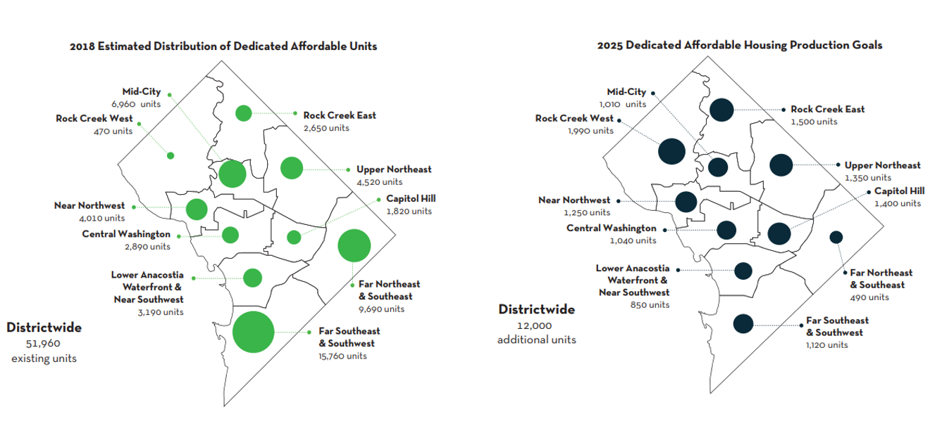
Figure 10: Affordable Housing: 2018 Estimated and 2025 Goals (Muriel Bowser, Mayor, n.d.)
Although Mayor Bowser administration does not include CLT in its official city affordable housing initiatives, a CLT workforce pilot program was previously implemented from 2007 – 2010, focusing on housing employees of DC and its instrumentalities. This 2007 Workforce Community Land Trust (CLT) policy delineated some shared powers; its goals and objectives were vague regarding certain activities CLTs promote like community engagement or personal developmental workshops. The statute focused more on affordable housing provision goals. This CLT policy was implemented through City First Enterprises, a non-profit organization, which provided financial subsidies to assist qualified participants in obtaining homes. However, some DC residents felt this policy did not focus on the lower-income residents who needed assistance most. Policy interpretation by administrations heavily impacts how a policy is implemented and who qualifies for the public good or service; policy interpretation is a type of administrative burden. Administrative burdens have traditionally been perceived as policemen of policy to prevent waste fraud and abuse of public programs both for the implementing agency and end-user of the program (Lavertu, Lewis & Moynihan, 2013). However, administrative burdens can also be arduous mandates or consensual agreements that direct government officials in their daily workloads (Herd & Moynihan, 2018). They are perceived as being expensive, obstructive, or the root of delays and uncertainty. These burdens permeate every aspect of governments creating inter and intra-relational conflicts amongst public agencies employees and legislators tripling down to the end-user of the public programs (Herd, DeLeire, Harvey & Moynihan, n.d). Administrative burdens may alter administrative structures within an agency when policies are not clearly defined making it extremely difficult to put into practice (Lerner & Wanat, 1983). Research indicates that the administrative burden of policy interpretation influences organizational behavior. Lerner and Wanat described the burden of policy interpretation by administrators as being crisp or fuzzy. A Crisp policy interpretation is well-defined and usually easily interpreted, whereas fuzzy policies are ambiguous and give ample room for intentional or unintentional misinterpretation (Lerner & Wanat, 1983).
By examining DC's Community Land Trust policy, both past, and future may help understand how government and non-profit administrators interpret those policies and determine if their interpretations influence the DCLT start-up phase. Administrators’ and staff's interpretation of a policy or legislation affects implementation to the public. An organization’s staff may misinterpret a crisp policy from management or elected officials due to miscommunication or different levels of knowledge attainment. Misinterpretation can be due to personal internal cognition capacity or inadequate external information on the subject (Lerner & Wanat, 1983). Consequently, roles, responsibilities, and performances are altered from the policy intent. When the vice versa occurs, a fuzzy policy is interpreted as crisp, which may also be a tactic leadership utilizes to ward off criticism of management decisions or validation of its cultural workflow. A cultural workflow is the implemented workflow versus the official written workflow not implemented. Leadership within an organization may purposely misinterpret a policy regulation if it is a threat to their mission or current workflow. "Threats can include drastic workflow amendments, lack of resources/personnel provision, work overload, conflicting goals, the unlikeliness of policy implementation, adverse effects on program participants, intensifying existing friction amongst staff, required tasks complexity, and administrative intensity” (Andrews, Boyne & Mostafa, 2017). Administrative intensity is the ratio of back-office resources to front-office activities. An already taxed organization with an imbalanced resource ratio will not be able to allocate additional time and finances to quality improvement (Andrews, Boyne & Mostafa, 2017). Skewed administrative intensity can also create frictional interactions between employees, building tension in the work environment. As a result, it is difficult for an organization to effectively follow the policy, meet required goals, and possibly incorporate workarounds.
Therefore, considerable interest exists in DC's CLT model start-up and policy interpretation guiding its implementation since CLTs models are not a one size fits all formula. Research shows that many cities have various CLT leadership strategies, community engagement, and community land control activities (Davis, Jacobus, & Hickey, 2008). These strategies highlight the core values and mission that guides the CLT to achieve its objectives/goals. Since DC is not a state, its CLT model must incorporate all the factors that affect its start-up, especially politics. DC is unique in that it has the worst trend of gentrification displacement rates in the US. It is both the nation's capital and a proto-state or quasi-state, which is a political entity that lacks all the criteria of statehood. DC is not a state; it only masquerades as a state. Congress has full control over DC affairs; however, Congress allocates limited authority to the DC local government (Council of the District of Columbia, n.d.). The control of Congress over DC may impact DCLT efforts in obtaining funding from the city or enacting legislation. In addition to DC's uniqueness, its average population age is millennials, which entices curiosities if the CLT model would be very appealing to this generation known for being more adapted to sharing space; further research can be conducted to determine if generational acceptance of CLT exists.
The millennial generation is the largest in history, making up 83.1 million of the USA; they aid in driving the ideologies of a sharing economy (US Census Bureau, 2015). For example, peer-to-peer car-sharing services like Uber/Lyft/Maven or home-sharing like Airbnb/VRBO or We Work, a co-working space, or We Live where people can work and live-in shared spaces. The CLT may also be a potential opportunity to attract low-and-moderate income millennials to own their first home. Studies show that massive student loan debt has impeded millennials' desire to purchase a home. More and more millennials are delaying homeownership and are less likely to buy a home than the older Baby Boomers and Gen X generations (Low, 2018). Homeownership rates among 24 -32-year-olds have decreased 9% from 2005 – 2014, adversely impacting the economy (Noguchi, 2019). Housing is a critical pillar of local, state, and national economies. It is the real estate construction and related activities that directly contribute to the US Gross Domestic Product (GDP). GDP is a country’s measure of its economy and its growth (Bureau of Economic Analysis, n.d.). The US average housing contribution to its GDP is 15-18% (National Association of Home Builders, 2009). According to the National Association of Realtors, "approximately one job is generated for every two homes sold.” For example, 1,000 homes sold can generate 500 jobs.
Moreover, every home sold contributes about sixty thousand dollars to the economy of GDP (National Association of Realtor, n.d.). Real estate produced approximately $1.5 trillion of the US economic output in 2018; it plays a substantial role in generating jobs (Amaded, 2020). Real estate construction has consistently and significantly contributed to the nation’s GDP. In 2006, it peaked at $1.19 trillion, 8.9% of the GDP, and in 2017, housing contributed $1.13 trillion (Amaded, 2020).
Economists usually measure key housing contributions through employment, spending, and tax profits (Housing Virginia, 2011). Personal consumption or spending make-up, almost 70% of the US economy” (US Bureau of Economic Analysis, 2020). Consumer spending has a domino effect on the economy; a decline in spending can also trigger the economy to deteriorate—deterioration due to a decrease in jobs, salaries, and spending. “If the Federal Reserve does not intervene by reducing interest rates, then the country could fall into a recession. The only good news about lower home prices is that it lessens the chances of inflation."(Amaded, 2020).
As mentioned earlier, housing affects a city’s economic infrastructure as well as the national economy, in that the real estate industry was a significant factor of the 2007/2008 recession: stressing to policymakers housing economic power and effect on an economy.

Rationale for the Study
DC, the anchor for the United States federal government, like many cities, tells a story of two tales: exponential community development growth and displacement. The housing crisis has created a local uproar in finding evidence-based, affordable housing solutions. This study suspects that during the Douglass Community Land Trust (DCLT) start-up stages, there will be challenges and advantages that highlight the activities that align or hinder goal attainment. Examining if activities occurring aligns with what administrators articulate they are pursuing will help to identify any gaps. By capturing the foundational building of DCLT will aid in disseminating lessons learned and best practices (Bertram, Blase, & Fixsen, 2015). This study goes a step further in examining the start-up phase in real-time, which may guide local leaders and DC's Mayor Bowser's administration efforts in counteracting expensive housing in other DC's Wards.
Mayor Bowser's response to the persistent housing calamity was her inaugural investment in the creation and preservation of affordable homes. Mayor Bowser has increased annual funding in the Housing Production Trust Fund (HPTF). Funding has increased from $58.6 million to $167.6 million from 2015 – 2018. The Mayor has delivered 7,200 affordable homes, 5,200 under construction, and endorsed the formation of the 18-member DC. Housing Preservation Strike Force. (Department of Housing and Community Development, DC government, 2017). DC. Housing Preservation Strike Force, comprised of DC's housing experts and the publics' choice stakeholders, establishes plans that generate, maintain, and safeguard DC's affordable housing stock. Around 2014, BBAR announced plans to establish a Community Land Trust (CLT) in DC's Ward 8 Southeast Anacostia 11th Street Bridge neighborhood to produce homes for over 100 families (Nonko, 2018).
CLT is not a foreign strategy for DC stakeholders; however, the prior CLT was established but thwarted. The previous attempt to secure and maintain DC’s CLT dates back to the 1976 incorporation of the New Columbia Community Ownership Project (CHCOP) through both the evangelical Christian group called Sojourners and the Community for Creative Nonviolence (CCNV), an organization founded by Father Guinan and a group of George Washington students. The 1960s and early 1970s were at a time of rioting, the assassination of Martin Luther King Jr, decaying and overcrowding homes, and gentrification, creating a CLT platform (Roots and Branches, 2019).
DC's prior attempt at a CLT was CHCOP, which was only able to obtain three buildings. However, CHCOP acknowledged that the CLT formation was premature (Roots and Branches, 2019). Since repairing and maintaining these properties, funding and volunteers became too demanding, resulting in the CLT dissolution and reselling of the buildings. Nevertheless, in 1990 a CLT was established by New Columbia Community Land Trust (NCCLT) that exists to this day. Today NCCLT is a community-based land acquisition, housing development, and community education organization. NCCLT serves as a “housing development coordinator/consultant to tenant groups seeking to exercise their "first-right-to-purchase" single-family or multifamily buildings when their landlords put them up for sale. In addition to a ground lease, NCCLT provides tenant organization support, project feasibility, financial packaging and loan applications, architect and contractor selection, construction monitoring, and permanent financing and close-out.” (Sturtevant, 2017). Although CHCOP's prior CLT attempt did not go according to plans, new efforts were established to launch a classic CLT in DC’s historical Southeast Anacostia 11th Street Bridge neighborhood. DCLT project was launched through City First Enterprises (CFE) and Citi Community Development (“Community Land Trust in Anacostia, DC, Announced by City First Enterprises and Citi Community Development,” 2017). CFE had experience with CLTs in the form of a financial subsidiary and received previous funding from DC’s 2007 Workforce Policy to implement a CLT. Therefore, DCLT was incubated within CFE with the intention of it branching off to its non-profit organization.

Case Study Overview: DC’s Economy Structure/Capacity
DC faces the same economic pressures as other states and cities throughout the US; equity and creating space for diversity amongst its inhabitants. However, its local government structure has a unique character. It is a federal city making its CLT models a fascinating case study to initiate as well as create a foundation for future longitudinal analysis. Although the DC government has allocated local power, Congress still maintains the ability to overturn local laws (Council of District of Columbia, 2016). DC residents can elect a Mayor, who has sole authority and responsibility for DC government agencies. DC has 13 Council Members, 1 for every 8 Wards, and 5-At-Large Councilmembers including the Chairman At-large (DC council, US) as well as 40 Advisory Neighborhood Commissioner (A.N.C.) (Advisory Neighborhood Commissions, n.d.). However, DC is unique because some agencies like the Office of the Chief Financial Officer are autonomous from the Mayor's authority and classified as regional bodies (Office of the City Administrator, n.d.). The Office of the Chief Financial Officer focuses on "enhancing the fiscal and financial stability, accountability and integrity of the government, "in which it micromanages DC's budget (Office of the Chief Financial Officer, n.d.). This separation of financial power affects DC's local government's plans to implement public projects. DC's provincial government has limited tax authority, and only 25% of its budget comes from the federal government; other cities receive more funding without Congress oversight (State of Washington, DC, 2019).
DC's unique government structure affects its ability to raise and collect revenue and provide public services. Although DC's non-residential population make-up two-thirds of DC income tax and individual entities use DC's public spaces and services, they do not contribute to DC's revenue (Rivlin, 2009). For instance, DC does not tax the incomes of non-resident DC employees, the federal government (DC's largest employer) sales, property or income taxes, and many tax-exempt non-profits (Rivlin, 2009). Also, DC may not be reimbursed by the federal government for grand events like demonstrations or the Presidential inauguration. Another compounding factor is DC is at the mercy of Congress's unstable power plays between rival partisan groups. DC's recent tax amendments lowered income tax on those earning above $350,000. Moreover, in 2015 the Tax Revision Commission recommended business tax reduction. The Government Accountability Office estimated that the DC deficit costs from $470 million to $1.1 billion.
According to DC Vote and DC Statehood:
"DC citizens pay "state like," or District taxes, to the tune of $5 billion per year. This money is sent to Congress and is appropriated back to DC to pay for DC's municipal budget. This process causes some to believe the money is derived from Congress mistakenly. In 1997, because DC receives no income from the state, Congress agreed to pay for 70% of DC's Medicaid costs ($168 million) and DC's prisons and courts (about $300 million). Congress restricts DC's ability to raise revenues. The federal government pays no taxes on the land it uses or exempts, exempts itself from a PILOT (Payment in place of Taxes), and imposes added requirements on public services the police force. Congress exempts those who work in DC but live just miles away in the states of Virginia and Maryland from contributing even five percent or less of their state taxes to DC, resulting in a windfall for those states, a loss to DC of a billion dollars a year. The result is higher local taxes on businesses and individuals. It is resulting in DC residents paying full federal taxes, which is the highest per capita or personal income taxes in the US (Richards, n.d.).”
The three primary tax sources in DC come from individual income, property, and sales/use tax (Government of the District of Columbia, 2015). Moreover, DC residential property tax is the cheapest in the region, making it the most appealing for investors, contributing to higher housing rates. Figures 8 and 2019/2020 Property Tax Table below shows a map and compares DC's lower property tax rates with the nearest Maryland and Virginia Counties/Cities. Residential property tax is charged by local government or state on permanently attached land and structures like buildings, homes, or land. Real estate properties are grouped based on their uses and taxed according to that specific group. Therefore, properties in different groups, like commercial or residential, have different tax rates. A tax rate is the amount of tax per $100 of the assessed property value and may change from year to year (Office of Tax and Revenue, n.d.).
Moreover, compared to adjacent jurisdictions, DC's commercial property tax rate is slightly higher, which can affect small businesses. DC's political structure influences its priorities on where financial resources are allocated to public investment; therefore, private-public partnerships are critical to community development. One of DC's partnership projects is the elevated 11th Street Bridge repurpose park (Genealogy Research, Resources, and Records, n.d.).
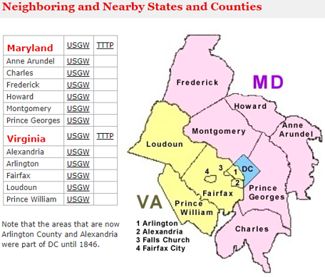
Figure 11: DC’s Neighboring Maryland and Virginia (Genealogy Research, Resources, and Records, n.d.).

Table 1
2019-2020 Property Tax Table
2019-2020 Property Tax Table (As of July 29th, 2019)

State | Location | Property Tax Per $100 of Assessed Value
Washington, DC |  | $0.85
Maryland State | Anne Arundel County | $1.047  (City of Annapolis & Town of Highland Beach have different tax rates)
Maryland State | Charles County | $1.317  (La Plata & Indian Head have additional tax rates)
Maryland State | Frederick County | $1.172  (the City of Frederick has a different tax rate)
Maryland State | Howard County | $1.362
Maryland State | Montgomery | $0.8286  (excludes transit tax, fire district, Advanced Land Acquisition tax-rate varies geographically throughout County)
Maryland State | Prince George County | $1.486  (Tax-rate varies geographically throughout County)
Virginia State | City of Alexandria | $1.130
Virginia State | Arlington County | $1.026
Virginia State | City of Fairfax | $1.075
Virginia State | Fairfax County | $1.150
Virginia State | Loudoun County | $1.045
Virginia State | Prince William | $1.125  MD, VA, DC property taxes are paid on 100% of the assessed value
The Department of Assessment and Taxation, 2020) |  | (Rivers, 2015)

DCLT Case Study Overview: New Source of Prosperity

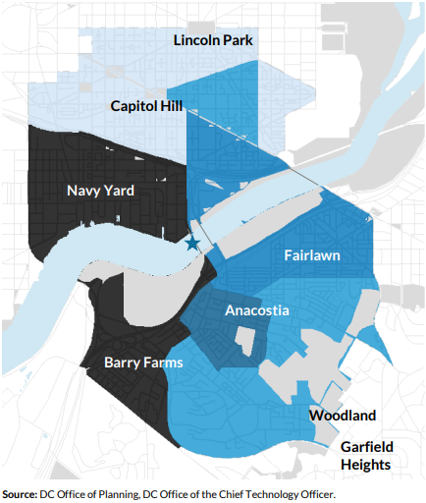

Figure 12: The 11th Street Bridge Park Location (11th Street Bridge Park, n.d.)
Building Bridges Across the River (BBAR), DC's Ward 8-based non-profit organization, have partnered with the DC government to repurpose the 11th Street Bridge into a park, DC's first pedestrian-only elevated park in Ward 8. Figures 12 and 13 show the location and the before and after pictures of the 11th Street Bridge Park, an old freeway bridge structure that will be repurposed into a new civic space (11th Street Bridge Park, n.d.).
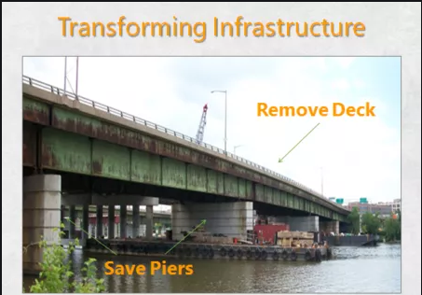
Figure 13(a): 11th Street Bridge Park Project (before) (11th Street Bridge Park, n.d)
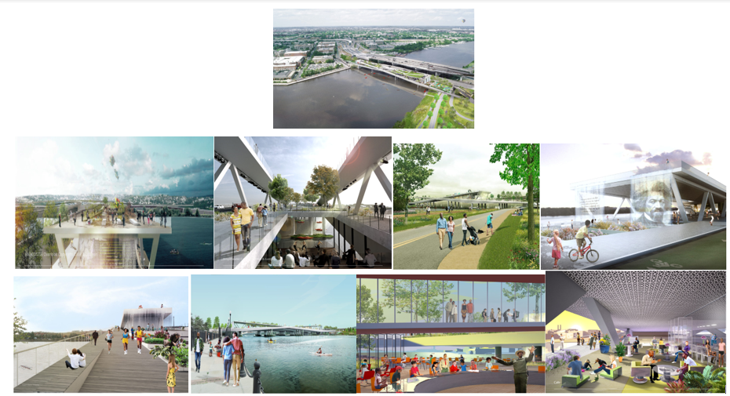
Figure 13 (b): 11th Street Bridge Park (after) (11th Street Bridge Park, n.d)
This 400-yard-long pedestrian-only bridge park will connect DC's wealthier Ward 6 Capitol Hill/Navy Yard neighborhoods to underinvested Ward 8 Anacostia neighborhoods. The 11th Street Bridge Park project will boost economic activity, create jobs, recreation, eco-friendly education, and art entertainment, attracting a lot of investment attention. According to Governing the Future of States and Localities,
“Much of the excitement for the (11th Street Bridge Park) project is not about the specific amenities. Rather, it's about the chance to unite two parts of the City that sometimes seem worlds apart: the prospering area west of the river, where tourists flock to the museums and monuments on the National Mall, and the less known Anacostia neighborhood to the east” (Vock, 2014).
Ward 8 also contains 10% of DC's subsidized homes and the highest number of subsidies expiring by 2020 compared to DC's seven Wards (Tatian et al., 2015). Also, according to DC's 2019 Housing Conditions report, Ward 8 residents reported the most significant number of housing condition issues (please see Table 2), and those in subsidized housing were two times more likely to have two housing conditions than those living in non-subsidized homes (Office of the Deputy Mayor for Planning and Economic Development, n.d.).
Table 2
2019 Housing Conditions Report Survey: Housing Conditions
2019 Housing Conditions Report Survey: Housing Conditions
Broken toilet
A broken stove, refrigerator, or other appliance
Broken window
Broken door to the outside, or broken lock on a door to the outside
Exposed electrical wire
Peeling paint
Mice, rats, cockroaches, bedbugs, or other household pests

The 2019 Housing Equity Report found that "across Washington DC's eight wards, the majority of residents surveyed felt that the current geographic distribution of affordable housing in the city is unfair, and most felt very strongly that this should change" (Government of the District of Columbia, 2019). As seen in Figure 14, Ward 8 has the most at 31% of affordable housing units (DC Office of Planning, 2018). Ward 8 has the highest level of residential instability, whereas Wards 1, 2, 3, and 4 had the lowest. According to August's research, higher-income residents believe moreso than lower-income residents that property values decrease when nearby low-income housing opportunities are present (August, 2014). Higher-income residents’ resistance to having lower or mixed-income neighborhoods have used legal parameters to control low-income personal activities within the community by using nuisance abatement laws to increase police scrutiny, causing alienation toward lower-income residents. Moreover, the middle-class has shown antagonistic behavior towards low-income housing opportunity recipients (August, 2014). Subsequently, this discrimination has created tension and feelings of rejection among low-income residents.
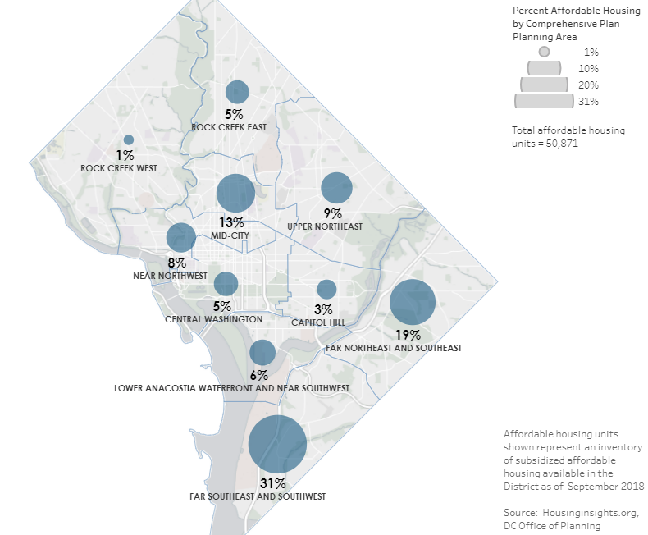
Figure 14: DC’s Affordable Housing Units per Ward (DC Office of Planning, 2018)
The outspoken desires to reduce concentrated affordable housing coupled with more upscale commercial/residential investments coming to Ward 8 will make efforts to attain and maintain community and city buy-in for affordable housing preservation difficult, but not impossible. (Office of the Deputy Mayor for Planning and Economic Development, 2019; Cohen & Tatian, 2018). An approach to reduce low-income residential displacement is to keep these residents in place as redevelopment occurs, which some view as keeping an area too concentrated with affordable housing. This covertly or overtly spoken viewpoint prefers to replace indigenous low-income residents with higher-income residents for the good of the community and its residents. Failing to understand that low-income residents want investments in their communities and the opportunities that come with them which enables economic upward mobility and improved quality of life. In turn, as lower-income residents’ quality of life improves, so does the DC economy. These conflicting viewpoints of affordable housing concentration highlight DCLT's need to acquire permanent community land control where residents, investors, nor the government cannot displace CLT residents since the CLT owns the land.
To avert low-and-moderate-income residents’ displacement from their homes, the 11th Street Bridge Park planners and community stakeholders collaborated to develop a 5-year Equitable Development Plan, which incorporates the creation of the Douglass Community Land Trust (DCLT), a name voted by the community in honor of abolitionist Frederick Douglass, to serve residents and businesses in the area. The BBAR's Equitable Development Plan (EDP) aims to guarantee that the 11th Street Bridge Park propels inclusionary development that enables opportunities for all mixed-income residents living in the surrounding neighborhoods. The EDP addresses civic engagement for residents, employment training for existing residents, and the utilization of local residence for construction jobs, entrepreneurial opportunities, and fundraising efforts. The EDP represents an illustration of inclusive collective community development efforts in a community riddled with abandonment, the anticipation of displacement, and the solution to utilize DCLT (Cohen & Tatian, 2018).
DCLT states it will incorporate evidence-based policy recommendations of local for-profit and non-profit organizations, experts, residents, and government to produce and secure permanent quality affordable rental and homeownership housing units with resale-restricted protocols as well as financing options with private, public subsidies or Inclusionary Housing Ordinance funding mandates. The 5-year EDP seeks to bring an economical source of prosperity to DC's Ward 8 while creating the DCLT to ensure affordable housing provision (Cohen & Tatian, 2018).
Ward Eight: The DCLT Client Community
Now, please close your eyes; what do you imagine when you think of DC’s Ward 8 community? Please open your eyes. Is it this?
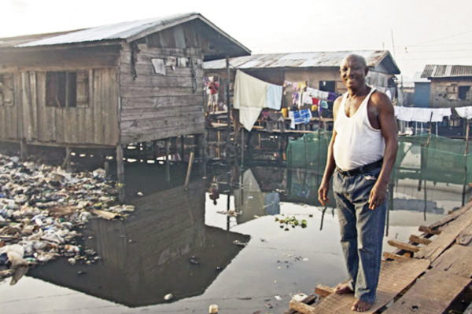
Figure 15: Photo by Unknown Author is licensed under CC BY (Turrentine, 2016).
Figure 15 is not Ward 8, but this is the implicit bias image many have of Ward 8 from its history of disinvestments. Ward 8 is the last and economically invested of D.C.'s eight wards. Contrary to these extreme mentally pictured biases and despite its many economic setbacks, Ward 8 is a hidden jewel that spans across 8.7 square miles with the lowest taxable land in DC. Figure 16 below shows DC eight Wards geographic location, in which Ward 8 sits on the furthest and lowest right side separated by the heavily polluted Anacostia River from DC's other six wards (Turrentine, 2016).
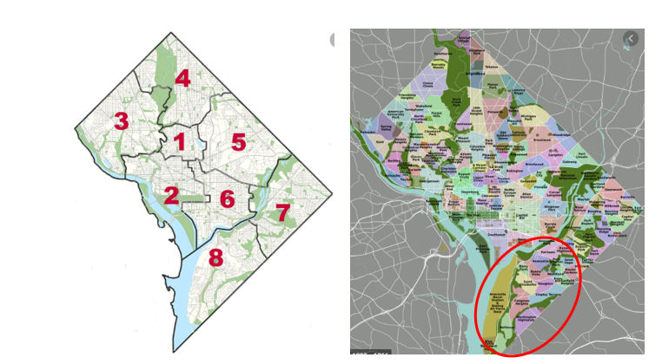
Figure 16: DC’s 8 Ward Map
Ward 8 is a multi-faceted, precious gem with historically deep roots and proud rich heritage of cultural icons and places like abolitionist Frederick Douglass's house. A close-knit community and oasis where many low and middle-income and successful Washingtonians call home. Althea Holford, a resident/student advocate, described Ward 8 as a:
"Vibrant local community steeped in tradition, pride, and neighborhood relationships, known for a thriving commitment to civic engagement. There is great pride in neighbors helping neighbors. It was the home of the late Marion "DC’s Mayor for life" Barry. There is also a growing arts culture with the Community Smithsonian, Cultural Center, Anacostia's Art Center, and Playhouse (see pictures below). There is a beat and feel to Ward 8 that is unique (A. Holford, personal communication, May 25, 2020).”
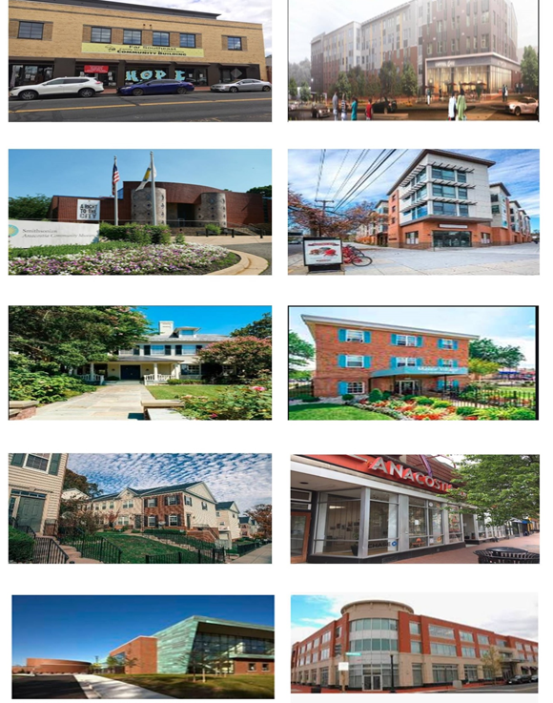
Figure 17: Anacostia's Art Center, Community Center, Playhouse, Ward 8 housing/apartment styles, St. Elizabeth campus, DC’s Department of Housing and Community Development (DHCD)
Throughout Ward 8, seen in Figures 17 and 18 are the homes of several large federal and local institutions and the military Bolling Air Force Base. D.C. and the U.S. governments jointly own 53 million square feet of land (Taylor, 2015). The estate of Saint Elizabeth's Hospital, established in 1855, holds panoramic views of D.C.; also scheduled for major redevelopment. South of Historic Anacostia sits Congress Heights neighborhood, which has a substantial number of garden apartments and single-family bungalows the most extensive commercial zone. Just south of Congress Heights lies Washington Highlands, which includes many apartment complexes and new single-family homes. South of Washington Highlands, the Bellevue neighborhood, has a few detached houses with lawns from the 1940s, numerous garden apartments, and a high-rise apartment building (Office of Planning, DC government, n.d.).
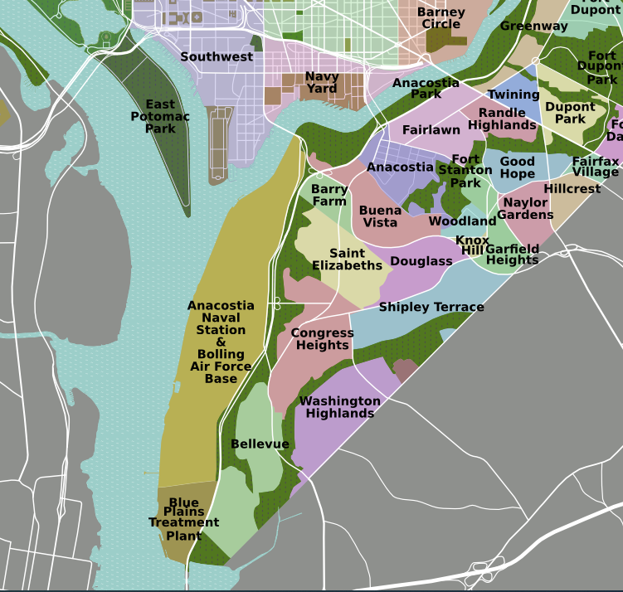
Ward 8
Figure 18: Ward 8 close-up (Peter Fitzgerald self-made, tracing done from PD satellite imagery Ward 8 Map)
The beauty may go unnoticed when standing on the ground; still, Ward 8 landscapes contain some of DC’s breathtaking central green spaces like the Kingman & Heritage Islands (which seeks re-development proposals) (Department of Energy & Development, n.d.; Kingman & Heritage Island, n.d.). Anacostia Park, Oxon Run Park, Fort Stanton, and Shepard Parkway. Its historical neighborhood Anacostia (please see Figure 19) was established in 1854, making it the oldest DC Ward and D.C.'s first suburb (“Your Guide to Anacostia River Park,” 2018). Ward 8 is anticipating billions of dollars of investment projects; among those projects is the 11th Street Bridge Park located near Historic Anacostia, causing heightened residential displacement fears (Office of Planning, n.d.).
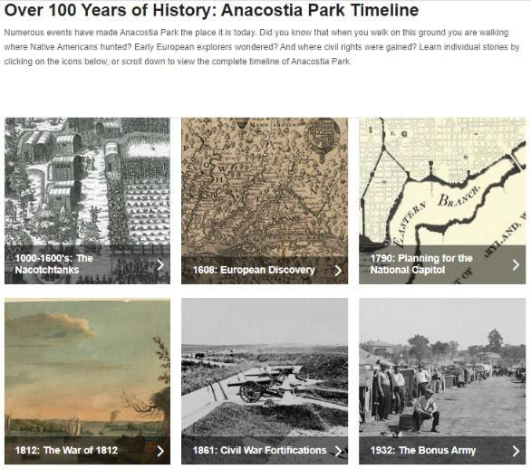
Figure 19: Over 100 years of history: Anacostia Park Timeline (“History & Culture”, 2019)
In Figure 20 below, Ward 8 has the second most listed neighborhoods in DC's 25 opportunity zones targeted for development. Ward 8’s seven opportunity zone neighborhoods are census tracts 7304 and 10400 of Congress Heights, Barry Farms, Poplar Point, Fort Stanton, Historic Anacostia, Fairlawn, and Bellevue (Office of the Deputy Mayor for Planning and Economic Development, n.d.). Opportunity Zones is a federal program enacted as part of the Investing in Opportunity Act (IIOA), in the Tax Cuts and Jobs Act of 2017, to drive long-term investments in new businesses and commercial projects to low-income distressed neighborhoods. In 2018, Mayor Bowser and the U.S. Department of Treasury nominated and certified 25 census tracts to be Opportunity Zones (Office of the Deputy Mayor for Planning and Economic Development, n.d.).
According to the DC Fiscal Policy Institute,
“There are many important policy questions surrounding Opportunity Zones. Because the tax benefits grow with the appreciation of the investments (e.g. rising property values) some experts worry that Opportunity Zones will serve as a subsidy for gentrification—especially because there is no requirement that investments provide any benefits for the community, such as affordable housing or high-quality jobs. Furthermore, place-based tax incentives have a poor record of success in attracting new investments that would not have occurred otherwise. Finally, the underlying premise of Opportunity Zones—that funneling capital investment into poor neighborhoods will, in and of itself, create new economic opportunities for low-income residents—is questionable (Zippel, 2018, para. 3).”
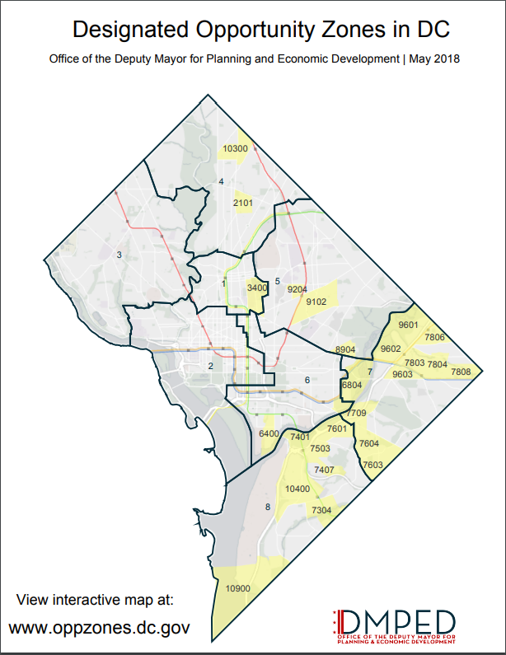
Figures 20: DC’s Opportunity Zones (Office of the Deputy Mayor for Planning and Economic Development, n.d.).
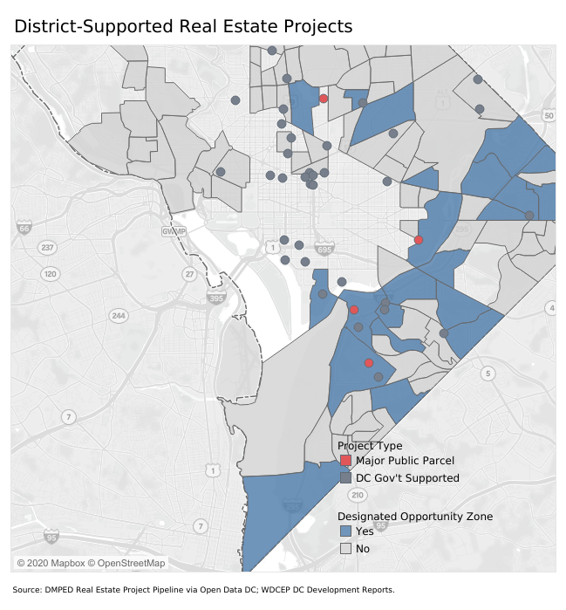
Figure 21: District-Supported Real Estate Projects
According to DC’s 2018/2019 Development report, DC has over 36 million square feet or 1 square mile of development in progress in these opportunity zones. From September 2017 to September 2018, DC has invested a total of $6.2 billion in commercial real estate and capital gains incentive of $163.4 million in real estate investment. D.C.'s capacity to retain value and withstand economic dips makes it a significant investment attraction for wealthy local, national, and offshore investors; almost 50% of each dollar invested over that last year were from foreign sources versus 11% nationwide. Multi-family housing units then retail properties are the most appealing for investors (Press Release, 2018). Eleanor Norton, DC's non-voting delegate in the House of Representatives, stated, "it's the first time D.C. federal government is crossing the river into Ward 8 in a big way. Federal agency buildings are proposed to be constructed in Ward 8, bringing amenities where these offices will be located. Residents want the amenities but not necessarily the federal buildings." (February 2020 Ward 8's Advisory Neighborhood Committee (A.N.C.) meeting). Ward 8’s St. Elizabeth Hospital campus redevelopment project “has been trumpeted as the second-largest commercial development effort undertaken by the Federal Government, since the construction of the Pentagon” (Urban Land Institute, Washington, 2010).
Policymakers' efforts and on-going funding to consolidate the Department of Homeland Security (D.H.S.) headquarters on Ward 8’s St. Elizabeth's hospital campus is still pending (the United States General Services Administration, 2019). According to this report, D.H.S. Headquarters Consolidation at St. Elizabeth's Draft Supplemental Environmental Impact Statement,
“From the District's perspective, the D.H.S. consolidation is seen as a potential catalyst for expanding the city's innovation sector and diversifying its economy. Over time, this federal agency will increase neighborhood demand for improved retail amenities and services. Moreover, proximity to D.H.S. and the historic character of the Saint Elizabeth's campus provides a unique advantage in attracting federal contractors and security-related businesses to this area. Such economic activity, in turn, will help increase entrepreneurial activity, venture capital investment, and workforce development within the District” (Government of District of Columbia, 2012).
Also, this same report highlighted the approved plans for Ward 8's Anacostia development.
"Anacostia Transit Area Strategic Investment and Development Plan: The Anacostia neighborhood and its transit area are northwest of Barry Farm and the West Campus and are poised to have unmet demands for housing and retail. Approved in 2006, the Anacostia Transit Area Strategic Investment and Development Plan provides coordinated, strategic investments of more than $150 million of public funding that has been committed to various projects in the Anacostia neighborhood and neighboring communities” ( U.S. General Services Administration, 2020).
Residents and community partners hope to promote the development and steward Ward 8 heritage do not come without fears of potential displacement for many of Ward 8's low- and middle-income residents. DC’s Demographics Comparison (2019) table below compares key indicators of Ward 8 to DC citywide and Ward 6 (US Census Bureau, 2018). When compared to other Wards, Ward 8 consistently suffers from a spatial mismatch in that it ranks third in the largest population size but lacks job opportunities creating a three times higher unemployment rate, the highest poverty rate at 35.7%, the lowest annual income at $31,954, and the lowest homeownership rates at 21% (US Census Bureau, 2018). Ward 8 has the second-highest concentration of Blacks at 89% after its similarly economically neglected neighbor Ward 7 at 92% (DC Health Matters, 2020; US Census Bureau, 2018). Ward 8 has the highest housing vacancy rate at 13%, the highest average number of people to a household at 3; most households are larger and have children at 37.8% compared to DC citywide at 20.3%. Ward 8 has 25% of families with children living in poverty compared to DC citywide at 10.33%, and only 15.6% of Ward 8 residents has an education above a bachelor's degree, leads with female Head of Household at 54% and ranks second in teen pregnancies (ages 15-19 years old) after Ward 7. “Basically, black women are undervalued,” in the healthcare system (Langer, 2019). Black women are three to four times more likely to die from pregnancy-related complications than white women (Langer, 2019). According to the Centers for Disease Control and Prevention and Harvard T.H. Chan School of Public Health experts believe these statistics are due to disparity and racism.” Moreover, Black women with college degrees are still more likely to give birth to premature babies than white women with high school degrees (PBS, Unnatural Causes, 2008). Although 90.5% of Ward 8 residents have some form of health insurance and the highest Medicaid recipients at 46.5%, 82.1% still did not go to the doctor when they needed it due to cost, and 78.9% did not take prescribed medication due to cost” (Garner, Lucas, Little, & Putzer, 2016). Ward 8 has the highest number of residents in DC who believe they have fair or poor health, have asthma, diabetes, COPD, and depression (DC Health Matters, 2020).

Table 3
DC’s Demographics Comparison; Ward 8, Ward 6, and Citywide (2019)

DC’s Demographics Comparison; Ward 8, Ward 6, and Citywide (2019)

Demographics | Ward 8 | Ward 6 | DC Citywide
Population | 80,085 | 100,003 | 710,893
Poverty | 35.7% (2018) | 13.1% (2018) | 16.6% (2018)
Median Family Income (family of 4) | $34,824 | $102,777 | $121,300
Unemployment  (Aged 16 and up) | 18.54% | 5.85% | 7.29%
Housing Units | #35,777 | #53,046 | #354, 004
2018 Primary Voting  (Board of Election DC, 2018)  2018 General Election Voting | Registered #55,782  Ballots Cast #4,634 | Registered #76,992  Ballots Cast #16,871 | Registered #479,723  Ballots Cast #89,513
 | Registered #58,189  Ballots Cast #18,539 | Registered #81,208  Ballots Cast #41,256 | Registered #500,511  Ballots Cast #231,700

Expensive housing costs create instability causing depression, developmental/educational challenges in children, food insecurity, inability to pay for transportation to school/job, or medical appointments worsening health indicators (Zipple, 2016). Housing, primarily residential segregation is a strong social determinant of health. Having a home is a vital foundational need and a critical element of equity. The amount of time, energy, and capital invested in housing is substantial. However, some communities make it difficult for low- and middle-income families to attain homes, creating income-segregated neighborhoods. Residential segregation impacts a person's quality of life. So much so, that residential segregation is 1 of the 10 Social Determinants of Health or "the economic and social conditions that influence individual and group differences in health status” (Braveman & Gottlieb, 2014).

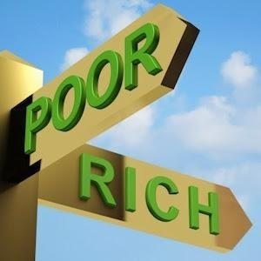
Figure 22: Poor & Rich
Ward 8 has suffered social exclusion and economic neglect when compared to DC citywide and Ward 6. Douglass Community Land Trust (DCLT) aspires to reduce Ward 8 historical residential segregation and discrimination by providing affordable housing and counteracting the exclusionary effects of restrictive land-use regulations by implementing a CLT. Studies show that "poverty-stricken communities are associated with lower education, lower salaries, higher criminal activity, behavioral pathologies, and erosion of collective socialization that adversely affects civic engagement.” At the same time, mixed-income neighborhoods benefit lower-income households (Kontokosta, 2014). “Residential segregation limits the freedom of housing choice and hinders political communication among segregated groups” (Blumer, 1958; Kontokosta, 2014). When residents perceive themselves as being neglected or unheard, mistrust towards government develops, resulting in less civic participation (Wang, 2001). Therefore, the DCLT efforts to involve Ward 8 residents and sustain community engagement must consider these residents’ psychographics.

Community-Based Social and Economic Segregation:
According to Place Matters book:
“The significance of housing location matters in the quality of people's lives. Low-income neighborhoods have widely different living conditions, uneven access to amenities and opportunities, and different levels of political influence. The fundamental reality is one of the growing economic segregation in the context of rising overall inequality. People of different income classes are moving away from each other, not just how much income they have but also where they live. America is breaking down into economically homogeneous enclaves exacerbating economic segregation. This dynamic harm the quality of life for the working and middle classes as well as for the poor imposes costs on society as a whole (including affluent families) and lessens American society's capacity to engage in vigorous democratic debate and to collaborate to address its pressing problems” (Lowry, 2003).
DC's Ward 8 communities have a history of economic abandonment. DCLT aims to be a driver in promoting collective residential and community engagement and provide a potential platform for economic mobility and flexibility for these residents. Economic and social segregation is evident in income, poverty, homeownership rates, and health status when comparing Wards 6 and 8, which are connected from the 11th Street Bridge Park (DC Health Matters, 2020; Claritas, 2020; US Census Bureau, 2018). Historically, Ward 8 communities have received less public and private investment from DC. This reality is often associated with ripple effects causing voter apathy or government mistrust resulting in reduced civic engagement (Ford, 2018; Wang, 2001). Some Ward 8 residents believe that "inequity is the result of public planning without any public input. Therefore, current discussions regarding equity are due to the invasion of newly affluent residents, causing interest in improving infrastructure and fears of displacement for low- and middle-income residents” (Samra, 2019).
DC's current community development investments in Ward 8 reflect concerns of displacements and hopes of economic and social integration. To combat displacement fears, D.C. Mayor Muriel Bowser has allocated almost $51 million towards 326 affordable housing units in Ward 8 through the DC Department of Housing and Community Development (DHCD), in which over $39.5 million came from the Housing Production Trust Fund (HPTF) (Department of Housing and Community Development, n.d.). Mayor Bowser has proposed a 2020 budget increase for the Housing Production Trust Fund (HPTF) investment, resulting in a total of $200 million (Office of the Mayor, 2019). The funding sources are HPTF- $130 million, Private Sector- $45 million, Workforce Housing Fund - $20 million that will leverage private sector investment by 9 to 1 (Office of the Mayor, 2019). The HPTF is:
The primary tool used to produce and preserve affordable housing in DC. It is a special revenue fund administered by DHCD’s Development and Finance Division (DFD) that provides gap financing for projects affordable to low- and moderate-income households. It was created by the Housing Production Trust Fund Act of 1988, which outlines its yearly requirements. This Act requires a Board to be established to advise the Mayor on the HPTF’s development, financing, operation, and other low to moderate-income housing matters. This Act also requires yearly funding of at least 50% of the budget to serve households with incomes below 30% of the area median income (AMI); At least another 40% for families with incomes between 30% - 50% AMI; and the balance serve families with incomes up to 80% AMI. Generally, at least 50% of the funds disbursed provide rental housing. This program is funded through 15% of revenue from deed recordation (property owner submits paperwork to the City that they own property), transfer taxes, and the District’s general fund (Department of Housing and Community Development, n.d.).
The Mayor has also utilized the DC Housing Finance Agency (DCHFA) to provide financial assistance toward affordable housing provision (DC Housing Finance Agency, 2020). DCHFA is a
“financial intermediary and administrator of affordable housing programs and resources for the District of Columbia. Through its Multifamily Lending and Neighborhood Investment and Capital Markets divisions, DCHFA issues tax-exempt mortgage revenue bonds to lower the developers’ costs of acquiring, constructing, and rehabilitating rental housing. The Agency offers private for-profit and non-profit developers low cost predevelopment, construction, and permanent financing that supports the new building, acquisition, and rehabilitation of affordable rental housing in the District” (Mayor's Office of Community Relations and Services, 2019; DC Housing Finance Agency, n.d.). At DC's 2020 Mayoral Conversation on Housing, Mayor Bowser strongly urged the region to do more for housing and not just offload it to the private sector (2020 Mayoral Conversation on Housing, personal communication, February 8, 2020).
DC's mayoral authority to increase and allocate funding to DC's programs comes from the 1973 Home Rule Act (Council of District of Columbia, 2016). This Home Rule Act is the Congressional statute that enables the DC local government to govern itself and mandates DC to establish a citywide Comprehensive Plan and Advisory Neighborhood Commissions (ANC's) (Council of District of Columbia, 2016; District of Columbia Home Rule Act, 2020). "This Comprehensive Plan, adopted in 2006, amended in 2011 and currently (2019) under draft amendments to address community needs, land use, economic development, housing, environmental protection, historic preservation, transportation, and more" (Office of Planning, n.d.). BBAR's Equity Development Report outlined plans for Ward 8's 11th Street Bridge Park project and the launching of Douglass Community Land Trust (DCLT) is attempting to tackle both the Comprehensive Plan recommendation for development and housing, among others. These are the complex, interrelated, and intersecting dynamics of housing issues that motivate this study of DC’s Community Land Trust.

DC’s Douglas Community Land Trust (DCLT):
DCLT was birthed through BBAR's 11th Street Repurpose Bridge Park Equity Development Plan. During BBAR's inclusive community outreach, the community proposed the formation of DCLT to reduce potential displacement from the 11th Street Bridge Park and the many developments coming to Ward 8. The idea for the 11th Street Bridge Park project began in 2009 by DC's Office of Planning, then Director Harriet Tregoning. Tregoning wanted to transform the old 11th street bridge piers into an elevated park and civic space (“Building (on) Bridges,” 2014, Blog post). According to the National Parks Conservation Association,
"The 11th Street Bridge Park concept was inspired by other examples of old infrastructure transformed into parks, such as Manhattan's High Line Park, Chicago's 606, and Poughkeepsie's Walkway Over the Hudson. The 11the Street Bridge Park planners wanted to establish themselves as a community-inclusive model by holding a design competition with entries from 82 of the top design firms in the world. A panel of experts, community stakeholders, and the public collectively designed and judged the park project competition.
The proposed 11th Street Bridge Park is a new signature destination built on the original pillars of the old road bridge crossing the Anacostia River between wards 6, 7, and 8, connecting the Capitol Hill and historic Anacostia neighborhoods. The park will be the length of three football fields and include programming such as a theater, urban agriculture, café, hammock grove, and classrooms to teach students about the river system. An Exelon Environmental Education Center, powered by solar panels and charging stations, will teach people about the river and environment (WDCEP, 2019).”
BBAR, Ward 8 non-profit and overseer of the 11th Street Bridge project stated:
"Working collaboratively with community members and stakeholders, government officials, business owners, and policy experts, Bridge Park is committed to changing the narrative of how development typically takes place. It is well known that signature public parks can significantly change land values and uses in surrounding areas. Indeed, a recent HR&A economic impact study found that property values in comparable park developments increased by 5 to 40 percent. The goal of Bridge Park's Equitable Development Plan is to ensure that the park is a driver of inclusive development. This development provides opportunities for all residents regardless of income and demography. By following a community-driven and vetted process, we hope that other cities can look to the Bridge Park as a prime example of how the public and private sectors can invest in and create world-class public space in an equitable manner” (11th Street Bridge Park’s Equitable Development Plan, 2018).
"From the beginning of this project, community engagement and feedback have driven Bridge Park's conceptualization and design. The first two years were filled with hundreds of neighborhood meetings on both sides of the river, leading to the identification of programming concepts for the park's design. These concepts were seamlessly woven into the park's design by architects OMA + OLIN, who have been working with the community to develop a world-class public space for recreation, arts, and environmental education. Throughout this community-led process, it became clear that the Bridge Park had the potential to be more than a park. In particular, the Bridge Park could symbolize a new unity and connection between a booming area of the city and one that has long been excluded from the city's economic progress, which is especially important for DC residents and small businesses located east of the river. Decades of disinvestment, coupled with the economic, racial, and geographic segregation of Wards 7 and 8, mean that many of the communities east of the river are areas of low homeownership, high poverty, and unemployment. This work has become a model across the country, inspiring similar equity plans in St. Louis, Dallas, and Los Angeles. This Equitable Development Plan supports the unprecedented investments made by Mayor Bowser, and the DC City Council is supporting workforce development, small businesses, housing, and cultural equity to create a more inclusive city” (11th Street Bridge Park’s Equitable Development Plan, 2018).
According to the Urban Institute 2019 Equitable Development and Urban Park Space research report,
"The Bridge Park presents a valuable case study on the challenges posed when a highly anticipated new public amenity takes shape near distressed neighborhoods in a rapidly gentrifying city. The park and its Equitable Development Plan offer an opportunity to assess how and whether current residents of surrounding communities can reap the benefits of new development in their neighborhoods when economic developers make equity a priority” (Bogle, Diby, & Cohen, 2019).
Brookings's 2019 report highlights how parks can be inaccessible to specific disenfranchised populations, and the efforts to bring access to them lead to concerns of residential displacement. This report stated (Kratz, 2019):
"While parks bring several positive benefits to a community, one's ability to access them is often shaped by income, race, and education. Parks can improve public health, serve as anchors for economic development, act as green infrastructure, and build social capital by bringing together residents who otherwise might not cross paths. However, cities have historically neglected to create these spaces in traditionally underinvested neighborhoods. Now that many cities are seeing significant new investments, some are concerned that even with the benefits new parks bring, they could also signal impending displacement.”
To ensure the 11th Street Bridge Park project is inclusive and equitable, the Equity Development Report (EDP) established goals and strategies. This EDP was developed in 2015 and revised in 2018. Figure 23, a page taken from the EDP, highlights the start and preparation of the EDP process. The 11th Street Bridge Park project overseers collaborated with Local Initiative Support Corporation (LISC), experts, and residents to obtain data on nearby residents, who will be affected by the park. They collaborated to formulate the strategies/recommendations in this EDP five years before the park was due to open. Figure 23 shows the EDP outlined activities and collaborative efforts made from 2014 to 2019. Stakeholders for the 11th Street Bridge Park project have prided themselves on being inclusive in reaching out and incorporating resident inputs, which resulted in the start-up of DCLT. Figures 23 and 24 partially highlights two of the four interactive Implementation Phases (discussed earlier Chapter 1 page 9) within the CLT critical time-period (one year before incorporation and two years of operation after) (NIRN, n.d.).
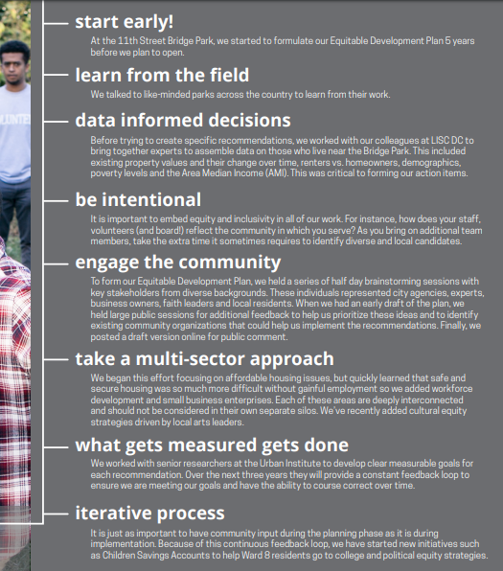
Figure 23: EDP formulation (NIRN, n.d.)
DCLT Exploration Phase 1: occurred in March-May 2017 with the help of BBAR, when the advisory team convened. The exploration phase is when the leadership team “identifies the need for change, learning about what it takes to implement the innovation effectively, developing a team to support the work as it progresses through the phase.”
DCLT Installation Phase 2: started in September 2017, when JP Morgan Chase invested 5 million to implement PRO Neighborhoods initiative, which included DCLT. The installation phase is to “build system capacity, securing and developing the support and feedback.”
DCLT Initial Implementation Phase 3: is when the innovation is first utilized. Supportive resources for implementation are improved and centered around data collection via processes.
It is suspected that the DCLT start-up phase is somewhere between the Installation and Initial Implementation Phases. Since DCLT is in its start-up phase, there was minimal publicly searchable desk-top literature data available. This research sought to investigate and understand the factors affecting the DCLT start-up phase, which encompasses the three steps before the Full Implementation Phase 4 (discussed on page 9).
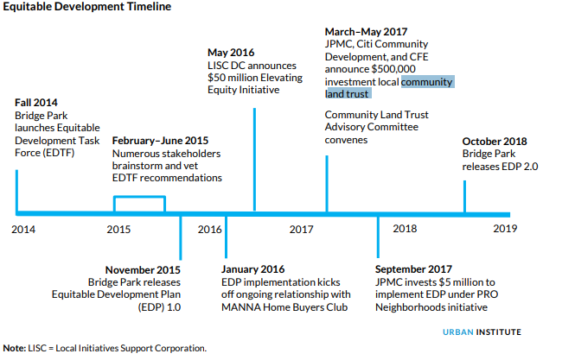
Figure 24: Equity Development Collaborative Timeline (Bogle, Diby, & Cohen, 2019)
The DCLT mission statement is, "The Douglass Community Land Trust plants the roots of affordability, security, and prosperity for current and future generations. We enable the inclusive and equitable development and preservation of permanently affordable housing, local small business, and other public assets through community ownership of land, today.” DCLT breaks down its mission into the following six core values: (Douglas CLT, n.d.).
- “Right to Stay and Thrive: Focusing on anti-displacement of low-income residents and small business as well as celebrating and preserving the culture and identity of all DC residents
- Community Control: Developing various strategies for residential engagement where they will have power and decision-making authority. Also, steward resident-controlled housing on community-owned land.
- Permanent Affordability for Housing: Preserving and increasing rental and home-ownership units that are permanently affordable for current and future generations of DC residents.
- High Quality, Healthy Housing: Healthy housing means embracing the environment as an asset. To the greatest extent possible, aiming to maximize sustainable building and operating practices benefitting the residents, the community, and the environment.
- Individual/Family Asset Building: Creating opportunities for equity-building through homeownership, creating savings opportunities through reduced rent costs and cost-savings via green sustainable practices, and partnering with other organizations doing asset building work.
- Operational Excellence: Run a transparent and effective operation that is financially sound, ensuring it will be in place to steward the programs and public resources, manage the assets, and forge intentional partnerships in perpetuity.”
The EDP stated that one goal of DCLT is to produce 1,000 rental and homeowner housing units at permanently affordable prices for its low- and moderate-income residents within the next ten years. Housed within the EDP is the DCLT collaborative process, which incorporates an advisory board and key stakeholders in the planning, implementing, and evaluative stages. The establishment of the DCLT advisory board or committee enabled stakeholder diversity and further outreach to engage the affected residents. The EDP detailed the establishment of a collaborative process preceding, during, and after DCLT implementation. DCLT start-up is a platform for bringing a variety of residents and organizations together to advocate for a common cause, affordable housing. Initial decision-making collaborations have begun, this research seeks to understand current stakeholder perceptions, interests, and outcomes. According to Yu and Leung research,
“Construction development projects are often complicated and influence multiple stakeholders with different requirements and interests. Public engagement (PE) has emerged as a prerequisite for collecting stakeholders' opinions and involving them in the planning and decision making of construction development projects. It is not easy to identify and manage stakeholders in PE because different stakeholders possess different types of power and interests that can potentially dramatically affect stakeholder behaviors and final project outcomes” (Yu, & Leung, n.d).
The following Figure 25 shows DCLT internal or those within or directly responsible for DCLT start-up, and the external stakeholders are those who have or will collaborate with DCLT (this list is not exhaustive).

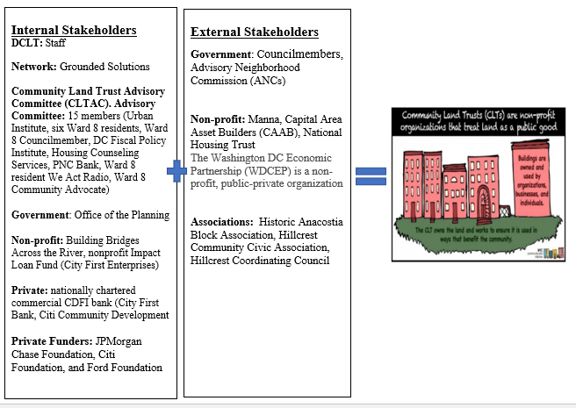
Figure 25: DCLT’s Initial Stakeholders (Douglas Community Land Trust, 2020)
DCLT's inaugural stakeholder was City First Homes (CFH), a non-profit that helps low-and-moderate income households obtain affordable housing, which assisted in initially housing DCLT and setting up DCLT’s governance (City First Homes, n.d.; Nonko, 2018). The DCLT governance or Advisory Committee comprises of Ward 8 community members, affordable housing specialists, and a council member; but the majority being residents (See Figure 26). Ward 8 has five Advisory Neighborhood Commissions (ANC), and within each ANC, there are seven members. ANC's are "non-partisan, neighborhood body made up of locally elected representatives established in 1976 by DC's Home Rule Charter," to build engagement between residents and government (Advisory Neighborhood Commissions, n.d.).
ANC's are responsible for advising local and federal agencies on things that affect their neighborhoods. Although they are not required to follow the ANC's' advice District agencies are required to give the ANC's recommendations "great weight." Moreover, District law says that agencies cannot take any action that will significantly affect a neighborhood unless they give the affected ANC's 30 days advance notice. The notice includes proposed projects that involve zoning, streets, recreation, education, social services, sanitation, planning, safety, budget, and health services” (Advisory Neighborhood Commissions, n.d.). Other inaugural players of DCLT included the funders, who were JPMorgan Chase Foundation, Citi Foundation, and Ford Foundation (Cohen & Tatian, 2018).
According to publicly available literature and news reports, DCLT collaborated with City First Bank, National Housing Trust, and JP Morgan. JP Morgan allocated a $5 million implementation grant to DCLT from the JPMorgan Chase PRO Neighborhood grant (Bogle, Diby & Cohen, 2019)
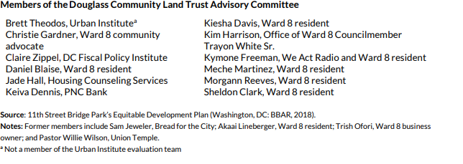
Figure 26: DCLT Advisory Committee (BBAR, 2018)
According to the EDP, “Bridge Park and its partners have produced notable results in the past two years, particularly in outputs like training provided, funds raised, and capacity building. Results with the greatest direct financial impact on DC and Ward 8 residents of modest means include 70 homes purchased, 31 full-time construction jobs created, and $525,000 in small business loans issued. Based on these results, the research team finds that the Bridge Park leaders and their allies are well on their way to achieving their goal that way, Bridge Park is a "driver of inclusive development" for the surrounding neighborhoods” (Bogle, Diby & Cohen, 2019).
DCLT is attempting to enable current residents to stay in place and benefit from Ward 8 investment plans. BBAR stated its success for DCLT
"is the development of a business plan, the creation of an advisory committee, hiring an Executive Director, creating initial governance documents, developing a pipeline of 185 housing and commercial units, and acquiring 65 rental units in Ward 8 (preserving affordability permanently) to stand up a new resident-led community land trust” (BBAR, n.d.).
There are few empirical CLTs studies focused on the start-up factors affecting community empowerment and collaboration dynamics and minimal on CLTs real-time case studies. This research aids in filling the gaps in the literature by analyzing the DCLT start-up phase in real-time.

Research Inquiry
The goal of this study is to determine the factors that influence the DCLT start-up. The following research probing questions assists in the development of constructs guides the literature review and will point to common data-driven themes that affect CLT start-up
- What is the status of the DCLT model and policy?
- Identify and analyze DCLT organizational and collaborative practices: What are the strengthens and weaknesses?
- What are the factors affecting Community Land Control?
- To what extent of community engagement and upward mobility does DCLT offer participants?

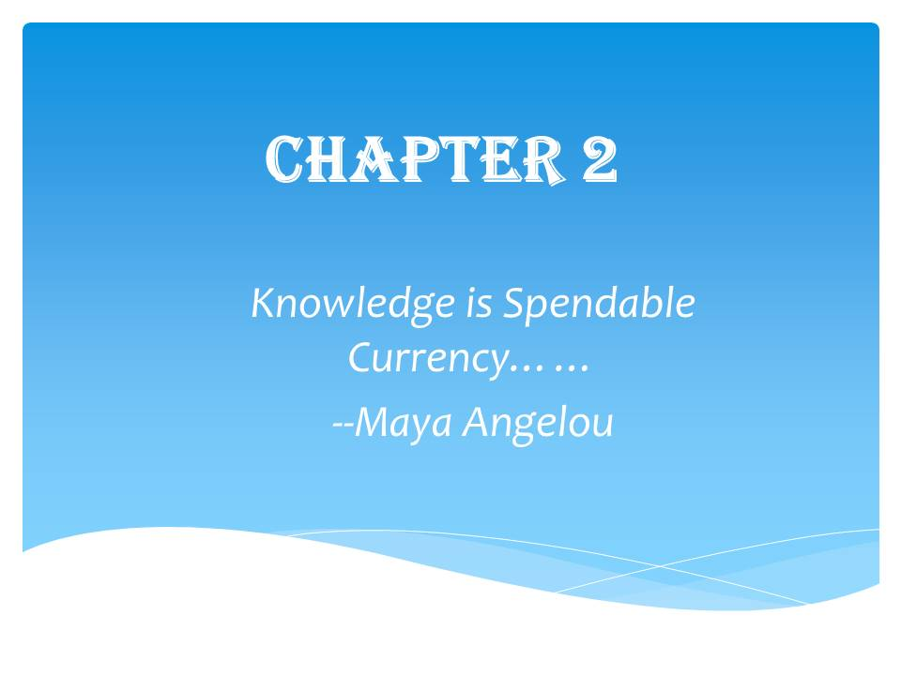

Chapter 2: Literature Review

INTRODUCTION
Low-income and middle-class households cannot obtain affordable rental units and homeownership due to housing costs outpacing income in the last six years (Greenberg, 2019; Rental Burdens: Rethinking Affordability Measures, n.d.). Unaffordable starter homes with high mortgage rates prevent young adults, weighted down with hefty student loans, and stagnate income growth, to afford monthly homeownership costs. Adults ages 20-24 salaries are down by 40%, and those ages 25-29 salaries are down by 16%, making it difficult to obtain a rental apartment. The United States (US) between 2015-2025 will need to develop 13.6 million homes and 11.5 million homes between 2025 and 2035 to keep up with the rising housing shortage crisis (McCue, Herbert, & Donahue, 2016). Plus, the costs to repair affordable homes can be more expensive to maintain than building new green affordable housing units (Bradshaw et al., 2005). The National Low-Income Housing Coalition Gap report found that 32% of very low-income, 8% of low-income, and 2% of middle-income renters are severely cost-burdened (Please see Income Note page x) (Aurand, Emmanuel, & Yentel, 2019). Almost 12 million renters and homeowners spend more than 50% of their income on housing. Figure 27 below reveals the 2020 Gap: A Shortage of Affordable Homes report for DC that 83% of extremely low-income, 71% of very low-income, 44% of low-income, and 25% of middle-income renters are cost-burdened or spending over 30% of their salary on rent. (Please see earlier figure Income Note page x) (NLIHC, 2020). Low salaries combined with limited and unavailable affordable housing makes it difficult for DC residents to obtain and maintain housing. Figure 28 shows the limited number of affordable housing available houses available for extremely and low-income residents at 40 and 65 houses available per 100 renter homes.

Figure 27: DC’s Renters Cost Burden by Income Bracket (NLIHC, 2020)

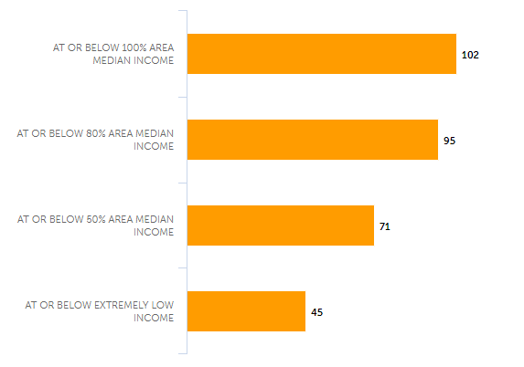
Figure 28: Affordable and Available Homes per 100 Renter Households (NLIHC, 2020)

“A family with one full-time worker earning the minimum wage cannot afford the local fair-market rent for a two-bedroom apartment anywhere in the United States.” Furthermore, in 2016, 2.3 million landlords filed for eviction, and in 2017, 1.4 million households were evicted the prior two years (Greenberg, 2019).
Affordable housing provision is exacerbated as cities attempt to boost their economy through community development efforts attracting new residents that result in gentrification and the displacement of financially vulnerable populations. Gentrification is “the process by which higher-income households displace lower-income [households] of a neighborhood, changing the essential character and flavor of that neighborhood.” (Gibbons, Barton, & Brault, 2018). According to Urban Displacement's extensive literature review, most studies concur that gentrification causes exclusionary displacement (limited low-income housing choices) and could oust some renters from their communities (Zuk & Chapple, 2015). Residential displacement of low and moderate-income populations results in many moving into overcrowded homes, public shelters, or becoming homeless. The adverse economic effects of one homeless individual cost taxpayers $30,000 to $50,000 a year (Newman, & Wyly, 2006; Ending Chronic Homelessness in 2017, n.d.).
The lack of affordable housing is due partly to the lack of interest from the private sector to fill the void. Studies show that private-sector housing developers’ inability to retain a profit in producing affordable housing disincentivize them to fill the gap in building affordable units, “the rents from the lowest income residents will not cover the costs of development and operating expenses.” Resulting in a sharp imbalance of housing constructions for high-rental units compared to low-rental units. Over the years from 2005-2015, there was an increase of 97% in housing constructions, with rental costs $2000/month and higher. However, a 2% waning of housing units with monthly rents of $800 or less (Newman, & Wyly, 2006). The trends from 2005 to 2015 showed the creation of 6.7 million high-cost homes but a decline of 260,000 homes that targeted rentals of $800/month (Aurand, Emmanuel, & Yentel, 2019).
As housing prices ascend, displacement worsens, the private sector apathy for affordable housing construction continues, local governments are becoming more interested in adopting laws that focus on diminishing inequalities and expanding economic opportunities for lower-income residents. Current interest has focused on the sharing of power with residents, community groups, and organizations to aid in reducing the affordable housing shortage. Many cities have restructured the nature of their contemporary city politics and turned to the Community Land Trust (CLT) model for reasonable housing provision. Community land trusts, commonly called CLTs, are becoming increasingly popular globally, especially within the United States. It is a model that enables the residents in the community to control property to create and preserve affordable housing, commercial spaces, and other community-approved development projects. It is another partial remedy cities use to lessen the tensions between our modern-day civil war of Community Development versus Community Displacement (Davis, Jacobus, & Hickey, 2008; Wagner, 2014). Currently, the US has roughly 250 CLTs; almost 20 CLTs are started every year.

Community Land Trust American History (Snapshot):
Community Land Trust or CLT is a young model. The first rural CLT established in the USA was in the 1970s by an unlikely collaboration, during the stormy racially charged decade by Charles Sherrod (a Black non-violent student coordinator at Albany state & grassroots organizer), Robert Swann (a White self-educated southerner), Slater King (a successful Black realtor, activist Northerner & cousin to MLK Jr), and Fay Bennett (a White female & then director of the National Sharecroppers Fund) (New Communities Inc, 2019). These founders may have crossed paths when they supported Albany Christian Community Church and Farm called Koinonia Farms in 1942, where racial mixing was allowed, but many residents and the local community hated it. Koinonia was fiercely ostracized by the local community, who tried to pressure the church to sell their land and harassments that included the Ku Klux Klan (a White supremacist hate group) shootings (New Communities Inc, 2019; Koinonia Farm, n.d.). The local small businesses boycotted purchases and sales to this church farm, but the farm withstood this terrorism and continued its practices and preaching on equality (Koinonia Farm, n.d.). Koinonia’s efforts resulted in the initiation of an independent low-income housing program called Koinonia Partners, the ancestor of Habitat for Humanity nonprofit organization, and the conceptualization of Community Land Trust (CLT) (Jordan, & Jordan, n.d.; Koinonia Farm, n.d.).
In later years founders King, Swann, Fey, and Sherrod established a CLT as a remedy to ensure African American farmers in Georgia had the opportunity to obtain and steward their property. Church ministries established the first urban CLT in a low-income African American neighborhood in Cincinnati, OH; urban CLTs boosted CLT expansion in later years (New Community Inc., 2019). During the civil rights movement, African American residents gained momentum in Northern states by fiercely pushing back against discriminatory policies and registering to vote. However, this led to retaliation, causing job loss and illegal evictions (Desmond, 2016).
This era was not only a pivotal benchmark for the civil rights movement but also the restructuring of cities in America. Citizen engagement was becoming widely-acknowledged in public housing programs, shifting city politics as residents organized to demand a voice and democracy in community development (Beider, 2007). Conservative government administrations in the late 1970s and 1980s pushed to attract the private sector to intervene as investors of economic growth and restructuring urban communities. US President Jimmy Carter signed the 1980s Housing and Community Development Act, which generated billions of private sector investments for urban revitalization. A 1980 Newsletter from the Department of Housing & Urban Development stated that:
“The first 1.5 billion dollars of UDAG government grant-generated $8.5 billion of private investment and over 400,000 jobs. The President’s centerpiece effort was to bring new jobs and private-sector investments to the nation’s most distressed areas.”
Following President Carter’s administration was President Ronald Reagan. President Reagan was a firm believer in reducing the growth of government spending and increasing the private sector’s role in economic development. “Government does not solve problems. It subsidizes them. You can’t be for big government, big taxes, and big bureaucracy and still be for the little guy. Whenever we lower the tax rates, our entire nation is better off” –Reagan” (Ronal Reagan, 2020). Moreover, in the 1982 Report of the Commission on Housing, President Reagan advocated for the role of the private sector in housing policy (McKenna & Hills, 1982).
“The explorers of the modern era are the entrepreneurs, men with vision, with the courage to take risks and faith enough to brave the unknown. These entrepreneurs and their small enterprises are responsible for almost all the economic growth in the United States.” 1988 Ronald Reagan, Speech at Moscow State University.” (Ronald Reagan, 2020).
“During President Reagan-era cutbacks in social services, many non-profits experienced even more pressure to provide basic human needs services to growing numbers of people. Non-profits became completely reliant on private donors and foundations, or dwindling government dollars to cope with ever-increasing demands, many non-profits began spending inordinate amounts of time writing proposals, designing programs to meet foundation guidelines, tracking, and evaluating programs to satisfy foundations, or soliciting private donations through direct-mail appeals, house parties, benefits, and other fundraising techniques.” (Paul Kivel, Social Service or Social Change Chapter, pg 139).
During the 1980s, under Reagan’s presidency, a political scandal unveiled corruption at the Department of Housing and Urban Development, also called HUD resulting in convictions (Miller, 2012). Convictions that included private-sector developers' illegal bribes to top HUD officials in exchange for federal low-income housing bids and housing subsidies or grants, which these private developers mismanaged.
The real estate industry, which includes housing developers, is traditionally a financial backer for elected officials since they hinge on agreeable housing policies. The US Department of Housing & Urban Development can administer low-interest financial loans and subsidies to housing developers, ensuring the monetary attainment of housing projects. Therefore, some elected officials receive substantial contributions from developers. These class-based housing politics in neighborhoods created an opening for CLTs adoption as an additional solution for affordable housing attainment (Domhoff, 1988).
In 1992 the Housing and Community Development Act enacted CLTs into federal law and designated them as Community Housing Development Organizations (CHDOs) (“H.R.5334 - Housing and Community Development Act of 1992”, 1992). This Act enabled CLTs to become grant funding recipients from the HOME Investment Partnership Program and other programs (“Shaking the Money Tree,” 2019). The HOME program is the largest Federal block grant to state and local governments, designed exclusively to create affordable housing for low-income households” (HUD, 2020)
Currently, approximately 250 CLTs oversee almost 12,000 owner-occupied units in the United States. The biggest CLT, established in the 1980s, is Burlington’s Champlain Housing Trust (CHT) (Wagner, 2014). By the 1990s, grassroots inner-city neighborhood advocates like New York’s Cooper Square and Boston’s Dudley Street were formed (Angotti & Jagu, 2007; Medoff & Sklar, 1994). CHT is unique because it has over 2,765 housing units; there are also five other large CLTs. CLTs are usually small, 220 CLTs have less than 50 housing units. CLTs’ goal is to maintain and expand their affordable housing units beyond solely concentrated blocks but instead, scatter them throughout the community (Miller, 2014).

Community Land Trust Outside American History (Snapshot):
The Community land trusts (CLTs) model did not just appear like a thief in the night. Its ancestries can be traced back to ideas outside of the United States. The idea that land is a God-given public resource to be shared and safeguarded, not to be hoarded, prostituted, or speculated by absentee property owners for profit. Origins trace back to communities like
- In Africa – the1960s Tanzania: “family-hood in villages” (Delehanty, 2020).
- Israel – the 1901 Jewish Trust Fund, the 1921 moshav, and the 1939 kibbutz (Israel Ministry of Foreign Affairs, 2013)
- England – Agricultural Common land and the 1946 Almshouse Associations Trusts (The Almshouse Association, 2020; The National Archives, n.d.)
- Scotland’s Croftlands (Shelter Scotland, n.d.)
- Mexico’s village lands Ejido (Whetten & Wisconsin, 1963)
- and the more influential India’s 1953 Spiritual leader Vinoba Bhave and the Village Land Gift program Gramdan (“Gramdan Villages in India,” 2019). Vinoba Bhave was a human rights activist in India, who was often associated with renowned Mahatma Gandhi, a civil rights advocate, who said
“Earth provides enough to satisfy every man’s needs, but not every man’s greed.” -- Gandhi
India’s Land Gift program was one of the influential models of early America Borsodi CLT structure and start-up. After learning that the donated 3 million acres of land redistributed directly to needy families resulted in them quickly losing their homes. India Land Gift program established local trustees within communities to collect the land donations, oversee, and lease the land to low-income families (“Gramdan Villages in India,” 2019). Similar to India land gift program but minus the trustees, the USA 1865 Special Field Orders, No. 15, known as the 40 acres and a mule policy, gave freed Black slaves a plot of land, but most of the land was confiscated and restored to its pre-war White owners. Early CLT founders rationalized that direct land donations to economically oppressed populations may be risky, so incorporating a Land Trust or overseer enabled community economic leverage to prevent families from losing their homes. Present-day growing interest circulates the possibilities of utilizing CLTs as a form of reparation for low-income African American residents (Cimbala, 1989; Schumacher Center, 2020).

Communal Land Concepts within US History:
Even though the first official US CLT established is acknowledged in the 1970s, the evolution of communal land-sharing ideas was also expressed earlier in US history. Renowned American ancestors like North American Red Indian Chief Seattle in 1854 stated (Flanagan, Alcantara, & Le Dressay, 2010).
“The President in Washington sends word that he wishes to buy our land. But how can you buy land or sell the sky? The land? The idea is strange to us. If we do not own the freshness of the air and the sparkle of the water, how can you buy them.”
Today, Chief Seattle would turn in his grave after hearing about oxygen for sale in Colorado bars. They sell oxygen to people who want to alleviate breathing pressures due to the state's higher altitudes (Colorado Oxygen Bar, n.d.). Or the words of Thomas Paine, a best-selling 1776 American author, and activist. In his 1797 Agrarian Justice, he argued the ideologies that (Paine, 2000):
- There are two types of property: God-given like the earth, air, water versus artificial/ invented, or human-made.
- Earth is the common property of the human race. Since men did not create the earth (land), he had no right “to locate as his property in perpetuity any part of it; rather, he had a natural right to occupy the land.” Therefore, everyone has a valid claim to certain lands or its equal
- Improvements on the land can increase its value 10-fold
- Land Monopoly yields the ultimate evil; the universal right of all is puzzlingly handed to an individual’s right.
John Stuart Mill, a historical influential thinker, and believer of classical liberalism said,
“Landlords grow richer in their sleep without working, risking, or economizing. The increase in the value of land, arising as it does from the efforts of an entire community, should belong to the community and not to the individual who might hold the title”(Blaug, 2000).
Also, Abraham Lincoln, one of the most celebrated US republican Presidents, nicknamed “Ancient One” for his ancient wisdom, stated in a letter, “The land, the earth God gave to man for his home, sustenance, and support, should never be the possession of any man, corporation, society, or unfriendly government, any more than the air or water” --Men of His Time, His Cause, His Character and True Place in History by Robert H. Browne, 1907 (Roots & Branches, 2013).
Leading to the words of one of the pioneers of Georgia State Community Land Trust, Bob Swann acknowledged his eyes opened after learning that racial politics and economic inequalities towards Blacks after segregation still existed. He stated,
“injustice makes me want to work for a more equitable solution to land ownership and economic security. Part of the answer seemed to lie in a land-reform program that would restore some of the land taken from Blacks after the Civil War. I began to put Borsodi’s model (having a trusty overseer) together with Vinoba Bhave’s Gramdan or village gift program in India.” (Swan, 1998).

Intellectual Origins of American Community Land Trust:
The profoundly ingrained intellectual foundations of Community Land Trust are built on the ideas of Henry George (1839-1897) (Blaug, 2000). Henry George was an American political economist and journalist who suggested poverty is from the rising land values of privately-owned homes by a small gang of landlords, termed Georgism. CLT is founded on the idea that land should not be treated as a commodity since property value is caused and developed by society, not an individual property owner. George further suggested the idea of imposing a universal single land tax from the government (George, 1879). Cities like Pittsburgh have taken to the idea of putting higher taxes on land than the building itself. They believe that when taxes on the physical building itself is high, there is less building; therefore, hefty taxes should be applied to land use (Bourassa, 2006). George’s 1879 book Progress and Poverty emphasized the “Great Enigma and Unearned Increment.” Henry George struggled to understand the wealth vs. poverty tensions or “Great Enigma” and the uneven wealth accumulation of land distribution or “Unearned Increment” (George, 1879). Henry stated, “Material progress does not merely fail to relieve poverty – it produces it. This association of progress with poverty is the great enigma of our times.” George realized from John Stuart Hill's works the “Unearned Increment” is the larger profits landlords make off their land even though property values are a collective effort from society, not any one person. Therefore, its appreciation should return to the community, not just the landowner. George’s ideas even influenced Elizabeth Magie in 1904, the inventor of America’s favorite board game, Monopoly’s earlier version, the Landlord’s Game (Pilon, 2015). This game intended to show the evils of high land values and speculation from the economically privileged (Smith, 2015).
Thorstein Veblen, an American economist, and sociologist also discuss the intricacies of land speculation tactics. In his 1923 book “Absentee Ownership and Business Enterprise in Recent Times: The Case of America,” he coined real estate as the Great American Game (Veblen, 2017). Land speculation and surveying are ingrained in the history of the US. Land speculation and surveying is the technique, profession, art, and science to assess and buy land for cheap that is predicted to go up in value; buying low and selling high (Gates, 1942).
Land manipulation has been happening from the beginning of the US conquest. Founding fathers Benjamin Franklin, Patrick Henry, and George Washington, amongst others, obtained their fortunes by buying land that they foreknew would be developed and flourish. In their quests to get huge land profits in the western Appalachian Mountain Range, some of these land speculators transitioned to political revolutionists to resist any interference from Britain. George Washington, the first US President, was a land speculator, surveyor, and mapmaker before becoming a renowned soldier and President (Redmond, n.d.).
Throughout the 19th century, the US government promoted the Constitution’s undertone that property ownership/leasing builds a stable community, connectedness, and more civically engaged residents. Stressing the fundamental nature of government to also create opportunities for low-income residents to obtain a fair share of the housing market without undermining the entire Constitution (McCabe, 2016). Washington DC, the Great American Capital, is not exempt from real-life real estate monopoly games played all over. The real estate get-rich ploys have played a role in igniting the start-up for a Community Land Trust (CLT) in DCs Ward 8.

Community Land Trust Elements:
Community Land Trust (CLT) serves as a proud dual social innovation created to partially solve the problems of affordability and preservation through the separation of land ownership. Affordability is the ratio between household earnings and expenses (Kutty, 2005). A widely acceptable ratio for household costs, including rent and repairs, should be less than 30% of a household income. This ratio suggests that values above 30% lead a household to experience hardships. However, this affordability formula negates household size and its effects on the available income going toward other housing costs (Bramley, 1992; Stone, 2006).
Therefore, housing affordability has a direct effect on other housing expenditures. Expensive housing “can cause a household to reduce spending on food, clothing, healthcare, education, and other human capital investments.”(Stone, 1994). A household that spends more than 30% of its earnings on rent is considered a cost burden; furthermore, spending over 50% is considered severely cost-burdened. In 2016, 20.8 million households (47% of all renters) were cost-burdened, paying more than 30% of their monthly income toward rent (Rubin & Ponsor, 2019). For over 30 years, CLT has been responsive to human resources and assets by offering permanent affordable housing in vulnerable and gentrifying neighborhoods where land appreciation has skyrocketed. To understand CLT, we must examine the following structural components and actors involved:

Ownership, Structure, Participants:
Ownership: CLTs are usually a nonprofit organization that permanently holds the land for the community but entrusts it to the community via renting (residents or businesses) or homeownership, but only the property built on the ground to retain affordability. The property-holder or resident only pays the prearrange costs associated with the physical property and not the land. The landholder or CLT most commonly offers a transferable 99-year property agreement where the property-holder can transfer the property to their heirs. When a property-holder sells their home, they earn only a portion of the increased house value or equity; the CLT keeps the rest of the equity to preserve affordable housing for future financially vulnerable households. CLTs can offer multi-unit rentals, limited equity condominium units, and cooperatives housing units. CLTs may lease land to businesses, nonprofits, or government entities that own commercial space, community centers, low-income rental housing, parks, or gardens (Luberoff, 2019).
Structure: CLT’s goal is to have a tri-fold governing board consisting of one-third CLT residents, one-third community leaders/directors, and one-third technical experts (realtors/bankers/consultants). This mixture ensures that land assets are invested in community goals, funding is obtained, but most importantly, the land-based interests are voiced and not dominated by interest groups. Two-thirds of the board are nominated and elected by CLT residents or residents within the CLT target community. However, some neighborhood councils are extending voting privileges to invested residents outside CLT communities.
Participants: CLTs usually operate in a targeted urban or rural neighborhood where low and moderate-income residents are at risk of displacement, gentrification, or struggle to acquire affordable housing. Residents who live within the targeted CLT geographic boundaries can become a CLT member. Members that meet the financial quota and are committed to the CLT organizational affordable housing preservation have the first claim on CLT resources.
Keeping it Affordable: According to (Miller, 2014) CLTs have a pre-calculated formula for housing sale prices on the CLT land. This formula limits resale equity: however, it still enables property-holders or residents to get a fair equity return on their home sale. This housing formula helps the property-holder to get a specific locally priced inflation adjustment repayment versus generally priced inflation of their initial capital output (down payment and closing costs, most improvements, and all or some of the amortization of mortgage principal) to keep their paid investment at the same level with non-housing cost of living. Most utilized resale CLT property formulas are based on an appraisal formula that assesses original purchase costs and resale costs to regulate the property-holders appreciation. This appraisal is usually 25%. This 25% is added to the resale price, enabling the community market appreciation costs to be one-fourth (Abromowitz, 1991). CLTs can also purchase the property in a resale. CLTs also have a responsibility to make sure all housing units are safe and livable and make improvements if any units become dilapidated. Also, CLT can intercede and assist residents at risk for foreclosure.
Although CLT is considered one of the best affordable housing options, the following barriers do exist:
- According to the Grounded Solutions Network, “limited financial sources/subsidies, complexity, and reputation of the model are the main barriers to CLT growth. Access to land and capital as a key barrier to reaching scale, compounded with fluctuations in the housing market. Also, the model’s uniqueness and complexity as the main impediments to winning public and philanthropic funding.”
- “Lack of commitment to restricted equity forms of ownership, combined with internal conflicts and inadequate funding and staff.” (Bourassa, 2006).
- “The heavy hand that CLTs need to use in areas where affordability is scarce or nonexistent will hamper efforts to reconnect emerging neighborhoods to a market activity that those neighborhoods still need.” (Kelly, 2015).

Wealth Asset Building:
CLTs promote social good, including socioeconomic mobility or flexibility, by integrating and defending against housing market forces. Economic and population growth create market conditions that make housing affordability unattainable for financially-vulnerable residents, potentially resulting in widespread displacement unless advance prevention efforts are in place. During community development projects, real estate markets have the power to produce or destroy, encourage, or deter residential socioeconomic integration. A predicted byproduct of community development is gentrification, which can threaten a revered local identity and way of life. CLT enables stability and sustainability in hot markets, thus creating more public support for the CLT model. During desirable markets or economic expansion periods producing new affordable homes is difficult due to costly land expenses. Considerable subsidies are needed to provide low and moderate-income residents with affordable housing.
The CLT model structures land as a wealth-building channel for both the community and the individual. CLT offers access to wealth in many other forms, like access to opportunities, improved health, intergenerational wealth, and upward economic mobility. The CLT enables lower-income residents’ access to mixed-income communities where diverse neighborhoods bring a wealth of culture, assets, and better public amenities. CLTs use public and private subsidies to close the gap between the cost of developing, attaining, or renovating a housing unit. Also, lowering the cost of low-and-moderate-income households spend on housing without being cost-burdened. The CLT shared equity model is useful in building wealth for homeowners by enabling them to receive returns during resale while preserving affordability for the future generation (Luberoff, 2019). “Low-income residents are willing to forego unlimited wealth accumulation through fee-simple ownership to obtain an affordable but limited form of ownership” (Varady, 2012). Resale profits vary according to the different resale formulas used, the length of time a CLT homeowner stayed in their home, and the amount housing prices have appreciated at the time of resale. The average length of time CLT homeowners spends in their home before resale is 4.3 years. Homeowners usually receive a substantial return on their investment, leaving them with more wealth than what they started with when they first purchased their home (Luberoff, 2019).
Research indicated that in all CLT resale cases, the appreciated return was higher than an individual investing in a decade long treasury bond or S&P index fund while staying in a rental unit but less than someone who sells that home at market rate price (Palmer, 2019). Homeowners who sold their CLT homes were equipped and had economic leverage from their returns to purchase at market rate homes as well as the freedom to buy and live in neighborhoods with national housing rates (Palmer, 2019). To increase wealth, CLTs can intervene to prevent residents from losing their homes when they fall into financial default. A study done in 2010 involving 96 CLTs throughout the US discovered that property-owners participating in CLT models were almost seven times less likely to be exceptionally behind in mortgage payments and ten times less likely to be foreclosed than non-CLT homeowners (Palmer, 2019). CLTs also strives to empower and invest in its residents through facilitating developmental courses like homeownership educational and employment workshops (Temkin, Theodos, & Price, 2013).
One of CLT’s goals is two-fold to ensure long-standing interest in the model success of stewardship activities and to expand homeownership while building wealth for a smaller number of families. Another goal is community asset building via the CLT’s ability to obtain land for non-housing uses like incentivizing commercial investment where the community controls its development—thus preserving and creating space for small businesses, urban farms, and community gardens. Since money saved by CLT participants are usually recycled in the community, it further rebuilds the neighborhood. CLTs operate like a two-way street as residents grow or become more empowered, so does the CLT since residents take on more leadership and stewardship roles within the CLT. Studies show that CLT expansion strategies for growth include securing local public officials’ support, utilizing mixed portfolios and programs, leveraging partnerships, lowering dependence on grants, and advocating as a collective movement to increase political power (Thompson, 2015).

Civic Engagement:
CLTs align with Social Equity theory conceptual belief that a diverse collaborative participation process is a vital solution source to getting things done as well as enables residents to gain access to community land control within their inner-city neighborhoods. Studies indicate “top-down policies established without considering the effects on the target population are not sustainable; therefore, diversity advances the quality of a democratic state” (Goggins, 2017). Diversity enables social cohesion that embraces differences, not disregard them (Goggins, 2017). However, public administrators should be mindful that resistance to variety can occur due to feelings of alienation from those who feel a cultural loss when diversity advances. Historical neglect of a community plays a vital role in residents’ perspectives and attitudes toward civic engagement in their environments. Environments, behavior, and individual or personal factors are intertwined. These perpetuating factors are the ingredients of psychologist Albert Bandura's theory of Reciprocal Determinism (Bandura, 1978). In Figure 29, the Reciprocal Determinism suggests that Behavior influences and is influenced or governed by a person’s cognition/reasoning (inward processes: like expectations, beliefs, thinking, knowing, remembering, judging, and problem-solving) and their Environments (outward: like socially exciting events).
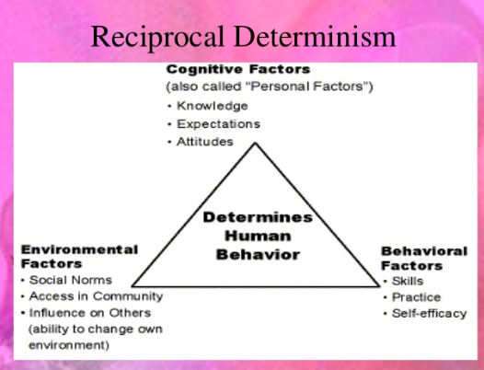
Figure 29: Reciprocal Determination (Slideshare.cdn.com)
Reciprocal Determinism claims that a person’s environment can create changes in them, and that person’s actions can create changes in their surroundings (Bandura, 1978). This theory emphasizes that peoples’ behaviors are not just a reaction as a result of learned reinforcements; their cognitive factors and behaviors affect how they interrelate with their environments. A person’s behavior or actions are a combination of their environment and personal factors that are continually interplaying.
One of CLTs’ objectives is to build social and political capital within the community environment. Social Capital is “social networks and norms of reciprocity and trustworthiness that arise from them….often developed through informal interactions of individuals (Anderson, Blair & Shirk, 2018). Social Capital is “social resources a person can access through contact with others in their social networks.” (National Association of Realtors, 2012). Since social capital empowers groups to voice their needs to government officials through voting, outreach to elected officials/community leaders or other channels results in improved government performance engagement.” Voluntary or civic engagement is a stepping-stone towards building political power; therefore, increased social capital increases policy activism.” Social capital’s strength is in the numbers of residents to influence decision-makers. Political Capital’s strength is in access to decision-makers. Political Capital is a piece of social capital that is discovered via social skills to enable citizens to organize themselves to promote collective goals. The focus is reliant on
organizational clout, where the citizen is a representative of that organization. Moreover, “individual capital focuses on exercising the inner personal power. Political power focuses on both individual and group social relationships” (Anderson, Blair & Shirk 2018). Although CLTs aim to build social and political capital amongst low and middle-income residents, social and political capital is impingent on the stability of a community. (Anderson, Blair & Shirk 2018). Housing mobility influences social capital. Therefore, organizations with fewer people moving out of the neighborhood have higher social capital than organizations with more people moving into the neighborhood.
Consequently, the effects of gentrification may affect social capital and civic engagement as residents move in and out. Low-income residents are less likely to participate in communal activities, primarily if distrust of the government or an organization exists. “Age, race, employment status, and homeownership influence social capital and engagement…however, younger non-White groups have stronger citizen governance, and homeownership is linked to higher levels of collective efficacy” (Anderson, Blair & Shirk 2018).
Neighborhood needs and stability also play a part in the various forms of engagement. Further research should be inquired regarding gentrification combined with the trends and conditions of civic participation. For example, it is suspected that a less stable neighborhood may have more civic participation in basic public amenities. In contrast, a more stable area may have their basic public needs met and may engage in more or higher-level activities like voting, taxes, and education. In general, citizens are more prone to participate in service function industries like zoning/planning, parks, recreation, policing, and community safety but least likely to partake in government staffing issues like hiring or firing, procurement supervision, and budgeting deliberations (Wand, 2001).
Although research indicates that collaboration between government and citizen-driven projects are operationalizable and stable, it remains underutilized (Holzer & Kloby, 2005). Recent trends have shown government attempts and interest to promote more civic engagement. This attempt aligns with the coined term “New Governance,” which is the “creation, execution, and implementation of activities backed by citizens and organizations’ shared goals, who may or may not have formal authority and policing power” (Holzer & Kloby, 2005). However, the responsibility of affordable housing provision and citizen collaboration lingers like a curse word, especially when it comes to determining whether “access to affordable housing” or “affordable housing itself” is a right.
Disagreements arise when housing is perceived as either a community resource or a source of profit; is housing a fundamental right or an economic privilege. Studies show that when an individual is left homeless or cost-burdened, society will inevitably be impacted; therefore, it is indicative of being proactive. Also, foreclosure “impose costs on municipalities due to vacant property demolition, administrative fees, and outstanding or declining property taxes” (Thaden & Rosenberg, n.d.). It cost cities like Chicago $34,199 per foreclosure and Minneapolis and St. Paul almost $27,000 per foreclosure. Periods of economic and population growth leads to sharp unaffordable housing rates; people are displaced at the expense of revitalizing a neighborhood. Also, when funding is scaled back on affordable housing projects, local communities are driven to step-up and push past setbacks by empowering local neighborhoods and providing democratic management of community assets to deliver affordable housing (Jarvis, 2015). Traits of a revitalized locality are “identified as having external connections, quality jobs, visionary leadership, strategic economic and social development, and often missing, power-sharing and thoughtful development of technology.” (Kusimo et al., 1999).
CLT is a multifaceted puzzle of relationships that serves as a vehicle for democratic stewardship at the local level. The CLT distinct self-managed governing design purposely increases interaction amongst neighbors and stakeholders in the community. CLT paves the path for local neighborhoods to build a collaborative governance culture that sustains the benefit of regeneration and development in their locale. This structure creates a breeding ground for the maturation of community organizers, advocates, and economic activities to engage residents in municipal initiatives (Jarvis, 2015). The CLT model enables residents “independent voice to enhance the legitimacy of decision making and improve trust and perceptions of government, seeking ‘power with’ rather than ‘power over.” (Nabatchi & O’Leary, 2005).
According to Mary Parker Follet’s book, The New State, genuine democracy is a mechanism to manage and represent the collective will of all classes in a community; therefore, management is “the art of getting things done through people” (Follett, 1920). In George Hegel’s work, Elements of the Philosophy of Right emphasized that democracy must be inclusive (James, 2017). Studies show that administrators “cannot delegate power. However, they should allow subordinates to develop their power,” permitting citizens to become self-governing in contributing solutions to their neighborhood problems.” This method reduces resentment, advances personal responsibility, and pride in their efforts (Follet, 1918). It goes beyond the Administrative Procedure Act, which requires government agencies to allow the public to provide feedback via written document, data, viewpoints, and arguments to the proposed regulation, a form of community engagement. The CLT goes a step further than traditional rulemaking forums; it gives a level of power or stewardship to the community. A community where residents become a pseudo-staff organization, which enables and promotes personal development and goal attainment. However, accountability is difficult to address with unpaid volunteers due to the belief of some public administrators that citizen engagement goals are unmeasurable, time-consuming, and expensive (Haunt & Feeney, 2016). As a result, administrators direct their energies to more concrete organizational outputs than residential collaboration. Further research should be conducted to determine the extent of motivation for sustainable stewardship accountability amongst CLT residents.
Citizen engagement efforts can be challenging to measure and enforce without support from administrators. An organization can say they tried to incorporate residential feedback but solely post required information for public comments on less-known web platforms that receive little participation.
The organization’s administrative managers and staff culture can be the gatekeepers of residential engagement. They can either create an atmosphere of engaging residents or hinder the process. The public-service manager's role is critical in developing a smooth operation of collaboration. The Public Service Motivating (PSM) model establishes that the more Intrinsic qualities a manager have, the more likely they are to welcome the cooperation (Haung & Feeney, 2016). Also, if an organization’s culture and missions share similar beliefs and values as the employee, it will influence that employee's intrinsic motivators making them more effective at involving citizens in decision-making. This “person-organization fit” value systems alignment is what keeps retention and motivation to implement the agency mission. The PSM consists of two factors Extrinsic and Intrinsic traits that can motivate an individual. Extrinsic factors are rewards/incentives given to an individual to persuade a behavioral change. Whereas Intrinsic factors are inherent characteristics of an individual that guides their behavior, it is "participating in an activity for inherent interest and joy." Managers with higher PSM are attracted to public service duties due to altruistic reasons (Haung & Feeney, 2016).
Some administrators/staff are stirred by a glut of social benefits like recognition, praise, feelings of accomplishment, belonging, and pride in their work. Administrators, whether public or non-profit managers, do not work on an island alone; their support staff is essential to residential engagement. However, barriers exist within the team in areas of inadequate training and skills for “Activation or the skill to get collaboration/network participation, Orchestration or using persuasive skills to get participation, and Modulation skills or use of rewards or incentives.” Also, administrators’ posture towards residential engagement. Residential engagement frequently bumps heads with “specialized, routine-orientated, hierarchical, and impersonal government bureaucracy.” (Haung & Feeney, 2016).
Studies revealed organizations lack in releasing performance data was due to staff reluctance in being accountable to the public. Public managers who are more open to residential involvement tend to have a master’s degree in Public Administration, be a member of a professional organization/network, be employed in a simplistic politically stable workplace, and have an optimistic attitude toward citizen engagement. On the contrary, managers who deter residential contributions tend to have a Bureaucratic Indifference personality. These negative professional experiences formed their reluctance to residential inclusion and preferred to maximize institutional power where they utilize formal administrative decision-making methods over residential collaboration. According to Zhang and Yang perspective models, administrators who fall in the below categories can have a negative or positive effect on citizen engagement (Zhang & Yang, 2009):
- Citizen Leadership - has a positive impact on citizen participation. Managers in this category are considered modernizers or public entrepreneurs. These individuals look for opportunities to try out social experiments using scientific management tools. Therefore, they are more likely to promote citizen engagement.
- Technocratic Expert – has a negative impact on citizen participation. These managers have friction between their expert knowledge and the democratic governance of including non-experts (citizens) in decision-making. Therefore, expert recommendations tend to overtake the participatory processes.
- Bureaucratic Indifference – in this category, city managers’ attitudes and actions are formed by their professional experience. In the budget process, they tend to lean away from including citizens due to their inability and reluctance.
Barriers to residential engagement also include internal employee interaction and external collaboration with agencies coupled with irrational external and internal politics. A modern hindrance to residential participation is due in part to the belief that direct residential engagement can be ineffective and insufficient, reinforcing the Technocratic Expert model. Larger bureaucratic government agencies or organizations can create stagnate residential engagement leaving those involved apathetic or grappling for power (Zhang & Yang, 2009). Human relations are essential in implementing the protocols of training staff, dealing with their requests/needs and conflicts, and fostering an atmosphere in the workplace that promotes unity. The Human Relation Theory emphasizes that relationships amongst managers and staff are critical in any workplace (Fredrickson, 2012). Furthermore, the extent to which the staff is motivated is crucial in elevating or sustaining productivity and pushing past barriers to residential participation. Achieving group acceptance by staff is a motivating strategy of this theory.
Moreover, when you look at Human Resource Theories, it explains how the behavior of Public Service Managers as well their leadership style can adversely or positively impact staff behavior (Fredrickson, 2012). Therefore, if a manager has doubts or is hostile toward the concept of residential engagement, it will be challenging to implement strategies to promote it even when a legal mandate exists. How administrators view residential participation can be aligned with the controversial Group Threat Theory, which states that when there is a larger external group (residents), and the more the ingroup (Public-managers/staff) perceives them as a threat to the agency agenda/mission, will leave the administrators with more unfavorable attitudes to the external group or residents (Schlueter & Scheepers, 2010). Therefore, the CLT organization's perceptions and efforts toward residential participation are critical.
In CLTs, participation and motivation are essential traits that exist on a continuum but varying amongst residents where one household is building their unit; another is self-organizing a neighborhood group to create communal amenities; whereas another forms a resident-led development charged with expanding social housing (Jarvis, 2015).
CLT’s robust efforts in community empowerment and democratic overseer make it a favorable engagement platform amongst the locals as well as enhances its governing body (Moore & McKee, 2012). Although studies indicate that CLTs’ tri-part governing board structure makes it fruitful in providing and maintaining affordable units, a gap still exists in comprehending the managing practices and interrelationships amongst local government, residents, and community members (Davis & Stokes, 2009). The collaboration of CLT’s agenda items calls for future inquiry since CLT civic engagements rely on volunteers to have time, motivation, willingness, and skills, which may not be equally disseminated, thus, restricting the democratic process to secure approvals on community projects (Moore & McKee, 2012). Like many things in life, time can be at the core of decision-making. Many residents struggle to allocate time to civically engaged, leaving them to believe it just does not fit into their daily schedule easily. This dilemma can lead to unequal participation since available citizens who may attend more events get to voice their agenda more. Furthermore, this type of involvement sets the stage for the cyclical pattern of non-participation, potentially impacting their next generation to get involved in community politics since no chronic intrinsic foundation was formed.
As a result of CLT’s unpredictable unavailable volunteer labor, many CLTs have acquired assistance from local housing associations to access grants, guide expensive development activities, and continuous supervision of CLT units. For instance, Seattle community planning fosters a culture of collaboration that includes calculated democratic forums, mutual accountability, progressive asset-based neighborhood efforts, methodical inter-relational structuring that spans to various stakeholders. Stakeholders included neighborhood councilpersons, commercial entities, nonprofits, government organizations, and other community partnerships (Siriani, 2007). The government uses more public hearings, advisory boards, community meetings, and town halls to reach out to the public. However, current trends show internet communication is being utilized the most. Technological advances, like social media, have enabled administrators to engage in larger populations easily (Wang, 2001).
Not all CLTs models are designed the same. Research indicates that some CLTs work in partnership with residents, where residents are deeply involved in the organization and governance processes. Whereas in other CLT models, the CLT is only a front or Symbolic Use (tactic administrators use to demonstrate interest; however, they have no intention of implementing) to obtain affordable land (Alkin & King, 2017). Hence, land control is the real goal, not community engagement. The CLTs’ leadership, coupled with residential and community involvement efforts and extent, determines the purposes for community land control and engagement (Thaden & Lowe, 2014). CLTs focused on community buy-in must also confront the woes that indigenous and new-coming residents may not want a CLT or more affordable housing programs in their communities, especially those in the higher-income brackets, including homeowners. Homeowners tend to be more invested in their communities. As a result, homeowners can create residential segregation by working to keep certain people and land use from invading their communities, hindering specific subpopulations from becoming homeowners (McCabe, 2016). Buy-in from oppressors of affordable housing programs and mixed-income neighborhoods enables the sustainability of low-income affordable homeownership opportunities in these areas. Getting buy-in is critical to keeping all income level residents in the communities; if higher-income residents leave, resources and businesses may follow, impacting the city’s economy. The Useful Community Development website suggested that benefits do exist for higher-income residents when neighborhoods are income mixed (Useful Community Development, n.d.). Middle-class individuals can learn how the woes of life created the poverty-stricken demise and the decisions that cause the increasing financial status of wealthier individuals.
Moreover, the idea of living up to your neighbor’s standards causing unnecessary increased debt can be mitigated when space is made for low-, and all-income residents as people value what they already have when they see others who lack resources and access. Also, the focus of shared experiences within a community distracts from obsessive materialistic pursuits (Useful Community Development, n.d.). Furthermore, the site goes on to say:
“As a wealthy individual living in a gated community in seclusion with others who also are in the highest tax bracket, they lose the opportunity to be of service in a democratic society, to model how restrained and noble wealth really can be, and to gain an appreciative audience” (Useful Community Development, n.d.).
Also, a study using 1,807 US adults concluded that (Roy, Godfrey & Rarick, 2016):
“High-income individuals living in low-income neighborhoods report higher subjective social status (relative to neighbors), whereas low-income individuals living in high-income neighborhoods (i.e., relative disadvantage) also reported higher subjective social status” (Roy, Godfrey & Rarick, 2016).
Many lower-income residents just want to stay, thrive, and be an asset in their community. Since roadblocks to residential engagement are also seen from the citizen side, further research should be conducted on getting buy-in from wealthier residents, especially those more actively engaged in local politics, to advocate and welcome mixed-income neighborhoods. For example, citizens who are active in community politics may be a small number of residents who lobby or advocate for their gain (Bingham, Nabatchi & O’Leary, 2005). Those who attend town hall meetings with elected officials can monopolize the sessions and over talk those who are less vocal but have legitimate concerns that affect the majority. This lopsided citizen engagement can exclude marginalized and disadvantaged populations. The research revealed that active, civically engaged residents are more likely to participate in future civic affairs deemed vital to them. As a result of those more vocally civically engaged, more attention is given to specific issues in their communities than others, where it may be needed (Wang, 2001; Haung & Feeney, 2016).
CLT engagement efforts must also be mindful of both its temporal climate and local socio-political environments in which it is birthed and how the broader and local politics are evolving to achieve sustainable objectives. According to Weir's 1999 classification of organizations’ political environment, CLTs can operate in either Elite-dominated, Patronage-Back, or Inclusive-Driven areas (Thaden & Lowe, 2014). Although not all CLTs fit in Weir's classification, it can be taken into consideration. The Elite-dominated area does not have background experience in community organizing, so it is unable to link the community organization to power. They are prone to stay small in scope (size) and scale (location). The Patronage-Back area has a little more historical experience in community organizing than the Elite-dominated areas. The Patronage-Back area tends to operate under the influence of local political figures who provide resources to the CLT benign or harmless activities, consciously controlling the CLT’s actions. The Inclusive-Driven areas enable CLTs the opportunities to independently be in control outside the political establishment, making this the ideal environment since the political establishment values community organizations, which allows them to partake in influential networks and resources” (Thaden & Lowe, 2014). CLTs also strive to partner with the government, non-CLT community members, and community organizations. A study by Lowe and Thaden, shown in Figure 30, revealed Weir classifications of sustained US CLTs-city partnerships. Vermont’s Champlain Housing Trust (the largest CLT) and Boston’s Dudley Street Neighborhood Initiative (smaller CLT) both operate in an ideal Inclusive-Driven territory. Whereas the other states listed are not. Vermont and Boston both have larger memberships at 5,000 participants compared to the other CLTs.
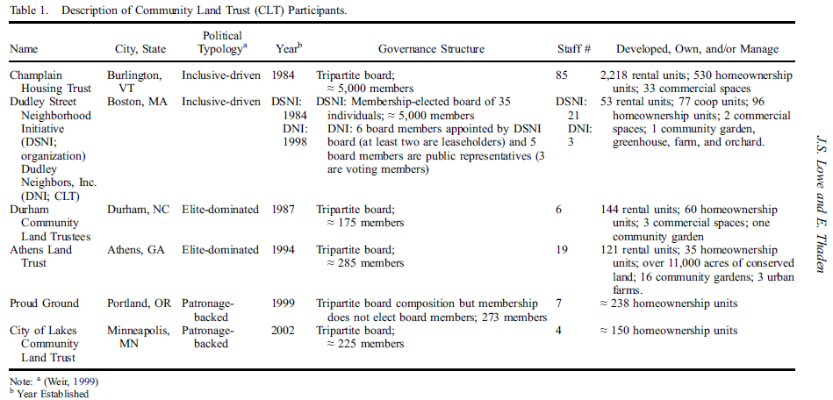
Figure 30: Weir Classification of US CLTs
Having a large, robust active membership helps to build social and political capital; there is power in the number of members, which aids access to politicians. However, not everyone is on the same level in embracing the complex, innovative CLT model. Targeted recruitment and partnership play a part in program uptake according to the Diffusion of Innovation (DOI) model (Dearing, 2009). The DOI theory was established in 1962 by EM Rogers to explain how an innovative idea or product gains momentum and spreads through a specific population or social system over time. Within this theory, which has two aspects (“Diffusion of Innovation Theory,” 2019): (1) the Adoption Process, and (2) Adopters or Innovators role. The Innovation Adoption has 5 phases, (1) Knowledge, (2) Persuasion, (3) Decision, (4) Implementation, and (5) Confirmation. (1) The Knowledge phase is when a potential adopter initially encounters the innovation but is unsure of what it is and wants to know more. (2) The Persuasion phase is where the potential adopter pursues further knowledge and information about the innovation. (3) The Decision phase is where the adopter decides to adopt or drop the design or is still waiting to decide. (4) The Implementation phase is where the adopter chooses to pilot-test the invention to determine its merit and worth. Merit and worth are the program’s quality to be expanded to other areas and the ratio of the program impacts, whether it adds value to the greater good versus the cost and its net benefits ability to outdo alternative solutions. The last phase (5) Confirmation is where the adopter believes in the innovation and continues support (Patton, 2011; “Diffusion of Innovation Theory,” 2019).
As for Adopters or Innovators role, “they are classified into the following five groups:
- Innovators - people who want to be the first to try the innovation, love new ideas, do not mind risks. Not much effort needed to persuade
- Early Adopters: the people who represent the opinion leaders. They enjoy leadership roles and embrace change opportunities. They are already aware of the need to change and so are very comfortable adopting new ideas. They do not need the information to convince them to change, but they need how-to manuals and information sheets on implementation
- Early majority –people who are leaders rarely adopt new ideas before the average person. They need evidence of success before they participate. They need success stories and proof of the innovation’s effectiveness
- Late majority – people who are skeptical of change and will only adopt an innovation after the majority has tried it. They need information on how many other people have tried the innovation and have adopted it successfully.
- Laggards - people who are bound by tradition and very conservative. They are very skeptical of change and are the most challenging group to bring on board. They need statistics, fear appeals, and pressure from people in the other adopter groups.
According to DOI, the percentage of people in these roles is spread across a bell curve as seen in figure 31 below.

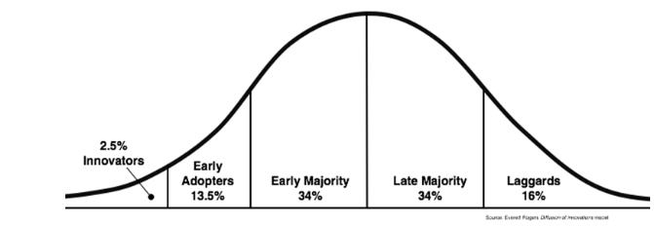
Figure 31: DOI Distribution of Acceptance across Adopters (“Diffusion of Innovation Theory,” 2019).

Working Conceptual Framework:
The National Academy of Public Administration defines Social Equity as:
“The fair, just, and equitable management of all institutions serving the public directly or by contract; and the fair and equitable distribution of public services, and implementation of public policy; and the commitment to promote fairness, justice, and equity in the formation of public policy.”
During the 1960s, civil rights and racial inequity grasped national interest; Social Equity gained attention in the public administration field (Frederickson, 1990). In 1968, H. George Frederickson coined Social Equity Theory as a pillar of public administration. Frederickson wanted to persuade public administrators that social and economic conditions impact citizens differently, emphasizing that citizens are not the same. The CLT model acknowledges the social and economic housing conditions facing city residents differ, therefore the CLT enables perpetuity equity in land control and utilizing a collaborative, democratic platform in which those who are disadvantaged are heard, leveling the playing field. The CLT is a representative of a collaborative network that functions as a platform for community and organizational participation in addressing the affordable housing shortage.
CLTs are mixed ownership and housing rental model that promotes equity allocation by delivering affordable housing that empowers local neighborhoods to operate as a democratic manager of neighborhood assets under a shared-power leadership. CLT seeks to address local housing concerns in which residents are directly involved with collaborating with organizations to shape their neighborhoods and live in alignment with social values and affairs. CLT adds to social wage and retards the adverse effects of gentrification. In a CLT operation, the CLT owns the land, and the resident owns or rents a home on that land; this separation enables a reduction in cost to the resident. Collective ownership and shared power amongst the local community can create an environment of cultural, social, economic, and material innovations (Sargisson, 2010). The CLT focuses on Social Equity theory’s Distributional Equity. According to the National Academy of Public Administration, Distributional Equity involves fostering a commitment to provide resources, equal access, and targeted intervention, such as when efforts attempt to correct wrongs and reduce risk factors for historically underserved groups. This literature review and research serve as a perpetuation of Social Equity as a pillar of public administration in policy and practice as it relates to affordable housing provision. Social Equity theory explains DC’s Community Land Trust model efforts to provide housing opportunities to marginalized residents. Also, it aids in understanding the following five data-driven influential factors affecting the early start-up of Douglass Community Land Trust (DCLT): (1) Policy Interpretation, (2) Community Land Control, (3) Preliminary Resident Engagement/ Leadership Fostering, (4) DCLT Structure/Capacity, and (5) Collaboration Dynamics.

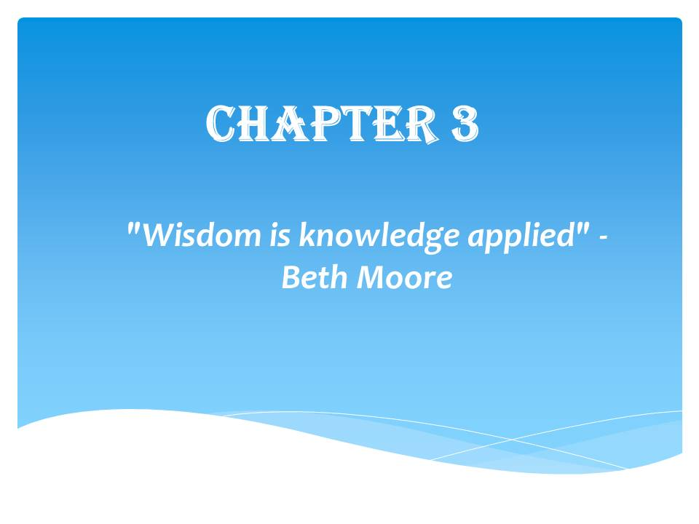

Chapter 3: Methodology

Methodology Terse Outline:
Part 1: What Counts for Evidence of Data:
- DC Community leaders, residents, and stakeholders’ input
- Demographic Data
- Social-economic data
- Congressional meeting/legislative/District/DCLT records

Part 2: How Do I Pursue or Collect Data.
- ANC/City council meetings
- Multiple search engines, which included the University of Baltimore online Robert L. Bogomolny Library, Public Administration Review, Scopus, Google, Google Scholar, Census Bureau, Web of Science, DC government websites, Library of Congress, relevant textbooks/books, and non-profit organization websites.
- DCLT stakeholders, Community leaders' and residents' interviews/focus groups
- Institutional data provided
- Institutional stakeholders - how they are collaborating during early CLT implementation). Determine/compare efforts according to what they articulate as their metrics and are they fulfilling their goals according to them
Research Question: What are the Factors affecting Douglass Community Land Trust Start-up Phase?

Investigation Context:
This research incorporated a Case Study and an extensive literature review to gain insight regarding the status and factors affecting DC's Douglass Community Land Trust (DCLT) start-up. The literature review focused on collecting quantitative/qualitative descriptive research on Community Land Trusts (CLTs), the factors leading up to DC's incorporation of a CLT, and the common factors affecting a CLT. Data collection also concentrated on DC's multi-faceted historical and current economic status as it relates to affordable housing. It helped determine "what is" happening in DC affordable housing and described DC's past and present experiences with affordable housing to help understand or connect the factors affecting DCLT start-up. The qualitative Case Study questions focused on five data-driven influential factors affecting the early start-up of DCLT: (1) Policy Interpretation, (2) Community Land Control, (3) Preliminary Resident Engagement/ Leadership Fostering, (4) DCLT Structure/Capacity, and (5) Collaboration Dynamics. This study assessed the DCLT start-up factors' strengths and weaknesses and explored program activities' connections to outcomes. It incorporated multi-level DCLT stakeholders, staff, Board members, and the targeted participants' attitudes/perceptions through focus groups to better understand any missional responsibilities, goals, or outcomes. Focus groups' data collection for this research context was ideal in that it enables quicker data collection than separate interviews. Moreover, it facilitates interactions between the researcher and participants, asks in-depth and follow-up questions making it easier for audience comprehension than complex statistical data, and allows ascertaining information from non-verbal cues like body language or facial expressions.
This research utilized a mixed-methods descriptive approach using both qualitative and quantitative data. This approach enabled wide-ranging data collection to describe the nature of the demographic segment. The Quantitative descriptive portion aided in describing the current status and providing systematic background information on the topic. The Qualitative portion helped to obtain and understand the attitudes, perceptions, in-depth insight from staff/stakeholders, participants, and the literature review/agency records regarding the DCLT. A portion of the secondary research data came from the DCLT agency records and public District of Columbia (DC) data on the DCLT. Primary data collected was from interviews, focus groups, and attendance at government forums. This Case Study used a purposive and convenience sampling to obtain a sample of the DCLT's Board, Staff, and DCLT Stakeholders. This sampling was ideal and feasible to get rapid detailed diverse viewpoints of all those knowledgeable or unaware of the DCLT program.

Data and sample:
This study used a combination of purposive and convenience sampling to obtain a representative sample of DCLT stakeholders. Emails were sent from November 2019 to March 2020 to DCLT 15-member Board and staff, Ward 8A and 8C ANCs, Grounded Solutions' Chief Executive Officer, BBAR non-profit, DC's Department of Housing and Community Development senior housing advisor, and the DC Mayor’s Office to conduct interviews. 65 DC residents who attended the forums were asked to participate in the CLT semi-structured questionnaire. The goal for this heterogeneous purposive sampling was to obtain tremendous insight into the DCLT start-up factors. This type of selection is ideal to quickly obtain diverse viewpoints of targeted portions for all those knowledgeable about DCLT. The sample subjects who agreed to participate in the study were DCLT's only two staff (Executive Director and Director of Organizing/Governance), 5 Board Members and the Chair, Ward 8 ANC Chair, Director of 11th Street Bridge Park project, BBAR’s Equitable Development Manager, and 30 citywide DC resident attending two ANC meetings and the 2020 Mayoral Conversations on Housing. DCLT is in its early stages of forming into a separate non-profit where its current housing portfolio is transitioning out from its parent entity; they are still formulating their portfolio participants. Due to this transition, there were no available DCLT residents to participate in the study. Instead, 30 DC residents participated, who were randomly asked outside DC's ANC's and Mayoral Housing forum to answer some questions on their knowledge on DCLT or CLTs in general and their views on the disadvantages and advantages of a CLT. The focus group participants were DCLT Staff and Board; the demographics recorded were Ethnicity, Employment, Gender, DCLT Volunteer hours, household income, residing in Ward 8, Age, Head of Household, marital status, and Educational Level (Please see Appendix C for questions)

Qualitative Design:
Data were extracted and triangulated from literature reviews, DCLT Program agency records, interviews, DC’s public data, and public records related to DCLT stakeholders. Microsoft Excel and Word were utilized to organize the data. Several worksheets were used in one workbook; each spreadsheet was labeled with one research topic. The headings listed were CLT elements, CLT Barriers, Citizen Engagement, Empowering Community, DC Demographics, DC CLT Policy, Economic Mobility, Theoretical Framework, and DCLT Online Information. Articles were organized by related themes and emerging subthemes with the article titles. To remain up-to-date and accurate, data collected regarding the DCLT target population demographics did not exceed before 2010, although data tracking trends were earlier than 2000.
DCLT Program Staff: Qualitative Portion: The two focus groups were conducted two weeks apart. The first focus group had four DCLT Board members and staff participate. The second focus group had three DCLT Board members and staff. Follow-up phone calls were conducted throughout to clarify responses. A total of five interviews were conducted; participants were DCLT staff, BBAR staff, and DHCD staff. Thirty (30) DC residents participated in answering CLT/DCLT related questions. Participants in the focus group and interviews were given a $10 cash stipend. All interviews, questions, and follow-ups were conducted from the Fall of 2019 - May 2020. It was limited to a small number of subjects connected with DCLT due to interviewing and following data analysis time constraints.
Measurement tools: semi-structured interviews, DCLT agency records, focus groups, and follow-ups implemented were via phone/in-person. The Data Collection Types and Factors Matrix table below aided in the decision to opt for the best option for collecting data regarding the DCLT start-up factors. In the Measurement Tool Matrix chart below, the measurement tools used in this study were selected based on an amalgam of cost, speed, response rates, diversity, level of detail, stakeholder input, and accuracy.
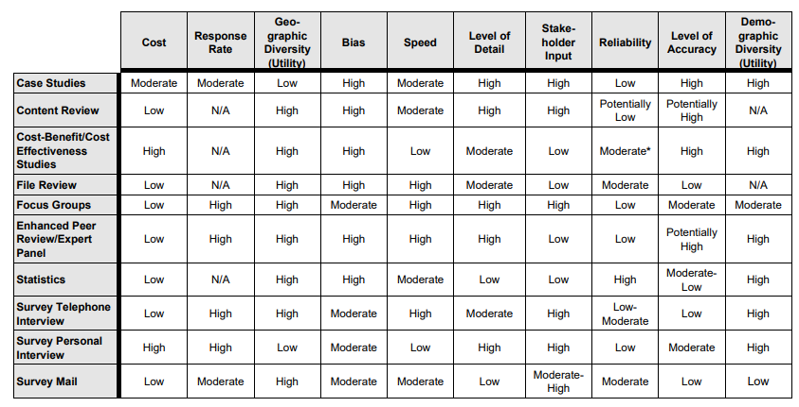
Figure 32: Measurement Tool Matrix

Research Design and Procedures:
The Case Study, the core of the research, followed a qualitative research approach in 3 stages, which overlapped in practice that deeply explored DCLT start-up factors. Figure 33 below shows the steps: The Preliminary Descriptive examination stage, which utilized wide-ranging qualitative and quantitative data to describe the research phenomenon, then transition to the Exploratory phase, which focused on investigating and understanding the factors to then the Explanatory phase, which explained the factors affecting DCLT in a detailed manner. However, all steps were multi-directionally interacting continuously.
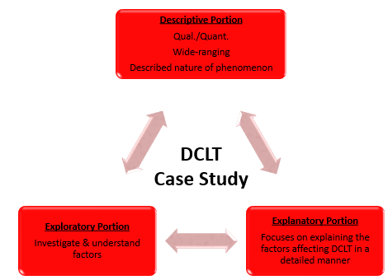
Figure 33: Research Three Interactive Stages
The stages encompassed the use of semi-structured interviews/focus groups as the primary method, an extensive desk-based literature review, the attendance of two ANC's meetings, the 2020 Mayoral Conservation on Housing forum, and an in-depth data analysis. Also, the research findings enabled the production of what I like to call DocuTUTORIAL DocuSPIRE documentary called ‘Community to Care (CtC): My Dissertation Journey to Understanding Washington DC’s Community Land Trust Factors.” Overall, research methods used in this study included: primary/secondary, purposive and convenience sampling, semi-structured interviews, and systematic/concurrent data collection and analysis procedures from 2018 to 2020.
Within the exploratory phase, data collected was on the DCLT project context: Setting, Social, Cultural, Legal, and Physical Environments. Then transitioned to an explanatory and interpretive phase that aided in understanding overall factors affecting DCLT's start-up. It helped in learning whether DCLT non-quantifiable merit and worth is a viable, affordable housing solution that incorporates social inclusion and upward mobility amongst its participants. According to research, CLTs implementation, and goal attainment are influenced by Policy Interpretation, Community Land Control, Resident Engagement/ Leadership Fostering, CLT Capacity/Structure, and Collaboration dynamics.
This qualitative primary data collection on the factors surrounding the DCLT start-up used semi-structured interviews/focus groups as the primary research approach that began in the Fall of 2019 and ended in June 2020. The exploratory round of questions revolved around the strengths and weaknesses of DCLT start-up organizational structures and practices affecting the Douglass Community Land Trust to govern, manage, and oversee land in a way that furthers its mission. The questions focused on five data-driven influential factors Policy Interpretation, Community Land Control, Preliminary Early Resident Engagement/ Leadership Fostering, CLT Capacity/Structure, Collaboration Dynamics. The following additional unstructured questions were grouped according to the 5 data-driven influential factors: What is your CLT vision, and how are you operationalizing it into a criterion to monitor what you are doing? What do you see as the metrics determining that? What and where are the bottlenecks and strengths in DCLT implementation that can affect operations? (Please see Appendix D for interview questions).
There were 41 interviews, and necessary follow-up interviews conducted during the Fall 2019 to Spring 2020 academic year. Data analysis of the initial exploratory interviews was conducted to obtain a preliminary understanding of the findings. Follow-up interviews were conducted to clarify initial interview responses as well as gain in-depth revelation of identified patterns.
All interviews and focus groups were video recorded and tape-recorded. Questions were pilot tested before the focus group session using a smaller similar population demographics to minimize confusion with the language and prevent cultural incompetence.
The interviews/focus group questions were informal and open-ended and carried out in a conversational style ranging for two hours. All participants were given Informed Consent paperwork to be signed (Please see Appendix A for form). Lunch was provided. Field notes and pictures were obtained along with the focus group, interviews, follow-up interviews, and observations for my documentary portion.
On the day of the focus group session, participants were welcomed and prompted to sign an informed consent form. They were reminded of the group's confidentiality and anonymity. To encourage active dialogue, they were advised of the importance of their answers and how useful and appreciated they are in the research. They were also told there are no wrong or right answers and to respect one another opinions. Participants were informed that the role of the facilitator (researcher) was just to record their views and beliefs. Therefore, no advice or ideas will be given by the facilitator. They were all given a blank card in case they choose to write their answers down instead of talking. They were thanked again and reminded that a tape recorder and video recording would be used to keep the flow of the discussion going smoothly.
Limitations: The following are the limitation for this study: Small sample population, selection bias, DC unique political and economic structure, and limited timeframe/funding for research. Findings may benefit other DC wards but not necessarily generalizable to other states. However, findings align with literature data. Studies indicate that although focus groups provide an exceptional level of detail, groupthink, monopolist, and moderator facilitation skills can skew the responses. Groupthink occurs when people’s desire to maintain group loyalty becomes more important than making the best choices. People often find it hard to think and act independently in group situations. A monopolist is someone who talks most in a focus group, not allowing others to voice their opinion. Another limitation is selection bias since participants volunteered and were not randomly chosen. Participants’ motivational levels, values, and other inherent traits may differ from than DCLT targeted population. However, the majority of the two focus groups were unpaid Board members who live in the community who openly and confidently stated the factors good and bad affecting DCLT start-up. Each participant contributed diverse, in-depth details. This research will provide informative new depth to CLTs start-ups in the literature data.

Data Analysis: SWOT AND SOAR MODEL:
Data analysis was on-going throughout the study. Data collection was protected and stored electronically in a home computer file and cabinet. The video and tape-recorded interviews analysis included color-coded memoranda notes and themes. NVivo, a software program that uses a coding system organized around different topics and themes, was utilized to transcribe audio recordings into text. Recordings were also transcribed manually multiple times to ensure correct interpretation. The documentary editor was also given a transcriptionist confidentiality consent form to transcribe redacted audio recordings for the film (Please see Appendix B for the way).
The following four processes were utilized for the meta-synthesis of the qualitative portion:
- Define the purpose and research question
- Conducted relevant literature review
- Utilization of the Inductive and Deductive method to group the findings’ themes. After data collection data was carefully reread three times for initial comprehension, coding/theme development, and final grounded coding. Reviewal of articles, their relative frequency in the body of data, and their relationship to the theoretical framework.
- Developed and applied an inclusionary criterion for articles.
The interviewees' insights and stories aided in understanding the complexities of the DCLT start-up phase in DC. The emerging themes from the process were organized into a chart, but the most prominent themes are detailed in the Discussion section. This extensive data collection creates opportunities for future in-depth studies into a specific theme.
To organize and analyze the data, the Strengths, Weaknesses, Opportunities, and Threats (SWOT) model was combined with the Strengths, Opportunities, Aspirations, and Results (SOAR) model to create Strengths, Weaknesses, Opportunities, And Threats + Aspirations and Results (SWOT + AR) model. A SWOT+AR matrix was applied to identify DCLT Strengths (within the organization), Weaknesses (within the organization), Opportunities (outside the organization), Threats (outside the organization), Aspirations, and Results to the different factors affecting DCLT start-up.

Table 4
SWOT + AR Model
SWOT+AR
Positive  Present  Negative | Internal Factors | External Factors
Positive  Present  Negative | Strengths  Greatest internal strengths along with critical assets, resources, capabilities, and accomplishments | Opportunities  Circumstances that could be leveraged for success from the outside
Positive  Present  Negative | Weaknesses  Internal processes needing improvements | Threats  Obstacles that can negatively affect the organization from the outside
Future  Goals | Aspirations  What is the preferred future?  What you want to be and achieve in the future? | Results  Tangible outcomes and measures

SWOT can be utilized as an analysis tool to help understand the internal and external elements affecting an organization. SWOT is more of a diagnosis and data capturing tool. Its primary objective is to help develop a full awareness of all the factors involved in an organization's daily operations and decision-making. SWOT analysis stimulates conversations to highlight the weaknesses needing improvements (Renault, 2017).
SOAR is similar to SWOT, except it focuses more on the possibilities of an organization and is more forward-looking. Plus, SOAR is an ideal tool for start-ups or young, less developed organizations that may not have identified their weaknesses or threats. SOAR is skewed towards what an organization can do and may miss the areas the organization should avoid (Cole, Cox, & Stavros, 2019). Combining both models enables a holistic data capturing approach.
Also, SWOT + AR makes the extensive wide-ranging data in this research more visually digestible and retainable. Studies show that using multiple strategies of reading comprehension involves more than reading words but includes the use of charts, illustrations, examples, diagrams, and timelines.
The following analytical Chapter 4 is divided into two parts. Part I will recap DCLT’s organizational preconception to its birth. Next, Part II will shift into describing and expressing the categorized pre-determined five data-driven influential factors (1) Policy Interpretation, (2) Community Land Control, (3) Preliminary Early Resident Engagement/ Leadership Fostering, (4) CLT Capacity/Structure, (5) Collaboration Dynamics. Analysis of these factors was conducted through the SWOT-AR framework. Immediately following each factor’s analysis will be a discussion. Finally, Chapter 5 ends with the conclusion and recommendations.

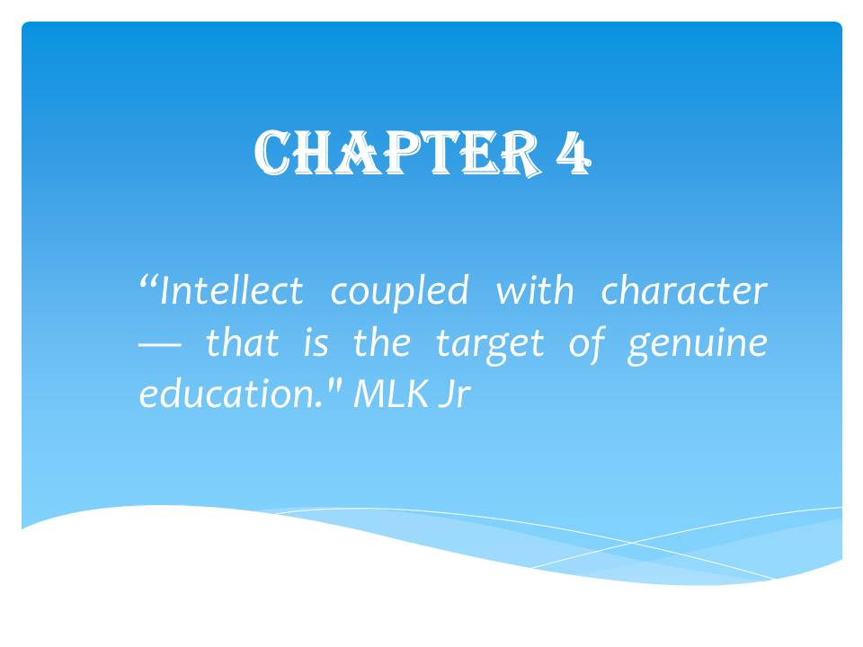

CHAPTER 4: Research Analysis

Part I: From Idea to Launch
Although previously mentioned, Figure 34 serves as a reminder of how CLTs are commonly structured and operate: A group of community members works together to form a non-profit organization. The non-profit buys and owns the land forever, but it rents or sells the physical property at an affordable price to low- and middle-income residents. The residents who purchase the property agree that if they decide to sell, it will be at a precalculated affordable price for the next low- and middle-income residents. The CLT is comprised of a tri-part Board (Residents, Public, Experts) and Members (anyone connected to or living within the CLT service area) who govern CLT activities.
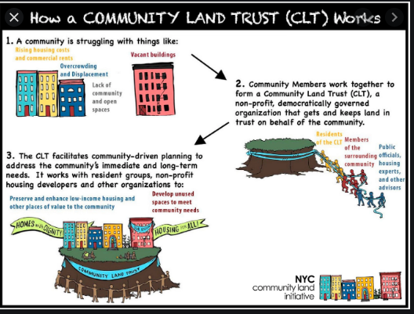
Figure 34: CLT Structure and Operation (Community Land Trust, 2018)
To better understand DCLT’s current status is to know its birthing pains. As mentioned earlier, DCLT was incorporated in the Building Bridges Across the River (BBAR’s) Equity Development Plan for the 11th Street Bridge repurpose park project as an additional mechanism to prevent displacement of local Ward 8 residents.
According to Scott Kratz, BBAR’s Vice President and Director of the 11th St Bridge Park Project, since 2012 the 11th St Bridge Park Project original discussions began with DC’s Office of Planning. Kratz recalled first being approached in 2011/2012 by the DC Office of Planning then-director Harriet Tregoning while he was working as Vice President of Education at DC’s National Building Museum. Katz was asked to help transform the old 11th Street Bridge with the broader idea of bridging wealthy Ward 6 and underinvested Ward 8 together. Figure 35 shows data collected by BBAR of the stark differences between the Wards the 11th Street Bridge connects. East of the River, Wards 7 and 8, has higher child poverty, unemployment, and lower home values when compared to Ward 6 West of the River. These homes east of the river are currently perceived as gold mines, attracting investors to flock to the area since the home values are the lowest in the City but are predicted to go up in value.
Table 5
Demographic Comparison East vs. West of 11th Street Bridge (“11th Street Bridge Park”, 2018)
 | East of the River surrounding 11st Bridge | West of the River surrounding 11st Bridge
Population | 22,622 | 24,335
Race (Black, non-Hispanic Residents) | 92.4% | 23.4%
Unemployment | 15.9% | 5.3%
Child Poverty | 49.2% | 15.7%
Renter-occupied Units | 74.4% | 53.9%
Median Value of Owner-Occupied Housing | $329,500 | $777,000
2017 Median Sales Price (Single Family Units)
All of DC - $692,000
Neighborhoods East of the River (Wards 7, 8) - $335,000
Neighborhoods West of the River - $910,00

The revitalization of the 11th Street Bridge Park shadows the urban transformational momentum other cities across the U.S. have been implementing as a community development initiative. Kratz stated,” there are 60 of these park projects around the country that are similar. Turning old infrastructures into parks.” Included in the 11th Street Bridge Park initiative was the goal to break historically conceptualized walls the river surrounding this bridge created; according to Kratz:
“The goal that most viscerally connects with residents is this river (Anacostia River) has been a dividing line for generations. So how do we create a physical and metaphorical bridge” (S. Kratz, personal communication, January 29, 2020)
Kratz being an active, civically engaged Southeast (SE) DC resident agreed to be part of exploring the 11th St Bridge Park project with the intent that the Bridge design is genuinely community-led and not symbolically. Symbolically meaning organizations or government agencies make advance plans that they later sell to the community with the facade as a community-driven project. Kratz emphasized community-collaboration as his driving force into the long journey of engaging Ward 6 and 8 residents, key stakeholders, agencies, non-profits, churches, civic leaders, and small businesses residing around the Bridge Park project. He sought to get collective input on whether the community wanted this park project, the community needs, and resources. Figure 35 shows a map of BBAR's targeted outreach target area in DC’s Ward 6 above the Anacostia River and Ward 8 below the river (BBAR, 2018).
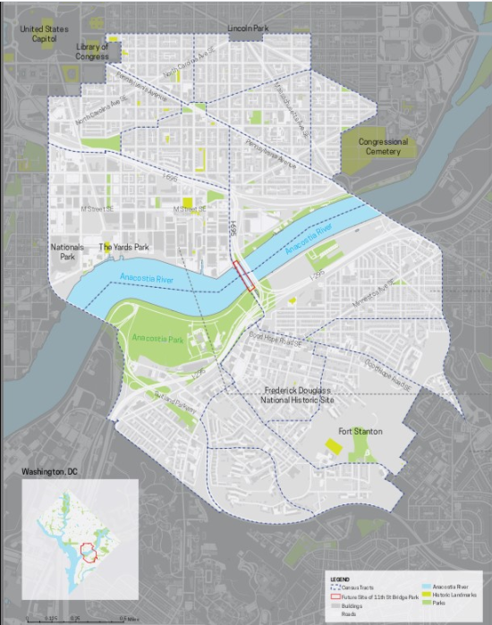
11th St. Bridge Park
Ward 8
Ward 6
Figure 35: BBAR’s Outreach Areas
The critical concept that came out of all BBAR’s outreach efforts was equity; the success of this bridge project was its ability to be inclusive of residents in the area. Kratz understood from attending civic engagement meetings that over a billion dollars of investments are coming to the river. To get a hold on equity, plans need to be formulating years ahead. As a result, from the long nights of volunteering and due diligence in hearing the community’s voice on the project, Kratz became an official employee of BBAR, which is a Ward 8 community-based non-profit that will oversee the Bridge Park project.
BBAR partnered with the active Local Initiative Support Corporation (LISC), a 30-year established community development financial institution that invests in affordable housing and workforce (“Who we are,” n.d.). According to Kratz, through the collaborations with LISC, an Equitable Development Task subcommittee made up of BBAR employees, LISC staff, Urban Institute senior scholars, DC Fiscal Policy Institute, a local think tank, and the DC Office of Planning was formed. With the subcommittee in place and BBAR staff of two, data-collection was geographically contained within a 1-mile radius of the Bridge project since anything more extensive was not feasible with the limited human resources. Collaborative meetings and forums with the community and key stakeholders like Kymone Freeman, a current DCLT Board member and an award winner radio recipient for Anacostia Map documentary, led to the emergence of a Community Land Trust (CLT) as a partial remedy for affordable housing and displacement prevention. According to Freeman, he was given a book on Community Land Trust by his documentary producer. Freeman emphasized when individuals are asked what should be done to improve the issue,
“activists and people, in general, are very clear on what they’re against but not as clear on what they are for, so when Scott Kratz asked me on what I would like to see happening. I said I think we should implement a Community Land Trust. I gave him the little info I had on it, and he went out into the city and made it happen” (Kratz, personal communication, January 29, 2020).
The common theme the community stressed for equity was the potentially high rates of displacement that would occur from this project and others coming to the area. According to Kratz, data collection made it
“very clear that if people didn’t have access to jobs and wealth creation. Having access to safe and secure housing was going to be that much harder. So, we added in a workforce piece; we had a small business development piece and a fourth bucket cultural equity strategies” (Katz, personal communication, January 2, 2020).
The process of implementing a CLT was transparent; public meetings and drafts were made available to the public for feedback. Subsequently, after all the refinements, BBAR’s 2015 Equity Development Plan included DCLT as one of its critical affordable housing strategies east of the River or Ward 8. Since BBAR did not have the capacity and to avoid reinventing the wheel, BBAR invited partnering organizations who had affordable housing experiences to the table; these collaborations included City First Enterprise (CFE), a non-profit financial holding institution (City First Enterprise, n.d.). CFE is a holding company for City First Bank with goals that focus on developing equity within its community investments (City First Enterprise, n.d.). Their mission is to
“reduce barriers and increase access to financial capital for affordable housing developers, small minority-owned businesses, diverse non-profits, and health, education and arts organizations, all of which are vital to thriving communities, economic equity and inclusion, and social mobility. We work with borrowers who are routinely denied access to capital owing to the nature of higher-risk, mission-focused investments” (City First Enterprise, n.d.).
Housed within City First Enterprise (CFE) is City First Homes (CF Homes). CF Homes webpage states it is “one of the fastest-growing Community Land Trusts in the country, keeps homes in DC permanently affordable even as housing prices rise” (City First Enterprise, n.d.). CF Homes acts as a CLT to gain land control but in the form of a financial subsidiary by providing funding towards affordable housing units. To comprehend CFE’s role, we must dive briefly into their history. CLTs in other cities have legislation that promotes its growth through direct funding, land donation/discounts, or combining CLT with other government programs. However, in DC, there is no official current CLT policy. Nevertheless, back in 2007, DC had a Workforce Housing Trust Policy and pilot program § 6–1061.02, which provided millions in financial assistance to City First Enterprise (CFE). According to Ginger Rumph, DCLT Executive Director, the term workforce defined in this 2007 DC Workforce Housing Trust policy is debatable since the
“term “workforce” separates lower and higher-income earners. Even homeless people are working. Statistics validate the high percentage of people who are homeless are working. So, saying that it is workforce housing but excludes impoverished people, I have a problem with that. When they used the workforce housing act, they were meeting between 80% - 100% of family income (G. Rumph, personal communication, January 6, 2020).
This 2007 policy was a pilot program to create affordable housing. With government funding, CFE was able to establish CF Homes (CFH), which incubated DCLT. CF Homes only provided and regulated financial support but not the actual land to its participants. CFH had two main ways of creating permanent affordability by (1) issuing a second mortgage to individual buyers and (2) providing capital to help develop or rehab buildings and then restrict the sales prices of the units to affordable levels. According to Rumph, CFE planned to leverage the government funding with the New Markets Tax Credit (NMTC) program. NMTC is an incentive tax program established in 2000 in which the U.S. Department of the Treasury, through Congress authority, competitively allocates tax credit for investments in low-income communities; investors receive a tax credit against their federal income tax (Tax Policy Center, 2020). However, when the 2008 recession occurred according to Rumph:
“NMTC tax credits did not and could not materialize at that time. City First returned five million dollars to the D.C. government. So, they were left with five million. They had already invested approximately half a million dollars into affordable housing development, and because of the collapse, that affordable housing development could not pay it back. So, the government asked City First to write it off the books. City First was left with 4.5 million dollars to do this permanent workforce housing. So, they set about the business of investing that money into a variety of different housing development projects. There were multiple amendments to this legislation in which City First was able to provide their final report on what they were able to implement with the funds (G. Rumph, personal communication, January 6, 2020).
2008 Housing Bubble Recession Note: During the early 2000s, mortgage interest rates were low. Home prices were increasing, which allowed borrowers (1) to acquire jumbo loans with a lower monthly payment, (2) obtain high-risk mortgages with little to no qualifying documentation, and (3) banks were able to repackage risky loans and sell them off to numerous investors before they defaulted; banks lacked accountability or incentive to ensure borrowers could repay the loan. This extraordinary expansion of mortgage lending enabled a large portion of subprime loans with predatory features to occur. The spread of risky mortgage loans with minimal government oversight and regulation led to the 2008 financial crisis when the housing market stalled, and interest rates started to increase during the mid-2000s contributing to the 2008 economic recession (Dwyer, Neilson, Nau,& Hodson, 2016; Symmes & Zulpo, 2013).
Although CF Homes did not utilize a classic Land Trust model, they were able to use different mechanisms to achieve permanent housing affordability, like providing funding to developers. In return, these developers had to build or rehab permanently affordable homes. According to Rumph, CF Homes's current portfolio, which she was hired to oversee, has approximately 187 cooperative or co-op units, one shared-appreciation co-op hybrid, and 44 shared-appreciation mortgage homes, including condos and single stand-alone units. Shared appreciation mortgages are similar to CLTs since homeowners share the equity upon the sale of the house. According to CF Homes:
“To achieve permanent affordability, City First Homes operates a "shared appreciation model," an innovative system that creates mixed-income communities to be sustainable for generations. A one-time, up-front subsidy is maintained by sharing appreciation when homes are resold. In essence, the selling homeowner shares the appreciation with the purchasing homeowner when they sell their home. This process allows the homeowner to build a moderate amount of wealth while offering a price affordable to the next buyer” (City First, 2017).
According to the Coalition for Nonprofit Housing and Economic Development, "Cooperative (co-op) Housing thrives in DC. DC has a rich history of housing cooperatives, in a cooperative, each resident owns a share in the corporation that owns their property, entitling them to reside in a specific unit.” (Falcon, 2013). A co-op has a board or association that determines the activities and behaviors of owners like renting or renovating their units or who can purchase a unit in the building. Co-ops prefer higher owner-occupancy rates than condos and making resale turn-over less likely (U.S. Department of Housing and Development, PD&R, n.d.). CF Homes co-ops do not have shared appreciation because they are co-ops. According to Dr. Huron's 2012 research, some DC residents were able to purchase their limited-equity co-ops in the cost range of $36,000 for a one-bedroom and $42,000 for a two-bedroom to keep it affordable. However, CF Homes also did a handful of first mortgages for co-ops. Research articles indicated Rumph was hired by CF Homes to launch DCLT in late 2018, one year after DCLT was awarded the 3-year JP Morgan Chase Pro-Neighborhoods grant funds. Additional funds came through CF Homes, the organization that has been incubating the DCLT. While DCLT received funds from other financial institutions like Citi and some national and local foundations, none provided as large an amount as Chase.
Rumph is responsible for launching DCLT as Ward 8's first independent non-profit Community Land Trust (Douglas CLT, n.d.). According to the DCLT Board, although talks and seed planting for DCLT began in 2016, DCLT filed for its 501c3 non-profit incorporation in 2019. CF Home's experience with housing trust/permanent affordability is why the DCLT was being incubated there, but the plan was always to create a new community-controlled CLT. Research indicates that most CLTs are new independent start-ups, while others were established or incubated through another older non-profit organization; it branched off from another institution. These older organizations either converted the entire organization into a CLT or just parts of existing programs into an independent CLT (Davis, Jacobus, & Hickey, 2008). In some cities, the local government, or city agency like its housing authority created and oversaw an affordable housing program similar to a CLT in that it utilized a limited equity resale homeownership on leased land. (Davis, Jacobus, & Hickey, 2008). DCLT has applied and still awaits its 501c3 non-profit official incorporation.
DCLT has launched with a staff of two and an interim Tri-partite Board of 15-members with assigned Officer positions in place. DCLT was able to establish this Board early. As mentioned previously when Kratz and BBAR staff were conducting the year-long community-led outreach efforts, a self-selected group of individuals who attended BBAR community events later formed the DCLT advisory committee. This advisory committee transitioned over into the DCLT interim Board. This study examined the activities of the DCLT Board and staff in its start-up phase. “The critical period in a CLT's start-up phase is the year immediately preceding incorporation and the first two years of operation.” (Davis, Jacobus, & Hickey, 2008).
In the case of DCLT, it is still in its start-up phase as it is still awaiting its incorporation from the IRS. Although research describes CLTs as distinctive organizations that differ from one another due to their adaptability to environments, conditions, and priorities, there is a CLT checklist to help start-up CLTs know they are on the right track. CLTs are expanding and evolving, utilizing this Checklist from the City-CLT Partnership Report acts as an illustrative but not exhaustive list (Davis, Jacobus, & Hickey, 2008). This list aided in analyzing the overall status of DCLT. Out of the 27 items on the Checklist below, DCLT has Completed 16, Pending 11, and Not Started 1. Following these lists will be the categorized research inquiry analysis, which will help understand the factors affecting the DCLT start-up.
Table 6
Checklist: Key Decisions before Incorporation
Checklist: Key Decisions Before Incorporation | Status  P-Pending  C- Completed  NS – Not Started
1. Beneficiaries: Whom will the CLT serve? | C (unspecified)
2. Service area: Where will the CLT work? | C
3. Development: What kinds of residential and non-residential structures will be developed on the CLT’s land – and what roles will the CLT play in the development process? | C
4. Governance: How will the governing board be structured and selected? Will the CLT have a membership (a vital feature of the “classic” CLT)? What role(s) will the CLT’s membership play? | C
5. Resources: Where will the CLT look for the funding it will need to pay for its projects and its operations? | C

Table 7
Essential Tasks before Incorporation
Essential Tasks Before Incorporation | Status  P-Pending  C- Completed  NS – Not Started
1. Planning committee. Assign responsibility for making critical decisions about how the CLT will be structured, where it will work, whom it will serve, and what it will do. | C
2. Education and organizing. Begin educating community residents and key stakeholders about the CLT. | C and P
3. Market assessment. Assess the market conditions, optimal prices, and likely demand for housing that would serve the population targeted by the CLT. | C with the help of BBAR
4. Resource assessment. Assess the availability and sufficiency of the public (and private) resources that can be accessed by the CLT to acquire land, build housing, bring the price of accommodation within the financial reach of the CLT’s target population, and cover the cost of the CLT’s operations. | P
5. Legal research. Conduct legal research as needed. In states where CLT development is non-existent – or where a proposed CLT is planning to boldly go where no CLT in that particular state has gone before (e.g., using tax increment financing for a CLT project, developing resale-restricted condominiums on leased land, converting mobile home communities into cooperative ownership on leased land, etc.) – there may be a need for legal research to determine whether the CLT can do what it proposes to do. | C and P
6. Articles and bylaws. Prepare the corporate documents that establish the CLT, including the articles of incorporation and bylaws for the CLT, institutionalizing the decisions made during the organizing process about how the CLT is to be structured and governed. | C

Table 8
Formative Tasks after Incorporation
Formative Tasks After Incorporation | Status  P-Pending  C- Completed  NS – Not Started
1. Board of directors. Seat and orient the CLT’s first board of directors | C
2. Ground lease. Design the ground lease and resale formula | P
3. Administrative systems. Implement bookkeeping, accounting, and reporting systems | P
4. Outreach and membership development. Develop outreach materials (e.g., brochure, website, PowerPoint) and an outreach plan for systematically educating the broader community (neighborhood organizations, nonprofit organizations, the business community, etc.) about the CLT and for building the CLT’s membership | P
5. Selection policy. Develop threshold criteria and a formal process for selecting buyers (or renters) of housing developed by the CLT | P
6. Homebuyer orientation. Develop and implement the CLT homebuyer orientation program. | P
7. Local attorneys. Educate attorneys who can advise prospective CLT homebuyers on the terms and conditions of this unique model of homeownership | P
8. Business plan. Create a three-year plan for building the CLT’s portfolio and bringing it to scale. Include, as well, a staffing plan, an operating budget, policies and procedures, and housing development goals | C (staffing still P)
9. Charitable status. Apply for a 501(c)(3) designation, requesting an exemption from federal taxes as a charitable organization | C and P IRS approval
10. Public funding. Review existing municipal and state programs for compatibility with the CLT model. Negotiate modifications that might give the CLT access to these funding sources. | P
11. CHDO status. Seek CHDO designation from the local Participating Jurisdiction | C
12. Local property taxes. Negotiate property tax treatment for resale-restricted, owner-occupied housing developed through the CLT | P
13. Private financing. Build relationships with private financial institutions, preparing for the mortgaging of resale-restricted, owner-occupied housing | C and P
14. Initial staffing. Develop job description(s) for the first staff and complete a hiring process | C and P
15. Acquisition strategy. Develop acquisition criteria and begin searching for the first property to be acquired by the CLT | C and P
16. Sustainability. Conduct a sustainability analysis, assessing the CLT’s prospects for eventually covering the cost of its core stewardship responsibilities out of revenues generated by its operations and portfolio | NS

Part II: Research Inquiry Analysis: 5 Categorical Data-Driven Factors:
Part II is separated into the following factors: Policy Interpretation, DCLT Structure/Capacity, Preliminary Resident Engagement/ Leadership Fostering, Community Land Control, and Collaboration Dynamics. Note: All DCLT statements in this study were from those who participated in the focus groups and interviews, which may or may not reflect the opinions of the other DCLT Board Members.
Figure 36 below shows a brief description of the significant areas under the umbrella of the above five factors affecting the DCLT start-up phase.

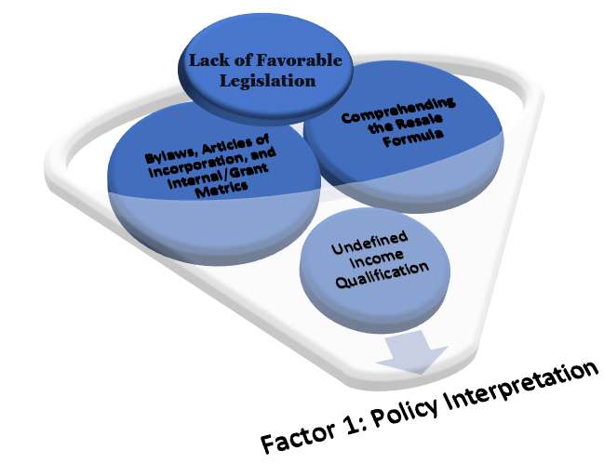
Figure 36: Factor 1: Policy Interpretation Outreach Areas
Factor 1: Policy Interpretation
- Lack of Legislation
- DCLT Clearly Defined Bylaws/AOI
- Defined Income Qualified Population/Housing Portfolio/Resale Formula pending
- Aspire Legislation for CLTs (1 large CLT preferred to avoid competition)
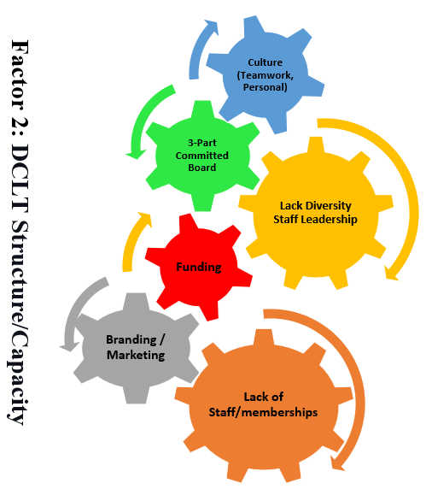
Figure 37: Factor 2: DCLT Structure/Capacity
Factor 2: DCLT Structure/Capacity
- 3-Part Committed Board
- Culture (Teamwork, Personal, like a family)
- Branding / Marketing
- Funding
- Lack of Staff/Memberships
- Limited CLT Knowledgeable pool of Applicants for Staff Positions
- Limited Staff/ Leadership Diversity 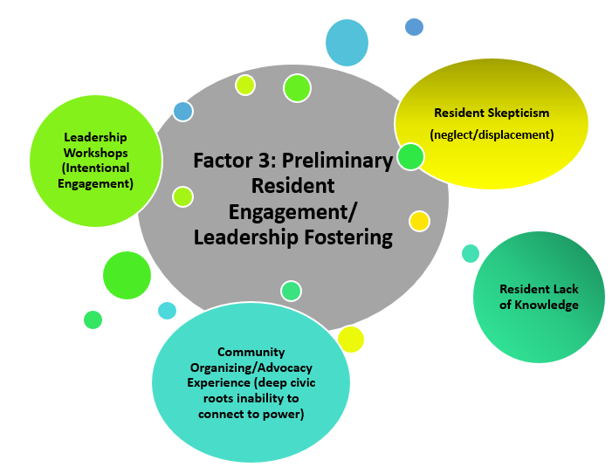
Figure 38: Factor 3: Preliminary Resident Engagement/ Leadership Fostering
Factor 3: Preliminary Resident Engagement/ Leadership Fostering
- Leadership Workshops (Intentional Engagement)
- Resident Skepticism (due to neglect/displacement)
- Resident Lack of Knowledge
- Community Organizing/Advocacy Experience (residents profound civic roots struggle to connect to power that leads to desired change)
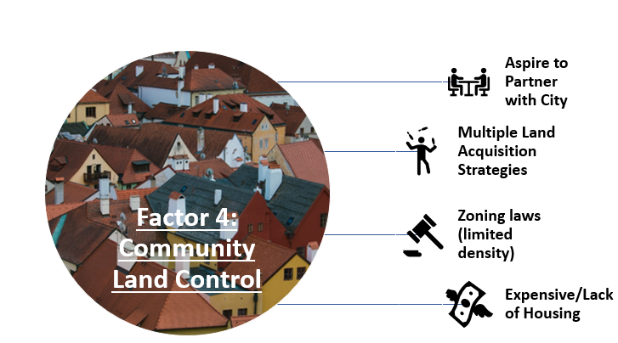
Figure 39: Factor 4: Community Land Control
Factor 4: Community Land Control
- Aspire to Partner with City
- Multiple Land Acquisition Strategies
- Zoning laws (limited density)
- Expensive/Lack of Housing
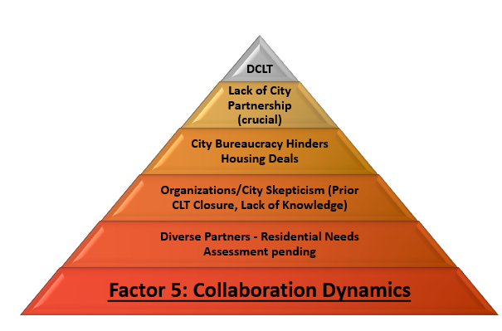
Figure 40: Factor 5: Collaboration Dynamics
Factor 5: Collaboration Dynamics
- Lack of City Partnership (crucial)
- City Bureaucracy Hinders Housing Deals
- Organizations/City Skepticism (Prior CLT Closure, Lack of Knowledge)
- Diverse Partners - Residential Needs Assessment pending
Factor 1: Policy Interpretation:
As mentioned earlier, there is no current DC CLT policy or city regulation for DCLT except for the 501c3 non-profit governing rules; there are specific requirements an organization must meet to become 501c3 tax-exempt. DCLT status is pending for its independent, 501c3 non-profit organization. The 2007 DC § 6–1061.02 Workforce CLT was a general Workforce Housing policy issued through the Office of the Deputy Mayor for Planning and Economic Development. It was an invitation requesting 501c3 non-profit organizations to submit proposals for development and administration for a community land trust to create affordable workforce housing. The 2007 DC § 6–1061.02 was the policy that funded City First Homes to become a financial subsidiary that provided finances to developers and income-eligible DC residents to obtain or provide permanently affordable housing units. But this 2007 policy states it was a pilot program and appears to no longer be in effect. DCLT is regulated by its internal Articles of Incorporation (AOI), Bylaws, Chase grant metrics, and In-house metrics, which are Property Acquisition & Equity Contribution Pathways, Portfolio, and Stewardship. According to Rumph, when she started as the founding Executive Director, DCLT only had a business plan. Hence, Rumph thought:
“our best course of action was to develop the bylaws. To be clear about who we are, what we’re trying to do, how we’re going to do it and to ensure there’s synchronicity between the bylaws and the articles of incorporation. So basically, once we got to about 90-95 percent of the questions that we were trying to answer to be able to write the bylaws, the articles of incorporation mirror the first section of the bylaws” (G. Rumph, personal communication, January 6, 2020).
The following SWOT-AR analysis matrix is the collected responses from interviewees regarding the DCLT guiding AOI, Bylaw, and total metrics.
Table 9
AWORT-AR Analysis Matrix: Factor 1
SWOT-AR | INTERNAL | EXTERNAL
PRESENT | STRENGTHS  -Bylaws Flexibility – not too much sign-off for Director  -Bylaws Derived from Consensus (diverse viewpoints)  -Bylaws Clearly stated and accessible to staff, board, and public  -Bylaws Plasticity - states multiple pre-calculated resale formulas (situational)  -Internal Metrics measurable goals and indicators | OPPORTUNITY  -Bylaws enable 501c3 status more funding  -Bylaws establish DCLT as a legitimate organization. More people will become members  -Council Member White tried to put through legislation for funding CLTs. DCLT can align for more recognition
PRESENT | WEAKNESSES  -Bylaws rigid amendment process – can slow down good changes but also protect against bad changes. Articles can only be amended by members and Board then legally changed through DC’s DCRA  -Bylaws directed only towards DC and not the DMV area  -Bylaws not clearly stated the definition of low and moderate-income populations it serves  -Internal Metrics Lack of staff onboarding objectives/goals  -Chase grant due expire 2020, not enough time to meet metrics | THREATS  -DC policies/legislation may make it challenging to comply  -Local politics competing against other organizations, especially for funding  -Misinterpretations of pre-calculated re-sale formulas
FUTURE | ASPIRATIONS  -CLT model to be better understood in the community and government officials  -CLT portfolio that aligns with Internal/External metrics, Articles of Incorporation, and Bylaws  -Grant extension from Chase | RESULTS  -Resources needed and barriers identified  Bylaws, AOI  -Internal Outcome Metrics-driven metrics delineated into  - Participants  - Land  - Funding
The Articles of Incorporation (AOI) is DCLT's authoritative statute for its 501c3 eligibility; this is the document submitted to the Internal Revenue Service (IRS). Under the U.S. Code Title 26, a 501(c)(3) is an IRS recognized charitable organization that is released from paying federal income taxes and allows benefactors who donate goods, cash, and other assets to that organization to receive tax deductions (IRS, n.d. ; Code of District of Columbia, 2020). Employees can earn a salary, wages, or contract fees; however, profits earned from the non-profit organization cannot be taken by employees. Therefore, all profits made must be recycled back into the non-profit. DCLT’s AOI guides the activities implemented by the DCLT governing Board and Executive Director. Most of the Articles are the first two pages of their Bylaws. DCLT's legally binding primary purposes listed in the Articles are to "assist current, and future generations of residents to stay and thrive in the District of Columbia by securing permanent affordability for rental and ownership housing.” Also, help local businesses, community-serving organizations, cultural institutions that serve low-and-moderate-income residents or operate in low-income neighborhoods, and provide and facilitate additional pathways to build economic, racial, and social equity in the District of Columbia (DCLT, personal communication, January 14, 2020).
The Articles of Incorporation states a brief baseline in 3 pages regarding DCLT Purposes, Membership/Board of Directors/Bylaws formulation, Personal Liability limitation, its 501c3 Activity Limitation, Dissolution process, Office location, and Names of assigned Board members. The Bylaws go into more details of DCLT frequent activities.
The Bylaws have 10 Articles subdivided into 40 sections. The 10 Articles are as follows:
Article 1: General Provisions:
States the purposes of DCLT as a community-serving organization that "contributes to building economic, racial, and social equity in D.C."
Article 2: Membership:
States the requirements for voting and non-voting members, membership board meetings, meeting protocols, and memberships, member resignation/removal/vacancies.
Article 3: Board of Directors:
States the number, composition, compensation (which is unpaid currently), nomination, and election of board directors.
Article 4: Officers:
States the roles, responsibilities, tenure, election, and removal of the Board of Directors. List Officers: President, Vice President (VP), Secretary, VP of Equity & Membership, Chair of the Property Acquisition, and Treasurer (if necessary more can be appointed).
Article 5: Conflict of Interest:
States Board of Directors or a committee with delegated powers must submit an annual notification listing "all of his or her professional, financial, and personal affiliations that might affect his or her independent decision-making capacity during board service."
Article 6: Stewardship of Land Use:
States the principles of land use, encumbrance or restricted land acquisition process, and land sale/release process.
Article 7: Ownership of Housing and Other Improvements Located on The Corporation's Land, and Limitations on Resale:
States the activities the Board of Directors may utilize for homeownership provision, ensure affordability preservation, and list resale formulas' adoption, amending, or removal.
Article 8: Amendment of Articles of Incorporation and Bylaws:
States the process to amend Bylaws
Article 9: Dissolution:
States the process to terminate or close DCLT
Article 10: Miscellaneous Provisions:
States the fiscal year time-period, funding deposit location, checks signage/Loan acquisition/Contracts process, and the legal protection of Board members accurately carrying out their duties.
Discussion:
The most prominent themes affecting DCLT Policy Interpretation early start-up were" Lack of Favorable Legislation, the Bylaws and Articles of Incorporation/Internal Metrics formulated, Income-Qualification it will serve and Comprehending the Resale Formula.
Favorable legislation: ensures a CLT sustainability, since competing for housing, particularly accessible, affordable housing is difficult in many big cities. DCLT is trying to work with local Councilmembers to draft legislation. Legislation efforts may spark more efforts to multiply CLTs; other non-profits have expressed interest in forming a CLT in other Wards. DCLT emphasized the need to have one large District-wide CLT to avoid competing for resources and to help increase leverage to maximum social and political capital power; more residential CLT participation in 1 CLT is equated with more power. Furthermore, at the 2020 Continued Conversations on Housing forum, designing the WE organization Co-founder April De Simone mentioned growing interest in having one national CLT organization. A CLT organization that can assist and fund smaller CLTs throughout the U.S. to ensure economic leverage for its low and middle-income residents. Currently, DCLT's daily activities are governed by the internal Board, Articles of Incorporation, and Bylaws.
An enormous feat housed within DCLT Articles and Bylaws is its desire to create equity, especially racial, and prevent displacement. DCLT guiding principles and laws are the very epitomai of H. George Frederickson Public Administration Social Equity theory. DCLT is attempting to create equitable and inclusive communities through opportunities that give equal conditions for Ward 8 low and middle residents to succeed. DCLT is seeking to stand in the gap of fair housing for DC residents. The cornerstone of Frederickson's theory is to understand that residents do not experience the same social and economic conditions; therefore, administrators’ efforts must level the playing field. Research uncovers the need for modern public administration to heed social equity in policy development and implementation—this call to include equity attempts to build public trust and rehabilitate ethical requirements by addressing underlying principles that sustain public administrators’ (Getha-Taylor, 2009). According to Johnson and Svara newly posited definition of Social Equity for all those involved in public governance is that it is an active commitment to fairness and justice when formulating policies, distributing and managing goods, and services to the public as well as promoting better equity in access, quality, and social outcomes (Johnson & Svara, 2015).
According to DC's Office of Planning Director Andrew Trueblood, "equity is a buzzword… it's not about what we grow in equity but about how we grew in equity. it's essential in how we think about planning a city's infrastructure (Carter, personal communication, February 2020)." "Equity is defined as fairness and racial equity is when race can no longer be used to predict life outcomes, and outcomes for all groups are improved.” (Nelson, Spokane, Ross, & Deng, 2015). According to the Government Alliance on Race and Equity, a national network of governments, “when systems and structures are not working well, they are often not working well across the Board. Many examples of strategies to advance racial equity are advantageous not only for people of color but also for all communities, including Whites.”
At the 2020 Mayoral Continued Conversations on Housing forum, Mayor Bowser emphasized: "the change in DC has been swift…it's a complicated conversation in which all income levels are anxious about housing” (2020 Mayoral Conversation on Housing, personal communication, February 8, 2020)." Mayor Bowser stated that having affordable housing legislation like the Comprehensive Plan in place will aid in keeping future elected officials accountable for ensuring and enforcing equitable policies that reduce displacement.
Furthermore, according to DC's newly drafted Comprehensive Housing Plan report, "displacement is a critical challenge when attempting to achieve an equitable city." The report defines and categorized displacement as the following: Displacement is a neighborhood change that forces a person to move out of their home. Displacement takes on multiple forms. You have (1) Physical Displacement, which is a move due to redevelopment (2) Economic Displacement, which is a move due to cost (3) Cultural Displacement, which is losing a sense of belonging and shared identity in the neighborhood due to change and growth. While these categories relate, they each have unique planning responses. Moreover, the report highlights DC as a city that has "one of the strongest sets of anti-displacement programs in the country. Programs that include rent control, eviction protection, Tenants' Opportunity to Purchase Act (TOPA), District Opportunity to Purchase Act (DOPA), locally subsidized rents, tax assessment caps, and finally, tax credits for low income and older homeowners” (Comprehensive Plan Housing Element, 2019). Despite these laws, many residents are still being or at-risk for displacements. Community revitalization is driving the redistribution of neighborhood assets leaving low-and-middle-income residents waiting on the side, struggling to get a piece of the real-estate pie. Just like party late-comers, the pie appears all eaten unless other partygoers or the host sets aside some pie for the late-comers. The same goes for equitable housing development. Those with the power to do so must set aside affordable housing units.
Bylaws and Articles of Incorporation: DCLT’s Bylaws are essential to aid in maintaining consistency in the operation of the organization. These Bylaws communicate organizational guidelines to prevent and resolve internal conflict. The Bylaws and Articles of Incorporations enabled DCLT to file for its non-profit 501c3 tax-exemption with the IRS, apply for federal/local level grants or contracts; increasing their likelihood to receive private donations. Bylaws also help to improve recognition with the public as another anti-displacement solution. DCLT is explicit in its Bylaws, Articles, and website in joining the ranks amongst DC's other affordable housing programs to minimize all forms of displacement. DCLT also created and was given metrics to meet for grant funding. Chase grant metrics focused on output-outcomes in terms of the number of people served, amount of funding earned/received, number/types of affordable units (commercial/residential) acquired or promised, demographics of people served, number of memberships, number of community events, and ground leases and bylaws creation. The DCLT internal metrics dug a little deeper into describing the participants, community land control, and the loans provided. DCLT metrics also outlined templates for upward mobility data capturing wealth attainment pre/post home sale and housing cost-burden ratios, residents’ personal experiences, if residents were able to stay in their neighborhood, personal growth, well-being, and other indicators. DCLT organized these metrics into three categories: Desired Results, Indicators, and Data Needed. Desired Results were the goals DCLT aspired to achieve for its participants and organization; Indicators were the measurable information for each category (People, Land, Funding) utilized to determine if DCLT implementation is meeting their outcomes as expected. DCLT stated its stewardship and outreach metrics are still formulating. DCLT also has Property Acquisition and Equity Contribution Pathways metrics to guide them in meeting their land acquisition outputs and outcomes (described in Factor 3: Community Land Control).
Defined Target Population: For DCLT to minimize displacement, it must define its target population. However, according to a few of DCLT Board members from the focus group, the Articles and Bylaws vaguely state its income qualification for the low-and-moderate-income communities it aspires to serve. This ambiguity may compound further misunderstandings of this already complex housing model. The Board and Staff expressed concerned and stated they are seeking to help those around and below the 60% AMI income bracket. DC's outdated 2007 Workforce CLT Policy website states its piloted CLT portfolio should not exceed 120% AMI but have an average of 80% AMI. DCLT stakeholders wonder if this policy focused more on those above 60% and not the working poor, whom the U.S. Bureau of Labor Statistics states make up almost 7% of the labor market (Code of District of Columbia, 2020; U.S. Bureau of Labor Statistics, 2019). The vagueness in DCLT’s targeted populations and undefined income brackets may interfere with DCLT's attempts to collaborate with residents, organizations, and the DC government leaving many to wonder who qualifies for the CLT housing assistance.
Resale Formula Comprehension: The DCLT Board, inquiring organizations and residents, frequently mentioned the difficulty in comprehending the Resale Formula mentioned in the Bylaws and the extent of its limitation on homeowners' freedom to alter their home's physical appearance. CLT's noted misconception is that it is a paternalistic entity that controls the homeowner or renter's home-maintenance behavior. According to Adam Maloon, who is DCLT Director of Organizing and Governance and City First Homes Vice President, homeowners have the freedom to make as many alterations as possible to their home if it aligns with their ground lease and local zoning laws. Zoning laws supersede home repairs and the CLT lease. Note: Zoning laws regulate how a residential or commercial property in a specified neighborhood can be utilized, including its size, placement, density, or height (DC Office of Zoning, n.d.). Maloon emphasized the importance of educating the community on the DCLT's model regarding equity and repairs to the home. Since the CLT resale formula limits the equity or profit collected by a homeowner upon selling their home, investing in luxury repairs may not be recuperated.
For example, if a homeowner paid $40,000 to put a jacuzzi in the bathroom, that improvement may only increase the overall home price by $ 10,000 (the market determines the value of added repairs to a home at the time of sale); so, the homeowner would lose $30,000. Another example is a homeowner paid $4000 to add a bathroom; at the time of purchase, the market indicates the improvement is worth $10,000, they could increase their home sale price by $10,000; profiting an extra $6,000. However, DCLT wants the homeowner to focus on enjoying their home and make it as comfortable as they wish but manage expectations on repairs and home values. Maloon stresses potential CLT participants to "do the things they want and not solely focus on what adds value” (A. Maloon, personal communication, January 22, 2020). Maloon said repairs that increase the value of the home might be added to the resale formula. However, the goal to keep in mind is its affordability for the next low-and-moderate income buyer; repairs should not make the home unaffordable to the next family.
Repairs specifications are listed in the homeowner's ground lease. Maloon states that DCLT assistance is not there to stop people from painting their house or planting gardens. DCLT is available to help answer inquiries on what significant structural changes to the home can be done and ensure CLT homeowners are getting the right contractors and if they know how to do repairs themselves (A. Maloon, personal communication, January 22, 2020). DCLT has a list of Resale formulas; the preference is to have one procedure, which is still being determined. They are considering formulas based on homeowner circumstances. According to Maloon here are commonly used Resale Formulas with examples.
Formula A: Index based on Average Median Income (AMI): AMI is a precalculated central income statistic for a given area (Metropolitan Council, 2018). AMI is the midpoint of a region's income distribution. For housing programs, income brackets are set relative to the AMI. For formula type A, an income-bracket is selected; for example, if 60% AMI is selected, the CLT property will always be affordable to people who earn 60% of the AMI bracket. Douglass Community Land Trust (DCLT) may consider a formula based on DC’s regional AMI, not a local Ward AMI; this helps to keep Ward 8 properties more affordable. The formula is tied to the regional AMI, which is likely to grow slower. If the formula is tied to the local AMI of Ward 8, where gentrification is booming, the AMI is likely to grow faster as wealthier people move in, which can maximize what people sell for but hinder the next low-income buyer. Some AMI formulas look at AMI over a timeframe. So, if a homeowner owns a home for five years, the formula will take a proportional percentage of the past ten years to smooth out spikes and dips of the AMI. That percentage is then applied to the time the homeowner owns the property. Circumstances may determine the decision on which formula to use.
One formula DCLT considered may allow a homeowner to sell what they purchase the home for plus a percentage increase equal to the difference in the AMI over that time. An example of formula A is as follows:
- In 2015 the Original home price was $100,000 when the AMI was $50,000
- In 2020 the New home price will be $120,000 since the AMI is $60,000. Homeowner limited equity is $20,000 plus any repairs
How so?
Because the difference between AMI $50,000 and $60,000 is 20%, this 20% is multiplied by the original purchase price of $100,000 ($100,000 x 20%), which equals $120,000, then any repairs or upgrades done by the homeowner will be added to this price. So, if the market says the homeowner's renovated bathroom is worth $10,000, then the new maximum home price will be $130,000 ($120,000 + $10,000-repairs). Nevertheless, remember if the repairs cost the homeowner $4000, then the homeowner made a profit, but if the repairs cost the homeowner $14,000, then the homeowner would lose since the market price for that repair at the time of sale is $10,000.
Formula B Index: based on Consumer Price Index (CPI): CPI is a measure of the average change over time in the prices paid by urban consumers for goods and services like “food and beverages, housing, apparel, transportation, medical care, recreation, education and communication, and other goods and services.” (U.S. Bureau of Labor Statistics, 2020). The U.S. Bureau of Labor Statistics tracks the changes in items. This formula can be tied to the increase in commodities or inflation. As AMI increases, then the costs of things will go up as well.
Formula C: based on Appraisal (25%/75%): this formula is more challenging for homeowners to figure out since the home's market-rate value must be tracked every year. It takes the difference between the market-rate increase or appreciation amount from the original price, then that appreciation amount is split with the Community Land Trust or CLT. The problem with this formula is in hot markets, if the new market-rate home price jumps from $100,000 to $300,000, it would be hard to keep this home at an affordable price for the next low-income resident. However, this formula is useful in that it incentivizes people to keep their homes in good condition. It does not explicitly track income levels, but the housing market may align with what people are earning/willing to pay, so prices will be around income levels and the supply of available housing; the more houses for sale then the closer to income levels (A. Maloon, personal communication, January 22, 2020). The less housing available, then the market will cater to the wealthy. An example of this formula is as follows:
- In 2015 the Market-rate sale price was $150,000, but the CLT precalculated sale price was $100,000
- In 2020 the NEW Market-rate sale price is $200,000, but the CLT NEW precalculated sale price will be $112,500. Homeowner limited equity is $12,500
How so?
Because the appreciation is $50,000, which is the difference between market prices from 2015 to 2020 or $150,000 to $200,000. From the $50,000, the CLT will keep 75%, and the homeowner’s equity will be 25% or $12,500
Formula D: based on Fixed Price: this formula is the easiest for homeowners to figure out. A flat percentage is picked and does not change based on market variances and usually not compounding. This formula is typically used in limited-equity coops. An example of this formula is as follows:
- In 2015 the Home Price was $100,000
- In 2020 the Home price will be $115,000. Homeowner limited equity is $15,000
How so?
A 3% simple interest more per year was picked. 3% of $100,000 or 3% x 100,000 (original home price is multiplied by .03=$3,000). Then, $3,000 is multiplied by five (number of years in the home) would be $15,000. The new home price is $115,000.
Factor 2: DCLT Organizational Structure and Capacity
Organizational structure and capacity are vital for the successful growth of an organization; it ensures responsibilities are unambiguously defined, and adequate human capital or resources are in place to achieve the organization's goals (Schaufeli, Maslach, & Marek, 2018). Also, organizational structure and capacity aids in ameliorating "occupational stress; burnout, the depletion of energy resources as a result of continuous emotional demands of the job.” Like many CLTs, at the heart of DCLT is stewardship
“and preserving affordability, retaining public subsidies, backstopping security of tenure, and maintaining the occupancy and condition of owner-occupied housing that are core commitments woven into the organizational fabric and operational competency of the CLT (Davis, Jacobus, & Hickey, 2008). Exact terms and conditions contained in a CLT's ground lease can vary significantly from one CLT to another, especially restrictions on inspecting, subletting, improving, and reselling the buildings.”
To keep DCLT organizational heart-pumping, it needs the proper functionally different but cohesive veins, arteries, ligaments, and muscles, which is DCLT human resources. Housed at the center of organizational structure are employees, in which its employees' genetic makeup is equally important. Shafritz & Russell contend that public administrators' duties include implementing laws with fairness and equity and fostering equity by having an inclusive, diverse workforce that has equal opportunity and provides ethical leadership and encouragement for residents to conduct themselves in fairness (Shafritz, Russell, & Borick, 2007). DCLT participants stated they aspire to acquire and raise a staff that resembles its target population. One of DCLT’s goals is to educate and engage the community more, so they can become general CLT members, Board-elected members, and staff someday.
Having the right structure and capacity is critical for DCLT to provide its goals to its participants/collaborators. The goals are as follows (DCLT, personal communication, January 22, 2020):
- Acquire affordable rental and homeownership units
- A Democratic process through its Board of Directors and Memberships for community land control
- Acquire commercial space for small businesses
- Provide wrap-around services determined by its members
- Legislation and can be underwritten into other affordable housing deals
Funding designated for operational support is essential for DCLT to implement its activities. Finances directed toward operational cost does not only go to housing specific developments but also staff salaries, program expenses, and headquarters/office space rent and materials, (Davis, Jacobus, & Hickey, 2008). Research by Davis, Jacobus, and Hickey, 2008 showed that standard operational support incorporates the following:
- General administration
- Strategic planning
- Exploring the development of new projects or programs
- Delivering homebuyer education
- Homebuyer outreach and eligibility screening
- Marketing homes
- Monitoring compliance with the ground lease
- Fundraising
- Advocacy and community education
- Membership development
The mixed sources of operational, financial support vary across CLTs in the following form of
Grants and Donations:
- Grants from Local Government
- Federal sources such as HOME and CDBG
- Local housing trust funds
- General local funds
Donations from Private Sources
- Foundation Grants
- Corporate Sponsorships
- Private Donations
- Fundraising Events
Revenues from Project Development
Developer Fees
Marketing Fees
Revenues from On-going Operations
- Ground Lease Fees
- Lease re-issuance/resale fees
- Membership dues
- Fees for services
Also, DCLT's unique model and service offerings enable them to provide services to other organizations as a fee for service. For example, if a non-profit or developer wants DCLT to manage, but not own, their affordable housing portfolio and offer residents the wrap-around services, DCLT will do so at a cost. The Community Land Control section gives examples of how other cities incorporated a CLT with other programs. Developing and implementing an organizational structure and capacity has its caveats in a start-up non-profit like DCLT.
The following SWOT-AR analysis matrix is the collected responses from interviewees regarding the DCLT of DCLT Organizational Structure and Capacity:

Table 10
SWOT-AR Analysis Matrix Factor 2
SWOT-AR | INTERNAL | EXTERNAL
PRESENT | STRENGTHS  -CLT is needed in DC  -Great Board (know each other close-knit, knowledgeable, caring, diverse, dedicated, involved, did CLEW leadership training)  -Strong Executive Director (Ginger-has lots of housing experience, very people-focused, aggressive, familiar/steady relationship with City Council)  -Good leadership training  -Consistent meetings  -Low staff/board turnover  -Low bureaucracy  -Received grant funding (JP Morgan Chase $3 million, City First Homes, Citi, foundations, etc.  -Well-known in Community, leaders, City Council | OPPORTUNITY  -Current partnerships organizations, developers; increases capacity  -The continuous growth of memberships by providing more units (diversity, viewpoints of housing crisis)  -DOPA/TOPA (Stop purchases and can become CLT acquire land increasing units and potential staff/capacity  -Promote/campaign/advocate for tenant control & empowerment  -Community members in general (residents advocate for themselves & join DCLT staff)
 | WEAKNESSES  -Board lack of experience  -Low staff  -Lack of knowledgeable potential staff  -Not enough time in the community  -Long-term funding  -CLT new concept (learning curve requires more effort to know what works and does not)  -Unpaid Board that is largely community-based (Big ask for lower-income participation some boards are paid) | THREATS  -DHCD – not enough support & red tape/administrative burdens  -Limited housing stock/High property values limit the capacity to grow portfolio & members  -Developers (competitors lack interest in building affordable housing) – Opportunity zones  -Lack of understanding of CLT from Community, Council, Residents (misinterpretation that CLT will solve something else and when it does not can result in CLT rejection  -Interest in having competing CLTs vs. growing 1 CLT (which is better)  -Housing Subsidies expiring 2020-2022 (displaced residents & potential members)
FUTURE | ASPIRATIONS  -Diverse long-term funding  -Offer stewardship services  -Community-driven at the forefront  -Robust active membership  -Membership/Board truly aligning to Bylaws with community representation  -Members feel connected geographically and tenure type (short or long-term tenants)  -Being able to offer services to Co-ops that may or may not be DCLT land | RESULTS  -Staffing Plan - acquire key staff (Community Engagement /Communications, Real Estate Property Acquisition Consultant, Governance, Fundraiser)  -Workshop/Educational Surveys: built-up expertise and knowledge in the community so they can become staff  -Stewardship Agreement (Physical/People)  -Partnerships Network Maintenance Plan  --Community Engagement Plan (marketing, specific pathways for people to participate, engaged time-limited volunteers/members  -Policy Advocacy (Acquiring land, favorably tax/zoning laws amendments) increases portfolio units & members

Many view CLTs' organizational structure as a socialist society. Socialism is a society where the community owns, shares, and regulates the production, distribution, and exchange of labor, capital goods, natural resources, and entrepreneurship (Gilabert & O'Neill 2019). In the case of DCLT, the land would not be considered a commodity to exploit but a shared appreciation of the community as a whole. Whereas, in a capitalist economy, it pushes people to be competitive. DCLT organizational structure is similar to the U.S. government sector (National Council of Nonprofits, 2009). Studies show CLTs Board of Directors acts as both the trustee member, representing the public interest and the supportive member, helping the CLT accomplish its mission. Like many CLTs, DCLT structure resembles the government in the following way (please see Picture DCLT below) (National Council of Nonprofits, 2009).
- The Board = Legislative branch establishes the overall direction and broad policies. They usually do not directly carry out the activities, approve the budget, and make sure there are adequate resources available to meet the needs.
- Executive Director = Executive branch, the general rule is that "the directors oversee, but do not directly engage in the corporation's day-to-day operations. Staff executes activities. ABA Guidebook. Boards and board members perform best when they exercise their responsibilities primarily by asking good and timely questions rather than by 'running' programs or implementing their policies. Board/staff relationships are what they should be when mutual expectations are agreed upon, and issues and responsibilities are clearly defined." --Richard Ingram, in Ten Basic Responsibilities of Nonprofit Boards
- Donors, Volunteers, Members = Judicial branch, delivers informal autonomous supervision to the other branches and the non-profit. Since they hold the purse they can stop supporting the nonprofit and can rule against the nonprofit activities if the nonprofit is operating incorrectly.
DCLT organization comprises the following employees and pseudo-employees (unpaid volunteers), portfolio, and funding.
- Two staff: Executive Director and Director of Organizing/Governance (one woman, one man, both White).
- One AmeriCorps vista (one male, Black)
- 15-member Board (ten women and five men, all people of color except 1) The 5 Board Officers were elected; 2 empty seats pending
- Members: Still pending
- The portfolio consists of 153 units in several housing cooperatives and 1 condo, 3 shared-appreciation units with second mortgages, and 20+ units in a few other communities. No commercial, garden, urban farms, or green spaces yet.
- Funders: Largest donor is JP Morgan Chase's $3 million grant over three years. Additional funds came through City First Homes, other financial institutions like Citi, and some national and local foundations.

Similar to
Judicial Branch

Similar to
Legislative Branch
Similar to
Executive Branch

Figure 41: DCLT Organization Structure

DCLT aspires to have a classic CLT organizational structure in which there is a tri-part Board. A Board comprised of the "Lessee Representatives, individuals representing CLT Lessee Members, General Representatives, individuals representing General Members, and Public Representatives, individuals representing the interests of the general public." The Board must be members and can be between 9-18 people in the following roles:

Figure 42: DCLT Board of Directors Structure
Lessee Representatives: are residents of a rental unit, ownership unit, or a resident in a co-op/condo receiving stewardship services, commercial unit, or any CLT property; Lessee members nominate Lessee Representatives. "Lessee Members. (1) must be 16 years or older (2) annually submit a signed membership (3) primary residence or place of business is a property owned, in whole or in part, or is otherwise being stewarded by DCLT; in which each property being a "Lessee Unit." Lessee Units are residential and non-residential units whose owners lease land owned by DCLT or any subsidiary of or partnership in which the Corporation has an ownership interest- (1) signatory to a Deed Restricted Covenant issued by DCLT. (2) Signer of a contract for stewardship services with DCLT. Each Lessee Unit would have one vote, regardless of the number of Lessee Members residing in the unit."
General Representatives: are (1) 16 years or older (2) not Lessee Members or members of a Lessee Unit, (3) Live, work, or have a demonstrated community affiliation in DC; (4) can be appointed as an initial Member in the Articles of Incorporations or submission of a membership application, including a signed statement of support for DCLT, (4) pays annual dues or obtains payment waiver. General members nominate General Representatives.
Public representatives: are individuals with experience and expertise in matters related to community land trusts, community development, community planning, or other such knowledge or positions as may be deemed beneficial to support the Corporation's mission and activities. The Board of Directors makes nominations for Public Representatives.
The Board of Directors' diversity is to ensure the representation of members. DCLT's goal is to have district-wide membership, where members pay a yearly fee that can be waived under extenuating circumstances. According to DCLT Executive Director Rumph,
“membership dues do not impact the financial sustainability of DCLT; the dues are more of a symbol of commitment from a member. We came up with a one-pager or two-pager I think on membership as fundamentally providing or operational sustainability. Why membership is so vital to the CLT, so I want to see us with a very robust membership not just by the volume of people but by participation. We're also talking with somebody who's helping us out right now to flush out a little bit more on our organizational structure to have chapters since we're going to be big. We know we are. So, right now, we're planning for all over the District of Columbia, which we aspire to be.”
Members play a huge role in electing the Board of Directors and voting on certain DCLT activities like land acquisition, types of services offered, and other activities. The Board consists of seven officers with delineated responsibilities. The current Board is self-selected and unpaid. Once membership grows, DCLT's goal is to have an election in the next election cycle. As a start-up organization, DCLT two staff wear multiple hats and rely heavily on the Board's help and connections. The Board has stepped in the gap as pseudo-employees and is described as driven by dedication whose salary is in the form of being able to create collective strategies for inclusive, affordable housing. Rumph and Board members describe DCLT as "driven by sort of this incredibly committed 15-member body." The Board was instrumental in developing the Article of Incorporation and Bylaws. Rumph stated:
“that since I came on, almost every board meeting, we tackled a portion of the Bylaws. We were going back and forth on the bylaws. We looked at the classic model Bylaws, and we looked at many versions of other CLTs Bylaws because some of them had been recently redone. For some of the CLTs that had been in operation for 30 - 40 plus years. For instance, Champlain CLT had fairly recently undertaken Bylaw amendments; it was all beneficial. Our markets are different, but Champlain CLT has the benefit of having all those decades of experience and knowing what to watch out for or avoid. So, we could see in their changes to the Bylaws of things that snagged them in their process.” (G. Rumph, personal communication, January 6, 2020).
“For the Articles of Incorporation, one of the first exercises we did was develop our value statement. We spent a long time over several meetings talking about the values and what are the things that are important to the Board. I needed to know since I wasn't there when they were standing DCLT up and designing the new business plan.”
Incorporating DCLT and creating the guiding principles was done in a systematic democratic way. According to the Board/staff, they worked to develop a culture of inclusivity and cohesiveness to formulate its values and rules. They wanted to be mindful of the human component, where everyone's opinions mattered enough to be heard and voted on as a whole.
The Organizational Culture Assessment Instrument (OCAI) categories were used to simplify data collections and get a bird's eye view of the Board's perception of the organizational culture they created (OCAI, 2020). Board members who participated similarly described DCLT as the following:
- Dominant characteristics – Personal, like a family, controlled and structured
- Organizational leadership – Mentoring, facilitating, nurturing (unanimous)
- Management of employees – Teamwork, consensus, and participation (unanimous)
- Organization glue – Emphasis on achievement and goal accomplishment, commitment to innovation, development, loyalty, and mutual trust
- Strategic emphases – Human development, high trust, openness, permanence and stability, acquisition of resources, creating new challenges
- Criteria of success- development of human resources, teamwork, concern for people (unanimous)
Naturally, in a start-up, the culture of the organization is deeply influenced by the founders. The founding team's personality may create the culture, but proactive efforts to drive the culture in a preferred direction is critical. Human relations as it relates to staff/management fostering an atmosphere in the workplace that promotes unity plays a role in shaping the culture. "The culture of an organization is widely considered to be one of the most significant factors in reforming and modernizing public administration and service delivery.” (Jung et al., 2009). Organizational culture is shared principles, symbols, and routines accepted by the organization's staff or participants. It defines the implementation steps or daily activities occurring within an organization especially problem-solving internal conflict (Claver et al., 1999).
In the case of DCLT, the Board and two employees repeatedly stated their biggest strength was the Board dynamics and how well they worked together: a cohesive culture. The similarities in the OCAI responses align with what leadership desires for its organizational culture. Rumph stated,
“I always want the members to be out front, the Board of directors representing the members. I would love for that to happen. I see myself as facilitating the things that they want. That's how it should be in a community-driven non-profit. I think that is what makes our work distinct.”
Since DCLT is still in its start-up phase, there are no memberships yet. The current Board is the self-selected Advisory Board from the initial community outreach efforts in 2016. According to Rumph,
“Before I was hired as an executive director, the advisory committee three years ago, created this CLT. That is almost unheard of, the fact that they built up their knowledge base and their capacity to undertake to hire somebody to start a business plan and oversee that whole process and then hire an executive director. It's impressive, and that's the real strength.” (G. Rumph, personal communication, January 6, 2020).
DISCUSSION
The most prominent themes affecting DCLT Organizational Structure and Capacity start-up was the DCLT Board cohesion and network outreach, potentially DCLT Staff Diversity, and the Lack of Staff, which ties into Funding. None of DCLT metrics set a quota for staffing build-up. DCLT aspires to maximize its close-knit Board/staff relationship to build resident engagement with hopes these residents will become staff or volunteers that advocate for themselves and others. Since the most considerable influence is staff dynamics, the following discussion will revolve around all three themes.
DCLT Board: The strength of the Board dynamics has enabled DCLT to maintain its momentum in becoming recognized as an additional solution for inclusive, affordable housing, upward mobility, and small business space. The current Board, which transitioned from the Advisory Committee, has been collaborating since about 2016. The Board has deep roots in the community. They are a group of individuals with wide-ranging, highly knowledgeable backgrounds, many holding high positions in their field, a bachelor’s degree or higher, and some are Ward 8 residents. The connections, wisdom, and genetic traits that resemble the target population have given them an upper hand in expanding DCLT growth. Research shows that a non-profit's Board's experience, expertise, and social relations are the three most desired competencies. Other qualities include ethical character, a deep commitment to the mission, time, and willingness to use personal and professional means to advance the mission (Roshayani et al., 2018). According to a few DCLT Board members, when the two staff members were officially hired, the intermingling was natural. The respect, admiration for each other, personal knowledge, and concern they have about each other’s personal lives are evident in speech. Also, they raved about the attentiveness, fairness, and cohesion of the Board. Board members need to be cohesive around critical organizational objectives. Cohesiveness needs diversity in its members and talents, and within that diversity, the confidence in knowing individual interests are acknowledged and represented. According to Sonnenfeld (2002) what makes a great governing Board are:
- “Regular Meeting Attendance
- Board Member Skills (wide-ranging)
- Board Member Age (older members are desirable to share experience/wisdom)
- Board Size and Committees (not small or too big)
- The Past CEO's Presence (serves as a mentor, idea board)
- Independence (diverse includes outsiders)
- Human Element: Robust, Effective Social Systems
  - Virtuous Cycle of Respect, Trust, and Candor. (successful teams usually have a chemistry that cannot be quantified)
  - A Culture of Open Dissent. (board members that are strong enough to withstand clashing viewpoints and challenging questions)
  - Fluid Portfolio of Roles (play a variety of roles, gives directors a broader view of the organization and the alternatives available to it)
- Individual Accountability (Many ways to enforce ex: Home Depot's board members must visit eight or more stores outside their home state between board meetings)
- Performance Evaluation (lack of feedback is self-destructive; feedback can be full board evaluation or individual self-assessment. Behavioral psychologists and organizational learning experts agree that people and organizations cannot learn without feedback. No matter how right the Board is, it is bound to get better if intelligently reviewed)"
DCLT appears to meet most of the above list except the past CEO since it is a start-up, and the Board race/ethnicity is not diverse. However, it does represent the community they plan to serve, and there is no accountability or performance evaluation on the record for the Board Members yet. Unofficial accountability appears during staff meetings when Board members are tasked and asked about follow-up assignments given from previous sessions.
Staff Diversity/Lack of Staff: Though the DCLT Board and staff said positive things about one another, the issue of race did emerge. The two staff members are Caucasian, whereas over 90% of the Board is people of color. Vaughn Perry, DCLT Board member, and BBAR's 11th Street Bridge Park Equitable Development Manager stated that finding people of color to hire was impossible. They tried very hard since they felt it was essential to hire someone who looked like the community. Rumph also insisted:
“There are two things I'd say about staffing is that we want to build up a lot of expert knowledge within the community so that we're drawing our next staff people from the city. In several years or when it happens, I want to be replaced by somebody who came up from the community and somebody who has taken a liking to CLTs and wants and is committed to the model and seeing it grow.” (G. Rumph, personal communication, January 6, 2020).
Hiring people of color in non-profit executive roles has been an issue of public debate. The National Center for Charitable Statistics (NCCS), a state and national database of non-profits, identified "about 1.56 million non-profits registered by the IRS in 2015, which had an increase of 10.4% from 2005, but few have diverse executive staff. This increase includes public charities, private foundations, chambers of commerce, fraternal organizations, and civic leagues.” (McKeever & Pettijohn, 2014). Moreover, not just staff, but the location of the non-profit is evident in DC. Figure 43 shows DC’s approximate 12,700 tax-free organizations are concentrated in the higher-income Northwest (NW) sector and least concentrated in the lower-income Ward 8 Congress Heights and Tacoma neighborhoods. This phenomenon is the added reason why BBAR's VP Scott Katz, who is also a white male, emphasized BBAR as being a community-based non-profit that reinforces visibility and staff community connection. Scott emphasized:
“the location of BBAR in Ward 8 sends a compelling message when the non-profit who's working with the district government on this 11th Street Bridge Park project is based east of the river and has been serving the community for the last 15 to 20 years, which is essential and critical.” (S. Kratz, personal communication, January 29, 2020).
The concept of a non-profit being in the community it serves creates a sense of connectedness and accountability to the community, potentially building trust.
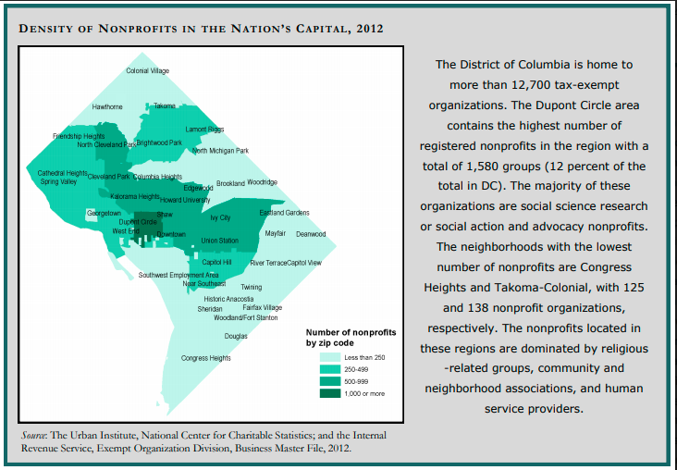
Figure 43: DC approximate 12,700 non-profits (Urban Institute, 2012)
Despite having a growing 1.56 million non-profits in the US, racial equity emerges as the gap of diversity in non-profit leadership continues to stagnate. According to Kunreuther & Thomas-Breitfeld, non-profit leaders do not reflect the population they serve. "Blacks, Latinos, Asians, and other racial and ethnic minorities still fill fewer than 20% of non-profit executive-director positions, a figure that has not budged for more than a decade." Figure 45, the findings of the 2016 Race to the Lead survey, supports the issue that diversity is lacking in leadership. This study surveyed over 4,300 people working in the non-profit sector. Figure 44 shows that people of color hold more CEO positions in organizations that are immigrant identity-based organizations than Whites. However, organizations that are non-identity based have more White CEOs than Blacks. Further research would need to investigate whether Blacks are more likely to be considered for a CEO position if the organization leads with a similar ethnicity/race.
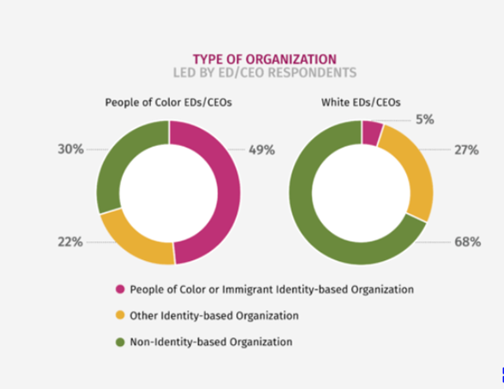
Figure 44: Non-profits CEO/ED Race
Moreover, Kunreuthern & Thomas-Breitfeld (2017) reported that “one of the big problems in the non-profit sector is that the leadership of non-profit organizations does not represent the country's racial/ethnic diversity.” Figure 45 goes on to highlight the viewpoints of 4,000 non-profit employees who participated in this study. These viewpoints reveal that when compared to Whites, more Blacks believed that non-profits CEOs do not reflect racial/ethnic diversity in the US. Moreover, organizations create tension they cannot handle in their attempts to address their organizational racial equity. However, both groups similarly believe racial/ethnicity diversity in non-profits is a complicated issue that is not easy to resolve and push to move forward.

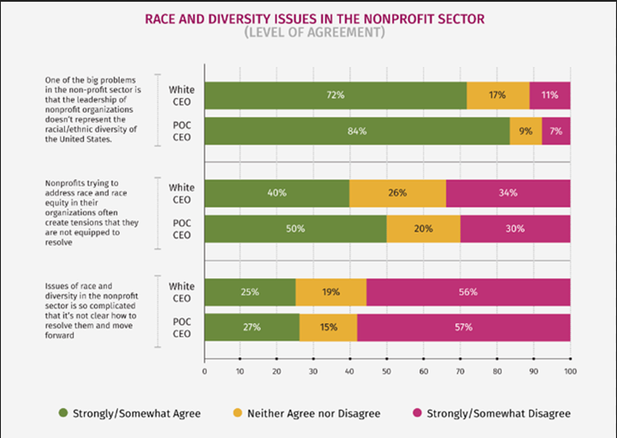Figure 45: Viewpoints of Non-profits' Employees on Race and Diversity in the Sector
Although author McGirt (2017), highlighted "cracks are beginning to form in the glass ceiling, a metaphor for the lack of promotion of women, African-American women barriers to promotion still exists. This barrier is coined the "Black Ceiling" (Hartman, 2018). McGirt reports the contributing factor for this "Black ceiling" is the school system.
“The state of schools and communities fail to care for low-income children of color and graduate them ready to work. It takes 20 years of education to grow an entry-level employee, or more if they are going to have a specialty that employers want, like STEM or professional services. Even with Black women graduating from college in record numbers, "not enough is coming out of the education system to get them all the way through to the C-suite or executive level. Resulting in Black women who do make it, often end up in support positions rather than the operational roles that lead to CEO jobs.” (McGirt, 2017).
The Minority Administrator: Problems, Prospects, and Challenges research go a step further in placing a partial burden on the government and the educational system to remedy this issue (Herbert, 1974). According to Herbert:
“Responsibility derives from executive orders and congressional mandates, and the reality that there frequently is a minority perspective on public problems in which policy-makers should understand if available programs are to be truly responsive and effective. Schools of public affairs also have a significant charge to educate more minority administrators to assume these critical positions. The minority academic also has a role to play in supporting these efforts to provide the kind of professional training essential to the development of the number and caliber of top-flight minority administrators so critically needed in public agencies.” (Herbert, 1974).
Research also indicated that another contributing factor to the diversity gap in non-profit leadership was the hiring requirements' bias. The Building Movement Project conducted the Non-profits, Leadership, and Race study, which involved 4,000 people working in the non-profit sector, discovered that people of color were more likely to aspire to be leaders than White respondents. Kunreuther, F., & Thomas-Breitfeld, S. (2017) study suggested that despite non-profit executives stating there was a lack of interested and qualified people of color to lead the non-profit organizations, their study findings revealed the following.
Finding 1: Training– "people of color were very similar to Whites with comparable salaries, little difference in the training they received in essential non-profit functions, such as financial planning, goal setting, articulating a vision, advocacy, and collaboration."
Finding 2: Being Black is a Duty – "most of those who took the survey felt overworked and experienced high burnout rates. However, people of color reported that they faced an extra duty: They were often called upon to represent people of their race or ethnicity both inside and outside of their organization, which created increased responsibilities and work. Survey responses also included how staff members looked to people of color to deal with race problems, which was emotionally taxing and not a job requirement and completely unacknowledged." (Please see Figure 37)
Finding 3: Promotion Hindrances; “people of color in non-profits face additional tasks and challenges that got in the way of climbing the career ladder."
Finding 4: Low Confidence - "even though employees of color received similar training compared with their White counterparts, they worried more about whether they had enough training in management and related skills to be a leader. Survey responses showed that "aspiring leaders of color do not need more training; they are just preparing for the extra scrutiny and judgment they will face as they seek to advance their careers."
Recommendation: Figure 46 shows, "people of color need access to networks and resources for advancement. Latinos, Blacks, Asians, and other racial and ethnic minorities reported that they did not have the relationships with donors, role models, and the other types of networks that they thought would help them succeed as leaders. In other words, they were less likely than Whites to say they had the contacts and relationships needed to advance. Rather than needing more skills training, people of color need professional connections and access to funding sources that are crucial factors in successful organizational leadership. Grantmakers should assess their practices to think about ways to connect grantees and staff members of color to networks that can open doors for career advancement and funding."
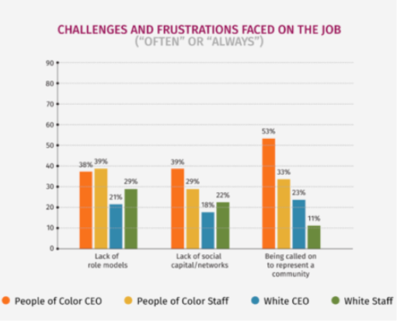
Figure 46: On the Job Challenges
DCLT is unique in that the Board of Directors comprises mostly people of color who desire diversity and to recruit people of color as well as other diverse populations for DCLT memberships, Board of Directors, executive roles, and staff. Studies emphasized that non-profits must have employees and leadership that mirrors the community they are serving; it is strategic in solving multifaceted social issues where diversity may be a significant influence underlying organizational performance (Knowlton, 2001).
According to the DCLT participating Board and staff, the uniqueness and complexity of the DCLT affordable housing model made it very difficult, and it is still difficult to recruit staff. The workforce pool in the CLT field or specialty is tiny, and many of the experts are already working for CLTs in other cities. DCLT stated their current efforts are to raise a workforce by training the community using their Community Leadership Empowerment Workshops (CLEW) to find their next staff. CLEW’s curriculum entails learning the city planning process, empowering personal leadership skills, and understanding community organizing. Perry stated:
“Our very first cohort, we piloted CLEW with a number of the advisory committee members. We had train-the-trainer and another fellow. We had people who participated in the train-the-trainer that were former CLEW participants, who would help teach the new group. We will be looking to expand CLEW in all of the communities that we're working in now.” (V. Perry, personal communication, January 2, 2020).
DCLT's Board was adamant in hiring qualified staff regardless of race; they hoped to hire a qualified person of color. Although the two staff are White, the Board stressed they are very talented. Furthermore, the Board described the staff as very people-oriented; therefore, they do not think their race will be a barrier to organizational performance. Also, Ward 8C ANC Chair Mike Austin stated:
“Ginger's resume seems super solid. I would have an issue if she weren't qualified and just got the position through nepotism. I don't have any opposition; she knows what she's doing, and she seems genuine. I would love a person of color to have that position, but I also want them to get it right. Who it is, I don't care about the color as much as getting it right the overall effect on the community. I've seen folks my color (Black) sell out the community. I want someone with a genuine interest and genuinely going to do the work because it's not going to be easy." (M. Austin, personal communication, February 6, 2020).
DCLT Board/staff stated they are actively seeking to have a tri-part Board and staff that is diverse and reflects the community they are serving. The National Council of Nonprofits posted on their website the importance of expressing and
“denouncing racism, bigotry, and intolerance. Nevertheless, taking a "stand" is not enough. Along with many other charitable non-profits, we are traveling a journey to identify how to build the core values of diversity, equity, and inclusion into all our non-profit operations, as well as a model of those values as we advance our mission. We believe that embracing diversity, equity, and inclusion as organizational values is a way to intentionally make space for positive outcomes to flourish, whether in the non-profit capacity building or public policy spheres.” (National Council of Nonprofits, 2020).
Like the National Council of Nonprofits' stance, DCLT professes its journey of inclusive labor by starting a community labor movement, raising the next generation of affordable housing advocates and community liaisons. DCLT looks to nurture a community to answer its own social and political problems. DCLT understands the need for and lack of human resources, therefore, they are energetic and optimistic in supplying their own need for employees through educational engagement workshops. DCLT is not alone in this feat. Studies show others face the same human capital shortages:
"As service providers, non-profit organizations report higher demands for their help. Moreover, as employers, securing and retaining a workforce with the right combination of knowledge, skills, and abilities has been a longstanding challenge for non-profit organizations both within and without the charitable subsector. Increased competition from other sectors for highly skilled employees, high executive management turnover, the labor intensity of some portions of the industry, and limited success in recruiting and retaining experienced volunteers all combine to make 21st-century human resource management in the non-profit sector and enormous demanding activity (Kearney, & Coggburn, 2016).
Besides, Bridgespan Group, a 20-year-old global nonprofit organization, conducted a non-profit survey for JP Morgan Chase (Kearney & Coggburn, 2016). Over 200 non-profits serving low-and-middle-income communities who participated agreed that the leading area's non-profits need increase support were:
- Fundraising (61%)
- Communications and Marketing (51%),
- Program Evaluation (38%),
- Performance Management (33%),
- Technology (31%)
- Strategic Planning (29%)
- Other less prominent areas were Bolstering Board Governance, Human Resource Management, Financial Planning
Funding: Although funding plays a role in hiring competent staff in the case of DCLT, finding staff, in general, was and still is difficult. As a result, the two staff manages an assortment of responsibilities in which they rely heavily on the Board. Despite not getting funding from the City government, DCLT was fortunate in receiving grants from various organizations to launch its start-up. DCLT Executive Director Rumph stated that the DCLT start-up funding stream was significantly enhanced by JP Morgan Chase's $3 million 3-year grant. BBAR won this highly competitive pro-neighborhoods grant to launch DCLT. The grant was given in 2018. Most of the funding has been allocated to land acquisition/securing space for permanent affordability, with the balance to help cover start-up operations, including the two staff members' salaries, consultants, pre-development costs, and more.
City First Homes is transferring the permanent affordability covenants of 153 affordable housing units in several housing cooperatives and a condo, along with 3 of its 44 shared appreciation units with second mortgages, which enables DCLT to launch with affordable units in its start-up portfolio. DCLT will also be taking on the responsibility of stewarding those units and over 20 units in a few other communities. Although DCLT appears to be off to a decent start with about 187 affordable housing units, studies show CLTs must maintain a mixed portfolio to remain financially stable and sustainable. Although co-ops are essential in providing affordable units, they do not generate revenue like shared-appreciation units. When CLT’s homeowners of shared-appreciation units sell, the CLT receives a more substantial profit split than from the sale of a co-op unit. A portfolio with many shared-appreciation units is beneficial. To do so, having key staff dedicated to property acquisition is advantageous and prevents staff burnout. Another issue connected to funding was the skepticism residents felt about JP Morgan Chase's hefty donation. Some residents are skeptics about DCLT having one large donor. They fear it can cause mission drift and believe that CLTs are a grassroots operation. Therefore, it should be funded like grassroots, from the community and not big banks or organizations, who may try to control the CLT activities, thus changing its mission. In the Revolution Will Not be Funded: Beyond the Non-Profit Industrial Complex (2007) book, authors emphasized the accountability struggle of non-profits as either to their funders or grassroots advocates; top-down or bottom-up accountability.
CLTs rely heavily on funding in its early stages as its sustainability is tied into its multiple activities especially the housing portfolio profitable shared-appreciation units. Once the portfolio is stable and prosperous, the CLT can become more self-sufficient. DCLT stated they aspire to have diverse long-term funding sources.
Since DCLT 501c3 tax-exempt status is still pending with the IRS, they would need a sponsor to accept donations. According to IRS, non-profit contributions received while it is pending 501c3 approval do not have an advanced assurance of deductibility., so tax-exemption status is not guaranteed. It may be challenging to find more willing donors without an accompanying tax deduction at this time. However, once their application is approved, any donation made prior can be tax-deductible and backdated. Technically the non-profit can accept contributions without tax-exempt status or get a financial sponsor before its approval. Despite these donation receiving options some donor organizations may still be hesitant. DCLT, like any non-profit organization's need for diverse funding, is indispensable.
Having consistent funders and a sustainable portfolio will enable DCLT to hire key start-up staff or consultants like community engagement coordinator, communication specialist, real estate property acquisition, governance (legislation), and a fundraiser. All these key start-up staffs can be tasked with many duties. For example, the following mentions a few responsibilities. A real estate property acquisition/consultant may aid a CLT to meet its internal land/housing acquisition goals, create and implement pathways to acquiring housing units. A governance specialist would be able to foster relationships with government officials, assist in writing legislation favorable to CLTs, and foster housing packaged development deals. A fundraiser can focus on ensuring that finances are continuously flowing. Most of all, a community engagement coordinator and communication specialist can market, build, and manage multi-level community relationships. Getting residents involved maximizes a CLT mission and goals and keeps those goals secured for future generations.
Mayor Bowser announced at the 2020 Conversations on Housing forum, elected officials and community leaders may put things in place to bring equity and benefits to the community. However, it is up to the residence to get involved and keep future leadership accountable (2020 Mayoral Conversation on Housing, personal communication, February 8, 2020).
Factor 3: Preliminary Resident Engagement/ Leadership Fostering
The Community Land Trust model enables DCLT to leverage the duality of residents playing both the roles of beneficiary and advocate. Residents are both the forerunner and backbone of DCLT; they put the "C" in DCLT. According to DCLT, their community outreach events, workshops, and partnerships consistently have good turn-out; however, they faced and still face many challenges. The following SWOT-AR analysis matrix is the collected responses from interviewees regarding the DCLT Preliminary Resident Engagement/ Leadership Fostering.
Table 11
SWOT-AR Analysis Matrix Factor 3
SWOT-AR | INTERNAL | EXTERNAL
PRESENT | STRENGTHS  -CLEW workshops  -Ramping up for Residential Engagement Process  -Aiding & witnessing people grow  -Intentional engagement – a variety of events and strategies  -Strong partnerships  -Board is cohesive, consensus (talk and care about engagement) | OPPORTUNITY  -Long timeline to educate residents  -Started early to get people involved before transactions  -More CLT units mean more CLT members to engage  -Aligns with Mayor Bowser plan to develop 12,000 affordable houses  -Gentrification – as new developments go up, more potential members (but can also be a threat)
PRESENT | WEAKNESSES  -Not having a brand or active website but still having to spread the word  -Still incubated under CF Homes no sponsor yet  -CLT is a complex model not easy for residents to understand model yet  - Time-consuming  - Limited staff -no dedicated outreach staff | THREATS  -Strong Adversaries  -Not in DC City Plans  -CLT complex model  -Some residents do not believe in Ward 8 having more affordable housing (other Wards should have more)  -People lack knowledge and assumptions of affordable housing comes with high crime, lower amenities, low home rates, and undesirables, which are people labeled as horrible neighbors  -Some residents feel their neighborhood is so undesirable it does not deserve quality housing developments
FUTURE | ASPIRATION  -Community-led robust memberships/board  -Designated Community Outreach Staff  -Community-led wrap-around-services  -Lots of community participation and events | RESULTS  -Residential Engagement metrics

DCLT Board and staff define residential engagement as alignment with membership. Jade Hall, DCLT Board Treasurer, stated:
"Engagement means residents from the community are joining the Land Trust…being active and caring to participate" (J. Hall, personal communication, January 2, 2020).
Maloon further adds engagement as:
“Having an array of ways for people to interact" (A. Maloon, personal communication, January 22, 2020).
According to Sheldon Clark, current chair of the DCLT Board of Director, adjunct Professor at Howard University's College of Engineering and Architecture, and co-owner of the architecture firm Define Design Group, stated the need for leadership fostering came about when interviewing candidates for the DCLT executive position. They interviewed people from England (Country) and Georgia-USA, which proved the lack of a pool of potential candidates with CLT experience. Moreover, Clark stated,
"The idea of something so central to our community, but we couldn't even put-up candidates from the community regardless of racial makeup; we didn't have candidates” (S. Clark, personal communication, January 19, 2020).
Rumph openly acknowledged and discussed the optics and reality of having her as the founding director to represent a community organization :
"Does come with difficulties; therefore, raising leaders from within the community is essential for the DCLT." Raising a next-generation staff of leaders from within the community is a crucial priority of DCLT” (G. Rumph, personal communication, January 6, 2020).
Mercedes ‘Meche’ Martinez, a DCLT Board member and realtor, stated:
"Ideally, if we're talking community control of land, it would be nice if the community was part of that and helped. The community wants to see people who look like them, act like them, talk like them, similarities of things they can relate to each other" (M. Martinez, personal communication, January 19, 2020)
Perry, DCLT Board member, and BBAR's 11th Street Bridge Park Equitable Development Manager stated
"The empowerment and momentum component that occurs when educating the community; seeing those who participate in leadership training grow to become community activists, and a source of information who disseminates to their community is invigorating for the Board" (V. Perry, personal communication, January 2, 2020).
Fostering leadership and residential engagement is time-consuming since CLTs in general are a very complex model, and DCLT has limited staff dedicated to this element. DCLT states that getting people involved early before transactions (community investments) occur will give residents the knowledge and skill to leverage investments to benefit and thrive in place.
The DCLT Board and staff stated they are incredibly cohesive in the goals of building up residents' knowledge base and skills in collaborating with DCLT. Although they do not have any memberships yet, they have put metrics in place that focuses on both upward mobility and engagement. DCLT budding metrics are put in place to guide them in recruiting District-wide members as the city ramps up housing provisions to meet Mayor Bowser's goal to build 12 000 affordable housing units by 2025. This goal is an opportunity for DCLT to acquire CLT units; more units means more potential CLT members to engage. The metrics for upward mobility will collect data on DCLT residents. The metrics are as follows: Residents
- Reduction of housing cost
- Increase in assets/wealth creation
- Stable employment or improved
- Salary increase or at the same pace with housing cost
- Resident able to live in the desired area or stayed in the neighborhood
- Work commute improved
- Residual effects of stable housing (ex: education attainment, health, stories about their living situations)
- The resident became a homeowner
- Housing security (no foreclosure or eviction)
- Leadership classes CLEW and Train-the-Trainer workshops (those who participated, those who became workshop trainers)
- Matched savings account
The Engagement component tracks data on leadership workshops, memberships attained, participation activities, and joining the Board. DCLT stated they have many resourceful partners who can assist them in offering services to the community. The Board and staff stressed the importance of asking the community first and then implementing the resources the community (residents and members) say they need and want rather than offering services DCLT thought were best. This approach reinforces the co-heirship with the community DCLT promotes. In knowing Ward 8’s history of predatory lending and schemes, DCLT outreach efforts excluded going door-to-door to avoid being portrayed as predators. A baseline multi-level stewardship agreement draft is pending.
According to Lowe and Thaden:
“Resident engagement is crucial for the success of CLTs. It also considers how resident engagement practices reproduce stewardship that challenges the conventional private market approach to property ownership while achieving resident awareness and explicit buy-in is critical. The CLT is not just for transformational alternatives to private market prescriptions for land use, tenure arrangements, and individualized property ownership. Transformation can be achieved by pursuing three intimately linked objectives (resident betterment, community control of land, and asset preservation) for intensifying stewardship. Together, these three activities are referred to as "stewardship" by CLT practitioners” (Lowe, & Thaden, 2016).
DCLT specific organization purposes listed in its Articles of Incorporation is its ability to
- "Act as stewards of an increasing inventory of perpetually affordable residential and commercial units that are affordable to low-middle income District residents and those entities which serve and benefit them and
- Foster leadership and community involvement in the creation and preservation of affordable spaces through a responsible and informed Board of community members."
DCLT aspires to raise knowledgeable residents that can advocate for their right to access high-quality, healthy affordable housing, to stay and thrive in their communities, and have a seat and power at the decision-making table. For DCLT to contribute to building economic, racial, and social equity in DC its processes must include a variety of DC residents in its request for a diverse supply of inclusive permanent affordable (ownership/rental) housing, community empowerment, planning, decision-making, and community development. "Researchers view resident engagement as a more purposeful and innovative attribute of the CLT sector compared to other sectors of community development.” (Lowe, & Thaden, 2016).
Two DCLT Board members stated Ward 8 residents have some experience in community advocacy and organizing. Advocacy is actions taken to influence decision-making within political, economic, and social establishments (Powell & Steinberg, 2006). Community organizing is the ability of a community to work together to achieve a shared interest. Despite Ward 8 residents having the same objectives, they may not always work well together. Either fighting for resources or recognition prohibiting them from accomplishing what they initially set out to do. Rumph, DCLT Executive Director and a native of Pittsburgh Pennsylvania, an area known for having a strong history of advocacy and organizing labor unions, adds,
"Ward 8 has some incredibly deep civic associations but connecting to power is very uneven." (G. Rumph, personal communication, January 6, 2020).
Advocacy that connects to power is crucial to impacting community decisions. Clark, DCLT Board member, and Ward 8 resident mentioned Ward 8 residents are
"not going toe-to-toe and meeting developers on equal ground and being able to shape the outcome of the development effectively. We have the power to shut down the development altogether, but it's never indefinitely more of protest or stalling. Stalling through court appeals, lawsuits, and injunctions have very little to do with the advocates' desired goal. Whereas, in other communities, they can negotiate and affect the development on the front end. At times, our residents are organizing after the fact on the back end. An excellent example of when Ward 8 residents worked on the front-end of a development project was when a grassroots organization asked for Bus Boys and Poets restaurant to come into the neighborhood or shaped how the Anacostia metro station will go into the community." (S. Clark, personal communication, January 19, 2020).
According to The Nonprofit Sector: A Research Handbook, some researchers “contend Americans are disengaging from civic involvement, “bowling alone” and substituting “checkbox” advocacy by professional social movements and “protest businesses’ for direct participation….from this viewpoint, advocacy has a minimal substantive impact on policy and contributes little too political and civic engagement” (p. 307)
Discussion
The most prominent themes affecting DCLT Preliminary Resident Engagement/ Leadership Fostering start-up were Skepticism, Lack of Knowledge/Misunderstanding, Disunity, and Limited Equity. DCLT is emerging more on the affordable housing scene, like a debutante coming out, capturing the attention, interest, and concerns of residents, public agencies, and private organizations. The secure connection stemming from DCLT Board/staff and BBAR’s outreach efforts has enabled DCLT to grow in recognition throughout DC.
The most significant inhibiting factor to Residential/Leadership Fostering mentioned was skepticism, limited equity, the concern for residential/community disunity, and, most of all, the community's lack of knowledge on CLTs in general. Potentially compounded on these factors is DCLT's limited capacity to pay its Board members, engagement/service locations, and branding DCLT as another affordable housing strategy. Maintaining a social media and community presence is challenging with limited staff for DCLT.
Branding is an essential component of any organization since it enables clients to recognize an organization’s offerings or services; it is the organization's distinct impression on audiences. The Board/Staff mentioned current grants pending would go towards operational support to help DCLT create and market their brand as an additional innovative, affordable housing option. According to Clark getting residents to become members and potentially be on Board is a feat since the Board positions are unpaid (S. Clark, personal communication, February 8, 2020). Having unpaid Board members in a predominantly low-income community may affect participation (S. Clark, personal communication, February 8, 2020). DCLT must also be mindful of creating the space for residential engagement to occur and the potential location disruption of partnering organizations that provide services to their clients. According to the D.C. Bar Pro Bono Center’s report, recent trends in gentrifying neighborhoods show a spike in non-profit organizations, like healthcare clinics, domestic violence, homeless shelters, schools, and other learning facilities, and art groups needing to move or enlarge their space to more accessible locations, which may be further away from clients. Also, being further from their clientele can create gaps for those clienteles who stay in the community and are not displaced (D.C Bar Pro Bono Center, n.d.). Gentrification has contributed to the displacement of indigenous community organizations and businesses.
Lack of Knowledge/Misunderstanding: According to the Board and staff, during their outreach efforts, they realized the community's resistance to DCLT is due in part to the lack of knowledge or misunderstanding of DCLT. According to DCLT interviewees the following opposition with an undertone of misinformation was spoken at DCLT outreach efforts:
- Oppose the DCLT model altogether; there is an anti-CLT Facebook page.
- Too much affordable housing being placed in Ward 8. These people feel other wards should share the burden of making equitable space for affordable housing. Also, the labeling of affordable housing as an attraction for high crime, lower amenities, low home rates, and undesirable neighbors moving into the community
- The belief they are undeserving of high-quality housing in their dilapidated community
- Since it is not in DC's official city plans it is irrelevant
- Suspicion of the model
- Limited Equity
To acquire a deeper understanding of residents' perspective of DCLT and gain more insight attendance at two Ward 8 ANC meetings, the 2020 Mayoral Continued Conversations on Housing forum, and Interviewing Ward 8 ANC Chairman was critical. DCLT does not have any members yet. A total of 51 people were given a semi-structured anonymous questionnaire 31 returned it, in which 21 heard of DCLT, and 10 did not hear of DCLT.
Residents' responses about CLTs were mixed. Statements regarding
Table 12
Advantages and Disadvantages of CLT
Advantages of CLT | Disadvantages of CLT
- A good option that will act in residents best interest giving them homeownership and prosperity, planned equity is best  - Believes all residents, especially low and moderate-income, should get involved but never mention why or if they are active.  - Empowering people, sense of pride  - I could play a role as a future homeowner. Keeping my family in Ward 8 would be a bonus as a single parent  -Preventing displacement, improving neighbor stability  -They live in a community, so they do have a role that includes advocacy. Gentrification affects me, so DCLT affects me based on who owns what  - Gives people the confidence to maintain their homes and hope in Ward 8  - Combats gentrification  -Sense of pride  - Wealth building  - Just heard about DCLT at an Arlington VA forum  - Keep speculators from getting rich | -Since they do not live in the community, they have no role as a single parent  -DCLT is sketchy since solely funded by one big bank  -Most of Ward 8 depend on the government, but people like me who work do not qualify  -No one in Ward 8 will qualify  -Concerned about community involvement  -We do not have control over process  -It limits people equity and slows down wealth building but may not necessarily be all bad  -Previous CLT in DC struggled in downturn  - Possible tax increase for single homes  - False sense of pride  -Targets non-formally educated residents who may not have background or experience to know other options.  -Makes money off the backs of low and moderate-income residents  -Can take a long to see results  -Benefits some but not all  -People may not purchase homes on CLT  -Limiting to certain surrounding areas as investments are spent elsewhere  -Socialist concept – if the government keeps out of the economy, the market will stabilize its supply & demand

According to Mike Austin, Ward 8C ANC Chair, who says he knows about DCLT but unsure about the qualifications details, which goes back to the Policy Factor (page 129) Bylaws being unclear on who or income-bracket the CLT will target.
“I support CLT as a vehicle to enable the community to invest and own the land. The biggest fear is who can buy-into the CLT; everyone won't get a share. Still, it is not a true representation of the community. If I am wealthier, I can buy more units. We need income diversity; DC does a lousy job of clustering poverty. Every building with 4-units is section 8. Businesses struggle to survive because they don't perform well in SE and the lack of amenities. It's unfair because it gives the impression we don't want, or we're not attracting new residents. It doesn't become partially or fully beneficial to affluent or non-native or non-long-term residents" (M. Austin personal communication, February 6, 2020).
Those who heard and did not hear about DCLT, but read the general knowledge about Community Land Trust, both shared similar comments about it as a potential affordable housing option. Other comments appeared rooted in skepticism from past disappointments and unfounded assumptions, as mentioned by the DCLT Board/staff. According to Clark:
“Skepticism existed, especially after the housing crisis, which came out in the community meetings, skepticism. These same banks that had ruined the economy and put out bad mortgages in our community are now somehow throwing millions of dollars to invest inside our community, a very hot button of contention. Separating people from their land sounds like the making of a scheme. It can be challenging, especially since the two staff members and BBAR director Scott Kratz don't come from or live in the community. People were skeptics at first even though their hearts and intentions are in the right place" (S. Clark, personal communication, January 19, 2020).
This skepticism is an essential element for administrators to consider when implementing plans in a historically neglected or disenfranchised community. Studies show that "whether residents seek out non-profits depends on many factors." One of them, according to recent research, is their perception of local government. A study by American University researchers found that the “more positively citizens felt about their government services, the more likely they were to use non-profit services as well.” (AbouAssi et al., 2019).
The National Community Reinvestment Coalition study discovered that gentrification occurs in phases. The first phase of gentrification is community neglect or reduction in supportive services in low-income neighborhoods, including lending discrimination and redlining. The final stage creates exclusionary zoning practices for disadvantaged populations, typically Blacks (Richardson, Mitchell, & Franco, 2019). Subsequently, the mental distress from feelings of no control or housing insecurity coupled with emotions of oppression from displacement as well as disadvantaged populations losing supportive structures and neighborhood members weighs heavier than fond memories and uneasiness with the unknown (Richardson, Mitchell, & Franco, 2019). Residents believe their skepticism is not unmerited. Residents want community development to be inclusive of their voices, especially people of color whose oppressively neglectful history is still repeating itself in covert forms. According to Mike Austin, Ward 8C ANC. Chair stated,
“I think we (community) must have a large voice on how the organization is formed. I talk to DC's Office of Planning all the time, and none of them look like me, or some of them are not even from here, and so the vision from the director and Mayor is always for us, and not necessarily with us and many times they come with their plan and try to tell us what they want to do. Many times, it's checking a box of engagement. The projects are already done, probably have developers ready to go. Then they just tell us, oh how do you feel about this, we can probably say no, and it won't change a thing, and that's not real engagement or responsible development or proper development with us” (M. Austin personal communication, February 6, 2020).
“DCLT is tied with the 11th Street Bridge Park project; they have been presented together. They will be catalytic for the community, the entire Ward and surrounding community"….." engagement has to be consistent and intentional talking with everyday residents, not just councilmen or elected folks. DCLT and BBAR engage the city in a meaningful way that I appreciate: understanding gentrification and how they don't want to cause it or displace people. DCLT and BBAR were transparent and had a plan to address concerns A plan that included a people aspect, a business aspect, monetary investment, which included a plan to slow down gentrification and be sensitive to community concerns. I see them being intentional about going to different civic groups to go above and beyond to talk to folks about the project” (M. Austin personal communication, February 6, 2020).
Martinez, a DCLT Board member, stated:
“People have stated the Bridge Park project, which initiated DCLT, is not for our community, it's for the community west of the river. It just happens to come to our side of the river….it is happening, but it’s not for them. and the land trust is connected to the Bridge Park, so people look at it as it not being for them, especially if they see leadership or board members who don’t look like them.” (M. Martinez, personal communication, January 19, 2020).
Skepticism also included the idea that community development was too lovely for their neighborhood.
"The aspect of something is nice and looks excellent or high quality. For instance, when a pool and recreation center was built in Berry Farms, another neighborhood in Ward 8, or the dance/exercise classes offered at the BBAR community center, people stated, "this isn't for us. Why would they build or offer something so lovely for us? (S. Clark, personal communication, January 19, 2020).
This perspective is two-fold; residents feeling unworthy of high-quality development or suspicious that more beautiful amenities coming to their community as a sign of approaching displacement. More beautiful amenities are being built for the desired higher-income in-movers who will eventually replace them. These skeptical viewpoints and experiences leave many conflicted with optimistic feelings about their future community development plans and the anguish inflicted by political and social alienation. Residents who do not become physically displaced fear their sense of community will be lost as the red carpet is rolled out for the wave of new residents pouring into their neighborhoods. Rumph stated the desire to find ways in their DCLT Pathways to Engagement plan to address feelings of disconnect. Rumph stated:
"We want to make sure that people feel connected to their community. So, they don't feel like folks in Northwest DC are deciding what is happening east of the river or folks in Anacostia is telling the folks in Deanwood what to do. We want to have people feel like they're closely connected geographically and also by tenure." (G. Rumph, personal communication, January 6, 2020).
DCLT aspires to ameliorate residents' and small businesses' fears of displacement. DCLT hopes to capitalize on DC's Office of Planning Comprehensive Draft Plan, which states DC's need to channel a more substantial amount of funding from its booming housing market to new affordable housing programs (Comprehensive Plan Housing Element, 2019). DCLT does not want to compete for existing housing funds but prefers to have new funding sources emerge for them; they want collaboration, not competition. According to the Homes for an Inclusive City Task Force report, DC can potentially lose over 10% or almost 30,000 affordable housing units and shelters. To avoid this catastrophe, every accessible unit lost must be replaced by a new affordable unit or a 1:1 ratio. In addition to addressing physical displacement, DCLT wants to create a sense of community belonging and empowerment through its membership and Pathways for Engagement processes. DCLT intends to rely heavily on a democratic process where members make decisions in both DCLT and their community. For DCLT to achieve its aspiration to leverage economic mobility for its participants and collaborators, identifying and discussing skepticism to create unity is critical. You cannot have a Community without unity.
Community Disunity Concerns: Skepticism can spur community disunity, which can negatively impact residential engagement. Mike Austin, Ward 8C ANC Chair, stated:
“My goal is to engage people as much as I can. The ANC meetings have maybe 100 people come out, which is not an accurate representation of the 18,000 people in Congress Heights. The overall majority of folks are not engaged in things that will drastically change their community. A CLT gives us a vehicle to include more members, engage folks, give them interest, so they are far more invested. People care about the tangible they can see. If you ask about zoning, they won't care, but if you say a Starbucks is coming or 100 jobs, then they care” (M. Austin, personal communication, February 6, 2020).
Concerns of disunity include both newcomers and current residents' apprehension from displacement. Many current DC residents agree with one DC resident and ANC Chair statement that:
“I feel like an outsider in my community. I go outside, and these people who have been here for 15 minutes look at me like, 'Why you here?' That's that sense of privilege they bring wherever they go; I have been here since '78. They have been here six months or a year, and they question my purpose for being here (Gringlas, 2017).
"There's no cure for gentrification. There's a real fear that it will negatively affect them to lose home and be displaced” (M. Austin, personal communication, February 6, 2020).
“Folks who move in don't get to know their neighbor or engage folks. They just get their alarm system and feel secure in their homes and never talk to each other; that's the difference between old-time DC to where we are now. Before, it used to be a small town where neighbors talked and the sense of community and pride; you knew your whole block. There's no sense of that now, that's the direction of low-income communities” (M. Austin, February 6, 2020).
Research indicated that gentrifying communities experienced lower community connections than non-gentrifying cities. Moreover, in a Philadelphia study, in gentrifying areas in which the Black and Hispanic population increased, and the White population did not, there were positive increases in feelings of community. Whereas an increase in wealthier White and non-White populations harmed the sense of community, highlighting superficial demographic diversity where people may be physically integrated but still not comingling socially (Ding, Hwang, & Divringi, 2016). Certain demographic changes in revitalizing neighborhoods can weaken community bonds. As one DC resident put it,
“You sometimes get the effect that nothing existed here before they came," said Lee. "(Gringlas, 2017).
All the goodness that has come with the gentrification and certainly the refurbishing and preservation of buildings has been material in nature, and very little has been done to preserve the human aspect of being transformed. We have our gathering spots; they have their gathering spots. The fact that we use the same sidewalks and streets has very little to do with ongoing communication. (Gringlas, 2017).
Studies show that residential friction can emerge as a community gentrifies, where current residents can feel alienated and experience intense emotions about being displaced both physically and socially (Ding, Hwang, & Divringi, 2016). Disunity also occurs amongst Ward 8 residents in their community. As mentioned above, community members express concerns and disagree with one another over certain redevelopments in their neighborhoods. According to Dr. Danilo Pelletiere, a senior housing advisor at the Department of Housing and Community Development (DHCD):
"Ward 8 is a large complex community, in which folks contact (DHCD) tend to be around certain projects or situations. We hear from a variety of folks, ANC, council people, a broad range." These residents voice their concerns, which can be opposing their neighbors." (D. Pelletiere, personal communication, February 12, 2020).
Also, disunity amongst DC residents occurs in other affordable housing programs like TOPA and co-ops, which are legal joint purchases by residents who own equal shares of their building. According to DHCD, when residents are unable to resolve their internal conflicts, they call on the City to intervene. However, the City encourages them to work it out as they are legally bound to each other as equal owning homeowners. This kind of experience adds to the District's hesitations to quickly support DCLT efforts to steward community control over the land.
Gentrification creates mixed feelings in many people, public and private organizations, either positive, neutral, harmful, or combined. On the flip side, some Ward 8 residents are optimistic about gentrification and have feelings of affinity toward incoming affluent neighbors, who come with improved amenities of better schools, public services, and reduced crime. These neighborhood improvements create feelings of well-being and promote civic participation (Ding, Hwang, & Divringi, 2016).
According to Ward 8C ANC Chair Austin:
“Investment for Ward 8 revitalization makes folks feel more comfortable in Southeast (SE) and want to check out Ward 8. SE has a terrible connotation of being drug-filled, crime-filled, and dilapidated. Some of it is partially true, but folks realize the value and what we have to offer over here. We have a sense of community. The 11th Street Bridge Park project will be a connector. When I talk to people, it's DC, and then it's SE mainly because of the body of water that separates us. It separates resources, amenities, jobs, opportunities, and a little better quality of life than what we have. SE is becoming the new hot place to go to on the map; hipsters put the pedal to the metal. Also, commercial real estate is still relatively cheap compared to the District” (M. Austin, personal communication, February 6, 2020).
Limited Equity: Another central stumbling block misunderstood is the limited equity DCLT offers homeowners. Residents struggle to understand DCLT homeowners not being able to sell their homes at market-rate. One DC resident stated DCLT
"Will keep people poor by undercutting their potential land value for the good of everyone. Socialist concepts always fail in the long run" (Anonymous, February 10, 2020)
Ward 8C ANC Chair Austin's response to limited equity resale profits was,
“I understand the resident's perspective. People will need to adjust their expectations. When a person is given many opportunities going in, there will be restrictions on how much you can take home. I understand the CLT perspective too. It's not perfect, but it's a good deal” (M. Austin, personal communication, February 6, 2020).
The DCLT model describes itself as being one strategy of affordable housing provision. It aids those who would never be able to become homeowners without the CLT. Also, DCLT's wrap-around services goal is to help renters prepare to become homeowners, as the money they save on rent can be applied to purchase a CLT home and then eventually if they can buy a market-rate home. Studies show many CLT units have been stepping-stones for participants.
DCLT leadership understands the hard work and long haul it must undertake due to Ward 8 inherited legal abuse of neglect combined with the preconceived notion that traditional real estate resale is the only option. However, DCLT believes a shifting of neoliberal and presumptuous paradigms must be addressed. The US is deeply influenced by neoliberalism when it comes to community revitalization and development (Lowe & Thedan, 2016). Neoliberalism favors the private free market with limited government involvement. Whereas DCLT is shaking up the community into being open-minded about the way they view land ownership. Rumph stated:
It's fundamentally a shift in the way that we're thinking about real estate and the way that we think about who gets to make decisions. Who gets to control what we think of as an essential public resource, shifting that from a wholly privately owned thing to a publicly owned or moving that definition to a real representative body that is the membership of a CLT” (G. Rumph, personal communication, January 6, 2020).
Some CLTs are not focused on the "C" part (Community) of the model, but more on the "L" part (Land). Therefore, community engagement is ignored in place of land acquisition for low-and-middle-income residents. Other CLTs struggle to get residents to engage since some residents' goal is just to obtain an affordable home. However, DCLT's mission is to get the CLT residents and DC district-wide residents involved through memberships. Although they are still an infant organization, they stated their focus is to ramp up intentional engagement.
Briefly mentioned in Chapter 2, CLT's history stems from ideas of India's Gramdan Land Gift program, where homes were initially given to needy residents, who quickly lost them. So, a trust or CLT was instituted to guide, help, and protect people from losing their land. Even looking at US history of the 40 acres and mule policy, freed Blacks were promised land that was later taken back from them (Gates, 2013). Current talks surround using CLTs as a modern-day reparation for people of color. When low or moderate-income do not have the means to obtain and maintain their homes, they are vulnerable and statistically more likely to lose their home. Studies show that foreclosure rates on CLTs are lower than the market-rate sector. When looking at the foreclosure rates of 2008, almost 2.3 million people lost their homes, but disadvantaged populations were affected disproportionately. A study conducted by Pew Research indicated:
“Higher rates of foreclosure were associated with unemployment rates that were higher than average and home price appreciation lower than average. Other factors linked to higher rates of foreclosure were higher rates of homeownership among immigrants and minorities, high cost of housing, and a greater incidence of higher-priced lending to Blacks and Hispanics’ (Kochhar et al., 2009).
According to the Economic Policy Institute, from 2007 to 2008, the US poverty rate went from 12.5% to 13.2%: an additional 2.6 million people living in poverty (Shierholz, 2009). DCLT aspires to ameliorate potential foreclosure and sketchy lending practices risks to low and moderate-income residents. By empowering residents through personal development services and helping them become more civically engaged in their communities as advocates. The goal is to create generational opportunities for wealth attainment for low- and moderate-income residents.
Within the neoliberal paradigm, some adversaries of CLTs tend to view personal financial gains in terms of generations and dynasties as it relates to resale equity. Accumulating wealth for themselves and future family, so they believe the CLT model will hinder their generational financial attainment goals. However, success cannot be judged on a limited timeframe like instant resale profits, especially where land speculation and development look more like an ever-increasing pyramid scheme. Short-term capital gains for one low-to-moderate-income individual through their home resale in the private-market is a remarkable feat. However, it still makes it difficult for the next low-to-moderate-income generation to acquire the inflated priced home. The CLT model aspires to create a generational dynasty of accessible, affordable housing for not just one, but many low to moderate-income residents. Research suggests that “CLTs may only be transformative to the neoliberal paradigm of property ownership when residents explicitly understand the inflammatory nature of the CLT and consciously acknowledge that the primary purpose for engagement is to bring about that transformation.” (Lowe & Thaden, 2016). Thus, helping residents understand the CLT model and assisting a community to work collectively toward its goal of community empowerment for land control increases CLT success.
Promoting Equity Acknowledging History: The battle for DCLT to create new equity is to overcome history. Fairness is reliant on social and historical context.
Skepticism, disunity, mistrust, lack of knowledge, concerns around limited equity, and apathetic voter/civic engagement are all mental byproducts of some ward 8 residents’ experiences, stemming from their perpetuating Environments, Personal factors, and Behavior. These perpetuating factors make up the Reciprocal Determinism theory discussed in Chapter 2 Literature Review.
This theory postulates that peoples' behaviors are not solely a reaction from learned behavior but a byproduct of their factors and actions that affect how they connect with their environments. To label or box, Ward 8 residents as unreliable civically engaged citizens would be premature in fully understanding their perspective. A person's actions are a combination of their environment and personal factors that are continually interplaying. Ward 8 residents or people of color are not stuck in the past or imagining inequity. Inequity is very much still alive but emerges in new forms. For example, look at the trends in Figures 47 (a, b, and c) and 48; over time, from 2014 - 2017, people of color incomes has been slow growing compared to Whites; from 2003 – 2019, Ward 8 residents have had the lowest household income and the highest unemployment rates and rent burden compared to other Wards.
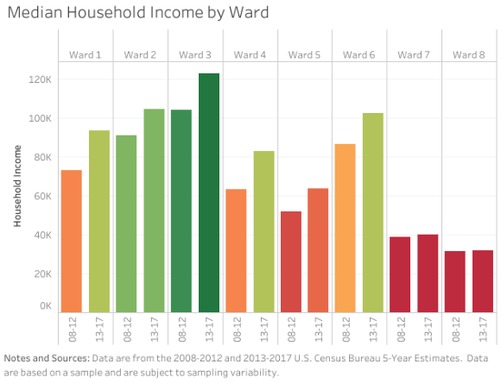
Figure 47 (a): Median Household Income by Ward

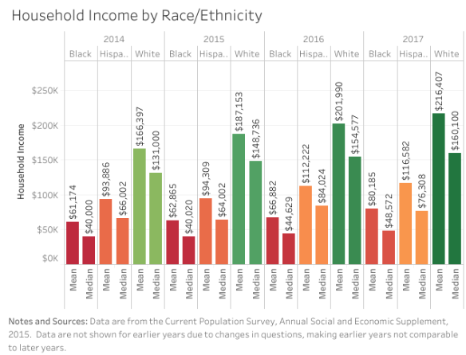
Figure 47 (b): Household Income by Race / Ethnicity
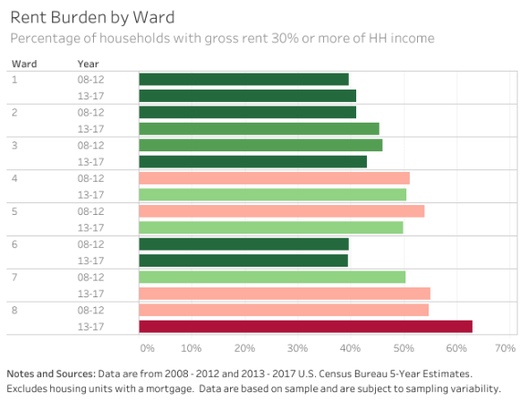
Figure 47 (c): Rent Burden by Ward
Figure 47: Three charts showing DC Income by Ward/Race, Rent Burden, and Unemployment rates by ward (Household Income by Race/Ethnicity, 2020)
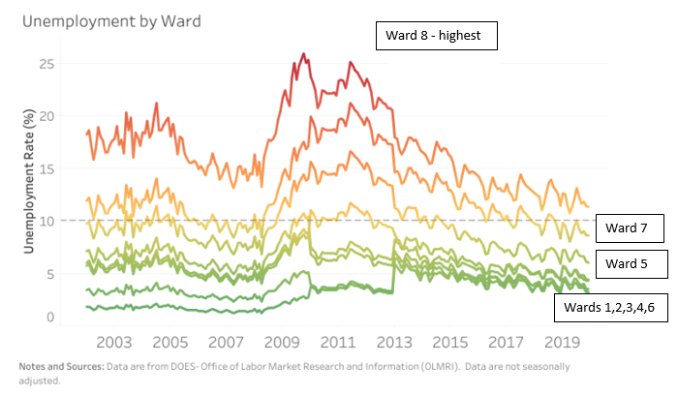
Figure 48: Unemployment by Ward (Household Income by Race/Ethnicity, 2020)

Ward 8 residents, in which about 92% are Black, are stricken with fears of being displaced as their neighborhoods are rapidly gentrifying; some believe history repeats itself. Figure 50 below shows DC has had the most displacement of Blacks in and near gentrifying neighborhoods than adjacent cities Alexandria and Baltimore from 2000 – 2013. Moreover, when analyzing trends from 1970 – 2015 in Figure 49 below the Black population has been receding in an eastern pattern in the District.
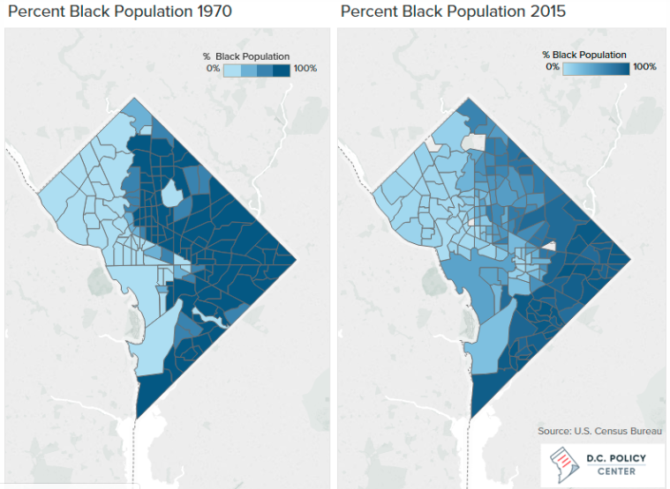
Figure 49: DC Black Population Change from 1970 – 2015 (Rusk, 2017)
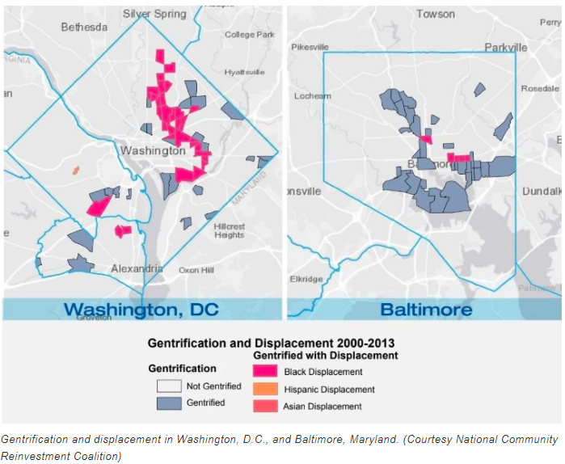
Figure 50: DC’s Black Displacement Rates near Gentrified Neighborhoods
According to the DC Policy Center, DC's distribution of wealth from homeownership opportunities and home values, in which $68 billion belongs to 100,074 homeowners, verifies deep-seated historical roots of inequality. Moreover, DC local and federal policies that revitalized the Southwest (SW) quadrant in DC, eliminated most SW buildings and pushed out
“15,000 businesses and displaced 23,000 residents, 70% of whom were Black and 90% of whom were poor….Almost half of the displaced residents moved to the far southeast (Ward 8 is also located), where 75% of the land was zoned for apartments—a policy with implications lasting today” (Taylor, 2018).
DCLT has the potential opportunity to disrupt Ward 8 residents' reciprocal determinism elements. By influencing all three factors via changing their Environment through providing affordable rental/homeownership/business space units; changing their Personal/Cognitive factors: through the offering of wrap-around services and a platform for personal development through its leadership workshops; changing their Behavior: through creating a platform for residents to exercise their newly learned skills/empowerment confidence as volunteers or community advocates, a few potential outcomes of participation. DCLT aspires to acquire community land control, so residents are at the forefront of changing their environments. Ward 8 residents' environment influences the intensity and frequency of their suspicious or apathetic civically engaged behavior. According to Ward 8C ANC Chair Austin:
“Ward 8 has been through a lot from a slew of our elected officials caught in scandals. ”Poverty pimping" (the coined term for a leader who intentionally keeps residents impoverished to profit at the expense of disadvantaged residents) makes some residents not want to engage or vote or do inconsistent or weird things at the polls—for instance, writing in any names like Mickey Mouse. These types of stunts make elected officials question if this Ward will vote for them. Many Ward 8 elected officials have won their seats from the majority of votes coming from other Wards. Also, some elected Council do not have good standing relationships with the Mayors' past and present, which can hinder economic growth in Ward 8, creating the inconsistent residential involvement of some residents” (M. Austin, personal communication, February 6, 2020).
From the history of neglect and discrimination that prevented many residents from safe and desirable neighborhoods and pushing them to oversaturated public and private deteriorated housing to the current displacement trends that have plagued this community for decades. The accessibility of safe quality housing is more than just fighting the rapid upsurge of housing prices. According to The Color of Law and Chocolate City authors, local and federal regulations segregated people of color into intentionally underinvested neighborhoods. Thus, prohibiting them from homeownership opportunities that build intergenerational wealth.
These underinvested neighborhoods were targets for the industrial industry to build landfills and land waste sites that were hazards to residents' health. Also, under the orders of the Federal Home Loan Bank Board, the Homeowners Loan Corporation created 200 neighborhood maps that scored cities based on racial, ethnic, and class prejudice. This scoring systemically devalued racially mixed and predominantly people of color communities, deterring private investments. Whereas White neighborhoods received subsidized construction for community development and mortgage loans. Furthermore, during the 1960s DC, had "more than 12% of black homes in the city lacking running water; more than 16% lacked electricity." This inhumane community treatment contributed to the stigma that "African Americans were slum dwellers in the eyes of Whites who lived in neighborhoods where integration may have been a possibility." The 1930s – 1960s Federal Housing Underwriting Manual enacted regulation cosigning the devaluing of communities where "undesirables" or disliked or unwanted people lived (Rutan, 2016; Babcock, 1932). Today, this sociological and ideological perspective remains unchanged in the way some people view certain races and the communities they live.
During these historical racial perverse times, zoning laws were also used to keep specific neighborhoods low-density, single-family homes, but oversaturated apartment buildings in low-income neighborhoods. DC has a history of exclusionary zoning. For instance, Ward 3 has mostly been zoned for single-family units, but Ward 8 consists of multi-family units. Early to the mid-1900s, DC's exclusionary and segregationist housing policies have impacted later generations and their ability to transfer wealth through homeownership. This and the social effects of residential segregation and disinvestment burdened people of color families. In 99% of Census tracts, Black boys have lesser incomes as adults than their White counterparts." This phenomenon has perpetually contributed to Black residents having lesser rates of upward economic mobility than their White counterparts.
Modern-day redlining, a strategy used to reject people of color access to specific neighborhoods or services, still exists but in subtle forms compare to the overt discrimination during the 1960s. To add to redlining would be greenlining, this dissertation coined term, which is the rejection of all low-income residents from specific neighborhoods. Subtle forms of disparity exist in access to resources or services, which also inhibits political involvement and influence, creating biased political agendas that benefit wealthier, more influential groups (Frederickson, 2005). Moreover, 90% of the USA's wealth is held by the top 20% of earners, confirming the exacerbated inequity of wealth distribution and setting the tone for unjust income diffusion. In the Revolution Will Not be Funded: Beyond the Non-Profit Industrial Complex (2007) book, authors describe this lopsided wealth distribution as a political/economic structure resembling a pyramid.
“In the United States, 1% of the population (top of pyramid) controls about 47% of the net financial wealth, and the next 19% of the population (middle of pyramid) controls another 44%. That leaves 80% of the population (bottom of pyramid) with just 9% of the remaining financial wealth. The result is that large numbers of people in the United States spend most of their time trying to get enough money to feed, house, clothe, and otherwise support ourselves and our families, and many end up without adequate housing, food, health care, work, or educational opportunities” (Paul Kivel, Social Service or Social Change Chapter, pg 130).
Furthermore,
“Top earners in this pyramid or ruling class have always wanted to prevent people at the bottom of the pyramid from organizing to maintain the power, the control, and, most importantly, the wealth that they have accumulated. At the same time, they have generally wanted to avoid directly managing people on the bottom of the pyramid. To maintain this separation and to prevent themselves from becoming the objects of people's anger, they have used legal, educational, and professional systems to create a network of occupations, careers, and professions to deal directly with the rest of the population. This buffer zone comprises all occupations that carry out the agenda of the ruling class without requiring ruling-class presence or visibility. Some of the people employed in the buffer zone fall into the 19% section of the pyramid; however, most have jobs that put them somewhere near the top of the bottom 80%. These jobs give them a little more economic security and just enough power to make decisions about other people's lives-those who have even less than they do. The buffer zone has three primary functions” (Page 134).
In 2015, the Associated Bank, NA, was charged with discriminatory and predatory lending practices for refusing loans to Black and Hispanic people; the case settled for $200 million (one of the largest redlining HUD cases) (HUD Archives, 2015). Former Housing and Urban Development (HUD) Secretary and 2020 Presidential candidate Julián Castro stated, "discriminatory lending practices have too often cut off too many credit-worthy families from the opportunities they need to thrive.” (Lane, 2015). Moreover, HUD final changes to the 2013 Disparate Impact Rule (Fair Housing Act), have caused many to express concerns that this amended rule tilts housing discrimination lawsuits in” favor of businesses, governments, and housing providers accused of discrimination, shifting the burden of proof to victims of discrimination (NLIHC, 2020; Federal Register, 2020; HUD, 2020)
DC Center Policy discovered that the gap "between White homeownership and Black homeownership was greater in 2016 than it was in 1900.” (Zickuhr, 2018). Though much of this inequality seems to be linked to the varying credit scores after the 2008 recession, other studies indicate that redlining is not entirely a relic of the past.
“It is still a serial displacement of people, culture, and lived experiences.…. African-Americans, Latins, Asians, and Native Americans are still more likely to be denied a conventional mortgage loan than White applicants in dozens of US metropolitan areas (including the DC metro area), even after controlling for the applicants' income, loan amount, and specific neighborhood characteristics.” (Zickuhr, 2018).
Although the federal government passed and continues to pass laws like the Fair Housing Act and many congresspersons, activists, and people fight to mitigate unfair housing treatment, pockets of discrimination still exist making it difficult for people of color to obtain the American dream of homeownership. Governments, institutions, and people all share in the responsibility to prevent and stop discrimination (HUD Fair Housing Act, n.d). We must all press harder to share in its solutions. America has come a long way and is better today than in its past; it is not where it used to be but not where it wants to or should be. Freedom is near and here. Freedom from the chains of oppressive thoughts, actions, and behaviors through the choices in treating others as we would want to be treated each day and never giving up in doing so because tomorrow gives you another chance to try again if you have fallen short today.
Between inherited prejudices and a history that keeps stagnating people of color, Ward 8's current community development efforts may make it difficult for low-and-moderate-income residents’ upward mobility into quality housing or maintaining their existing homes. These rapidly changing community developments are a potential petri dish for catastrophic homelessness if not handled with responsible equity. DCLT aspires to intervene as one of the accountable equity housing options.
“When people get together, they build community by establishing projects, organizations, friendships, connections, coalitions, alliances, and an understanding of differences. Identifying common goals, supporting each other, working for organizational and institutional change, building community-these are the elements of creating a better world, and fighting against the agenda of the ruling class. These activities put us into a contentious relationship with ruling-class power” (Paul Kivel - In the Revolution Will Not be Funded: Beyond the Non-Profit Industrial Complex, pg. 141)
Factor 4: Community Land Control: DCLT has several strategies to acquire land. Plans include partnering with developers, contractors, and residents by providing direct loans in exchange for making the land permanently affordable. DCLT aspires to partner with the City government like other cities to take advantage of the Mayor's quest to build 12,000 affordable housing units by 2025.
The following SWOT-AR analysis matrix is the collected responses from interviewees regarding the DCLT Community Land Control
Table 13
SWOT-AR Analysis Matrix Factor 4
SWOT-AR | INTERNAL | EXTERNAL
PRESENT | STRENGTHS  -Acquiring approx. 187 units  -DCLT Board connections/expert in housing acquisition (real estate agent, architect) | OPPORTUNITY  -Mayor’s goal build 12,000 affordable units  -Many development projects occurring in DC; can partner with developers, residents  -As neighborhoods beautify from development, many homeowners needing funding for repairs may partner with DCLT for funding
 | WEAKNESSES  -Housing transferred from CF Homes mostly coops and not profitable shared-appreciation units  - Not one dedicated staff hired for property/land acquisition yet  - Funding | THREATS  - DHCD – not enough support & red tape/administrative burdens  - Limited housing stock/High property values limit the capacity to grow property portfolio & members  - High property and improvement taxes  - Developers (competitors lack interest in building affordable housing) – Opportunity zones  - Housing Subsidies expiring 2020-2022 (displacing of residents but potential DCLT members)  -Other organizations providing affordable housing may feel DCLT competes with their resources  - Housing rates in Ward 8 increasing rapidly as wealthier residents/ development moves in.
FUTURE | ASPIRATIONS  - A CLT friendly tax legislation  - Diverse long-term funding  -Community-driven land control  - Robust active membership  -Membership/Board truly aligning to Bylaws with tri-part community representation  -Members feel connected geographically and tenure type (short or long-term tenants) | RESULTS  - Staffing Plan: Acquire Key Staff (Community Engagement /Communications, Real Estate Property Acquisition Consultant, Governance, Fund Raiser)  - Pathways to Property Acquisition metrics  - Collaboration with Ward 8 council on Draft legislation  - Policy Advocacy (Acquiring land, getting tax/zoning laws favorably amended) increasing portfolio units & members

In general, CLTs are not just focused on one project on one piece of land or neighborhood; they are interested in scalability, acquiring an ever-increasing portfolio of land for affordable housing. Therefore, CLTs tend to be scattered throughout their service area. Scattering CLT units create income-heterogeneous communities. According to the National League of Cities, "creating equitable and inclusive communities with the opportunity for all can lead to a level playing field where everyone has a chance to succeed."
When communities are divided or homogenous based on race, income, and geography, access to resources, amenities, employment, affordable housing, quality education, and healthcare decreases for low-income residents. Moreover:
"More segregated counties have higher rates of severe cost-burden, for both White and Black households. However, Black residents face greater barriers to opportunity and health than White residents. Nearly 1 in 4 Black households spend more than half of their income on housing. Severe housing cost-burden affects health and is linked to barriers to living long and well. Across counties, increases in the share of households severely cost-burdened are associated with more food insecurity, more child poverty, and more people in fair or poor health.” (2019 County Health Ranking, 2019).
In the case of DCLT, their priority area is Ward 8, since significant investments coming to the area will put many residents at risk of becoming cost-burden or displaced. Also, DCLT aspires to have just one large CLT non-profit organization but affordable housing units throughout the District. Ten years ago, many CLTs housing portfolios were small, comprising of one urban neighborhood or rural area. However, today almost 70% of CLTs portfolios are comprised of units in multiple neighborhoods or the entire city/county/ or multi-county region. Depending on the CLT's ability to acquire land, a CLT portfolio can grow sluggishly or rapidly and can be confined or spread out (Davis, Jacobus, & Hickey, 2008).
DCLT's property portfolio is still being solidified as they separate from City First Homes. DCLT is also trying to enact favorable legislation that will enable more funding and land acquisition for its low-and-moderate-income residents. DCLT emphasized their aspirations of getting legislation that creates new sources of funding and support to avoid competing in other housing programs resources. Legislation proposed by Councilman Trayon White attempted to acquire funding and land for CLTs, in general, but the bill did not pass. Although the legislation was premature, needing more detail and editing, according to the DCLT Board, it was a good start in the local government showing support. According to Rumph, DCLT Executive Director, legislation can aid DCLT with a list of things, including amending current laws and enacting new laws.
“Things like land dispossession you get from the District of Columbia or from private owners for that matter. It is amending some tax laws so that it can potentially expand the universe of affordable housing projects that can get a waiver for taxes. Taxing affordable housing properties on the one hand and then, on the other hand, the government gives an active voucher because of all the debt the housing project has to carry and expenses it can't afford. So, this arm of the government gives them money to be able to pay for the taxes that the government mandates on the other arm. Why would you do that? This was one of the most shocking things when I came here from Pittsburgh. When we did real estate development in Pittsburgh, we rarely created an affordable housing development that had permanent long-term debt. We didn't do that because they couldn't afford it. If the government and philanthropy as the developer couldn't get together a package that did not put a ton of debt on the building, you didn't do the project. We don't do that here in DC." (G. Rumph, personal communication, January 6, 2020).
DCLT aspires to obtain legislation that alleviates tax pressures for CLT properties and residents. In Figure 51, property assessments have gone up in DC for single-family and condos from 2006-2018.
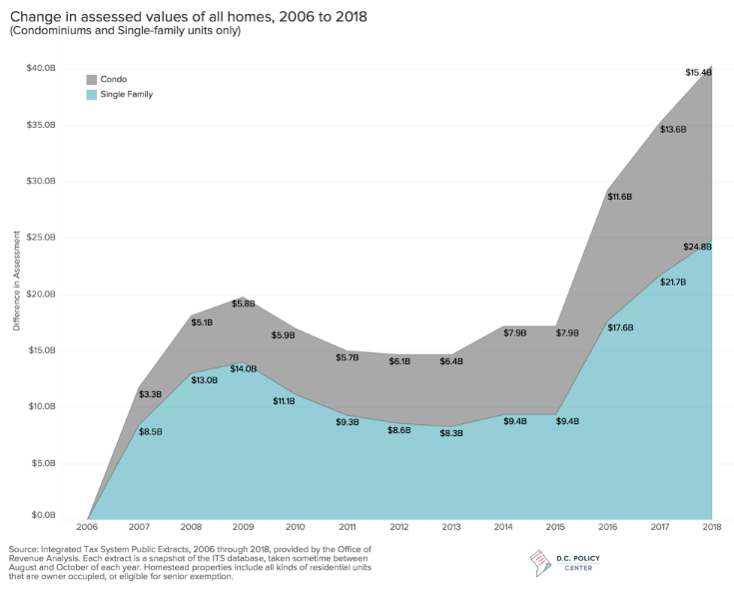
Figure 51: DC Property Assessment from 2006 - 2018
DC's tax laws have had inadvertent adverse effects on racial equity in its public programs. According to the DC Fiscal Policy:
"Homestead deduction and property tax cap create inequalities within neighborhoods. The tax policies that support homeownership could have good intentions, but they result in amplified inequalities that are sharper along racial lines. Of the $163 million of housing tax expenditures, more than half ($88 million) is due to 2 programs: Homestead Deduction and the Real Property Tax Cap. The homestead deduction exempts a fixed amount of housing value from real property taxes for owner-occupied homes. In 2018, this amount was $73,450. The real property tax cap limits the growth in the taxable assessments of owner-occupied homes to 10% (and beginning next year, to 5% for seniors with low incomes). These two tax preferences have affected different parts of the City in different ways, benefit parts of the City where price appreciations have been most dramatic. These policies have created all kinds of inequalities, some systematically reflecting the different appreciations that follow the path of gentrification."
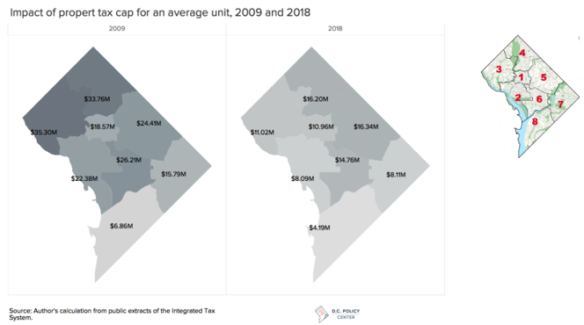
Figure 52: Impact of DC Property Tax 2009 and 2018 (Taylor, 2018). DC other 7 wards had higher tax caps impact when compared to Ward 8
As seen in Figure 52, Ward 8 (lowest right corner) had the smallest tax cap impact than the other Wards in 2009 and 2018. These higher tax benefits were concentrated in DC’s Wards with higher-income and homeownership rates. Overall, declining rates from 2009 and 2018 are partly due to the 2009 recession affecting home prices. “In 2018, 53% of the value of the tax expenditures associated with the homestead deduction and property tax cap benefited the rapidly gentrifying Wards of 4, 5, and 6.” Furthermore, Wards 2, 3, 4, and 6 hold 72% of all homeownership wealth, whereas Ward 8 holds 2%. In Wards 7 and 8, there are no homes assessed over $750,000, and 66% and 78% of single-family homes are under $250,000. In Ward 2, 92% of home values are at or over $750,000, and Ward 6 has 94% of households over $750,000. To give proximity to the stark differences, Ward 2 is four miles from Ward 8, and Ward 6 is even closer at three miles away from Ward 8 (Taylor, 2018).
Tax advantages from the District will enable DCLT Ward 8 residents to obtain and maintain homeownership opportunities. Reduce tax incentives assists DCLT as they acquire and provide affordable rental units. “Of the 120,000 DC households headed by a Black resident, 73,500 rent their homes.” Black homeowners hold a meager share of the housing wealth—mostly because of where they live.” (Taylor, 2018). Research indicates that many CLTs get support from their local appraisers in valuing and taxing CLT units different from market-rate homes to produce and preserve affordable units for low-to-moderate-income homeowners (Davis, Jacobus, & Hickey, 2008). As mentioned earlier, Pennsylvania is experimenting with getting rid of repair and building taxes in place of taxing the land heavily since taxes on buildings are a disincentive not to build. Taxing the land puts stress on CLT as they own the land to make the physical property on the land affordable to those who are unable to compete in the private market, so a tax break or incentive enables CLTs to be sustainable in soaring markets. The National League of Cities emphasizes
“how governments at all levels are partially responsible for many of today's stark inequalities; therefore, the government must be the forerunners of solutions. Federal, state, and local public policies have created and exacerbated many of the disparities that our communities are struggling with throughout time (ESSENCE, 2003).
Furthermore, a study done on tax practices by DC Policy Center stated that:
"No matter how many adopted policies even with gains like building codes for safety, taxation to raise money for services, zoning to preserve neighborhood character, and—much later—anti-discrimination laws, rent control, public housing, participation in federal programs (such as FHA loans and Section 8 rental assistance), Housing Production Trust Fund, DOPA, and TOPA laws, Inclusionary Zoning requirements, preservation efforts to reduce housing discrimination, encourage housing production, preserve some neighborhoods affordable, and increase affordability in others…. they have not stopped the growing cost of land inequalities in homeownership.
DCLT has yet to receive incentive start-up funding or land from the District, DCLT must compete for both City and private sector land. The famous line from an Award-winning Academy film "Gone with the Wind" could be one of DCLT intro anthem song,
“Why, land is the only thing in the world worth working for, worth fighting for, worth dying for, because it's the only thing that lasts.”
DCLT leadership view "community control of land" as the notion that their residents are in charge and get a voice on what happens in their community land trust. Therefore, the Board/staff emphasizes the need for engagement via residential memberships and Board members. Rumph stated:
“It has to be people in the community, making decisions about what happens to the land and land can't just simply be sold to any private individual in our context. It has to be that land is remaining permanently affordable, and potentially additional use restrictions might be placed on it. For instance, on the commercial side that it remains available for use by small local businesses and the type of businesses the community wants. Community land control can't be that in name only, or it will just be a self-perpetuating non-profit board of directors. It has to be the members, the people in the community who have a say about what is happening to their community." (G. Rumph, personal communication, January 6, 2020).
To accomplish their quest to obtain land, DCLT has drafted a Pathways for Acquisition Plan, which has seven different principles to acquire land, including deed-restrictive covenants or permanent legal/clause restrictions to keep a unit affordable. DCLT is very clear that they have no intention of playing the developer; they prefer to partner with mission-driven developers. Rumph stated:
"What we have been doing is working and talking with trusted developers that are mission-driven, whose mission aligns with us, and see if there are opportunities for us to partner in and fill a gap in some way. It might be financial or programmatic so that we can get permanent affordability in exchange. We are looking at another pathway to provide funding directly to folks who are looking for housing. So, we have an emerging partnership with a housing counseling entity. This entity provides housing counseling that works with very low-income individuals trying to purchase their first home. Also providing some additional capital for these individuals in exchange for the land. We are looking at ways to acquire land through policy shifts within the government. There are some specific things that we're looking at, right now, we are trying to determine if we can take advantage of any existing legislation, existing policies." (G. Rumph, personal communication, January 6, 2020).
DCLT has been seeking opportunities to partner with developers while pending its 501c3 tax-exempt status. Since waiting on this tax-exempt status may create an obstacle for them to receive donations, DCLT prefers not to become developers in funding their own building construction. Rumph emphasized:
“So right now, we might need to rely on development partners. We do not want to be a developer. That's not our intent. We want to partner with developers, but we will serve as a joint developer. We will partner in a lot of different ways, but we are not here to compete. We're not here to compete as a developer." (G.Rumph, personal communication, January 6, 2020).
Pathways to Acquire properties into the Douglass Community Land Trust (DCLT),
- Direct Funding to Developer – DCLT will partner with developers by providing subsidies on new or existing projects like new construction, preservation, residents exercising TOPA rights, existing limited equity housing co-ops that need modest renovation where cash flow does not permit
- Acquisition of "Unimproved" Lots – DCLT will hold these lots short-term in which the community decides how it will be utilized either for housing or other public assets. DCLT will publicize a Request for Proposals to partner with a developer to do the actual work.
- Unimproved Lots are considered land that does not have basic amenities, including electricity, telephone, street access, or the availability of water utilities. It is land that requires upgrades to become livable. Upgrades could be minor like utilities to landscaping or building structures or streets.
- Although Unimproved lots require research on its prior usage, suspicious title insurance, deed restrictions, getting utilities to the property, and environmental hazards, they offer excellent cheaper opportunities to create the highest and best usage of the land. DCLT must be careful with unimproved lots left unattended as DC Code Annotated 16-1113 and 12-301 allows squatters to have legal rights over the land they illegally occupy after 15 years
- Partnership with a Developer and Contractor – DCLT will partner with a developer by first finding the property (single or multi-family) needing minor repairs. Repairs will be contracted out, which DCLT will oversee. The property will be purchase by the developer. DCLT's contribution will be monetary throughout the process in exchange for permanent affordability. Properties may also be Real Estate Owned (REO), which are properties owned by a lender (bank, government agency/or loan insurer) that failed to sell at a foreclosure auction
- Direct Funding to Home Buyer (Single-family Home Ownership) – DCLT will provide extra funding at closing to reduce the cost to the homebuyer who could not purchase the home without assistance. The homebuyer finds the home they wish to buy. One of DCLT's partners is Ward 8 Homebuyers Club, a free club that preps future homebuyers or other entities within the community that assists homeowners needing additional subsidies.
- DCLT will also provide funding to homebuyers whose homes need repairs. According to DCLT, there are a limited number of low-income housing units in livable conditions in DC. Available housing units for households whose annual incomes range from 60,650 – 97,040 need renovation. Also, the HUD 203K policy has limited repair coverage, and the maximum repair payout is $35,000. HUD 203K is an "insurance that enables homebuyers and homeowners to finance both the purchase (or refinancing) of a house and the cost of its rehabilitation through a single mortgage or to finance the rehabilitation of their existing home” (HUD.gov/203k, n.d.)
Option 1: The homebuyer could use DCLT funds instead of 203K. The buyer works with an approved contractor, DCLT funds can be layered into any additional programs like HPAP.
Option 2: Either DCLT will partner with the developer, who owns the home, completes repairs, and then sells it to the buyer, who will be given funding at closing in exchange for the land deed; or the developer will take ownership of the home for the portion of the renovation that exceeds the amount able to be financed by the buyer. Repair, then sell to the buyer
- Land- Owner Donations – property-owners whose mission is to keep long-term affordability can donate or sell their home at a reduced rate to DCLT and receive tax breaks. If the property needs repair, DCLT will partner with a developer to directly oversee repairs in which DCLT will pay for repairs and sell the home to the buyer.
- DCLT Direct Acquisition of Properties From:
- DHCD or other District-owned PADD
- REO
- Private Housing Market
The acquisition will be through DC’s Department of Housing and Community Development (DHCD) or the District-owned Property Acquisition and Disposition Division (PADD), and REO. Note: PADD is responsible for "decreasing the number of vacant and abandoned residential properties in the District, and transforming vacant and abandoned residential properties into homeownership opportunities
DISCUSSION
DCLT's most pressing issues influencing their ability to acquire land are Deficit in Housing Stock, Expensive Land Value, Lack of Support from the City, and Zoning Regulation.
Deficit in Housing Stock: According to DC’s 2017 Census data, there are an estimated 308,161 housing units, but only 277,985 are occupied, leaving about 30,176 vacant units in the District's housing stock. DC's 2015 Posts from the Office of Revenue Analysis shown in Figure 53 below revealed that DC has 300 million square feet of vacant, unimproved land in which (a) 24 million is owned by non-profit, non-taxable entities such as hospitals, universities, and churches (b) 14% or 42 million square feet are owned by private entities and individuals concentrated in zip codes 20017 (mostly Ward 5), 20020 (mostly Wards 7/8) and in 20002 (mostly Ward 2) (c) 34 million square feet is owned by the District and District's Housing Authority (d) the US government owns 197 million square feet of land or 66%-of this, 133 million square feet are in Wards 7, and 8. (e) The DC and US government jointly own 53 million square feet of land concentrated in Ward 8 or zip code 20032. With all this land, the Office of Planning estimated DC could add 175,000 new households for a total of 485,000 units by 2040 (Taylor, 2015). DC's 2019 housing trajectory in Figure 53 shows the 175,000 additional housing units will not be entirely met by 2040; it will be short by 28,110 units in 2050.
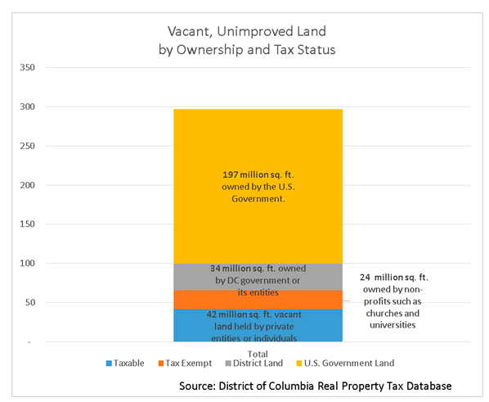Figure 53: DC's Vacant Unimproved Land
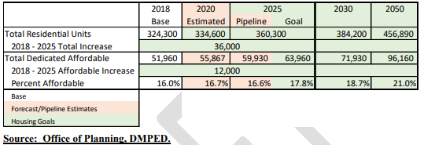
Figure 54: Total Residential and Affordable Unit Goals 2018 – 2050 (Office of Planning, n.d.)
DC's 2019 Comprehensive Draft Plan states DC must increase housing production, and the housing stock is predicted to increase 97,000 units from 2015 – 2035. According to this report, there are currently 324,300 total residential housing units. From 2015 – 2020, 23,000 new units are expected to be built. The current aggressive housing construction goal is 36,000 units from 2018 to 2025 for a total of 360,000 units by 2025. This goal requires the construction of 5100 new units annually, requiring DC to increase its current permits issuance from 4,483 units annually to meet the goal.
Repurposing existing stock plays a significant role in providing market-rate and affordable housing, enabling the opportunity for DCLT to acquire properties. However, the current shortage still exists. For example, DC’s population spiked by 13.2% or 79,447, but housing stock rose by only 5% or 16,999-units from 2010 – 2016; the population almost tripled compared to housing (Taylor, 2018).
The availability of housing units across income levels is unevenly distributed. Wealthier families are occupying affordable housing stocks for extremely and middle-income households. "The 3.5 million out of 7.5 million rental homes affordable to extremely low-income are being rented by higher-income tenants" (National Low-Income Housing Coalition, 2018). "Nearly 1.1 million very low-income, 1.1 million low-income, 400,000 middle income, and 1 million above median income households occupy rental homes affordable to extremely low-income households (National Low-Income Housing Coalition, 2017). Making them unavailable to extremely low-income residents; resulting in a shortage of 7.4 million homes for the 11.4 million extremely low-income households” According to 2018 Taking Stock of The District's Housing Stock report, DC's wealthier singles, seniors, and young couples are occupying larger apartments, limiting the supply of family-sized housing stock for families (National Low-Income Housing Coalition, 2017). Studies reveal that building housing units for higher-income households can also create more space for lower-income households to obtain homes.
DC's housing phenomenon creates both a dilemma and an opportunity for DCLT. The current Mayor's goal to build more overall housing units and designate some to affordable housing will enable DCLT to place itself to compete strategically. Moreover, the Mayors' plan to build affordable housing per Ward enables DCLT to expand its reach into other DC Wards if it decides to do so. However, the influx of new residents and the housing market's inability to keep up at the same pace will also make it very challenging for DC to acquire affordable land in a highly competitive market. Also, the Mayor’s affordable housing goal per neighborhood may limit the number of units in Ward 8. This neighborhood limit on the affordable housing goal is a response to spread affordable housing throughout the wards and reduce the concentration of affordable units in one Ward. DCLT will need a competitive advantage from the City. Right now, DCLT has no unique collaboration, legislation, or benefit with the City.
Expensive Land Value: Compounded on DC's inadequate housing stock is its high land value. According to Mayor Bowser, "we know the land value. We won't be able to do a lot about land value in the District." Many have concluded, especially city officials, that gentrification cannot be controlled only managed. Skyrocketing land value, which can make up 20% and even go up to 60% in major cities like DC, is a force of nature that seems impossible to combat. DC has a small number of starter homes or homes under $560,000 in its inventory that is affordable to moderate-income households (Taylor, 2018).
Mayor Bowser's goal to build 36,000 homes with 12,000 being affordable will enable wealthier residents to move into the newer homes freeing up affordable units coupled with the 12,000 proposed units that will allow DCLT to bid for the land. DCLT's overall mission is to create equity for low-and-middle-income residents and enable homeownership opportunities for those who otherwise would not be able to own a home. Urban studies report that when new market-rate units are available for affluent residents, the displacement of low-and-middle-income families reduces. The California State Legislative Analysis Office study found that. "California communities with the greatest expansion of market-rate housing had the lowest low-income displacement. U.C. Berkley's Karen Chapple and Miriam Zuk discovered that new market-rate homes have almost half as much impact on measured displacement as building a subsidized home enabling space for low-income residents to stay in place." These findings, amongst others, led DC Fiscal to conclude that these same market forces in which more market-rate homes were built reduced displacement, therefore, it may be possible in DC when new market-rate homes are built.
More market-rate housing will potentially become available as private-city housing partnerships expire, resulting in affordable housing units being converted to market-rate. Many 20-40-year affordability contracts like section 8 on apartment buildings are expiring, in which several are located in gentrifying neighborhoods. Approximately 13,700 contracts had expiration dates between 2016-2020. Also, 30-year requirements for Tax Credit on affordable housing units will pass (Comprehensive Plan Housing Element, 2019). These expirations can be problematic and create more displacements and homelessness for low-moderate income residents. However, with laws like DOPA or TOPA, in which TOPA gives tenants the first-right-to-purchase if their building goes up for sale or DOPA the District can purchase the property to convert to affordable housing; both laws give residents a fighting chance against displacements. Many can look to DCLT to manage different purchase options since it can be a costly, time-consuming nuisance for property owners and the city to buy, sell, or manage these affordable housing units. DCLT can appeal to the city or property owners in providing tenant management services should a developer renew its contract with the City or work with tenants in using their TOPA rights or DCLT direct purchase of the land from the developer. Also, laws like inclusionary zoning, a law requiring developers to set aside 8-10% of new or rehab apartments for low-income residents (DC Municipal Regulations, 2018; DHCD, n.d.), can create an opportunity for DCLT to acquire or manage those set-aside units by relinquishing the developer from having to monitor those units (Comprehensive Plan Housing Element, 2019).
Developers participating in affordable housing programs are required to check and manage affordable units to ensure tenants meet the requirements. The activities involved in maintaining these units can be demanding to some developers who are new to or dislike the process. DCLT aspires to take advantage of this opportunity by offering its fee-for-services to maintain these units for the developers. DCLT can position itself as the liaison between public-private partnerships. Also, the DC Comprehensive Draft Plan proposed a Public-Private Affordable Housing Preservation Fund to combat losing affordable housing contracts. "This innovative fund mixes both public and private dollars to provide rapid bridge acquisition and predevelopment financing. Capitalized in 2017 with $10 million of public financing, with an initial capital of $30 million from private partners, the Fund could leverage a total of $80 million toward the preservation of expiring affordable housing.” These opportunistic circumstances can threaten or benefit DCLT.
Lack of Support from City: Currently, DCLT has not received any land, discounted land, tax breaks, or special incentives advantages to compete for City land. According to DCLT Board/Staff, they are in the works of drafting legislation and pioneering for assistance. Studies show that:
“Public resources are offered to CLTs because municipal officials are convinced of the CLT’s worth and committed to its projects. They have the same stake in seeing the CLT succeed as the CLT’s staff. The challenge lies in finding the most supportive and productive ways of putting these resources to work. Too many municipalities have structured their assistance, regulated the CLT’s activities, or taxed the CLT’s homes in such a way as to undermine the productivity and sustainability of the model they have decided to support” (Davis, Jacobus, & Hickey, 2008).
According to DCLT Board/Staff, the DC government’s lack of action is slowing down and, at times, hindering their start-up efforts. Furthermore, some developers may be hesitant to partner with DCLT due to DC’s government, which includes DHCD, bureaucratic red tape, and exhausting administrative burdens in getting City approval on an affordable housing project. Housing developers’ greatest desire is for “DC government agencies to create smoother, faster paperwork processes, including building/paperwork inspections. Common complaints from housing developers were that “DC government agencies complex administrative processes, untimeliness in processing applications, tedious application bureaucracy, and unprofessional, rude behavior” (Ground Solution Network, n.d.).
DCLT aspires to collaborate with the DC government like many other successful CLTs around the country have and are doing. Partnership with the DC government, that is, real substantive collaboration, may bolster DCLT’s ability to secure permanently affordable spaces and provide necessary long-term stewardship, i.e., post-purchase asset management and technical assistance. DCLT’s model is to work with others who are developers and homeowners. Since the DC government also serves as a gatekeeper to other organizations and residents. DCLT states that being in partnership with the DC government is critical. Specifically, the Department of Housing and Community Development (DHCD), which is DC’s agency responsible for providing an array of services to people and organizations seeking housing or business development opportunities in DC. DHCD is also headquartered in Ward 8.
DHCD is faced with its agency’s red-tape regulation, which is a type of administrative burden placed on an agency to create and obey guidelines/protocols/actions that some view as rules that do not add value or legitimize the proposed reason they were established (Tummers, 2016). DHCD must effectively work within its red-tape bureaucracy entanglements that involve handing out administrative burdens attached to housing projects. Research reveals that administrative burdens influence organizational behaviors and are perceived, from a citizen or organization’s staff, as impediments that can diminish program take-up (Herd & Moynihan, 2018).
Administrative burdens can make demands that organizations cannot deliver, affecting quality and service outputs resulting in staff managing heavy workloads with scarce resources (Herd & Moynihan, 2018). Also, distrustful political/public figures may sometimes stealthily utilize these burdens to control, amend or prevent administrators who have different opposing missions/goals (Steven, 1998; Lavertu, Lewis, & Moynihan, 2013). Anonymous DCLT stakeholders have stated DHCD bureaucracy and red tape has prevented DCLT from closing affordable housing development deals (Anonymous, personal communication, January 30, 2020). Even though DCLT is a program that is outside of the City’s official affordable housing initiatives, these questions remain: does the District support permanently affordable housing and homeownership through a Community Land Trust? Is DC ready to embrace DCLT in development projects? Dr. Pelletiere, a senior housing advisor at DHCD, stated he does not officially speak on behalf of the DC government, but personally commented that:
“The government has bureaucracy, lots of it is for good reasons, to protect public resources. We cannot take risks or overlook certain things; you have to provide a whole level of information and not undercut people’s wages; we have well-meaning legislation. These are good public policies, but they do add paperwork, and paperwork does not get done all the time. As an agency, we are under various regulations, legislation, and other bureaucracy that require time. We try to get through that to meet our statutory and fiscal and do things by the book and produce affordable housing. When it comes to the CLT, it adds an extra layer.” (D. Pelletiere, personal communication, February 12, 2020).
“Affordable housing can pull funding from multiple sources complicating the paperwork. You can get private-sector high flying finance people who come into an affordable housing deal. They are shocked at the sheer complications, the number of documents, and various requirements that go into it. Each program may have a few requirements, but when you put 3-4 funding streams in, and even if they are similar requirements, they may still be different, it [the paperwork] can be a foot high. When you insert a CLT into that with its covenants, papers, etc., it will complicate things. If a developer wants to do it and it serves the deal, it will get done. I think it comes back to whether the District adds it to the list of programs, or the District says you have to do a CLT to get our resources. Then the DHCD staff who underwrites [the deals] have to determine if this deal is helping the District or is it a complicating factor that will blow up in the long run. I cannot speak for the underwriters, but when you have a CLT deal, it’s an extra layer of scrutiny of paperwork and questions. The DCLT doesn’t have a track record [for us to be able] to say either this or that, so we’re still trying to figure out where it fits in this market. Hard for me to say.” (D. Pelletiere, personal communication, February 12, 2020).
Dr. Pelletiere response to DHCD collaboration with DCLT was as follows:
“If DCLT becomes owners of properties serving households that we serve, it is possible, they will do it without District financing. We will likely collaborate if they become a corporate entity that owns property in the District and serves low—and moderate-income clientele. I don’t see a way we wouldn’t collaborate or be involved. Also, if they are unsuccessful, we would be involved if they can’t maintain properties, they are likely to come to us through Tenant Opportunity to Purchase Act (TOPA). If there are properties we are involved with that are unsuccessful and can be helpful, we will be involved. We are in the same area pursuing similar missions. Our resources are available, so even if we don’t specify this as our CLT program, this is our CLT special relationship. We will still be involved with each other.” (D. Pelletiere, personal communication, February 12, 2020).
“DCLT is another institution that needs to prove its value like many other institutions. DCLT faces similar problems many institutions face in how they demonstrate their value if I don’t do something but if we let you do something, but you haven’t proven your value, and then you screw it up. CLTs are sort of a way to organize, bring capital and experts to the deals. If DCLT had 50 buildings and were all doing great, then we would have no questions, then we would be like, “Let’s get them in the deal, then we are sure we will have a good project.” (D. Pelletiere, personal communication, February 12, 2020).
“Like any small business start-up with that problem, like Shark Tank (a TV show about start-ups pitching their invention for support), DCLT will need to prove why they belong in this deal. Corporations can bring in many advantages in structure and bringing in investments. It doesn’t mean all corporations are profitable. Once cities figure out how to help the CLT-City partnership work well together in achieving the mission of cost-effective, permanently affordable housing provision….” (D. Pelletiere, personal communication, February 12, 2020).
Zoning/Land Use regulation: Zoning ordinance regulates how a city divides its neighborhoods, dictates the specific property structures, and amounts in each area, either commercial or residential, which are implemented in urban planning. DC Zoning laws regulate the “height, bulk, number of stories, and size of buildings and other structures, the open spaces around them, the density of population, and the uses of buildings, structures, and land.” (Title 11 zoning, n.d.). Zoning can limit or prevent types of businesses or housing types from being built in residential neighborhoods. Zoning laws intend to provide an organized land use that benefits all community members and property owners, protect against hazards or objectionable services of adjacent properties, and prevent disproportionate exposure to pollutants, keeping industrial entities from overpopulating a neighborhood. However, zoning laws can also be covertly used by neighborhoods as exclusionary strategies to keep certain classes of people out of the community. For example, a high-income community can advocate against having public transportation zoned in their area, which covertly keeps out low-income residents who rely on public transport. They can also limit the number of multi-family units in a neighborhood to control the number of families entering their communities. Zoning can also limit the amount of housing available in urban areas.
According to DC 2019 Comprehensive Draft Housing Plan, specific neighborhoods in DC with coveted amenities and resources have “minimal potential for future development under current zoning laws.” (Comprehensive Housing Plan, 2019). Also, the report states that a needed strategy to produce more housing is to “review and update zoning regulations to encourage accessory apartments, reduce parking requirements, and encourage residential development.” (Comprehensive Plan Housing Element, 2019). Within the pending updated Comprehensive Plan are proposals to amend land use in Ward 8. DCLT may be able to capitalize on the increased locations for denser housing units. The following Figures 55 and 56 show the current land use and the potential future land use once approved. The future land use indicates more residential units in Ward 8, but not much commercial density compared to Ward 6. Limited retail space can be an issue since DCLT aspires to create opportunities for small businesses. Limited commercial space means more competition and higher costs for small business owners.
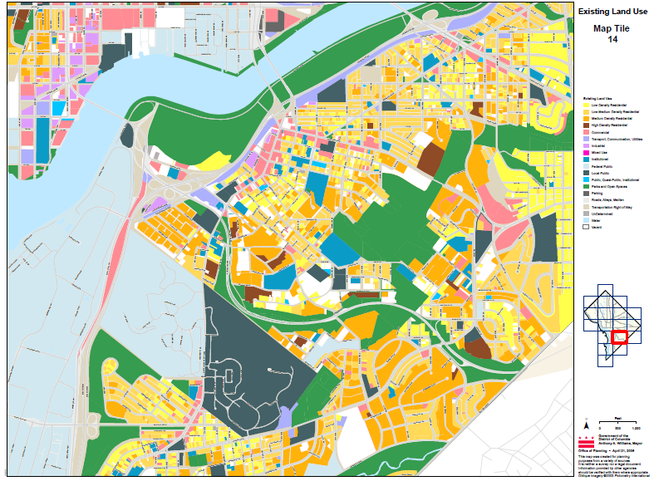
Figure 55: DC Existing Land Use Regulation (Office of Planning, n.d.)
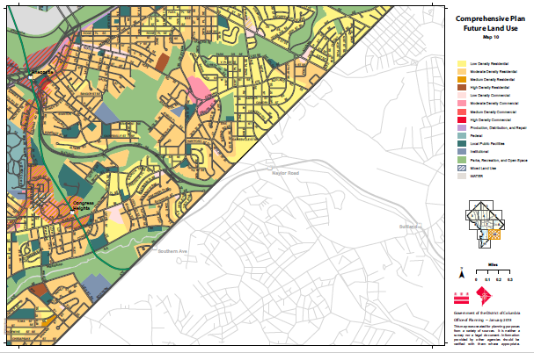
Figure 56: DC Future Planned Land Use Regulation (Office of Planning, n.d.)
According to the DC Fiscal Policy,
“Some neighborhoods in the Northeast and Southeast quadrants of the city have significant family housing stock that is affordable but lacks the resources that these “families would need to thrive truly. Lack of public and private investments in amenities desired by families such as good schools, safe streets, access to transportation, retail, and job centers provide little incentive for the investor-owners to improve or sell the units they currently use for rental income. The absence of these amenities also ill-serve low-income District residents who live in these neighborhoods, reducing their quality of life, limiting their livelihoods, and the opportunities for their children. These exacerbate the racial and socioeconomic divides in our city.”
Sheldon, DCLT Board chair and small business owner, emphasized the need for small business commercial spaces in Ward 8, using his circumstance, stated:
“commercial space is competitive now in Ward 8. I am renting commercial space for my business elsewhere even though I live in Ward 8; I couldn’t get a place to rent due to availability and cost.” (S. Clark, personal communication, January 19, 2020).
ANC Ward 8 chair, Austin emphasized how many people do not talk about it; but towards the end of former Mayor Marion Barry’s career, Mayor Barry stressed economic development by utilizing zoning laws as a key to creating more opportunities for Ward 8 residents. If zoning laws combined parts of Ward 6 into Ward 8, residents would have more amenities, resources, and services.
Compared to DC’s other ward, Ward 8 has the most zones or neighborhoods in DC’s 25 Opportunity zones targeted for redevelopment. As DC addresses the housing crisis with its initiative, DCLT will face challenges and prospects to acquire land. DC’s government acknowledges displacement and efforts to minimize it by addressing housing stock units and the types of units. The 2019 Draft Comprehensive Housing plan states:
“An important part of growing “inclusively” is to develop and maintain, across neighborhoods and throughout the city, a diverse housing stock of all sizes and types that can fit the needs of all varieties of these households, including growing families as well as singles, couples, and aging residents.” (Comprehensive Plan Housing Element, 2019).
This Draft Plan mentions single room occupancy units, student housing, cooperatives/shared housing/co-housing (housing with private bedrooms, but shared kitchens and common areas) as a more affordable alternative to condominiums. Once approved, this Draft Plan will spark more buildings and renovations, giving DCLT new avenues to compete innovatively.
Factor 5: Collaboration Dynamics: Collaborating with other organizations, and the government is a vital component of a CLT’s model in general. DCLT board/staff stated they have many organizations that are and willing to work in partnership with them. Within DCLT efforts to collaborate, aspirations and challenges do exist. The following SWOT-AR analysis matrix is the collected responses from interviewees regarding the DCLT Collaboration Dynamics.

Table 14
SWOT-AR Analysis Matrix Factor 5
SWOT-AR | INTERNAL | EXTERNAL
PRESENT | STRENGTHS  - Good relationships with other organizations to fill gaps  -Funds available to partner with developers to fill gaps  -Pro-partners, multidisciplinary (Chase funding partners)  -Ability to be layered into many RFP (DC’s Government Request for Proposal) or service opportunity offering, can be written into other grants for partner organizations  -Event activities good turnout  -Current staff/Board maintaining partnerships | OPPORTUNITY  - Draft legislation in the editing phase  - Non-profit developers  -Able to provide many services through partner organizations
 | WEAKNESSES  -Lack of designated staff to maintain relationships  -Partner support/interest can change  -Lack of CLT participants to determine/offer services  -Lack of designated PR/Marketing  -Time-consuming to acquire/maintain networks | THREATS  -Disunity; some Ward 8 residents do not want CLT, so influence others not to participate/collaborate  -Political interest ebbs and flow on & off-election years  -Shaky relationship with DHCD unsupportive  -All other affordable housing programs fall under DHCD  -DCHD appears hesitant on USA CLTs success. Temporary vs. indefinite affordable housing, against the limited-equity covenant. believes people should phase-out of affordable housing  -Limited partners available  -Lack of CLT model understanding  -Some organizations hesitate to assist since City has not been supporting or promoting  -Tension wealth creations vs. affordability  -Conflicting interest outside of affordable housing with other non-profit organizations  -Residents/Organizations unsure who qualifies for a CLT.
FUTURE | ASPIRATIONS  -Robust supportive collaboration with City  -Supportive legislation  -Designated Staff to acquire/ maintain Networks  -Partners providing services and DCLT providing services/funding to organizations and residents  -Partnerships with Developers and good reputation as an organization to partner to help fill in gaps | RESULTS  Collaboration and Accountability Metrics

Currently, DCLT is waiting for its residential and CLT membership assessments to determine what services and resources the community want before setting up specific collaboration workshops. As of right now, collaboration with certain community organizations are pending; according to Rumph, “collaborating is a pretty strong word.” When the time comes to partner, DCLT will have a collection of resourceful entities to contact for support. There are approximately 55 non-profits in Ward 8 (Twombly, 2006). Rumph, DCLT Executive Director, states:
“It is essential for us to collaborate with. We don’t want to replicate things; we’re not trying to trip over people. We’re trying to fill a gap, and to do that, we also don’t want to tax people’s time. Furthermore, it goes back to the assets, right. Like what can be utilized, what’s here already we don’t have. I have no problem paying/working with other organizations. We did a seminar with a couple of organizations last year, and I had people calling me saying, did you hear about this. Did you hear about this seminar that they’re doing about CLT? I said, yeah, I did; I organized that here.” (G. Rumph, personal communication, January 6, 2020).
Jade Hall, a DCLT Board Treasurer, stated:
“Collaboration also enables exposure, exposure to inform”…..Well, exposure to the different clientele that other organizations are serving and even exposure to their resources. Exposure to the clientele they are serving, resources, and networks. Also, collaboration allows you to tap the expertise. I am not greedy; we want to share resources.” (J. Hall, personal communication, January 2, 2020).
DCLT Board also agreed with Hall statement (both focus group dates)
“I think the issue is we’re trying to address housing affordability and community power. It’s something that is an intersectional issue. Having allies who address those intersecting needs helps make us more powerful, more comprehensive (J. Hall, personal communication, January 2, 2020).
Rumph, DCLT Executive Director stated:
“The other thing is we don’t need to be seen as the entity out front. There’s a fine balancing act. Some organizations do need that. It’s their lifeblood. It’s a way that they’re set up and how they operate. We’ll need to do that every so often; step out and make sure people know we’re there. However, not because the organization is egoistic, but to get people engaged.” (G. Rumph, personal communication, January 6, 2020).
Clark, DCLT Board Chair, described:
“We have an abundance of organizations already and just making sure they’re active and coordinating with each other instead of competing.” (S. Clark, personal communication, January 19, 2020).
As DCLT is preparing to transition out of City First Homes to an independent non-profit, they have created a database of their future collaborating organizations. However, due to limited staff, they do not have a designated employee to maintain those networks. DCLT aspires to collaborate with local and District-wide governments. According to the Building Better City-CLT Partnership report:
“In many cities/counties/towns, CLTs have partnered with their government “– an ally rather than an antagonist. Especially in places where a local government has put a social priority on promoting homeownership for lower-income families while placing a fiscal priority on protecting the public’s investment in affordable housing, CLTs have become favored recipients of municipal investment.” (Davis, Jacobus, & Hickey, 200).
Furthermore, these CLT supportive metropolises have made (1) special efforts to comprehend the CLT resale-restricted, owner-occupied housing model, and (2) alterations to city programs, policies, and taxes to assist the CLT in succeeding.
Presently, DCLT has not received tangible resources from DC’s governing body. The lack of support, either intentionally or accidentally, is not a new phenomenon. Primitive CLTs were launched through advocacy efforts without local government support. Moreover, CLTs before the 1990s still coordinated despite resistance in regulations, community disinvestment, and reinvestment plans (Davis, Jacobus, & Hickey, 200). Present-day this resistance still exists, especially in communities of color. “CLTs are being erected as bulwarks against market pressures of speculation, gentrification, and displacement made worse by the actions of City Hall.” However, studies show a municipal obstruction of CLTs is moreso accidental. CLTs, in general, aspire to partner with their local jurisdictions for resources (Davis & Jacobus, 2008).
CLT-City engagement efforts must also be mindful of its local socio-political environments in which it is birthed and how the broader and local politics are evolving to achieve long-term goals. As mentioned in Chapter 2 literature review, Weir’s 1999 classification of organizations’ political environment, CLTs can operate in any of three categorical areas: (1) Elite-dominated, (2) Patronage-Back, or (3) Inclusive-Driven areas. Although not all CLTs, especially DCLT, fit into Weir’s classification, it can still be considered. (1) The Elite-dominated area does not have background experience in community organizing, so it is unable to link the community organization to power. They are prone to stay small in size and location. (2) The Patronage-Back area has a little more historical experience in community organizing than the Elite-dominated area. They tend to operate under the influence of local political figures who provide resources to CLTs for harmless activities, secretly controlling CLTs’ actions. (3) The Inclusive-Driven areas allow the CLTs to exercise power outside the political establishment independently. This is the ideal environment since the political establishment values community organizations enabling CLTs to partake in influential networks and resources.”
DCLT is too young of an organization to be classified in Weir categories since it has not established any advantageous relationship to receive monetary, legislation, or land support from the DC government. Nevertheless, later research can be conducted to determine if DCLT activities are stealthily controlled by large funders, CF Homes and BBAR, the organizations responsible for launching DCLT. Also, if the lack of official support from the DC government is another form to control DCLT activities; lack of support covertly encourages failure. DCLT Executive Director Ginger Rumph aspires to collaborate with the community and local government to create more opportunities, especially in the form of legislation for DCLT to thrive. Rumph is among many policy entrepreneurs who advocate for low-and-middle-income residents, looking for opportunities to create upward mobility for DC residents—creating more fundamental ways to enable residents and businesses to stay and thrive in DC. By encouraging anti-displacement and preservation that promotes a sense of place. Rumph appreciates the limited support from the local government provided so far. Although the District has yet to provide material, like land or money support, they have offered intellectual capital or information. According to Rumph, the local council
“serves as idea boards for DCLT. For instance, things that would be very beneficial to their constituents. Trends that they might be seeing. Probably a handful of legislative aides in various council members offices whom I can call and say, hey what’s going on with this particular legislation, or is there an opportunity for us to do X Y or Z.…Conversations that we have had with them have helped to inform how we’re moving forward in positive ways. I mean, other politicians are supportive and interested in supporting us, but they haven’t contributed anything yet. We would love them too.” (G. Rumph, personal communication, January 6, 2020).
According to DCLT agency records, Councilman Trayon White, whom DCLT met with numerous times, attempted to submit to the DC Council the B23-055 “The Affordable Housing Community Land Trust of 201” legislation to fund CLTs; but it never passed. Also, his Chief-of-Staff is on the DCLT Board not as Council staff but as a community member. DCLT Board members stated, “politicians are involved, but we would like them to be more involved, in a more directed way.” The attempted bill submission by Councilman White to legislate dollars into the DC budget was more of a general bill, not DCLT specific; however, this bill was a valuable potential opportunity for DCLT. According to the DCLT Board:
“There was a consensus on the Board that the attempted legislation needs to be rewritten and redirected because ultimately it’s a funding opportunity, it’s an opportunity for more education to the public on what community land trusts are and specifically our community land trust.”
It was also highlighted that this bill could be a potential threat since it spoke of CLTs in general and not specifically DCLT. This kind of universal language in the policy can potentially promote and motivate a proliferation of CLTs to emerge. DCLT Board stated,
“So right now, we’re very geographically specific. However, if you were to generate other organizations trying to do the same thing in the same geographic area, then it’s a competition for CLT projects.”
DCLT’s goal is to have one large CLT non-profit organization District-wide versus multiple smaller CLTs to increase leverage for community control over land where CLT units can still be city-wide. The DC government also serves as a gatekeeper to other organizations and residents; it reinforces a silent seal of approval. According to DCLT, some individuals and organizations hesitate to collaborate with them due to a lack of acknowledgment and support from DC’s Department of Housing and Community Development (DHCD). According to DHCD, DCLT is a program outside of the City’s affordable housing initiatives, in which they are open to working with but are still trying to figure out how to play a role. As mentioned earlier, DHCD is DC’s agency responsible for providing an array of housing or business development opportunities/services; it moved to Ward 8 in January 2009 (Department of Housing and Community Development, n.d.). According to Daniel Rojo, an avid urbanist and designer, Federal agencies housed in neighborhoods can have positive and negative effects on the community in that
“federal office buildings are inherently single use. Office workers do little for neighborhoods after business hours. It can be especially damaging when agencies cluster, creating large single-use neighborhoods. By spreading offices throughout the region, federal projects can invigorate many different neighborhoods instead of negatively affecting just a handful” (Rojo, 2012, para. 4).
“Federal buildings farther from transit often use shuttle buses. These could also provide a desirable transit option for neighborhood residents, but security rules often bar non-employees from riding. This has been part of the conversation around the Department of Homeland Security’s new offices at the former St. Elizabeth’s hospital site between Ward 8 Anacostia and Congress Heights. In urban conditions, security hurts the streetscape by restricting building access from the street and forbidding retail from lining the outside of buildings. Security drives many design decisions for federal projects; many agencies are tackling these issues” (Rojo, 2012, para. 5).
DISCUSSION
The significant issues affecting DCLT Collaboration efforts are (1) their Good Standing Relationships with other organizations via the current staff/Board maintaining partnerships and the (2) Lack of Support from DC’s government.
Partnerships: Good Standing Relationships: Like early CLTs, DCLT was somewhat organized through grassroots efforts birthed through the BBAR-City initiative to rehabilitate the 11th St Bridge into a pedestrian-only sky-line park. BBAR, overseers of the park project, sought out the community to find solutions for potential displacement. After many conversations and forums, the idea for a CLT was launched. As a result of BBAR’s outreach efforts, the DCLT advisory committee was formed, the current Board of Directors. According to DCLT Board/staff, the Board’s strong connections and knowledge of other organizations gave them the advantage to promote and educate these organizations about DCLT’s mission and get them to join forces. It is these kinds of partnerships, coupled with DCLT funders especially Chase Pro-neighborhood's $3 million competitive grant along with other national/local grants that enabled their start-up. According to research, many local large private organizations understand the need for affordable housing for their workforce and are interested in donating to CLTs. Individual and formal fundraising campaigns can also bring in revenue; local fundraising can cover approximately 5% of operating expenses (Davis, Jacobus, & Hickey, 2008).
The DCLT Board stresses that its unique and flexible model enables it to collaborate with the private sector, individuals, and other organizations, especially developers, which DCLT feels is beneficial to DC’s economy. This current interim Board is made up of the following: a director of a community association/former DC Zoning commission, VP/relationship manager of community development banking, a senior fellow at a local housing organization, Councilmember staff, architect/college professor, architectural engineer graduate, community activists/co-founder of an independent radio/tv studio, realtor, strategy manager, equity development manager, tenant services manager, and a local church reverend. Some Board members are also Ward 8 residents. DCLT Board/Staff organizational relationships before and during the DCLT start-up enabled it to secure its pending portfolio, funding, and prospects. Since this Board originated as the DCLT advisory committee, they were part of acquiring and disseminating information on DCLT from the platform of the 11th Street Bridge Park community outreach efforts. From attending community meetings, they were able to meet and collaborate with other influential stakeholders. DCLT Board relationships strengthen its ability to leverage and provide community support. For instance, if a developer or individual wants to purchase or repair a home, DCLT can deliver the funds in exchange for the permanent affordability of the land (person/developer agrees to keep the future resale of the physical property affordable). Collaborating individuals and businesses can also participate in DCLT memberships; growing DCLT’s capacity, as members participate to achieve DCLT mission. DCLT Board believes its collaborative model is a better option for DC’s economy than some affordable housing options.
Some of DC’s affordable housing programs give residents or developers an upfront subsidy. Still, when that person sells the home to the next resident, DC must provide the next buyer with a subsidy too. This never-ending subsidy chain goes on forever; there is but so much subsidy to go around. According to Rumph:
“The reality is if CLT acquires a property you put the funding or subsidy in one time… However, if it’s for a home sale on the private market, you must keep putting in the subsidy. If it’s not similar to a CLT shared-appreciation for permanent affordability, you’re going to keep depending on the government or the philanthropy to give a subsidy, who will have to keep putting money in time and time again. So, let’s say people sell every five to seven years over 30 years, you’re looking at what five to six times you have to keep putting in a subsidy. That’s crazy.” (G. Rumph, personal communication, January 6, 2020).
Research indicates the issues with government upfront subsidies are
- Dwindling subsidy funds are helping fewer people each year
- Increasing home prices outpaces income, requiring more significant subsidies to make homes affordable to low- and moderate-income residents. Resulting in most cities having to restrict or stop allowing these homeowners from pocketing their initial down-payment subsidies when they resell their homes at market rate.
- Cities face pressure to keep up with ever-increasing subsidies that force them to mandate more from private developers to provide affordable units’ in exchange for perks like permits to build above zoning limits, parking waivers, or other incentives. Then to see the affordable unit sold within 5-7 years is added fiscal pressure to make that home affordable continuously.
CLTs intercede by securing subsidies. Societal investments do not vanish or shrink but rather stay with the home making it affordable forever for the next income-qualified resident. Limited support is found for first time homeowners, whether public or privately funded, despite the data revealing that low-income residents have a hard time keeping up with their property and paying the mortgage and more likely to foreclose. CLT wrap-around services help these homeowners in good and hard times by assisting with mortgage defaults, preventing foreclosure, home repairs, personal development workshops, and other services. One study found that CLTs’ residents were almost seven times less likely to be exceptionally behind in mortgage payments and ten less likely to be foreclosed than non-CLT homeowners (Davis, Jacobus, & Hickey, 2008).
Collaboration is a critical component for DCLT, collaboration with organizations, and residents create a collective powerhouse to advocate for the community's needs. Having a Board with strong community ties and connections enables CLT start-ups to bring key stakeholders to the table. Although DCLT has a plethora of potential partnering organizations, they have not obtained residential memberships and, therefore, cannot determine what wrap-around services the community desires. However, when the time comes, DCLT states they will be able to provide or connect residents to partnering organizations for wrap-around services. DCLT’s limited staff and lack of designated Public Relations and Engagement Specialist make it challenging to build memberships and collaboration projects. Among DCLT priorities is to seek additional operational funding and to expand its staff. In maximizing their good standing relationships, DCLT aspires to gain economic leverage for its residents through legislative enactment and City partnership.
Lack of Support from DC’s Government:
“The number of community land trusts (CLTs) in the United States has increased in recent years (in Figure 57) due largely to the expanding investment and involvement of local government. Municipalities support CLT start-ups, CLT projects, CLT operations, and the equitable taxation of resale-restricted CLT homes. This CLT-City partnership is still evolving with municipal officials and CLT practitioners still exploring the most effective ways of working together” (Davis, Jacobus, & Hickey, 2008).
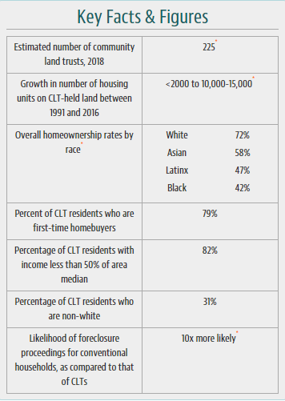
Figure 57: USA CLTs Facts
CLTs momentum seems unstoppable; Figure 58 collection of maps shows the proliferation of CLTs in the USA and Europe (Wales and England). CLTs also exist in other parts of the world like Africa, Brazil, etc.
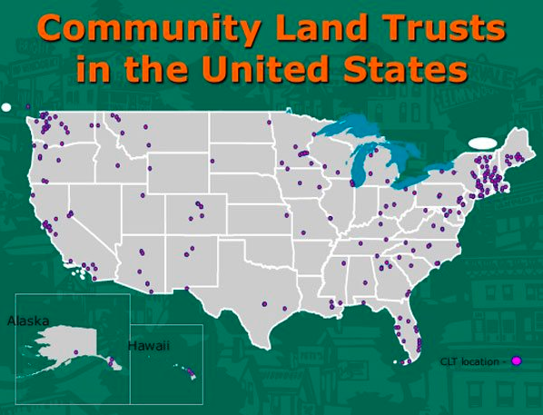
Figure 58: CLTs in the USA (Dubb, 2018)

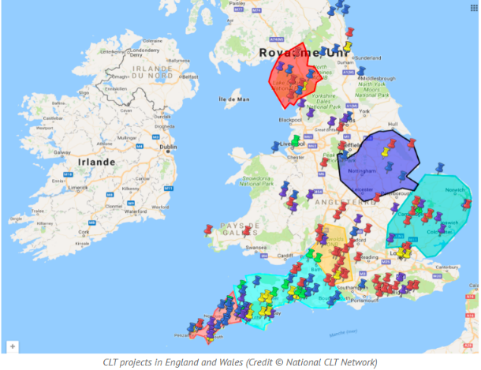
Figure 59: CLTs in Europe (Wales, England) (Bettini, 2017)
Although many other cities and countries see the benefits of a CLT, the DC government still lags in supporting the DCLT. Mayor Bowser has aggressively proposed a goal of 12,000 affordable housing units over the next five years, in which she has directed funding and legislation to the District affordable housing projects. DCLT is not under the umbrella of DHCD projects, so they must convince and compete like other organizations for support from the city. Studies show “commitment of municipal resources to CLTs are coming much earlier and more abundantly than ever before.” (Davis, Jacobus, & Hickey, 2008). The cause of the City’s lack of support appears to be a conundrum. Many inquiring minds ponder why the City has yet to establish support to DCLT. Could it be due to (a) the current city or local public officials personal bias against ground leasing, permanent affordable land control, residential involvement, or resale limits or (b) the CLT model is so complex to unravel, finding consensus on which government activity inhibits or supports it is just too burdensome to figure out or (c) the City is painstakingly slow to come to the table? According to Rumph,
“The District government, the DHCD staff, are not wholly comfortable with the CLT and particularly as it relates to homeownership, and there is not uniform embrace. I have been told that DHCD does not have a policy one way or the other of embracing the CLT concept for ownership housing. In reality, what that means is they’re not embracing it as of yet. So, we haven’t been able to move forward. We have had a variety of deals come through but fell through.” (G. Rumph, personal communication, January 6, 2020).
The lack of support from the District affects other avenues DCLT tries to implement. Research reveals that market-rate developers are not accustomed and prefer to relinquish regular monitoring/reporting of affordable housing regulations, which opens opportunities to CLTs. CLTs attract not only affordable housing developers but also for-profit developers in the private sector, who may have limited experience in selling resale-restricted units to lower-income homebuyers. Other cities have encouraged developers to meet their inclusionary zoning government mandates by donating or partnering with CLTs (Davis, Jacobus, & Hickey, 2008). However, the District's unfavorable bureaucratic processes make it difficult for developers in general and DCLT as an added layer more challenging. DCLT and housing developers want DC government collaborations to have smoother, faster paperwork with less complicated administrative processes for affordable housing provision (Grounded Solutions Network, n.d.). According to Rumph
“When DHCD funding is required in a collaborating project, we want to be able to leverage all of the conversations with them. We want to be able to leverage all of the resources because it will stretch everybody’s funding more.” (G. Rumph, personal communication, January 6, 2020).
On the other end of this dilemma is the DHCD perspective. Since DCLT is not a direct initiative of the City, DCLT must compete like other organizations. However, in the case of DCLT, there are many complications for it to contend with. The Mayor’s administration has demonstrated tremendous interest and efforts in affordable housing solutions; however, DCLT is unclear on her stance on CLTs in the District. DC’s Office of the Mayor administration stated in an email to direct all research inquiries for this dissertation to DHCD. Rumph stated:
“I don’t know directly if the Mayor’s administration has said their stance on DCLT prior to me even taking the job. I asked around. Yes. I heard people speak very positively about it. It is one thing to say that you’re in support of the CLT, and of course, it’s another to demonstrate that via action. Either with additional funding or making it easy to do a deal with one of the public agencies by providing land or working to align covenants. Even if you just need time to speak with the agency to help them understand CLT and how it would intersect with existing covenants. I don’t know to say they are not supporting it. We would like to see if I could have a sit-down and just have a conversation with the Mayor. I don’t have that kind of juice to say; Hey Mayor Browser, can you come and sit down with me and let me tell you about this. She gets phone calls like that all the time for people to talk with her. My understanding is that she’s supportive; she’s supportive of a wide range of solutions that could help meet the affordable housing goal. I mean, I truly do believe that she is. She has certainly put out a call for those 12000 additional units of housing. It seems like her administration is trying to do more.” (G. Rumph, personal communication, January 6, 2020).
DCLT’s desire to have the City on board with its mission is not an unusual ask; many CLTs have managed to create a conducive partnership with their municipalities. Figure 19 below shows specific ways other cities have partnered with their municipality. Support from municipalities enables the scalability of the CLT portfolio. Cities have supported CLT in the following ways:
- CLTs receive city-owned land donations, grants of municipally controlled funds, and low-interest loans in developing and financing the CLT’s projects.
- CLTs receive organizational funds/grants to maintain their operations, which includes development funding, and financing for marketing and managing their units
- CLTs receive fair tax assessments on their units safeguarding low-income CLT homeowners will not be taxed on rates they are unable to collect.
- CLTs partner with cities to enforce continual control over the eligibility, occupancy, and affordability of housing units acquired from private developers through other housing programs like inclusionary zoning, density bonuses, and other regulatory laws or discounts.
As a CLT starts to take on projects, bigger shares of its operating profits may come from development fees, marketing fees, or other activities related to the project income (Davis, Jacobus, & Hickey, 2008). It is easier for CLTs with established recognized accomplishments to appeal to foundations, corporations, and individuals for grants. However, during a CLT start-up or growing phase, local municipal backing aids in the CLT’s sustainability. Research shows that local government backing may decrease as the CLT profits increase, however, a steady increase of support from local government enables the CLT to start new projects and create systems that allow sustained growth (Davis, Jacobus, & Hickey, 2008).
Most of the US 200 CLTs are “young and small and still in the early growth phase” (Davis, Jacobus, & Hickey, 2008). However, many older CLTs have obtained a capacity in their operations that enables them to be more independent and less reliant on local government operating grants. As CLT units of ownership increase, the CLT is then able to rely more on the fees they charge on ground leases memberships, resales, and other profits produced (Davis, Jacobus, & Hickey, 2008). Many newer CLTs forecasted that they can obtain a “sustainability threshold” when their portfolio reaches 150-200 units (Davis, Jacobus, & Hickey, 2008). Once a CLT reaches its sustainability threshold, it will be able to generate adequate income to cover the cost of its stewardship responsibilities (Davis, Jacobus, & Hickey, 2008).
Although start-up CLTs strive to be more self-reliant, they still receive support from local government; older CLTs still collect operating support from local municipal and private institutions(Davis, Jacobus, & Hickey, 2008). When a CLT’s land acquisition portfolio reaches a specific amount, much of its external operating support is redirected to new projects rather than stewardship of the existing CLT units. According to the City–CLT Partnership Municipal Support for Community Land Trusts, the following chart shows estimates of how CLTs have partnered with their local/state/federal government to acquire Land, Regulation, Funding, or Administrative support (Davis, Jacobus, & Hickey, 2008; Davis, 2010):

Table 15
Types of Support CLTs have received from their Municipals
CLT | Land Support |  | Regulation Support | Funding Support | Administration Support
Burlington, VT | -City donated decommissioned firehouse converted to a homeless shelter for families)  -1st right to buy a small % of developers newly constructed condos at below market price to sell at an affordable rate with restricted resale |  | -Reduction or waivers of impact fees for new construction with affordability controls  -1% add-on property tax  -Land taxed at a reduced 37% from the market value of the similar structure | -$200,000 start-up grant  -No interest or low-interest loans  -Regular support from the housing trust fund  annual grant for CLT operation from City 1% add-on property-tax rate  -2019 received operational grants and community center funding from city block grant & City Trust Fund (Champlain Housing Trust, 2019) | -Institute for Community Economics (ICE) in a neighbor state was retained by the City’s Community & Economic Development Office to assist in establishing a city-wide CLT (Davis & Stokes, 2009)
Ashland, OR |  |  | -Willing to waive Covenants, Conditions and Restrictions and Homeowners Association requirements |  | -Endorsed by Council-appointed Affordable Housing Task Forces and Burlington Community & Economic Development Office  -City contracted technical assistance for CLT
Clackamas County, OR |  |  | -Willing to waive Covenants, Conditions and Restrictions and Homeowners Association requirements
Bellingham, WA |  |  | -50% bonus density (developed 14 homeownership units in an area zoned for 9 homes) | -Annual operating grant  -Committed $10 million in public  funds to help subsidize the first 1,000 units of housing  developed by a district-wide CLT
Boulder, CO | -1st right to buy a small % of developers newly constructed condos at below market price to sell at an affordable rate with restricted resale |  | -Developers encouraged to sell IZ units to CLT (20% of the project is presold to CLT very attractive)  -Land tax heavily subsidized when 1st placed on local tax rolls  -Land taxed annually based on current CLT home price | -Globeville, Elyria-Swansea (GES) Affordable Housing Collaborative, partner community members GES Coalition, nonprofit Brothers Redevelopment Inc. and the Colorado CLT received $2M grant from the Colorado Department of Transportation in 2018 (Schumacher Center for New Economics, 2020)
Los Angeles, CA |  |  | -Land tax heavily subsidized when 1st placed on local tax rolls | -$3.8 million for operations and initial projects | -Federal law, the Cranston-Gonzales National Affordable Housing Act (Act), allows CLTs to obtain organizational support, technical assistance, education, training, and community support from the government in fulfilling their housing mission” (California State, Board of Equalization, n.d.)
Berkeley, CA |  |  | -Land Tax assessed on actual sales price | -2018, got $50,000 to develop its Small Sites Program  -2019 got $100,000 (Fasah, n.d.)  -2019 Oakley City Council Passes New Budget $12 Million to Preserve Permanently Affordable Housing with CLT (Oakland CLT, 2019) | -Federal law, the Cranston-Gonzales National Affordable Housing Act (Act), allows CLTs to obtain organizational support, technical assistance, education, training, and community support from the government in fulfilling their housing mission” (California State, Board of Equalization, n.d.)
Boston, MA | -City donated 30 acres of blighted/abandoned land (converted into 155 units, commercial and public open spaces)  -CLT will assist in City proposed 53,000 new home construction and preservation of affordable housing by 2030 |  | -Boston Redevelopment Authority granted the power of eminent domain to Dudley Neighbors Inc. (DNI) giving DNI power to transform vacant land in the neighborhood into permanently affordable housing (Curtin & Bocarsly, 2008) | -Regular support from the housing trust fund  -City partnered with DNI so that any city-owned land could be transferred to DNI at minimal cost | -Looking into partnerships with Mayor's Mural Crew (youth paint murals throughout city) to aid in keeping cultural identity in neighborhoods
Highland Park, IL | -HTF donated land to the CLT |  | -Land Tax assessed on actual sales price, which is much lower than market value | -$1.3 million given to CLT  -No interest or low-interest loans  -Annual grants $100,000 for operations  -CLT’s operational funding comes from Housing Trust Fund (HTF) -Receives direct donations  Specific projects are funded through HTF, Lake County affordable housing fund, Illinois Development Authority, the state donation tax credit, & the Federal Home Loan Bank (Burnett et al., 2008) | - 1998 City joint task force included a CLT as a solution  -City-provided staff to plan and organize CLT startup (Baldwin et al., 2015)  -2001 CLT’s initial role was to help manage IZ mandates (finding buyers for affordable IZ units) (National Association of Home Builders, 2020)  -Endorsed by Housing Task Force,  -Enactment of Inclusionary Zoning in combination with CLT  -City contracted technical assistance for CLT
Hennepin County, MN |  |  |  | -$25,000 start-up grant  -11 municipalities on funders list (HWR Funder and Donors, 2016)
Minneapolis, MN |  |  | -City charges a flat marketing fee $2500 per unit for a home sold vs. % of the sales price of sold homes | -Interest-free, 30-year deferred loans | -2019, the City Council hosted a workshop highlighting CLT in Twin Cities
Syracuse, NY | -Large city-owned parcels transferred for redevelopment to CLT  Deeded 12.5 acres of land to CLT |  | -1986 CLT partnered with the City’s Community Development Department to build affordable homes in a  disinvested Black neighborhoods
Albuquerque, NM | -City conveyed title to all 27 acres of vacant land to the Sawmill CLT (Roots & Branches, 2019)  -Prospect of large parcels of city-owned  land being transferred for redevelopment |  |  | -No interest or low-interest loans  -$200,000 Recurring operating grants in Community Development Block Grant (CDBG) funds
Orange County, NC |  | -Land taxed based on $10,000 more than the initial purchase price |  | -No interest or low-interest loans
Lawrence, KS |  |  |  | -No interest or low-interest loans  -Interest-free  deferred loans with a 30-year term  Community Development Block Grant (CDBG) Non-Public Service funds.
King County, WA | -Received land at below-market sales and donations of excess land |  | -King County taxes CLT-owned homes at the resale restricted rates rather than at full appraised value. | -$30,000 Community Housing Development Organization (CHDO) operating support  -Willowcrest Townhomes in Renton, CLT received funding from many sources
Chapel Hill, NC | -City suggested developers sell below market price, 30 units to CLT. CLT brought units after the developer had found a buyer with a mortgage finance |  | -Amended homebuyer assistance program subsidies retained in CLT homes | -Housing bond funds and HOME funds for a 32-unit development in Chapel Hill (Davis et AL., 2008) | -Municipal officials served on the advisory committee  -City & County agreed on layer funding from different sources with CLT (prevents regulatory conflicts)
Irvine, CA | -Planned to place Future (inclusionary zoning) IZ units in the CLT portfolio-  -City urged Developers to meet their IZ mandate by donating them  to CLT |  | -City strategized to develop 9,700 affordable housing units & put most  under CLT the stewardship (Davis et al., 2008) | -$250,000 initial grant  -For the first few years, covered cost of staffing, overhead and administrative costs | -Mayor & City Councilmember served on the planning committee  -City-provided staff to plan and organize CLT startup (Curtin & Bocarsly, 2008)  -City contracted technical assistance for CLT
Chicago, IL | -1st right to buy a small % of developers newly constructed condos at below market price to sell at an affordable rate with restricted resale |  | -Revised housing assistance programs to ensure CLT access  -Committed to tax CLT homes on their permanent restricted resale value | - In 2004, U.S. Dept. of Housing and Development (HUD) gave technical assistance grant, so the City’s Dept of Housing (DOH) explored the creation of a CLT (Smith & Frantz, 2010) | -Commissioner of Housing was on the Advisory Committee & Board  -City-provided staff to plan and organize CLT startup (Baldwin et al., 2015)  -City employee worked out of Dept. of Housing  -City Attorney gave legal advice  -City worked with consultants to create a municipally sponsored CLT (Burlington Associates in Community Development, LLC, 2012)
Petaluma, WA | -3-party agreement (city, CLT, developer) City requires the Developer to donate land to CLT who manage sales |  | -City offered developers the option to convey  homes to the CLT of Sonoma County  to meet city IZ mandates
Truckee, CA |  |  |  | -$45,000 start-up grant | -The city government assigned staff to work with the committee in initial policy decisions.
Cleveland, OH | -Received tax-foreclosed land from the city |  | -Stewardship housing strategy | -Subsidized Loans
Delray Beach, FL | -Pledged to convey vacant parcels of land  -Discounted city-owned land to CLT |  | -A portion of Tax Increment Finance (TIF) given to CLT operating cost  -CLT Land tax assessed as having no value | -Annual operating grant | -City contracted technical assistance for CLT
Sarasota, FL |  |  | -Pledged annual grants $250,000 for 1st four years | -Received grants or no-interest loans from local jurisdictions | -City contracted technical assistance for CLT-related services (advice on organizational development, ground lease issues, project feasibility, business planning)  -City & County agreed to a development project (multiple covenants, loans, programs matched) (prevents regulatory conflicts)
Portland, OR | -Received land from the city  -Received land/buildings from the Portland Development Commission  -Received tax-foreclosed land from Multnomah County |  | -Amended homebuyer assistance program subsidies retained in CLT homes  -In 2005, Housing is assessed at 75% of the purchase price Yearly increases cannot be more than 3% (The City of Austin, Neighborhood Housing & Community Development –Austin Housing Finance Corporation, Kelly Weis, 2005) | -$100,000 start-up cost for 1st three years  -$80,000 annually for operating costs  -No interest or low-interest loans | -City contracted technical assistance for CLT
Madison, WI |  |  | -Amended IZ law to become a part of CLT portfolio  -Land taxed flat rate $18,000  -In 2005 Homes sold by CLT are on a tax roll at the original value sold to the homeowner. then it is put on a lower curve when calculating the increased value over time. (The City of Austin, Neighborhood Housing & Community Development--Austin Housing Finance Corporation, Kelly Weis, 2005) | -City allows CLT to take 15% of total project costs on all projects which the city provide funds  -Allows CLT to take 15% project total development fee for CLT operation costs

DCLT stated they appeal diligently to build metaphoric collaborative bridges with the City. However, the city’s lack of action leaves many residents feeling alienated and, more like the city is building walls in front of DCLT attempts. On the other side of this problem is DHCD, whom residents feel is at an impasse with DCLT. Despite CLTs’ success stories and city partnerships in other cities, DHCD has its reservations. Dr. Pelletiere, a senior housing advisor, stated:
“CLTs are good; in general, it’s a good idea that enables development to occur without land value increasing. It’s one of the many strategies for affordable housing.” (D. Pelletiere, personal communication, February 12, 2020).
“Frequently CLTs had emerged from situations where the City had property it wanted to have an investment in and CLT was a good way to do it that ensure public benefit to low- and moderate-income households.” (D. Pelletiere, personal communication, February 12, 2020).
DHCD, like many cities’ community and housing agencies, have limited resources. DHCD tries to approach resource distribution with due diligence by being prudent with DC’s funding and resources. Although Dr. Pelletiere acknowledges CLTs as an affordable strategy that can promote upward mobility, there are concerns about the implementation of DCLT. Dr. Pelletiere stated:
“When it comes to DCLT, it is determining what role it plays in communities where land values are already high. What are the advantages of being in a high land value market? CLTs in low or falling land values benefit residents as the land values increase over time, and those residents aren’t pushed out by gentrification, increasing land cost, or taxes, etc. In the case of DC, how do you establish a cost-effective CLT, and then like any human institution? A discussion I have all the time, it comes down to what the bylaws are, what the Board is, and how the institution is set up. In my mind, CLT is not too different from a corporation. It’s a particular way of organizing humans, human capital, and capital to achieve some end.” (D. Pelletiere, personal communication, February 12, 2020).
Dr. Pelletiere clarifies the above statement by mentioning how in areas with low and falling home prices, CLTs can buy or even be gifted land that owners or the jurisdiction views as a liability. Suppose the CLT is successful in increasing the attractiveness of the property and the community around it, such that the land values increase, the CLT can protect the residents (households or businesses) from pressures of those increased values. Then the CLT is like any other player in the market, and the city must ask what gives it an advantage, and how does it transfer value to residents.
DHCD, public officials, community leaders, and residents want to see the idea of CLT manifested into a reality that is fruitful and true to its mission. According to Harvard Business Law, “the ability to come up with a brilliant novel idea is not enough. Ideas are useless unless used. The proof of their value is their implementation. Until then, they are in limbo.” (Levitt, 2002). According to Dr. Pelletiere, questions like
“How is DCLT organized are unanswered? Will it have the ability to pass down those benefits that theoretically come from the CLT over time? Are the folks involved going to be able to keep it going? Moreover, when those folks aren’t involved 5-10-20 years from now, does it have the institutional strength to keep going? When you have a CLT that gets into trouble that isn’t able to maintain properties, isn’t able to maintain benefits, unwinding that is unwinding people’s homes, so it’s a very different calculation, so it needs to be clear around the theoretical say and benefits. The Bylaws, Board, and mission need to be clear because that is what will guide it.” (D. Pelletiere, personal communication, February 12, 2020).
DC’s previous experience with a CLT and contentious Tenant Co-op Boards has left a skepticism scar among some public administrators. According to an employee at the DC Office of Planning, the potential challenge of DCLT is its experience with “struggling in an economic downturn.” As mentioned in earlier chapters, DC’s previous CLT, established in 1976, had to dissolve due to its inability to maintain repairs, funding, and volunteers. The failures of DCLT ancestors are being counted against DCLT today. However, in all fairness, knowing history helps to avoid repetitive mistakes. DC’s original CLT was established during a time of civil unrest and disunity, in which housing equity was not a high priority on the budget or agenda. Unlike today where Mayor Bowser has publicly announced her commitment to affordable housing implementation.
In attempting to implement the Mayor’s affordable housing goal, DHCD faces a double-edged sword Community Development vs. Community Displacement. DHCD is accountable to both the DC government and residents, so ensuring both sides are positively affected in a CLT implementation is essential. According to Dr. Pelletiere, DHCD is trying to figure out how DCLT can benefit the city and address residents’ concerns; to the extent that DCLT is successful, DHCD will become involved with them. Dr. Pelletiere states, although Ward 8 residents, A.N.C., and Council did not contact them specifically about DCLT, they do contact DHCD with other concerns,
“About the lack of affordable housing, too much concentration of it in its neighborhoods and how it’s too expensive to build housing or the government is not spending enough money to make homes historically accurate. Or some say I brought a home here (in Ward 8); why aren’t you creating retail and other experiences. I haven’t heard about DCLT from the community. I don’t think we are being associated with that project, so we don’t get many questions, at least not me, per se. We do have interactions with Rumph and Kratz and others involved in DCLT but more in an institutional way”. (D. Pelletiere, personal communication, February 12, 2020).
To understand DHCD’s hesitation towards DCLT, the Diffusion of Innovation (DOI) model discussed in Chapter 2 Literature review was utilized. The DOI theory explains how an innovative idea or product gains momentum and spreads through a specific population or social systems overtime in two aspects: (1) the Adoption Process and (2) Adopters or Innovators role. The Innovation Adoption has 5 phases: (1) Knowledge, (2) Persuasion, (3) Decision, (4) Implementation, and (5) Confirmation. It appears DHCD is somewhere between the first 3 phases. (1) The Knowledge phase is when a potential adopter DHCD initially encounters the innovation, which is DCLT, but is unsure of what it is and wants to know more. (2) The Persuasion phase is where the potential adopter DHCD pursues further knowledge and information about the innovation (DCLT). (3) The Decision phase is where the adopter DHCD decides to adopt or drop the innovation (DCLT). DHCD is still waiting to decide (4) Implementation phase is where the adopter (DHCD) decides to pilot-test the innovation (DCLT) to determine its merit and worth. Merit and worth are the program’s quality, its ability to be expanded to other areas, the ratio of the program impacts, whether it adds value to the greater good versus the cost, and its net benefit ability to outdo alternative solutions. The last phase (5) Confirmation is where the adopter (DHCD) believes in the innovation (DCLT) and continues support.
Adopters are classified into five groups.
- Innovators
- Early Adopters
- Early Majority
- Late Majority
- Laggards
According to DOI theory, the percentages of people in these roles are spread across a bell curve in figure 60 below.
Figure 60: DOI Distribution of Acceptance across Adopters
DHCD appears to fall somewhere between the Early and Late Majority. Although the future of a DCLT-City remains unanswered, there may be a glimmer of hope. DHCD feels they are open about whether DCLT will compete for land and resources the District makes available or if they will have a specific distinct collaboration role. A credible anonymous source, working closely with DHCD, stated how the DC government might:
“Collaborate, engage, and interact, and all that stuff. Whether the City has a specific role in providing land or resources specifically to DCLT or the 11th Street Bridge Park is not something considered yet. We haven’t reached any agreement, there’s nothing on the table, but there is much interest. Although missions are similar and dovetail, it remains unclear of any special relationship developed as of yet” (Anonymous, personal communication, May 20, 2020)
“Since DCLT is not a direct initiative of the City, so we are still working on our involvement, we prefer to see DCLT established itself successful” (Anonymous, personal communication, May 20, 2020).
As mentioned earlier by Dr. Pelletiere, DHCD senior advisor, the discussion to collaborating and engaging with DCLT is:
“We will likely collaborate if they become a corporate entity that owns property in the district and serves low—and-moderate income clientele. I don’t see a way we wouldn’t collaborate. Also, if they are unsuccessful, we would be involved if they can’t maintain properties, they are likely to come to us…If there are properties we are involved with that are unsuccessful, and they can be helpful, then we will be involved. We are in the same area pursuing similar missions. Resources are available, so even if we don’t have specific, this is our CLT program or this is our CLT special relationship; we will still be involved with each other.” (D. Pelletiere, personal communication, February 12, 2020).
Inquiries into DHCD-DCLT partnership reveals DHCD is trying to discover whether DCLT will be one of the many entities competing for District resources or have an inherited edge for the resources or will this advantage need to be created through policy.

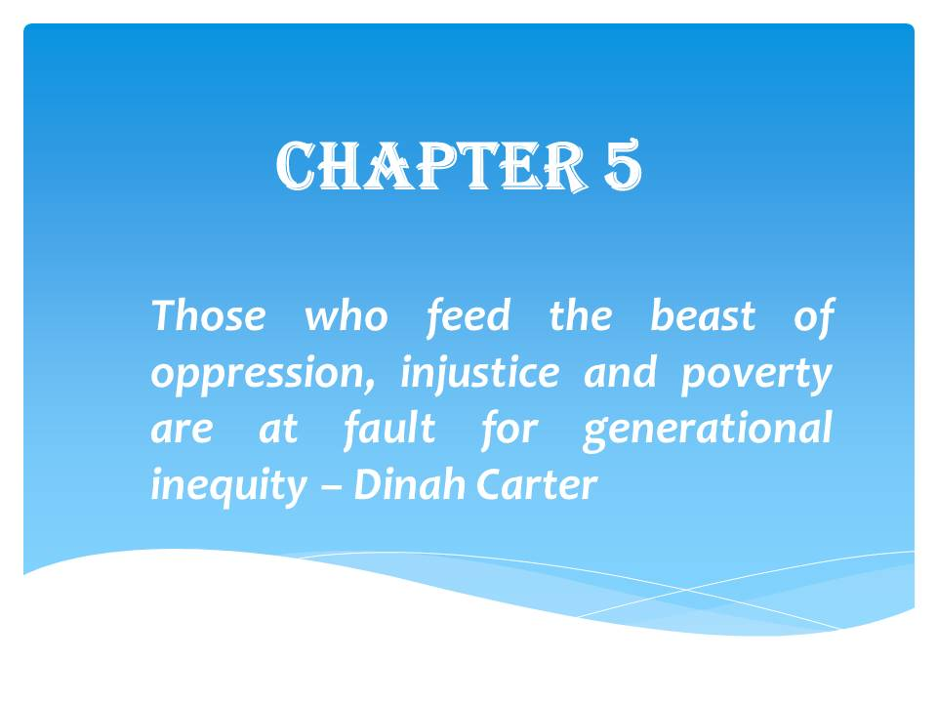

Chapter 5: Conclusion
Conclusion
Community Land Trust also called a CLT is a resourceful permanent affordable housing solution that empowers communities and enables marginalized residents’ upward mobility. CLTs prevent the renter or homeowner from carrying the heavy burden of land expenses. By separating the land from the home purchase averts market forces from increasing housing rates, guaranteeing affordability for future residents, and giving them access to the right to own property in a booming housing market where home values have become unaffordable. A CLT is created by a group of community members who work together to form a non-profit organization. They buy and own land to make it affordable forever. The CLT rents or sells the physical property on the land to low-and moderate-income residents and small business owners. However, essential pillars in place to support the model are crucial for its start-up and sustainability. In short, DCLT start-up pillars strive to (1) form a stand-alone Douglass CLT or the non-profit organization that forms the CLT with a robust active Board and memberships, (2) Acquire land or property to provide affordable housing to qualifying residents, and (3) Trust or reputation that conveys confidence in DCLT as another partial remedy for affordable housing that promotes collaboration. It is these pillars that create the platform for a CLT model. Furthermore, within these pillars or building blocks are various factors, discussed in Chapter 4 and throughout this dissertation, that affect the start-up of Douglass CLT (please see Table 16 below for a brief list of factors).
Table 16
Factors Affecting DCLT Start-up
Factors Affecting DCLT Start-up
Factor 1: Policy Interpretation | - Lack of Legislation  - DCLT Clearly Defined Bylaws/AOI  - Defined Population/Housing Portfolio pending  - Aspire Legislation for CLTs (1 large CLT preferred to avoid competition)
Factor 2: DCLT Structure/Capacity | - 3-Part Committed Board  - Culture (Teamwork, Personal, like a family)  - Branding / Marketing  - Funding  - Lack of Staff/Memberships  - Limited CLT Knowledgeable pool of Applicants for Staff Positions  - Limited Staff/ Leadership Diversity
Factor 3: Preliminary Resident Engagement/ Leadership Fostering | - Leadership Workshops (Intentional Engagement)  - Resident Skepticism (due to history of neglect/displacement)  - Resident Lack of Knowledge  - Community Organizing/Advocacy Experience (residents profound civic roots struggle to connect to power that leads to desired change)
Factor 4: Community Land Control | - Aspire to Partner with City  - Multiple Land Acquisition Strategies  - Zoning laws (limited/exclusionary density)  - Expensive/Lack of Housing
Factor 5: Collaboration Dynamics | - Lack of City Partnership (crucial)  - City Bureaucracy Hinders Housing Deals  - Organizations/City Skepticism (Prior CLT Closure, Lack of Knowledge)  - Diverse Partners - Residential Needs Assessment pending

At the center of the pillars as seen in Figure 61 below is Community, which are the Participants, Members, and Staff.
Community
Figure 61: DCLT Start-up Pillars and Community
Community is the most influential component of Douglass Community Land Trust (DCLT). After all, it is its middle name; it will take a community for it to succeed. You cannot have a community without unity, unity does not mean uniformity; it embraces diversity, which is equally important. Community members of all levels residents, non-profits, the private sector, and government participation are vital for DCLT to thrive in achieving socio-economic mixing, upward mobility, and reduction of displacement and poverty for DC’s Ward 8 low-and moderate-income households. DC’s government role is most critical in aiding DCLT to achieve its mission especially since DC’s history, like many other US cities, is plagued with housing discrimination. A government that is hostile or indifferent toward its CLT makes it more difficult for the CLT to withstand housing market pressures particularly in cities where housing prices are soaring. DCLT aspires to have support from the DC government that is substantive and does not tap into other housing programs resources. In DC, the former CLT during the late 1970s had to dissolve itself due to onerous activities and the lack of support from the local government. Other CLT’s in cities throughout the US with similar economies to DC have received support from their local government that has proven success in its CLT growth and sustainability.
The government takes on both a democratic and paternalistic role in underinvested communities of color. CLT’s idea of shifting power to the people is a major paradigm shift in solving the tensions of racial injustices in housing, one of the root causes of slums or neglected poverty-stricken communities. Despite hesitations CLTs peak the curiosities of municipalities, twenty new CLTs are built annually. The CLT model is an innovative solution but viewed by some cities as a scary structure to implement due to its organizing start-up activities and philosophy of giving power to people. Residents should be confident in former President Reagan's words “government works for us not we work for the government.” However, President Reagan's words are unequally distributed, some power-influencers or privileged groups of people with access to sway decisions can get the government to work quicker in their favor than other disadvantaged or power-oppressed groups. Just because a person is impoverished does not mean they are not qualified to contribute solutions to their problems.
If a community is asking for a CLT, which is the case for Ward 8, then the government should play a strong role to ensure it comes to fruition. Ward 8 is pregnant with a solution to its affordable housing crisis. Besides, working with the people to problem-solve aids in building public trust and may subside potential anarchy and rioting; the people will have their way. If the government takes on a true paternalistic role over disadvantaged neglected communities then letting the people lead in solving their problems is no different from parents grooming their children to be less reliant on them by enabling more freedom to the child to solve their problems. Like most things in life, unintended consequences may exist and occur in problem-solving. Unintended consequences should not be an excuse to delay or prevent residential engagement to solve their community issues. Pre-planning and data-driven solutions may minimize these unintended consequences. This “what comes first the chicken or the egg” dichotomy in which the city desires to see the CLT independently succeed before they assist vs the CLT desire for government-provided resources to ensure sustainable success must be resolved.
The paternalistic grip of government needs to relinquish trust and responsibility to communities but also support them as they get their feet off the ground ensuring success. The same way the government gives developers funding to ensure affordable housing development, the DC government should lead as an additional source in providing resources to its CLT in the form of land, funding, technical support, or other routes mentioned in Table 15 on page 220. DC has the potential to utilize a CLT like cities with similar economies that have already implemented CLTs. Support from the local government can subdue DC’s strong market forces to give DCLT a bigger chance to become another sustainable affordable housing remedy. CLTs also have a responsibility in educating the public and promoting themselves especially to communities’ riddle government distrusts and suspicions. Although a CLT is a non-profit, it should not lead with the expectation of an automatic handout for resources from the government but lead as an innovative and branded partial remedy for affordable housing, a movement not a cause. Emanating confidence of proven success that collaborators will be proud to support. Since the model is so complex CLTs should gain buy-in from the public by having their organizational paperwork, staff roles, defined target population, implementation plan especially outreach efforts, evaluation, and solutions for worst-case scenarios thoroughly planned. Although this preparation requires time during CLT start-up, it will help the CLT brand itself as a high-quality community-led trusted model and help outreach efforts to gain buy-in from the public, especially residents.
As previously mentioned, residents believe Ward 8 has a unique beat in its location, culture, and community making it an up-coming coveted place to live and do business. Residents advocated for a DCLT to be implemented in Ward 8. The core chamber of DCLT’s heartbeat is its goal to identify, engage, and reenergize people, government, and businesses who want to prevent residential and commercial displacement as Ward 8 community is being revitalized. It is not only about housing or development projects but also creating a neighborhood economical hub that is inclusive of all incomes and races; it is a movement. One of DCLT philosophy is a “pay-it-forward” model which is their goal to not focus on one generation of families but
“each household that lives in a CLT home over the years, and the impacts on the community as a whole. Rather than one family taking all the appreciated value with them when they resell their CLT home, each family chooses to leave part of the increased value in the property, so similar families can benefit from it in the future.”
DCLT is another partial solution targeted to those individuals or families who need it most and may not be able to rent or own a home without a CLT especially in major cities. By owning the land CLTs lay down the foundation in which they sow micro seeds or opportunities for housing and amenities that can blossom into thriving communities. Public, private, and non-profit administrators hold the key to bring awareness that all people are not the same; some groups need more assistance than others; therefore, administrators are also gatekeepers that enable social equity. CLT administrators bridge the gap of housing equity by providing homes for society’s destitute and working class. Seen in Figure 62 is a brief description of DCLT challenges and potential advantages.
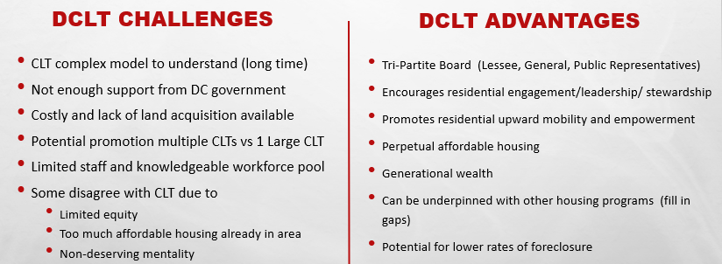
Figure 62: Challenges and advantages of DCLT
Although DCLT, a non-profit organization, is not a government entity it has taken on the role of a public administrator pressing for equitable affordable housing access. It contends against the social and cultural drivers of community development that alienates and displaces indigenous disenfranchised populations. Public administrators are public servants working in public departments, non-profits, and agencies at all levels of government. Among its many tasks, public administrators are responsible for implementing and managing government policies. According to Paul Appleby, a 1940s public administration theorist, public administrators use democratic approaches in executing policies that respect the dignity, value, and potential of citizens (Appleby, 1947). Also, it suggests notions of fairness, freedom, and broader economic opportunity for citizens. Frederickson goes a step further in adding Equity alongside Economy, Efficiency, and Effectiveness as a pillar of public administration, which focuses on whom the program/policy is working for and its effectiveness and efficiency. This theory of social equity is the primary building block to explaining the DCLT program model. DCLT attempts to fill the gap without specific government legislative backing, where government and market forces have undercut or limited access to housing for its low to moderate-income DCs’ residents. Like many cities, DC’s economy is growing at exponential rates in which the government has limited control over; this growth can only be tamed and directed.
As investments pour into Ward 8, economic and social tensions may become increasingly divisive between indigenous and new-comers and low and higher-income residents, where inequality is the epicenter of public frustration. Government agencies and non-profits seek solutions to the various social issues of expanding income gaps, unequal access to neighborhood resources, racial groups/cultural conflict, and unavailable housing for specific income brackets.
The administrator role of DCLT is to promote social equity and work towards holding policies accountable to providing just and fair statues for those at the bottom of the income ladder. The most impeding overarching start-up factors affecting DCLT’s role as an affordable housing administrator are the strength and cohesion of their current Board/Staff, Understaffed, Lack of Public Knowledge, and Lack of Government Support. Although DC has a jaded past with implementing an unsuccessful CLT, the concept is still a relatively innovative complex model in which DCLT will have to prove itself as a start-up business. Strategies should include branding, staff build-up, a multi-level educational outreach/marketing that addresses rebuttals and skepticism using hard facts, narratives, and success stories.

Board:
The Board has been and still is instrumental in launching the DCLT start-up. Incentives should be considered to keep the momentum going and avoid burnout. Plus, a paid Board will attract more residents to participate and aid in upward mobility for its clientele that is low-and-moderate-income residents.

Staffing:
To achieve smaller objectives, designated staff and interns/volunteers will have to be in place to avoid burnout and missed opportunities. A vital staff team includes a Public Relations Marketing, Community Engagement Specialist, Governance/Advocacy, Finance/Fundraiser, and a Property/Asset Acquisition Specialist. Since it is the non-profit start-up phase one or two staff can be assigned the Public Relations Marketing, Community Engagement Specialist, Governance roles. Community residents should be marketed and utilized as Interns who can learn a skill and be the next potential staff for DCLT. Maybe partnerships with schools/universities to house students in exchange for work. Having predetermined volunteer roles that participants can choose may aid in getting participation interest, match volunteers’ strengths/good fit to roles, and keep volunteers organized into teams with team leaders. Fundraising should have specific categories especially on obtaining money for operations/staff build-up. Once people are put in place for problem-solving, then DCLT’s potential can flourish; People- Place – Problem solving- Potential.

Outreach:
Outreach must begin with a well-defined branding or image of DCLT. DCLT vision and purpose are tied into its mission statement. Branding is the organization’s purpose; it is what people say about the organization when staff is not around. Branding will aid in DCLT public recognition, create trust as a legitimate organization, support their public relations marketing efforts, ensure future business, inspire staff, and generate new and more participation and brand loyalty towards DCLT over the lifetime. Loyalty is why private companies spend millions of dollars on branding their product or idea. Branding will also assist staff, the Board, volunteers, and interns in their outreach efforts with individuals, organizations, and government. Also, it helps to have a branded 30-second elevator pitch about its complex model. Having everyone trained and comfortable speaking about such a complex CLT model through its brand may bolster outreach.
Targeted outreach and marketing are vital. Weekly or bi-weekly virtual or live information sessions can flood more information about who DCLT is and its goals. To reinforce its brand name as a community-inclusive program or movement. If DCLT publicly posts its funding allocation information on its website may strengthen transparency. Transparency enables the average person or resident to know where the funding is coming from and going. This funding allocation notice should be posted in the form of a simple community-user friendly way on the website and not in a detailed report; some churches and fundraisers do it. Just like the private-sector, DCLT should cater its outreach efforts according to the audience's psychographics. Psychographics is a critical component in successful marketing. According to Demby, psychographics describes the human characteristics of consumers that have a bearing on their responses to products, packaging, advertising, and public relations. Many non-profit and government organizations have targeted outreach efforts based on demographics, transactional, or behavior, missing out on the importance of psychographics. To understand the characteristics of consumer’s emotions, values, desires, goals, interests, and lifestyle assists in creating a brand that speaks to individuals’ values.
Understanding both the demographics and psychographics may help create an even more successful targeted outreach campaign. Private sector businesses take the time to study their target audience. They are unbeaten in understanding people, creating demand for their product where there is none; hence how people come to buy things they do not need with money they do not have is from strategic psychographic marketing. Understanding what makes or motivates people to do what they do helps to create better cost-effective outreach programs in any organization. In the case of DCLT, marketing focused on broadcasting itself as an innovative public-good opportunity with targeted different interest levels for its residents, government officials, and private sectors may increase program up-take. Especially when pursuing partnerships with private-sector community development projects to help reduce displacement. Targeting displacement at the start of a community development project shows compassion and can gain more community buy-in, similar to BBAR’s quest for equity development at the beginning of the 11th Street Bridge Park project. A community buy-in or acceptance of CLT helps and can speed up the CLT progress. As mentioned earlier in the DOI model, the following phases occur when an individual adopts an innovation or agrees to partake in the DCLT program; (1) awareness and need of DCLT, (2) Decision to adopt, (3) Initial use, and (4) continued participation in DCLT. However, for a resident or organization to adopt an innovation, five factors do play a role:
- Relative Advantage - degree DCLT is a solution that outdoes current ideas, programs, or solutions.
- Compatibility – how consistent is DCLT mission aligns with potential adopters’ values, experiences, and needs
- Complexity - how difficult is DCLT to understand and participate
- Trialability – the scope DCLT can be pilot tested before a commitment is decided
- Observability - extent DCLT can show tangible results
In identifying the above factors, DCLT should focus on the initial outreach efforts on partnering with the DOI categories Innovators to assist them in getting the word out and placing their Early and Late Majority adopters to create targeted marketing materials and strategy. DCLT support from the city enables it to comfortably remain sustainable initially. DCLT will need to consider the organizational psychographics of DHCD, elected officials, and other hesitant organizations in its continued discussions and educational workshops. Incorporating much data and specifics explaining DCLT organizational structure, processes, the details of their objectives/goals while addressing challenges and specifics (pros/cons) in different ways the DHCD/District can support them. A concern for elected officials was the inconsistency or disunity of residents. DCLT must incorporate conflict management training to help residents communicate and work together cohesively. Although understanding residents’ psychographics requires its genre of homework, it can help get residents engaged at different levels. Outreach efforts must be initiated in addressing peoples’ fears and skepticism to empower them to be effective advocates they desire to become.
If DCLT is to overcome its young roots and past reputations of DC’s previously failed CLT, it may consider using forward and backward mapping to present its implementation process of affordable housing provision to skeptical audiences it craves support.
“Forward mapping is the strategy that comes most readily to mind when one thinks about how a policymaker might affect the implementation process. It begins at the top of the process, with as clear a statement as possible of the policymaker’s intent, and proceeds through a sequence of increasingly more specific steps to define what is expected of implementers at each level. Many policies use forward mapping when implementing a policy/program.” (Elmore, 2014).
However, in the case of DCLT, Backward Mapping should be utilized to rebuttal hesitation from supporters. Backward Mapping focuses on the end behavior from the beginning to identify possible worst-case scenarios and plan alternative options. Showing skeptics, a thoroughly thought-out implementation where possible planned alternative options are identified for worst-case scenarios can ease uncertainty.
The following essential reminders aids in analyzing all the moving parts:

B.A.C.K.ward Reminders:
- The Behavior to Change: is the result or behavior DCLT wants to change. For DCLT, the targeted behavior to change is the displacement of vulnerable Ward 8 residents, Support from community and government
- Analyze: thinking about all the key players/individuals or lowest organization levels duties, motivations, culture, and intra/inter-agency collaborations in detail to discover decentralized alternatives that may be overlooked.
- Contemplate Interventions: thinking strategically about the chain of behaviors that connect DCLT to its desired outcomes enables foresight of potential problems to develop interventions; strengthening implementation success
- Keep Watch: Identifying supporters of DCLT helps to ensure political backing and implementation success. However, it is equally important to detect DCLT opposers, worst-case scenarios, and good prospects for successful implementation.

Upon completion of this research, a significant pandemic virus called Covid-19 emerged, affecting the economy dramatically, especially in the way people interact. The impacts of this virus have caused worldwide mandates of quarantining, physically distancing 6 feet apart, and temporary and permanent closure of many businesses, organizations, and public agencies. Further research should be conducted on the effects of this pandemic on affordable housing provisions, especially within the CLT model, which relies heavily on community engagement.

The end
“Earlier in my life, I thought the things that mattered were the things that you could see, like your car, your house, your wealth, your property, your office. But as I've grown older, I've become convinced that the things that matter most are the things that you can't see -- the love you share with others, your inner purpose, your comfort with who you are.”
― Jimmy Carter, US President

REFERENCES
11th Street Bridge Park. (n.d.). Retrieved from https://bbardc.org/the-park/
11th Street Bridge Park’s Equitable Development Plan. (2018). Retrieved from https://bbardc.org/wp-content/uploads/2018/10/Equitable-Development-Plan_09.04.18.pdf
2019 County Health Ranking. (2019). Key Findings Report. County Health Rankings & Roadmap. Retrieved from https://community-wealth.org/sites/clone.community-wealth.org/files/downloads/2019%20County%20Health%20Rankings.pdf
2020 Demographics. (2020). Retrieved from https://www.dchealthmatters.org/demographicdata?id=131495
2020 Inclusionary Zoning Maximum Income, Rent, and Purchase Price Schedule. Retrieved from https://dhcd.dc.gov/publication/2020-inclusionary-zoning-maximum-income-rent-and-purchase-price-schedule
AbouAssi, K., Faulk, L., Tran, L., Shaffer, L., & Kim, M. (2019). Use and Perceptions of the Availability of Local Government and Nonprofit Services in Diverse Urban Settings. Nonprofit & Voluntary Sector Quarterly, 48(5), 975–997. https://doi-org.proxy-ub.researchport.umd.edu/10.1177/0899764019845521
Abromowitz, D. M. (1991). An essay on community land trusts: Towards permanently affordable housing. Miss. LJ, 61, 663.
Advisory Neighborhood Commissions. (n.d.). DC government. Retrieved from https://anc.dc.gov/page/about-ancs
Advisory Neighborhood Commissions. (n.d.). DC government. Retrieved from https://anc.dc.gov/page/about-ancs
Affordable housing is a significant issue in the national survey of mayors. (2019). New Hampshire Business Review, 41(3), 40
Amaded, K. (2020). Real Estate's Impact on the US Economy. Retrieved from https://www.thebalance.com/how-does-real-estate-affect-the-u-s-economy-3306018
Anderson, G., Blair, R., & Shirk, J. (2018). Neighborhood associations and community development: Differences in needs and strategies. Community Development, 49(5), 504.
Andrews, R., Boyne, G., & Mostafa, A. M. S. (2017). When bureaucracy matters for organizational performance: Exploring the benefits of administrative intensity in significant and complex organizations. Public Administration, 95(1), 115-139.
Angotti, T., & Jagu, C. (2007). Community land trusts and low-income multifamily rental housing: The case of Cooper Square, New York City. Cambridge, MA: Lincoln Institute of Land Policy.
Appleby, P. H. (1947). Toward better public administration. Public Administration Review, 7(2), 93-99.
August, M. (2014). Negotiating Social Mix in Toronto's First Public Housing Redevelopment: Power, Space and Social Control in Don Mount Court. International Journal of Urban and Regional Research, 38(4), 1160-1180.
Aurand, A., Emmanuel, D., & Yentel, D. (2019). The gap: a shortage of affordable homes. Washington, DC: National Low Income Housing Coalition, 2018.
Austin Housing Finance Corporation, Kelly Weis. (2005). THE COMMUNITY LAND TRUST REPORT: CREATING PERMANENT AFFORDABLE HOMEOWNERSHIP OPPORTUNITIES IN AUSTIN, TEXAS. Final Draft. Retrieved from https://d36iur3orme9ke.cloudfront.net/wpcontent/uploads/2014/05/www.ci_.austin.tx_.us_housing_downloads_AFINAL-CLT-Council-Report-Revised-I-II-III-72505.pdf
Babcock, F. M. (1932). The valuation of real estate. McGraw-Hill.
Baldwin, B., Gay, M., Nagin, R., Kulwicki, T., & Wool, J. (2015). Development Without Displacement: The Case for Community Land Trusts. In Medford: Practical Visionary Workshop, Tufts University.
Bandura, A. (1978). The self-system in reciprocal determinism. American Psychologist, 33(4), 344–358. https://doi-org.proxy-ub.researchport.umd.edu/10.1037/0003-066X.33.4.344
Bardach, E. (1977). The implementation game: What happens after a bill becomes a law.
Barrett, S. Colin Fudge, eds. 1981. Policy and Action: Essays on the Implementation of Public Policy.
BBAR. (2018). DC government. Retrieved from https://bbardc.org/wp-content/uploads/2018/10/EAST-WEST-River-Stats.jpg
Beider, H. (2007). Neighborhood Renewal and Housing Markets. London: Blackwell Publishing Limited.
Berman, P. (1978). The study of macro and micro implementation of social policy.
Bertram, R. M., Blase, K. A., & Fixsen, D. L. (2015). Improving Programs and Outcomes: Implementation Frameworks and Organization Change. Research on Social Work Practice, 25(4), 477–487. Retrieved from https://search-ebscohost-com.proxy-ub.researchport.umd.edu/login.aspx?direct=true&db=eric&AN=EJ1065356&site=eds-live
Bettini, F. (2017). The Rise of Community Land Trust in Europe. Retrieved from https://labgov.city/theurbanmedialab/the-rise-of-community-land-trust-in-europe/
Bingham, L. B., Nabatchi, T., & O’Leary, R. (2005). The new governance: Practices and processes for stakeholder and citizen participation in the work of government. Public administration review, 65(5), 547-558.
Blaug, M. (2000). Henry George: rebel with a cause. European Journal of the History of Economic Thought, 7(2), 270–288. https://doi-org.proxy-ub.researchport.umd.edu/10.1080/096725600361816
Blaug, M. (2000). Henry George: rebel with a cause. The European Journal of the History of Economic Thought, 7(2), 270-288.
Blumer, H. (1958). The UNITED STATES OF AMERICA. International Social Science Journal, 10(3), 403-447.
Board of Election DC. (2018). Primary Election 2018 - Certified Results. Retrieved from https://electionresults.dcboe.org/election_statistics/2018-Primary-Election
Bogle, M., Diby, S., & Cohen, M. (2019). Equitable Development and Urban Park Space.
Bourassa, S. C. (2006). The Community Land Trust as a Highway Environmental Impact Mitigation Tool. Journal of Urban Affairs, 28(4), 399–418. https://doi-org.proxy-ub.researchport.umd.edu/10.1111/j.1467-9906.2006.00302.x
Bourassa, S. C. (2006). The Community Land Trust as a Highway Environmental Impact Mitigation Tool. Journal of Urban Affairs, 28(4), 399–418. https://doi-org.proxy-ub.researchport.umd.edu/10.1111/j.1467-9906.2006.00302.x
Bradshaw, W., Connelly, E. F., Cook, M. F., Goldstein, J., & Pauly, J. (2005). The costs and benefits of green affordable housing. Cambridge (MA): New Ecology.
Bramley, G. (1992). Homeownership affordability in England. Housing Policy Debate, 3(3), 815-853.
Braveman, P., & Gottlieb, L. (2014). The social determinants of health: it's time to consider the causes of the causes. Public health reports, 129(1_suppl2), 19-31.
Building (on) Bridges (2014). National Parks Conservation Association [blog post]. Retrieved from https://www.npca.org/articles/405-building-on-bridges
Building Bridges Across the River, (2020). Retrieved from https://bbardc.org/our-organization/
Building Bridges Across the River, B. (2020). OUR MISSION. Retrieved July 17, 2020, from https://bbardc.org/our-organization/
Bureau of Economic Analysis. (n.d.). What is GDP? Retrieved from https://www.bea.gov/sites/default/files/2018-04/GDP-Education-by-BEA.pdf
Burlington Associates in Community Development, LLC. (2012). Retrieved from https://burlingtonassociates.com/
Burnett, K., Khadduri, J., & Lindenmayer, J. (2008). Research on state and local means of increasing affordable housing. Retrieved on October 12, 2013 from https://www.nahb.org/-/media/NAHB/advocacy/docs/top-priorities/housing-affordability/case-study-highland-park-il.pdf
California State, Board of Equalization. (n.d.). Legislative Enrolled Bill Analysis. Retrieved from https://www.boe.ca.gov/legdiv/pdf/2818abEnrolled16rmk.pdf
Cashin, S. D. (2000). Middle-class black suburbs and the state of integration: A post-integrationist vision for metropolitan America. Cornell L. Rev., 86, 729.
Census Reporter. (2018). Washington-Arlington-Alexandria, DC-VA-MD-WV Metro Area. Retrieved from
Champlain Housing Trust (2019). Embrace annual report fiscal year 2019. Retrieved from www.getahome.org 2019 report.
Chapple, K. & Zuk, M. (2016). Forewarned : The Use of Neighborhood Early Warning Systems for Gentrification and Displacement. Cityscape, 18(3), 109.
Cimbala, P. A. (1989). The Freedmen’s Bureau, the Freedmen, and Sherman’s Grant in Reconstruction Georgia, 1865-1867. Journal of Southern History, 55(4), 597–632; https://www.pbs.org/wnet/african-americans-many-rivers-to-cross/history/the-truth-behind-40-acres-and-a-mule/
Citi Community Development & The Rockefeller Foundation. (2019). Menino survey of mayors. Retrieved from http://www.bu.edu/ioc/research/menino-survey-of-mayors-middle-page/
Citi. (1 C.E. 2019). New Menino Survey of Mayors, from Boston University Initiative on Cities, Reveals Housing Costs, and Lack of Living Wage Jobs as Top Obstacles to Social Mobility. Business Wire (English).
City First Enterprise. (n.d.). About Us. Retrieved from https://www.cfenterprises.org/about-us/
City First Homes. (n.d.). Retrieved from https://cfhomes.org/
City First. (2017). Annual Impact Report. Retrieved from https://www.cityfirstbank.com/sites/default/modules/ckeditor/ckfinder/userfiles/files/City%20First%202017%20Annual%20Report-Web%20Res.pdf
Claritas. (2020). Summary Data for Ward: Ward 8. 2020 Demographics. Retrieved from https://www.dchealthmatters.org/demographicdata?id=131495
Claver, E., Llopis, J., Gascó, J. L., Molina, H., & Conca, F. J. (1999). Public administration: from bureaucratic culture to citizen‐oriented culture. International journal of public sector management.
Code of District of Columbia. (2020). § 16–1113. Defense of adverse possession; enclosure. Retrieved from https://code.dccouncil.us/dc/council/code/sections/16-1113.html
Cohen, M., Tatian, P.A. (2018). Urban Institute: Neighborhoods, Cities, and Metros.[Blog Post]. Retrieved from https://www.urban.org/urban-wire/can-community-land-trust-give-long-term-residents-foothold-changing-neighborhood
Cole, M. L., Cox, J. D., & Stavros, J. M. (2019). Building collaboration in teams through emotional intelligence: Mediation by SOAR (strengths, opportunities, aspirations, and results). Journal of Management and Organization, 25(2), 263-283.
Colorado Oxygen Bar. (n.d.) Retrieved from https://www.coloradooxygenbar.com/
Community Land Trust in Anacostia, DC Announced by City First Enterprises and Citi Community Development. (2017). 3BL media. Retrieved from https://www.3blmedia.com/News/Community-Land-Trust-Anacostia-DC-Announced-City-First-Enterprises-and-Citi-Community
Community Land Trust. (2018). Urban Omnibus. Retrieved from https://urbanomnibus.net/2018/01/community-land-trusts/
Comprehensive Plan Housing Element. (2019). Draft Amendments. Retrieved from https://plandc.dc.gov/sites/default/files/dc/sites/op/page_content/attachments/Chapter%205_Public_Review_Draft_Housing_Oct2019.pdf
Congress for the New Urbanism [CNU]. (2019). Partnership in DC focuses on minimizing displacement ahead of bridge park. Retrieved from https://www.cnu.org/publicsquare/2019/10/16/partnership-dc-focuses-minimizing-displacement-ahead-bridge-park
Congress for the New Urbanism [CNU]. (2019, October 16). Partnership in DC focuses on minimizing displacement ahead of bridge park. Retrieved July 17, 2020, from https://www.cnu.org/publicsquare/2019/10/16/partnership-dc-focuses-minimizing-displacement-ahead-bridge-park
Council of District of Columbia. (2016). D.C. Home Rule. Retrieved from https://dccouncil.us/dc-home-rule/
Council of District of Columbia. (2016). DC Home Rule. Retrieved from https://dccouncil.us/dc-home-rule/
Council of the District of Columbia. (n.d.). D.C. Home rule. Retrieved from https://dccouncil.us/dc-home-rule/
Curtin, J. F., & Bocarsly, L. (2008). CLTs: A growing trend in affordable homeownership. Journal of Affordable Housing & Community Development Law, 367-394.
Curtin, J. F., & Bocarsly, L. (2008). CLTs: A growing trend in affordable homeownership. Journal of Affordable Housing & Community Development Law, 367-394.
D.C Bar Pro Bono Center. (n.d.). The Impact of Gentrification on Nonprofit Organizations in The District of Columbia. Retrieved from https://www.lawhelp.org/files/7C92C43F-9283-A7E0-5931-E57134E903FB/attachments/6AE44815-21C6-4E8B-9FAD-1254AF95C58F/the-impact-of-gentrification-on-nonprofit-organizations-(002).pdf
Davies, T., & Mason, C. (1982). Gazing up at the bottoms: Problems of minimal response in the implementation of manpower policy. European Journal of Political Research, 10(2), 145-157.
Davis, J. E. (2010). The Community Land Trust Reader. Lincoln Institute of Land Policy.
Davis, J. E. (2014). Origins and Evolution of the Community Land Trust in the. Retrieved July 17, 2020, from https://community-wealth.org/sites/clone.community-wealth.org/files/downloads/report-davis14.pdf
Davis, J. E., & Jacobus, R. (2008). The city-CLT partnership: municipal support for community land trusts. Lincoln Institute of Land Policy.
Davis, J. E., & Stokes, A. (2009). Lands in trust, homes that last: a performance evaluation of the Champlain Housing Trust. Champlain Housing Trust.
Davis, J. E., Jacobus, R., & Hickey, M. (2008). Building Better City-CLT Partnerships: A Program Manual for Municipalities and Community Land Trusts. Lincoln Institute of Land Policy.
Davis, J. E., Jacobus, R., & Hickey, M. (2008). Building Better City-CLT Partnerships: A Program Manual for Municipalities and Community Land Trusts. Lincoln Institute of Land Policy.
Davis, J., Jacobus, R., & Hickey, M. (2008). (Rep.). Lincoln Institute of Land Policy. Retrieved July 23, 2020, from www.jstor.org/stable/resrep18252
Davis, J., Jacobus, R., & Hickey, M. (2008). (Rep.). Lincoln Institute of Land Policy. Retrieved July 23, 2020, from www.jstor.org/stable/resrep18252
Davis, J., Jacobus, R., & Hickey, M. (2008). (Rep.). Lincoln Institute of Land Policy. Retrieved July 23, 2020, from www.jstor.org/stable/resrep18252
Davis, J.E. (2014). Origins and Evolution of the Community Land Trust in the United States. Retrieved from https://community-wealth.org/sites/clone.community-wealth.org/files/downloads/report-davis14.pdf
DC Board of Election. (2018). Primary Election 2018 - Certified Results. Retrieved from https://electionresults.dcboe.org/election_statistics/2018-Primary-Election
DC government. (2020). Department of employment services. Retrieved from https://does.dc.gov/service/office-wage-hour-compliance-0#:~:text=Beginning%20July%201%2C%202020%2C%20the,the%20size%20of%20the%20employer.
DC Health Matters. (2020). Measuring what matters in DC. Retrieved from https://www.dchealthmatters.org/?module=demographicdata&controller=index&action=index&id=131493&sectionId=
DC Housing Finance Agency. (2020). Press Releases. Retrieved from https://www.dchfa.org/media-room/press-releases/
DC Housing Finance Agency. (n.d.). Retrieved from https://www.dchfa.org/about/
DC Municipal Regulations (2018). Planning and Economic Development, Office of the Deputy Mayor for - Notice of Final Rulemaking - Inclusionary Zoning. Retrieved from: https://www.dcregs.dc.gov/Common/DCMR/RuleList.aspx?ChapterNum=14-22
DC Office of Zoning. (n.d.). Zoning Maps of the District of Columbia. DC government. Retrieved from https://maps.dcoz.dc.gov/
Delehanty, S. (2020). From Modernization to Villagization: The World Bank and Ujamaa. Diplomatic History, 44(2), 289–314. https://doi-org.proxy-ub.researchport.umd.edu/10.1093/dh/dhz074
Department of Energy & Development. (n.d.). DC government. Retrieved from https://doee.dc.gov/service/kingman-island-and-heritage-island-development-project
Department of Housing and Community Development, DC government (n.d.). Inclusionary Zoning for Residential Developers. Retrieved from: https://dhcd.dc.gov/service/inclusionary-zoning-residential-developers
Department of Housing and Community Development, DC government. (2017). Mayor Bowser Delivers More than 7,200 Affordable Housing Units in First Term. Retrieved from https://dhcd.dc.gov/release/mayor-bowser-delivers-more-7200-affordable-housing-units-first-term
DePuyt, B. (2019). Leaders Tackle Regional Housing Strategy. Maryland Matters. Retrieved from https://www.marylandmatters.org/2019/04/11/council-of-governments-leaders-tackle-regional-housing-strategy/
Derthick, M. (1970). The influence of federal grants: Public assistance in Massachusetts. Harvard University Press.
Desmond, M. (2016). Evicted: Poverty and Profit in the American city. Broadway books.
Diffusion of Innovation Theory. (2019).Boston University School of Public Health. Retrieved from https://sphweb.bumc.bu.edu/otlt/MPH-Modules/SB/BehavioralChangeTheories/BehavioralChangeTheories4.html
Dimock, M. (2019). Defining generations: Where Millennials end and Generation Z begins. Pew Research Center, 17, 1-7.
Ding, L., Hwang, J., & Divringi, E. (2016). Gentrification and residential mobility in Philadelphia. Regional science and urban economics, 61, 38-51.
District Department of Transportation. (2020). DC government. Retrieved from https://ddot.dc.gov/page/south-capitol-street-corridor-project-frederick-douglass-memorial-bridge;%20https://dmped.dc.gov/page/barry-farm;%20
District of Columbia Home Rule Act. (2020). Chapter 2. District of Columbia Home Rule. Retrieved from https://code.dccouncil.us/dc/council/code/titles/1/chapters/2/
Domhoff, G. W. (1988). Big money in American politics. Theory and Society, 17(4), 571-588.
Douglass Community Land Trust [DCLT]. (2020, June 10). Home. Retrieved July 17, 2020, from http://douglassclt.org/
Dubb, S. (2018). Growth of Community Land Trusts Still Falls Short of Potential. NPQ. Retrieved from https://nonprofitquarterly.org/growth-community-land-trusts-still-falls-short-potential/
Dwyer, R. E., Neilson, L. A., Nau, M., & Hodson, R. (2016). Mortgage worries: young adults and the US housing crisis. Socio-Economic Review, 14(3), 483–505. https://doi-org.proxy-ub.researchport.umd.edu/10.1093/ser/mwv018
Edwards, G. C. (1980). Implementing public policy. Congressional Quarterly Press.
Edwards, G.C. (1980). Implementing Public Policy(III). Washington, DC: Congressional Quarterly Press.
Einstein, K. L., Glick, D. M., & Palmer, M. (2019). Neighborhood Defenders: Participatory Politics and America's Housing Crisis. Cambridge University Press.
Elmore, R. (2014). Backward mapping: Implementation research and policy decisions. Political Science Quarterly, 94(4), 601-616.
Elmore, R. F. (1978). Organizational models of social program implementation. Public policy, 26(2), 185.
Ending Chronic Homelessness in 2017. (n.d.). United States Interagency Council on Homelessness. Retrieved from https://www.usich.gov/resources/uploads/asset_library/Ending_Chronic_Homelessness_in_2017.pdf
ESSENCE: The 2003 Futures Report Divided We Fall: Inequality and the Future of America’s Cities and Towns, National League of Cities, 2003
Falcon, E. (2013). Cooperative housing thrives in DC. Greater Washington. Retrieved from https://ggwash.org/view/32376/cooperative-housing-thrives-in-dc
Fasah, A.A. (n.d.). Making affordable housing a human right, through democratic co-ops. Bay Area Community Land Trust. Retrieved from https://www.bayareaclt.org/
Federal Register. HUD's Implementation of the Fair Housing Act's Disparate Impact Standard. A Rule by the Housing and Urban Development Department on 09/24/2020. The Daily Journal of the United States Government. Retrieved Form: https://www.federalregister.gov/documents/2020/09/24/2020-19887/huds-implementation-of-the-fair-housing-acts-disparate-impact-standard
Fernando, F. N., & Hearne, R. (2017). Housing for essential service workers during an oil boom: opportunities and policy implications. Journal of Housing and the Built Environment, 32(4), 755-786.
Flag Wars (2003, June 17). What is gentrification?. Retrieved from http://archive.pov.org/flagwars/what-is-gentrification/
Flanagan, T., Alcantara, C., & Le Dressay, A. (2010). Beyond the Indian Act: Restoring aboriginal property rights. McGill-Queen's Press-MQUP.
Follett, M. P. (1920). Prophet of management: a celebration of writings from the 1920’s. (1995). in management services (Vol. 39, Issue 4, p. 4).Ford, K.R. (2018). Primary Election 2018 - Certified Results. District of Columbia, Board of Elections. Retrieved from https://electionresults.dcboe.org/election_statistics/2018-Primary-Election
Follett, M. P. (1923). The group principle at work.
Frederickson, H. G. (1990). Public administration and social equity. Available Administration Review, 50(2), 228-37.
Frederickson, H. G. (2010). Social Equity and Public Administration: Origins, Developments, and Applications : Origins, Developments, and Applications. Routledge
Frederickson, H. G. (2015). Social Equity and Public Administration: Origins, Developments, and Applications: Origins, Developments, and Applications. Routledge.
Frederickson, H.G. (2012). The Public Administration Theory Primer (2nd Ed.). Boulder: Westview Press.
Garner, T., Lucas, G., Little, D., Putzer, E. (2016). District of Columbia Department of Health Behavioral Risk Factor Surveillance System (BRFSS) 2014 Annual Health Report. Retrieved from https://dchealth.dc.gov/sites/default/files/dc/sites/doh/publication/attachments/BRFSS_Annual_Report_2014.pdf
Gates, Jr, H. L. (2013). The Truth Behind'40 Acres and a Mule'. The Root.
Gates, P. W. (1942). The role of land speculator in western development. The Pennsylvania Magazine of History and Biography, 66(3), 314-333.
Genealogy Research, Resources, and Records (n.d.). Neighboring and Nearby States and Counties. Retrieved from http://www.theusgenweb.org/dcgenweb/geography/counties.shtml
Gentrification and Neighborhood Revitalization: WHAT'S THE DIFFERENCE? (2019, April 05). Retrieved July 17, 2020, from https://nlihc.org/resource/gentrification-and-neighborhood-revitalization-whats-difference
George, H. P. (1879). Poverty New York: Robert Schalkenbach Foundation, 1979.
Getha-Taylor, H. (2009). Where's (Dwight) Waldo?. Public Performance & Management Review, 32(4), 574-578.
Gibbons, J., Barton, M., & Brault, E. (2018). Evaluating gentrification’s relation to neighborhood and city health. PLoS ONE, 13(11), 1–18. https://doi-org.proxy-ub.researchport.umd.edu/10.1371/journal.pone.0207432
Gilabert, P., & O'Neill, M. (2019). Socialism.
Goggins, S. L. (2017). Social Equity in Public Administration.
Government of District of Columbia. (2012). Master Plan and Design Guidelines. Retrieved from https://stelizabethseast.com/wp-content/uploads/21087-GL-DRAFT_2012_0605_FINAL_with_appendices.pdf
Government of the District of Columbia. (2015). D.C Tax Facts. Retrieved from https://cfo.dc.gov/sites/default/files/dc/sites/ocfo/publication/attachments/2015%20DC%20Tax%20Facts.pdf
Government of the District of Columbia. (2019). Housing Equity Report: Creating Goals for Areas of Our City. Retrieved from https://housing.dc.gov/sites/default/files/dc/sites/housingdc/page_content/attachments/Housing%20Equity%20Report%2010-15-19.pdf
Gramdan Villages in India. (2019). Roots & Branches. Retrieved from http://cltroots.org/the-guide/foreign-born-pioneers-precedents/gramdan-villages
Grannis, J. (2020). Case Study: Homestead Community Land Trust - King County, Washington. Homestead Community Land Trust. Retrieved from https://www.adaptationclearinghouse.org/resources/case-study-homestead-community-land-trust-king-county-washington.html
Grant, B. (2003, January 17). What is Gentrification?: Flag Wars: POV: PBS. Retrieved July 17, 2020, from http://archive.pov.org/flagwars/what-is-gentrification/
Greenberg, D.M. (2019). Community Land Trusts & Community Development: Partners Against Displacement. Community Wealth. Org. Retrieved from https://community-wealth.org/content/community-land-trusts-community-development-partners-against-displacement
Gringlas, S. (2017). Old confronts new in a gentrifying DC neighborhood. NPR. Org, http://www. npr. org/2017/01/16/505606317/dcs-gentrifying-neighborhoods-a-careful-mix-of-newcomers-and old-timers. Accessed: 17.
H.R.5334 - Housing and Community Development Act of 1992. (1992). Retrieved from https://www.congress.gov/bill/102nd-congress/house-bill/5334
Hargrove, E. C. (1975). The missing link: The study of the implementation of social policy (Vol. 797, No. 1). Urban Inst Pr.
Hartman, R. R. (2018). Interrupting the Patterns: a Phenomenological Study of African American Women Re-purposing Leadership via the Intersectionality of Plato and Critical Race Theory.
Harvard T.H. Chan School of Public Health. Retrieved from: https://www.hsph.harvard.edu/news/hsph-in-the-news/black-women-pregnancy-complications/
Herbert, A. W. (1974). The Minority Administrator: Problems, Prospects, and Challenges. Public Administration Review, 34(6), 556. https://doi-org.proxy-ub.researchport.umd.edu/10.2307/974351
Herd, P., Moynihan, D. P. (2018). Administrative burden: policymaking by other means. New York Russell Sage Foundation.
Hirsch, J. E. (1983). Discrete Hubbard-Stratonovich transformation for fermion lattice models. Physical Review B, 28(7), 4059.
History & Culture. (2019). Anacostia Park. Retrieved from https://www.nps.gov/anac/learn/historyculture/index.htm
Hjern, B., & Hull, C. (1982). Implementation research as empirical constitutionalism. European journal of political research, 10(2), 105-115.
Holzer, M., Kloby, K. (2005). Sustaining citizen-driven performance improvement: models for adoption and issues of sustainability. The Innovation Journal: The Public-Sector Innovation Journal, Volume 10 (1), article 6 Retrieved From https://pdfs.semanticscholar.org/c00a/4059fe94754971ab7c31cfda8abea7ea33b0.pdf
Household Income by Race/Ethnicity. (2020). DC Economic Strategy. Retrieved from https://dceconomicstrategy.com/household-income/
Housing Virginia. (2011). The Effects of Housing on the Local Economy. Retrieved from http://www.housingvirginia.org/wp-content/uploads/2016/02/WhitePaperFinal.pdf
Huang, W. L., & Feeney, M. K. (2016). Citizen participation in local government decision making: The role of manager motivation. Review of Public Personnel Administration, 36(2), 188-209.
HWR Funder and Donors. (2016). Homes Within Reach, West Hennepin Affordable Housing Land Trust. Retrieved from https://homeswithinreach.org/wp/funders-and-donors/
Institute of Metropolitan Opportunity. (2019). American Neighborhood Change in the 21st Century. Retrieved from https://www.law.umn.edu/sites/law.umn.edu/files/metro-files/american_neighborhood_change_in_the_21st_century_-_full_report_-_4-1-2019.pdf
Institute on Metropolitan Opportunity. (2019). Executive Summary: American Neighborhood Change in the 21st Century. Retrieved from https://www.law.umn.edu/sites/law.umn.edu/files/metro-files/american_neighborhood_change_in_the_21st_century_-_executive_summary_-_4-2-2019.pdf
Institute on Metropolitan Opportunity. University of Minnesota School of Law. (2018, October 31). American Neighborhood Change. Gentrification, WASHINGTON D.C. REGION. Retrieved July 21, 2020, from https://www.law.umn.edu/institute-metropolitan-opportunity/gentrification
Institute on Metropolitan Opportunity. University of Minnesota School of Law. (2019, April). American Neighborhood Change in the 21st Century. Retrieved July 21, 2020, from https://www.law.umn.edu/sites/law.umn.edu/files/metro-files/american_neighborhood_change_in_the_21st_century_-_full_report_-_4-1-2019.pdf
IRS. (n.d.) Contributions to Organization with IRS Application Pending. Retrieved from https://www.irs.gov/charities-non-profits/charitable-organizations/contributions-to-organization-with-irs-application-pending
Israel Ministry of Foreign Affairs. (2013). Kibbutz and Moshav: Unique forms of cooperative farming. Retrieved from https://mfa.gov.il/MFA/AboutIsrael/Maps/Pages/Kibbutz-and-Moshav.aspx
James, D. (Ed.). (2017). Hegel's Elements of the Philosophy of Right': A Critical Guide. Cambridge University Press.
Jarvis, H. (2015). Community-led Housing and “Slow” Opposition to Corporate Development: Citizen Participation as Common Ground? Geography Compass, 9(4), 202–213. https://doi-org.proxy-ub.researchport.umd.edu/10.1111/gec3.12206
Johnson, N. J., & Svara, J. H. (2015). Justice for All: Promoting Social Equity in Public Administration: Promoting Social Equity in Public Administration. Routledge.
Jordan, C. & Jordan, F. (n.d.). Brief History. Koinonia Farm. Retrieved from https://www.koinoniafarm.org/brief-history/
Jung, T., Scott, T., Davies, H. T. O., Bower, P., Whalley, D., McNally, R., & Mannion, R. (2009). Instruments for Exploring Organizational Culture: A Review of the Literature. Public Administration Review, 69(6), 1087–1096. https://doi-org.proxy-ub.researchport.umd.edu/10.1111/j.1540-6210.2009.02066.x
Kearney, R. C., & Coggburn, J. D. (2016). Public Human Resource Management : Problems and Prospects. CQ Press.
Kelly Jr., J. J. (2015). Sustaining Neighborhoods of Choice: From Land Bank(ing) to Land Trust(ing). Washburn Law Journal, 54(3), 613. Retrieved from https://search-ebscohost-com.proxy-ub.researchport.umd.edu/login.aspx?direct=true&db=edo&AN=108566592&site=eds-live
Kingman & Heritage Island. (n.d.). Retrieved from http://www.kingmanisland.org/history-1
Kneebone, E., & Berube, A. (2013). Confronting suburban poverty in America. Brookings Institution Press.
Knowlton, L. W. (2001). Study shows gaps in nonprofit management-and ways to improve. Nonprofit World, 19(3), 29-31.
Kochhar, R., Gonzalez-Barrera, A., & Dockterman, D. (2009). Through boom and bust: Minorities, immigrants, and homeownership.
Koinonia Farm. (n.d.). Brief History. Retrieved from https://www.koinoniafarm.org/brief-history/
Kontokosta, C. E. (2014). Mixed-Income housing and neighborhood integration: evidence from inclusionary zoning programs. Journal of Urban Affairs, 36(4), 716–741. https://doi-org.proxy-ub.researchport.umd.edu/10.1111/juaf.12068
Kratz, S. (2019). How a Washington, DC park can serve as a model for bridging social and economic divides. Brookings. Retrieved from https://www.brookings.edu/blog/the-avenue/2019/07/09/how-a-washington-d-c-park-can-serve-as-a-model-for-bridging-social-and-economic-divides/
Kristen Norman-Major. (2011). Balancing the Four Es; or Can We Achieve Equity for Social Equity in Public Administration? Journal of Public Affairs Education, 17(2), 233.
Kunreuther, F., & Thomas-Breitfeld, S. (2017). It’s Bias That Hobbles People of Color, Not Lack of a Leadership Pipeline. Chronicle of Philanthropy, 29(8), 30–31.
Kusimo, P. S., Keyes, M., Balow, N., Carter, C. S., Poe, R., & AEL, I. C. W. (1999). Economic Development, Education, and Community Engagement in Rural Persistent Poverty Communities: Conference Summary (Arlington, Virginia, October 27-29, 1999). Retrieved from https://search-ebscohost-com.proxy-ub.researchport.umd.edu/login.aspx?direct=true&db=eric&AN=ED448958&site=eds-live
Kutty, N. K. (2005). A new measure of housing affordability: Estimates and analytical results. Housing policy debate, 16(1), 113-142.
Lane, B. (2015). HUD: Associated Bank ‘redlining’ settlement largest ever. Retrieved from https://www.housingwire.com/articles/34006-hud-associated-bank-redlining-settlement-is-largest-ever/
Langer, A. (2019). Why black women face a high risk of pregnancy complications.
Lavertu, S., Lewis, D. E., & Moynihan, D. P. (2013). Government reform, political ideology, and administrative burden: the case of performance management in the bush Administration. Public Administration Review, 73(6), 845. https://doi-org.proxy-ub.researchport.umd.edu/10.1111/puar.12132
Lerner, A. W., & Wanat, J. (1983). Fuzziness and bureaucracy. Public administration review, 500-509.
Levine, M. (1990). The Need for the Special Relationship Doctrine in the Child Protection Context. Brook. L. Rev., 56, 329.
Levitt, T. (2002). Creativity Is Not Enough. Harvard Business Review. Retrieved from https://hbr.org/2002/08/creativity-is-not-enough
Lineberry, R. L. (1977). Equality and urban policy: The distribution of municipal public services (Vol. 39). Sage Publications, Inc.
Linton, J. (2017). Community Land Trusts: An Overlooked Model for L.A. Housing Affordability. Retrieved from https://la.streetsblog.org/2017/08/03/community-land-trusts-an-overlooked-model-for-l-a-housing-affordability/
Low, W. I. I. S. (2018). Millennial Homeownership.
Lowe, J. S., & Thaden, E. (2016). Deepening stewardship: resident engagement in community land trusts. URBAN GEOGRAPHY, 37(4), 611–628. https://doi-org.proxy-ub.researchport.umd.edu/10.1080/02723638.2015.1101250
Lowery, D. (2003). Place Matters: Metropolitics for the Twenty-first Century. By Peter Dreier, John Mollenkopf, and Todd Swanstrom. Lawrence: University Press of Kansas, 2001. 328p. $35.00 cloth, $15.95 paper. Perspectives on Politics, 1(1), 183-184.
Luberoff, D. (2019). STRATEGIES FOR SUSTAINABLE GROWTH IN COMMUNITY LAND TRUSTS [blog post]. Retrieved from https://www.jchs.harvard.edu/blog/strategies-for-sustainable-growth-in-community-land-trusts/
Lung-Amam, W. (2017). An Equitable Future for the Washington, DC Region?: A “Regionalism Light” Approach to Building Inclusive Neighborhoods. A Shared Future: Fostering Communities of Inclusion in an Era of Inequality." Cambridge, MA: Harvard Joint Center for Housing Studies. Accessed April 3, 2019.
Maciag, M. (2017). Migration to D.C. remains stable but plummets for the rest of the region. Retrieved from https://www.dcpolicycenter.org/publications/migration-to-d-c-remains-stable-but-plummets-for-region/
Mayor's Office of Community Relations and Services. (2019). Mayor Bowser Breaks Ground on Ward 8’s First Affordable Assisted Living Community. Retrieved from https://mocrs.dc.gov/release/mayor-bowser-breaks-ground-ward-8%E2%80%99s-first-affordable-assisted-living-community
Mazmanian, D. A., & Sabatier, P. A. (Eds.). (1981). Effective policy implementation. Free Press.
Mazmanian, D. A., & Sabatier, P. A. (Eds.). (1981). Effective policy implementation. Free Press.
Mazmanian, D., & Sabatier, P. A. (1989). Implementation and public policy (rev. ed.). Latham, MD: University Press of America.
McCabe, B. (2016). The Area Median Income (AMI), explained. Greater Washington. Retrieved from https://ggwash.org/view/42671/the-area-median-income-ami-explained
McCabe, B. J. (2016). No place like home: Wealth, community, and the politics of homeownership. Oxford University Press.
McCabe, M. P. (2016). Building the Planning Consensus: The Plan of Chicago, Civic Boosterism, and Urban Reform in Chicago, 1893 to 1915. American Journal of Economics and Sociology, 75(1), 116-148.
McCue, D., Herbert, C., & Donahue, K. (2016). Updated household projections, 2015-2035: Methodology and results. Joint Center for Housing Studies Working Paper.
McKeever, B., & Pettijohn, S. L. (2014). The nonprofit sector in brief. The Urban Institute.
McKenna, W.F., Hills, C.A. (1982). The Report of The President’s Commission on Housing. Retrieved from https://www.huduser.gov/portal/Publications/pdf/HUD-2460.pdf
Medoff, P., & Sklar, H. (1994). Streets of Hope: The fall and rise of an urban neighborhood. South End Press.
Metropolitan Washington Council of Government. (2016). Member Jurisdictions. Retrieved from https://web.archive.org/web/20160502184656/http://www.mwcog.org/about/jurisdiction/
Miller, S. R. (2014). Community Land Trusts: Why Now Is the Time to Integrate This Housing Activists’ Tool into Local Government Affordable Housing Policies. Journal of Affordable Housing and Community Development Law, (Issue 3-4), 349. Retrieved from https://search-ebscohost-com.proxy-ub.researchport.umd.edu/login.aspx?direct=true&db=edshol&AN=edshol.hein.journals.jrlaff23.27&site=eds-live
Miller, W. R. (2012). The Social History of Crime and Punishment in America : An Encyclopedia. SAGE Publications, Inc.
Montjoy, R. S., & O'Toole, L. J. (1979). Toward a theory of policy implementation: An organizational perspective. Public Administration Review, 39(5), 465-476.
Moore, T., & McKee, K. (2012). Empowering local communities? An international review of community land trusts. Housing Studies, 27(2), 280-290.
Moss, M. (2009). Washington, DC: The Real Winner in This Recession.
Muriel Bowser, Mayor. (n.d). Mayor Bowser Highlights DC FACES Working Group to Evaluate Legacy of Named Public Spaces and Statues in DC. Retrieved from https://mayor.dc.gov/
Nabatchi, T., O’Leary, R. (2005). The new governance: practices and processes for stakeholder and citizen participation in the work of government. Public Administration Review, 65 (5), 547-557. http://spp.xmu.edu.cn/wp-
Nakamura, R. T., & Smallwood, F. (1980). The politics of policy implementation (pp. 7-8). New York: St. Martin's Press.
National Association of Home Builder. (2020). Washington DC. Retrieved from https://www.nahb.org/
National Association of Home Builders. (2009). Housing’s Contribution to Gross Domestic Product. Retrieved from
National Association of Realtors. (2012). Social Benefits of Homeownership and Stable Housing. Research Division. Retrieved From: https://www.nar.realtor/sites/default/files/migration_files/social-benefits-of-stable-housing-2012-04.pdf
National Association of Realtors. (n.d.). Jobs Impact of an Existing Home Purchase. Retrieved from https://www.nar.realtor/jobs-impact-of-an-existing-home-purchase
National Council of Nonprofits. (2009). How to Be a Great Nonprofit Board Member. Retrieved from https://www.councilofnonprofits.org/sites/default/files/documents/How%20to%20be%20a%20Great%20Board%20Member.pdf
National Implementation Research Network (NIRN), University of North Carolina. (2016). Active Implementation Practice and Science. Retrieved from https://nirn.fpg.unc.edu/sites/nirn.fpg.unc.edu/files/resources/NIRN-Briefs-1-ActiveImplementationPracticeAndScience-10-05-2016.pdf
National Implementation Research Network (NIRN), University of North Carolina. (n.d). What are the implementation stages? Retrieved from https://nirn.fpg.unc.edu/module-4/topic-1-implementation-stages-overview/what-are-stages
National Low Income Housing Coalition (2019, April 05). Gentrification and Neighborhood Revitalization: WHAT’S THE DIFFERENCE?. Retrieved from https://nlihc.org/resource/gentrification-and-neighborhood-revitalization-whats-difference.
National Low Income Housing Coalition (2020). Preliminary Analysis of HUD’s Final Disparate Impact Rule Retrieved From: https://nlihc.org/resource/preliminary-analysis-huds-final-disparate-impact-rule
National Low-Income Housing Coalition (2017). The Gap, a shortage of affordable homes. The Affordable Housing Gap Analysis 2017. Retrieved From: https://nlihc.org/gap
National Low-Income Housing Coalition (NLIHC). (2020) The Gap: A Shortage of Affordable Homes. Retrieved From: https://reports.nlihc.org/gap/2016/dc
Naveed, M. (2017, December 15). Income Inequality in DC Highest in the Country
Nelson, J., Spokane, L., Ross, L. & Deng, N. (2015). Advancing Racial Equity and Transforming Government: A Resource Guide to Put Ideas into Action. Government Alliance on Race & Equity. Retrieved from https://racialequityalliance.org/wp-content/uploads/2015/02/GARE-Resource_Guide.pdf
New Communities Inc. (2019). ROOTS & BRANCHES. Retrieved from http://cltroots.org/the-guide/early-hybrids-breeding-and-seeding-the-clt-model/georgia-seedbed
New Hampshire Business Review. (2019). Retrieved from https://www.nhbr.com/issue/new-hampshire-business-review/march-1-2019/
Newman, K., & Wyly, E. K. (2006). The right to stay put, revisited: Gentrification and resistance to displacement in New York City. Urban Studies (Routledge), 43(1), 23-57. doi:10.1080/00420980500388710
NLIHC. (2019). Gentrification and Neighborhood Revitalization: WHAT’S THE DIFFERENCE?. Retrieved from https://nlihc.org/resource/gentrification-and-neighborhood-revitalization-whats-difference
Noguchi, Y. (2019). Heavy Student Loan Debt Forces Many Millennials to Delay Buying Homes. All Things Considered. National Public Radio. Published February 1.
Nonko, E. (2018). D.C. Bridge Park Gets a Head Start on Equitable Development. Next City. Retrieved from https://nextcity.org/daily/entry/d.c.-bridge-park-gets-a-head-start-on-equitable-development
Norman-Major, K. (2011). Balancing the Four E s; or Can We Achieve Equity for Social Equity in Public Administration?. Journal of Public Affairs Education, 17(2), 233-252.
Oakland CLT. (June 25, 2020). New $12M Municipal Fund for Resident-led CLT Housing Preservation Projects. Oakland City. Retrieved from https://oakclt.org/
Office of Planning, DC. Gov. (n.d). About ward 8. Retrieved from https://planning.dc.gov/page/about-ward-8
Office of Tax and Revenue. (n.d.). DC government. Retrieved from https://otr.cfo.dc.gov/page/real-property-tax-rates
Office of the Chief Financial Officer. (n.d.). DC government. Retrieved from https://cfo.dc.gov/page/about-ocfo
Office of the City Administrator. (n.d.). DC government. Retrieved from https://oca.dc.gov/page/dc-government-organization
Office of the Deputy Mayor for Planning and Economic Development – DMPED. Opportunity Zones in Washington, DC. Retrieved From: https://dmped.dc.gov/page/opportunity-zones-washington-dc
Office of the Deputy Mayor for Planning and Economic Development. (2019, June). DC Housing Survey Report. Retrieved July 21, 2020, from https://dmped.dc.gov/sites/default/files/dc/sites/dmped/publication/attachments/Formatted%20DC%20Housing%20Survey%20Report_FINAL%206-24_1.pdf
Office of the Deputy Mayor for Planning and Economic Development. (2019). DC Housing Survey Report: A Supplement to the Assessment of the Need for Large Units in the District of Columbia. Retrieved from https://dmped.dc.gov/sites/default/files/dc/sites/dmped/publication/attachments/Formatted%20DC%20Housing%20Survey%20Report_FINAL%206-24_1.pdf
Office of the Mayor. (2019). Mayor Bowser Makes Historic $138 Million Investment in Affordable Housing. Retrieved from https://mayor.dc.gov/release/mayor-bowser-makes-historic-138-million-investment-affordable-housing
Office of the Mayor. (2019). Mayor Bowser Makes Washington, DC, the First City in the Nation to Set Affordable Housing Goals by Neighborhood. Retrieved from https://mayor.dc.gov/release/mayor-bowser-makes-washington-dc-first-city-nation-set-affordable-housing-goals-neighborhood
Organizational Culture Assessment Instrument (OCAI) online. (2020). Retrieved from https://www.ocai-online.com/
O'Toole Jr, L. J., & Montjoy, R. S. (1984). Interorganizational policy implementation: A theoretical perspective. Public Administration Review, 491-503.
Paine, T. (2000). Agrarian justice. Alex Catalogue.
Patton, M. Q. (2011). Essentials of utilization-focused evaluation. Sage.
PBS (2008). Unnatural Causes. Retrieved From: https://www.pbs.org/unnaturalcauses/hour_02.htm
Pilon, M. (2015). MONOPOLY'S LOST FEMALE INVENTOR. Financial History, (113), 12.
Pohorelsky, J. (2019). Gentrification without Displacement? A Cautionary Tale from Brooklyn to Detroit. Harvard Kennedy School Review, 19, 1–6.
Powell, W. W., Steinberg, R. (2006). The nonprofit sector : a research handbook (2nd ed.). Yale University Press
Press Release. (2018). Norton Says $400 Million for St. Elizabeth’s DHS Campus in Trump’s Budget Shows Completion of Largest Federal Construction Project is in Sight. Retrieved from https://norton.house.gov/media-center/press-releases/norton-says-400-million-for-st-elizabeths-dhs-campus-in-trump-s-budget
Pressman, J. L., & Wildavsky, A. (1984). Implementation: How great expectations in Washington are dashed in Oakland; Or, why it's amazing that federal programs work at all, this being a saga of the Economic Development Administration as told by two sympathetic observers who seek to build morals on a foundation (Vol. 708). Univ of California Press.
Prince Joerg’s County. (2018). Comprehensive Housing Strategy. Retrieved from https://www.princegeorgescountymd.gov/DocumentCenter/View/23332/Prince-Georges-County-Comprehensive-Housing-Strategy_for_public_review_Oct2018
Redmond, E. (n.d.). George Washington Papers Collection. Library of Congress. Retrieved from https://www.loc.gov/collections/george-washington-papers/articles-and-essays/george-washington-survey-and-mapmaker/washington-as-land-speculator/;%20https://lehrmaninstitute.org/history/founders-land.html
Rein, M., Rabinovitz, F., Burnham, W. D., & Weinberg, M. W. (1978). American politics and public policy.
Renault, V. (2017). Section 14. SWOT analysis: strengths, weaknesses, opportunities, and threats. Community Toolbox.
Rental Burdens: Rethinking Affordability Measures. (n.d.). PD & R EDGE. Retrieved from https://www.huduser.gov/portal/pdredge/pdr_edge_featd_article_092214.html
Richards, M.D. (n.d.). 10 Myths about the District of Columbia. Retrieved from https://www.dcvote.org/10-myths-about-district-columbia
Richardson, J., Mitchell, B., & Franco, J. (2019, March 19). Shifting neighborhoods: Gentrification and cultural displacement in American cities " NCRC. Retrieved July 17, 2020, from https://ncrc.org/gentrification/
Richardson, J., Mitchell, B., and Franco, J. (2019). Gentrification and cultural displacement in American cities. Retrieved from https://ncrc.org/gentrification/
Rivers, W. (2015). DC Fiscal Policy Institute [Blog Post]. Retrieved from https://www.dcfpi.org/all/dc-homeowners-pay-the-lowest-property-taxes-in-the-region-2/
Rivlin, A.M. (2009). If the District of Columbia becomes a State: Fiscal Implications. Brookings. Retrieved from https://www.brookings.edu/testimonies/if-the-district-of-columbia-becomes-a-state-fiscal-implications/
Rojo, D. (2012). Can federal offices change neighborhoods for the better?. Greater Greater Washington. Retrieved from https://ggwash.org/view/12709/can-federal-offices-change-neighborhoods-for-the-better
Ronald Reagan. (2020). Celebrating the 19th Amendment/Closure Notices. Retrieved from https://www.reaganlibrary.gov/research/speeches/110788b;
Roots & Branches. (2013, August 19). Toward a Loud and Proud CLT Movement. Shelterforce. Retrieved from http://cltroots.org/archives/129
Roots and Branches. (2019). A Gardener's Guide to the Origins and Evolution of the Community Land Trust. Retrieved from http://cltroots.org/the-guide/early-hybrids-breeding-and-seeding-the-clt-model/urban-adapters
Roshayani, A., Hisham, M. M., Ezan, R. N., Ruhaini, M., & Ramesh, N. (2018). Desired board capabilities for good governance in non-profit organizations. Administratie si Management Public, (30), 127-140.
Roy, A. L., Godfrey, E. B., & Rarick, J. R. (2016). Do we know where we stand? Neighborhood relative income, subjective social status, and health. American journal of community psychology, 57(3-4), 448-458.
Rubin, R., & Ponsor, A. (2019). Affordable Housing and Resident Health. Journal of Affordable Housing & Community Development Law, 27(2), 263–317. Retrieved from https://search-ebscohost-com.proxy-ub.researchport.umd.edu/login.aspx?direct=true&db=asn&AN=135562573&site=eds-live
Rusk, D. (2017). Goodbye to Chocolate City. DC Policy Center. Retrieved from https://www.dcpolicycenter.org/publications/goodbye-to-chocolate-city/#_ftn1
Rutan, D. Q. (2016). Legacies of the Residential Security Maps: measuring the persistent effects of redlining in Pittsburgh, Pennsylvania (Doctoral dissertation, University of Pittsburgh).
Salviati, C. (2020, July 28). Apartment List National Rent Report. Apartment List. Retrieved from https://www.apartmentlist.com/research/national-rent-data
Samra, R.A. (2019). East of the Anacostia residents discusses how transportation can be more equitable. Greater Washington. Retrieved from https://ggwash.org/view/72518/east-of-the-anacostia-residents-talk-transportation-equity
Sargisson, L. (2010). Cohousing: a utopian property alternative. Retrieved August 15, 2016.
Schaufeli, W., Maslach, C., & Marek, T. (2018). Professional Burnout : Recent Developments in Theory and Research. CRC Press
Schlueter, E., & Scheepers, P. (2010). The relationship between outgroup size and anti-outgroup attitudes: A theoretical synthesis and empirical test of group threat-and intergroup contact theory. Social Science Research, 39(2), 285-295.
Schuetz, J. (2020). COVID-19 is already affecting the Washington, D.C. real estate market. BROOKINGS. Retrieved from https://www.brookings.edu/blog/the-avenue/2020/05/12/covid-19-is-already-affecting-the-washington-d-c-real-estate-market/
Schumacher Center for New Economics. (2020). Colorado. Retrieved from https://centerforneweconomics.org/colorado-clts/
Schumacher Center. (2020). A BLACK COMMONS. Retrieved from https://centerforneweconomics.org/newsletters/a-black-commons/
Shafritz, J., Russell, E. W., & Borick, Christopher P. (2007). Introducing public administration (5th ed.). New York: Pearson Longman.
Shaking the Money Tree. (2019). Roots & Branches. Retrieved from http://cltroots.org/the-guide/many-gardens-model-becomes-clt-movement/fertilization
Shelter Scotland. (n.d.). About crofts and crofting. Retrieved from https://scotland.shelter.org.uk/get_advice/advice_topics/finding_a_place_to_live/crofts_and_crofting/about_crofts_and_crofting
Shierholz, H. (2009). New 2008 poverty, income data reveal the only tip of the recession iceberg. Economic Policy Institute, 10.
Sirianni, C. (2007). Neighborhood planning as collaborative, democratic design: The case of Seattle. Journal of the American Planning Association, 73(4), 373-387.
Smith, A., Frantz, E. (2010). Chicago Community Land Trust (CCLT) provides long-term affordability protection for affordable units created through city programs. Chicago Community Land Trust (CCLT). Financing. Retrieved from https://www.metroplanning.org/uploads/cms/documents/homegrown_2010_financing_cclt.pdf
Smith, M.M. (2015). The Woman Inventor Behind “Monopoly.” Lemelson center. Retrieved from https://invention.si.edu/woman-inventor-behind-monopoly
Sonnenfeld, J. A. (2002). What makes great boards great. Harvard business review, 80(9), 106-113.
State of Washington, DC. (2019). Why Statehood for DC. Retrieved from https://statehood.dc.gov/page/why-statehood-dc
Steven J. B. (1998). Administrative Procedures and Political Control of the Bureaucracy. The American Political Science Review, 92(3), 663. https://doi-org.proxy-uLavertu, S., Lewis, D., & Moynihan, D. P. (2013). Administrative reform, ideology, and bureaucratic effort: Performance management in the Bush era. Public Administration Review, 73(6), 845-856.b.researchport.umd.edu/10.2307/2585488
Stone, M. E. (1994). Comment on Kathryn P. Nelson's" Whose shortage of affordable housing?”.
Stone, M. E. (2006). What is housing affordability? The case for the residual income approach. Housing policy debate, 17(1), 151-184.
Sturtevant, Lisa (2017). A Guidebook for Increasing Housing Affordability in the Greater Washington Region Local Resources and Strategies for Housing Production and Preservation. Housing Leaders Group of Greater Washington. Retrieved From: http://docs.wixstatic.com/ugd/06af46_0268b7d74a0a40ec88b5a7cfaa11333f.pdf
Swan, R. (1998). PEACE, CIVIL RIGHTS, AND THE SEARCH FOR COMMUNITY: AN AUTOBIOGRAPHY. Schumacher Center. Retrieved from https://centerforneweconomics.org/publications/peace-civil-rights-and-the-search-for-community-an-autobiography/
Symmes, D., & Zulpo, A. (2013). Recovery and Recession : Select Research and Analyses. Nova Science Publishers, Inc.
Tatian, P., Leopold, J., Oo, E., Joseph, G., MacDonald, G., Nichols, A., ... & Abazajian, K. (2015). Affordable Housing Needs Assessment for the District of Columbia. Phase II.
Tax Policy Center. (2020). What is the new market tax credit, and how does it work?. Retrieved from https://www.taxpolicycenter.org/briefing-book/what-new-markets-tax-credit-and-how-does-it-work
Taylor, Y.S. (2015). Where is the vacant land in the District?. District, Measured. Retrieved from https://districtmeasured.com/2015/02/20/where-is-the-vacant-land-in-the-district/
Taylor, Y.S. (2018). Tax practices that amplify racial inequities: Property tax treatment of owner-occupied housing. DC Policy Center. Retrieved from https://www.dcpolicycenter.org/publications/tax-practices-that-amplify-racial-inequities-property-tax-treatment-of-owner-occupied-housing/
Temkin, K. M., Theodos, B., & Price, D. (2013). Sharing equity with future generations: An evaluation of long-term affordable homeownership programs in the USA. Housing Studies, 28(4), 553-578.
Thaden, E., & Lowe, J. S. (2014). Resident and community engagement in community land trusts. Lincoln Institute of Land Policy.
The Almshouse Association. (2020). About the Association. Retrieved from https://www.almshouses.org/about-the-association/
The City of Austin, Neighborhood Housing & Community Development –
The Department of Assessments and Taxation. (2020). 2019-2020 County & Municipality Tax Rates. Retrieved from https://dat.maryland.gov/Documents/statistics/Taxrates_2019.pdf
The National Archives. (n.d.). Land ownership use and rights: common lands. Retrieved from https://www.nationalarchives.gov.uk/help-with-your-research/research-guides/common-lands/
The revolution will not be funded : beyond the non-profit industrial complex. (2007). South End Press
Thompson, M. (2015). Between Boundaries: From Commoning and Guerrilla Gardening to Community Land Trust Development in Liverpool. Antipode, 47(4), 1021–1042. https://doi-org.proxy-ub.researchport.umd.edu/10.1111/anti.12154
Title 11 Zoning. (n.d.). Retrieved from https://dcoz.dc.gov/sites/default/files/dc/sites/dcoz/publication/attachments/Subtitle%20C_10.pdf
Tummers, L., Weske, U., Bouwman, R., & Grimmelikhuijsen, S. (2016). The impact of red tape on citizen satisfaction: An experimental study. International Public Management Journal, 19(3), 320-341.
Turrentine, J. (2016). Healing the Anacostia's Troubled Waters. NRDC. Retrieved from https://www.nrdc.org/stories/healing-anacostias-troubled-waters
Twombly, E. C. (2006). Community Anchors East of the River: An Analysis of the Charitable Infrastructure in Wards 7 and 8 in Washington, DC.
U.S. Bureau of Economic Analysis. (2020). Gross Domestic Product [GDP]. Retrieved from FRED, Federal Reserve Bank of St. Louis; https://fred.stlouisfed.org/series/GDP, August 19, 2020.
U.S. Bureau of Labor Statistics. (2019). A profile of the working poor, 2017. BLS Reports. Retrieved from https://www.bls.gov/opub/reports/working-poor/2017/home.htm#:~:text=Although%20the%20poor%20were%20primarily,from%207.6%20million%20in%202016.
U.S. Bureau of Labor Statistics. (2020). Consumer Price Index Frequently Asked Questions. Retrieved from https://www.bls.gov/cpi/questions-and-answers.htm#Question_1
U.S. Census Bureau (2018). American Community Survey 5-year estimates. Retrieved from Census Reporter Profile page for Ward 8, DC http://censusreporter.org/profiles/61000US11008-ward-8-dc/
U.S. Census Bureau (2018). American Community Survey 5-year estimates. Retrieved from Census Reporter Profile page for Ward 6, DC http://censusreporter.org/profiles/61000US11006-ward-6-dc/
U.S. Department of Housing and Development, PD &R. (n.d.). 203(K) Rehab Mortgage Insurance. Retrieved from: https://www.hud.gov/program_offices/housing/sfh/203k/203k--df
U.S. Department of Housing and Development, PD &R. (n.d.). Condos and Co-Ops: Unique Forms of Housing. Summary. Retrieved from https://www.huduser.gov/periodicals/ushmc/summer03/summary_2.html
U.S. Department of Housing and Urban Development Home Investment Partnerships Program (2020). FY 2016 HOME Information Retrieved From: https://www.hud.gov/program_offices/comm_planning/affordablehousing/programs/home/
U.S. Department of Housing and Urban Development (2015). HUD & Associated Bank Reach Historic $200 Million Settlement Of 'Redlining' Claim. HUD Archives: News Releases. Retrieved From: https://archives.hud.gov/news/2015/pr15-064b.cfm
U.S. Department of Housing and Urban Development (n.d). Housing Discrimination Under the Fair Housing Act. HUD.gov. Retrieved From: https://www.hud.gov/program_offices/fair_housing_equal_opp/fair_housing_act_overview
U.S. Department of Housing and Urban Development (n.d). Discriminatory Effects Rule. Retrieved From: https://www.hud.gov/sites/documents/DISCRIMINATORYEFFECTRULE.PDF

U.S. Department of Justice (n.d). Fair Housing Act. Retrieved From: https://www.justice.gov/crt/fair-housing-act-2

U.S. General Services Administration. (2020). Master Plan Amendment 2 Supplemental Environmental Impact Statement. Retrieved from https://www.gsa.gov/cdnstatic/St_Elizabeths_DEIS_Chapters_1-9_May_2020.pdf
United States General Services Administration. (2019). Master Plan Amendment for the Department of Homeland Security Headquarters Consolidation at St. Elizabeth. (NCPC FILE NUMBER: MP211). Retrieved from https://www.ncpc.gov/docs/actions/2019November/MP211_Final_Master_Plan_for_the_Department_of_Homeland_Security_Headquarters_Consolidation_at_St._Elizabeths_Staff_Report_Nov2019.pdf
Urban Institute. (2012). Are There Too Many Nonprofits?. THE CENTER ON NONPROFITS AND PHILANTHROPY. Retrieved from https://www.urban.org/sites/default/files/2015/02/11/aretheretoomanynonprofits.pdf
Urban Institute. (2015, May). Affordable Housing Needs Assessment for the District of Columbia Phase II. Retrieved July 21, 2020, from https://www.urban.org/sites/default/files/publication/50151/2000214-affordable-housing-needs-assessment-for-the-district-of-columbia_0.pdf
Urban Land Institute, Washington. (2010). A Technical Assistance Panel Report. Retrieved from https://washington.uli.org/wp content/uploads/sites/15/2015/09/Anacostia-Gateway_TAP_FINAL.pdf
US Census Bureau. (2015). Millennials Outnumber Baby Boomers and Are Far More Diverse, Census Bureau Reports (Release No. CB15-113). Retrieved from https://www.census.gov/newsroom/press-releases/2015/cb15-113.html
US Census Bureau. (2016). QuickFacts: District of Columbia. Retrieved from https://www.census.gov/quickfacts/DC
Useful Community Development. (n.d.). Mixed-Income Housing Leads to Vibrant Neighborhoods. Retrieved from https://www.useful-community-development.org/mixed-income-housing.html
Van Meter, D. S., & Van Horn, C. E. (1975). The policy implementation process: A conceptual framework. Administration & Society, 6(4), 445-488.
Varady, D. (2012). A Review of “The community land trust reader.” Journal of the American Planning Association, 78(2), 216–217. https://doi-org.proxy-ub.researchport.umd.edu/10.1080/01944363.2012.674885
Veblen, T. (1938). Absentee ownership: Business enterprise in recent times: The case of America. Transaction Publishers.
Vock, D.C. (2014). Washington, D.C., Looks to Bridge Divide with Bridge Park. Retrieved from https://www.governing.com/topics/transportation-infrastructure/gov-washington-dc-looks-bridge-divide-bridge-park-economic-development.html
Wagner. (2014). In Land We Trust: A Primer on The Community Land Trust Model for Affordable Housing. Retrieved from https://wpqa.nyu.edu/wagnerplanner/2014/03/12/in-land-we-trust/
Wahpdc. (n.d.). Retrieved from http://www.wahpdc.org/landtrust.html
Wang, X (2001). Assessing public participation in U.S. cities. Public Performance & Management Review, 24 (4), 322–336. https://pdfs.semanticscholar.org/c7fe/948d899cd6c286c4da3b3637bf1658221fdd.pdf
Washington DC Economic Partnership (WDCEP). (2019). WDCEP Releases DC Development Report: 2019/2020 Edition. Retrieved July 21, 2020, from https://14x1z243z988315lc25fjqzl-wpengine.netdna-ssl.com/wp-content/uploads/2017/10/dcdr_2019.pdf
Washington DC Economic Partnership. (2019). Washington DC, Development Report. Retrieved from https://14x1z243z988315lc25fjqzl-wpengine.netdna-ssl.com/wp-content/uploads/2017/10/dcdr_2019.pdf
Washington Home Prices & Values. (n.d.). Retrieved from https://www.zillow.com/washington-dc/home-values/
Welfeld, I. H. (1992). HUD scandals: Howling headlines and silent fiascoes. Transaction Publishers.
Whetten, N. L., & Wisconsin Univ., M. L. T. C. (1963). The Role of the Ejido in Mexican Land Reform.
Who we are. (n.d.). LISC. Retrieved from https://www.lisc.org/dc/who-we-are/
Your Guide to Anacostia River Park. (2018). Anacostia Western Trust. Retrieved from https://www.anacostiatrust.org/guide
Yu, J., & Leung, M. (n.d.). Structural Stakeholder Model in Public Engagement for Construction Development Projects. JOURNAL OF CONSTRUCTION ENGINEERING AND MANAGEMENT, 144(6). https://doi-org.proxy-ub.researchport.umd.edu/10.1061/(ASCE)CO.1943-7862.0001462
Zhang, Y., Yang, K. (2009). Citizen participation in the budget process: the effect of city managers. Journal of Public Budgeting, Accounting & Financial Management, 21 (2), 289-317. http://Pracademics.Com/Attachments/Article/765/Callahan-yang_symp_at2_zhang-yang.Pdf
Zickuhr, K. (2018). Discriminatory housing practices in the District: A brief history. DC Policy Center. Retrieved from https://www.dcpolicycenter.org/publications/discriminatory-housing-practices-in-the-district-a-brief-history/
Zippel, C. (2016). A Broken Foundation: Affordable Housing Crisis Threatens DC’s Lowest-Income Residents. DC Fiscal Policy Institute, December 18.
Zippel, C. (2018). Opportunity Zones: Will Sweeten District-Supported Real Estate Deals. DC Fiscal Policy Institute, June 18.
Zuk, M., & Chapple, K. (2015). Urban Displacement Project. Retrieved from https://www.urbandisplacement.org/research#section-27).
Zuk, M., Bierbaum, A. H., Chapple, K., Gorska, K., & Loukaitou-Sideris, A. (2001, June 14). Gentrification, Displacement, and the Role of Public Investment - Miriam Zuk, Ariel H. Bierbaum, Karen Chapple, Karolina Gorska, Anastasia Loukaitou-Sideris, 2018. Retrieved July 17, 2020, from https://journals.sagepub.com/doi/10.1177/0885412217716439
Zuk, M., Bierbaum, A. H., Chapple, K., Gorska, K., & Loukaitou-Sideris, A. (2018). Gentrification, displacement, and the role of public investment. Journal of Planning Literature, 33(1), 31-44.

Appendix A: Interview Informed Consent
Whom to Contact about this study:
Principal Investigator: Dinah R. Carter, Doctor of Public Administration Candidate
Department: University of Baltimore: Department of Public Administration

CONSENT FORM FOR PARTICIPATION IN INTERVIEW
INTRODUCTION/PURPOSE:
You are being asked to participate in a research study. The purpose of this dissertation study is to understand affordable housing, displacement, and factors affecting the early stages of the Douglass Community Land Trust (DCLT) model as an affordable housing solution. For example, I am interested in gaining more knowledge about four factors that affect DCLT: Policy Interpretation, Community Land Control, Early Resident Engagement/ Leadership Fostering, DCLT Organization/Collaboration with others. I would love to gain in-depth information on the attitudes of participants’ and their opinion of the strengths, weaknesses, and barriers facing DC’s DCLT as an affordable housing solution. You are being asked to volunteer because you have either been involved in the activities of DCLT, live in Ward 8 community, a community activist/leader, or have shown interest and have valuable information to add to the research. Your involvement in this study will begin when you agree to participate and will continue until July 2020.
PROCEDURES:
As a participant in this study, you have a choice to have the information you disclose during this interview to be kept anonymous. If you wish to remain anonymous, I will only record your responses by writing down the answers without identifying your name. This way, the information will not be traced back to you. If you do not want to verbally respond to any question or wish to share more than the time allotted, you have the option to write your responses on the handout given to you at the start of the session. I will use a tape recorder and video recorder to keep the discussion moving along smoothly. The tape recorder helps to avoid having to stop and write down every response. This is voluntary if, at any time you are uncomfortable, you do not have to answer all questions, or you may choose to leave without any consequences. You will be asked to come to the determined location in Anacostia, DC. Your participation in this study will be informal and open-ended and carried out in a conversational style ranging from 1.5 – 2 hours. A $5 cash stipend will be given.
RISKS AND BENEFITS:
Your participation in this study does not involve significant risks, and you have been informed that your participation in this research will be beneficial for the Community Land Trusts research field. And society to understand the different issues, barriers, and lessons learned affecting DCLT during its early stages.
You have been informed that participation in this study may involve the following risks; since DCLT is a new policy currently being implemented, your input, feelings, and opinions may be of generous support to others by telling what is happening. However, others may disagree or be concerned.
I am here to record your voice on the situation; you are the expert. It is a privilege to learn more about this community, what you are doing, and I value all the input you share.
CONFIDENTIALITY:
Any information learned and collected from this study in which you might be identified will remain confidential and will be disclosed if you give permission. All information contained in this study will be stored in a locked file cabinet in a locked room. Only the investigator and members of the research team will have access to these records. If information learned from this study is published, you will not be identified by name unless you give permission. By signing this form, however, I allow the research study investigator to make my records available to the University of Baltimore Institutional Review Board (IRB) and regulatory agencies as required to do so by law.

Consenting to participate in this research also indicates my agreement that all transcribed information collected from me individually may be used by current and future researchers in such a fashion that my identity will be protected unless permission is given. Such use will include sharing anonymous information with other researchers for checking the accuracy of study findings and for future approved research that has the potential for improving human knowledge.
Check if images or video are recorded during the research study:
☐ Yes, I permit to use my transcribed video recording for this project and future studies and publications.
☐ No, I do not give permission to use my transcribed video recording for this project and future studies
Check if voice recordings are used during the research study:
☐ Yes, I permit to use my transcribed voice recording for this project and future studies and publications.
☐ No, I do not permit to use of my transcribed voice recording for this project and future studies and publications.
SPONSOR OF THE RESEARCH:
The University of Baltimore is the sponsor of this research study.
This research study is for a doctoral dissertation
COMPENSATION/COSTS:
My participation in this study will involve no cost to me. I will be paid for my participation $5 in cash
CONTACTS AND QUESTIONS:
The principal investigator(s), (Dinah R. Carter, and faculty chair Dr. Lenneal Henderson has offered to and has answered any questions regarding my participation in this research study. If I have any further questions, I can contact the researcher.
For questions about rights as a participant in this research study, contact the UB IRB Coordinator:
VOLUNTARY PARTICIPATION
I have been informed that my participation in this research study is voluntary and that I am free to withdraw or discontinue participation at any time.
I will be given a copy of this consent form to keep.
SIGNATURE FOR CONSENT
The investigator mentioned earlier has answered my questions, and I agree to be a research participant in this study. By signing this consent form, I am acknowledging that I am at least 18 years of age.
Participant’s Name: ________________________________ Date: ___________________
Participant’s Signature: _____________________________ Date: ___________________
Investigator's Signature: _____________________________ Date: ___________________

Appendix B: Transcription Confidential Agreement
Transcriptionist Confidentiality Statement
I (Name of transcriptionist) agree to hold all information contained on audio recorded tapes/ and in interviews received
from Dinah R. Carter, primary investigator for Understanding the Start-up Factors Affecting DC’s Community Land Trust Model as a Partial Remedy for Affordable Housing and Upward Mobility? University of Baltimore Dissertation Project in confidence about the individual and institutions involved in the research study. I understand that to violate this agreement would constitute a severe and unethical infringement on the informant’s right to privacy.
I also certify that I have completed the CITI Limited Research Worker training in Human Research Protections.

Signature of Transcriptionist Date

May 11, 2020
Signature of Principal Investigator Date

Appendix C: Demographics Questions
Good morning / afternoon / evening  thank you for participating in this DCLT student research focus group. |  |  |  |  | Date
 |  |  |  |  |  |  | MM |  |  | DD |  |  | YY
This is | Dinah R. Carter, Doctoral Candidate
Thank you, participant. Do you mind sharing the following demographics?  DCLT volunteer hours_________  daily, weekly, monthly (please circle) |  | Employment  Ethnicity  Gender  Age |  |  |  | Full Time (40+ hours week)  Part-Time (less than 40 hours a week)  Student  Unemployed  Retired  Self-employed  Unable to Work  Race/Ethnicity  Black, non-Hispanic  White, non-Hispanic  Hispanic  Other  Gender  Male  Female  Age  18-25  26-35  36-45  46-55  56-65  66+
Head of Household |  | Yes |  | No |  |  |  | Do you have kids? And How many kids?
Housing Location  Employment Location |  | Ward 1 2 3 4 5 6 7 8 (Please Circle)  Ward 1 2 3 4 5 6 7 8 (Please Circle)
Marital Status |  | Marital Status  Single  Married  Separated/Divorced  Widowed
Education Level |  | Education Level  Less than High School  High School Diploma  Some College  Bachelor’s / Associate Degree  Master’s Degree  Doctorate Degree/Advanced Degree (Law, Doctor, etc.)
Household Income (Annually) |  | Household Income (Annually)  Less than $20,000  Less than $30,000  Less than $40,000  Less than $50,000  Less than $60,000  Less than $75,000  Less than $100,000  More than $100,000

Appendix D: Interview/Focus Group Questions
DCLT Research Design: Focus Group/Interview Draft Questions
Follow-up questions: Why do you say that?” Or “Can you tell me more about that?” Or “Can you explain
Ice Breaker: word Association
Community
Land
Trust
Policy Interpretations (Interview for Ginger/Adam – CEO/CFO)
Do you think the Articles of Incorporation/Bylaws will be useful in supporting CLTs in DC Ward 8 and in general?
What are the SWOTs of the Articles of Incorporation/Bylaws?
Strengths (Internal) ex: providing affordable homes, target population recipients clear | Weaknesses (Internal) ex: vague/unstated goals/objectives, not providing housing for the most disadvantaged groups, policy target population doesn’t match ward eight demographics
Opportunities (External) ex: support from political figures, guaranteed annual funding | Threats (External) ex: push back from certain groups of people, yearly policy amendments
Are there other initiatives in the area that are also bringing resources to this community?
CLT Organizational Capacity (Focus Group: For CLT Board Members, CEO/CFO)
What is the DCLT structure and roles (governance structure, #staff/volunteers, #memberships? Membership dues/bylaws or responsibilities, residents, #units developing, do you want to provide both rent/own/commercial, and Manage or outsource?
Bylaws on taxes and adjustments/repairs (build shed in the backyard) to their homes
What are your vision for DCLT organizational structure and behavior (meaning how do you envision DCLT operating/workflow) and capacity? Ex: paint a picture of an ideal flow
How do you plan to make this vision a reality?
How do you measure this vision?
What metrics have you put in place, or will you put in place?
What is the SWOT of the DCLT structure and capacity now?
Strengths (Internal) ex: staff/volunteers’ attitudes, motivation, training, experience, expertise, communication, office space | Weaknesses (Internal) ex: conflicting staff/volunteers’ interest, attitudes, diversity, short staff, etc.
Opportunities (External) recruiting diverse staff/volunteers, funding | Threats (External) ex: opposers of CLT, funding

Are there other initiatives in the area that are also bringing resources to this community?
Community Land Control (Focus Group for DCLT Board Members, CEO/CFO, Developers)
How do you understand the idea of “community control of land”?
What is your vision for how the DCLT can enable community control of the land?
How are you operationalizing that vision for community control of land within DCLT?
What criteria do you plan to use to ensure that the community maintains control over the land over time?”
What are you doing to acquire land? Ex: Eminent Domain, land donation, blighted properties
What are the challenges and opportunities of acquiring land and the creative ways you are trying to acquire land?

Early Residential Engagement/ Leadership Fostering (Focus Group: For DCLT Board Members, CEO/CFO, Residents) (elite-dominated, patronage-backed, and inclusive-driven places)
I understand that one of the goals of DCLT is to foster residential engagement and leadership.
What do you mean by residential engagement?
Does this locality have a history/experience in community organizing/advocacy? Ex: is there a history of resident engagement and having mechanisms for connecting community-based organizations to power
What do you mean by leadership?
Why do you think residential engagement and leadership are essential?
How do you think DCLT can help foster these things?
What is your vision for DCLT Early and future Residential Engagement/ Leadership Fostering?
How do you plan to make this vision a reality? (operationalizing vision into a criterion to monitor? Measuring metrics?)
Are you engaging residents now? What have you done, and are you doing now to engage residents? How are/will you measure whether you are successful in these efforts?
Are you fostering residential leaders now? What have you done, and are you doing now to enable residential leaders? How are/will you measure these efforts?
Resident Question: what do you think is your role in DCLT?
What are the SWOTs for your residential engagement methods?
Strengths (Internal) recruitment | Weaknesses (Internal) recruiting, lack of commitment/motivation, conflicting interests/outreach efforts, engagement meeting times and dates and PR
Opportunities (External) staff training /development courses | Threats (External) Community perception of CLT complexity

Inter-organizational Dynamics (For DCLT Board Members, CEO/CFO, Collaborating Organizations)
Why do you think collaborating with other organizations is essential?
Are local politicians involved in the process?
How involved are these politicians?
Do they provide resources? Ex: they give help to specific activities
What is your vision for DCLT collaborating with other organizations?
How do you plan to make this vision a reality? (operationalizing vision into a criterion to monitor? Measuring metrics?)
Are you engaging in other organizations?
Who?
What do you think are their responsibilities?
What have you done, and are you doing now to engage organizations? How are/will you measure these efforts?
Collaborating Organization Representative Question: What do you think is your role in collaborating with DCLT?
Any challenges with collaborating with DCLT?
What are the SWOTs for Inter-organization engagement methods?

Strengths (Internal) ex: Outreach/PR marketing person | Weaknesses (Internal) ex: short staff, funding
Opportunities (External) ex: more orgs want to partner | Threats (External) ex: Where do you get the most push back from?

December 2019: Focus Group 1 (total of six people): Board Members
December 2019: Focus Group 2 (Total 7 people): Residents (2ppl), Collaborating Organizations (2ppl), Board Members (2ppl)
Private Interviews: Ginger (CEO), Adam (CFO), We Act Radio, Collaborating Organization, Local Politician/councilperson, Department of Housing and Community Development Staff, Ward 8 resident and Ward 6 resident
DC Residents: 30

